Clustering figures of Paper 2 - methods
Cohort concat_source_v17 · written 2026-10-20 from the figure scripts in 02_FBM_Clustering · every number quoted as a v17 result is read from the files named beside it; numbers in the worked examples are illustrative unless stated otherwise.
This document describes, figure by figure and panel by panel, what is computed, by which function, with which parameters, and from which files. Section 1 to 3 cover what every figure shares: the representation of an electrode, the three clustering models, and the criteria used to choose K. Sections 4 to 10 follow the figures. Script and function names are set in monospace; equations are numbered per section.

1 Data and representation

1.1 Cohort and the ERSP of one electrode
The cohort is the dataset cache outputs/_dataset/concat_source_v17 (built 2026-10-17): 1 587 gated electrodes from 29 patients, out of 2 917 electrodes that the gate saw. For every electrode and each of the three task conditions (audio, picture, reading) the pipeline stores an event-related spectral perturbation (ERSP): power in dB relative to the pre-stimulus baseline on a grid of 103 frequency bins (up to 398 Hz) by 300 time-normalised bins, the stimulus occupying the first half of the block and the response cue sitting at mid-block. The time axis is warped per trial so that every electrode and every condition share one axis.

1.2 Feature sets
A feature set is a fixed summary of that ERSP, concatenated over the three conditions, so that one electrode is one row of numbers. Four sets were fitted on v17 (all in dB versus baseline):
feature set | frequency bands | time bins / condition | features per electrode
concat_bands15 | 15 bands | 30 | 15 × 30 × 3 = 1 350
concat_bands5 | 5 bands | 30 | 5 × 30 × 3 = 450
concat_bands2 | 2 bands (30-50 Hz, 70-150 Hz) | 30 | 2 × 30 × 3 = 180
concat_hfa | 1 band, HFA 70-150 Hz | 30 | 1 × 30 × 3 = 90

Three earlier sets (concat_hg, concat_rawds, concat_bands5z) were retired on 2026-10-16 and have no v17 run.

1.3 Fitting space
Every model is fitted on unit-normalised rows: each electrode's feature vector x is divided by its Euclidean length, so that only the shape of the response enters the fit and its amplitude does not (lf_cluster_run.unit_norm; recorded in each run as "space": "unit-norm").
 | $$x̃ = \frac{x}{{\left\|x\right\|}_{2}} , {\left\|x\right\|}_{2} = \sqrt{\sum_{f}{{x_{f}}^{2}}}$$ | (1.1)

Example. Two electrodes with the same shape at different gain, x = (2, 4, 4) dB and y = (1, 2, 2) dB, both become (0.33, 0.67, 0.67) and are treated as identical.
Reviewer 2
- Unit-norm per electrode discards amplitude: a weak but shaped response weighs like a strong one, and the noise shape of a marginal electrode is amplified. The clustering happens in unit-norm space while FIG 1 displays the means in dB.
To do
- State the unit-norm step and its consequence in Methods, and show the partition is robust to it: refit one set in dB (240/241 expose FIT_SPACE = 'dB'; for cNMF pass params['space'] = 'dB' through lf_cluster_run) and report its agreement with the unit-norm partition (FIG 5's diagonal share on the same electrodes).
- Say in FIG 1's legend that the means are shown in dB while the fit was in unit-norm space.

2 Clustering models
Three models are fitted to the same matrix X (1 587 electrodes × F features, unit-normalised) at every K from 5 to 30, by the three scripts 242_cluster_cnmf.py, 240_cluster_kmeans.py and 241_cluster_hierarchical.py. Each produces one run directory under outputs/clustering/<method>/<feature_set>/runs/<stamp>/ tagged with the cache it was fitted on; every figure refuses a run that is not on the current cache (lf_runs.StaleRunError).

2.1 Convex non-negative matrix factorisation (cNMF)
Convex NMF (Ding, Li & Jordan 2010; in-house NumPy implementation lf_decompose.convex_nmf) factorises the signed matrix X as
 | $$X ≈ G \left(W^{T} X\right) , W ≥ 0 , G ≥ 0$$ | (2.1)

where W (n × K) weights the electrodes and G (n × K) are the loadings. The K components are therefore weighted averages of real electrodes,
 | $$c_{j} = \frac{\sum_{i}{W_{ij} x_{i}}}{\sum_{i}{W_{ij}}}$$ | (2.2)

so each component is itself a plausible response profile, and G_ij says how much of component j electrode i contains. The factors are found by the multiplicative updates of Ding et al. on the split Gram matrix (A = X Xᵀ, A⁺ = (|A| + A)/2, A⁻ = (|A| − A)/2), which is what lets X carry negative values; initialisation from a k-means partition, 1 000 iterations in the K = 5 … 30 sweep whose loadings every figure reads (loadings_by_k; 242_cluster_cnmf.py N_ITER = 1000; the publish fit at K* behind labels.csv uses 300), relative tolerance 10⁻⁶ on ‖X − G WᵀX‖_F, fixed seed. Two derived quantities are used everywhere downstream: the row-normalised loadings, read as a probability of belonging, and the hard label, the component with the largest loading.
 | $${G̃}_{ij} = \frac{G_{ij}}{\sum_{k}{G_{ik}}} , l_{i} = {arg max}_{j}{G_{ij}}$$ | (2.3)

Example (K = 2). An electrode with loadings G = (0.9, 0.3) has G̃ = (0.75, 0.25) and hard label 0. A second electrode with G = (0.4, 0.4) has G̃ = (0.5, 0.5): the hard label is a coin toss, which is exactly what the graded figures keep and the hard ones discard.

2.2 k-means
Lloyd's algorithm (Lloyd 1982; sklearn.cluster.KMeans, 20 random initialisations, fixed seed): choose K centres, assign every electrode to the nearest centre in squared Euclidean distance, move each centre to the mean of its members, repeat until nothing moves. Hard labels only; the figures that need a loading matrix use a one-hot G̃.

2.3 Ward's hierarchical clustering
Agglomerative clustering with Ward's criterion (Ward 1963; scipy.cluster.hierarchy.linkage, Euclidean): every electrode starts as its own cluster; at each step the two clusters whose merger increases the total within-cluster sum of squares the least are joined; the tree is cut at K. Hard labels only.

2.4 What a run contains
file | content | read by
X_train.npy | the fitted matrix (dB; the fitting space is re-applied on read) | FIG 1, 2, 3
labels.csv | patient_id, electrode, published-K label per electrode | all
cluster_labels_by_k.csv | hard labels at every K of the sweep (k_5 … k_30) | FIG 1 D, FIG 2, FIG 4 D, K trade-off
loadings_by_k/G_kKK.npy | cNMF loadings at every K | FIG 1-5
feature_schema.json | the feature names (band × bin × condition) | FIG 1
params.json | k_range, seed, space, n_init / linkage | lf_runs

Reviewer 2
- Convex NMF is non-convex and fitted from one fixed seed (k-means initialisation, cfg.RANDOM_STATE). The stability sweep tests subsampling, not initialisation.
To do
- Refit each set at K* from at least 20 seeds and report per-cluster agreement across seeds (measure_cluster_stability.py already has the initialisation test); quote the minimum.

3 Choosing K
Two criteria are computed for every feature set and every K. The first asks how well a K-component model predicts data it has not seen; the second asks whether the clusters are response types or single patients. They pull in opposite directions, and the second decides. A third, consensus across resamples of the patients (6.5), was added on 2026-10-26 and has not entered the v17 figures.

3.1 Held-out variance explained (bi-cross-validation)
Script make_heldout_variance.py (bicv), protocol of Owen & Perry (2009). The electrodes are split at random into 4 row folds and the features into 4 column folds (seed 0). For each of the 16 fold pairs:
- fit the model on the training rows × training columns (300 iterations for cNMF);
- for every held-out electrode, obtain its loadings g_i from its training columns only (non-negative least squares against the training components for cNMF; the nearest training centroid, one-hot, for k-means and Ward);
- extend the components to the held-out columns from the training rows (a least-squares solve for cNMF, the same rows' mean on the test columns for the hard methods);
- predict the held-out electrodes' held-out columns and score
 | $$V(K) = 1 - \frac{\sum_{i∈R_{te}}{{\left\|x_{i,C_{te}} - B_{te} g_{i}\right\|}^{2}}}{\sum_{i∈R_{te}}{{\left\|x_{i,C_{te}}\right\|}^{2}}}$$ | (3.1)

averaged over the 16 fold pairs. Because the loadings never see the columns they are scored on, an extra component only raises V if it predicts features it was not fitted to. The curves are written to outputs/clustering/bsf_comparison/heldout_variance_ALL.csv (one row per fold pair and K) and the per-set peak to heldout_peaks_cnmf.csv.
Example. A held-out block whose entries have a total sum of squares of 100 and whose prediction misses by a summed squared error of 40 scores V = 0.60.

3.2 Patient-dominance rule
Notebook 249_cluster_statistics.ipynb / make_cluster_statistics.py, and the same arithmetic in 00_Paper2_Figures.generalization_by_k. At exvery K of the sweep, for every cluster j with n_j electrodes of which n_jp come from patient p:
 | $$s_{j} = \max_{p}{\frac{n_{jp}}{n_{j}}}$$ | (3.2)

 | $$F_{c}(K) = \frac{1}{K} \sum_{j}{1\left[s_{j} > 0.5\right]} , F_{e}(K) = \frac{\sum_{j}{n_{j} 1\left[s_{j} > 0.5\right]}}{N}$$ | (3.3)

 | $$K^{*} = \max\left\{K : \max_{j}{s_{j}} ≤ 0.5\right\}$$ | (3.4)

F_c is the share of clusters that are more than half one patient and F_e the share of electrodes sitting in such clusters; two of twenty small clusters failing is not two of five large ones, and only F_e tells them apart. K* is the largest K at which no cluster is over the line. Held-out variance cannot see this failure: splitting a cohort until each patient has their own component predicts held-out data perfectly well. The per-K table is outputs/clustering/bsf_comparison/patient_dominance_by_k.csv (columns worst, n_dominated, frac_electrodes, …).
feature set | run | K* (largest K with worst ≤ 0.5)
concat_bands15 | 20261017_194301 | 7
concat_bands5 | 20261017_195011 | 8
concat_bands2 | 20261017_195555 | 10
concat_hfa | 20261017_200121 | 6

Example. A cluster of 50 electrodes of which 35 come from one patient has s = 0.70 and counts as dominated. For the null used in FIG 1 D (patient_composition), 50 electrodes are drawn at random without replacement from the whole cohort 400 times; when the largest patient holds 10% of the cohort the largest share in such a draw is about 0.14, so 0.70 is far above what size alone produces.

3.3 The K trade-off figure
Script make_k_tradeoff_figure.py draws both criteria for all four sets on one page: left, V(K) per set from eq. 3.1 (variance_curves, mean over fold pairs, marker at the peak); right, F_c (red) and F_e (orange) from eq. 3.3 (dominance_curves, which calls the FIG 1 function so the arithmetic exists once); a filled marker at K*. Output paper_figures/FIG_K_tradeoff_cnmf.png (10-17 23:07, on v17).

3.4 Reading the K trade-off figure (v17)
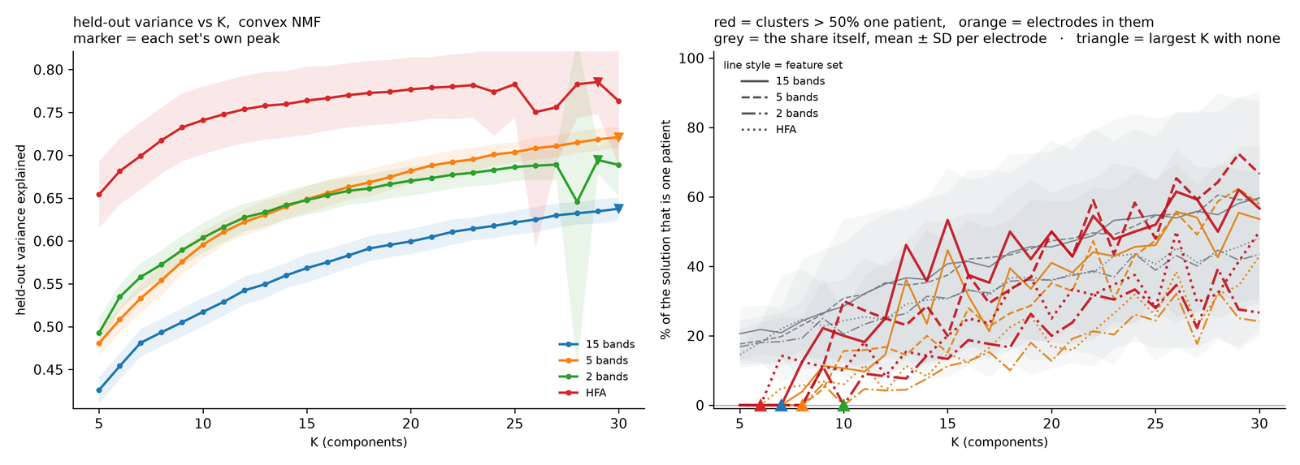
FIG_K_tradeoff_cnmf.png, drawn 2026-10-17 23:07 on the v17 runs (make_k_tradeoff_figure.py).
Left panel. Each line is V(K) of eq. 3.1 for one feature set, the mean over the 16 fold pairs (variance_curves, read from heldout_variance_ALL.csv); the shading is ± one SD across fold pairs and the triangle marks the K where the line is highest, the peak recorded in heldout_peaks_cnmf.csv. On v17: HFA explains most (0.65 at K = 5 rising to 0.78), 5 bands and 2 bands travel together (0.48 and 0.49 at K = 5, 0.72 and 0.69 at their peaks), 15 bands lowest (0.42 to 0.64); all four peak at K = 29 or 30, the end of the range.
How to read it. The height of a line is not a quality score across sets: a set with fewer, smoother numbers per electrode (HFA, 90) is easier to predict than one with 1 350, so HFA sits on top by construction. What matters is the shape. A line that rose to a peak and then fell would name a K; these keep rising to the largest K tried with no knee, so this criterion alone cannot choose and nominates K ≈ 30. The shading tells how much the 16 fold pairs disagree; a wide band (2 bands around K = 27) is one fold pair that failed to fit, not a feature of the data.
Right panel. Red is F_c(K), the share of clusters that are more than half one patient, orange F_e(K), the share of electrodes sitting in such clusters (eq. 3.3; dominance_curves through generalization_by_k, the table patient_dominance_by_k.csv); the line style is the feature set, the grey band the mean largest-patient share per electrode ± SD, and the triangle on the axis is K* of eq. 3.4: 6 for HFA, 7 for 15 bands, 8 for 5 bands, 10 for 2 bands.
How to read it. Every line sits on zero up to its triangle and climbs after it: by K = 15, 13 to 53% of the clusters are mostly one patient and 11 to 45% of the electrodes sit in them (2 bands lowest, 15 bands highest), and by K = 30 it is 27 to 67% and 24 to 58%, so each component added beyond K* describes a patient rather than a response type. A set whose red line were already above zero at K = 5 would have no clean K at all. Where the orange line runs far below the red one the dominated clusters are small (few electrodes); where the two coincide they are large. The grey band drifting upward says that even below the 50% line the typical cluster becomes more one-patient as K grows, which is why the rule takes the largest K with none over the line and not the K where the lines peak.
Reviewer 2
- Four feature sets x three algorithms x 26 values of K, with the K rule adopted after the held-out criterion failed to turn over: a garden of forking paths.
- The bi-cross-validation holds out random feature columns. Adjacent time bins and neighbouring bands are strongly correlated, which can keep V(K) rising with K whatever the structure; it does rise to K = 30 for every set, so as it stands the curve is not evidence for any K.
- The 50% dominance line has no null, and panel D's curves across K have no chance reference: a random cluster of 50 electrodes has a far higher chance top share than one of 300.
To do
- Declare one primary analysis (feature set, K, test) before the results; present the other sets and algorithms as sensitivity analyses.
- Re-run make_heldout_variance.py with blocked column folds (whole conditions, or contiguous time blocks within each band) and report whether a knee appears; if the curve still rises, say the criterion is uninformative here and K comes from the dominance rule alone.
- Give the dominance rule a null: the size-matched draws of patient_composition at every K, so F_c and F_e are read against their chance level (the 95th percentile of the draws) rather than against a 50% convention.

4 Figure 0 - the task and the cohort
Script 00_paper2_figure0_coverage.py; on v17 run as --feature-set concat_bands15 --k 7. Outputs FIG0_cohort_v17.png and FIG0_cohort_supplement_v17.png with their captions and tables.

4.1 The activity gate
The gate decides which electrodes enter the cohort. It is re-derived in the figure from the stored per-row proportions (load_gate) and must reproduce the stored flag on every row, or the script stops. For one electrode-condition ERSP of 103 × 300 = 30 900 bins, with the trial-average noise estimated from the two halves of the trials,
 | $$σ = \frac{sd\left(h_{1} - h_{2}\right)}{2}$$ | (4.1)

 | $$θ_{+} = \max\left(+2.2 dB, 2σ\right) , θ_{-} = \min\left(-3.0 dB, -2σ\right)$$ | (4.2)

 | $$p_{pos} = \frac{\left|\left\{bins > θ_{+}\right\}\right|}{30900} , p_{neg} = \frac{\left|\left\{bins < θ_{-}\right\}\right|}{30900}$$ | (4.3)

 | $$m = \max\left(\frac{p_{pos}}{0.02} , \frac{p_{neg}}{0.04}\right) , pass ⟺ m ≥ 1$$ | (4.4)

In short, equation 4.1 quantifies the noisiness of that electrode at that condition by calculating the standard deviation of the difference of the two halves of the trials. Equation 4.2 calculates the threshold for positive activity as anything above 2.2 dB from baseline or 2 noise levels (ie just sd of difference) while for negative it is 3 dB from baseline or similar noise limit as for positive. Then, the positive and negative proportions are calculated wrt the total number of bins. An electrode is kept if any of its three conditions passes either the 2% positive or 4% negative minimums in each condition (ie which make m at least 1 in 4.4). The thresholds and proportions are those recorded in the cache (params.json: thr_pos +2.2, min_prop_pos 0.02, thr_neg −3.0, min_prop_neg 0.04, noise_k 2, schema 3).
Example. 1 500 bins above θ₊ give p_pos = 0.049 and m = 0.049/0.02 = 2.4: pass. 400 bins above give m = 0.65: fail on the positive side. 1 000 bins below θ₋ give p_neg = 0.032 and 0.032/0.04 = 0.81: that side alone also fails. The caption of FIG 0 reports each exemplar's three margins (e.g. audio 7.00, picture 4.42, reading 1.75) and the number of bins the 2% and 4% rules correspond to.

4.2 The blob gate (planned for the v18 cache)
The second gate replaces the share of bins by the strength of connected regions of the ERSP. It is the valley-blob segmentation written for the blob clustering of August 2025 (lf_blob_metrics.s21_segment_valley_blobs, parameters in lf_blob_clustering_config.py), rerun in the gate window of the LM visualizer (rule = blob, 2026-10-20) with the noise-scaled thresholds of eq. 4.2. In the terms of image processing and of neuroimaging statistics this is hysteresis thresholding (the two-threshold step of the Canny edge detector, 1986; the h-maxima of grayscale reconstruction, Vincent 1993) scored by cluster mass (Bullmore et al. 1999), the statistic of cluster-based permutation tests on time-frequency maps (Maris & Oostenveld 2007); θ₊ and θ₋ of eq. 4.2 play the part of the cluster-forming threshold, two noise standard deviations with a floor of +2.2 / −3.0 dB. Threshold-free cluster enhancement (Smith & Nichols 2009) is the published generalisation that integrates over every δ instead of fixing one. For one electrode-condition ERSP of 103 × 300 = 30 900 bins, with θ₊ and θ₋ from eq. 4.2 and a growth margin δ:
 | $$C_{+} = \left\{b : {ERSP}_{b} ≥ θ_{+}\right\} , R_{+} = \left\{b : {ERSP}_{b} ≥ θ_{+} − δ\right\}$$ | (4.5)

C⁺ is the set of seed bins, R⁺ the set of bins that may belong to a positive blob. A positive blob B⁺ is an 8-connected component of R⁺ - a bin touches its eight neighbours in frequency and time - that contains at least one seed; the negative blobs are built the same way from ERSP ≤ θ₋ (seeds) and ERSP ≤ θ₋ + δ (growth). A blob is scored only when its mean is beyond the mean floor:
 | $$\operatorname{mean}\left(B_{+}\right) ≥ 0.7 θ_{+} , \operatorname{mean}\left(B_{−}\right) ≤ 0.8 θ_{−}$$ | (4.6)

With δ = 0.5 dB the floor of eq. 4.6 never binds, since every bin of a blob lies within δ of its threshold: mean(B⁺) ≥ θ₊ − 0.5 ≥ 0.7 θ₊ for every θ₊ ≥ 1.7 dB, and mean(B⁻) ≤ θ₋ + 0.5 ≤ 0.8 θ₋ for every θ₋ ≤ −2.5 dB; it is kept for continuity with the 2025 module. The score multiplies how strong a blob is by how much of the plane it covers: it is the blob's cluster mass, the sum of its dB values, written per cent of the plane:
 | $$s(B) = \left|\operatorname{mean}\left(B\right)\right| · \frac{100 · \left|B\right|}{N}$$ | (4.7)

|B| is the number of bins of the blob, N = 30 900, so the score is in dB·% (mean dB × per cent of the plane). The frequency penalty 1 + α·f_peak/f_max of the 2025 module (α = 3, up to four-fold at the top row) was dropped on 2026-10-21: with it the best blobs sat in the lowest rows, where the penalty is zero, and the window behaved as a 0–30 Hz detector; without it the score is the plain cluster mass and the only parameter beside the thresholds is δ. Per condition and sign the best blob carries the value (0 when there is none):
 | $$s^{+} = \max_{B ∈ {blobs}_{+}}{s(B)} , s^{−} = \max_{B ∈ {blobs}_{−}}{s(B)}$$ | (4.8)

A condition passes when either value lies inside its bounds, and an electrode is kept if any of its three conditions passes:
 | $$pass ⟺ s^{+} ∈ \left[\min_{+}, \max_{+}\right] or s^{−} ∈ \left[\min_{−}, \max_{−}\right]$$ | (4.9)

The lower bounds start at the medians of the cohort's best s⁺ and s⁻ (the 2025 module proposed its cut from the 90th percentile of the score distribution); the upper bounds are open unless set. The gate therefore has one free decision the share rule does not: where the two cuts sit. They are the one input the v18 cache still needs: read off the gate window on the v17 review bundle, they go into params.json of the cache (schema 4) together with δ, and a cache built with other values is refused.
parameter | gate window of the page (2026-10-20) | lf_blob_clustering_config (2025-08)
thresholds θ₊ / θ₋ | noise-scaled, eq. 4.2: max(+2.2 dB, 2σ) / min(−3.0 dB, −2σ) | fixed +2.5 / −3.5 dB
growth margin δ | 0.5 dB (box) | 1.5 dB (DELTA_VALLEY)
mean floor | mean ≥ 0.7 θ₊ / ≤ 0.8 θ₋ (inert at δ = 0.5, see above) | the same (0.7, 0.8 factors)
frequency penalty α | none (dropped 2026-10-21) | 3
area | % of all bins | number of bins
connectivity | 8-connected (3 × 3 neighbourhood) | 8-connected (ndimage.label, 3 × 3)
blobs kept | every scored blob; s⁺, s⁻ = the best per sign | the 6 best by score (MAX_BLOBS)
resolution | review thumbnails, time downsampled × 2 | the full 103 × 300 cube
the cut | min / max bounds per sign; first lower bounds = the medians of the best values | score_min proposed from the 90th percentile (BLOB_SCORE_QUANTILE)

Beside the score, the page reports for the best blob of the best condition the largest-blob fraction (area of the largest scored blob over the total area of all seeded blobs; 1 = one wave), the number of seeded blobs, the solidity (its area over the area of the convex hull of its bins; 1 = a full convex patch), the time extent (% of the axis) and the frequency extent (Hz). They describe the blob and do not enter the pass rule.
Example. With θ₊ = 2.2 dB and δ = 0.5, a bin at 2.5 dB is a seed; its neighbours at 1.9 and 1.8 dB join the blob (≥ 2.2 − 0.5 = 1.7), a neighbour at 1.5 dB does not. Suppose the blob covers 1 240 bins (100 × 1 240 / 30 900 = 4.0% of the plane), its mean is 3.1 dB (above the floor 0.7 × 2.2 = 1.54): s = 3.1 × 4.0 = 12.4 dB·%, wherever in frequency it sits. With a cut min⁺ of 5.0 it passes; a blob of the same mean over 1.0 % of the plane (s = 3.1) fails.

4.3 Why an electrode is not in the cohort
Function fate assigns every electrode the first reason that applies, in the order the pipeline applies them: patient not in the cohort, a condition missing, non-neural channel, grid contact, microelectrode, failed the gate. Only "kept" and "failed the gate" are what the gate saw (universe); the figure refuses to run if any electrode passes the gate, is absent from the cohort, and no filter explains it.

4.4 Panels
panel | content | computed by
A | four hand-picked electrodes (auditory, visual, motor, preparatory): position on their own hemisphere and the three-condition ERSP with the GO cue marked; the caption records coordinates, gate margins and cohort status | EXEMPLARS, panel_exemplar → cube_of (the electrode's stored ERSP arrays), draw_cube, strip_0
B | every electrode the gate saw, on fsaverage from the left, above and the right; kept in green, rejected in grey; counts under each view | universe, fate, coords (fsaverage table of step 17, 250 recon), panel_brains
S0 A | per patient: electrodes the gate saw (hatched) and kept (solid) | per_electrode, panel_bars
S0 B | the same on the brain, kept in the patient's colour | panel_brains
S0 C, D | of the kept electrodes, those with a LanA value (bars, and on the brain) | F3.lana_lookup (section 7.1), panel_bars, panel_brains
S0 E, F | the electrode that just passed and the one that just failed, preferably on one shaft: from the 60 kept with the lowest margin and the 60 rejected with the highest, the same-shaft pair with the smallest gap | pick_examples, panel_example

Brain renders. All brain panels in FIG 0, 1, 2 and 3 use one pipeline (00_Paper2_Figures._scene, render_hemi): PyVista/VTK off-screen rendering of the fsaverage pial surfaces, each hemisphere seen from its own side, with the house material constants read from functions/lf_recon_shared_config.py so that the paper figures and the visualizer cannot disagree.

4.5 Reading FIG 0 and FIG S0 (v17), and the conventions every figure shares
Conventions. Every ERSP panel has the same geometry: three condition blocks (audio, picture, sentences), each a stimulus half and a response half with the GO cue as a dashed line at 50% of the block; the x axis is % of the trial, warped per trial so that electrodes and conditions share one axis; the y axis is frequency (rows, 0-400 Hz, or the band labels of a feature set); the colour is dB relative to the pre-stimulus baseline, red above and blue below, on a ±7 dB scale. Cluster ids (c0 … c6) and their colours are the same in every figure and in the cluster visualizer: c3 is c3 everywhere, only its position on a page changes. On the brains each hemisphere is seen from its own side, 'from above' shows both, and the number under a view is the count of electrodes visible in it. The footer of every figure names the run, the cache, K and the drawing time: that line is the provenance.
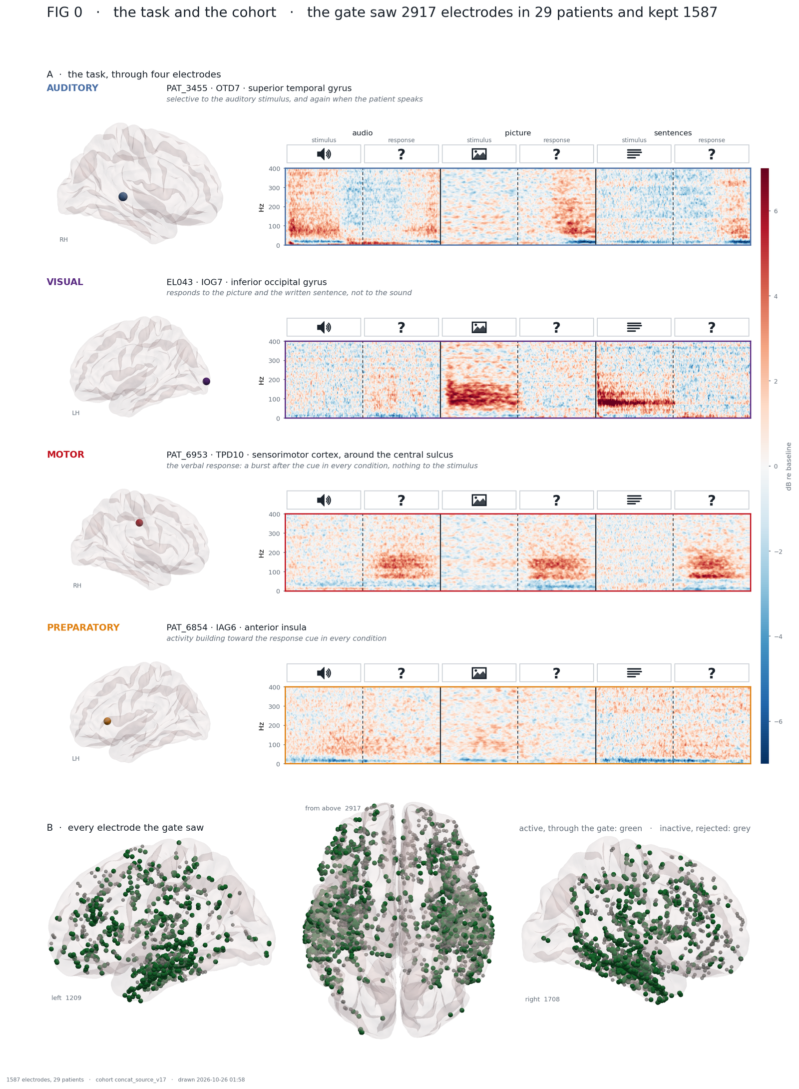
FIG0_cohort_v17.png, drawn 2026-10-26 01:58 (00_paper2_figure0_coverage.py --feature-set concat_bands15 --k 7, on the 20261019 atlas sampling); the 10-26 layout fix only (the 'from above' count in the top-left corner), numbers unchanged.
Title line. 'the gate saw 2917 electrodes in 29 patients and kept 1587': the universe of section 4.3 and the gate of eq. 4.4; 1587 ÷ 2917 = 54% pass.
A, the four exemplars. For each electrode: where it sits on its own hemisphere (fsaverage coordinates of step 17) and its three condition blocks, drawn by panel_exemplar from the electrode's stored ERSP arrays. The margins of eq. 4.4 are in FIG0_cohort_v17_exemplars.csv: the auditory electrode PAT_3455 OTD7 has audio 7.00, picture 4.42, reading 1.75; the preparatory one PAT_6854 IAG6 has 2.14, 1.25, 2.61. Reading: the auditory electrode is red at 50-400 Hz during the audio stimulus and again after the cue when the patient speaks; the visual one only during the picture and the sentences; the motor one after the cue in all three; the preparatory one builds up toward the cue. They are hand-picked illustrations of what the task evokes, chosen by eye and said so in the caption; no statistic selected them.
B, every electrode the gate saw. Green = kept, grey = rejected by the gate (universe, fate, panel_brains); the counts under the views (left 1209, from above 2917, right 1708) are electrodes visible in that view. Reading: green concentrates in temporal and ventral cortex, grey marks cortex that was recorded but where nothing crossed the threshold in any condition. A region that is grey everywhere is not 'silent', it is outside the cohort every later figure is computed on.
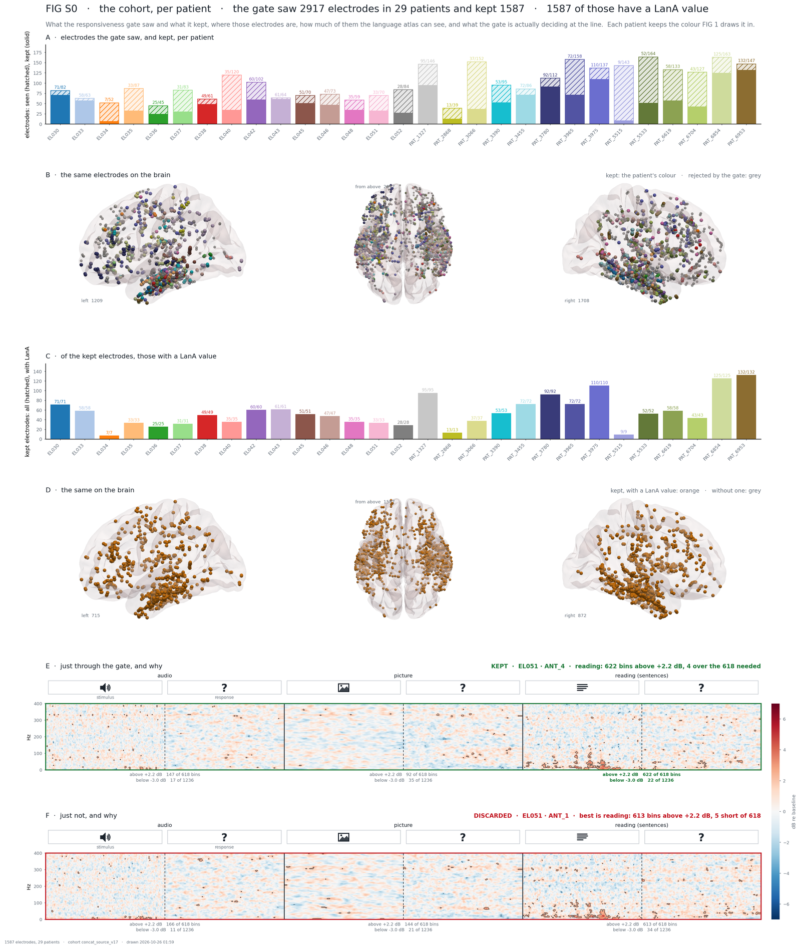
FIG0_cohort_supplement_v17.png, drawn 2026-10-26 01:59, same script; the strip words 'stimulus' / 'response' no longer hang into the ERSP.
S0 A, per patient. Hatched = electrodes the gate saw, solid = kept, in the patient's colour (panel_bars; the table FIG0_cohort_supplement_v17_patients.csv). Reading: a short solid bar is a patient with few responsive electrodes (EL034 7 of 52, PAT_5515 9 of 143) and a tall one a patient who carries much of the cohort (PAT_6953 132 of 147, PAT_6854 125 of 163). The cohort is not balanced across patients, which is exactly what FIG 1 D and the rule of section 3.2 guard against.
S0 B and D, on the brain. B colours the kept electrodes by patient; D shows which kept electrodes have a LanA value (orange) and which do not (grey).
S0 C, atlas coverage. Of the kept electrodes, those with a LanA value, from the same lookup FIG 3 uses (F3.lana_lookup): since the atlas was re-sampled on the current coordinates on 2026-10-19, 1587 of 1587 - every bar is fully solid and no patient is missing. In the 10-19 render of this figure the 09-07 sampling covered 1395, with PAT_1327, EL051 and EL052 absent whole; that gap is closed, and panel D is orange throughout.
S0 E and F, the gate at the line. The kept electrode with the lowest margin and the rejected one with the highest, on the same shaft when possible (pick_examples, panel_example): EL051 ANT_4 is kept with 622 bins above +2.2 dB in the reading block, 4 over the 618 required (2% of 30 900), ANT_1 is discarded with 613, 5 short. The outlined bins are the ones that count. Reading: the gate is a count, and at the line nine bins separate kept from discarded. That is why eq. 4.4 reports a margin rather than a yes/no, and why the gate window of the LM visualizer has a border band.
Reviewer 2
- The gate (2% / 4% of bins beyond a noise-scaled threshold) defines the cohort and is arbitrary; no sensitivity of the partition to the gate is shown.
- Time warping to percent of trial smears response-locked activity across trials of different length and puts the GO cue at 50% by construction.
To do
- Compare the v17 partition with the v18 (blob-gate) partition on the shared electrodes with FIG 5's share, and report how the gate parameters move the cohort size and the clusters.
- Add reaction-time distributions per patient and condition to the supplement, and one response-locked control: align to response onset, recluster, report the agreement.

5 Figure 1 - one feature set, convex NMF
Script 00_Paper2_Figures.py, one figure per feature set, each at its own K* (section 3.2): FIG1a_concat_bands15_cnmf_K7, FIG1b_concat_bands5_cnmf_K8, FIG1c_concat_bands2_cnmf_K10, FIG1d_concat_hfa_cnmf_K6 (all run20261017-…). The run is read by load_run: the published-K loadings, the feature schema, the labels and the fsaverage coordinates joined by electrode key.

5.1 Panel A - held-out variance against K
Function panel_A draws V(K) of eq. 3.1 for all four sets with this one emphasised, a triangle at each curve's peak and a mark at the K the figure is cut at. Nothing is computed here; the panel reads heldout_variance_ALL.csv and heldout_peaks_cnmf.csv. It is identical in 1a-1d so the four can be laid side by side. Since 2026-10-21 that table is the merge of the three per-method tables that 240/241/242 write (the home pass, K 5-30, 300 iterations).

5.2 Panel B - one block per cluster
Cluster mean and spread (cluster_mean_sd). Under the default display rule (members = hard labels, plain traces) the block's top trace is the mean over the cluster's members at every band × time × condition cell, with the sample SD across members (n − 1). The weighted form, used when the trace is loading-weighted, is the weighted second moment about the weighted mean with Kish's effective sample size, so a hard and a graded cluster are described by one formula:
 | $$m = \frac{\sum_{i}{w_{i} x_{i}}}{\sum_{i}{w_{i}}} , s^{2} = \frac{\sum_{i}{w_{i} {\left(x_{i} - m\right)}^{2}}}{\sum_{i}{w_{i}}}$$ | (5.1)

 | $$n_{eff} = \frac{{\left(\sum_{i}{w_{i}}\right)}^{2}}{\sum_{i}{{w_{i}}^{2}}} , SD = \sqrt{s^{2} · \frac{n_{eff}}{n_{eff} - 1}}$$ | (5.2)

Outlined cells (agreement, outline_cells). A cell is outlined where the members agree on the sign of the response, defined as the ±1 SD band across members not crossing zero:
 | $$\left|m_{b}\right| > {SD}_{b}$$ | (5.3)

This is a description, not a test: there is no null and no correction over the 450 or 1 350 cells. A cluster of one electrode has SD 0 everywhere and is given no outline rather than a complete one.
Brain renders (render_hemi). The members are drawn on the left hemisphere seen from the left and the right from the right. Since 2026-10-26 an electrode below a normalised loading of 0.30 on the cluster shown is not drawn at all (LOAD_CUT); above the cut, colour greys toward the background as the loading falls (full cluster colour from 0.50, loading_rgb), dot size shrinks with it (full radius from 0.70, loading_t) and opacity follows the same ramp (loading_alpha). A rendering rule only: the counts and the statistics use the argmax membership. On 15 bands at K = 7, 1 341 electrodes (84.5 %) are at or above the cut at their own cluster and 246 (15.5 %) are not drawn there.
Patient bar (patient_bar). The cluster's composition by patient, one segment per patient, widest first, in colours shared by the whole figure (patient_colours).
Order of the blocks (block_order, match_clusters). Blocks are ordered to match the reference solution, cNMF on concat_bands5 at the same K. The reference's own order is by condition similarity, the mean pairwise Pearson correlation between the cluster's three condition profiles (condition_similarity; a sort key, not a result). Every other run is matched to the reference one-to-one by the Hungarian assignment (Kuhn 1955; scipy.optimize.linear_sum_assignment) on the K × K matrix of correlations between loading columns across electrodes; when one side is a hard partition the score is the number of shared electrodes instead. The quality of each matched pair is reported as the Jaccard index of the two hard member sets:
 | $$J(A,B) = \frac{\left|A∩B\right|}{\left|A∪B\right|} = \frac{\left|A∩B\right|}{\left|A\right| + \left|B\right| - \left|A∩B\right|}$$ | (5.4)

Cluster ids, colours and every CSV keep their own numbering; only the position on the page changes.
Example. Cluster A has 100 members, its matched partner B has 120, and 80 electrodes are in both: J = 80 / (100 + 120 − 80) = 80 / 140 = 0.57. Identical clusters give 1; disjoint ones 0.

5.3 Panel C - how to read a cluster mean
An idealised schematic drawn with this feature set's exact geometry (schematic, trial_strip): the two screens per condition and the GO cue at 50% of the block. No data enter this panel.

5.4 Panel D - response type or one patient?
Function panel_D draws F_c and F_e of eq. 3.3 at every K of the sweep (generalization_by_k, labels_by_k: for cNMF the hard labels are the arg max of each K's loadings), with the held-out curve faint behind them, and, at the published K, each cluster's largest patient share against the size-matched random draw of section 3.2 (patient_composition, 400 draws). The table behind it is written as FIG1x_…_generalization.csv; the per-cluster composition as …_patients.csv; the match to the reference as …_matching.csv.
The caption written beside each PNG records the run, the cache, the K, the cluster sizes, the display rule and the match to the reference.

5.5 Reading FIG 1a (15 bands, K = 7) and FIG 1d (HFA, K = 6), v17
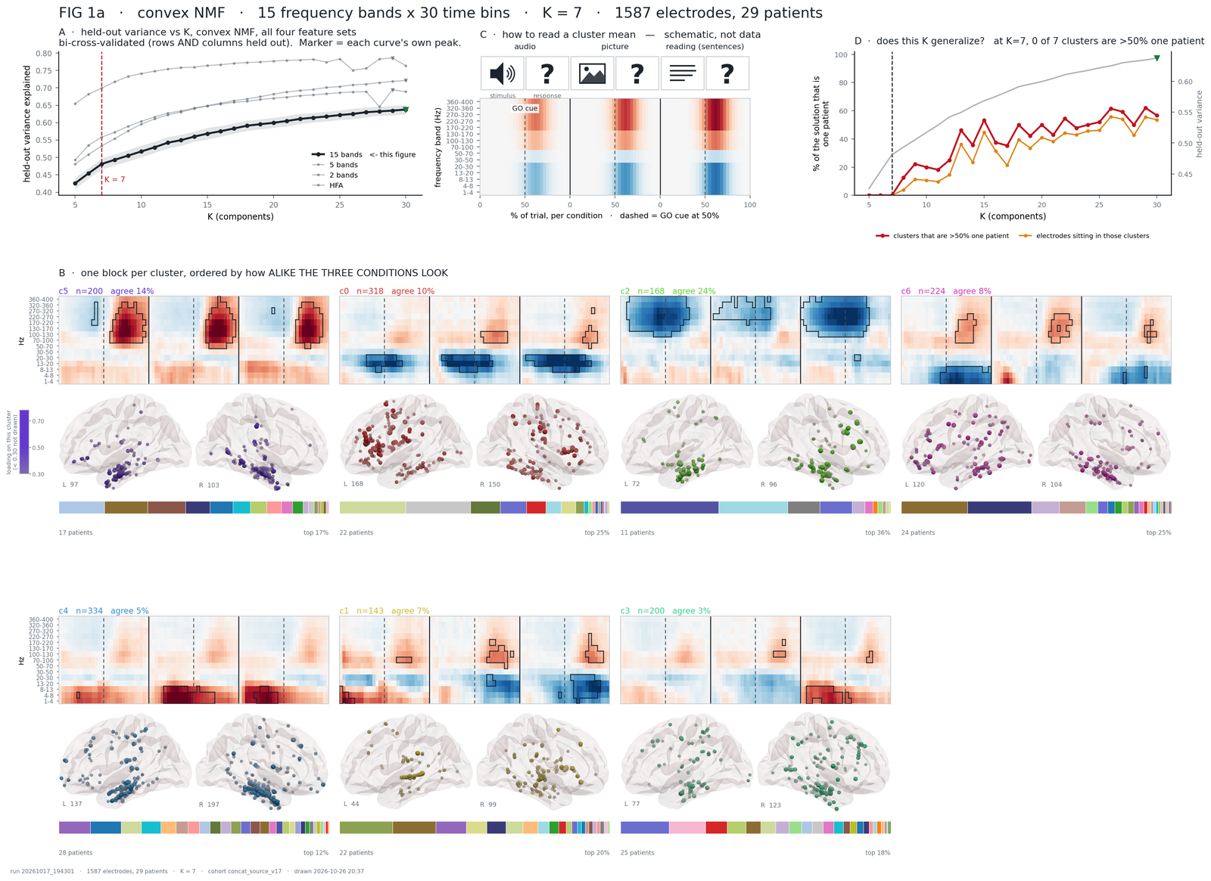
FIG1a_concat_bands15_cnmf_K7_run20261017-194301.png, drawn 2026-10-26 20:37 (00_Paper2_Figures.py --feature-set concat_bands15 --k 7): the brains apply the 0.3 cut of section 5.2, the footer sits under the last row and panel D's legend under its axes (the 10-26 layout fixes); every number unchanged.
Panel A. The four curves of section 3.1, read from the merged held-out table: 15 bands in black with its ± SD band over the 16 fold pairs, the other three sets in grey, the triangle on each curve at its own peak (K = 30 for 15 bands, 30, 29, 29 for the others) and the red dashed line at the cut, K = 7. Reading: the curve still rises at the cut and keeps rising to K = 30, which is the point of panel D beside it - the held-out criterion would take every K offered. The faint grey line on the right axis of panel D is this same curve, so the two criteria can be read against each other. This panel was empty in the 10-19 render; the fix is recorded in the comment.
B, one block per cluster. Seven blocks, one per cluster, in the order of section 5.2: matched to cNMF on 5 bands at K = 7 (FIG1a_…_matching.csv: c5 is matched to reference cluster 1 with Jaccard 0.33 and drawn first, c2 to reference 3 with 0.73, c6 to reference 5 with 0.09 - the weakest match). The header of a block gives the id, n = members (hard labels) and 'agree' = the share of the 1 350 cells outlined by eq. 5.3. The top of the block is the mean ERSP of eq. 5.1 (15 band rows × 30 bins × 3 conditions), red above and blue below baseline, with the outlined cells where the members agree on the sign. Under it the two hemispheres with the members coloured by loading (dot size and opacity from 1/K up to 0.70, the bar on the left), with the L / R counts, then the patient bar: one segment per patient, widest first, and 'n patients · top x%' = n_patients and top_share of FIG1a_…_patients.csv (c5: 200 electrodes, 17 patients, top 17%; c2: 168, 11 patients, top 36%; c4: 334, 28 patients, top 12%).
How to read a block. Red or blue says the direction, the outline says how reliably the members share it (|mean| > SD, not a test), the brains say where, the bar says who. Examples on this figure: c5's outlined cells are all in the 70-400 Hz rows after the GO cue, in all three conditions - a response-locked high-frequency burst whatever the stimulus, the production type; c0's outlines are blue in the 13-50 Hz rows through stimulus and response in every condition - a beta decrease, with a small high-frequency rise after the cue (28 red cells above 70 Hz); c4's outlines are red in the 1-13 Hz rows, most of them in the stimulus halves (47 of its 62 outlined cells) - a low-frequency increase while the stimulus is on; c2 is a broadband high-frequency decrease, strongest in the stimulus halves (209 outlined cells) and still there after the cue (111), and with 11 patients and a top share of 36% it is the least general cluster at this K. 'agree 3%' (c3) is a cluster whose members agree on little: a weak or mixed type; 'agree 24%' (c2) the most coherent one. A patient bar made of one long segment would be one patient's electrode strip; at K = 7 the largest segment is 36%.
C. The key to a block: an idealised response with this feature set's geometry, the screens of each condition above it. No data.
D, does this K generalise? Red = F_c(K), orange = F_e(K) of eq. 3.3 for this run at every K of the sweep (FIG1a_…_generalization.csv): 0 and 0 up to K = 7 (the dashed line), 12.5% and 3.9% at K = 8, 53% and 45% at K = 15, 57% and 54% at K = 30. Reading: the figure is cut at the last K before the lines leave zero; every component added beyond it is increasingly one patient. The title repeats the verdict at the cut: 'at K = 7, 0 of 7 clusters are > 50% one patient'.
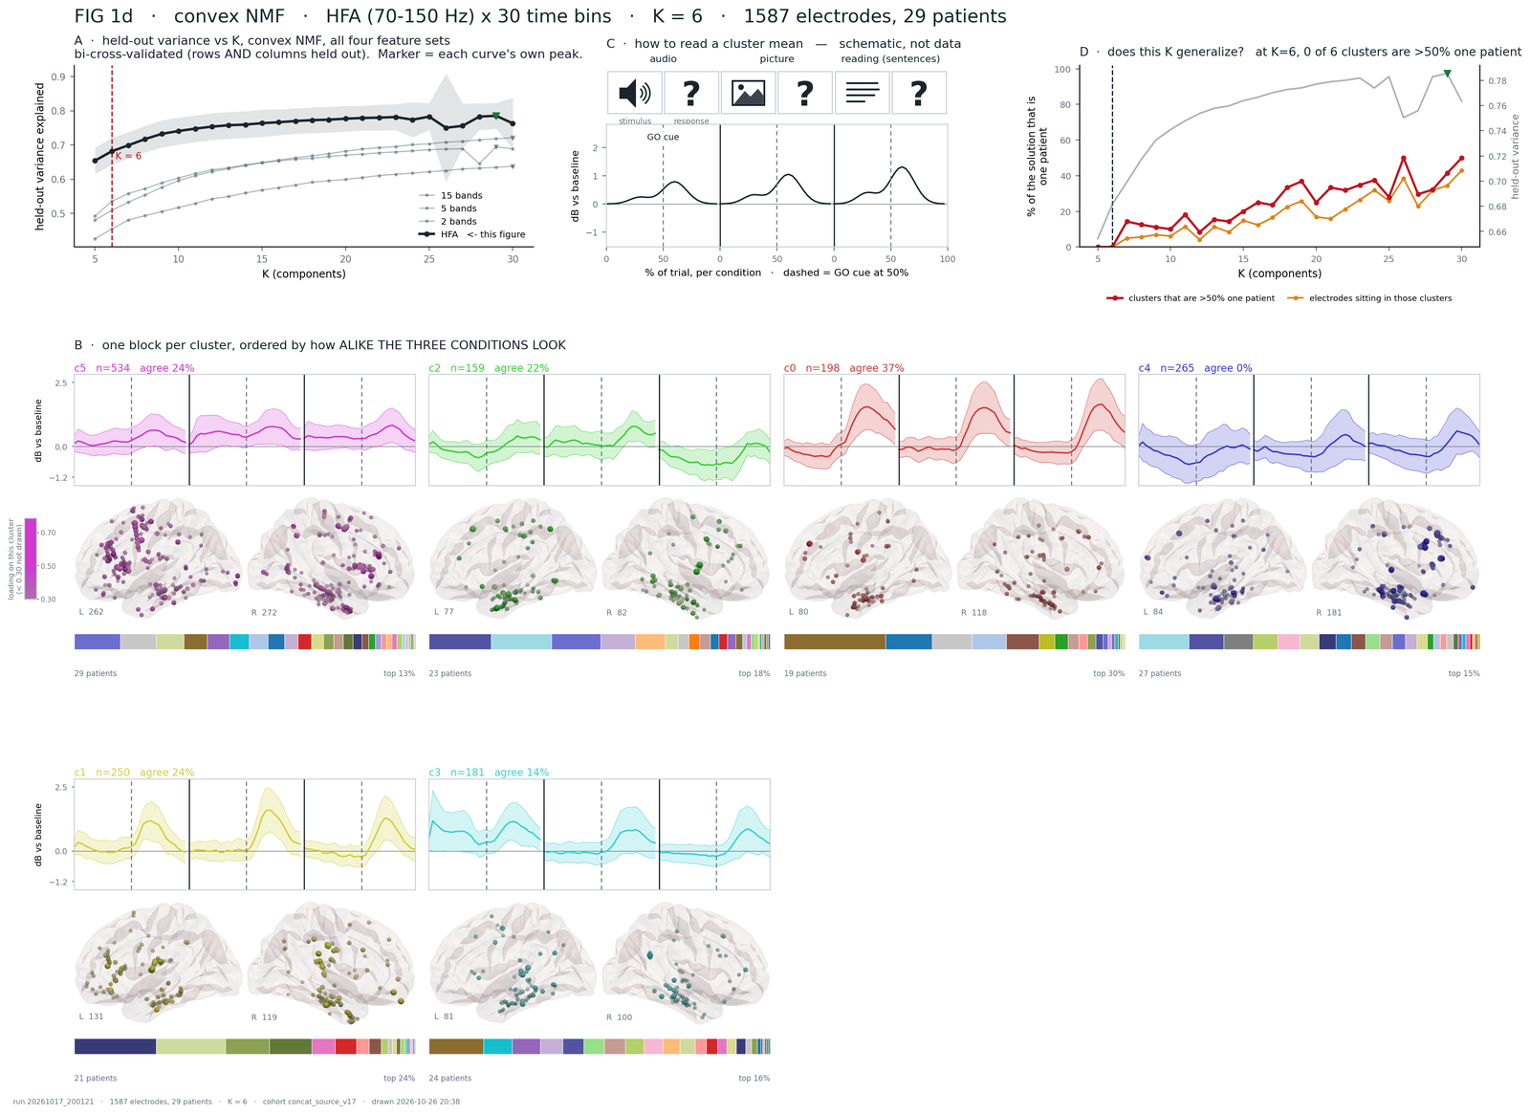
FIG1d_concat_hfa_cnmf_K6_run20261017-200121.png, drawn 2026-10-26 20:38 (--feature-set concat_hfa --k 6), with the same cut and layout fixes.
FIG 1d, the same figure on HFA. HFA is a single band, so a block is a line - the mean of eq. 5.1 - with a band of ± 1 SD across members (eq. 5.2 in its plain form); where the band clears zero is where the outline would be. Reading: c0 (198 electrodes, agree 37%) rises after the GO cue in every condition, the production type again; c1 (250) rises after the cue in every condition, most for pictures (+0.8 dB) and about +0.5 dB for audio and sentences; c5 (534 electrodes, all 29 patients, top 13%) is the largest cluster: a modest rise of 0.1 to 0.6 dB through stimulus and response in every condition (agree 24%), the catch-all a single-band representation makes of everything the other bands carry; c4 (265) is the cluster with no consistent HFA response - its mean stays within 0.3 dB of zero and its band crosses zero in every cell (agree 0%). A band that crosses zero everywhere means the members disagree on the sign everywhere: the mean is then an average of unlike things. Panel D is cut at K = 6 for this set; its lines leave zero at K = 7.
Reviewer 2
- Seven dense blocks with 29-colour patient bars are unreadable at print size; 'agree %' reads like a statistic and is not one; 1a-d are four figures for one message.
To do
- Keep FIG 1a (the primary set) as the main figure and move 1b-d to the supplement; drop the 'agree %' number, keep the outline and define it in the legend; put n, patients and top share per cluster in a table under the figure.

6 Figure 2 - agreement across feature sets and across algorithms
Script 00_paper2_figures2_2.py; on v17 run as --k 7 --algo-feature-set concat_bands15 → FIG2_agreement_concat_bands15_K7_run20261017-194301. Two halves ask the same three questions. The top half varies the feature set with the method fixed (cNMF on the four sets; reference cNMF on concat_bands5); the bottom half varies the algorithm with the feature set fixed (cNMF, k-means, Ward on concat_bands15; reference cNMF).

6.1 Solutions and alignment
A solution is one run at one K (solution: loadings if graded, hard labels, run directory, electrode keys). gather refuses to compare solutions that do not label the same electrodes in the same order, or that are not at the same K. Every solution in the figure therefore labels the same 1 587 electrodes.

6.2 Panels A and D - how much any two solutions agree
Rand index and ARI (Hubert & Arabie 1985; sklearn.metrics.adjusted_rand_score). For two partitions U and V of the same n electrodes, with n_ij the number of electrodes in cluster i of U and cluster j of V, a_i and b_j the cluster sizes, and C(x, 2) = x(x − 1)/2 the number of pairs:
 | $$Index = \sum_{ij}{C\left(n_{ij}, 2\right)} , Max = \frac{\sum_{i}{C\left(a_{i}, 2\right)} + \sum_{j}{C\left(b_{j}, 2\right)}}{2}$$ | (6.1)

 | $$E = \frac{\sum_{i}{C\left(a_{i}, 2\right)} · \sum_{j}{C\left(b_{j}, 2\right)}}{C\left(n, 2\right)}$$ | (6.2)

 | $$ARI = \frac{Index - E}{Max - E}$$ | (6.3)

The plain Rand index is the share of electrode pairs on which the two partitions agree (together in both, or apart in both); the adjustment subtracts what two random partitions with the same cluster sizes would score, so 0 means no better than chance and 1 identical.
Example (exact). Four electrodes, U = {1,2}{3,4}, V = {1,2,3}{4}. Of the six pairs, three agree (1-2 together in both; 1-4 and 2-4 apart in both), so RI = 0.5. Index = C(2,2) = 1; row pairs Σ C(a,2) = 1 + 1 = 2; column pairs Σ C(b,2) = 3 + 0 = 3; E = 2 × 3 / 6 = 1; Max = (2 + 3)/2 = 2.5; ARI = (1 − 1)/(2.5 − 1) = 0. Half the pairs agree, and that is exactly what chance gives.
Normalised mutual information (Vinh, Epps & Bailey 2010; sklearn.metrics.normalized_mutual_info_score, arithmetic normalisation):
 | $$NMI(U,V) = \frac{I(U;V)}{\frac{H(U) + H(V)}{2}}$$ | (6.4)

I is the mutual information between the two labellings and H their entropies. ARI is dominated by the large clusters and NMI is not, so the two are shown together and a gap between them is informative. pairwise_ari and pairwise_nmi fill the matrix in panel A.2 / D.2; ari_by_k draws the curve above it: the mean ARI over every pair of solutions at every K from 5 to 30, read from the runs' cluster_labels_by_k.csv, so that one K is never read in isolation.

6.3 The per-cluster table (B and E; written, not drawn) - each cluster against the reference
Matching and Jaccard (cluster_agreement). Every solution is matched one-to-one to the reference exactly as in section 5.2 (Hungarian on loading correlations, or on shared counts when a side is hard). The cell for reference cluster p and solution s is the Jaccard index (eq. 5.4) of p with its partner. The row is dropped for the reference column itself.
What the others think. Because the panel is asymmetric - a cluster every other solution finds but the reference does not would read as 'did not survive' - each row also carries the best Jaccard between two non-reference solutions about the same cluster.
Cell-wise null (cluster_jaccard_null). Chance overlap depends on the two cluster sizes, so every cell has its own null: the partner solution's labels are permuted across electrodes (its cluster sizes kept), re-matched to the reference the way the real ones are, and the Jaccard recomputed 1 000 times (N_PERM_NULL; the figure of 2026-10-25 and the default). The cell's null is the mean, and its p the share of permutations reaching the observed value.
Split count (split_counts). For each reference cluster and each solution, the number of that solution's clusters holding at least 25% of the reference cluster: 1 is a clean correspondence, 2 or more a split that a one-to-one match has to score as one good pair and one failure. The 25% is a reading convention, not a test.
Example. Reference cluster p (100 electrodes) lands 60% in solution s's cluster 3 and 30% in its cluster 5: split count 2. The Hungarian match pairs p with cluster 3 and J = 60 / (100 + |c3| − 60); the 30 electrodes in cluster 5 count against the pair although s found the same structure in two pieces.

6.4 The ceiling and PAC - a solution against its own refits
Consensus matrix (Monti et al. 2003; written by sweep_stability.py --native into <run>/stability_by_k_native/k_KK/consensus_matrix.npy). The run's own method is refitted R = 50 times on random subsamples of 80% of the electrodes, and for every pair of electrodes
 | $$M_{ij} = \frac{1}{R_{ij}} \sum_{r}{1\left[i and j in the same cluster in refit r\right]}$$ | (6.5)

counted over the refits in which both were drawn. Ceiling (self_stability; column mean_jaccard of stability_by_k_native.csv): per cluster, the mean of M_ij over all pairs of its members, then averaged over clusters. Cross-solution agreement cannot exceed what a method manages against its own refits, so a Jaccard of 0.4 against a ceiling of 0.55 and the same 0.4 against 0.90 are different results.
The quantity is Hennig's (2007) simplest per-cluster stability measure, pairwise co-occurrence within the labelled group.
PAC, the proportion of ambiguous clustering (Şenbabaoğlu, Michailidis & Li 2014; the robustness score of SC3, Kiselev et al. 2017; pac):
 | $$PAC = \frac{1}{C\left(n, 2\right)} \sum_{i<j}{1\left[0.1 < M_{ij} < 0.9\right]}$$ | (6.6)

An entry near 1 means two electrodes always cluster together, near 0 never; anything between is the resampling disagreeing with itself. Lower is better. It is read from the same consensus matrix, not recomputed.
Example. Two electrodes that land together in 48 of 50 refits have M = 0.96 and are not ambiguous; two that do so in 25 of 50 have M = 0.5 and count towards PAC. A cluster whose members pair up at M = 0.96 on average has a ceiling of 0.96.

6.5 Consensus stability across patients (consensus_stability.py)
Script consensus_stability.py (2026-10-25), outputs under outputs/clustering/consensus/concat_source_v17/<feature set>/<method>/ with the cross-cell files one level up. It asks the question of 6.4 at the level of patients. Section 6.4 refits a solution on 80% of the electrodes; here every refit drops 20% of the patients and keeps every electrode of the rest, so what is measured is whether a cluster survives the removal of whole patients, the unit that changes between cohorts and the unit of the leave-one-patient-out placement test of make_cluster_statistics.py. Electrodes are never resampled individually: contacts on one shaft share a reference, and electrode-level resampling makes co-clustering look more stable than it is. It runs on all twelve cells (four feature sets × three methods) on the v17 runs' X_train.npy (md5 identical across the three runs of a set, the check of the statistics script), with the fitters of measure_cluster_stability.fit_any in unit-norm space, for K = 2 to 12 (--ks). Consensus clustering is Monti et al. (2003); the PAC statistic and the null are Şenbabaoğlu, Michailidis & Li (2014).
Consensus matrix. H = 200 draws (--H). Draw h samples 23 of the 29 patients without replacement (80%), refits the method on their electrodes (a fresh seed for k-means and cNMF; Ward is deterministic and varies only through the draw), and for every pair of electrodes present in the draw records whether they share a cluster:

 | $$M_{K}(i, j) = \frac{\# draws with i and j in one cluster}{\# draws with i and j both sampled}$$ | (6.7)

Two electrodes of different patients are both sampled in about 63% of the draws, two of the same patient in 80%, so every entry rests on 100 to 160 draws at H = 200; the minimum is logged per cell (verification.json). M is stored as float16 (M_kKK.npy). PAC(K) is eq. 6.6 applied to it: the share of pairs with 0.1 < M < 0.9.
Null and RCSI. PAC falls with K almost by construction, since finer splits turn ambiguous pairs into separated ones, so it is read against a null, the Gaussian cloud: measure_cluster_stability.surrogate, one cloud of points with the real matrix's mean and covariance and no cluster structure, the generator the separation test of the statistics script already uses. One cloud per feature set and null draw, shared by the three methods, with the real patient labels attached, goes through the identical procedure (D = 25 draws of 50 iterations, --null-draws, --null-H). For each K:

 | $$RCSI(K) = \log\left({mean}_{d} {PAC}_{null, d}(K)\right) − \log{PAC(K)}$$ | (6.8)

 | $$p(K) = \frac{1 + \#\left\{d : {PAC}_{null, d}(K) ≤ PAC(K)\right\}}{1 + D}$$ | (6.9)

RCSI is positive where the real data are more stable than noise of the same covariance; p is the share of null draws at least as stable as the data, with a resolution of 1/26, a ranking rather than a test. The Gaussian cloud carries no patient structure, so a K whose clusters follow patients can look stable against it. The chosen K is therefore the largest RCSI among the Ks whose consensus partition passes the rule of eq. 3.4 (no cluster with s_j > 0.5), and the unconstrained argmax is reported beside it with a flag when the two differ. The consensus CDF, Monti's A(K) and Δ(K) and the running-max Δ̂(K) of Şenbabaoğlu et al. (needed because A(K) is not monotone for k-means and cNMF) are written to k_curve.csv for every K but do not decide.
Consensus partition. The matrix is clustered itself: average-linkage hierarchical clustering on 1 − M, cut at K (lf_decompose.consensus_labels), at the chosen K and at the current K of the set (peak_k.json). This partition uses all H draws at once and depends on no seed, which answers the single-seed objection to cNMF in 2.4. It is compared by ARI with the published partition of the newest run, with a plain refit at seed 42 (the reference of the statistics script) and, for k-means and cNMF, with a second full consensus run from another master seed: an ARI near 1 says the procedure reproduces itself, below 0.9 the cell is flagged to raise H. The cross-method ARI of the three consensus partitions at the current K is written beside the single-fit values of stats_agreement.csv.
Stability scores. Cluster consensus m(k) is the mean of M over the pairs inside cluster k; item consensus m_i(k) the mean of M between electrode i and the members of k other than itself:

 | $$m(k) = {mean}_{i<j∈k} M_{K}(i, j), m_{i}(k) = {mean}_{j∈k, j≠i} M_{K}(i, j)$$ | (6.10)

Per electrode, items_kKK.csv carries its own-cluster consensus, the best other cluster's and the margin between them; per patient, patients_kKK.csv the mean own-cluster consensus of its electrodes and the share below 0.5, ranked, with the Spearman correlation against the leave-one-patient-out placement accuracy of stats_lopo_predict.csv at the current K. A cluster with m(k) < 0.6 is flagged unstable, a convention and not a test. Figures per cell: the heatmap of M at both Ks in optimal leaf order of the consensus dendrogram with a patient strip and a cluster strip, PAC and RCSI against K, the CDFs; across cells, RCSI against K for the twelve cells on one 4 × 3 page, summary_cells.csv and SUMMARY.md. Every existing file the script reads (the runs' labels and X_train, the statistics tables) is hashed before and after a run. The sweep ran on 2026-10-26 (12 cells, 12.0 h, every pre-existing file unchanged by hash); 6.6 reads it.
Example. Six electrodes, e1 to e3 from one patient and e4 to e6 from another, with M(e1, e2) = 0.95, M(e1, e3) = 0.90, M(e2, e3) = 0.85, M(e4, e5) = 0.80, M(e4, e6) = 0.30, M(e5, e6) = 0.35 and every cross pair at 0.20 or below. Average linkage on 1 − M merges e1 and e2 (distance 0.05), then e3 (mean distance 0.125), then e4 and e5 (0.20); e6 is 0.85 from the first group and 0.675 from the second and joins the second. At K = 2 the clusters are {e1, e2, e3} with m = (0.95 + 0.90 + 0.85) / 3 = 0.90 and {e4, e5, e6} with m = 0.48, flagged. For e6 the own-cluster consensus is (0.30 + 0.35) / 2 = 0.33 and the best other cluster 0.15, a margin of 0.18: an electrode on the fence. The second patient's mean own-cluster consensus is 0.48 with one electrode of three below 0.5. Both clusters are one patient each, so this K fails eq. 3.4 and could not be chosen.

6.6 Reading the consensus sweep (v17, 2026-10-26)
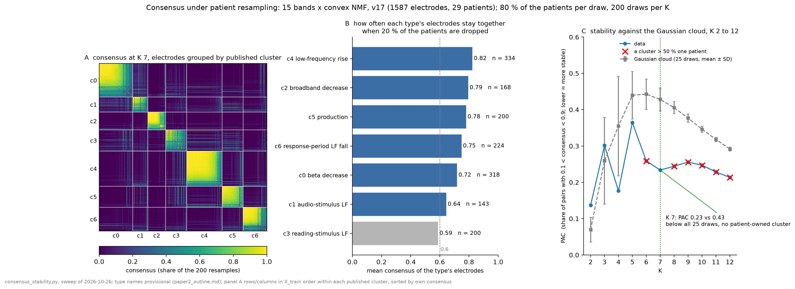
consensus_bands15_cnmf_K7_slide.png, drawn 2026-10-26 from the sweep's own files (M_k07.npy, items_k07.csv, k_curve.csv, the run's cluster_labels_by_k.csv), beside SUMMARY.md under outputs/clustering/consensus/concat_source_v17/. The sweep: consensus_stability.py, all twelve cells, K = 2 to 12, H = 200, 25 null draws, one terminal, 12.0 h; existing_outputs_check.json says the 186 files it reads were unchanged by hash.
Panel A. The consensus matrix of the main cell (15 bands × convex NMF) at the published K = 7, rows and columns grouped by the PUBLISHED cluster of each electrode (c0 to c6 of FIG 1, k_7 of the run of 2026-10-17 19:43) and, inside a cluster, sorted by own-cluster consensus. A block that is yellow to its edge is a type whose electrodes stay together whichever 20% of the patients are dropped; a block that frays into the off-diagonal is a type that exchanges electrodes with another when some patients are missing. The partition of the matrix itself (average linkage on 1 − M, cut at 7) maps onto the published one almost one to one, ARI 0.83: c0 → 294 of 318 in one consensus cluster, c1 130 of 143, c2 159 of 168, c3 174 of 200, c4 316 of 334, c5 190 of 200, c6 203 of 224.
Panel B. Mean consensus of each published type's electrodes with the consensus cluster they land in (eq. 6.10 read per published label): c4 low-frequency rise 0.82 (n = 334), c2 broadband decrease 0.79 (168), c5 production 0.78 (200), c6 response-period low-frequency fall 0.75 (224), c0 beta decrease 0.72 (318), c1 audio-stimulus low-frequency 0.64 (143), c3 reading-stimulus low-frequency 0.59 (200). Electrodes whose margin between their own cluster and the best other is below 0.2: 4% of c2, 5% of c5, 6% of c4, 13% of c6, 14% of c0, 16% of c1, 28% of c3. The dashed line is the 0.6 convention of 6.5; c3 sits on it. Mean cluster consensus of the partition is 0.73 (consensus clusters 0.82, 0.82, 0.76, 0.76, 0.72, 0.62, 0.58).
Panel C. PAC of the data (blue) against the Gaussian cloud (grey, mean ± SD of the 25 draws) for K = 2 to 12; a red cross marks a K at which the consensus partition has a cluster more than half one patient (eq. 3.4), the dotted line the published K. At K = 7: PAC 0.234 against 0.428 ± 0.031, RCSI 0.61, below every one of the 25 draws (p = 1/26 = 0.038, the floor of eq. 6.9), and no patient owns a cluster (the largest share is 39% of the broadband-decrease cluster from PAT_3965; the single fit has 36%). At K = 6 one cluster is 59% PAT_3975; from K = 8 on, one cluster is 100% PAT_3455, the patient with the response-locked broadband burst. The script's own choice for this cell is K = 4 (RCSI 0.70, p = 0.23, above two of the 25 draws), the second-highest RCSI being K = 7.
How to read it. The published K = 7 solution of the main cell is more stable across patient resamples than noise with the same covariance, its types are the published types, and it sits between a K where one patient holds half a cluster and a K where one patient holds a whole one. Consensus does not single K = 7 out: a coarser K = 4 has a higher RCSI without clearing the draws, so the criterion supports the chosen solution and is not the K selector; the selector stays eq. 3.4 with the held-out curve of 3.1. The per-type ranking lands on the same side as the correspondence test of 8.7 with one correction: it is the condition-specific low-frequency types (c1, c3) that are fragile, not low-frequency types as such, since the shared low-frequency rise c4 is the most stable type of the seven.
Patients. Mean own-cluster consensus at K = 7 runs from 0.86 (EL052, PAT_3965) and 0.85 (PAT_5515) down to PAT_6619 0.65, EL038 0.64, EL051 0.60 and PAT_3455 0.58, where 31% of the electrodes sit below 0.5; PAT_3975 is 0.70. Against the leave-one-patient-out placement accuracy of stats_lopo_predict.csv the Spearman correlation is ρ = 0.67 (p < 0.001) over the 29 patients (patients_k07.csv); EL051 is the outlier in both (LOPO 0.64). The seed rerun of this cell was made at the script's chosen K = 4 (ARI 0.947), not at K = 7.
The twelve cells at their published K (7 / 8 / 10 / 6 for 15 bands / 5 bands / 2 bands / HFA; summary_cells.csv and each cell's k_curve.csv). Only 15 bands × cNMF is both below the draws and free of a patient-owned cluster. On 15 bands, k-means at K = 7 has RCSI 0.29 (p = 0.12) with a cluster 57% PAT_3975, Ward 0.31 (p = 0.04) with one 99% PAT_3975. On 5 bands at K = 8 the three methods have RCSI 0.01 / 0.21 / 0.27 (k-means / Ward / cNMF) and each a cluster 97 to 100% PAT_3455; on 2 bands at K = 10, 0.18 / 0.18 / 0.24 with 56 / 100 / 97% PAT_3455; on HFA at K = 6, −0.42 / −0.04 / −0.01 with 66 / 100 / 53% PAT_3455, i.e. HFA is not more stable than the cloud at its published K. The single fits of 2026-10-17 passed eq. 3.4 at these Ks (that is how they were chosen); the consensus partitions isolate PAT_3455 one K earlier. The script's chosen K per cell: 6 / 4 / 4 on 15 bands, 3 / 3 / 3 on 5 bands, 4 / 8 / 6 on 2 bands, 3 / 2 / 3 on HFA (k-means / Ward / cNMF). Seed reruns reproduce the consensus partitions at ARI 0.94 to 0.97 except HFA × cNMF at 0.90, flagged to raise H. Cross-method ARI of the consensus partitions at K = 7 on 15 bands: k-means vs cNMF 0.49, k-means vs Ward 0.41, Ward vs cNMF 0.27, against 0.51 / 0.33 / 0.26 for the single fits of stats_agreement.csv; the HFA pairs at K = 6 rise most (0.61 / 0.50 / 0.44 against 0.39 / 0.28 / 0.24).
Reviewer 2
- The Gaussian cloud has the data's covariance and no patient structure, so a K whose clusters follow patients can beat it; eq. 3.4 is the guard, and at K ≥ 8 it is the only thing that stops the cell.
- With 25 null draws the smallest p is 0.038 and every K from 6 to 12 reaches it on the main cell: the p column ranks, it does not test. The null SD is 0.14 at K = 4 and 0.03 at K = 7, which is why K = 4 has the larger RCSI and the larger p at once.
- A consensus ranking across feature sets is not comparable: HFA's chosen K is 2 to 3, and any partition into two or three is stable. Compare sets at matched K (the published K, above) or not at all.
- The consensus partition and the single fit disagree about whether K = 8 on 5 bands and K = 10 on 2 bands are patient-clean. Either the cross-set Ks are re-chosen on the consensus partition, or the paper says the K rule is a single-fit rule and the resampled partitions are a sensitivity analysis.
To do
- Decide what enters the paper: a stability supplement (this figure plus the 4 × 3 RCSI page rcsi_by_k.png), and the consensus-partition ARIs beside the single-fit ARIs in FIG 2, as proposed in 6.5.
- Rerun HFA × cNMF with a larger H (seed-rerun ARI 0.90), and the main cell's seed rerun at K = 7, before any of its numbers are quoted outside this document.
- Carry the c4 correction into the FIG 4 sentence (8.7) and the outline, and the PAT_3455 line into the limitations.

6.7 Panels C and F - which electrodes are placed consistently
Function electrode_agreement. Through the matching of 6.3 every solution's labels are translated into the reference's block positions. For each electrode the agreement count is the number of solutions giving its most common position (the mode, so the reference is not privileged: an electrode on which the reference is the odd one out still reads as agreement among the rest). The count is drawn on the brain (render_counts, red = 1 to green = all) and as bars against chance (stacked_agreement). The null (electrode_agreement_null) permutes each non-reference solution's labels, re-matches it to the reference, and recounts, 1 000 times; re-matching is the point, because the observed pipeline optimises the alignment before counting. The number of one-patient clusters (eq. 3.2 at the figure's K) is printed on the panel (one_patient_clusters).
Example. Four solutions give one electrode the positions (2, 2, 2, 5): agreement 3 of 4. An electrode at (1, 4, 2, 7) has agreement 1 - no two solutions put it in the same place.
Outputs: the PNG, …_electrode_agreement.csv (per electrode, the count and its block positions), …_cluster_agreement.csv (the B/E matrix, nulls and split counts) and the caption.

6.8 Reading FIG 2 (reference 5 bands / convex NMF, K = 7, v17)
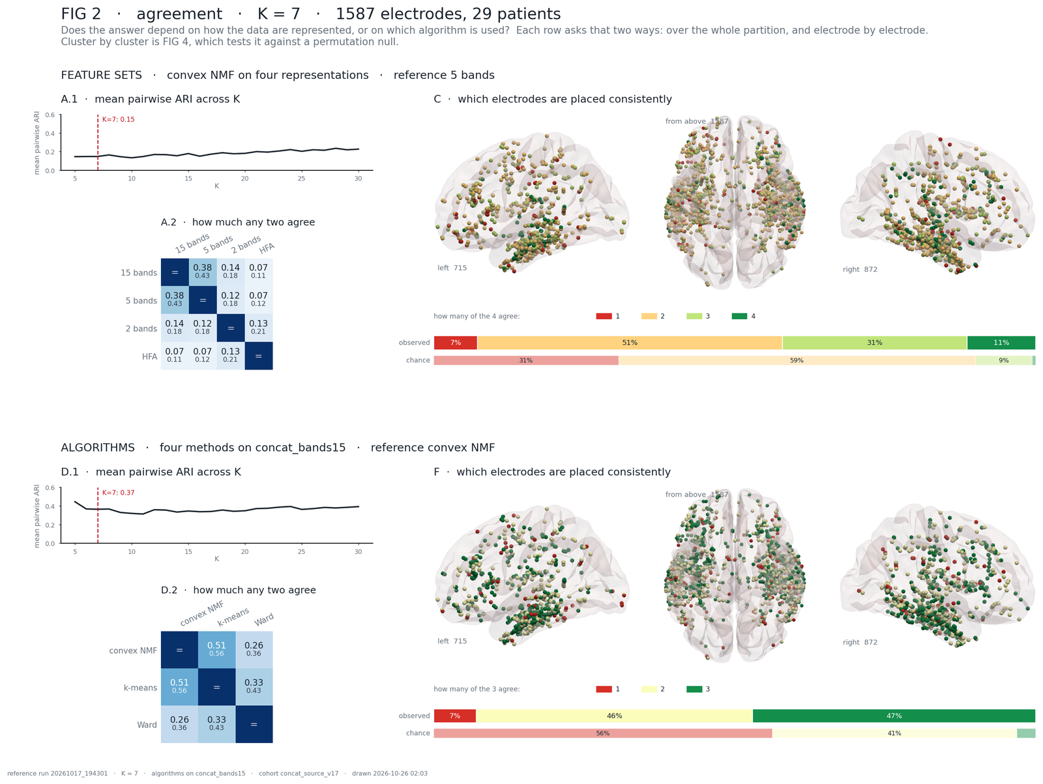
FIG2_agreement_concat_bands15_K7_run20261017-194301.png, drawn 2026-10-26 02:03 (00_paper2_figures2_2.py --k 7 --algo-feature-set concat_bands15), 1 000 permutations as on 10-25; the 10-26 layout fix only (tighter grid, the subtitle wrapped, the 'from above' count in the corner), numbers unchanged.
Two halves. The top half asks whether the representation changes the answer (cNMF on 15 bands, 5 bands, 2 bands and HFA; reference 5 bands), the bottom half whether the method does (cNMF, k-means, Ward on 15 bands; reference cNMF). Each half asks it twice: over the whole partition (A, D) and electrode by electrode (C, F).
A.1 and D.1, mean pairwise ARI across K. Eq. 6.2 for every pair of solutions at every K from 5 to 30, averaged (ari_by_k, from the runs' cluster_labels_by_k.csv); the red dashed line is this figure's K. On v17: feature sets 0.15 at K = 7, between 0.15 and 0.24 at every K (highest 0.24 at K = 28); algorithms 0.37 at K = 7, highest 0.45 at K = 5, then about 0.35. Reading: ARI is 0 at chance and 1 for identical partitions, so 0.15 is weak agreement and 0.37 moderate. A flat line means no K rescues the disagreement; the algorithm line falling from K = 5 means the three methods agree most on the coarsest cut and drift apart as the cut gets finer.
A.2 and D.2, every pair. The upper number in a cell is the ARI, the lower the NMI of eq. 6.3 (pairwise_ari, pairwise_nmi). 15 bands vs 5 bands is the closest pair (0.38 / 0.43); every pair involving HFA is 0.13 or less; cNMF vs k-means 0.51 / 0.56, cNMF vs Ward 0.26 / 0.36, k-means vs Ward 0.33 / 0.43. Reading: representations that share bands agree, HFA agrees with none; k-means is the method closest to cNMF. NMI above ARI in every cell says the disagreement sits in the large clusters more than in the small ones, because ARI is dominated by the large clusters and NMI is not.
C and F, which electrodes are placed consistently. Each electrode is coloured by how many solutions put it in the same (matched) cluster, red = 1 to green = all (section 6.7, electrode_agreement); the bars under the brains compare the observed distribution with chance, the null of permuted and re-matched labels. From FIG2_…_electrode_agreement.csv: across the four representations 7% of electrodes are placed alike by no two solutions, 51% by two, 31% by three and 11% by all four, against a chance of 0.6% for all four (the lower bar is the whole chance distribution); across the three algorithms 7 / 46 / 47% against a chance of 3.1% for all three. Reading: an observed bar shifted to the green side of the chance bar means the electrodes are placed more consistently than chance - 47% of the cohort keeps its cluster under all three methods where chance gives 3%, but only 11% keeps it under all four representations. On the brain, a red electrode is one whose type depends on how its signal was represented or which method cut it; a patch of green is a response type every solution finds. An observed bar equal to the chance bar would mean the solutions share nothing beyond their cluster sizes.
The ceiling and PAC, now measured. The native sweep of 2026-10-21 (50 refits on 80% subsamples, K 5-10, all twelve runs) gives each solution its own reproducibility at K = 7: cNMF on 15 bands 0.82 mean co-clustering, on 5 bands 0.54, on 2 bands 0.57, on HFA 0.55; k-means on 15 bands 0.76, Ward 0.64 (FIG 2 caption). Reading: the 15-band cNMF solution is the most reproducible under subsampling and the three other sets reproduce themselves at about 0.55, so a cross-set Jaccard of 0.24 against HFA is read against a ceiling of 0.55, not 1, and the representations disagree less than the raw numbers suggest. Ward's 0.64 against cNMF's 0.82 on the same data says the hierarchical cut is the least stable of the three methods here.
Reviewer 2
- Two matching bases in one panel: loading correlation for cNMF pairs, shared counts for k-means and Ward. The Jaccards that follow are not comparable across the two.
- ARI and NMI are given without intervals, and the electrode-level nulls permute electrodes freely although contacts on one shaft share a reference, a neighbourhood and a patient.
- The 'ceiling' is the consensus block mean, not the Jaccard the caption names.
- FIG 2, 4 and 5 ask the same question three times.
To do
- Match every pair on shared electrodes (one basis), or show both bases side by side.
- Bootstrap patients for ARI and NMI (29 draws with replacement, intervals printed in the matrix); add a within-patient permutation to electrode_agreement_null and cluster_jaccard_null, as FIG 4 has.
- Rename the ceiling 'mean co-clustering' in the caption and the code, or compute Hennig's bootstrap Jaccard and name that.
- Keep FIG 2 as the agreement figure (ARI matrix plus per-electrode agreement); FIG 4 to the supplement; FIG 5 merged into FIG 4 C or dropped.

7 Figure 3 - where the clusters sit in the LanA language atlas
Script 00_paper2_figure3_lana.py; on v17 run as --feature-set concat_bands15 --k 7 → FIG3_lana_concat_bands15_K7_run20261017-194301.

7.1 The atlas value of a contact
P_lana is the LanA probabilistic language atlas (Lipkin et al. 2022, 806 individuals) sampled at the contact's fsaverage position: the fraction of the atlas's subjects whose language network covers that point. It is an atlas prior about a location, not a measurement in this patient; a high value does not say that this electrode responded to language. lana_lookup reads whichever table under outputs/clustering/atlas/lana_*/runs/*/ covers the most contacts (on v17: lana_all/20261019_pbins), checks every other table against it with a tolerance of 0.001 where both have a value, and stops if they disagree. Since 2026-10-21 only the tables of the newest sampling date are compared with each other; an older sampling (20260907, taken on the coordinates before the recon regeneration of 10-12) is named and ignored, because the two disagree exactly for the contacts that moved.
Electrodes without a value are excluded from every statistic, not counted as zero. On v17 every cohort electrode has a value (the 20261019 sampling), so nothing is excluded; the coverage safeguards - per-cluster coverage under every bar, red below 70%, whole-patient gaps listed in the caption - stay in the figure for a cohort whose atlas run lags its reconstruction.

7.2 Per-cluster statistics
Function analyse. With labels ℓ, normalised loadings G̃ and P_lana over the electrodes that have a value, for every cluster j:
 | $${P̄}_{j} = {mean}_{i : l_{i} = j}{P_{i}} , ρ_{j} = \operatorname{Spearman}\left({G̃}_{·j}, P\right)$$ | (7.1)

P̄_j is how much atlas probability the cluster's members sit in; ρ_j, the Spearman rank correlation between the cluster's loading and P_lana across all electrodes with a value (rank both, then Pearson on the ranks; scipy.stats.spearmanr), asks whether belonging more strongly to this cluster goes with sitting further into language cortex.
Two nulls, 1 000 permutations each by default; the v17 figure used 5 000. Shaft shift (shaft_roll_index; the one that leads): within every shaft, the cluster labels and loadings are rolled along the contacts by a random offset while P_lana stays in place. Contacts millimetres apart share an atlas neighbourhood, so this keeps the run's structure along each shaft intact and breaks only its alignment with the atlas - a spatially constrained null in the spirit of the spin test (Alexander-Bloch et al. 2018; cf. Burt et al. 2020). Within patient (within_patient_perm): P_lana is shuffled among each patient's own contacts, which keeps every patient's set of atlas values and coverage exactly. The two are shown side by side so the reader can see how much the answer depends on which is asked. For a statistic T with null draws T_t:
 | $$p = \frac{1 + \#\left\{t : T_{t} ≥ T_{obs}\right\}}{n_{perm} + 1}$$ | (7.2)

(two-sided on |ρ| for the correlation). K clusters is K tests, and the panel ranks them, which is exactly the situation that manufactures a best-looking one, so the p-values are corrected by Benjamini & Hochberg (1995; bh_fdr): with the p-values sorted ascending,
 | $$q_{(i)} = \min_{j ≥ i}{\frac{K · p_{(j)}}{j}}$$ | (7.3)

Confidence intervals. Patients, not electrodes, are the resampling unit: the patients are drawn with replacement 1 000 times by default (2 000 in the v17 figure), all of each drawn patient's contacts come along, and P̄_j and ρ_j are recomputed; the interval is the 2.5th to 97.5th percentile. An electrode bootstrap would give intervals several times too narrow because contacts on one shaft are not independent.
Example (shaft shift). A shaft with six contacts labelled (c2, c2, c2, c5, c5, c5) and offset 2 becomes (c5, c5, c2, c2, c2, c5): still two clusters of three, still adjacent, but no longer where the atlas puts them. Example (FDR). Three clusters with p = (0.01, 0.03, 0.20): K·p/j = (0.03, 0.045, 0.20); taking the minimum from the right gives q = (0.03, 0.045, 0.20). Example (ρ). ρ = +0.20 means that electrodes loading more on this cluster tend, weakly, to sit deeper in language cortex.

7.3 Panels and outputs
panel | content | drawn by
A | clusters ranked by P̄_j, with both nulls, coverage under each bar | panel_rank
B | ρ_j ranked, with bootstrap CI and q | panel_rho
C | loading against P_lana, every electrode, per cluster | panel_scatter
D | P_lana on this coverage: left, right, from above | panel_brain

Panel B's y axis is shared across feature sets through FIG3_extents_K07.json (extents_of, resolve_extents); panel A spans the full range of P_lana, the same electrodes in every feature set. Tables: …_clusters.csv (one row per cluster: n, n_lana, coverage, mean and median P_lana, ρ, the share inside the network at P ≥ 0.1 and ≥ 0.2 (frac_t10, frac_t20), each with both nulls, p, q and the patient-bootstrap interval) and …_electrodes.csv (patient, electrode, cluster, loading, P_lana).

7.4 Reading FIG 3 (15 bands, K = 7, v17)
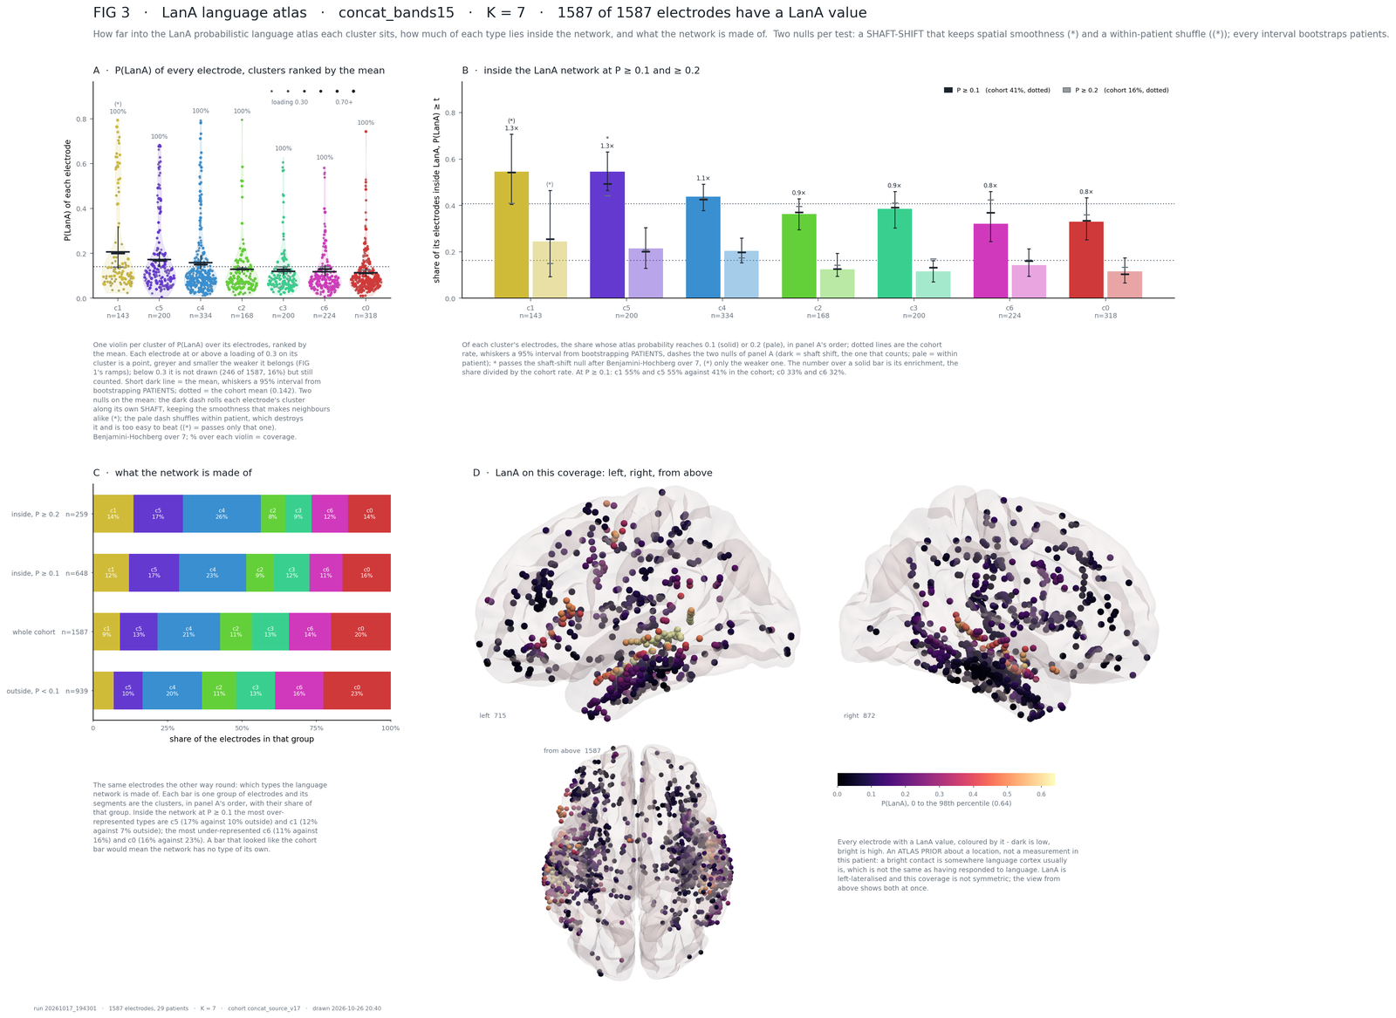
FIG3_lana_concat_bands15_K7_run20261017-194301.png, drawn 2026-10-26 20:40 (00_paper2_figure3_lana.py --feature-set concat_bands15 --k 7 --n-perm 5000 --n-boot 2000, atlas sampling 20261019). Panels B and C were rebuilt on 10-26 (the share inside the network; the network's composition) and panel A redrawn as violins with the 0.3 cut; the statistics of panel A are unchanged since 10-21.
Title line. '1587 of 1587 electrodes have a LanA value': the 20261019 sampling covers the whole cohort, so every number below is computed on all 1 587 electrodes.
A, P(LanA) of every electrode, clusters ranked by the mean. One violin per cluster over its members' P_lana (panel_rank); the short dark line is P̄_j of eq. 7.1 with the 95 % interval from 2 000 patient bootstraps; the dotted line is the cohort mean, 0.142; every electrode at or above a loading of 0.30 on its cluster is a point, greyer and smaller the weaker it belongs (the ramps of section 5.2), below 0.30 not drawn (246 of 1 587, 16 %) but counted; the % over each violin is the coverage, 100 % for all seven. From FIG3_…_clusters.csv: c1 0.207 [0.133, 0.317] with 143 electrodes, c5 0.172, c4 0.159, then c2 0.129, c3 0.120, c6 0.118, c0 0.113. The two nulls are dashes: dark = shaft shift, pale = within patient. c1 carries '(*)': it beats the within-patient null (q 0.0014 after FDR) but not the shaft-shift null (q 0.374); no cluster does.
How to read it. A mean above the dotted line whose whisker clears it says the cluster's electrodes sit in more language-probable cortex than the cohort average. The shaft-shift null is the one that counts, because contacts on one shaft share a neighbourhood: c1 fails it, so its elevation is explained as well by whole shafts lying in language cortex as by the cluster assignment, and the figure says so with the bracketed star. A mean below the line means electrodes in less language-probable cortex, never 'avoids language'. With every cluster at 100% coverage the coverage warning no longer applies to this cohort.
B, inside the LanA network at P ≥ 0.1 and ≥ 0.2 (panel_inside, rebuilt 2026-10-26). Of each cluster's electrodes, the share whose P_lana reaches 0.1 (solid) or 0.2 (pale), in panel A's order, against the cohort rate (dotted: 40.8 % and 16.3 %), with the same two nulls as dashes and the same patient bootstrap; the number over a solid bar is the enrichment, the share divided by the cohort rate. At P ≥ 0.1: c1 54.5 % and c5 54.5 % (1.3×), c4 43.7 %, c3 38.5 %, c2 36.3 %, c0 33.0 %, c6 32.1 %. c5 is the one cluster that clears the shaft-shift null (q 0.036); c1 clears only the within-patient one (q 0.0028). At P ≥ 0.2 no cluster clears the shaft-shift null (c1 24.5 %, 1.5×, within-patient q 0.0056 only). The mean of panel A is set by the mass of electrodes below P = 0.1, where nothing happens; the relation lives in the tail, and this panel reads it directly. The Spearman ρ of eq. 7.1 is no longer drawn; it stays in the table (c1 +0.14, c5 +0.04, c3 −0.09 pass the shaft-shift null after FDR; largest |ρ| 0.14), and the shares here are not compositional, unlike the seven ρ.
C, what the network is made of (panel_mix, rebuilt 2026-10-26). Four bars: the electrodes inside the network at P ≥ 0.2 (n = 259) and at P ≥ 0.1 (n = 648), the whole cohort (1 587) and the outside at P < 0.1 (939), each split into the clusters in panel A's order with their share of that group. Inside at P ≥ 0.1 the over-represented types are c5 (17 % against 10 % outside) and c1 (12 % against 7 %), the under-represented c6 (11 % against 16 %) and c0 (16 % against 23 %). A bar that looked like the cohort bar would mean the network has no type of its own.
D, LanA on this coverage. Every electrode, coloured by its value from 0 (dark) to the 98th percentile 0.64 (bright), left 715 and right 872 (panel_brain). Reading: bright contacts sit in the left temporal and frontal cortex where the atlas puts the language network; LanA is left-lateralised and this coverage is not symmetric, so A to C are read against this picture and not in a vacuum.
FIG 3b, the spin null and the network's own response (00_paper2_figure3_spin.py, 2026-10-26). The shaft-shift null of 7.2 leaves the atlas where it is and moves the labels; for a type that fills whole shafts the roll changes nothing and the null reproduces the observed statistic, so it has no power there. The spin test (Alexander-Bloch et al. 2018, NeuroImage 178:540) does the opposite: every electrode is anchored to its nearest fsaverage pial vertex (median 0 mm; 34 affine-placed white-matter contacts of PAT_3975 and EL051 sit 2 to 10 mm off), that vertex's point on the fsaverage sphere is rotated by a random rotation (its mirror on the right hemisphere), and the atlas is read at the landing vertex's pial coordinate with the sampler of 7.1. The electrodes, shafts, patients and labels stay; the map moves; 5 000 spins, two-sided against the spun maps, Benjamini–Hochberg over K. Everything is computed on all electrodes and on the left hemisphere alone (715 of 1 587), because LanA is left-lateralised and the coverage is right-heavy.
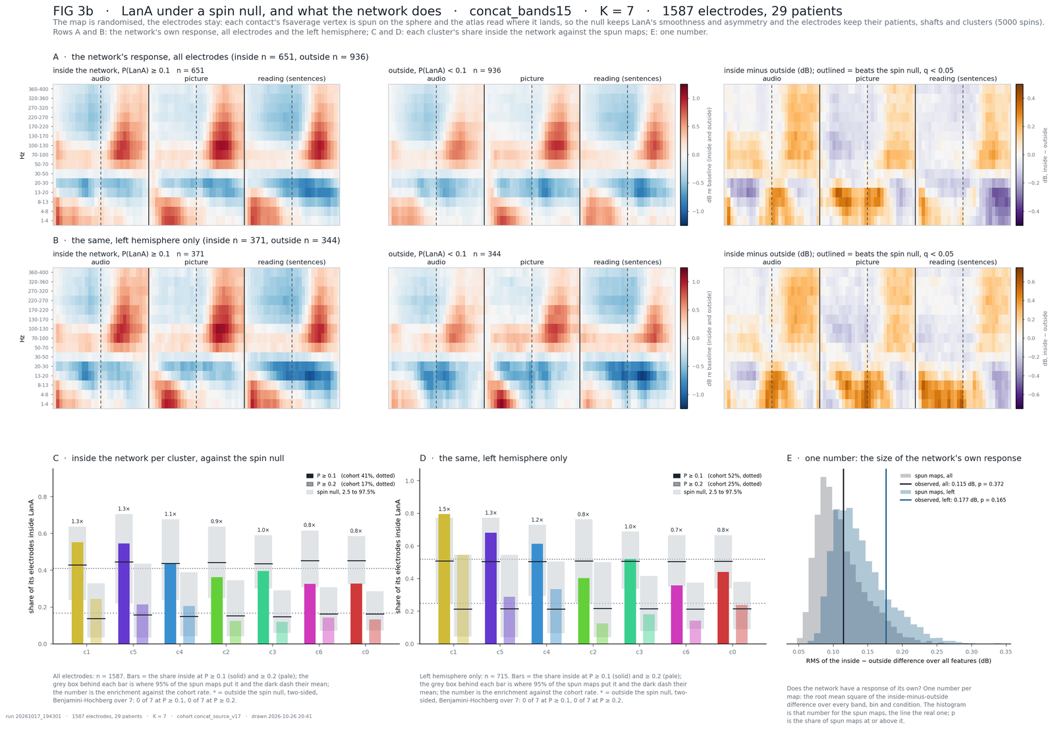
FIG3_spin_concat_bands15_K7_run20261017-194301.png, drawn 2026-10-26 20:41 (00_paper2_figure3_spin.py --feature-set concat_bands15 --k 7 --n-spin 5000); tables …_clusters.csv (per stratum × threshold × cluster), …_cells.csv (per stratum × feature), …_summary.json.
Reading. C and D: no cluster keeps more of its electrodes inside a rotated map than inside the real one, on all electrodes or on the left (the spun maps put c1 anywhere between 24 % and 64 % inside at P ≥ 0.1, the real map at 55 %); the one effect that survives is c1's mean P_lana on the left hemisphere, 0.378 against 0.152 for spun maps (p 0.004, q 0.027), its share inside not (q 0.22). A and B: the network's mean response inside the network against outside, band × time × condition, and their difference; no cell is beyond the spun maps (0 of 1 350 after FDR), and the RMS of the difference (E) is 0.11 dB against a spun mean of 0.11 (p 0.37; left 0.18 against 0.14, p 0.17). The language network, as the atlas draws it, does nothing in this task that the rest of the sampled cortex does not; with a naming task that is expected, since the sentences-versus-nonwords contrast behind LanA subtracts the perception and articulation systems the task drives.
Reviewer 2
- The atlas is sampled at the single voxel nearest each contact (lf_atlas_corr.sample_atlas_at_contacts), with millimetre localisation error, and it is left-lateralised: right-hemisphere contacts are low by construction, so 'language cortex' is confounded with hemisphere.
- The seven rho are compositional (an electrode's loadings sum to 1); a negative bar is drawn as if it were a result. — no longer drawn since 10-26; the shares of panel B are not compositional.
- BH runs within four families (two statistics x two nulls), and paragraphs of explanation are printed inside the figure.
To do
- Average P_lana within a 3-5 mm radius of each contact; test within the left hemisphere, or add hemisphere as a stratum of the within-patient null. — the left-hemisphere stratum is in FIG 3b (10-26); the radius is still open.
- Grey out or drop the negative bars in B and say why in the legend. — done 10-26: B is now the share inside the network.
- One FDR family over the 14 tests (7 clusters x 2 statistics) under the shaft-shift null; move the text blocks from the figure to the legend.

8 Figure 4 - correspondence: the same clusters more often than chance?
Two scripts. 00_paper2_figure4_correspondence.py does the computation and writes the tables (and a plain figure of the correlation matrices); 00_paper2_figure4_panels.py redraws the paper figure from those tables in seconds. The design answers a weakness of FIG 2: there, clusters are matched by shared electrodes and then scored by shared electrodes, so the number quoted is the number that was optimised. Here the two steps are independent: clusters are paired by the shape of their mean response and the pairing is tested on electrode overlap.
Two axes: A, same feature set, different algorithms (cNMF / k-means / Ward on concat_bands15, all three pairs); B, same algorithm, different feature sets (cNMF on concat_bands15 against each of the other three).

8.1 One description space for every cluster
A clustering fitted on 90 HFA features and one fitted on 1 350 band features live in spaces of different size, so their centroids cannot be correlated directly. Every cluster is therefore described by the concat_bands5 representation of its member electrodes (description_space: the 450 bands5 features of the whole cohort, rebuilt from the cache by lf_concat.concat_bands5_features), each electrode scaled to zero mean and unit SD across its own features so that shape and not amplitude enters (electrode_z):
 | $$z_{if} = \frac{Z_{if} - μ_{i}}{σ_{i}} , c_{j} = \frac{\sum_{i}{W_{ij} z_{i}}}{\sum_{i}{W_{ij}}}$$ | (8.1)

with W the normalised loadings G̃ for cNMF and one-hot labels for the hard methods, so the weighted statistics collapse to the hard ones by construction. align proves that every solution describes the same electrodes in the same order before anything is compared.

8.2 Pairing by shape
Function corr_matrix: after subtracting each solution's own mean centroid, the Pearson correlation between every centroid of solution 1 and every centroid of solution 2 (a K₁ × K₂ matrix; the uncentred version is kept beside it). greedy_match then takes the pair with the highest correlation, removes both clusters, and repeats; the pairs are kept in the order they were taken, which is their rank. With K₁ ≠ K₂ the surplus clusters stay unmatched: a solution is allowed to have found something the other did not.
The pairing uses no electrode identity at all; that is what makes the overlap test independent of it.

8.3 Overlap of a matched pair
Function overlaps. For the hard labels, the Jaccard index of the two member sets (eq. 5.4). For the graded weights, the Ruzicka index, which is the Jaccard index generalised to weights and reduces to it for 0/1 weights:
 | $$J_{w} = \frac{\sum_{i}{\min\left(w_{i}^{(1)}, w_{i}^{(2)}\right)}}{\sum_{i}{\max\left(w_{i}^{(1)}, w_{i}^{(2)}\right)}}$$ | (8.2)

Example. Three electrodes with weights (0.8, 0.2, 0.5) in one cluster and (0.6, 0.4, 0) in its partner: the minima sum to 0.6 + 0.2 + 0 = 0.8, the maxima to 0.8 + 0.4 + 0.5 = 1.7, J_w = 0.47. With weights (1, 0, 1) and (1, 1, 0) the same formula gives 1/3, which is |A∩B| / |A∪B| for A = {1, 3}, B = {1, 2}.

8.4 The null, the z-score and the p-value
Function null_distribution. Solution 2's electrodes are reassigned at random - plainly (any electrode to any cluster) or within patient (permutation_index: each patient's electrodes shuffled among themselves, so that the patients' different implantations are kept) - which changes its centroids as well as its membership; the pairing of 8.2 is redone and the matched overlap recorded against the side-1 cluster it fell to. Side 1 is never touched, so every draw has an entry for each of its clusters. 1 000 draws per null by default - the v17 tables at K = 7 and K = 10 were made with 5 000, the K = 8 table with 1 000 - for the hard and the weighted overlap. Then, per side-1 cluster (empirical):
 | $$z = \frac{J_{obs} - μ_{0}}{σ_{0}} , p = \frac{1 + \#\left\{t : J_{t} ≥ J_{obs}\right\}}{n_{perm} + 1}$$ | (8.3)

The panels plot the chance-corrected overlap, which is 0 at chance and 1 at identity whatever the cluster sizes (adjust in the panels script; the same construction the adjusted Rand index uses):
 | $$J_{adj} = \frac{J - J_{0}}{1 - J_{0}}$$ | (8.4)

Example. Two clusters of 340 electrodes overlap by J ≈ 0.09 for nothing, two of 130 by about 0.055, so a raw 0.45 against a raw 0.28 is partly a statement about sizes. With J = 0.45 and a null mean J₀ = 0.09, J_adj = 0.36/0.91 = 0.40.

8.5 Contingency table and diagonal share
Beside the overlap test the script also reports, per comparison, the contingency table of the hard labels and the share of all electrodes that sit on the matched pairs (contingency, diagonal_share):
 | $$A_{ij} = \left|\left\{e : l^{(1)}(e) = i, l^{(2)}(e) = j\right\}\right| , S = \frac{\sum_{(i,j)∈pairs}{A_{ij}}}{N}$$ | (8.5)

with a pairing null of 1 000 random one-to-one pairings of the same table (pairing_null): that re-pairs, it does not re-cluster, so it measures how much of the diagonal is earned by the alignment rather than by the data.

8.6 Panels and outputs
panel | content | function
A | the six correspondence matrices, both axes reordered by match rank so the diagonal decays from the top left; the value is J_adj, a dot marks p < 0.05 under both nulls | panel_matrix
B | J_adj against match rank for every pair | panel_rank
C | mean J_adj per comparison: algorithms against representations | panel_summary
D | every cNMF-on-bands15 cluster against each other solution, with a mark where a cluster is more than half one patient | panel_left_out, patient_share

Tables written by the correspondence script, all tagged K and run: FIG4_matched_*.csv (one row per pair and weighting: r, overlap, both nulls, z, p), FIG4_summary_*.csv, FIG4_corr_<pair>_*.csv and FIG4_contingency_<pair>_*.csv; the panels script reads the newest FIG4_matched_K<K>_run*.csv.

8.7 Reading FIG 4 (15 bands reference, K = 7, v17)
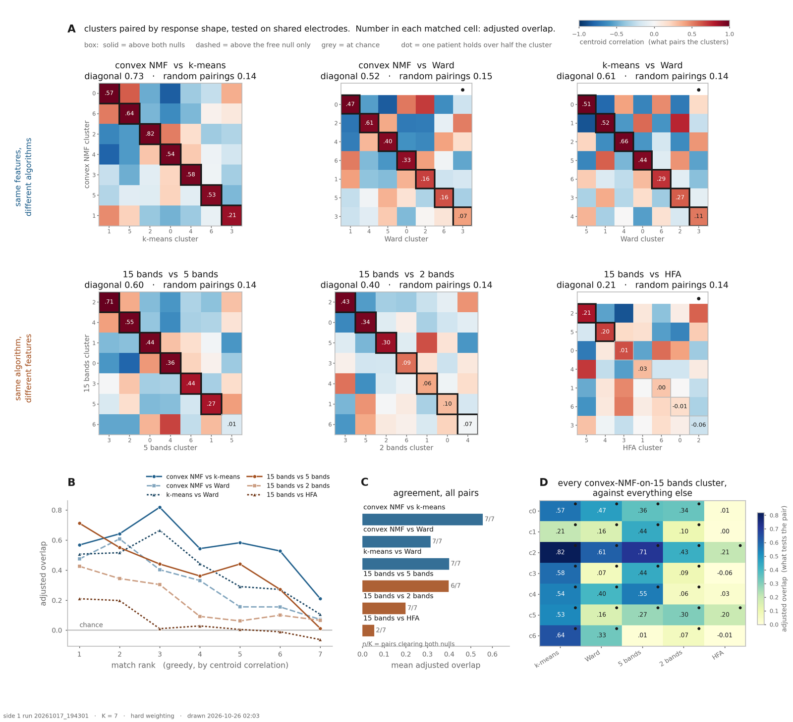
FIG4_K07_run20261017-194301.png, drawn 2026-10-26 02:03 (00_paper2_figure4_correspondence.py --k 7 --n-perm 5000, then 00_paper2_figure4_panels.py --k 7): panel B with one line style per comparison and its legend above the axes, the colour bar above the third title; numbers unchanged.
Panel A. Six matrices, one per comparison (panel_matrix): the top row the three algorithm pairs on 15 bands, the bottom row cNMF on 15 bands against 5 bands, 2 bands and HFA. The colour of a cell is the centroid correlation of eq. 8.1 and section 8.2, both axes ordered by match rank; a box is a matched pair with its adjusted overlap of eq. 8.4 - solid above both nulls, dashed above the free null only, grey at chance - and a dot marks a cluster more than half one patient. The titles give the diagonal share and the random-pairing share of eq. 8.5: cNMF vs k-means 0.73 against 0.14, cNMF vs Ward 0.52, k-means vs Ward 0.61; 15 vs 5 bands 0.60, 15 vs 2 bands 0.40, 15 vs HFA 0.21 (random pairings 0.14 throughout). 5 000 permutations per null.
How to read it. The correlation decays from the top left by construction and the overlap follows it loosely: rank-1 pairs sit at 0.43-0.71 in five comparisons and at 0.21 for HFA, the highest cell is 0.82 (cNMF c2 with its k-means partner, rank 3), and the last pairs sit at -0.06 to 0.21. Algorithm pairs beat feature-set pairs: at the same K the method changes the answer less than the representation does, and HFA changes it most - only two of its seven pairs clear both nulls, the rest sit at chance. The dots say that at the shared K = 7 Ward's c3 is 99% one patient and cNMF-on-HFA's c2 79%: HFA is past its own K* of 6 here, which is why section 8's reviewer block asks for own-K comparisons.
B, adjusted overlap against match rank. One line per comparison (panel_rank), blue = algorithms, orange = feature sets. Every blue line stays above 0.15 to rank 6; 15 vs HFA touches chance from rank 3. The rank at which a line reaches zero is how many pairs are real.
C, the headline. Mean adjusted overlap per comparison with n/7 = pairs clearing both nulls (panel_summary): cNMF vs k-means 0.56 (7/7), k-means vs Ward 0.40 (7/7), cNMF vs Ward 0.31 (7/7); 15 vs 5 bands 0.40 (6/7), 15 vs 2 bands 0.20 (7/7), 15 vs HFA 0.05 (2/7); 36 of the 42 matched pairs clear both nulls. At K = 8 and K = 10 the means by axis are 0.38 / 0.22 and 0.37 / 0.22, so the shared-K result does not hinge on which K was shared.
D, each cNMF cluster against everything else. Rows are the seven cNMF-on-15-bands clusters, columns the five other solutions, cells the adjusted overlap of the matched pair, dots the one-patient clusters (panel_left_out, patient_share). c2 is the row every solution finds (0.82 k-means, 0.61 Ward, 0.71 5 bands, 0.43 2 bands, 0.21 HFA) - the broadband decrease of FIG 1a; c6 is found by k-means (0.64) and Ward (0.33) and by no other representation; the HFA column is pale throughout (0.21 at best): what the 15-band solution calls a type is largely invisible to a single-band description.
Reviewer 2
- At the shared K (7, 8, 10), HFA is past its own K* of 6 in every comparison and 15 bands past its 7 in two of the three, so those pairs include one-patient clusters - at K = 7 the figure marks Ward c3 (99% one patient) and cNMF-on-HFA c2 (79%).
- The adjusted overlap uses the free-null mean for J0 while significance is read from both nulls; nothing adds a within-shaft null.
To do
- Compare each set at its own K* with --k1 / --k2 and keep one shared-K figure as a check.
- Adjust with the within-patient null mean (the stricter one) or show both adjustments; add a within-shaft reassignment (shaft_roll_index of FIG 3) as a third null.
- Supplement, unless the per-cluster view is the paper's point.

9 Figure 5 - every solution against every other
Script 00_paper2_figure5_confusion.py (it imports the loader of FIG 4 so the two cannot disagree about a run). FIG 4 compares solutions along one axis at a time; this puts every solution (three algorithms × the feature sets) on both axes of one matrix, so 'does the algorithm matter more than the representation' is read off one picture.
Since 2026-10-21 the script runs on the four current sets: twelve solutions, 66 pairs, the files named by the 15-band cNMF run.

9.1 The number: diagonal share after Hungarian matching
Function hungarian_share. For two solutions at the same K the contingency table A of eq. 8.5 is formed on the hard labels, and the clusters are paired one-to-one by the Hungarian assignment that maximises the diagonal sum (scipy.optimize.linear_sum_assignment; Kuhn 1955). The cell reports
 | $$S = \frac{\max_{π}{\sum_{i}{A_{i,π(i)}}}}{N}$$ | (9.1)

the fraction of the cohort placed in matched clusters: 1 for identical partitions, falling towards chance for unrelated ones. Unlike FIG 4, the matching here is chosen on the electrodes it is then scored on; that is what makes it the ordinary confusion-matrix accuracy, and why the null matters.
Note on Jaccard versus the diagonal share. The Jaccard index (eq. 5.4) divides the intersection of two clusters by their union, so it penalises both the members A has that B lacks and the reverse, and it describes one pair. The diagonal share divides the sum of the intersections over all K matched pairs by the whole cohort, so it describes two partitions at once and counts only what they share. The Hungarian algorithm is not a similarity measure in either case: it is the assignment step that chooses which clusters are paired. In sections 5 and 6 it maximises a correlation or a shared count and the Jaccard is then reported for the chosen pairs; here it maximises the intersections themselves.
Example. A has 100 members, B 120, 80 shared. Jaccard: 80 / 140 = 0.57. In the diagonal share this pair contributes 80 / 1 587 = 0.05, and the other six pairs add theirs; a total of 0.60 means that 60% of all electrodes sit in matched clusters.

9.2 The null and the chance-corrected share
Function null_shares. Solution 2's labels are shuffled across the electrodes (cluster sizes kept) and the table, the matching and the share redone, 1 000 times. Reported per cell: the null mean, its 95th percentile, the empirical p of eq. 7.2, and
 | $$S_{adj} = \frac{S - {S̄}_{0}}{1 - {S̄}_{0}}$$ | (9.2)

Example. Matched diagonal 950 of 1 587 electrodes: S = 0.60. Shuffled labels give S̄₀ = 0.18, so S_adj = 0.42/0.82 = 0.51 and the pair is far above chance.

9.3 The K-by-K panel
Function kk_panel. For each solution, the same share between its own partitions at K_a and K_b (rectangular table, min(K_a, K_b) matched pairs), one small matrix per solution over the K values given. It answers whether a solution's partition at one K is a refinement of the one at another or a different cut.
Example. k-means on bands15 at K = 6 against K = 7: six pairs; a share of 0.85 means 85% of the electrodes stay with their matched cluster when one more is asked for.
Outputs: FIG5_K<KK>_run*.png and FIG5_pairs_K<KK>_run*.csv per K; FIG5_pairs_allK_run*.csv, FIG5_KbyK_run*.png and FIG5_KbyK_run*.csv when several K are given in one call.

9.4 Reading FIG 5 (twelve solutions, K = 7, v17)
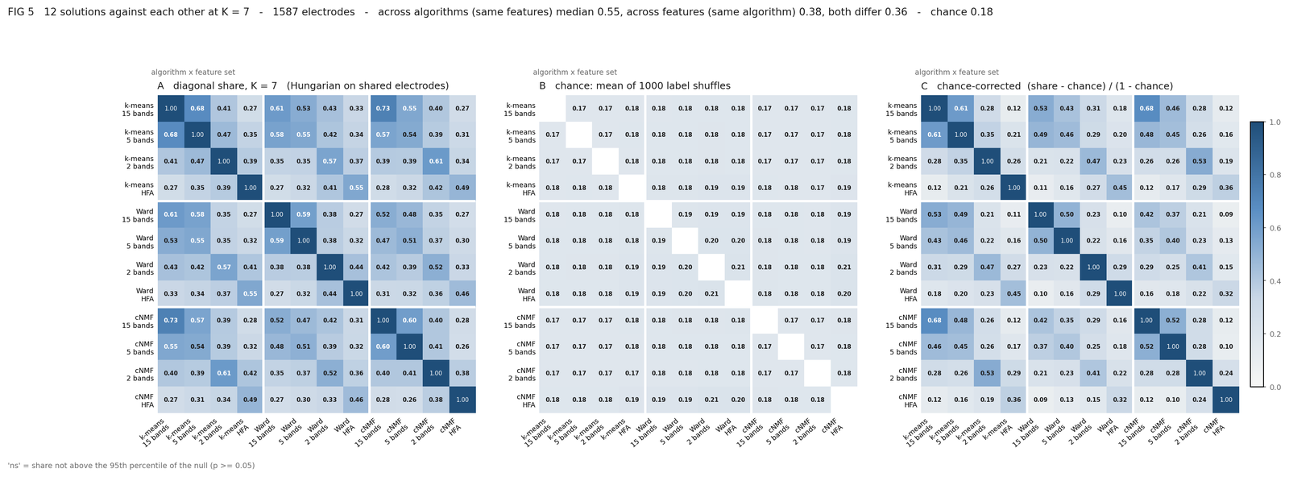
FIG5_K07_run20261017-194301.png, drawn 2026-10-26 02:05 (00_paper2_figure5_confusion.py --k 5 6 7 8 9 10, 1 000 shuffles per pair); the 'ns' note moved up under the tick labels; numbers unchanged.
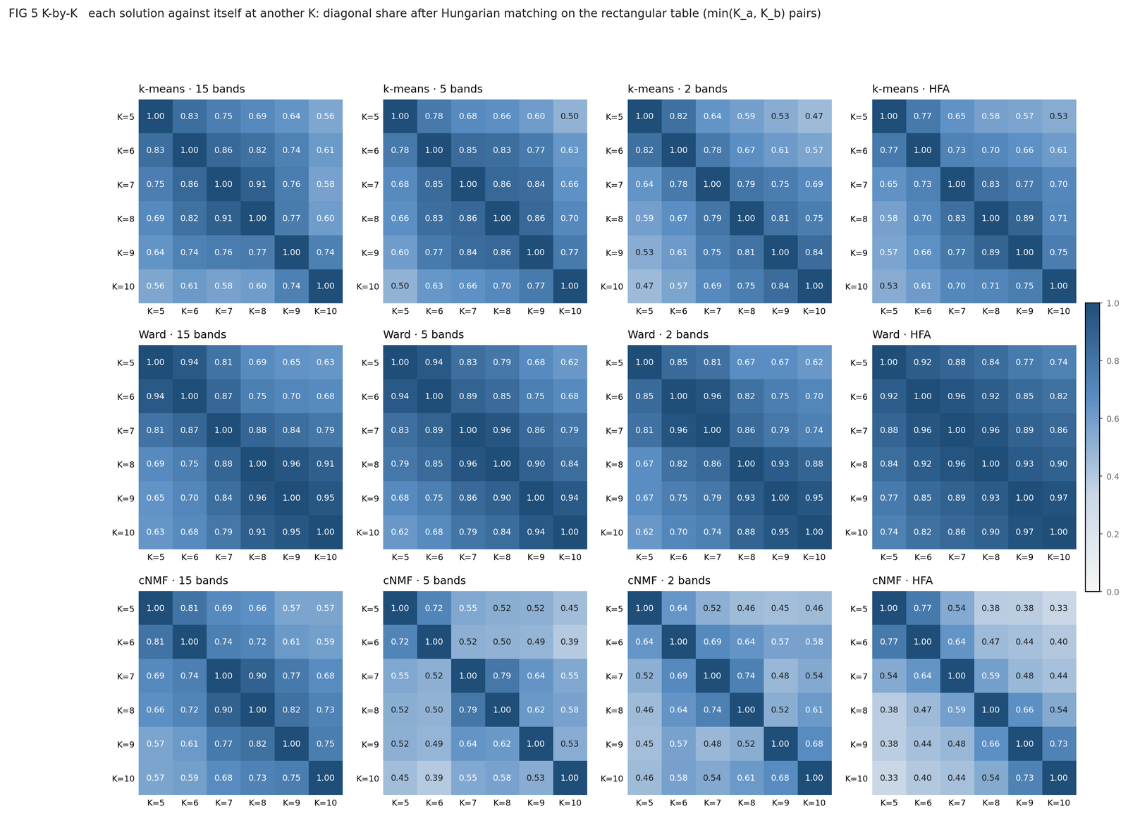
FIG5_KbyK_run20261017-194301.png, drawn 2026-10-21 21:06: each solution against itself at another K (min(K_a, K_b) matched pairs).
A, B, C. Twelve solutions (three algorithms × four feature sets) on both axes, 66 pairs. A is the diagonal share of eq. 9.1 (hungarian_share); B the mean of 1 000 label shuffles (null_shares), 0.17-0.21 everywhere; C the chance-corrected share of eq. 9.2. The title gives the medians: across algorithms on the same features 0.55 (corrected 0.45), across features under the same algorithm 0.38 (0.25), both differing 0.36 (0.23), chance 0.18. The highest pairs are k-means vs cNMF on 15 bands (0.73, corrected 0.68), k-means on 15 vs 5 bands (0.68 / 0.61) and k-means vs cNMF on 2 bands (0.61 / 0.53); the lowest pairs (0.26-0.27, corrected 0.09-0.12) all have HFA on one side; a cross-representation pair with HFA reaches 0.44 at best, and the three HFA solutions agree with each other at 0.46-0.55. No pair is 'ns'.
How to read it. The 4 × 4 blocks along the diagonal are one algorithm on the four sets; the same column position in another block is the same set under another algorithm. Two methods on the same representation agree at 0.46-0.73, the same method on two representations at 0.26-0.68, and a solution on HFA agrees with one on another representation at 0.26-0.44 - the same ordering as FIG 4 C, with all twelve solutions in one picture. Because every pair clears its null, the p-values carry no information here; the corrected shares and their ordering are the result.
K by K. For cNMF on 15 bands the share between its own partitions is 0.81 for K 5 vs 6, 0.74 for 6 vs 7, 0.69 for 5 vs 7 and 0.57 for 5 vs 10 (FIG5_KbyK_…csv): adding a component moves 10 to 26% of the electrodes (0.90 for K 7 vs 8, 0.75 for 9 vs 10), so the cut at K* is a cut through a continuum, not a step between discrete solutions.
Reviewer 2
- The null shuffles labels freely across electrodes; with 1 587 electrodes every one of the 66 pairs clears it at every K from 5 to 10 (no 'ns' anywhere), which says nothing.
To do
- Report the chance-corrected share with a patient-bootstrap interval and drop the p; add a within-patient shuffle; merge the matrix into FIG 4 or move it to the supplement.

10 Graphical abstract
Script make_graphical_abstract.py (1200 × 1200 px). Built from the same run, centroids, hemisphere renders and palette as FIG 1a, imported from 00_Paper2_Figures.py, so it cannot drift from the figure it condenses. Every number on it is read from the tables the figures wrote (numbers: FIG 1a _generalization.csv and _patients.csv, FIG 2 _electrode_agreement.csv and caption, FIG 3 _clusters.csv); nothing is typed in. The type names are descriptive labels read off the centroid shapes, except "ramp to cue", which is measured: the cluster whose mean rises most over the last fifth of the block before the GO cue, averaged over conditions; the script refuses to run if the cluster drawn under that name is not the one the measurement picks.
Output GA_graphical_abstract_<set>_K<K>.png with a caption saying where each number came from.
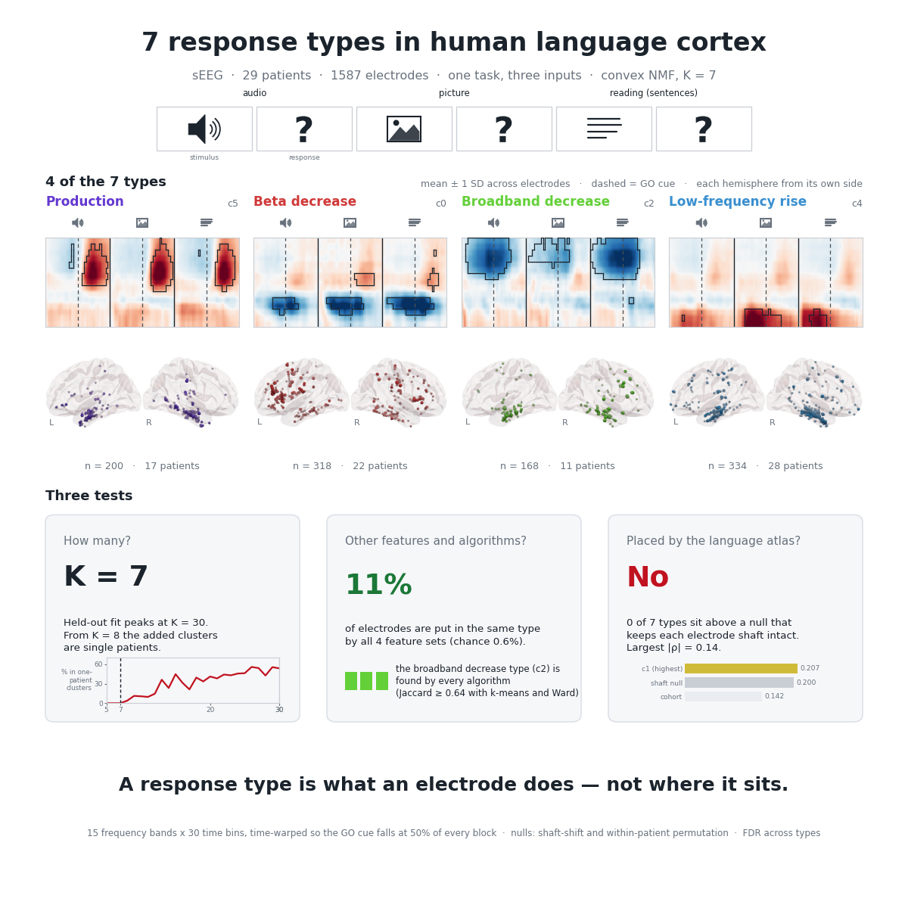
GA_graphical_abstract_concat_bands15_K7.png, 1200 × 1200 px, drawn 2026-10-26 20:38 after the FIG 1 rerun, its brains with the 0.3 cut (make_graphical_abstract.py); type labels provisional.
Reading the abstract. Every number is computed: K = 7 with the held-out peak at K = 30 and one-patient clusters from K = 8 (section 3); 11% of electrodes in the same type under all four feature sets against 0.6% by chance (FIG 2 C); 'No' for the atlas - 0 of 7 types above the shaft-shift null by mean atlas probability, largest |ρ| 0.14, c1 at 0.207 against a shaft null of 0.200 and a cohort mean of 0.142 (FIG 3 of 2026-10-26 20:40); since 10-26 the tile adds the one share effect of 7.4, c5 inside the network (q 0.036), and the abstract has to be redrawn for it; c1's left-hemisphere mean against the spin null (q 0.027) stays in FIG 3b. The 'found by every algorithm' tile names c2, the cluster with the highest minimum Jaccard against k-means and Ward (0.64) in FIG 2's table. The four tiles are c5, c0, c2 and c4 with provisional names, and there is no 'Ramp to cue' tile because no cluster ramps before the cue in this fit.
Reviewer 2
- The type labels are provisional, read by eye; no cluster of this fit ramps before the cue, so the 'premotor candidate' of the earlier abstract has no counterpart. The ramp index took band 0, which is HFA for the single-band set the script was written for but 1-4 Hz for a band set; corrected on 2026-10-21 before any band-set abstract was drawn.
To do
- Name the types yourself; decide whether the abstract condenses the 15-band or the HFA solution; re-check every sentence in the manuscript that rests on the old ramp cluster.

11 Software
NumPy (Harris et al. 2020) for the factorisation and all array arithmetic; SciPy (Virtanen et al. 2020) for the Hungarian assignment, Ward linkage, non-negative least squares and Spearman correlation; scikit-learn (Pedregosa et al. 2011) for k-means, ARI and NMI; PyVista/VTK for the fsaverage renders; pandas for every table. The orchestration of the v17 figures is run_paper_figures_v17.py (14 steps: FIG 0, FIG 1 × 4, FIG 2, FIG 3, FIG 4 correspondence × 3 K, FIG 4 panels × 3 K, FIG 5 over K 5-10).
All figures land in 02_FBM_Clustering/outputs/clustering/paper_figures/, each PNG beside its caption and tables, named with the feature set, K and run stamp.

References
Alexander-Bloch, A. F., Shou, H., Liu, S., Satterthwaite, T. D., Glahn, D. C., Shinohara, R. T., Vandekar, S. N. & Raznahan, A. (2018). On testing for spatial correspondence between maps of human brain structure and function. NeuroImage, 178, 540-551.
Benjamini, Y. & Hochberg, Y. (1995). Controlling the false discovery rate: a practical and powerful approach to multiple testing. Journal of the Royal Statistical Society: Series B, 57(1), 289-300.
Burt, J. B., Helmer, M., Shinn, M., Anticevic, A. & Murray, J. D. (2020). Generative modeling of brain maps with spatial autocorrelation. NeuroImage, 220, 117038.
Ding, C. H. Q., Li, T. & Jordan, M. I. (2010). Convex and semi-nonnegative matrix factorizations. IEEE Transactions on Pattern Analysis and Machine Intelligence, 32(1), 45-55.
Harris, C. R. et al. (2020). Array programming with NumPy. Nature, 585, 357-362.
Hennig, C. (2007). Cluster-wise assessment of cluster stability. Computational Statistics & Data Analysis, 52(1), 258-271.
Hubert, L. & Arabie, P. (1985). Comparing partitions. Journal of Classification, 2(1), 193-218.
Kiselev, V. Y. et al. (2017). SC3: consensus clustering of single-cell RNA-seq data. Nature Methods, 14(5), 483-486.
Kuhn, H. W. (1955). The Hungarian method for the assignment problem. Naval Research Logistics Quarterly, 2(1-2), 83-97.
Lipkin, B. et al. (2022). Probabilistic atlas for the language network based on precision fMRI data from >800 individuals. Scientific Data, 9, 529.
Lloyd, S. P. (1982). Least squares quantization in PCM. IEEE Transactions on Information Theory, 28(2), 129-137.
Monti, S., Tamayo, P., Mesirov, J. & Golub, T. (2003). Consensus clustering: a resampling-based method for class discovery and visualization of gene expression microarray data. Machine Learning, 52(1-2), 91-118.
Owen, A. B. & Perry, P. O. (2009). Bi-cross-validation of the SVD and the nonnegative matrix factorization. The Annals of Applied Statistics, 3(2), 564-594.
Pedregosa, F. et al. (2011). Scikit-learn: machine learning in Python. Journal of Machine Learning Research, 12, 2825-2830.
Şenbabaoğlu, Y., Michailidis, G. & Li, J. Z. (2014). Critical limitations of consensus clustering in class discovery. Scientific Reports, 4, 6207.
Vinh, N. X., Epps, J. & Bailey, J. (2010). Information theoretic measures for clusterings comparison: variants, properties, normalization and correction for chance. Journal of Machine Learning Research, 11, 2837-2854.
Virtanen, P. et al. (2020). SciPy 1.0: fundamental algorithms for scientific computing in Python. Nature Methods, 17, 261-272.
Ward, J. H. (1963). Hierarchical grouping to optimize an objective function. Journal of the American Statistical Association, 58(301), 236-244.

