Integrated Genome Browser User’s Guide

March 2009

Table of Contents
Getting started 7
Introduction 7
Overview of IGB functionality 7
Unique features and benefits of IGB 7
Finding documentation and source code 8
Document conventions 8
Installation 9
System requirements 9
Typical installation using Java Web Start 9
Advanced installation 10
Launching IGB 10
Launching using Java Web Start 10
Other choices 11
Getting familiar with IGB 12
Terminology 12
Genomes and chromosomes 12
Annotations, sequences and graphs 12
The main window 13
The title bar 13
The status bar 14
The viewer 14
Annotations 15
Track handles 15
Zoom sliders and scroll bars 16
The hairline position marker 16
Tabbed panels 16
The console 17
Navigation 17
Choosing a genome and chromosome 17
Zooming and scrolling horizontally 18
Zooming and scrolling vertically 18
Going to a specific coordinate 19
Bookmarks 20
Clearing the view 20
Advanced navigation 20
Selecting items with a mouse 20
Zooming to selected items 21
Customization 21
Opening tab panels in new windows 21
Keyboard shortcuts 22
Customizing display properties 22
Setting preferences 22
Loading annotations 23
Data sources 23
Loading annotations from QuickLoad 23
Loading annotations from DAS servers 25
Loading from DAS/1 25
Loading from DAS/2 26
Loading annotations from files 28
Merging with current genome 29
Viewing in a new genome 30
Annotation file formats 30
Details for selected features 31
Links to public web sites 31
Working with sequence residues 33
Loading sequences 33
Loading from QuickLoad 33
Loading from a DAS server 33
Loading from a file 34
Viewing sequence residues 35
Copying sequence bases 36
Searching 37
Finding an annotation by name 37
Browsing for annotations 37
Finding sequence patterns 38
Finding instances of a known sequence 39
Finding instances of a sequence containing unknowns 40
Clearing pattern search results 41
Customizing annotation tracks 42
Changing the width of track handles 42
Re-ordering tracks top-to-bottom 42
Selecting tracks 43
Changing track properties 43
Changing annotation colors 44
Changing track names 44
Hiding and showing annotation tracks 44
Hiding and showing strands 44
Collapsing and expanding tracks 45
Setting a row limit 45
Removing the row limit 46
Using annotation id labels 46
Using color to represent scores 47
Tools for comparing annotations 48
Highlighting matching endpoints 48
Slicing 48
Viewing deletions and insertions 49
Disabling the sliced view 50
Adjusting the sliced view 50
Summarizing tracks 50
Looking at density of annotation coverage 51
Combining tracks 53
Working with graphs 55
Introduction 55
Loading graph files 56
Changing graph appearance 57
Change the height of a graph 58
Change graph styles 58
Change graph color 60
Change scale 60
Hiding and deleting graphs 61
Advanced graph manipulations 62
Graph labeling 62
Floating graphs 63
Transforming to a non-linear scale 63
Duplicating graphs 63
Joining and splitting graphs 64
Graph arithmetic 65
Applying thresholds to graphs 66
Using thresholding 67
Specify the threshold level 68
Specify the threshold direction 68
Control gaps 68
Specify offsets 69
Capture the threshold bars 69
Useful graph customizations 70
Getting details about a graph 70
Saving and bookmarking graphs 70
Saving graph data as a file 71
Bookmarking graph views 71
Printing graphs 71
Setting graph preferences 71
Visualizing probe sets 72
Introduction 72
Invoking IGB via links from NetAffx 73
Loading probe sets from data files 73
Probes and probe sets on display 74
Probe set design sequence 74
Probes and probe sets. 75
Probe set labels 76
Polyadenylation sites 76
Recognizing putative probe set targets 76
Getting more information for a probe set 77
About alignments 77
Probe mappings 77
Viewing tips 77
Capturing, saving, and sharing data 78
Viewing a region in the UCSC browser 78
Saving annotation tracks 78
Copying sequence bases 78
Saving graph files 79
Bookmarking 79
Creating bookmarks 79
Using bookmarks 79
Viewing and changing bookmark details 79
Exporting bookmarks 80
Importing bookmarks 80
Copying data from table cells 80
Printing 80
Pivot View 81
Compare expression across experiments 81
Scored interval files 81
Loading .egr files 81
Map data in the main window 81
Map data in the Pivot View 82
Graph scaling 84
Changing the graph style 85
Hiding and sorting tracks 86
Exporting data 86
Display tips 86
Configuring data sources 87
Personal QuickLoad URL 87
Synonyms 88
The file cache 89
Advanced Features 90
Clamping on a view 90
Shrink-wrapping 91
Showing ORFs and stop codons 91
Clearing ORFs from the viewer 92
Identifying a translation frame 92
Interacting with other genome browsers 93
Track lines 93
Controlling IGB through a browser 94
Appendix 1 Java Web Start 96
Troubleshooting 97
Web Start Console 97
Appendix 2 Troubleshooting 99
Troubleshooting specific areas 99
IGB seems slow or sluggish 99
Keyboard shortcut command doesn’t work 99
Out of memory errors 99
Tab or tab window is missing 100
Tier labels don't line-up with tiers 100
You can't see all the tiers 100
Reverse strand data appears above the axis 100
General troubleshooting 100
Appendix 3 Preferences 102
Importing and exporting preferences 102
Exporting preference settings 102
Importing preference settings 103
Customizing the default appearance of tracks 103
Changing the name of the track 104
Changing the color of annotations 104
Changing the background color of the track 104
Displaying both strands in one track or two 104
Collapsing annotation rows into a single row 104
Setting the maximum number of annotation rows to display 105
Grouping exons 105
Choosing annotation id labels 105
Adding DAS/1 data sources 106
Changing keyboard commands 107
Setting graph preferences 108
Setting color and axis display preferences 108
Setting axis display – option descriptions 109
Setting edge-matching colors 109
Setting ORF and stop-codon colors 109
Setting other options 109
License 111
Index 115

Getting started

Introduction
The Integrated Genome Browser (IGB) is a powerful tool to help genome researchers:
- Compare experimental results to computational results
- Visualize and compare multiple genomic annotation sets from a variety of public and private sources
- Target areas of interest to explore further via other tools and/or experimentation
- Provide guidance for fine-tuning or modification of experiments

Overview of IGB functionality
Generally, use IGB to:
- Select and load genomic annotations to analyze from a variety of sources including your own experimental results
- Compare variations in annotations and expression activity in different data sets
- Search for and drill down in areas of interest

Unique features and benefits of IGB
IGB combines in one viewer your own experimental or computational results, common reference information, and access to public and private data banks.
Other features unique to IGB include:
- A slicing tool that facilitates examination and manipulation of alternate splicings, intron and exon boundaries
- Ability to view graphs of scores at specified points along the genome in the same view as genomic annotations
- Facility in handling large amounts of genomic annotations with speed and efficiency
- Can be controlled from a web browser or any other program capable of sending HTTP requests
- Runs on multiple platforms, including Windows, Linux and Macintosh
- The entire program, including all third-party components, is open-source and written in Java
- The license allows all of part of the program to be incorporated into derivative applications

Finding documentation and source code
IGB is part of the open source GenoViz project. Links to all documentation and Java source code for IGB, including the most recent version of this document, can be found on the home page for the GenoViz project: http://genoviz.sourceforge.net/
There are also links to discussion forums and ways to provide feedback.
Guides for using data from various Affymetrix programs are available on the Affymetrix Tools web page: http://www.affymetrix.com/support/developer/tools/affytools.affx
and on the Affymetrix Developer’s Network web page: http://www.affymetrix.com/support/developer/tools/devnettools.affx.
Those pages contain information for dealing with data from these sources, among others:
- GCOS
- CNAT
- Expression Console
- Tiling Analysis Software
- NetAffx

Document conventions
Onscreen text (i.e., menus, button labels, folder names, field values, etc.) is indicated by Arial font.
An item followed by a “greater than” symbol followed by another item means “click the first item; the second item will become visible; then click the second item.”
Examples:
- File menu > Open File means “click on the File menu and choose Open File.”
- QuickLoad tab > Load Sequence Residues means “click the QuickLoad tab and then click the Load Sequence Residues button”
Screen shots were current at the time this document was prepared. Small changes in the locations or names of controls may occur as IGB evolves through different versions. Since IGB can be run on multiple operating systems with different look-and-feel conventions, the appearance of the screen shots may not exactly match what appears on your screen.
Unless otherwise noted, all commands are described as used on the Linux operating system. Minor differences sometimes occur on different operating systems. Operations in this document that require right-clicking can be performed on a Macintosh with a single-button mouse by holding down the control key while clicking the mouse.

Installation

System requirements
IGB can be used on any computer which has the Java Runtime Environment (JRE) version 1.5 or higher, installed. Version 1.6 or higher is recommended, but version 1.5 or higher is supported.
Java is available for many operating systems, including Windows, Linux, and Macintosh. Java software is free and can be installed by visiting http://java.com/
IGB is developed and tested mostly on Macintosh and Linux, but should work on any Java environment.
The amount of RAM memory and disk space required depends on the type of data you intend to view. Minimum recommendations are posted at: http://sourceforge.net/docman/?group_id=129420
Note for Macintosh users: Operations in this document that require right-clicking can be performed on Mac by holding down the control key while clicking the mouse.

Typical installation using Java Web Start
To install IGB using Java Web Start, visit: http://igb.bioviz.org/download.shtml.
If Java is properly installed on your computer, you should see one or more buttons labeled “Launch IGB”, or something similar. Simply press any of these buttons to download, install, and launch IGB.
If IGB has not already been installed, or if an update is available, the most current version will be installed automatically. If IGB has already been installed, pressing these buttons will simply start the program that is already installed on your machine.
If you did not see one or more buttons labeled “Launch IGB”, you need to install Java Web Start, which is included with current versions of the Java Runtime Engine. (See System requirements above.)
After Java Web Start is installed, close and restart your browser, then return to the web page mentioned above and press one of the buttons labeled “Launch IGB”.

Advanced installation
Advanced users may choose to install IGB without using Java Web Start. This is appropriate for developers who wish to view or extend the source code, and for advanced users who are willing to forgo the automatic updating provided by Java Web Start. These other installation options are described at http://genoviz.sourceforge.net/.

Launching IGB
The procedure used for launching IGB will depend on whether you installed with the typical method described in Typical installation using Java Web Start on page 9 or one of the methods described in Advanced installation on page 9.
Regardless of which method you use, launching multiple instances of IGB simultaneously is not recommended. (This is because IGB saves various settings, including your bookmarks, on your disk. If two instances of IGB are reading and writing those same files, the results are unpredictable.)

Launching using Java Web Start
If you installed IGB using the method in Typical installation using Java Web Start launch IGB using one of the following methods: The effect is the same regardless of which method you choose; your local copy of IGB will be updated if updates are available and will then launch.
- From a web browser: Return to the web site and click on one of the “Launch IGB” buttons.
Or create a web page containing the following link and click on it: http://igb.bioviz.org/download.shtml
- From a shortcut: If you chose to integrate IGB with your desktop environment when you installed IGB, you can launch IGB by clicking the IGB icon on your desktop or choose it from Start menu > Programs.
- From the Web Start console: If you did not choose to integrate IGB with your desktop environment when you installed IGB, first open the Java Web Start console.
How you open Java Web Start console varies depending on Java version and operating system. See Web Start Console on page 91.
Choose IGB in the list of applications, then click Start.
By using Java Web Start, the most current version will be downloaded and installed automatically each time you start the program. If you do not want to install the most current version of IGB, either do not use Web Start, or make sure that you are not connected to the internet when you launch IGB with Java Web Start.
The first time you launch IGB, it may need to download some data files from a central server. If you are on a slow connection, this could take a while. IGB uses a cache system to store this data on your computer so that it will load faster the next time you start the program.

Other choices
If you installed IGB using the procedures described in Advanced installation, the procedure for starting IGB should have been described in the instructions that were available where you downloaded the files. Typically, you will start the program with a script named “run_igb.bat” (on Windows) or “run_igb.sh” (on Unix). Since users' computing environments vary greatly, it may be necessary to edit those startup scripts for your particular machine. Thus the use of Java Web Start is encouraged for most users.

Getting familiar with IGB

Terminology

Genomes and chromosomes
All data viewed in IGB, regardless of its source, is organized into distinct genomes and chromosomes.
In IGB, a chromosome refers to any single sequence. Often this will be the sequence of an actual chromosome. At other times it may be a BAC, or EST, or any other DNA sequence. All chromosomes in IGB are assumed to be DNA, rather than RNA sequences.
A genome refers to any group of these so-called chromosomes.
For example, NCBI versions 35 and 36 of the human genome are considered to be two separate genomes. Each one contains multiple chromosome sequences, including the expected chromosomes 1 to 22, X, and Y. Other sequences, such as “chr22_random” are also considered distinct chromosomes for the purposes of display in IGB.
Each sequence in IGB is identified by its genome and chromosome names, which must therefore be distinct. There can not be two genomes with the same name nor two chromosomes in one genome with the same name. Chromosomes in different genomes often do have the same name.
Unfortunately, different groups tend to refer to the same genome or chromosome by different names. Thus NCBI human genome build 35 is also known as hg17 and ensembl1834, as well as H_sapiens_May_2004. When IGB is able to recognize that two names refer to the same genome or chromosome, it will merge the data. Otherwise it will keep the two data sets distinct. Currently, IGB uses a simple table of synonyms to store these associations. You can create your own set of synonyms that will extend this set if needed. See Synonyms on page 82.

Annotations, sequences and graphs
IGB can work with three distinct types of data: annotations, graphs, and genomic sequences. Some features of the program make sense only with some of these types of data.
Annotations indicate the known or suspected locations of features, such as mRNAs, exons, promoter regions, pseudogenes, and so forth. Alignments of EST sequences, GeneChip probe sequences, and other sequences to a chromosome are also treated as annotations. Annotation data can be loaded from files, QuickLoad, and DAS servers.

Sequences are sets of DNA residues. Although IGB is designed as a visualization program primarily for viewing annotations and graphs, sequences can also be loaded for the purpose of simple analysis and for comparison with the other data. Complex analysis of sequence data is best done in other programs. Sequences can be loaded from files, QuickLoad, and DAS servers. It is typical to load sequence data only for small regions of the genome, since it requires a great deal of RAM memory.
Graphs indicate scores or other numeric values as a function of genomic position. Graphs are generally displayed as some form of plot (x,y-plot, bar plot, etc.). The results from GeneChip tiling arrays and from chromosome copy number analysis are generally represented as graphs. Simple graphs represent values for individual genomic positions. Interval graphs represent values for ranges of genomic positions. Graph data is generally loaded from files.

The main window
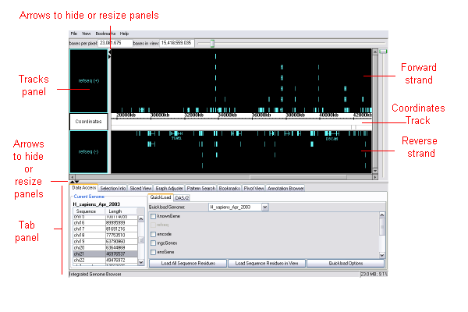
When annotation data is loaded into IGB, the browser looks similar to this:

The viewer may be empty the first time you start IGB, or it may have loaded some default data. To load data, see Loading annotations on page 22.

The title bar
The title bar is located at the top of the window.
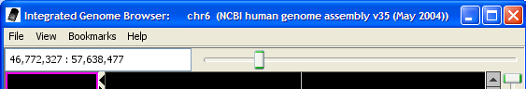
When you are viewing data, the genome version (genome assembly) and chromosome or sequence being viewed are identified in the title bar.

The status bar
The status bar is at the bottom of the main window.
The left-hand portion displays information about current selected items or other short messages. The right-hand portion shows the amount of memory used and the total amount authorized for use by the program. If the amount used gets too close to the amount available, you may be unable to open any more data or perform certain functions. (Java programs require that the maximum amount of authorized memory be declared at start-up. To increase this amount, you must re-start the program.)

The viewer
The main portion of the browser window is the viewer window. It contains several annotation tracks or tiers. These tracks in IGB are comparable to annotation tracks in other genome browsers. Typically, a coordinates track will be shown, with forward strand annotation tracks above it and reverse strand annotation tracks below it, though the tracks can be reconfigured in other ways.
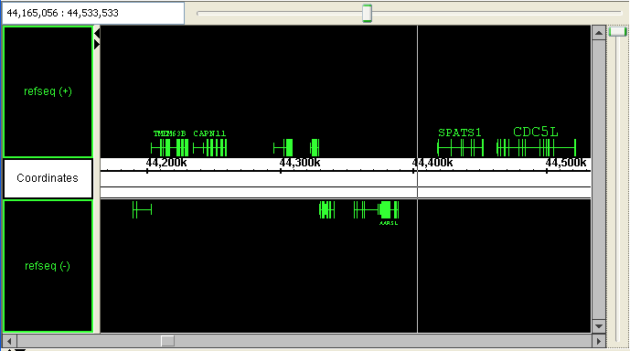
Around the edges of the viewer you will find horizontal and vertical scroll and zoom sliders that can be used to control how much data is in the view at one time.
When the data is available, IGB will also display cytobands in the coordinates tier, above the axis, and contig locations below the axis..
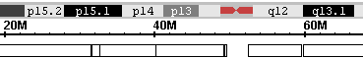

Annotations
Annotations in the annotation tracks are typically shown as rectangular blocks, often connected by lines. For instance, mRNAs are shown using rectangular blocks for the exons, with lines connecting the exons across the intron regions. Translated regions of the transcript are shown using thicker rectangles, and untranslated regions (UTRs) are indicated by thinner exons, or a “tongue” at either end of a gene, as in this example:
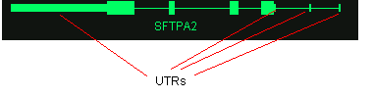
Data on location of UTRs is not included in all loaded data, so will not always be displayed.
The gene name or annotation id of each annotation may be shown above or below it, when you are zoomed-in close enough. By default, gene names and labels are not shown for most annotation types. You will learn how to turn on these labels for any annotation type later. See Choosing annotation id labels in Appendix 3 Preferences.

Track handles
Each annotation track has an associated track handle on the left-hand side of the viewer. Click and drag these track handles to re-arrange the tracks. You can also click on the handles to select tracks and right-click to open a menu that allows you to perform various options on the selected tracks.
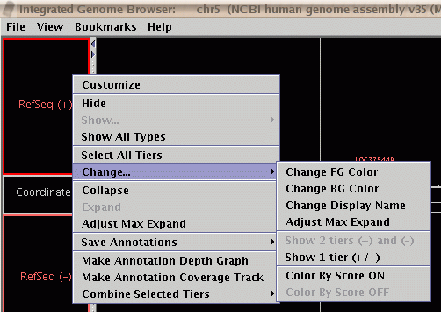
More information about using tracks can be found in the section Customizing annotation tracks on page 37.

Zoom sliders and scroll bars
Controls for scrolling and zooming the view are located around the edges of the viewer. The scroll bars are always located to the right and bottom of the view. The zoom sliders are typically located on the opposite sides of the view from the scroll bars, but they can be moved to be on the same side through the setting of a user preference.

The hairline position marker
When you click on any empty area in the viewer, a vertical hairline will be placed there as a position marker. The hairline location also serves as the center point for horizontal zooming.
The hairline coordinate location will be shown in the left-hand side of the status bar at the bottom of the main window.
To see the coordinate location of the hairline also printed on the hairline itself, choose View menu > Toggle hairline label. To turn off the label, choose View menu > Toggle hairline label again.
To keep the hairline always in view when you scroll, you can set a preference. See Setting other options on page 102 of Appendix 3 Preferences.

Tabbed panels
The bottom of the main window contains several tabbed panels. The number and order of these tabs may vary. You choose a tabbed panel to work with by clicking its label.
You can open any or all of the tabbed panels in separate windows, if you prefer. See Opening tab panels in new windows on page 20.
The Data Access panel is of particular importance. It is typically open by default when you start IGB. This panel is useful both for navigating around in the genomes and chromosomes you have loaded, and for loading new data.
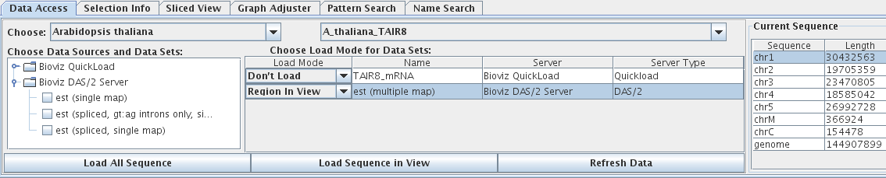
The various parts of this panel are described in more detail later.

The console
Informational messages, warning messages and error messages are printed to the IGB console. During normal operation, most of this information will not be of use to you, but you may need to consult the console when an unexpected error occurs. The messages there may be of use in diagnosing problems. Open the console with Help menu > Show Console.

Navigation
This section describes how to navigate in IGB to see annotations on the genomes and chromosomes you have loaded and how to zoom-in on areas of interest. Searching for annotations by their Ids or searching for sequence patterns are covered in separate sections. See Searching on page 32.

Choosing a genome and chromosome
At the top of the Data Access tab there are combo boxes to specify a list of genomes available on the known servers. Select any genome from that list to view it.
A list of chromosomes in the current genome appears to the right. Select any chromosome in the list to view it.

To see data for a genome that is not already loaded, you will need to load the data, either from QuickLoad, from a DAS server, or from a data file. See Loading annotations on page 22. Any genomes that are loaded will then appear in the pull-down list and can be selected in future.

Zooming and scrolling horizontally
The horizontal zoom slider is located along the top (or bottom) edge of the viewer. To zoom in, move the zoom slider to the right. To zoom out, move the zoom slider to the left.
The hairline marks the focus of horizontal zooming. Click in any empty position in the view to reset the hairline position and thus reset the center of zooming.
When you are zoomed in, you can scroll through the view in several ways:
- Use the horizontal scroll box slider at the bottom of the viewer panel to scroll along the sequence. Slider size and speed of movement will vary according to the current zoom level.
- Click in the scroll bar trough on either side of the slider to move it in the direction of your click.
- For finest precision when zoomed in, click the arrows at the ends of the scroll bar.
When you are zoomed all the way out (the horizontal zoom control slider is at the far left), you are already viewing the entire range of the loaded data and the scroll box slider is not available.
You can also set IGB to automatically scroll along the chromosome. This is useful occasionally for presentations. Choose View menu > AutoScroll.

Zooming and scrolling vertically
Zooming and scrolling vertically are similar to zooming and scrolling horizontally. Zooming vertically is especially useful for viewing ESTs or any other annotation types with many rows of annotations. (You will later see how to collapse or even hide tracks with too many rows of annotations. See Customizing annotation tracks on page 37)
The vertical zoom slider is located immediately to the left (or right) of the main view. To zoom the view vertically, drag the vertical slider down:

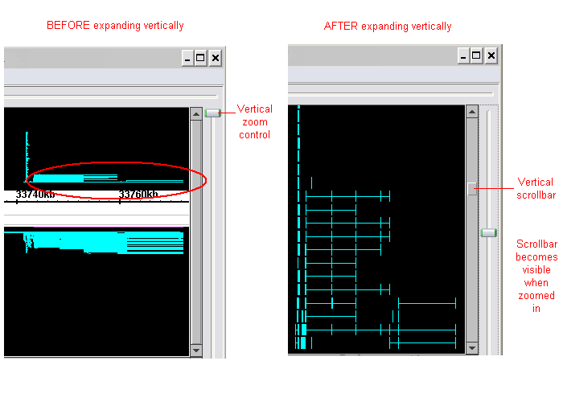
After expanding vertically, use the vertical scrollbar to view different annotation rows.

Going to a specific coordinate
To go to a specific coordinate or coordinate range, use the coordinate range box located at the left-hand side of the horizontal zoom slider, which is either directly above or below the main view.
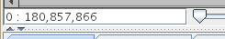
The range box displays the current coordinate range. But you can also type a new location into the box to go there quickly. Enter the desired location in any one of these formats then press the <Enter> key:
- “chromosome : start - end”. sets the view to the given start and end coordinates on the given chromosome. This is the same format used by the UCSC genome browser, so you can easily copy coordinates from that application. Example: “chr3:100000-200000”.
- “start : end” or “start - end”: sets the view to the given start and end coordinates.
- “chromosome : start + width” or “start + width”: sets the view to the given start coordinate and sets the zoom level such that the given width of coordinates is visible.
- “position”: Moves the hairline to the given position. Example: “100,000”. If possible at the current zoom level, the view will be scrolled such that the given position is in the center of the view.
If the specified chromosome or position does not exist in the currently loaded genome, an error message will be shown.
If you have clamped to a view (see Clamping on a view on page 84) you will become un-clamped if you switch to a different chromosome.

Bookmarks
You can save your favorite locations as bookmarks so that you can quickly return to them. See Bookmarking on page 73.

Clearing the view
To clear the contents in the viewer in order to work with a different data set:
- Choose File menu > Clear All
This clears only the display. The data remains loaded and can be viewed again by selecting the desired genome and sequence in the Data Access tab panel.
To clear data from memory, you must close and re-start IGB.

Advanced navigation
There are also some advanced navigation tools described in the sections Shrink-wrapping and Clamping on a view.

Selecting items with a mouse
Select annotations, graphs and sequence regions in order to perform certain operations on them. The following are ways to select items in the viewer window using a mouse.
To do this: | Do this:
Select a single annotation | Click on it.
Select a gene instead of an exon. | Directly select a whole gene by clicking on the line connecting the exons.  If you mistakenly select an exon instead of a gene, right-click in the blank background or on a selected annotation and choose Select parent
Select a single graph | Click on its handle: the rectangle at the left inside the main view window.
Select an annotation track | Click on its track handle in the left-hand panel. See Track handles on page 14.
Select multiple annotations or graphs | Drag the mouse through a region to select all enclosed items. For graphs, the drag should include the graph handle. A drag must begin in the empty area, not on top of any annotation or in the coordinates track.  You can use shift-click or shift-drag to select additional items.
Select a sequence region | Drag along the axis of the coordinates track to select a set of residues. To select residues, the drag must begin in the axis tier.
Deselect everything | Click the empty background space in the viewer window.
Add to the current selection | Shift-click to add individual items or shift and drag to add multiple items.
Open a pop-up menu | Right click on an item that is already selected or on the empty background.

If you mistakenly select exons rather than their parent genes, you can easily select the parent gene: right-click in the blank background or on a selected annotation > Select parent.

Zooming to selected items
To center on and fill the viewer with the selected object:
- Right-click on an item > Zoom to selected

Customization

Opening tab panels in new windows
Each tab panel can be optionally displayed in a separate window. This allows you to make each tab panel larger while still leaving plenty of room for the main window.
To open a tab panel in a new window:
- Click the tab to open, then choose View menu > Open tab in new window.
The location and size of each open window will be remembered and restored when you re-start the program.
To return a window to the tab panel:
- Click the [X] in the upper right corner of the window to close the window. The window will close, but the contents will be returned to a tab panel.

Keyboard shortcuts
You can create keyboard commands (keyboard shortcuts) for some operations that you perform frequently.
See Changing keyboard commands on page 100.

Customizing display properties
Many properties of annotation tracks and graphs can be modified by the user. Many of the customizations will be automatically remembered between sessions with IGB. See the sections Customizing annotation tracks on page 37 and Working with graphs on page 50.

Setting preferences
Various other preference settings can be made through the Preferences window. Open this window with File menu > Preferences. Your preference settings will be remembered between sessions and can be exported and imported as a file. See Appendix 3 Preferences for details.

Loading annotations
IGB initially opens with a blank view, or with some default annotations for the genome you most recently looked at. Load annotation data from any source(s) below to compare annotations.
The types of data you may load include:
- Standard annotations such as RefSeq annotations, provided by public repositories
- Alignments of Affymetrix probe sets to the genome, provided by the NetAffx group at Affymetrix
- Alignments of 454 data
- Tiling array graphs, from the TAS program
- Copy number graphs from the CNAT program
- Data generated from other Affymetrix software tools, such as GCOS, Expression Console and ExACT
- Annotation and graph files prepared by any method in any of the supported formats.

Data sources
Data sources that IGB can work with include:
- QuickLoad, a system designed specifically for IGB.
- DAS/1 servers (Distributed Annotation System servers, such as UCSC).
- DAS/2 servers (a newer version of the DAS servers).
- Data files in many formats.
For more about each of these, see the appropriate sections below.
Some versions of IGB can load data directly from a SQL database. That feature is not included in the public version of IGB and is not described in this manual. One way to provide direct access to your personal database is to write a DAS server that interfaces with it.
Affymetrix maintains public QuickLoad and DAS servers for use with IGB. The data on those servers derives from and works with the NetAffx Analysis Center, which provides a web interface to access annotations for Affymetrix GeneChip products. The NetAffx Analysis Center is found from a link on the main Affymetrix web page, or here: http://www.affymetrix.com/analysis/index.affx

Loading annotations from Servers
- Make sure you’re connected to the internet (best on fast connections)
- Click the Data Access tab (already displayed by default at launch.) See Tabbed panels on page 15.
- Select a species and genome version.
- From the tree view, select a server to use. By default, a few should be listed (including NetAffx DAS/2 and Netaffx Quickload). To add more servers, see Configuring data sources on page 81.
- Available annotation types will be listed in the tree view. They will vary depending on the genome you selected. Select any of the annotation types shown in the panel by clicking the associated checkbox.
- The annotation type will then be displayed separately. Choose the method of loading (e.g., Region In View, Full Genome, Full Chromosome).
- Choose Region In View to load annotations for the range of bases that you currently see in the viewer. Loading large ranges may take a long time if the server or your connection is slow. Loading will begin when the Refresh Data button is pressed.
- Full Genome and Full Chromosome loading will begin immediately. This may take a very long time if the server or your connection is slow.
- RefSeq annotations and cytobands will load by default when they are available for the given genome.
- Wait a few moments for the annotation type to load. The data will be loaded over the internet, but a local cached copy will be made so that the data will load faster the next time.
- If IGB displays no annotations, choose a chromosome in the table at the right side of the Data Access tab panel. Not all annotation types will have data on all chromosomes. See Choosing a genome and chromosome on page 16.
- Contigs are indicated by outlined bars at the bottom of the Coordinates track. If no outlined bar is present, then there is no contig data available in the annotation type or for the region that you are viewing.
- (Optional) Load sequence residues for the selected chromosome. See Working with sequence residues on page 29. If the desired sequence does not appear, it may not be available for the genome you have selected.

After you have accessed a particular sequence from a particular source, IGB caches that sequence so that it loads quickly the next time you use it. To clear the cache, see The file cache on page 83.

QuickLoad
IGB uses a system which we call QuickLoad servers or QuickLoad directories to quickly load basic data, such as public reference data, that is generally useful to help analyze your specific experimental data.
QuickLoad servers contain sets of sequence names, contig location information, sequence residue data files and/or reference annotation files organized into subdirectories based on genome versions. Many of the files are in well-known data formats. We use specialized binary formats for certain data for efficiency.
Affymetrix maintains a publicly-accessible QuickLoad server containing public data as well as data generated by the NetAffx team. IGB is configured such that this server will be available by default. You can add additional QuickLoad servers if you would like quick access to data for genomes that are not included in the Affymetrix public server. (This is described in Configuring data sources on page 81.)

DAS servers
DAS stands for Distributed Annotation System. DAS is a protocol for a client-server system for exchanging genomic annotations and sequence data. Loading annotations from a DAS server gives you more flexibility than QuickLoad to specify the amount of data that you load. For example, instead of loading an entire genome, you can load annotations for a range of coordinates.
The first version of the DAS protocol is now know as DAS/1. There are many public DAS/1 servers available, and IGB can load and display data from many of them (specifically the UCSC server). You can add more servers to this list. (See Configuring data sources on page 81.)
A revised and extended version of the DAS protocol is known as DAS/2. There are currently few DAS/2 servers and clients available and they may not be fully functional. IGB contains a DAS/2 server, which is still experimental at the time of this writing.
For more information on DAS, visit the website: http://biodas.org

Loading from DAS/1
IGB initially is not configured with the addresses of any DAS/1 servers. You can add to or change the list of DAS/1 servers that you can access. To do so, see Configuring data sources on page 81.
A recommended DAS/1 server is UCSC: http://genome.cse.ucsc.edu/cgi-bin/das/
For information about the resources available on the UCSC server, visit http://genome.ucsc.edu/goldenPath/help/hgTracksHelp.html#IndivTracks

Loading from DAS/2
IGB is initially configured with multiple DAS/2 servers. You can add to or change the list of DAS/2 servers that you can access. To do so, see Configuring data sources on page 81.

Loading annotations from files
IGB can view data from one or more files. A variety of file formats is supported.
Data sets from different genomes are kept distinct in memory. You can switch between the data you have loaded from different genomes and chromosomes by using the pull-down genome selector and table of chromosomes in the Data Access tab panel. Refer to section Genomes and chromosomes on page 11.
Some file types already contain information specifying which genome (or occasionally genomes) they belong to. When this is the case, the file will automatically open in the specified genome and the view will be set to it. If that genome exists in your QuickLoad server, then the default RefSeq data for that genome will also be automatically opened.
Other file types do not specify which genome they belong to. In this case, you can choose to merge the file data with the current genome, or create a new genome for that data.
When opening a file, you must choose one of the options
- Merge with currently-loaded data, or
- Create new genome, using a name that you provide
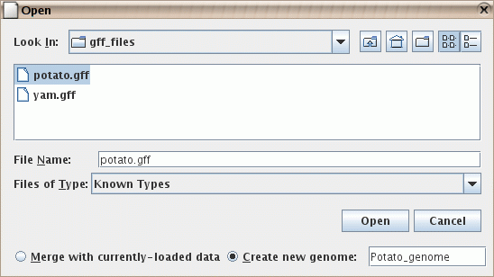
The merge option is generally the best choice. Load reference data for your genome from a server and then merge your file into it. The option Create new genome exists to help load data from file formats that do not specify a genome, particularly when the desired genome doesn't exist in one of the specified servers. If your file specifies which genome it belongs to, you cannot prevent it from merging with other data already loaded from that genome nor force it to merge into a different genome.
Unfortunately, different data sources often refer to the same genome version by different names. IGB can be told to consider several genome and chromosome names as equivalent through the use of a synonyms file. See Synonyms on page 82.

Merging with current genome
If you want to load a file and combine its data with the genome you are currently looking at:
- Make sure the genome version and chromosome of files that you want to open match those of the data already displayed. This is case-sensitive, so look out for, say, “chr1” versus “Chr1”.
- IGB recognizes standard terms for version and sequence. For details, see Synonyms on page 82.
- If in doubt, check the text at the beginning of the file to be opened. If genome version and chromosome cannot be matched, you may still be able to open a file if the sequence names match.
- Choose File menu > Open File.
- Select the Merge with currently loaded data check box.
- Choose the file and click Open.
Annotations from merged files will load as additional tracks alongside tracks already in the viewer.
You may need to adjust the vertical zoom level after loading new data. For instructions, see Zooming and scrolling vertically on page 17.

Viewing in a new genome
If you want to open a single file of data and do not want to continue displaying your previously loaded data at the same time, then you can create a temporary new “genome” to hold this data.
Any genome that is already displayed in the viewer will be hidden when you use this option. But you can access that data again later by choosing that previous genome in the genome selector in the Data Access tab panel.
To open a file in a new genome:
- Choose File menu > Open File.
- Select the checkbox to Create new genome.
- Enter a name for this temporary genome, or accept the default name that is provided.

Annotation file formats
IGB can display several types of standard genomic file formats.
IGB can display annotations, sequences and graphs. The differences between these data types is described in Terminology on page 11. Multiple file formats exist for each of these data types. This section describes some annotation file formats. Graph file formats are discussed in the section on viewing graphs.
All filenames must include the appropriate filename extension, for example “.gff” or “.psl”.
Compressed files can only be read if a recognized filename extension is part of the filename. The filename must include both the filetype extension and the compression extension, such as “myfile.gff.zip” or “myfile.psl.gz”. Zip files must contain only a single annotation file.
- .zip
- .Z
- .gz
- .gzip
Annotation data files give sequence coordinate locations of exons, genes, transcripts, etc. on the genome. Some accepted formats are described in the table below. Others can be seen by using File menu > Open File, and seeing the list of extensions available there.
.gff | There are several types of GFF files. You should identify the type of your GFF file in the header as GFF version 1, version 2, or version 3. More info is available at: http://www.sanger.ac.uk/Software/formats/GFF/index.shtml or http://genome.ucsc.edu/goldenPath/help/customTrack.html#GFF  GFF version 3 is described at http://www.sequenceontology.org/gff3.shtml
.gtf | For information, visit http://genome.ucsc.edu/goldenPath/help/customTrack.html#GTF  For IGB use, the track name(s) come from the source column, unless a different track name or names are specified with a track line. Coordinates will be transformed from Base 1 to Interbase 0.
.psl | Displays annotations with target name matching the loaded sequence. For additional information about .psl files and how to use them, see http://hgwdev.cse.ucsc.edu/~kent/exe/doc/psLayout.doc or http://genome.ucsc.edu/goldenPath/help/customTrack.html#PSL. Files of interest are available via the DAS server.  When you load them, you will be prompted to specify whether to use the Query or Target sequence. If in doubt, use the default.
.bed | Standard genomic file format. For information, visit http://genome.ucsc.edu/goldenPath/help/customTrack.html#BED

Some of those formats allow the use of track lines to control certain display properties. See Track lines on page 87.

Details for selected features
To get details about selected annotations or graphs:
- Select the item(s) of interest in the viewer.
- Shift-click to select more than one item.
- Open the Selection Info tab
- If you click an annotation and less information than you expect appears in the Selection Info panel, you may have selected an exon rather than a gene. Right-click on the exon or on the blank background and choose Select parent to see information about the gene.
The kinds of information displayed vary by item selected and source.
Selection Info shows one column for each gene that you shift-click to select in the viewer.

Links to public web sites
For many annotation types, more information about an annotation is available directly from the source. This feature takes you to NCBI (for RefSeq annotations), Ensemble (for EnsGene annotations), UCSC (many DAS annotations), or other web site depending on the source of the annotation you seek information on. Not all annotation sources contain the necessary link information for this feature; if the menu option is unavailable for the annotations you are examining, this means that the annotation type has not been associated with a website.
To view information for an annotation from a public web site:
- Right-click a gene in the viewer > Get more info
Instead of Get more info, the label may display more specific text indicating which web site it will open, or there may be a sub-menu to allow you to choose between web sites.
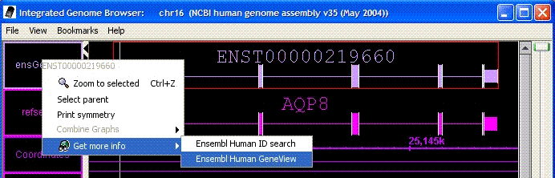
Information is usually retrieved in the indicated web-site based on the text id of the item.
Currently the only supported way to configure which web site appears for certain annotation types is by using track lines in the data file itself. See Track lines on page 87. This is only possible with text-based file formats and requires that you edit the annotation file yourself. We plan to add another feature to allow you to easily configure which web sites will appear for any annotation type.
Some data file formats, such as DAS/2 XML format, allows a custom link to be supplied for each individual feature.

Working with sequence residues
Many IGB features require sequence residues to be loaded, so you may want to load them initially during each IGB session. However, sequence data can require a great deal of memory, so only load sequences if you need them.

Loading sequences
There are three ways to load sequence residues into IGB. The first two of these are primarily for commonly-studied organisms.
- Load residues for a whole chromosome.
Click Data Access tab > Load all sequence
- Load residues for a small region. This is not always supported, in which case the full chromosome sequence will be loaded.
Click Data Access tab > Load sequence in view
- Load residues from a file.
Use File menu > Open File
- If data is not available on the configured servers for the selected sequence or chromosome, then an error message will appear. This error can also occur if you are viewing data from a genome that is not included in the configured servers.
- Wait while the sequences load. Sequence residues contain a large amount of data, so this may take a few minutes.
Some servers will reject requests for residues from a region that is too large. Others will return the data, but only after a very long wait.
- A gray bar at the bottom of the Coordinates track indicates the region(s) for which you have loaded sequence residues:
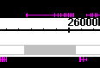
Find details for each of these methods below.
If you are using your own personal QuickLoad server, make sure you have created sequence data files in the “.bnib” format and have named the files to match the names of the chromosomes, such as “chr1.bnib”.

Loading from a file
You may choose to load sequence data for whole chromosomes, or even for whole genomes, from a file. The FASTA format can be used, but is only appropriate for small sequences. The filename should end with “.fasta” or “.fa”.
The FASTA format is described here: http://en.wikipedia.org/wiki/Fasta_format
Sequence files contain sequence residues only. If an annotation file you use lacks sequence residues, you can merge a sequence file for the same region.
To load a sequence file:
- Choose File menu > Open File.
- Navigate to the correct directory and select a file in FASTA format. The filename must end with “.fasta” or “.fa”.
- Choose whether you want to merge this with your current data:
  - If you want to load one or more sequence(s) for the genome you are currently looking at, choose “Merge with currently loaded data”.
If the name(s) of the sequence(s) in the file match the names in your currently-loaded genome, they will be merged into those chromosomes. Otherwise, new chromosomes will be added to your genome to hold the new data.
The number of residues should match the length of your loaded sequences. If not, then the sequence lengths will be increased as needed.
  - If you want to create a new genome using the chromosome(s) or sequence(s) specified in the file, select “Create new genome”.
A new genome will be created containing sequence data from the file. There will be no annotation data associated with this genome, but you can load any annotations and graphs you have created in other files.
The FASTA format is good for small sequences. For larger sequences, you should convert your files to a more efficient binary format
The public QuickLoad server maintained by Affymetrix provides some sequence data in a binary format called “.bnib”. This file format is much more efficient and is preferred for large sequences, such as whole chromosomes.
Users interested in creating their own “.bnib” files should read this document: http://sourceforge.net/docman/display_doc.php?docid=27770&group_id=129420

Viewing sequence residues
Sequence residues, when loaded, are visible in the Coordinates track when zoomed all the way in (see picture).
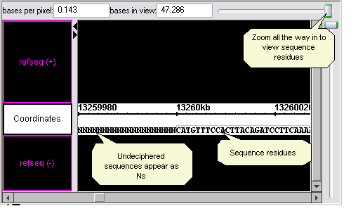
Unsequenced regions appear as Ns.

Copying sequence bases
You can copy a sequence of bases and paste the sequence into another application for use there.
To capture a sequence of bases:
- Make sure sequence residues are loaded. See above.
- Either select a single annotation or click and drag in the Coordinates track to select the desired coordinate range.
- Choose View menu > Copy selected residues to clipboard.
- Paste the text string into the target application or location.
If you have selected an annotation that has introns, the selected residues will include only the exon regions. If you want to capture all the residues including the intron regions, select the region by dragging in the Coordinates track.

Searching
Data sets from different genomes are kept distinct in memory. The search functions described below will search for data only in the current genome or chromosome, as noted below. You can switch between the different genomes and chromosomes by using the pull-down genome selector and table of chromosomes in the Data Access tab panel.

Finding an annotation by name
There are several ways to go to a particular annotation:
- Click the Pattern Search tab, then enter the id for the annotation you want to jump to in the second box (enter id of annotation to find), then press the <Enter> key. (Leave blank the other fields in this panel.)
- Use the Annotation Browser tab
Both of these search over all chromosomes, but only in the currently loaded genome.
We recommend that you use the Annotation Browser to search by id instead of Pattern Search, since it is easier to see when there is more than one item with the same ID.

Browsing for annotations
The Annotation Browser tab panel can be used to search for and browse through annotations by name, track, and location. (This tab is currently off by default, but can be re-enabled.)
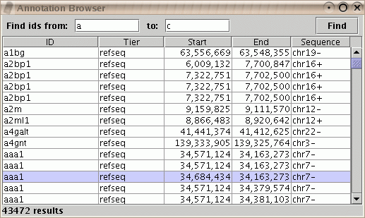
The Annotation Browser is located in one of the tab panels. It can also be opened in a separate window.
To see all annotations with names beginning with “a” or “b”, enter “a” and “c” in the boxes labeled Find annotations from: and to: and press Find. To see all annotations, leave the search fields blank and press Find. After a moment, the search results will be listed. If the number of results is too large, you may be required to reduce the range of your search.
Search results are listed in a table. Multiple annotations with the same ID are listed on different lines. Selecting any line will cause the browser to go to that annotation. It is easiest to scroll through the results when the search range was chosen to return a small number of results.
You can re-sort the lines in the results by one or more criteria. Click on the column header to set the primary sort column. Control-click on additional column headers to set secondary sorting criteria. In this image, results have been sorted first by Sequence then by Start.
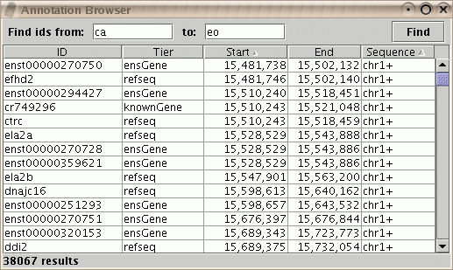
Additional search functions may be added to this browser in the future.

Finding sequence patterns
Use the Pattern Search tab panel to locate each instance of a short residue sequence you specify, either exact bases or a pattern including placeholders for unknown bases. All instances of that sequence on the current chromosome will be marked on the Coordinates track.
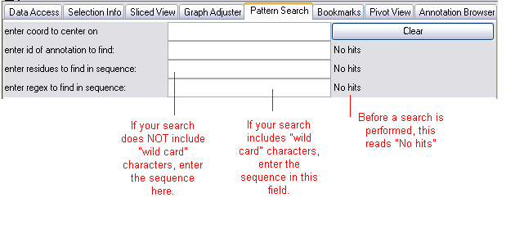
Sequence residues must be loaded before you can search based on residues.
“Enter residues to find in sequence”. This searches for an exact sequence of residues. It is not case-sensitive and it searches the forward and reverse strand.
“Enter regex to find in sequence”. This searches for sequence data based on a regular expression. Only the forward strand is searched.
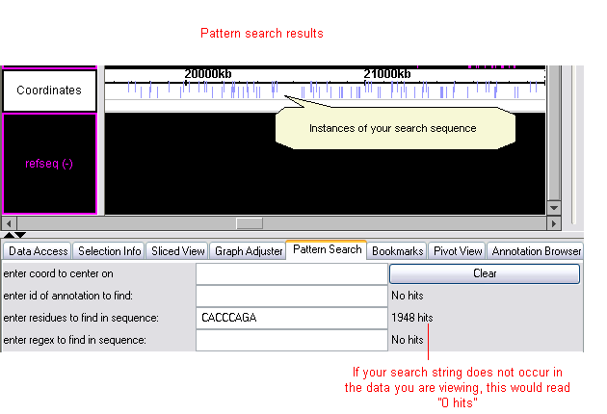
Found instances of your search sequence will be marked on the Coordinates track. Instances on the forward strand are positioned slightly above instances on the reverse strand.
The number of instances found appears in the tab window next to the field in which you entered the sequence string.
No hits means no search was performed for that function. 0 hits means no matches were found. (See the illustration.) Watch this indicator to know when IGB is finished processing your search. The cursor will also begin to blink in the text-entry field when processing is done.

Finding instances of a known sequence
In the chromosome being viewed, to identify all instances of an exact base sequence on the forward or reverse strand:
- Click the Pattern Search tab and type or paste a sequence in the field labeled “enter residues to find in sequence”.
- Press the <Enter> key. Wait a few moments.

Finding instances of a sequence containing unknowns
In the chromosome being viewed, identify all sequences on the forward strand matching a regular expression (a sequence containing “wild card” nucleotides).
This search is case-sensitive and limited to the forward strand for efficiency. FASTA files may contain both uppercase and lowercase sequences (lowercase is typically used for repeating sequences). If you are working with data with both upper and lower case residues, search for upper and lower case separately as desired. Or make the search be case-insensitive by using the flag “(?i)” at the beginning of the regular expression.
- Click the Pattern Search tab and enter a case-sensitive string of bases and wild cards (see table below for common ones) in the text-entry field called “enter regex to find in sequence”.
- Press the <Enter> key. Wait a few moments; this may take some time.
Example wildcard patterns:
Pattern | Represents | Example | Finds
. | any single nucleotide | ACCT.T | ACCTTT, ACCTAT, ACCTGT, and ACCTCT
… | any three nucleotides | ACCT…T | ACCTGAGT, Etc.
[CG] | a C or a G | ACCT[CG]TC | ACCTCTC and ACCTGTC
T{1,n} | 1 to n T’s | ACGGT{1,3}C | ACGGTC, ACGGTTC, and ACGGTTTC
T* | Zero or more T’s | ACGGT*C | ACGGC, ACGGTTTTTC, Etc.
.*? | a string of any length containing any nucleotides | TCGGGGTTAA.*?CTGGACTC | Many possibilities.
.* | the longest possible string of any length containing any nucleotides | TCGGGGTTAA.*CTGGACTC | Differs from the search above in that the longest possible result(s) will be found
(?i) | use case-insensitive matching | (?i)A[CG]T | ACT, agt, acT, AGt, Etc.

The full list of regular expression syntax that you can use in IGB is available at http://java.sun.com/j2se/1.4.2/docs/api/java/util/regex/Pattern.html
For more detailed information about wildcard searches in general, look for a book on the subject of “Regular Expressions”.

Clearing pattern search results
To delete pattern markers from the Coordinates track:
- In the Pattern Search panel, press the Clear button.

Customizing annotation tracks
Each annotation type that you load appears in its own annotation track. You can facilitate viewing and comparison by customizing the appearance of each annotation type and by adjusting the position and size of tracks relative to each other.
You can manipulate tracks in the ways described in the following sections. Many of these changes can also be made by opening the tier preferences panel with File > Preferences > Tiers panel. The effect is the same whichever method you use. Most of the changes will be remembered between sessions with IGB.
All annotation tracks have a track handle in the panel to the left of the viewer. For some annotation tracks, id labels will be displayed above or below each transcript. See Using annotation id labels below.

Changing the width of track handles
You can make the track handle panel wider or narrower. You may make the panel wider to make it easier to make selections or easier to read the track labels. Or you may make it smaller so that there is more room to display annotations.
To resize the tracks column, drag the separating bar or click the tiny arrows:
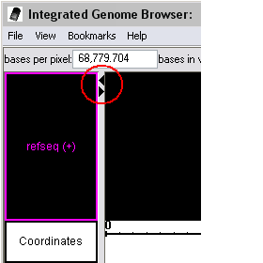

Re-ordering tracks top-to-bottom
To re-order the tracks:
- Click a track name (in the panel on the left) and drag the track up or down to the desired location.
There is nothing preventing you from placing forward and reverse strand data either above or below the axis, at your choice.

Selecting tracks
Before changing any track properties, you will first need to select one or more tracks.
- Select a single track by clicking on its label.
- Select multiple tracks by shift-clicking.
- Select all tracks by Right-click on track name > Select All Tiers
To perform right-click operations on all the selected tracks simultaneously, right-click one of the selected tracks to display the menu of track options.

Changing track properties
Select the track labels for the annotation types you wish to change. Right-click on the track label and choose Change. A sub-menu will appear that allows you to change various properties of the selected track(s).
Options include changing the foreground and background colors, changing the display name, and other properties described below.
It is not necessary to choose the tracks for both strands, as all changes are applied based on track annotation type name, regardless of strand.
You can also change these track properties by choosing the Customize menu item from the pop-up menu or from File menu > Preferences. The results are the same regardless of the method you use.

Changing annotation colors
To change the color of annotations in a track:
- Right-click the track name and choose Change > Change FG Color.
- Click a color in the palette, then click OK.
Change the background color in a similar manner. These changes will remain after you close and re-launch IGB and load the same data set.

Changing track names
Sometimes you will want to change the displayed names of tracks because the default names are too long or are confusing to you.
To change the display name of annotations in a track:
- Right-click the track name and choose Change > Change Display Name.
- Type the new name, then click OK.

Hiding and showing annotation tracks
Tracks can’t be deleted, but they can be hidden. To hide one or more selected annotation types:
- Right-click on the track or tracks you want to hide > Hide
All strands of the selected annotation track will be hidden.
To show hidden tracks:
- Right-click on a track label
- Select either Show All Types or Show > Track Name.
All strands of the selected annotation track will be shown, subject to your global choice of which strands to show. See the next section.

Hiding and showing strands
By default, all strands of data are shown. Annotations on the forward (+) and reverse (-) strands can be shown in separate tracks, or in the same mixed strand (+/-) track. Data with no known strand information is also indicated as a mixed strand (+/-) track. Forward strands typically show above the axis and reverse strands typically show below the axis, but at this time there is nothing preventing you from re-arranging the tiers so that this is not true.
You can control whether individual annotation types display as a single strand or as two separate strands. You can furthermore globally control which of these strand types are visible. These two functions interact to precisely limit the information shown to that which you are interested in.
To change the strands shown for each individual annotation type
- Select one or more track labels
- Right-click on a track label > Change
- Select either Show as single tier or Show as two tiers

To change the strands shown for all annotation types
- Choose View menu > Strands
- Select any of these to toggle the selection on or off
  - Show (+) Tiers
  - Show (-) Tiers
  - Show (+/-) Tiers

Note how these two functions interact with each other and with the hiding and showing of annotation types:
- Hiding the reverse (-) tiers will only hide tiers that contain only reverse-strand annotations. It will NOT hide the reverse-strand annotations in mixed-strand (+/-) tiers.
- If you have hidden an annotation type (such as RefSeq) and then choose to show it again, which tiers are visible will still be subject to your selections of which strands to display.

Collapsing and expanding tracks
For tracks containing multiple rows of annotations, collapsing tracks consolidates all rows within a track into a single row. Annotations on any of the rows will be included in the collapsed track.
Collapsing tracks is useful if you don't need to see all the details. But be aware that in collapsed tracks larger annotations may obscure smaller ones; annotations with introns may be obscured by annotations that don’t show the intron.
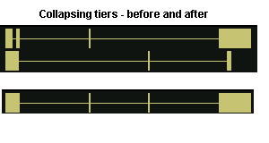
To collapse or expand selected tracks:
- Right-click on a track label > Collapse or Expand
All strands of the given annotation type will be affected.

Setting a row limit
If a single track contains many rows of annotations, some annotations may be represented by many instances while others have few representations. To focus on annotations that have fewer representations, or to reduce the amount of space that a track occupies in the viewer, limit the number of rows (depth) that IGB displays.
In the example below, to make the circled annotations more visible, the number of annotation rows in the track was limited to 10:
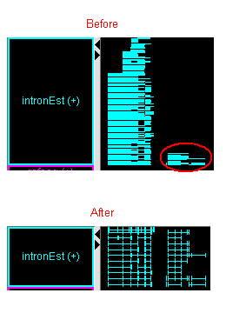
To limit the number of annotation rows in the selected tracks:
- Right-click on a track label > Adjust max expand
- Enter the new maximum track height
- Click OK
No change is visible in tracks that are collapsed, but the effect will be visible if the track is later expanded. All strands of the annotation type will be affected.

Removing the row limit
To return to the original view and make all annotation rows in selected tracks visible:
- Right-click on a track label > Adjust max expand.
- Enter 0 for the new maximum track height
- Click OK

Using annotation id labels
For some annotation tracks, labels will be displayed above or below each transcript. These labels will be hidden when there is no room to display them. Use the two zoom sliders to increase the annotation size until the text is visible.
You can hide annotation id labels or use as a label any property type that is available for that data set. For example, RefSeq annotations have both an “id” and a “gene name” property. You can choose to display either of these as a label.
Id labels are turned off by default for most data types. To choose which annotation types have labels and which data field to use as the label, see Choosing annotation id labels on page 99. IGB requires less memory to run and will draw the display faster when labels are turned off.

Using color to represent scores
For annotation data that contains scores, it is possible to represent those scores by a color map. The scores must have been included in the data when it was loaded. Files in GFF and BED format allow the specification of scores.
The scores must range from 1 to 1000. Exons with scores near 1000 will display in the chosen foreground color. Exons with scores near 1 will display in a color very close to the background color. Any other score, including 0, will display in the full foreground color, indistinguishable from data with the maximum score.
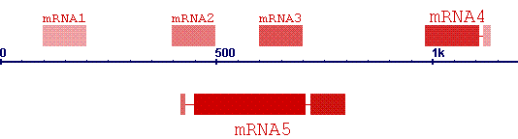
To turn color-by-score on or off,
- Right-click the track name and choose Change > Color by score ON or Change > Color by score OFF.
This has no effect on data that doesn't contain scores.
This feature can also be turned on by setting useScore=1 in the track line in the file header. See Track lines on page 87.

Tools for comparing annotations
IGB offers several tools to highlight patterns to aid in making comparisons. These are described in the following sections.

Highlighting matching endpoints
To see if different data sources show the same start and endpoints for an annotation:
- Select an item.
Matching edges of corresponding items in all tracks being viewed will be highlighted
- By default, the highlight color is white, which works well on a black background. If you change the background color, you may want to change the edge-matching color as well.
Use File menu > Preferences > Other Options tab panel > Edge Matching.

To specify the degree of closeness required for a match (how many base pairs difference is still considered a match):
- Choose View menu > Adjust edge match fuzziness.
- Slide the slider to the maximum number of base pairs difference that you want to consider a match.
By default, if edge match fuzziness is adjusted, all matching edges are highlighted in gray rather than in white. This color can also be changed using File menu > Preferences > Other Options tab panel > Edge Matching.

Slicing
Slicing makes slight variations more visible when comparing multiple annotations on the same sequence. Slicing cuts out long introns and realigns the exons of a selected annotation or set of annotations, making pattern irregularities and possible alternate splicing more obvious.

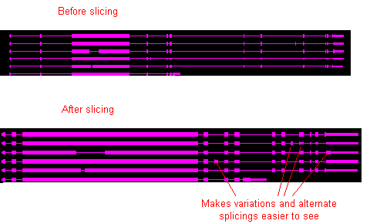
To compare multiple selections:
- In the main view, select all annotations to include in the slice. In the example above, you would select all 6 “copies” of the gene.
- Click the Sliced View tab.
- If desired, resize the tab panel or window to enlarge the viewing area of the Sliced View window.
- Make sure the Slice By Selection checkbox is checked.
IGB may take a few moments to display the sliced region. For easy comparison, the sliced view displays sliced versions of all annotation tracks and graphs in the region being viewed.
Use the zoom and scroll bars to navigate in the sliced view panel. Note that the numbers in the Coordinates track in the sliced view panel indicate scale; they don’t correspond to genomic coordinates. Endpoint matching in the upper and lower windows are independent of each other.
Note: If you use keyboard shortcuts for zooming and scrolling, the shortcuts will apply to both the main view and in the sliced view. The effect can be confusing when both views are visible in the same window at the same time. Opening the sliced view in a separate window can give more predictable shortcut behavior. See Opening tab panels in new windows on page 20.

Viewing deletions and insertions
When several transcripts share the same or overlapping exon regions, the slice view can help you to see where exons were deleted in one transcript relative to another one.
To examine alternate splicing, select only one of the transcripts in the main view. The slice view will show all transcripts as they have been sliced relative to that selected transcript.
In this image, the top-most transcript was selected in the main view. The other three transcripts each include one or more exons that are not included in the top transcript. The locations of these sliced-out (deleted) exons relative to the other exons is indicated with small “X” marks.
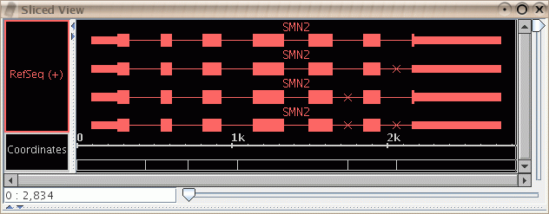

Disabling the sliced view
Slicing requires extra computation. Although this computation occurs on a background thread, you may still wish to turn it off to increase the speed of other computations.
You may also want to turn slicing off so you can preserve a static view of a particular result.
Turn slicing on and off with the check box Slice by Selection in the Sliced View tab panel.

Adjusting the sliced view
Each sliced region includes a buffer, in order to allow examination of the bases in the intron-exon boundary. The buffer is initially 100 bases on each side of each sliced region; if an exon in the same range that was not selected for slicing extends beyond the buffer, it may be truncated. To avoid this problem, increase the buffer enough to accommodate the entire exon by changing the number of base pairs before and after each exon.
To adjust the buffering number of base pairs before and after each exon:
- Visually estimate the number of base pairs required to achieve the adjustment needed
- In the Sliced View tab, change the value in the Slice Buffer field.
- Press the <Enter> key.
You may also set the slice buffer to 0 to completely eliminate the introns. This can be useful in conjunction with the Analyze ORFs function to find open reading frames. See Showing ORFs and stop codons on page 85.

Summarizing tracks
For tracks containing multiple rows of data, summarizing collapses a stack of annotations so that anomalies are readily visible. The height of the results at each position indicates the number of annotation rows that include each annotation. An area where the height is very low compared to the others indicates an anomaly in one or more of the rows.
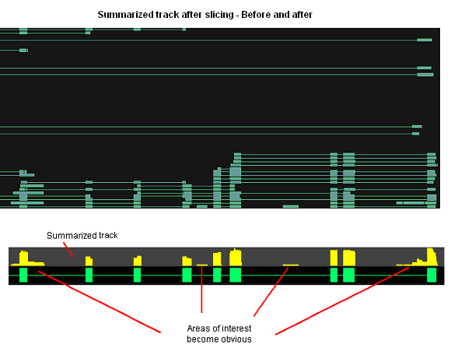
To summarize a track:
- Right-click on the track label > Make annotation depth track
- Wait a few moments for processing.
The summary track appears as a new track in the viewer window. The name of the track is “depth: <name of the track you summarized>”.

Looking at density of annotation coverage
You can generate an overview of the relative density of annotation coverage across an entire chromosome. The Make Annotation Coverage Track feature dynamically graphs the relative number of annotations in a track that are present at each pixel across the main window. As you zoom in and each pixel represents a smaller number of nucleotides, the graph automatically adjusts to indicate the relative number of annotations present in the smaller region covered by that pixel. When you are completely zoomed in, and each pixel represents a single nucleotide base, the graph shows either a 0 (no annotation is present) or a 1 (an annotation is present) for each pixel.
To show the density of annotation coverage for an annotation type that you are viewing:
- Right-click on the annotation type in the Tracks panel and choose Make Annotation Coverage Track.
The following illustration shows the relative annotation coverage at each pixel when the view is zoomed all the way out. In this example, suppose you conclude that the density of the circled region is significant and you want to examine it more closely.

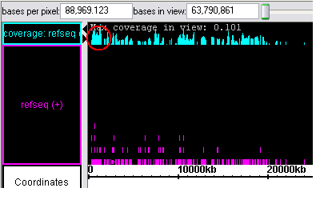
After you zoom in to display the relative annotation density within the region that is circled in the illustration above, you might decide to look more closely at the region of greater annotation density at the end of the pictured region.
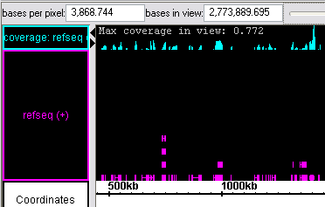

Combining tracks
You can highlight differences or commonalities between different annotations on two tracks by combining the tracks in any of several ways:
To combine tracks:
- Shift-click the labels of the two tracks to compare.
- Right-click a selected track label > Combine Selected Tracks.
Choose one of the options listed. The effects of each option is described below.
- Intersect: Yields only the overlapping portions of A and B
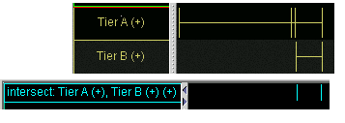
- Union: Yields all bases that are in either A or B
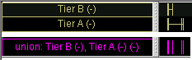
- A not B: Yields the part of A that does not overlap with B
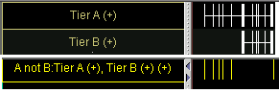
- B not A: Yields the part of B that does not overlap with A
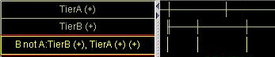
- XOR: the union of the yields of (A not B) and (B not A); i.e., all of the material that is in A or B but not both.
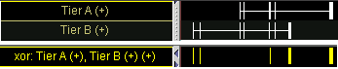
- Not: (Select only one track) Yields all coordinates that are not annotated in the selected track
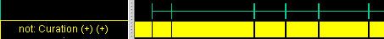

These actions are specific to the tiers and strands that you selected. If you selected a “RefSeq” tier containing forward strand data, and a “Genscan” tier containing forward and reverse strand data, then the data from the reverse strand of “RefSeq” will not be used. This can be used to your advantage. For example, if you want to know where on the chromosome there are “RefSeq” annotations that overlap on the forward and reverse strands, then choose the two tiers “RefSeq (+)” and “RefSeq(-)” and use the Intersect operation.
Another place where performing tier comparisons is useful is when you have created two tiers by performing thresholding twice on a graph with different threshold settings and you want to discover what is different between the two cases. To capture the graph thresholds in a track, see Applying thresholds to graphs on page 60.

Working with graphs

Introduction
Graphs contain numerical data associated with base pair positions along the chromosome sequence axis, such as sets of scores or chromosome copy numbers at specific positions. IGB allows you to visualize such graph data and compare it with RefSeq and other annotations.
Examples of suitable data include:
- Files generated from Affymetrix software tools, such as the Expression Console, CNAT, GCOS, or ExACT.
- Expression values from genome tiling arrays.
- Density of ESTs across chromosomes
- GC content along chromosomes
- Measures of conservation between two genomes
There are two basic types of graphs:
- Position graphs associate scores with single genomic positions.
- Interval graphs associate scores with ranges of genomic positions.
Here is a very simple example of several interval graphs:
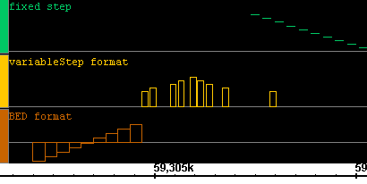
IGB will recognize whether the graph is a position or interval graph and will display it accordingly.
This chapter explains how to use IGB to examine your graph data:
- Compare graph and annotation data in the same region.
- Adjust graphs to highlight features
- Fine-tune graph scaling to improve visibility
- Use thresholding to transform graph data into annotation-like format, in order to examine it further using other tools in IGB.

Loading graph files
Graph files are loaded in the same way as annotation data files. To open graph files in any of the supported formats:
- Follow the procedures in Loading annotations from files on page 25.
IGB can display graphs in several file formats, developed at Affymetrix or elsewhere. For the most up-to-date descriptions of the formats IGB supports, check the File menu > Open File, and look for documentation on the site http://genoviz.sourceforge.net/
All filenames must include the filename extension, for example “.sgr”. Compressed files must include the graph type extension AND the compression extension, such as “mygraph.sgr.zip”.
Graph files may be in the following formats:
.bar | Generated from tiling arrays by TAS (Tiling Analysis Software.)
.chp | Binary files generated by Affymetrix software. These files contain data on scores for probe sets. There are multiple variations on this file format. IGB can read some, but not all of these formats.
.egr | Files containing data for scored intervals.  Files generated from Affymetrix GeneChip Operating Software (GCOS) or ExACT (Exon Array Computational Tool) software.
.sgr | Sequence graph files that show base coordinate scores. These files are generated by CNAT (the Affymetrix Chromosome Copy Number Analysis Tool software).  The format of .sgr text files is: chromosome identification, then two columns of numbers separated by a single space or a tab. The first number is the base position; the second number is the score.
.gr | A simple text format containing two columns of numbers separated by a single space or tab. The first number is the base position; the second number is the score.  Because this format does not include chromosome names, we recommend you use the “.sgr” format or “.wig” format instead.
.wig | Wiggle format. A text format developed for use in the UCSC genome browser. All three sub-formats of wiggle graph are supported by IGB: “fixedStep”, “variableStep” and “BED”.  See http://genome.ucsc.edu/goldenPath/help/wiggle.html  Files in wiggle format can use UCSC track lines to specify colors and other properties. See Track lines on page 87.

Important: Graph files in some formats do not contain information about which genomes and chromosomes they correspond to. These may be loaded and displayed alongside annotations on any chromosome, but the data may have no meaning if compared to the a chromosome it was not designed for.

Changing graph appearance
Most graphs are drawn in graph tracks that are similar to the annotation tracks used to display annotations. Floating graphs do not appear in such a track. See Floating graphs on page 57.
You can modify many properties of graph tracks in the same way you modify properties of annotation tracks. Right-click on the track handle and choose from the menu. See Customizing annotation tracks on page 37.
All graphs have a rectangular block drawn at the left-hand edge. This is the graph handle. It can be used to select floating graphs with the mouse. For graphs that are drawn in a graph track, it is easier to select them by clicking on the track handle instead.
Settings and adjustments that are specific for graphs can be made using the Graph Adjuster tabbed panel.
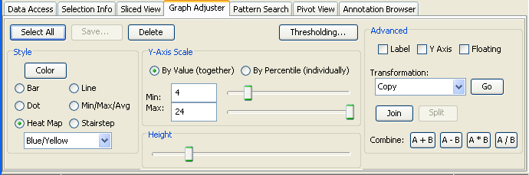
To change the settings for one or more graphs that are displayed in IGB:
- Click the Graph Adjuster tab.
- Select the graph(s) to change by doing one of the following:
  - To change a single graph, click the colored bar at the left side of a graph (the graph handle) or the track label to select it.
  - Shift-click to select additional graphs.
  - To change the settings for all graphs that are currently displayed, click the Select All button in the Graph Adjuster panel.
- Make changes to the graph settings by typing in new values or by operating sliders in the Graph Adjuster panel. For details, see the sections that follow this procedure.
Any changes you make to the values in the Graph Adjuster panel will apply to all currently selected graphs.

Change the height of a graph
There are several ways to change the vertical height of a graph:
- Select the graphs you want to change by clicking on their handles, then drag the Height slide bar in the Graph Adjuster tab.
- If the graph is floating (see Floating graphs on page 57), hold down the shift key and drag your mouse up or down on the colored bar at the left end of the graph.

Change graph styles
Graphs can be shown in various representational styles. The type of graph that is most appropriate depends on the type of question being asked about the data. For example, when comparing trends and patterns, it is very useful to use the line graph display method. The number of expression intervals being shown also can affect the graph display choice. The user is encouraged to experiment with the different display types to find out which method works best for specific purposes.
To change the graph style:
- Click the colored bar at the left end of the graph to threshold.
- Click the Graph Adjuster tab.
- In the Style section choose one of the options.
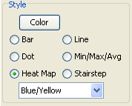
The following graph styles are available in IGB:
- Bar – Individual values are shown as vertical bars that are one base wide for position graphs and of variable width for interval graphs.
- Line – Subsequent values are linked with a line. Even if the input file was not sorted, the values will be connected in order along the genomic coordinate axis.
- Dot – Shows a single dot for each data value. For interval graphs, horizontal lines will be connect the start and end points.
- Min/Max/Avg – This is the default style for most graph data types and is usually fine for most purposes. It is especially useful for showing very densely populated graphs with data points for large numbers of positions.
When IGB is zoomed all the way in, the display is equivalent to the Bar style. When zooming out, IGB starts to summarize values. When the scale of the display reaches the point where individual x-values are associated with multiple score values, IGB picks the maximum and minimum values and draws a vertical bar between them. In addition, IBG draws lines through the average of all the data points represented at each x value.
- Stairstep – Similar to the bar graph style, except that bar widths along the horizontal axis are stair-stepped.
For example, if position 100 has a value of 50 and position 200 has a value of 75 and there are no values in between, then IGB will draw a bar of height 50 that starts at position 100 and stops at position 200. Then, at position 200, IGB will draw a new bar of height 75 that terminates at the next location with a value.
This style is particularly useful for viewing .egr and .sgr files, ESTs, or other high-density data.
- Heat map – Instead of showing relative intensity via the height of the line at each pixel or coordinate as in most other graph styles, a heat map shows expression levels via color or brightness of the line at each pixel or coordinate. This graph style is useful if you want areas of greater expression to jump out at you. If a graph does not render or is hard to see, adjust the visible bounds of the graph until features are readily visible. Several heat map color maps are available to choose from. Transparent color maps are available and may be useful for floating graphs.
The following image illustrates how a single data set would look in each of the graph styles. The graph used for this image is a simple position graph. An example of an interval graph was given in the introduction to this chapter.
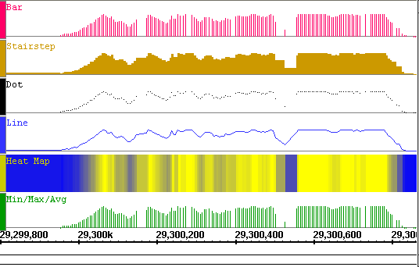
Note that with the heat map style for position graphs, the background (here in white) does not show through in regions where there are no data points. This is because the heat map first applies the stair-step function on the data before choosing colors to display. Compare the widths of the color bands in the heat map graph to those in the stair-step graph. For interval graphs displayed in the heat map style, the background will show through in regions with no data.
Due to the high zoom level in the above image, the Min/Max/Avg graph style is displayed exactly the same as the Bar style. When zoomed out, it reverts to showing the minimum, maximum and average values of all the data in the whole range of coordinates under each horizontal pixel width.
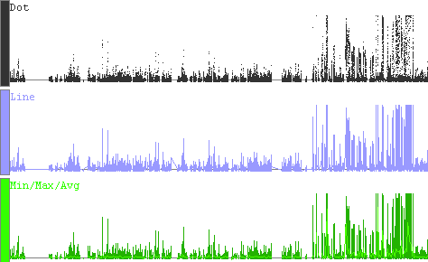

Change graph color
To change graph color:
- Click the colored bar on the left end of the graph to select the graph.
- Click the Graph Adjuster tab. In the Style section, click the Color button.
- Choose the desired color, and then click OK.
For graphs in the heat map style, the chosen color will only be used on graph labels and handles. The data colors come from the chosen heat map.

Change scale
Changing the visible bounds involves changing the scale of the graph by setting the maximum and minimum values to be displayed.
Scaling is an important issue to consider when viewing expression values because the distribution of these values across the range defined by their minimum and maximum may be highly asymmetrical.
For example, the majority of values could range between 100 and 1,000, with just one or two percent exceeding 100,000. These extremely high values (relative to the rest) would tend to dwarf the others if displayed to scale in a graph because the vertical axis would be forced to show a range of 1 to 100,000. Although technically accurate, such a graph would not be very informative because most of the information – the relative differences in value between different base pair positions – would be impossible to discern visually.
Setting minimum and maximum bounds based on percentile offers one solution to the distribution problem. When you set minimum and maximum bounds, these thresholds define the visual range of values displayed. Any extreme values that are above or below the chosen thresholds are truncated from the display, and the values in between are displayed across a range that allows their differences to be noted.
To set these visible bounds, use the Y-axis scale section of the Graph Adjuster tabbed panel:
- Select the graph(s) to change: Click the colored bar at the left end of each graph to change. (Shift-click to select more than one.).
- Click the Graph Adjuster tab.
- If thresholding is on, toggle it off before you adjust the graph bounds, then on again after you are finished. See Applying thresholds to graphs on page 60.
- Adjust the visible graph bounds:
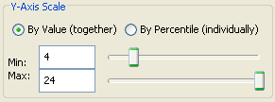
  - To set specific values, select By Value. The chosen minimum and maximum value will be applied to each selected graph. You are free to set maximum and minimum values that cover a range smaller or larger than the actual range of your data.
  - To set values by percentile, select By Percentile. Percentile ranges will be computed separately for each graph, which means that the absolute minimum and maximum range values for each selected graph may be different.
- You can use the sliders or enter values in the Min and Max fields.

To display the full range of the data:
- Chose By Percentile and set the Min to 0 and Max to 100

Hiding and deleting graphs
Hide graphs to remove them from the display without deleting them from memory. Hidden graphs can be restored later. Delete graphs to permanently remove them from the viewer and from memory.
For a graph attached to a tier, you can hide it in the same way you hide an annotation tier. Right-click on the label tier and select Hide from the menu. Floating graphs must be attached to a tier before they can be hidden.
To delete one or more graphs:
- Select the graph or graphs.
- Open the Graph Adjuster tab. Click the Delete button.

To delete all graphs currently displayed:
- Choose File menu > Clear graphs.

Advanced graph manipulations
Controls for the graph features below can be found in the Advanced section of the Graph Adjuster tab.
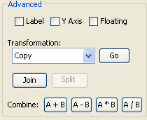

Graph labeling
You can modify the labels for graphs that are currently selected by checking checkbox options in the Advanced portion of the Graph Adjuster panel.
- Show or hide the Y Axis scale
- Show or hide the identifying Label of the graph source (typically the same as the name of the graph file)
An example graph showing both options turned on is shown below:
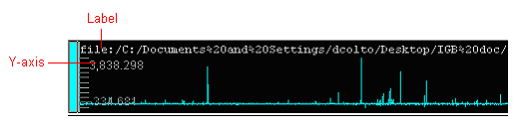

Floating graphs
An attached graph appears in its own track, like other annotation types. A floating graph is drawn on top of other tracks with a transparent background. Since a floating graph is not in a track, it has no track handle. Instead, use the graph handle to select the graph, or to drag it to a new location. The graph handle is the colored bar to the left-hand side of the graph.
Controls for floating or attaching a graph can be found in the Advanced section of the Graph Adjuster tab.
To attach a graph into its own regular graph track:
- Click the colored bar at the left side of the graph (the graph handle) to select it, then deselect the Floating checkbox.
To detach a graph from its track and let it float:
- Click the colored bar at the left side of the graph (the graph handle) to select it, then select the Floating checkbox.
You can set default preferences so that graphs load either initially floating or attached as a track. See Setting graph preferences on page 101.

Transforming to a non-linear scale
By default, all graphs display in linear scale. If you wish to scale the data in a non-linear way:
- Select the graph(s) to change: Click the colored bar at the left end of each graph to change. (Shift-click to select more than one.).
- Click the Graph Adjuster tab.
- Select the type of transformation you would like to perform from the pull-down menu labeled Transformation in the Advanced section.
- Click GO
IGB duplicates your graph in a new track and applies the selected scale to the new graph. Your original graph is not deleted. Note that one of the choices of scale is Copy, which makes a copy of the graph without re-scaling it. That can be useful if you want to explore the effects of showing one graph in two graph styles at the same time.

Duplicating graphs
You may want to duplicate a graph to experiment with different graph adjustments without losing adjustments that you have already made.
To duplicate a graph:
- Click the colored bar at the left end of a graph to select it.
- Click the Graph Adjuster tab. In the Advanced section, under the label Transformation select Copy and click Go.

Joining and splitting graphs
It is possible to join two or more graphs into a single annotation track. The two graphs will then have a single track tier label and can be moved and adjusted as a group.
To join multiple graphs, select them, then press the Join button in the Advanced portion of the Graph Adjuster panel. To separate graphs that were earlier joined together in this way, select them and press the Split button.
When the tier is in the expanded state, the multiple graphs are shown in separate non-overlapping bands:
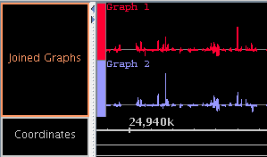
If the tier is collapsed, all graphs are shown in the same, overlapping band:
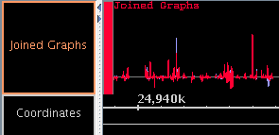
When joined graphs are collapsed, any opaque regions of the top graph will hide corresponding features of the lower graph or graphs.
Joining graphs into a single annotation track can be very useful for expression data from multiple experiments. Here, data from several experiments at different times during the development of an organism are shown together in a single track, and it is easy to see that expression of genes is being regulated over time.
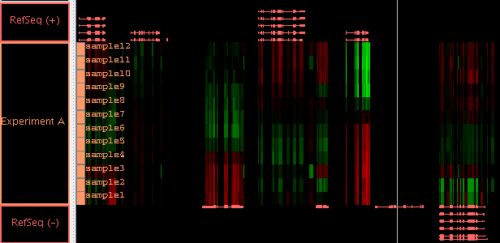
By selecting the single tier label, here labeled “Experiment A”, you can easily set the graph style and data range for all these graphs to be identical.

Graph arithmetic
You may need to compare the relative differences in expression levels between two graphs that represent data that occupy the identical genomic position on the chromosome. For example, a graph of cancerous cells will show what’s turned on or off when compared to a graph of normal cells. Results that show significantly more or less activity than a control graph for the same region may indicate an area of interest.
Arithmetically combining two graphs may make the differences and correlations easier to see.
To arithmetically combine two graphs:
- Shift-click the bar at the left end of each graph to select the graph. The graph you click first is A, the graph you click second is B.
- Use one of the four Combine buttons in the Advanced portion of the Graph Adjuster tab labeled A+B, A-B, A*B, and A/B.
- Alternatively, right-click the bar at the left end of either graph and choose Combine Graphs, then choose one of the following:
  - Create Sum Graph (A+B)
  - Create Difference Graph (A-B)
  - Create Product Graph (A*B)
  - Create Ratio Graph (A/B)
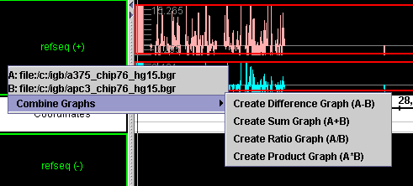

Applying thresholds to graphs
A common analysis step is to determine meaningful regions on a sequence based on graph values being above or below a certain threshold. To screen out non-meaningful values and to view meaningful features of a graph as annotations, use the thresholding feature in IGB.
Thresholding displays graph features as annotation-like bars in locations where the graph value at the coordinate meets your defined threshold. You can convert this data into a standard annotation track in order to analyze your graph data using all of the features in IGB for working with and comparing annotations.
In some cases, you may want to adjust your graph thresholds so the bars correlate to existing annotations; any threshold bars visible at that point that don’t have known annotation counterparts (or vice-versa) may indicate areas for further investigation.
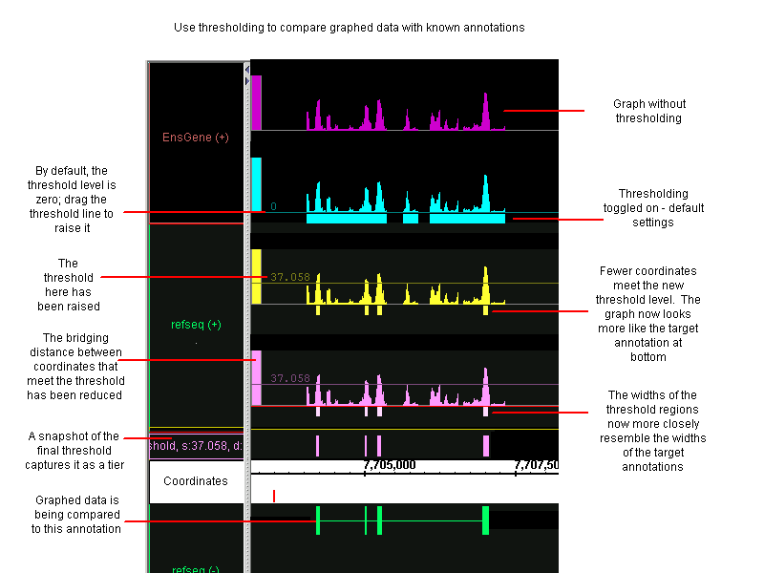

Using thresholding
To use thresholding:
- Select one or more graphs.
- Click the Thresholding button in the Graph Adjuster tab panel.
This will open the Graph Thresholds window.
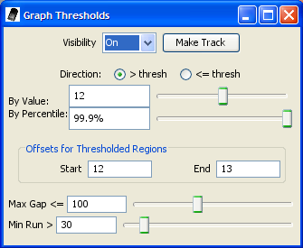
- Set Visibility to On.
- Modify the thresholding parameters.
By default, the threshold is set midway between the graph minimum and maximum values. To obtain more meaningful thresholds, adjust the threshold settings using the methods described in the following sections.
- (Optional) Save the resulting threshold regions to an annotation track by clicking Make Track.
After an annotation track has been created with Make Track, it is frozen and is no longer linked to changes in the Graph Thresholds window. But you are free to modify the criteria in the Graph Thresholds window and create another annotation track.
Settings in the Graph Thresholds window will apply to all currently-selected graphs.

Specify the threshold level
To change the thresholds of selected graphs so that more or fewer points meet the threshold limit, modify these settings in the Graph Thresholds window:
- By Value – specify the exact threshold value.
- By Percentile – sets the threshold based on the percentage of graph values greater or less than your threshold.

Specify the threshold direction
Specify whether the threshold bars represent values that are above the threshold you specified or below it.
In the Thresholding section of the Graph Adjuster tab, choose:
- > thresh – finds values greater than the specified threshold
- <= thresh – finds values less than or equal to the specified threshold
For example, for expression results graph score represents the level of hybridization activity. For a hybridization activity level to be considered significant, the score must be above a certain threshold. So you would choose the > thresh option and set your desired threshold value. If you need help to pick a threshold level, toggle the Y-axis on to see the graph’s scale on the Y-axis. See Graph labeling on page 57.

Control gaps
Experimental data can be noisy. If you are looking for general trends and want to ignore small local variations, you can use the Max Gap and Min run settings.
Slide the sliders to adjust thresholding, or enter values into the boxes for each parameter:
- Max Gap: Groups of coordinates that meet the threshold may be separated by gaps where the threshold is not met. By default, thresholding bridges such gaps if they are less than 100 bps long. For example, if there are 300 bps that meet the threshold, then 99 bps that don’t, followed by 100 that do, the threshold bar would bridge the 99 bps to produce a single threshold annotation 499 bps long. To change the length of this bridge, enter a different value into the Max Gap text-entry field.
- Min run: minimum number of bases in a row that must meet the threshold before an annotation bar will appear. For example, by default the Min run is 30 base pairs, so a sequence of 29 base pairs that meet the threshold will not be marked by an annotation bar.

Specify offsets
The Offsets for Thresholded Regions feature is designed specifically for working with tiling array data.
Captured data from tiling array probes should usually be shifted for display. Since the probes are 25 base pairs long, but the x-coordinates given represent the starting coordinate, you should shift the threshold data so that it starts at 12 base pairs past the given beginning, and ends at 13 base pairs past the beginning. This is the default placement of all graph threshold bars.
If these offsets are not correct for the data you are analyzing, you should change them.
If you are viewing typical tiling array data, modify these settings in the Graph Thresholds window:
- Set the Start value to 12.
- Press the <Enter> key.
- Change the End value to 13, then press <Enter>.
When you view non-tiling array data in IGB, you should adjust the offset to 0 to correctly align the threshold bars with their actual coordinates.
To adjust the offset values for non-tiling array data modify these settings in the Graph Thresholds window:
- Set the Start value to 0.
- Press the <Enter> key.
- Change the End value to 1, then press <Enter>.

Capture the threshold bars
Capture the threshold bars (which look similar to annotations) in their own track to more easily compare different threshold settings for a single graphed region. (See the thresholding illustration, above)
To capture the threshold bars and convert them to annotation tracks:
- Click to select the graph
- Click the Make Track button.
A snapshot of the current thresholded graph will be created as a new annotation track. This track will be given a default label which you can later change if desired.
To permanently capture the threshold snapshot for later use or sharing:
- Right-click the track and choose Save Annotations.
- Choose one of the file formats.
- Name your file. Be sure to include the correct filename extension.
After you have captured threshold “annotations” from a graph or other set of data, you can examine these “annotations” using all of the tools in IGB for working with and comparing annotations.

Useful graph customizations
Some common useful graph customizations are:
- Dampen the distorting effects of outliers – for example, ignore any points that are above the 99.5th percentile or below the .05th percentile. This makes it easier to see the bulk of your data.
Under Y-Axis Scale, set By Percentile to the desired lower and upper percentile bounds.
- Apply matching scales when comparing multiple graphs. For example, if one graph has a minimum value of 12 and a max value of 24, and another has a min value of 24 and a max value of 48, make them easier to compare by changing the visible bounds so they have the same scale. For each graph being compared, toggle the Y-axis on to view the min and max values for each, then adjust the Y-Axis Scale using By Value to make them compatible
- Display the optimal type of graph for a particular purpose, for example use a stairstep style graph for analyzing ESTs or performing other density analyses. Then slice the selection to see details.
- Use the thresholding feature to find areas of activity that may be significant, for example areas that do not coincide with known exons. Adjust your threshold bars to match the known annotations; any “extra” threshold bars visible in your graph indicate potential areas of interest.

Getting details about a graph
Textual information about some graphs is available in Selection Info.
Click the colored bar at the left of the graph, then click the Selection Info tab. Resize the columns if needed.

Saving and bookmarking graphs
Most graph properties that you set in IGB can be captured for future use by saving or bookmarking.

Saving graph data as a file
You can save a graph as a separate file for future reference or off line use. Note that this saves only the graph data, without any visualization customizations you may have made to it.
To save graph data to a file:
- Select the graph by clicking the colored bar at the left end of the graph.
- Click the Graph Adjuster tab. Click the Save button.
- Specify location and graph name.
- Pick one of the graph formats offered. Typically choose “.egr” format for interval graphs and “.sgr” format for other graphs.
- You will be prompted to add the proper “.sgr” or “.egr” filename extension depending on the type of graph data.
- Click OK.
Graph properties, such as color, scale, and so forth, may not be saved along with the data. Some graph formats, such as “.bed”, “.gff”, and “.wig” allow such properties to be specified in “track lines”.

Bookmarking graph views
By creating a bookmark, you can save a link to your graph along with the customizations you have made to its appearance. See Bookmarking on page 73.
You can also export your list of bookmarks to share it with other users. If your bookmarks contain links to graph files on your file system, those files may not be available to users on other file systems.

Printing graphs
Use Print menu > Print as EPS to save a high-quality graph image.

Setting graph preferences
To set preferences that apply by default when you load graphs, see Setting graph preferences on page 101.

Visualizing probe sets

Introduction
IGB can be used to visualize data from Affymetrix showing the locations of GeneChip Expression Array probe sets aligned to a genome.
Chip design procedures have varied somewhat from chip to chip, but, in general, probes on Affymetrix’s standard commercial expression microarrays (such as the Human U133 chip) are designed to match the 3’ regions of known or computed mRNA sequences. These probes are typically 18 to 25 bases long depending on the chip.
In standard arrays, probes are grouped conceptually into probe sets, groups of probes that are expected to measure expression for individual known or computationally-deduced mRNA molecules.
Probe sequences are typically selected from the 3’ regions of these design sequences in order to maximize the amount of sample mRNA to be measured. (This so-called “3-prime bias” will most likely change as sample preparation protocols improve over time.)
These design sequences may be identical to known mRNA sequences in GenBank, or they may have been produced computationally by merging ESTs or mRNA sequences into a single sequence, sometimes called a “consensus” sequence.
IGB can be used to visualize the location of design sequences and probes within the genomic sequence. Seeing where these sequences are located within the genome can be extremely useful when several overlapping probe sets recognize diverse mRNAs originating from the same gene. Around 60% of human genes produce multiple variants, and these diverse variants often exhibit very complex configurations of exons and introns. As a result, it often helps to be able to view a diagram of these complex structures together with probes in order to determine which individual mRNAs are being detected by a given probe set.
To make this easier, IGB shows where the design sequences and their probes align to the genome together with alignments between the genomic sequence and known or predicted mRNAs. By showing probes, known mRNAs, and design sequences in the same view, IGB makes it possible to determine quickly which known mRNA a probe set could detect.
However, it is important to note that these genome alignments can only be as good as the genomic sequence on which they are based. Genomes vary in their level of quality – for example, the human and fruit fly genomes are very high quality, having gone through several releases involving many refinements. More recently-sequenced genomes (such as mouse or rat) are not yet as reliable. For the less-refined genomes, there may be many examples of design or mRNA sequences that simply do not align anywhere to the genomic sequence or, if they do align, do so imperfectly. Readers interested in understanding more about these issues can read more about this topic at the following link: http://www.pubmedcentral.nih.gov/articlerender.fcgi?tool=pubmed&pubmedid=12149135/.

Invoking IGB via links from NetAffx
Probe set pages on the NetAffx customer support Web site contain links to the IGB browser under the “Genomic Alignments” section of the page. Clicking these links (labeled “IGB” as shown below) will tell IGB to show the region of the genome containing the probe set and its design sequence.
IGB must currently be running for these links to work. If IGB is not currently running, start it in your usual way or by clicking the “start IGB” link provided for that purpose. If IGB is already running, then the current scene will be replaced with a view of the probe set design sequence alignment region.
Depending on the probe set, there may be more than one reasonably good alignment for the design sequence. Most genomes contain large amounts of duplicated sequence, and so it is to be expected that many design sequences will align to multiple locations.
For example, the figure below shows links to two different alignments for a single probe set and its corresponding design sequence.
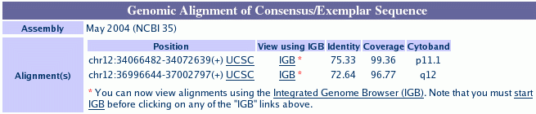
IGB links in probe set page.

Loading probe sets from data files
Sometimes it is useful to load up an entire chip’s design sequence alignments into IGB. To do this, download the files from the Affymetrix customer support Web site.
These can be obtained on-line at the NetAffx customer support Web site. To obtain these files for individual chips, go to http://www.affymetrix.com/support and choose the array of interest. On the array’s support page, look for alignment data files in the "NetAffx Annotation Files" section. Note that alignment data files will only be available for species with well-characterized genomes.
These alignment files are in a format called “PSL” (pslayout) which was first designed by Jim Kent of U.C. Santa Cruz. For more details on this format, visit the UCSC Genome Bioinformatics Web site at http://genome.ucsc.edu.
To visualize all the probe sets and associated design sequences for a particular chip, load the genome of interest and merge a probe set data file. Follow the same procedure used to load any annotation file. See Loading annotations from files on page 25.

Probes and probe sets on display
Once the data have been loaded, the probes and design sequence alignments will appear in a separate track labeled by chip. Within the track, probes and their matching design sequences always appear together. The following figure shows an example from the rat 230 chip.
This image shows a probe set that detects mRNA transcripts from the rat Rp14 gene, which encodes a ribosomal protein.
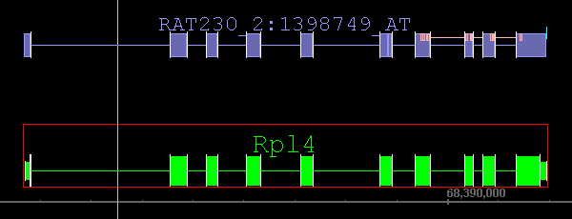
Probe set design sequence aligned to genome.
RefSeq
mRNA
Probes
Polyadenylation site

Probe set design sequence
The alignment between the probe set design sequence and the genome is represented at the top of the figure as a series of blocks. Each block represents a block of alignment in which each base in the genome matches a corresponding base in the design sequence. Gaps between the blocks typically represent areas where the genomic sequence contains inserts relative to the aligned design sequence. Usually, these gaps are due to introns.
There are some exceptions to this, however. For example, the sixth and seventh blocks in the figure above are so close together that they almost appear as a single block at this level of zoom.
Zooming in for a closer view reveals that these two alignment blocks are immediately adjacent to each other. This indicates that these two blocks of alignment were separated by an insert in the design sequence relative to the genomic sequence. That is, the design sequence contained some bases that were not present in the genomic sequence. This may present a problem if this missing region (in the genome, that is) contains some probe sequences. In this particular case, however, the alignment irregularity occurs in a 5’ region, outside the area covered by the probes. (See the discussion below.)

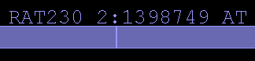
Adjacent alignment blocks
How can this happen? There are a number of reasons, but gaps in the genomic sequence – regions that simply have not yet been sequenced – are the most common culprit.

Probes and probe sets.
Each design sequence is shown with its corresponding probe set. Each probe set consists of a group of probes, which are shown superimposed on the alignment blocks of the design sequence.
The figure below shows a close-up view near the 3’ end of the design sequence. The 3’ end of the design sequence is annotated with blocks which represent individual probes.
Two things are important to notice about this image. First, sometimes individual probes are split across gaps in the alignment, which typically correspond to introns. When this occurs, the two halves of the probe are connected by a line.
Second, sometimes probes overlap with each other. This can be seen by clicking on probes. If a selection outline is visible in the middle of what otherwise looks like a single block, then there is really more than one block.

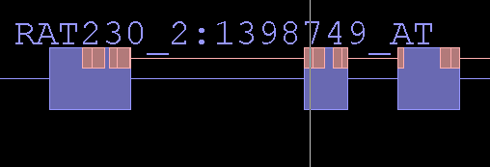
Probe split across genomic gap (intron)

Probe set labels
Each probe set and probe set design sequence is labeled with the name of the chip (Rat230_2, in this case) and the probe set identifier.

Polyadenylation sites
For many probe set design sequences, bioinformatics scientists have used computational methods to predict putative polyadenylation sites near the 3’ end of the design sequence. These are shown as dark or light blue boxes riding on top of the terminal alignment span.
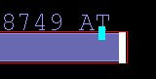
Predicted
polyA addition site
If the box is light blue, then the site was deduced from the overlap of multiple expressed sequences (usually 3’ ESTs) whose genome alignments all terminate at a common location. This is sometimes called a “polyA stack.”
If the box is dark blue, then the site has been deduced through sequence analysis of an individual, exemplar sequence, such an mRNA sequence record from GenBank. This is sometimes called a polyA site to distinguish it from a polyA stack.

Recognizing putative probe set targets
It is usually a good idea to load additional tracks of data besides just the probe set information. For example, in the figure above, the track below the probe set track shows the probe set’s likely target, an mRNA from the Rp14 locus. Based on their relative alignments to the genome sequence, it appears that both sequences overlap in the region that contains the probes. Thus, it is very reasonable to assume that this probe set does indeed detect the mRNA shown below it.

Getting more information for a probe set
Right-clicking a probe set or its design sequence and selecting the Get More Info option will open a web browser window and direct it to a page in the NetAffx Analysis Center showing detailed information about that probe set, including its design sequence.

About alignments

Probe mappings
A program called “blat” was used to map probe set target sequences onto various versions of various genomes. More information can be obtained about this program from the U.C. Santa Cruz Genome Web site, which also uses the blat program to map mRNA sequence onto genomic sequence. The link to this Web site is: http://genome.ucsc.edu/ .
The location of the probes within the probe set design sequence is already known from the design process. This information, in combination with information about the location of the probe set design sequences within the larger genomic sequence, was used to map probes onto the genome.
Many chip probe names use special suffixes to indicate when a probe set may detect multiple distinct target mRNAs. For details, consult the data sheet for your array of interest or contact Affymetrix technical support. (See: http://www.affymetrix.com/site/contact/index.affx for contact information.)

Viewing tips
Use the spliced view display to examine probe sets, probe set design sequences, and mRNA transcript annotations. Introns in mammalian genomes tend to be very large. The “sliced” view takes away the uninformative intronic sequence, allowing one to take in the entire structure of a gene without having to scroll or zoom.

Capturing, saving, and sharing data
There are several ways to save data for use in other applications, sharing, or later use in IGB.
Save or share data from IGB in any of several ways
- Viewing a region in the UCSC browser
- Saving annotation tracks
- Copying sequence bases
- Saving graph files
- Bookmarking
- Copying data from table cells
- Printing

Viewing a region in the UCSC browser
The UCSC web genome browser is a rich source of genomic information.
For more information on what’s available there, visit http://genome.ucsc.edu/.
To view in the UCSC browser the same region currently displayed in IGB:
- Select an item in the viewer window
- Choose View menu > View region in UCSC browser
Results may be slow to appear. (You may want to set your web browser preferences to show loading progress -- for example, Microsoft Internet Explorer has a bar on the bottom of the web window. See the documentation for your web browser.)

Saving annotation tracks
IGB is mainly designed for viewing existing data, not producing new data files. Nonetheless, you can save any single annotation track to a file by selecting the track tier label, performing a right-click and selecting Save to file. You will be given the option of saving in several formats, such as BED and DAS/2 XML.

Copying sequence bases
You can copy a sequence of bases to the clipboard and paste the sequence into another application for use there.
See Copying sequence bases on page 31.

Saving graph files
See Saving graph data as a file on page 65.

Bookmarking
To return later to a region or annotation and zoom level of interest, you can bookmark it. Items that you bookmark will appear under the Bookmarks menu. You can edit your bookmark list, as well as exporting and importing bookmark lists, with the Bookmark Manager window.
Any bookmarks that you create during a session will be saved when you exit, and will be available the next time you launch IGB.

Creating bookmarks
Before you add bookmarks, make sure you are not running multiple instances of IGB.
There are two types of bookmarks in IGB:
- Position bookmarks. These record the currently shown genome, the location, and the current zoom level.
  - To create, choose Bookmarks menu > Add position bookmark
- Position-and-graphs bookmarks. These record the same things as position bookmarks, but also keep track of any graphs that you have loaded thus far. In addition to remembering the data files that you have loaded, position-and-graphs bookmarks can also remember many of your customizations for graph appearance, such as color, graph bound adjustments, thresholding, and labeling.
  - To create, choose Bookmarks menu > Add position & graphs bookmark.

Using bookmarks
To load a view that you have bookmarked.
- Choose Bookmarks menu > [name of your bookmark].

Viewing and changing bookmark details
You can view details about your bookmarks, such as their position, which genome they refer to, or customizations for position-and-graphs bookmarks. You can also modify some details, such as the name of a bookmark or customizations of a position-and-graphs bookmark.
To view or change bookmark details:
- Click Bookmarks menu > Manage Bookmarks.
- Select a bookmark.
- Right click the selected bookmark or click the Bookmarks menu in the Bookmark Manager window and then select the Properties button.
- The information will appear in tabular format in a new window.
- (Optional) Modify the bookmark details.
- Click Apply Changes or Cancel. Changes will not take effect unless you chose Apply Changes.

Exporting bookmarks
To save a copy of the bookmarks to a file:
- Click Bookmarks menu > Manage Bookmarks.
- In the bookmark manager window, choose Bookmarks menu > Export Bookmarks
Bookmarks are saved in a single file in the Netscape bookmarks file format. This format resembles XML and HTML, but is not identical to either of those, so use caution if you choose to edit the file.

Importing bookmarks
You can import and use bookmarks, for example bookmarks that other people give you:
- Click Bookmarks menu > Manage Bookmarks.
- In the bookmark manager window, choose Bookmarks menu > Import Bookmarks > choose the file containing the bookmark of interest.
You can import multiple sets of bookmarks during the same IGB session. Imported bookmarks will be added to the end of the list of existing bookmarks. All imported bookmarks will be persistent between sessions of IGB.

Copying data from table cells
You can copy and paste table cells from the Selection Info panel (or most other tables) to the clipboard and paste them into Excel or some other program.
To capture data in table cells:
- Click and drag to select the cells you want.
- Copy (using Control-C) and then paste into the target application.

Printing
To print directly to your printer:
- Choose File menu > Print.
You can also print to an EPS format file. Files in the EPS format print in high-resolution and can be imported into many graphics programs. Files printed in EPS format are suitable for use in publications. To print to an EPS file:
- Choose File menu > Print to EPS File.
- Choose to print the entire window or one of the other selections.
- Choose a name for your file, using the extension “.eps”.

Pivot View

Compare expression across experiments
Use the Pivot View tabbed panel to examine and compare the results from multiple gene expression experiments.
Using Pivot View is similar to using graphs in that both show expression values in the context of genomic sequence. The difference is that in the Pivot View, the information on the x- and y-axes is flipped and individual sequence segments are separated into individual rows.
With graphs, expression values from a single experiment appear as a plots laid out across the horizontal sequence axis. In Pivot View, columns represent individual experiments, while rows represent individual regions.

Scored interval files
Pivot View displays data from “.egr” files, which are tab-delimited plain text files containing numerical score data for genomic intervals.
If you wish to create “.egr” files, the format is described on the website for the GenoViz project: http://genoviz.sourceforge.net/
As with graphs, it is important to load the file that corresponds to the genome currently being viewed.

Loading .egr files
Loading .egr files is similar to how other annotation files are loaded:
- Make sure the genome version and chromosome of files you want to open match those of the data already displayed.
- Choose File menu > Open
- Check the Merge with currently loaded data checkbox.
- Select an .egr file.
The data from this merged file will automatically be added to an additional track alongside the tracks already in the viewer.

Map data in the main window
When an “.egr” file is first loaded, the data appear in a new track named after the data file. The image below shows a new track that appeared after loading a data file called “tau0.4-pp0.egr.”
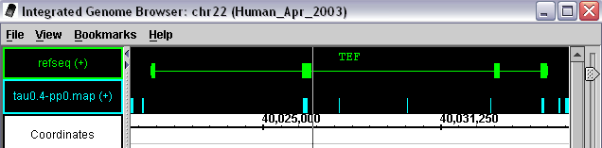
In the picture above, the blue blocks above the genomic sequence axis represent expressed intervals occurring at the indicated positions. These purely positional data correspond to the interval information that was stored in the loaded file. When strand information is known, these position indicators may appear in separate forward and reverse strands.
Expressed intervals
Expressed intervals in main display window.
When an “.egr” file is loaded, the score data may or may not also be presented in graph tracks in the viewer window. This behavior is controlled by a preference setting. See Setting graph preferences on page 101.

Map data in the Pivot View
To view score data associated with the intervals, select them in the main window: Each annotation that is selected in the main view becomes a track in the Pivot View.
The image below shows a sample Pivot View display that was built by selecting two intervals near the Aco2 gene.
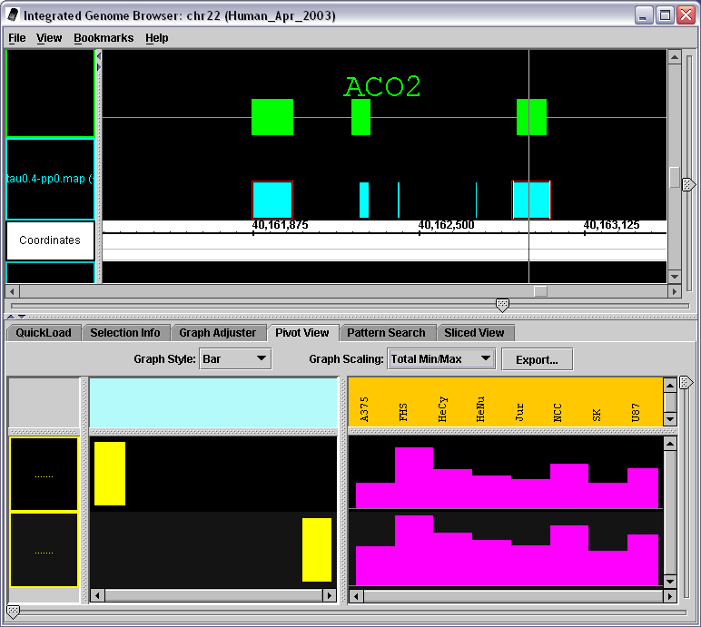
Pivot View showing expression values for two expressed intervals
Expression
Values
panel

To select a region of scored intervals for display in Pivot View, click-drag over the displayed blocks. To add more intervals to the selection, click or click-drag over additional blocks while pressing the SHIFT key.
In this figure, the two expressed intervals that were selected are outlined in red in the main display. They also appear as the yellow blocks in the left-hand portion of the Pivot View tabbed panel. Note that individual expressed interval blocks occupy separate rows, and their positions within the row indicate where they lie with respect to the genomic sequence axis. Thus, the leftmost block represents the 5’-most interval, while the rightmost block represents the 3’-most interval.
Expression patterns for each interval appear in the expression values panel occupying the right side of the Pivot View. This panel shows the expression values for each expression interval (rows) measured across several experiments (columns).
In this example, the expression panel shows expression values as a bar graph that represents expression for an individual expression interval across a panel of experiments. Within each graph, the height of individual bars represents expression intensity. Taller bars indicate higher levels, while shorter bars indicate lower levels of expression.
What should be clear from this very simple example is that the overall pattern of expression for both blocks is similar. That is, if you compare the height of bars in adjacent cells for both blocks, you notice that when the expression for one block goes up from experiment to experiment, the expression for the other block goes up as well. Similarly, if expression goes down from experiment to experiment for one block, the expression of the other blocks also decreases. This makes perfect sense when you consider that the two blocks probably represent nearby exons in the same mRNA transcript. Thus, it is very likely that these blocks measure expression of that transcript.
To compare the blocks shown in Pivot View with RefSeq annotations in the main view, just add the annotation of interest to the currently selected items by clicking the item while holding the SHIFT key. The following figure shows how this looks for our example.
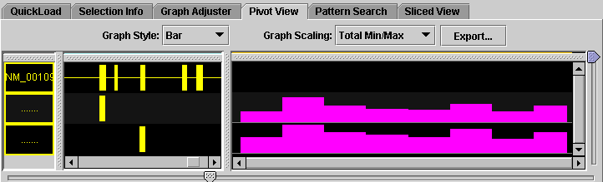

Graph scaling
The Scaling menu at the top of the Pivot View tab contains settings that control the vertical scaling and range of values displayed in the expression panel.
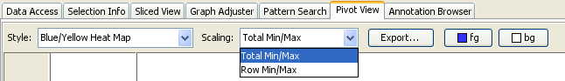
For example, if a row occupying 1 cm of vertical space has an expression value range of 0 to 1000, then a bar that is 0.10 cm high indicates an expression value of 10 expression units.
The Graph Scaling menu contains two options:
- Total Min/Max
- Row Min/Max
In Total Min/Max scaling, each row shows the same range of values. The top end of this range is set as the largest expression value across all the rows, while the bottom end of this range is set by the minimum value across all the rows.
In Row Min/Max scaling, scaling is done on a per-row basis. That is, the maximum and minimum values within a row determine the relationship between vertical space, or heat-map color, and expression values. Use Row Min/Max scaling when one row has unusually high or low values.
Newly displayed graphs will use the same scaling you used for the last graph.

Changing the graph style
Using the Style selector, it is possible to switch between different graph presentation styles. The options currently available include:
- Bar graph
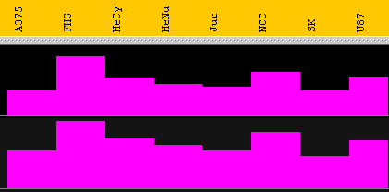
- Line Graph
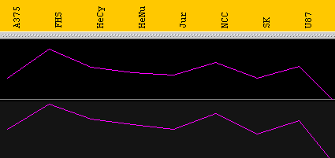
- Several heat maps
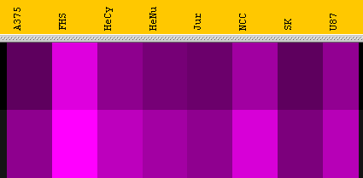
The type of graph that is most appropriate depends on the type of question being asked about the data. For example, when comparing trends, it is very useful to use the line graph display method because this method makes it easier to compare trends and patterns. The number of expression intervals being shown also can affect the graph display choice. Experiment with the different display types to find out which method works best for your specific purposes.
You may also change the foreground and background colors. Your choices will be remembered between sessions.

Hiding and sorting tracks
You can re-sort, or hide and show tracks in the pivot view similarly to the way you hide and show tracks in the main viewer. Click on a track label to select it. Click and drag to move it up or down. Right-click on the track label to see a menu with options such as Hide and Show.

Exporting data
Click the Export button to export data from the Pivot View.
You will have the option of saving the data in several file formats, such as tab-separated values, comma-separated values and hypertext (html). The rows will be saved to the file in the order they are shown in the viewer. If you have chosen to hide some of the rows from the view, the hidden rows will not be saved to the file.

Display tips
When viewing data from a large number is of expression experiments and map files, it helps to put the Pivot View panel into its own separate window on the desktop. This is easily done by choosing View menu > Open Tab in New Window.

Configuring data sources
By default, IGB is configured to load data from locations that contain data useful for the majority of Affymetrix's customers. Depending on the data sets you want to work with, you may find it convenient to configure IGB to use different data sources.
Use File menu > Preferences > Data Sources to open the data sources configuration panel.
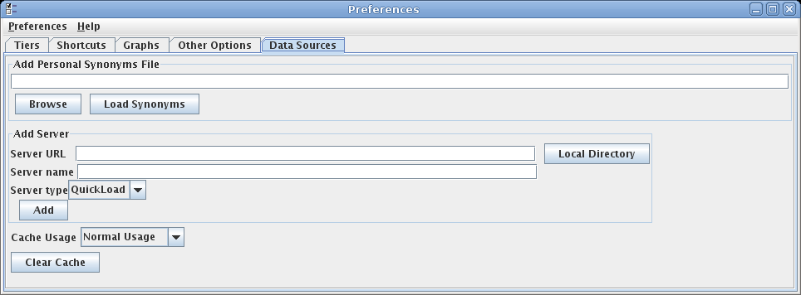

The configurations that can be made in this panel are described below.

Add Server
If there is no public QuickLoad server that hosts reference data for the organism you are studying, or if you don't want to load data over the internet, you can create a personal QuickLoad server on your own file system.
For information about setting up your own QuickLoad server, see the document titled How to create a QuickLoad Directory for use in IGB by going to http://genoviz.sourceforge.net/ and clicking on Other Documentation.
To add an additional data source:
- Choose File menu > Preferences > Data Sources.
- In the section labeled Add Server, enter the URL of the new server.
The URL may begin with the “file://”, “http://”, or “https://” protocols. (A URL for a directory on a Windows machine might look something like this: “file:///C:/Documents and Settings/QuickLoad/”.)
If this is a local QuickLoad server, you can use the Local Directory button to easily browse to this directory.)
- Choose a unique name for this new server.
- Choose the server type (DAS/1, DAS/2, or QuickLoad).
- Click Add.
Your new server will be available to use immediately. The default servers will still be available to you. You can freely switch between servers while IGB is running by using the controls in the Data Access tab panel.
If your server does not appear to be working, check the messages in the IGB console. You may have typed the URL incorrectly, or you may have forgotten to include some of the necessary configuration files.
Note that the QuickLoad system is designed for loading common reference data files. It is best to store your experimental data elsewhere.

Synonyms
Different data sources often refer to the same genome version or chromosome by different names. What NCBI refers to as human genome build 35 is known as hg17 at UCSC and can also be called ensembl1834 or H_sapiens_May_2004. Human chromosome 2 is identified sometimes as “chr2”, or “chrom 2” or simply “2”.
When IGB is able to recognize that two names refer to the same genome or chromosome, it will merge the data. Otherwise it will keep the two data sets distinct.
IGB uses a simple table of synonyms to store these associations. The default QuickLoad server used by IGB stores a default synonyms file. (This default file is at http://netaffxdas.affymetrix.com/quickload_data/synonyms.txt)
You can create your own set of synonyms that will extend this set if needed. If you have created your own QuickLoad server you can place your synonyms file on that server. You can also load an additional personal synonyms file from your computer file system.
To add a personal synonyms file:
- Choose File menu > Preferences > Data Sources.
- Use the Browse button to locate the file.
- Press Load Synonyms.
The format is a simple tab-delimited file where each row contains a list of synonyms separated by tabs. Every term in each row is considered synonymous. In addition, the synonyms are transitive, such that if “A” is a synonym of “B” and “B” is a synonym of “C”, then “A” is automatically considered a synonym of “C”.
Each time IGB restarts, synonyms will be loaded and merged from all the servers in use as well as from any personal synonyms file that you have specified.
When possible, try to standardize all of your files to use the same genome and chromosome names and only add synonyms when it becomes necessary.

The file cache
IGB caches data that you have loaded over the web in order to speed the loading process the next time you use it. Files loaded from your local file system will not be cached.
In current versions of IGB, we recommend that the cache settings should always be left in their default values. Options for turning off the cache were more useful earlier, before the caching system was mature and stable. You still may choose to clear your cache from time to time if you are running out of disk space.
To set preferences for caching or clear the cache.
- Choose File menu > Preferences > Data Sources.
- Click Clear Cache to clear all data from the cache and thus free disk space on your machine.
- By default Cache Usage should be set to Normal Usage.

Advanced Features

Clamping on a view
Normally, if you are zoomed in on a small region, it is very easy to scroll away from the target region and lose it. Clamp to view so you don’t lose what you’re examining as you browse the region using the zoom and scroll sliders.
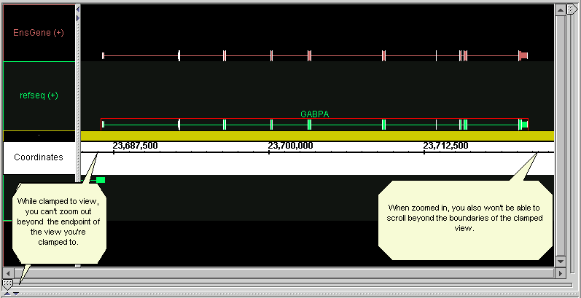
Clamping restricts the max and min coordinates of the view to the boundaries of the clamped view, so that you cannot zoom out or scroll beyond the range you’ve clamped to.
For example, if you want to examine the gene GABPA more closely, zoom in so the gene is the width of the window, then clamp to view. When you then zoom in further for a closer look, the scrollbar now will not scroll beyond the begin- and end-points of the gene.
Clamping also allows finer control when scrolling with the horizontal slider. To clamp to a view:
- Zoom in on a region of interest. If you’re zoomed all the way in or out, you can’t clamp.
- Choose View menu > Clamp to View
- To unclamp and zoom out to or scroll along the entire chromosome or file content, choose View menu > Unclamp.
You will automatically become unclamped if you switch the view to a different chromosome.

Shrink-wrapping
Shrink-wrapping provides a way to quickly zoom-in and lock the view on the annotated region of a chromosome.
When working with a file that contains annotations that only cover a small region of the sequence (for example, a set of annotations on a contig rather than on an entire chromosome), you can tell IGB to ignore the unannotated portion of the sequence range and zoom in on the annotated region.

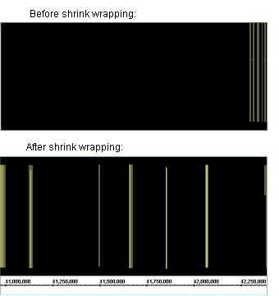

To turn shrink-wrapping on and off:
- Choose View menu > Toggle Shrink Wrapping.
Shrink-wrapping is essentially the same as clamping, but it automatically zooms to the region where there are some annotations.
Note that this will have no effect if any of your loaded annotation types already span the whole chromosome and have no empty space to eliminate.

Showing ORFs and stop codons
Use ORFs to find coding regions; the longer the ORF is, the more likely it is to contain live coding regions.
To show ORFs and stop codons:
- Make sure sequence residues are loaded.
- Select an item of interest in the main view and click the Sliced View tab.
- ORF settings are at the bottom of the panel.
- Adjust the slider to set the minimum length of ORFs you want to see, if necessary. By default, only ORFs 300 bps or longer are shown.
- Click the Analyze ORFs checkbox.
Three rows of ORFs in each direction appear, one for each start position. Stop codons are pink. ORFs of the specified length or longer appear as a green line:
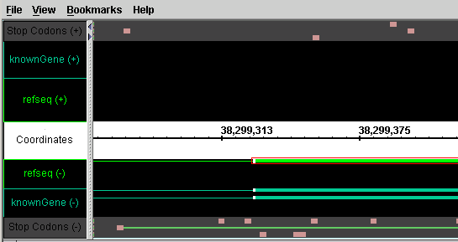
If too many green lines (ORFs) appear, increase the minimum ORF length (see step 4 above). If too few appear, decrease the length. If you do not see the result of each change, click the Analyze ORFs check box after you change the minimum length.
Note: You can change the colors that indicate ORFs and stop codons. See the Setting ORF and stop-codon colors section in Appendix 3 Preferences.

Clearing ORFs from the viewer
To clear ORF and stop codon markers from the viewer window:
- In the Sliced View tab, deselect the Analyze ORFs checkbox.

Identifying a translation frame
To identify a translation frame:
- Load sequence residues for the region you’re viewing. See Working with sequence residues on page 29.
- Slice the region. See Slicing on page 43.
- Adjust the slicing to a buffer of 0 bases to completely remove the introns.
- Analyze the ORFs as above.
- Look for the long, continuous green line that corresponds to your strung-together exon set. This is your translation frame.
- Currently, if a stop codon is located beyond the region being viewed, the green line is not visible; instead, the evidence of a translation frame is the lack of stop codons over a long sequence.

Interacting with other genome browsers
IGB can be used in conjunction with other applications, including web-based genome browsers. Web-based browsers have the advantages of being installed and maintained on a remote computer, and of giving you access to large amounts of remotely-stored data. IGB, and other stand-alone applications, have the advantages of more rapid navigation, ability to work when off-line, and secure access to private, local data. It is thus natural that users will make use of web-based applications along with IGB.
Web-based browsers include
- The UCSC Genome Browser
http://genome.ucsc.edu/
- GBrowse, from the Generic Model Organism Database project
http://www.gmod.org/
By using some of the standardized data file formats, such as FASTA for sequences, data files can be used in multiple applications.
IGB contains a menu item that will open the UCSC browser on the same region you are currently viewing. IGB also allows the configuration of selection-based links to other web-pages.
The reverse process is also possible. Web pages and other programs can control IGB through the use of hyperlinks. See the section Controlling IGB through a browser below.
To facilitate sharing of data files between IGB and the UCSC browser, IGB allows the use of track lines to specify some display properties. Since these track lines were defined by UCSC for use in their browser, not all properties are directly applicable in IGB, but those which are applicable are used. See http://genome.ucsc.edu/goldenPath/help/customTrack.html#TRACK

Track lines
For many text-based file formats, it is possible to configure the track name, color, and other properties through the use of track lines in the file header or comments. Track lines were invented for use in the UCSC genome browser, and the full format is described on their web site. IGB understands a subset of the full format, and will ignore property settings that it doesn't use.
In “.wig”, “.bed”, “.psl”, or “gff” format (version 1 or 2), the track line begins with “track”. In “.gff” format version 3, the track line must begin with “##track” to indicate it as a meta-directive, since track lines would otherwise disobey the GFF3 specification. (GFF3 has its own rich methods of specifying annotation styles. A future version of IGB may make use of this.)
Here is a sample track line that can be understood by IGB:
track name="Example" description="Example Description" visibility=full color=200,100,0 useScore=1 url=”http://sample.com/search?id=$$”
IGB understands these track line properties:
name | Short track name.
color | Track color, in the format r,g,b; where r, g, and b are numbers from 0 to 255.
description | Human-readable short description of the track.
visibility | In IGB, visibility=1 and visiblity=dense will cause the track to be displayed in "collapsed" mode. Otherwise, the displays in "expanded" mode.
url | A URL for linking to an outside website. Any instances of $$ in the URL will be replaced with the item id. See Links to public web sites on page 28
useScore | Whether to convert score data to color values. Valid values are useScore=0 and useScore=1 Files in “.bed” and “.gff” format can contain scores. See Using color to represent scores on page 42.
itemRgb | If itemRgb=On, use the data in column 9 of “.bed” files to determine the colors of individual annotations. Using this function requires additional memory.
graphType | Sets the graph type for graph files in the “wiggle” format. Can be graphType=bar or graphType=points. See Loading graph files on page 51.

Controlling IGB through a browser
You can save your bookmarks as an HTML file using Bookmarks > Manage Bookmarks > Export. If you open this file in a web browser and then click one of the links while IGB is running, then IGB will respond by changing the display to show the selected bookmark.
This will only work for the first instance of IGB that you are running. For example, if you are running two copies of IGB, then the browser will only affect the IGB window that you started first.
This same feature can be used by any web page or any program that is capable of sending an http request. The NetAffx Analysis Center on the Affymetrix website makes use of this feature.
The following is a simple description of how this works. The control commands include more options than shown here. Interested developers should contact the IGB development team.
If you open a bookmarks file in a text editor, you will find that the URL for each bookmark looks something like http://localhost:7085/UnibrowControl?seqid=chr21&version=Human_May_2004&start=44534188&end=44542686.
Here “localhost:7085” refers to port 7085 on your local machine. IGB, by default, “listens” to port 7085 on whatever machine it happens to be running. So if a Web browser sends a request to “localhost:7085,” IGB will hear it and respond. If the URL contains the right parameters (version, seqid, start, end, etc.) then IGB responds by showing the genomic “scene” described in the bookmark.
However, if you start up a new instance of IGB while one is already running, which we do not recommend, the new instance will listen to a different port – the first port above 7085 that happens to be vacant. This is why the bookmark links will only work for the first IGB instance and not for any others you start running after that.

Appendix 1 Java Web Start
We recommend a free utility from Sun Microsystems called Java Web Start to simplify installation and updating of IGB. When you launch IGB with this utility, it will download and install updates as they become available.
In many cases, the Java Runtime Environment, including Java Web Start, will already be installed on your machine by default. (In the past it was necessary to install Web Start separately, but now Java Web Start is a standard component of the Java Runtime Environment.) We strongly recommend you use a recent version of Web Start. Versions prior to 1.4.2 have problems that may sometimes interfere with launching IGB.
The following information is current at the time this document was written. What you will see on Sun’s web site is subject to change.
To use IGB with Java Web Start:
- Go to the Bioviz site for IGB: http://igb.bioviz.org/download.shtml.
If you see buttons labeled “Launch IGB” or something similar, then Java Web Start is already installed on your computer and you can start IGB by pressing one of those buttons.
If you do not see those buttons, continue with the rest of these instructions.
- Go directly to http://java.com
- Click the link “Download Now”.
- Click to download the application for the platform that you are using (Windows, Linux, etc.) You can use either the off-line or the regular version.
- Read and accept the license.
- Click Open to run the installation from the Sun server, or click Save to save the installer to your hard disk and run the installation from there. When you run the installer, you can accept the defaults.
- After installation is complete, close down and restart your browser.
- Return to the web page listed in the first step of this procedure and click the Launch IGB button.
- You may see a message asking if you would like to integrate IGB into your desktop environment.
If you wish to place a shortcut to IGB on your desktop and in your Start menu > Programs, click Yes. Otherwise, click No
IGB will launch.

Troubleshooting
If you have an old version of Java Web Start installed, an error may occur during start-up. Specifically, you may see the message “Missing signed entry in resource”. This should not occur if you have a recent version of Web Start. Open the Web Start Console or Java Control Panel to find out if you have version 1.4.2 or greater.
It is possible to have more than one version of Java Web Start installed. To be sure you know which version your web browser is using, please try to open this link in your browser:
http://java.sun.com/products/javawebstart/apps/player.jnlp
This should open a Web Start Console. If not, other methods to open that console are listed below.

Web Start Console
The Java Web Start Console allows you to manage all the Web Start applications you have installed on your computer. You may also be able to use it to create a desktop shortcut to allow you to launch IGB without visiting the Affymetrix web page.
Here is how the console looks in Java 1.6 (also known as Java 6) on Windows XP:
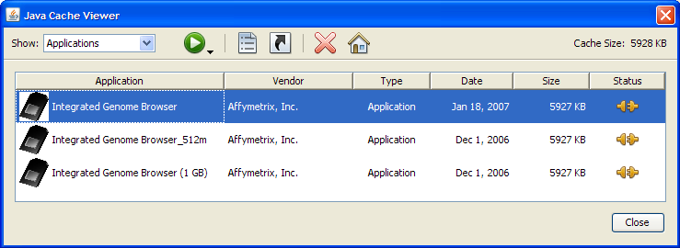
The three apparently different versions of IGB here are really the same program invoked with different memory allocations (256K, 512K, 1G). Choose one and click the house-shaped icon to create a desktop shortcut.
Various versions of Java and Web Start are invoked in different ways, depending on the version and operating system. Here are some of the ways you may be able launch the Web Start Console (choose one):
- BEST: Attempt to open this link in a browser:
http://java.sun.com/products/javawebstart/apps/player.jnlp
- Type “javaws -viewer” on a command line.
- Type “javaws” on a command line.
- Windows only: Start menu > Control Panel > Java
Opening the console from your web browser is the best choice because you might have more than one version of Web Start installed, and you need to find out which version you have linked to your browser.
To find out what version of Java and Java Web Start you have, click on General > About in the Java Control Panel.
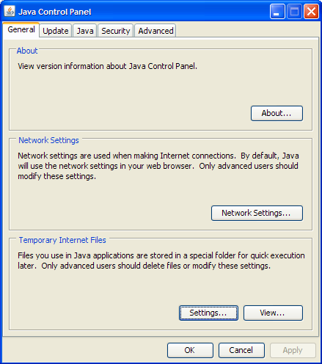

Appendix 2 Troubleshooting
If you have problems, first double-check the instructions for the specific task you’re working on, and then try solutions below that are specific to the area of IGB you’re working on, and finally try the general troubleshooting items at the end of this appendix.

Troubleshooting specific areas
Below are troubleshooting tips for some areas of IGB.

IGB seems slow or sluggish
Try the following:
- Delete any graphs you don't need.
- Hide any annotation tracks you don't need.
- Turn off slicing: See Slicing on page 43. Or make sure the Slicing tabbed panel is closed.
- Turn off graph thresholding if you are not actively using it.
- Turn off the gene id labels for all tracks.
- Turn off color-by-score in all annotation tracks.
- Experiment with different graph styles. Some styles draw faster than others.
- Launch IGB using a larger RAM memory allocation. See Typical installation using Java Web Start on page 9.

Keyboard shortcut command doesn’t work
You may have changed the shortcut key in the preferences. See Changing keyboard commands on page 100. Note that after changing the shortcut keys, you must close and re-launch IGB before the changes will take effect.
Alternatively some component other than the viewer window may have the “keyboard focus”. For example, your key strokes may be going to a text entry box or to another application. Click anywhere in the viewer to return the keyboard focus to it.
Keyboard shortcuts for scrolling and zooming may behave unexpectedly if the main view and the slice view are open in the same window. Try closing the slice view or moving it to a separate window.

Out of memory errors
If you are working with many graphs or sequences, you may run out of memory. These errors are most likely to occur during file parsing, but sometimes occur at other times. After you receive an out-of-memory error, most functions will become unusable and you will have to close and re-launch IGB.
You may need to launch IGB using a larger RAM memory allocation. See Typical installation using Java Web Start on page 9.
The ratio of memory used to memory available is shown in the status bar. See The status bar on page 13.

Tab or tab window is missing
If you have opened a tab in a new window, the tab window may have become hidden behind the main IGB window or another window. Each operating system has ways to help you locate and navigate between all open windows. On the Windows operating system, the combination of <Alt> and <Tab> keys often works to cycle through all open windows.

Tier labels don't line-up with tiers
From time to time, it is possible that the tier labels on the left-hand side of the main view will not line-up vertically with the tiers in the main view. If this happens, simply drag the border between the labels and the tiers to the left or right to resize the tier labels. They should snap back into alignment.

You can't see all the tiers
You may need to zoom-in vertically. See Zooming and scrolling vertically on page 17. Or you may have hidden some tiers manually. See Hiding and showing annotation tracks and Hiding and showing strands on page 39.

Reverse strand data appears above the axis
By default, IGB places reverse strand data below the coordinates axis and positive strand data above the axis. But if you have re-arranged any of the tiers, it is possible that reverse strand tiers will end-up above the axis. We may change IGB in future to make this situation impossible, but there is currently nothing preventing this from happening. If you want to put the reverse strands below the axis, you can move them there manually. See Re-ordering tracks top-to-bottom on page 37.

General troubleshooting
If anything you’re working on doesn’t work, try these common fixes, even if they don’t seem intuitive:
- Read the section in this document related to the task you are trying to accomplish.
- Load sequence residues for the chromosome or file you’re using.
- Make sure the genome version and chromosome in the viewer match those of whatever you’re trying to load or compare.
- Make sure you’ve selected the gene, not the exon, or vice-versa.
- Unclamp the view. See Clamping on a view on page 84.
- Try limiting the region in the viewer to less than 2 million bases when loading data from DAS servers.
- Make sure you’re connected to the network and the server or data source that you’re connecting to is up and running.
- Make sure you haven’t hidden any tracks or graphs.
- Open the console and look for error or warning messages. See The console on page 16.

Appendix 3 Preferences
The preferences window contains a set of tabbed panels allowing you to set preferences for various aspects of the program. Open the preferences window by choosing File menu > Preferences.
You can set preferences for the following:
- Appearance of the viewer, tracks, annotations, and graphs
- Locations of data sources
- Keyboard commands for tasks that you perform frequently
- Appearance and function of specific features.
Most preferences, such as settings for tier properties, apply immediately to data that is already loaded. while others, such as default settings for graphs, apply only to future activity. A small number of preference changes, such as changing keyboard shortcuts, require that you close and re-launch IGB.
Preference settings will remain in effect after you shut down and re-launch IGB. You can also export and import these preferences in an XML file.
There is some documentation for specific preferences included inside the program. To view the Help, choose File menu > Preferences, then choose an option from the Help menu in the Preferences dialog box The documentation inside the program may be more recent or more complete than this document.

Importing and exporting preferences
You can set each preference manually, or you can export and import preferences to an XML file to save them or share them among a group of people who are working on similar or related projects. This is also useful if you want to move IGB from one computer to another. Affymetrix may also provide preferences files to optimize IGB for analyzing certain data sets.
The XML file used for preference export and import, is not intended to be edited by hand and we provide no documentation on its format.
Note: In earlier versions of IGB, preferences were set by the user by editing a file called “igb_prefs.xml”. That file is being deprecated, though it is still used by some users for some advanced functions.

Exporting preference settings
You can export preference settings for use in different instances of IGB or to share with other IGB users.
- Choose File menu > Preferences.
- In the Preferences dialog box, choose Preferences menu > Export Preferences.
- Choose the destination and filename to which you want to save your preference settings.
- Click Save.

Importing preference settings
You can import preference settings that you, Affymetrix, or another IGB user has exported using the procedure above. You can freely exchange preferences between Windows, Linux, and Macintosh systems.
Preferences in the file that you import are merged with your existing preferences.
- WARNING: be sure you trust the provider of the file.
- Choose File menu > Preferences.
- In the Preferences dialog box, choose Preferences menu > Import Preferences.
- Choose the saved preferences file and click Open.

Customizing the default appearance of tracks
You can customize the way an annotation type looks in the track.
For most annotation types, IGB remembers your settings so that the annotation type appears the same way each time you load it.
IGB does not remember settings for graphs and for temporary data resulting from arithmetic manipulations, such as intersections and unions of tracks.
You can set default values for most of track parameters so that all annotation types display by default using settings that you specify.
Your settings apply to both forward and reverse strands.
Some of these settings can also be made in the menu that is shown when you right-click the name of the annotation type in the Tracks panel. The effect is the same.
To customize the appearance of a track:
- Load the annotation type(s) to customize.
- Select File menu > Preferences > Tiers. Or Right-click on the track name in the Tracks panel and choose Customize.
- In the Preferences dialog box, make selections for the annotation type(s) to customize, following instructions in the sections that follow.
  - If the name of the track is shown in italic font, the settings for that track will apply only to the current session. (This is the case for certain tracks that were created through manipulations such as intersections or unions of other tracks.)
  - If the track name is shown in normal font, the settings will be used for future sessions.
  - The track labeled “default” will apply to any new track loaded in the future for which you have not already made customizations.
- When finished setting preferences, close the Preferences dialog box.
The check box labeled Auto Refresh determines whether your changes are applied as you make them or only when you close the Preferences dialog box. If you have loaded a large number of annotations and the screen takes a long time to draw, you should turn Auto Refresh off.

Changing the name of the track
You can change the label of the data set as it appears in the tracks panel.
- Double-click the cell in the Display Name column. Your cursor will blink in the field.
- Type the name you want to use. Leave this field blank if you want to use the default name for this track.
- Press the <Enter> key.

Changing the color of annotations
- Click the color that is showing in the Color column.
- Click a color in the palette.
- Click OK.

Changing the background color of the track
- Click the color that is showing in the Background column.
- Click a color in the palette.
- Click OK.

Displaying both strands in one track or two
To display forward and reverse strands in two tracks (+) and (-):
- Click the checkbox in the 2 Tracks column to add a check mark.
To display both strands in one track (+/-):
- Click the checkbox in the 2 Tracks column to remove the check mark.
There is also a global setting to choose to display or not to display each strand by accessing the View > Strands menu.

Collapsing annotation rows into a single row
To always display the data set with all annotation rows collapsed into the minimum height for the data set:
- Click the checkbox in the Collapsed column to add a check mark.
To display all annotation rows in the data set:
- Click the checkbox in the Collapsed column to remove the check mark.

Setting the maximum number of annotation rows to display
You can specify the maximum number of annotation rows to display when the annotation track is not collapsed:
- Double-click the cell in the Max Depth column. Your cursor will blink in the field.
- Type the maximum number of annotation rows to display. A suggested value is 5. A value of 0 indicates that there is no limit on the number of rows to display.
- Press the <Enter> key.
To cancel a restricted maximum that you have set:
- Double-click the cell in the Max Depth column. Your cursor will blink in the field.
- Clear the value in the field or set it to zero.
- Press the <Enter> key.

Grouping exons
This preference determines whether to connect groups of exons into transcripts.
For data with no intron-exon structure, such as repeats or contigs, exons should not be connected. For items that do have intron-exon structure, not connecting the exons may affect whether labels are displayed.
Almost all of the data types used in IGB should leave this setting with the default value of true.
To display annotations in the data track with exons connected or not connected:
- Click the checkbox in the Connected column to add or remove a check mark.

Choosing annotation id labels
Each annotation track can display id labels next to the annotations. You can hide annotation id labels or show them using any property type that is available for that data set. For example, RefSeq annotations have both an “id” and a “gene name” property. You can choose to display either of these as an id label.
You can also choose to turn off labels. IGB will require less memory to run and will draw the display faster when labels are turned off.
To see what label options are available for the data set that you are customizing, click an annotation in the browser window, then click the Selection Info tab. Look at the properties listed in the property column. The most typical property names that will be useful for labels are “id” and “gene name”, but some annotation types have other properties that might make good labels.
- Double-click the cell in the Label field column. Your cursor will blink in the field.
- Type the name of the source for annotation labels:
  - “id” - Most data sets include “id” values.
  - To display no label, leave the field blank. This reduces the memory that IGB requires to run, and speeds drawing of the display.
  - Other property names, if they appear in the Selection Info tab. Enter them as they appear in Selection Info. For example, “gene name” is a possible choice for RefSeq transcripts and “source” is a possible choice for data from GFF files.
- Press the <Enter> key.
Note: Exons and whole transcripts usually have different sets of properties. If you have chosen to display exons without connection lines, labels will only be visible if the individual exons have the property that you specify.

Changing keyboard commands
You can set keyboard shortcuts for many menu and other functions. The list of functions for which you can set keyboard shortcuts appears in the Preferences described in the following procedure.
To set or change keyboard commands:
- Choose File menu > Preferences.
- Click the Shortcuts tab.
- Click the action for which you want to establish a keyboard command.
- Click in the field labeled Type a shortcut for <the command you selected>.
- Press the keys that you want to assign to the function you selected, for example, Ctrl-Shift-X. You cannot use keystrokes that your operating system uses, such as Ctrl-Alt-Delete on Windows. If you make a mistake, simply type the keystroke(s) that you want, and the new keystrokes will replace the erroneous keystrokes that you entered.
- Click the Apply this shortcut button.
- Your new keyboard shortcut(s) will be available after you close and re-launch IGB.

To clear keyboard commands:
- Click the shortcut from which you want to remove the command.
- Click Clear this shortcut.
- Your changes take affect after you close and then re-launch IGB.
Some action names may appear that don't seem to have any function. This could happen if you have installed and then uninstalled some plugins, or if some actions have been renamed.
Keyboard Shortcut keys for zooming and scrolling the view will apply both in the main view and in the sliced view. The effect can be confusing when both views are visible in the same window at the same time. Opening the sliced view in a separate window can give more predictable shortcut behavior.

Setting graph preferences
You can set preferences for the way graphs display in the viewer window.
Changes affect graphs that you load after you complete the procedure below.
To change default characteristics of graphs:
- Choose File menu > Preferences.
- Click the Graphs tab.
- Choose options for the following:
  - Whether graphs float or are attached to tracks.
  - Whether the complete URL should be used as the file label (typically false).
  - Whether to create graphs from data in “.egr” files (typically true).
When importing .egr files, the genomic locations will be shown as rectangular blocks. If you de-select this box, then score data can be seen only by selecting these blocks and looking in the Pivot View. Check this check box to additionally display the score data in graph format.
  - The default colors to use for heatmap graphs.
- If you are finished setting preferences, close the Preferences dialog box.

Setting color and axis display preferences
Miscellaneous options are grouped together in the Preferences tab labeled Other Options. These include color and display properties for the axis, edge matching, ORF analysis, and other things.
To access these options:
- Choose File menu > Preferences.
- Click the Other Options tab.

Setting axis display – option descriptions
You can set the following preferences for the appearance of the coordinate axis track that runs horizontally across the center of the viewer window:
- Background
- Foreground
- Number format
  - Full displays like: 20000kb
  - Comma displays like: 20,000,000
  - Abbrev displays like: 20M

Setting ORF and stop-codon colors
By default, ORFs (Open Reading Frames) are indicated in the sliced view with green and stop codons are indicated in pink
- To change the stop codon color, click the button beside Stop Codon.
- To change the ORF color, click the button beside Dynamic ORF.
- Click a color in the palette.
- Click OK.

Setting other options
Other options you can set:
Option | Description
Ask before exiting | Whether IGB asks you to confirm that you really want to exit when you choose File menu > Exit or click the [X] in the title bar.
Keep hairline in view | Whether to automatically prevent the hairline from moving outside the view as you scroll. (Recommended true).
Browser Command | Command used to launch a browser (e.g., “/usr/bin/firefox').

- Check the check boxes beside the options you want to enable.

License
Source code for IGB is released under the Common Public License, v1.0, an OSI approved open source license. IGB uses other open source software packages that are not distributed with the IGB source code release, including Xerces and Jetspeed from Apache, and Jetty from Mortbay Consulting, which are covered by their own open source licenses. IGB is Copyright (c) 2000-2007 Affymetrix, Inc. Research and development of IGB is supported in part by NIH grant R01HG003040.

Common Public License Version 1.0

THE ACCOMPANYING PROGRAM IS PROVIDED UNDER THE TERMS OF THIS COMMON PUBLIC LICENSE ("AGREEMENT"). ANY USE, REPRODUCTION OR DISTRIBUTION OF THE PROGRAM CONSTITUTES RECIPIENT'S ACCEPTANCE OF THIS AGREEMENT.
1. DEFINITIONS
"Contribution" means:
a) in the case of the initial Contributor, the initial code and documentation distributed under this Agreement, and
b) in the case of each subsequent Contributor:
i) changes to the Program, and
ii) additions to the Program;
where such changes and/or additions to the Program originate from and are distributed by that particular Contributor. A Contribution 'originates' from a Contributor if it was added to the Program by such Contributor itself or anyone acting on such Contributor's behalf. Contributions do not include additions to the Program which: (i) are separate modules of software distributed in conjunction with the Program under their own license agreement, and (ii) are not derivative works of the Program.
"Contributor" means any person or entity that distributes the Program.
"Licensed Patents " mean patent claims licensable by a Contributor which are necessarily infringed by the use or sale of its Contribution alone or when combined with the Program.
"Program" means the Contributions distributed in accordance with this Agreement.
"Recipient" means anyone who receives the Program under this Agreement, including all Contributors.
2. GRANT OF RIGHTS
a) Subject to the terms of this Agreement, each Contributor hereby grants Recipient a non-exclusive, worldwide, royalty-free copyright license to reproduce, prepare derivative works of, publicly display, publicly perform, distribute and sublicense the Contribution of such Contributor, if any, and such derivative works, in source code and object code form.
b) Subject to the terms of this Agreement, each Contributor hereby grants Recipient a non-exclusive, worldwide, royalty-free patent license under Licensed Patents to make, use, sell, offer to sell, import and otherwise transfer the Contribution of such Contributor, if any, in source code and object code form. This patent license shall apply to the combination of the Contribution and the Program if, at the time the Contribution is added by the Contributor, such addition of the Contribution causes such combination to be covered by the Licensed Patents. The patent license shall not apply to any other combinations which include the Contribution. No hardware per se is licensed hereunder.
c) Recipient understands that although each Contributor grants the licenses to its Contributions set forth herein, no assurances are provided by any Contributor that the Program does not infringe the patent or other intellectual property rights of any other entity. Each Contributor disclaims any liability to Recipient for claims brought by any other entity based on infringement of intellectual property rights or otherwise. As a condition to exercising the rights and licenses granted hereunder, each Recipient hereby assumes sole responsibility to secure any other intellectual property rights needed, if any. For example, if a third party patent license is required to allow Recipient to distribute the Program, it is Recipient's responsibility to acquire that license before distributing the Program.
d) Each Contributor represents that to its knowledge it has sufficient copyright rights in its Contribution, if any, to grant the copyright license set forth in this Agreement.
3. REQUIREMENTS
A Contributor may choose to distribute the Program in object code form under its own license agreement, provided that:
a) it complies with the terms and conditions of this Agreement; and
b) its license agreement:
i) effectively disclaims on behalf of all Contributors all warranties and conditions, express and implied, including warranties or conditions of title and non-infringement, and implied warranties or conditions of merchantability and fitness for a particular purpose;
ii) effectively excludes on behalf of all Contributors all liability for damages, including direct, indirect, special, incidental and consequential damages, such as lost profits;
iii) states that any provisions which differ from this Agreement are offered by that Contributor alone and not by any other party; and
iv) states that source code for the Program is available from such Contributor, and informs licensees how to obtain it in a reasonable manner on or through a medium customarily used for software exchange.
When the Program is made available in source code form:
a) it must be made available under this Agreement; and
b) a copy of this Agreement must be included with each copy of the Program.
Contributors may not remove or alter any copyright notices contained within the Program.
Each Contributor must identify itself as the originator of its Contribution, if any, in a manner that reasonably allows subsequent Recipients to identify the originator of the Contribution.
4. COMMERCIAL DISTRIBUTION
Commercial distributors of software may accept certain responsibilities with respect to end users, business partners and the like. While this license is intended to facilitate the commercial use of the Program, the Contributor who includes the Program in a commercial product offering should do so in a manner which does not create potential liability for other Contributors. Therefore, if a Contributor includes the Program in a commercial product offering, such Contributor ("Commercial Contributor") hereby agrees to defend and indemnify every other Contributor ("Indemnified Contributor") against any losses, damages and costs (collectively "Losses") arising from claims, lawsuits and other legal actions brought by a third party against the Indemnified Contributor to the extent caused by the acts or omissions of such Commercial Contributor in connection with its distribution of the Program in a commercial product offering. The obligations in this section do not apply to any claims or Losses relating to any actual or alleged intellectual property infringement. In order to qualify, an Indemnified Contributor must: a) promptly notify the Commercial Contributor in writing of such claim, and b) allow the Commercial Contributor to control, and cooperate with the Commercial Contributor in, the defense and any related settlement negotiations. The Indemnified Contributor may participate in any such claim at its own expense.
For example, a Contributor might include the Program in a commercial product offering, Product X. That Contributor is then a Commercial Contributor. If that Commercial Contributor then makes performance claims, or offers warranties related to Product X, those performance claims and warranties are such Commercial Contributor's responsibility alone. Under this section, the Commercial Contributor would have to defend claims against the other Contributors related to those performance claims and warranties, and if a court requires any other Contributor to pay any damages as a result, the Commercial Contributor must pay those damages.
5. NO WARRANTY
EXCEPT AS EXPRESSLY SET FORTH IN THIS AGREEMENT, THE PROGRAM IS PROVIDED ON AN "AS IS" BASIS, WITHOUT WARRANTIES OR CONDITIONS OF ANY KIND, EITHER EXPRESS OR IMPLIED INCLUDING, WITHOUT LIMITATION, ANY WARRANTIES OR CONDITIONS OF TITLE, NON-INFRINGEMENT, MERCHANTABILITY OR FITNESS FOR A PARTICULAR PURPOSE. Each Recipient is solely responsible for determining the appropriateness of using and distributing the Program and assumes all risks associated with its exercise of rights under this Agreement, including but not limited to the risks and costs of program errors, compliance with applicable laws, damage to or loss of data, programs or equipment, and unavailability or interruption of operations.
6. DISCLAIMER OF LIABILITY
EXCEPT AS EXPRESSLY SET FORTH IN THIS AGREEMENT, NEITHER RECIPIENT NOR ANY CONTRIBUTORS SHALL HAVE ANY LIABILITY FOR ANY DIRECT, INDIRECT, INCIDENTAL, SPECIAL, EXEMPLARY, OR CONSEQUENTIAL DAMAGES (INCLUDING WITHOUT LIMITATION LOST PROFITS), HOWEVER CAUSED AND ON ANY THEORY OF LIABILITY, WHETHER IN CONTRACT, STRICT LIABILITY, OR TORT (INCLUDING NEGLIGENCE OR OTHERWISE) ARISING IN ANY WAY OUT OF THE USE OR DISTRIBUTION OF THE PROGRAM OR THE EXERCISE OF ANY RIGHTS GRANTED HEREUNDER, EVEN IF ADVISED OF THE POSSIBILITY OF SUCH DAMAGES.
7. GENERAL
If any provision of this Agreement is invalid or unenforceable under applicable law, it shall not affect the validity or enforceability of the remainder of the terms of this Agreement, and without further action by the parties hereto, such provision shall be reformed to the minimum extent necessary to make such provision valid and enforceable.
If Recipient institutes patent litigation against a Contributor with respect to a patent applicable to software (including a cross-claim or counterclaim in a lawsuit), then any patent licenses granted by that Contributor to such Recipient under this Agreement shall terminate as of the date such litigation is filed. In addition, if Recipient institutes patent litigation against any entity (including a cross-claim or counterclaim in a lawsuit) alleging that the Program itself (excluding combinations of the Program with other software or hardware) infringes such Recipient's patent(s), then such Recipient's rights granted under Section 2(b) shall terminate as of the date such litigation is filed.
All Recipient's rights under this Agreement shall terminate if it fails to comply with any of the material terms or conditions of this Agreement and does not cure such failure in a reasonable period of time after becoming aware of such noncompliance. If all Recipient's rights under this Agreement terminate, Recipient agrees to cease use and distribution of the Program as soon as reasonably practicable. However, Recipient's obligations under this Agreement and any licenses granted by Recipient relating to the Program shall continue and survive.
Everyone is permitted to copy and distribute copies of this Agreement, but in order to avoid inconsistency the Agreement is copyrighted and may only be modified in the following manner. The Agreement Steward reserves the right to publish new versions (including revisions) of this Agreement from time to time. No one other than the Agreement Steward has the right to modify this Agreement. IBM is the initial Agreement Steward. IBM may assign the responsibility to serve as the Agreement Steward to a suitable separate entity. Each new version of the Agreement will be given a distinguishing version number. The Program (including Contributions) may always be distributed subject to the version of the Agreement under which it was received. In addition, after a new version of the Agreement is published, Contributor may elect to distribute the Program (including its Contributions) under the new version. Except as expressly stated in Sections 2(a) and 2(b) above, Recipient receives no rights or licenses to the intellectual property of any Contributor under this Agreement, whether expressly, by implication, estoppel or otherwise. All rights in the Program not expressly granted under this Agreement are reserved.
This Agreement is governed by the laws of the State of New York and the intellectual property laws of the United States of America. No party to this Agreement will bring a legal action under this Agreement more than one year after the cause of action arose. Each party waives its rights to a jury trial in any resulting litigation.


Index
Alternate splicing 48, 49
Analyze ORFs checkbox 92
Annotation tracks 14, 42
Changing background color of 104
Changing color of 44, 104
Changing names of 44, 104
Collapsing 45, 104
Customizing 42
Deleting 44
Expanding 45
Hiding 44
Id labels 46, 105
Max expand 46
Reordering 42
Saving 70
Selecting 43
Setting maximum rows 45, 105
Showing hidden 44
Summarizing 50
Annotations 12
Cache 89
Comparing 48, 50, 53
Density of coverage 51
Finding 17, 37
Id labels 42, 47, 105
Scores 47
Selecting 20
Sources 23, 25, 26, 87
Ask before exiting 110
Bar graphs 58
Blat mapping 77
Bookmarks
Creating 79
Editing 79
Exporting 80
Importing 80
Using 79
Cache 28, 89
Chromosome 12
Clamp to view 20, 90, 100
Clear All 20
CNAT 23, 55
Combine Selected Tracks 53
Console 17
Contigs 15, 25, 91
Coordinates track 34, 35, 38, 39, 41
In sliced view 49
Setting preferences 108
Copy and paste
Sequence 36, 78
Table cells 80
Cytobands 15, 24
DAS 25
DAS/1 25
Adding and removing servers 106
DAS/2 26
Visible range 27
Whole sequence 27
Data Access tab 24, 26
Data sources
Configuring 87, 106
DAS 25
Files 28
QuickLoad 23
Deletions 49
Density of annotations 51
Desktop shortcut 97
Documentation 8
Dot graphs 58
Edge matching 48
Adjust match fuzziness 48
Setting colors 48, 109
Ensemble 31
EnsGene 31
ESTs 18, 51, 55, 59, 70
ExACT 23, 55
Exons
Connecting or not connecting 105
File formats 30
Annotation formats 30
Bar 56
Bed 31
Bnib 33, 35
Chp 56
Compressed 30
Egr 56, 81
Gff 30
GFF3 30
Gr 56
Graph formats 56
Gtf 30
Psl 31
Sequence formats 35
Sgr 56
Wig 56
File formats, 56
Files
Compressed 30
Extension 30
Graph 71
Loading 29
Merging 29
Finding
Annotations 37
Sequences 40
GCOS 23, 55
Genome 12, 29, 100
Genome
And QuickLoad 24
Definition 12
In title bar 14
Synonyms 88
GenoViz 8
Get more info 32, 77
Graph styles 58
In pivot view 85
Graph tracks 57, 63
Graphs 13, 55, 99
Adjusting 57
Arithmetic functions 65
Attached 63
Color 60
Comparing 65
Deleting 61, 63
Details 70
Duplicating 63
Floating 57, 63
Graph handle 20, 57, 63
Height 58
In sliced view 49
Interval graphs 55
Labeling 62
Non-linear scale 63
Position graphs 55
Saving 70
Scale 60, 70
Selecting 20, 57
Setting preferences 108
Styles 58
Thresholds 66, 70, 79
Visible bounds 61, 70
Y-axis 62
Hairline 16
Heat map graphs 59
IGB
Current version 9
Desktop shortcut 97
Installing IGB 9
Launching 10
Main window 13
Searching in 37
Insertions 49
Installing IGB 9
Java 9
Installation 9
Version 9
Web Start Console 97
Javaws 97
Keyboard commands 22, 49, 99, 107
Launching IGB 10
Multiple instances 10
Line graphs 58
Load DAS Features 25
Macintosh 9
Make annotation coverage track 51
Make annotation depth track 51
Max gap
Thresholds 68
Merge with currently loaded data 29
Min run
Thresholds 69
Min/Max/Avg graphs 58
Multiple instances of IGB 10
Navigating
To annotation 37
To coordinate 19
Navigation 17
NCBI 31
NetAffx 73
Offsets
Thresholds 69
Ontology 28
Open File 29
ORFs
Setting colors 109
Out of memory errors 99
PolyA site 76
PolyA stack 76
Polyadenylation sites 76
Preferences 102
Exporting 102
Importing 103
Printing 80
Print to EPS File 80
Probe sets
Files 73
Visualizing 72
Query sequence
In psl files 31
QuickLoad 23, 24, 33
Advanced features 87
Range box 19
RefSeq annotations 23, 24, 31
Scroll bars 16
Scrolling 16, 18
Auto-scroll 18
Restricting 90
Select parent 20
Selecting
Annotations 20, 100
Graphs 20, 57
Sequence residues 21
Sequence
Copy and paste 78
Selecting 21
Sequence residues 25, 33-35, 100
Sequences 13
Cache 28
Copy and paste 36
Finding 38
Selecting 20
Wildcard searches 40
Shortcuts 107
Show DAS query genometry 110
Shrink-wrapping 91
Slice Buffer 50
Slice By Selection 49
Slicing 48, 70, 92, 99
Source code 8, 10
Stairstep graphs 59
Status bar 14
Strands 44
Displaying both or one 104
Forward strand 44
Mixed strand 44
Reverse strand 44
Summarizing
Annotation tracks 50
System requirements 9
Tabbed panels 16, 21, 100
Tabbed panels
Annotation Browser 37
Data Access 17, 33, 34
Graph Adjuster 57
Pattern Search 37-41
Selection Info 31, 70
Sliced view 49, 77
Target sequence
In psl files 31
Thresholding 67, 70, 99
Tiling arrays 23, 55, 69
Title bar 13
Toggle Shrink Wrapping 91
Track handles 15, 42
Track lines 31, 93, 94
Tracks 14
Combining 53
Graph threshold 69
Zooming vertically 18
Tracks panel
Resizing 42
Translation frames 92
UCSC 31
DAS server 26
UCSC genome browser 78, 93
Unsequenced regions 35
Untranslated regions 15
UseScore 47
UTRs 15
Viewer 14
Zoom sliders 16
Zooming 18
Horizontal zoom slider 18
In sliced view 49
Vertical zoom slider 19

