**­Lorcan Nolan – Catering for Kings ERD – Lab Group DT228/3 C**

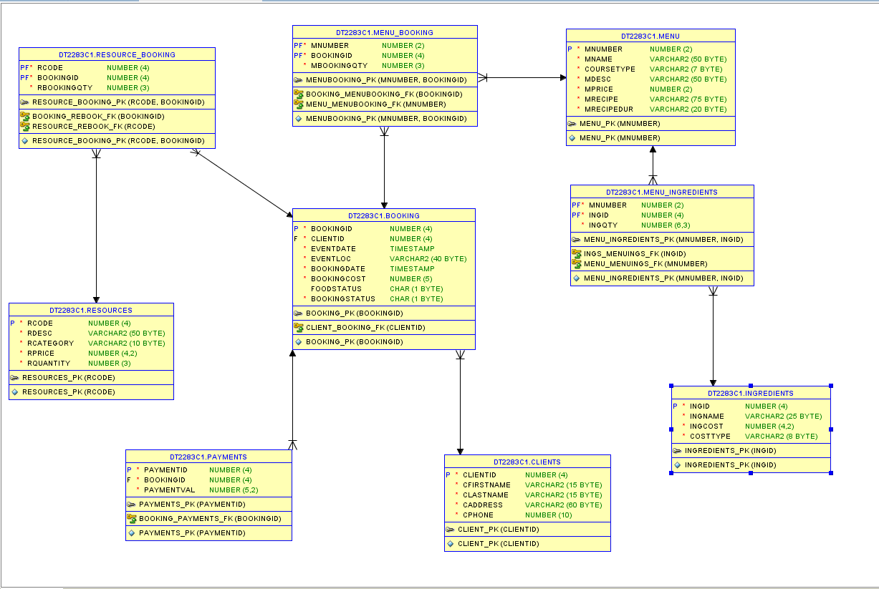

**Ingredients:**

Ingredients table is a straight forward table containing a primary key (IngID), a column for the name of each ingredient, a column for the cost of each ingredient and a column for how the cost of each ingredient is measured, i.e. per item or per kilo. The idea behind this was so that it was possible to calculate profits made from producing each item on the menu and then selling them on.

**Menu:**

Again, this is another relatively straight forward table whose column values can be seen in the ERD above. All the columns within this table were specified within the case study to be included.

**Menu_ Ingredients:**

This table has a many to one relationship with both the menu and the ingredients tables making this a weak entity. Its primary key is made up of two foreign keys, IngID from the ingredients table and mNumber from the menu table. The reason for being a weak entity is that a menu item can have many ingredients and an ingredient can also be in many menu items. Another value in this table is IngQty which specifies the amount of an ingredient needed within a menu item. If a value here is 0.5 it could either mean 500g or half an item depending on its cost type in the ingredients table.

**Clients:**

Clients table contains information on every client who made a booking with the catering company.

**Booking:**

The booking table contains a primary key (bookingID) and a foreign key from the clients table (clientID) as a booking can only have one client, however a client can make more than one booking. Contained within the booking table is the date the event is scheduled for, the location of said event, the date in which the booking was made, the total cost of the booking, the status of the food (whether the food has been produced or not) and the status of the booking.

**Menu_Booking:**

Similar to the menu_ingredients table, menu_booking has a many to one relationship with both the menu and booking tables. This makes it a weak entity table as its primary key is made up of two foreign keys, one from the menu table (mNumber) and one from the booking table (bookingID). Another column in this table is mBookingQty which used to track how many menu items was ordered in each booking.

**Resources:**

This table contains all the necessary information regarding the resources that this catering company has to offer to its clients.

**Resource_Booking:**

This table is virtually identical to the menu_booking table however it contains an rCode value instead of a bookingID value.

**Payments:**

The payments table was made because due to the sum of money a booking will cost, most people cannot pay it upfront. Instead people will pay it in instalments so this table keeps track of which bookings have been paid in full and which ones haven’t. Contains a foreign key from the booking table as one booking can have many payments.