**Lorcan Nolan**

**C15513717**

**Web Development**

**Assignment**

**DT228**

**Year 2**

**BSc Computer Science**

**PHP Pages Used Description & Screenshots:**

connectionAssignment.php

This page sets up the initial connection to my database that I use called “book”. If it fails to connect to the database an error message is displayed to the user.

loginAssignment.php

This is the first page the user will see when using this library website. It is simple to understand and gives the option to an existing user to login using their username and password that they have already registered. This username and password will be checked against existing usernames and passwords in the database to ensure the details are correct. If the user is successful in their login their username is sent to the sessionAssignment.php page. If the username and password is incorrect an error message will be displayed to the user to register their details. If a new user wishes to register as a member, they must press the register button to input all their details.

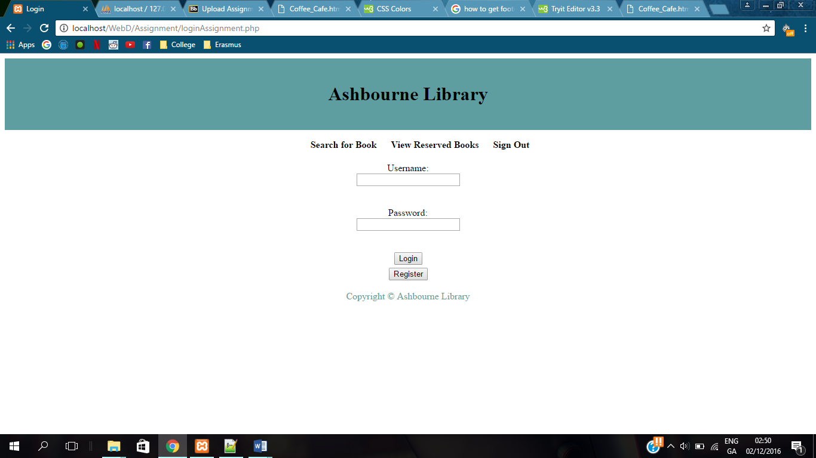

sessionAssignment.php

If the login is successful, the username is sent to sessionAssignment.php and set to a variable called $login_session to be used throughout the website. For example, once the user is logged in correctly their username will be inserted at the top of the page where it says “logged in as: *username*”.

register.php

For new users who want to enter the site they must register their details first. The register.php page is straight forward. The user must enter their details into a form and cannot leave any option blank. Once the user submits their details, their info will be sent to registering.php which they will not be able to see as they will be sent back to loginAssignment.php.

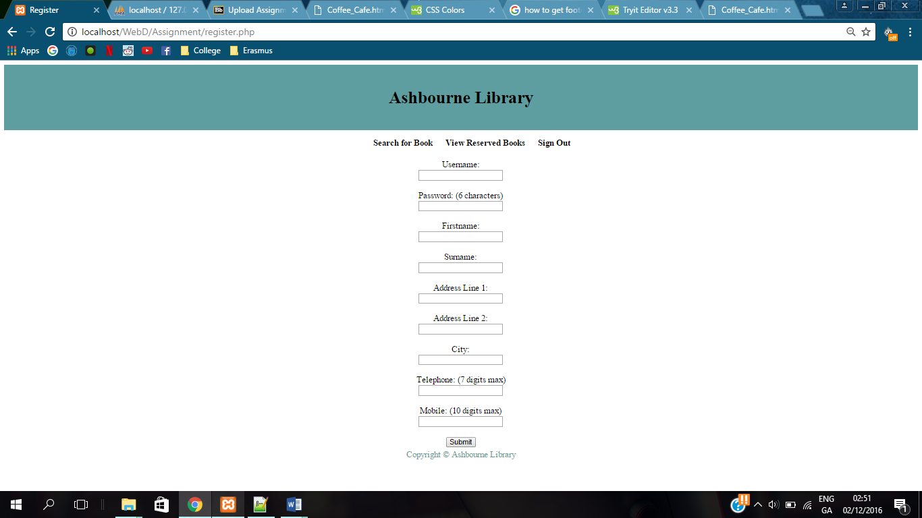

registering.php

As stated above, the users details are sent from register.php to registering.php where the info is inserted into the database to create a new user in the users table. There is no visual representation of this page to the users as they are sent back to loginAssignment.php.

search.php

As there is a menu bar at the top of the screen below the header for the user to change pages, I decided not to include a menu page as I thought it would be redundant. So, I automatically set the search.php page as the first page the user will see after logging in. Here the user is able to search for a book in as many ways possible. They can have no search specifications, search by category only, book only, author only, category and book, category and author, book and author, or by all three. The text input for book and author can also function as a partial search for the user. The info entered is then sent to searching.php where the results of the search is displayed to the user.

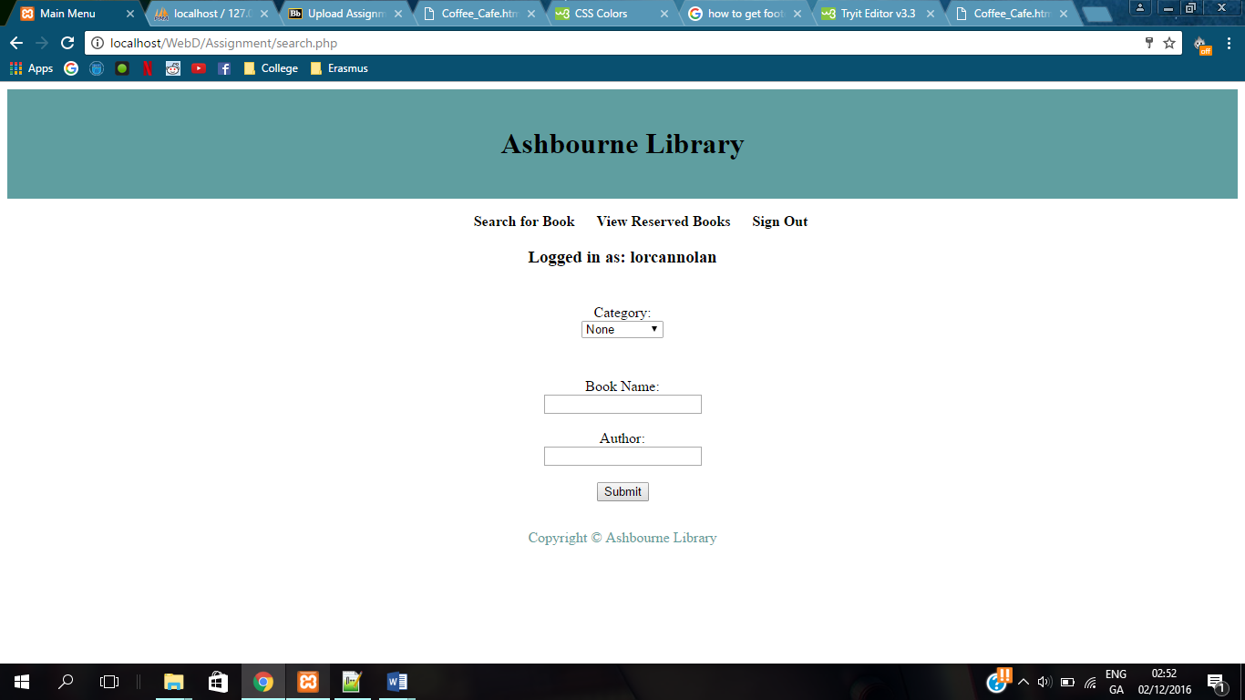

searching.php

Depending on what search specifications are entered by the user, the searching.php page will run an sql query on the “book” database to comply with the search specifications. The results are displayed in the form of a table. A limit of 5 results per page is set and if there is more than 5 results, they are spread over multiple pages. The user is able to press a button to go to the next, last, previous, or first page of results depending on what page they are on and how many results there are. There is a link below the table to search for another book which will take the user back to search.php page, this is the same as clicking the link for search for a book in the menu bar. The below picture displaying results had no search specifications, therefore displaying all books in the database.  
The user also has the choice of reserving a book if it is not already reserved by them or another user. If they can reserve it, a reserve button will appear in the reserve column of the table. If the user decides to reserve a book, the ISBN number of the book is sent makeReservation.php.

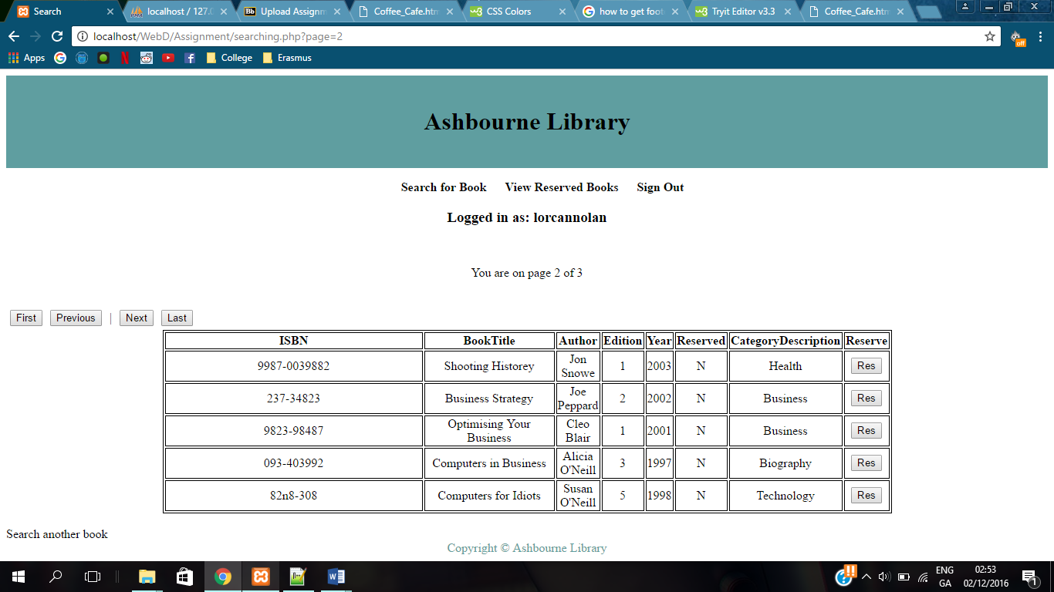

makeReservation.php

The makeReservation.php page takes the ISBN number of the book just reserved and runs two sql queries. The first is changing the value of Reserved in the books table to a Y so that no other user can reserve that book. Then, a second sql query will insert the ISBN number of the book just reserved, the username of the user who reserved the book using $login_session, and the current date and time to the reservations table in the database. This table records all reservations made by users. This page also has no visual display to the user, however it sends the user to the viewReserve.php page.

viewReserve.php

Here, the user will be able to see all the books that they have currently reserved. If the user has reserved a book in which they have also reserved in the past, that book will display the amount of times that the user has reserved it. I understand this is a slight error however, I was unaware of how to fix it. The user also has a choice of deleting a reservation in viewReserve.php. A delete button is displayed in the delete column of the table and if the user decides to delete that reservation, the ISBN number of that book is sent to makeDeletion.php.

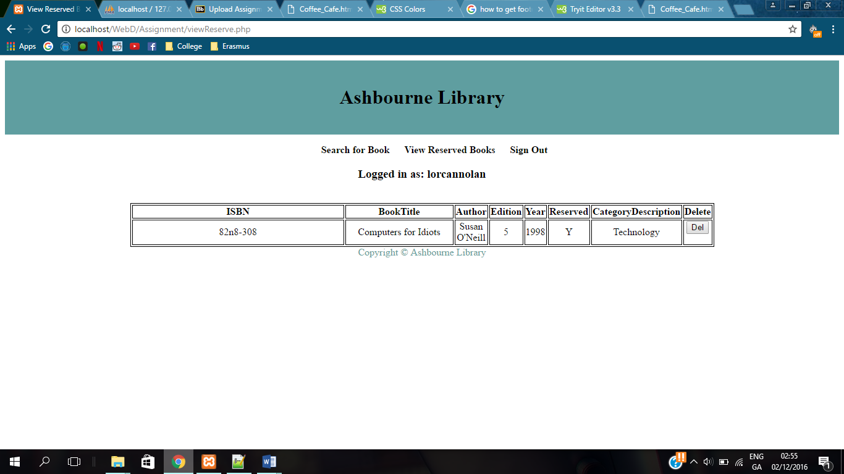

makeDeletion.php

The makeDeletion.php page takes the ISBN number of the book whose reservation will be deleted. It runs an sql query to change the value of Reserved in the books table to N so that other users can reserve that book. The user will be brought back to viewReserve.php where an empty table will be shown if they have no reservations, or a table of their reservations will be displayed. The below picture shows the result after deleting the reservation in the above picture.

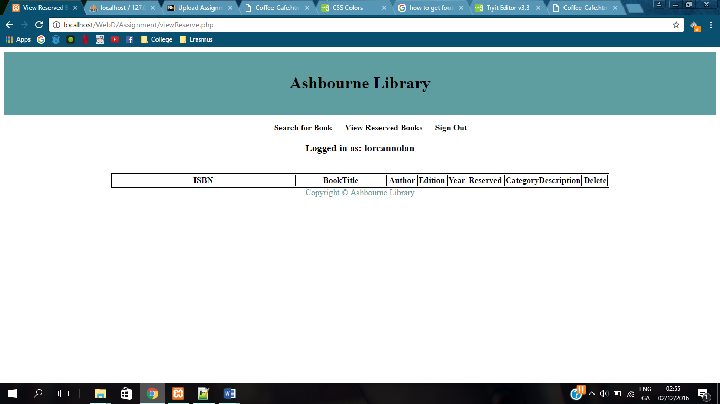

logoutAssignment.php

Once logged in the user can logout at any time by pressing the logout button in the menu bar. This stops the session and returns the user to loginAssignment.php, i.e. the login page.

header.html

This is a header file containing a header and a menu bar to be used throughout the website and it also contains some basic css to make the web pages neater and easier for the user.

footer.html

This is a footer file which contains a footer to be used throughout the website.

**Design Layout of Pages:**

Ashbourne Library Copyright

Footer

Login Page Content

Username:

Password:



Login

Register

Navigation/Menu bar

Ashbourne Library

Search for Book View Reserved Books Sign Out

Ashbourne Library Copyright

Footer

Register Page Content

Navigation/Menu bar

Ashbourne Library

Search for Book View Reserved Books Sign Out

Username:

Password:

Firstname:

Surname:

Address Line 2:

Address Line 1:

City:

Telephone:

Mobile:

Submit

Ashbourne Library Copyright

Footer

Search Page Content

Category:

Book:



Navigation/Menu bar

Ashbourne Library

Search for Book View Reserved Books Sign Out

**Logged in as:** *Username*

Author:

Submit

Ashbourne Library Copyright

Footer

Searching Page Content

**Logged in as:** *Username*

Page x of y

|  |  |  |  |  |  |  |  |
| --- | --- | --- | --- | --- | --- | --- | --- |
| **ISBN** | **BookTitle** | **Author** | **Edition** | **Year** | **Reserved** | **Desc** | **Res** |
| Info | info | Info | Info | Info | Info | Info |  |
|  |  |  |  |  |  |  |  |
|  |  |  |  |  |  |  |  |
|  |  |  |  |  |  |  |  |
|  |  |  |  |  |  |  |  |

Navigation/Menu bar

Ashbourne Library

Res

Last

Next

Previous

First

Search for Book View Reserved Books Sign Out

Ashbourne Library Copyright

Footer

View Reserved Books Page Content

|  |  |  |  |  |  |  |  |
| --- | --- | --- | --- | --- | --- | --- | --- |
| **ISBN** | **BookTitle** | **Author** | **Edition** | **Year** | **Reserved** | **Desc** | **Res** |
| Info | info | Info | Info | Info | Info | Info |  |

Navigation/Menu bar

Ashbourne Library

Search for Book View Reserved Books Sign Out

**Logged in as:** *Username*

Del