System modeling:
1) Left:

K = 1.678, Tau = 0.0985

Right:

K = 1.67, Tau = 0.1071

2) G(z) = K*( 1 – exp(-T/Tau) ) / ( z – exp(-T/Tau) )

3)
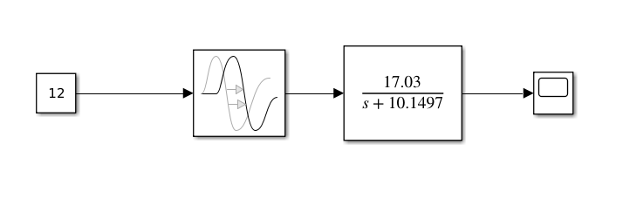
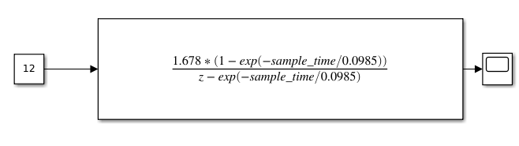

Controller design:

a) G(s) = K * k_p / (Tau * s)

T(s) = K * k_p / (K*k_p + Tau*s)

T_s = 5e-3, k_p for unstable = 25.0, closed loop poles = -442.92

T_s = 1e-1, k_p for unstable = 2.05, closed loop poles = -34.9

b)

for k_p = 25.0, T = 0.047s

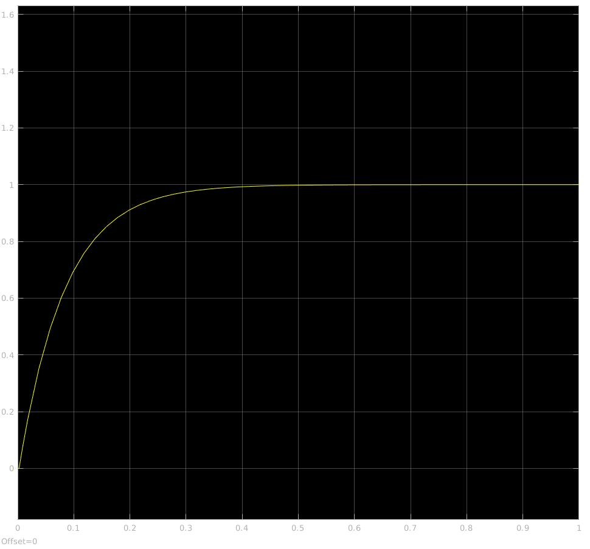
c) k_p = 0.7

2)

a) k_p = 4.612, k_i = 66.104

