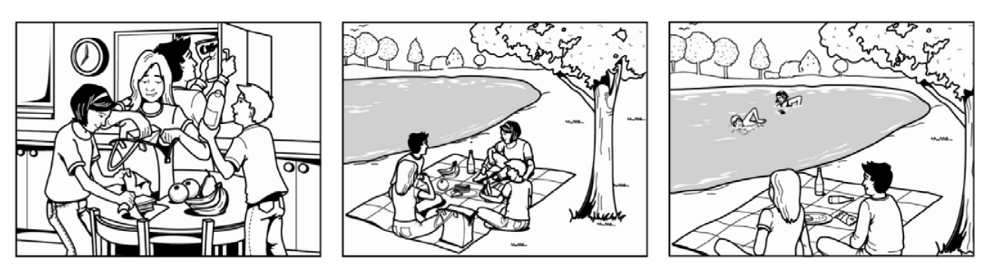
The guys are fulling a bag of some food. They are having a Good picnic in the park near a Little lake. Two of them are swimming meanwhile the other two are watching them.

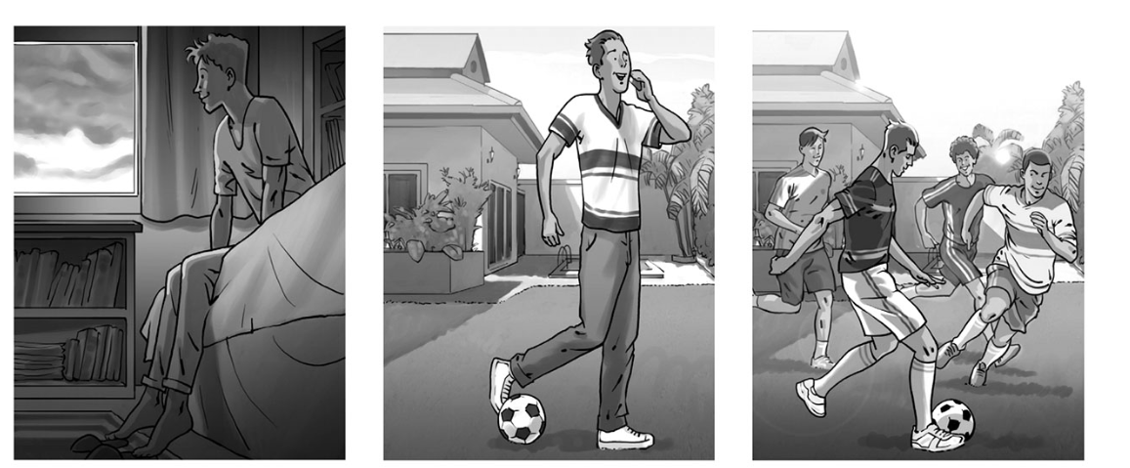
The man is thinking about playing soccer with his Friends outside. He is calling his Friends to invite them to play soccer. Then, he is playing soccer with his Friends near his house.

