Yassine FERHI  Master student in Engineering and Physics,  21 years old.  Tel : +33 6 19 12 91 65  Email : yassine.ferhi@institutoptique.fr  language: English - fluent | 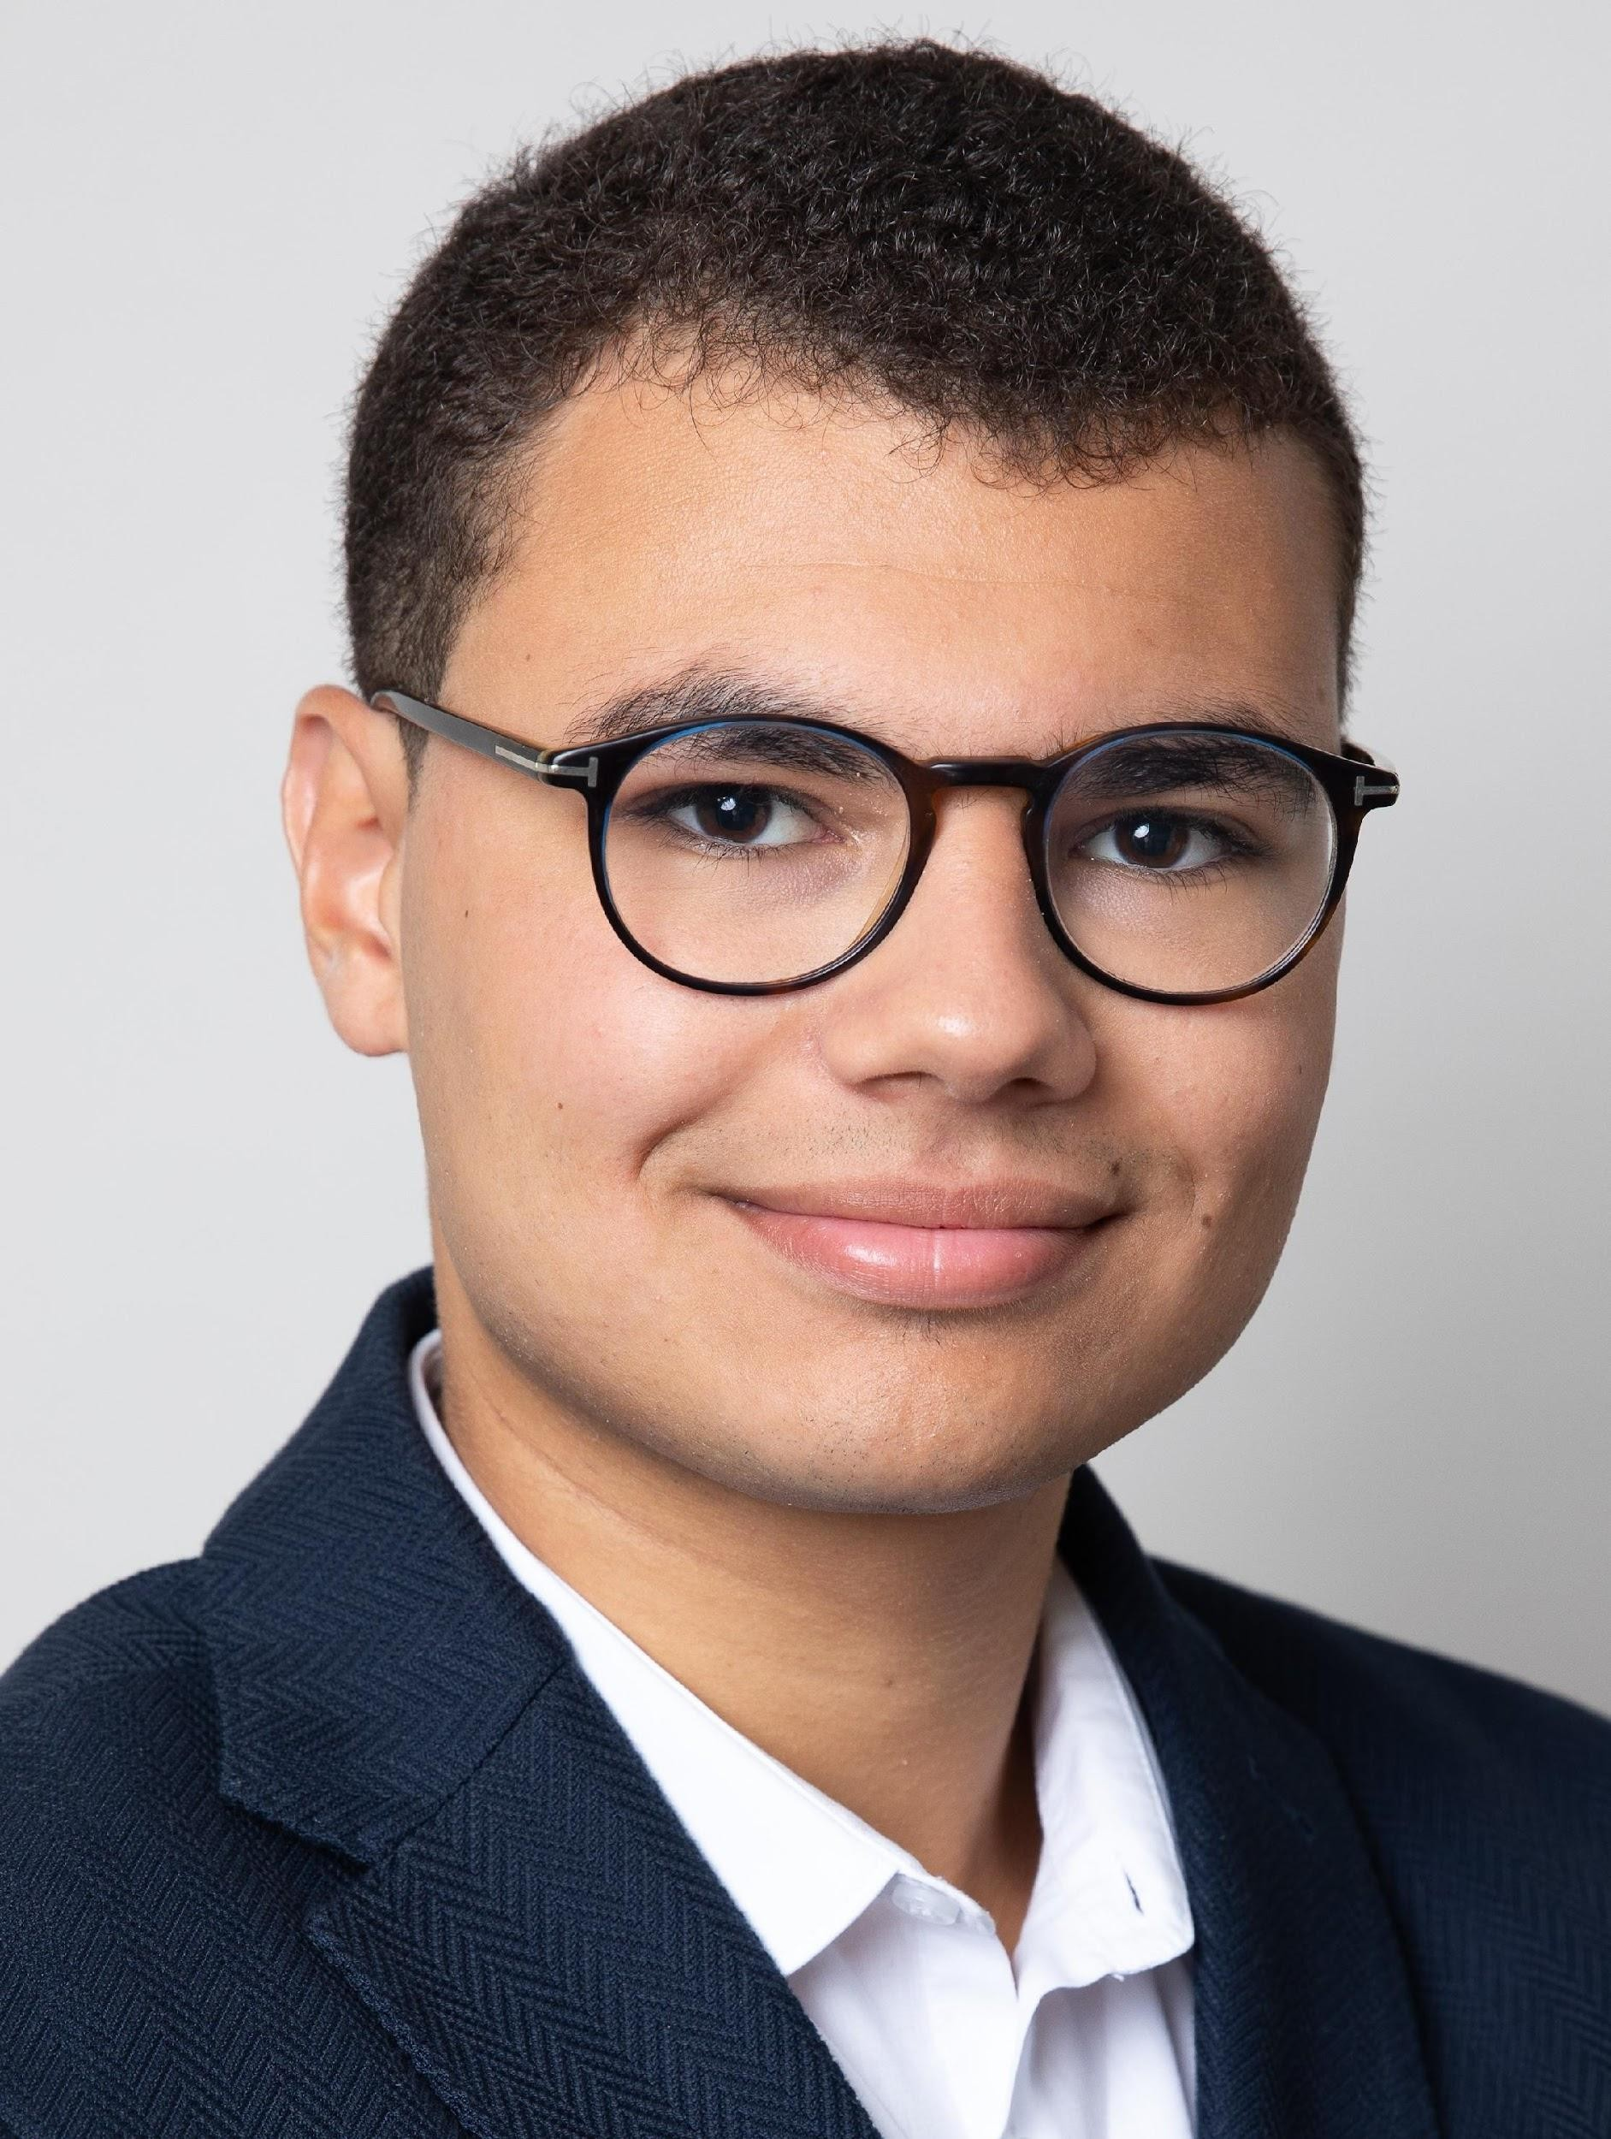

Research Experience

June 2025 - August 2025 Institut Fraunhofer (ITWM), Kaiserslautern, Germany
Research Internship – Quantum Image Processing Department

Design and performance analysis of quantum algorithms for image processing on Qiskit :
- Comparative analysis of the performance of various quantum pattern-matching methods with the integration of a quantum support vector machine (QSVM) classifier.
- Development of an algorithm performing an approximation of the convolution of two images using the quantum Fourier transform (QFT).

April 2025 Charles Fabry laboratory, IOGS, Paris
Research Internship – Nanophotonics Research Group

Development of a new simulation method for the propagation of electromagnetic fields in a multilayer medium :

Literature review and mathematical investigation of the Fourier-space formulation of Maxwell’s equations for diffraction

Using an innovating simulation approach on periodic surfaces.

Publications Pattern Matching Using Sliding Windows on Quantum Computers, Y. Ferhi, A. Geng, M. Kiefer-Emmanouilidis, and A. Moghiseh — Ferhi, Y., Geng, A., Kiefer-Emmanouilidis, M., Moghiseh, A. Quantum Engineering Sciences and Technologies for Industry and Services. QUEST-IS 2025. Communications in Computer and Information Science, vol 2744. Springer, Cham. https://doi.org/10.1007/978-3-032-13855-2_18
Quantum Approximation of Hadamard Products without Postprocessing, Y. Ferhi, A. Geng, M. Kiefer-Emmanouilidis, and A. Moghiseh — In publication process at Physical Review X.

Fourier Finite-Difference Method and Proper Orthogonal Decomposition for Fast Spectral Analysis of 2D
Periodic Photonic Structures, M. Besbes, Y. Ferhi, H. Benisty, and C. Sauvan —hal-05339190

Education

2024 –present Institut d’Optique Graduate School - IOGS
Master’s degree in Optical and Photonics Engineering

2025 – 2026 Université Paris-Saclay - UPS
Master’s degree (First Year) in Fundamental Physics

2025 – 2026 Aix-Marseille University - AMU
Bachelor’s degree in Fundamental Computer Science (double degree)

2024 – 2025 Université Paris-Saclay - UPS
Bachelor’s degree in Fundamental Physics (double degree)

2022 – 2024 CPGE MP2I/MPI* - Lycée Hoche, Versailles
Intensive program in Mathematics, Physics, and Computer Science

