Bash Challenges:

1. a) pwd shows the current directory you are working in.
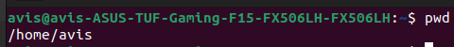

b) ls shows all the directories and files.

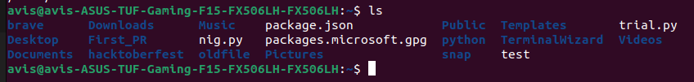

c) ls -a shows all the file and directories including the hidden ones.
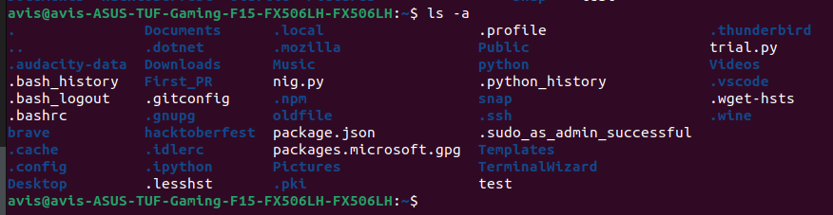

2. a) mkdir command is used to make directories.

b) cd command is used to move into a directory.

c) touch is used to make empty files.

d) file is used to find the type of a file. It returns empty as the file is completely empty.

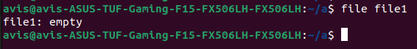

e)

f) cat command is used to read the elements in a file.

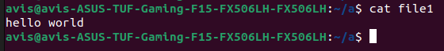

g) When the file command is run on the file ‘file1’ , it now returns ASCII text as there are alphabetic characters inside.

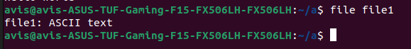

3. a) Touch command is used to create files.

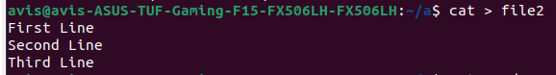

b) cat can be used to read as well as write to a file.
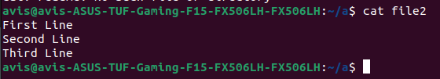

c) tac is used to print in the lines in the reverse order.

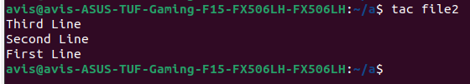

4. a) cat command is used to input into contents of file1 and file2 to file3.

b) Upon using the cat command to see the contents of file3, it gives:

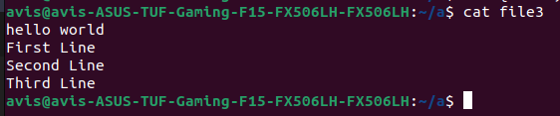

5. a) We can create multiple directories using mkdir statement in this way,

b)

c) using cp command , we can copy files to the specified location by mentioning its
path.

d) rmdir command is used to remove empty directories.

e) using the cp command , we can copy the file into the specified directory.

6. a) mv command can also be used to rename files and directories

b) To move the file to directory ‘a’ , i first moved to directory a to find its path. Then using that path
and the mv command, i moved ‘file()’ form directory ‘d’ to ‘a’.

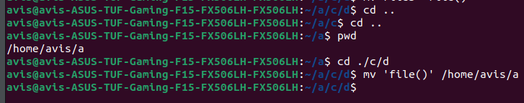

7. a) By simply executing ‘cd’ on the terminal, we can reach our home directory easily.

b) By specifing the paths for all the directories in curly braces, we can use the touch command to create files in directories a,b,c and d.

c) By using the find , we can find the path of the file using its name. When using a file name , it will return all the paths with the having the same file name.

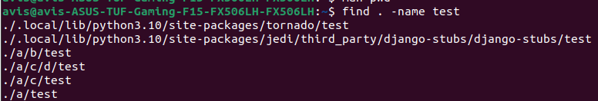

8. a) The redirection operator ‘ > ‘ helps to redirect the output obtained by ‘man grep’ into a text file.

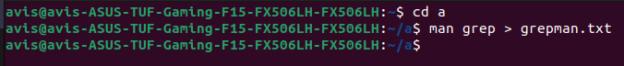

b) Using the ‘ | ‘ operator in linux terminal, we can grep the output after using cat on the file.
This helps filter out lines that do not have the word “FILE” in it.

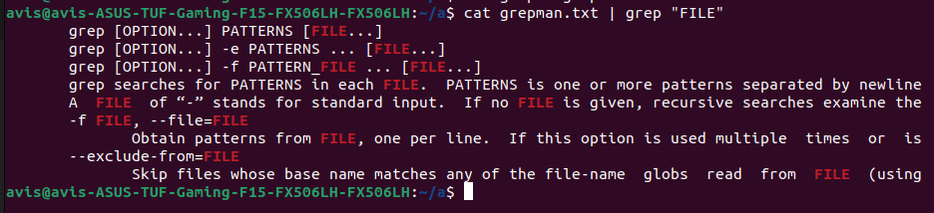

9. a) To remove a directory, the command rm is used with -r which is to mention that it is a directory.

b) To remove files with names having the same substrings , we can use the rm *<sub-string>* to remove the files.

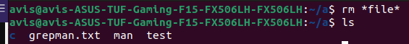

10. a) Using the wget command, we can access to logo png and download it. At first i tried to download it using “ https://blog.bi0s.in/ “ but it didn’t work. So i went to the website to find the logo.png and download it using its actual path.

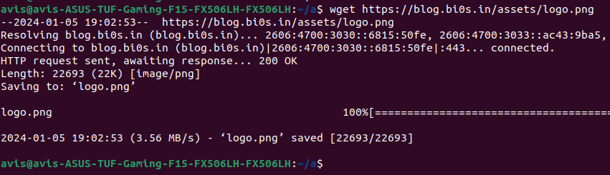

b) I wrote a python file in vs code and moved it to the directory a and executed it.

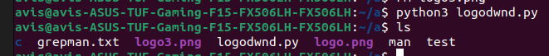
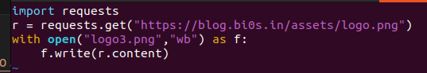

c) Using exiftool , we can easily take out the metadata of the image.

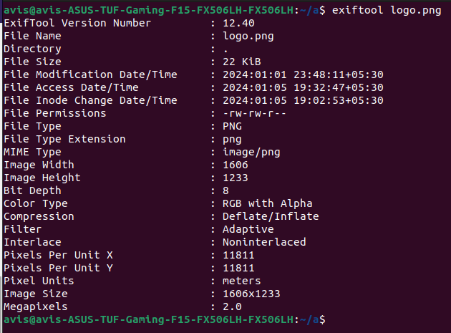

11. a) On using traceroute command on google.com, i got

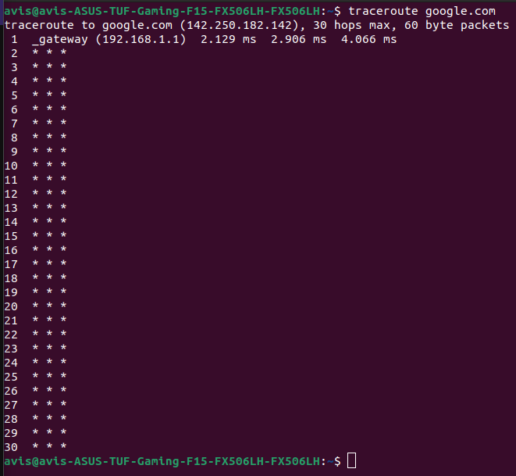
/

b) Using the nslook command , it give us the sub domains and addresses of google.com

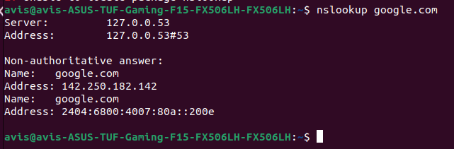

12. Upon using the python -m command, you can start a local host temperorily. When it is interupted the server is taken down automatically. After opening it on the web browser, i was able to access all my files on the web browser.

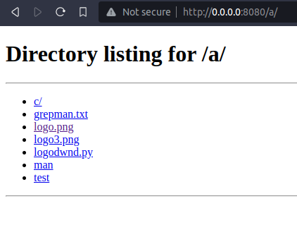

13. a) Using nmap on my device by using its ipv6 address, i got

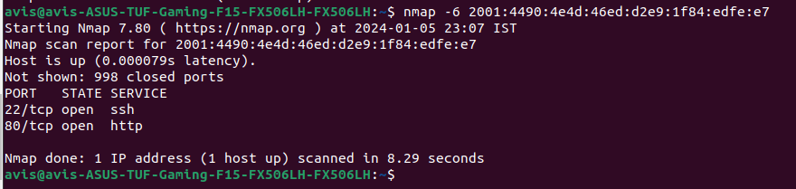

b) On using the -sS command with nmap, it allows you to scan a network stealthily. This returns the list of all open ports.

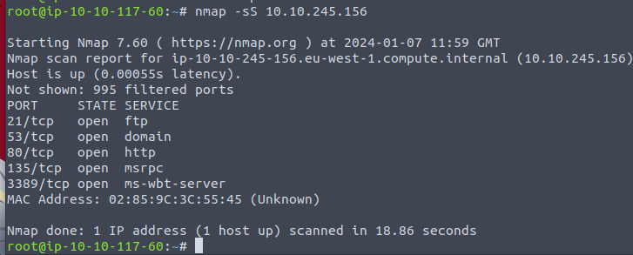

By using the -sV option with the grep command , we get the mac address and the service info.

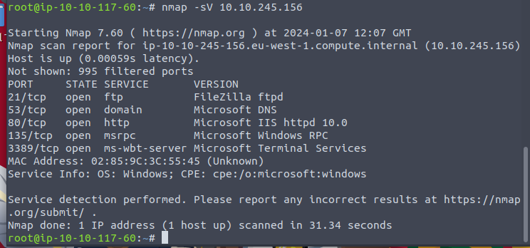

By using the -A option with grep command we are enabling os detection, version detection, scriot scanning and traceroute.

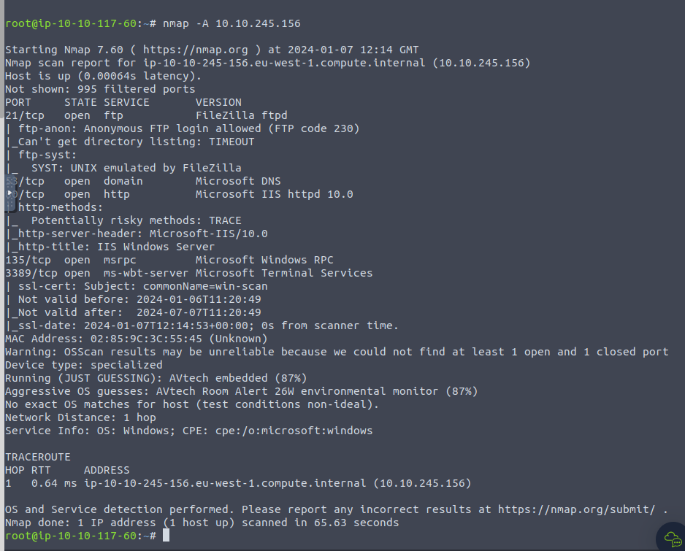
/

14. Netcat can be used to chat . It is not encrypted. By using the -v we can see the ongoing processess , -l is used to specify that it is a listener and -p and used to specify the port number.

Listener :

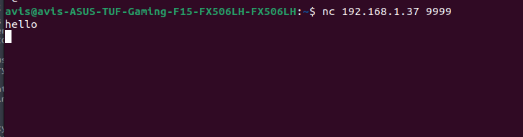

Client :

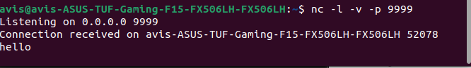
/

b. To do this task, i first created a text file named testfile.txt and sent the contents of it a file named newfile.txt. The tesfile.txt contained the message “hello world!”.

Server side:

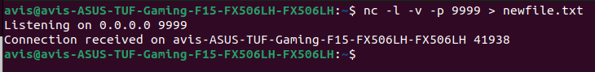
/
Here the output recieved from the client side will redirected to newfile.txt.

Client side:

/

Here -w is specified as two seconds , so that the nc will terminate itself after 2 seconds of completing its task. The contents of the test file is send to the server.

Reversing challenges :

1. Learn java After learning java, i started this challenge. So, at first, I did not know you have to decompile a class file to java file to read the code as i had opened the class file in vs code and it decompiled it for me. After reading the code i was able to understand the bytes in the program could lead me to an answer. I made a python script to print out the values of the bytes in the program and it gave me this : KnoW_YouR_A5C115} Then , after reading the main() again, I was able to understand that “flag{ “ has to added to the values i received. So, I entered flag{KnoW_YouR_A5C115} and received the output “ Access granted. “

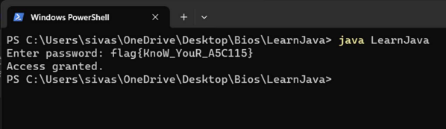

/

2. Encrypted flag. In this challenge, I first the main function. After seeing the lines “String var6 = yes(var2);” and “String var7 = no(var4, var3);” I was confused. I could not understand the exact meaning of the function. After reading the code over and over again , i was able to understand that that there is no change to the car2 and so i copied the random value “ G[Z@Z@G[VU_RT “. this random value is the first input followed by second input, “ flag .“

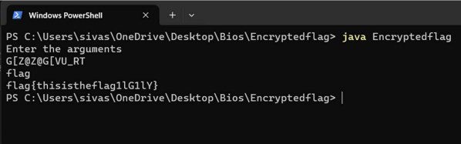

ASM pwn.college

Level 1 : At first i didn’t understand what to do. So instead of checking for the syntax for the assembly language i just typed one line of code , “mov rdi, ox1337” , thinking it would be the answer. After many failed tries i read the executed the run file more carefully and searched for the syntax. I found a video on youtube , from which i was able to understand to code in assembly.

Soon enough i almost got the answer. At first i got multiple errors which were said “To many memory references for mov” . Soon enough after looking for the syntax and writng a proper assembly code, i received the following flag.

Flag:

/

The code:

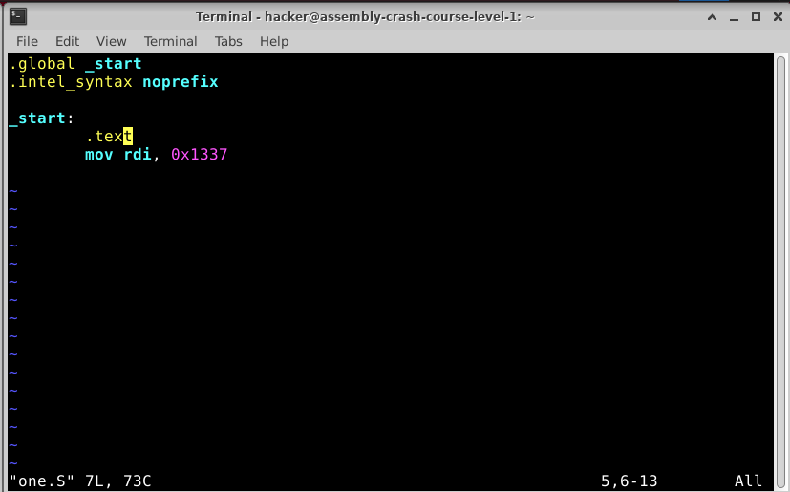
/

Level 2 : It was similar to the first challenge. So it was not very difficult. Got it in one try.

Flag:

Code :

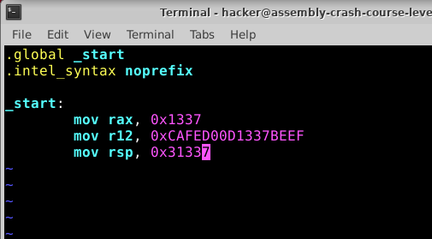

Level 3 : At first i tried to set the value of rdi value. But since the value changes dynamically before each run, setting it manually wasn’t working. So i tried the code without trying to set rdi. And i got the flag.

Flag :

Code :

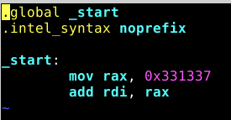

Level 4: It was similar to the third level , so it was not very difficult to understand . Hence i was able to complete it easily.

Flag :

/

Code:
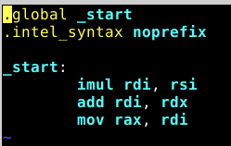

Level 5: It was not very difficult as it was to simply use div on rax and rsi.

Flag:

Code :

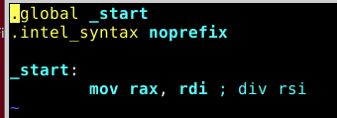

Level 6 : To obtain the modulus, i first copied the value of rdi to rax and the used div to divide rsi with rax. After that i multiplied rax with rsi and subtracted it with rax. And i move the final value to rax to obtain the flag.

Flag:

Code:
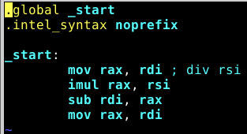

Level 7 : In this challenge i did not run into any errors. To set the upper 8 bits of rax, i just had to mov it to ah, which is the upper 8 bits of the rax.

Flag :

Code:

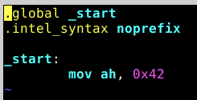

Level 8 : 25 is 2 ^ 8 and 65536 is 2^16 . So to find the modulus , i moved the lower 8 bits of rdi (dil) to al (the lower 8 bits of rax). And for the second one i moved the lower 16 bits of rsi(si) to the
lower 16 bits of rbx(bx).

Flag:

Code:
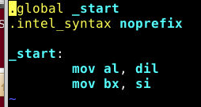

Level 9 : To extract the fifth least significant byte , i right shifted the values 4 times thinking i would get the answer. I did not. It was only moving 4 bits, but in order to obtain the values of the fifth least significant byte, i had to right the value by 8 * 4 bits.

Flag :

Code:

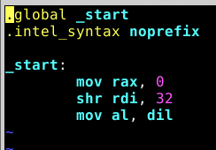

Level 10 : in this level i first did the or operation on rax and rdi and then the and operation on rax and rsi. But i did not get the flag. I assumed that rax was empty. So, after first using xor on rax itself , i was able to get the flag.

Flag :

Code :

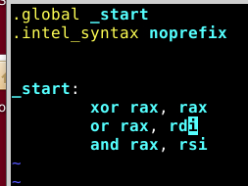

Coding challenge

1: a) Loops

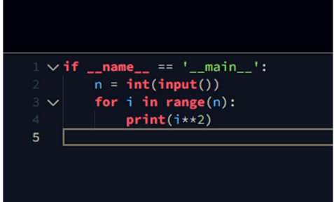

b) Arithmetic operators

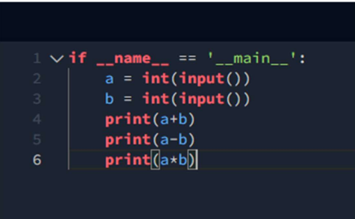

2. Leap year
For this question, i have used a method known as list comprehension. First i checked wether the given year is divisible by 4 and not by 100 and if false it checks wether the given year is divisible by 100 and 400. If any of the one given condition is true, the output will be “ Leap year “

Chatapp :

To make a chatapp using socket programming i first learnt the basics of socket programming like basic connections and sending unencryupted messages. It took time and i ran into a lot of errors in the beginning and could not understand it , but soon i learnt it and made a program.

Server side :

These are the main four functions in the program.

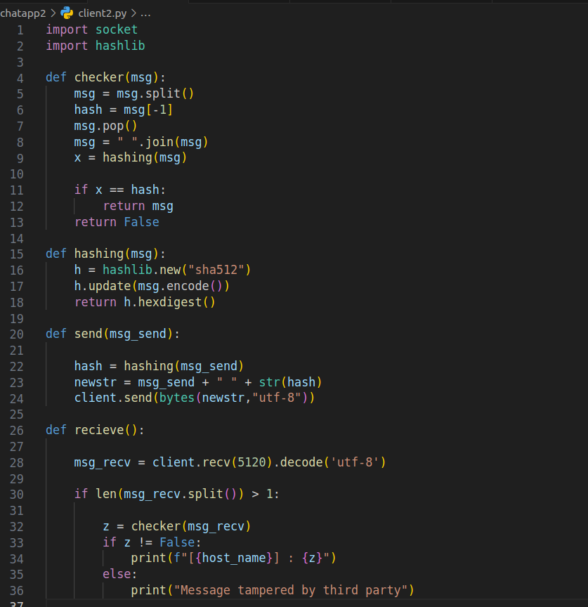

1 checker: this function is used to check wether the message received has been tampered with or not. It extracts the hash values which are sent alongside with the mesaage and creates the hash valuie of the received message and if the hashes do not match , the function returns false.

2 Hashing : This function is simply use to generate the hash values of the message.

3 Send : This function send the messages along with its hash value.

4. This function receives the message sent by the client and does integrity checks to make sure the message is not tampered .

This is main bit of the sever block.:

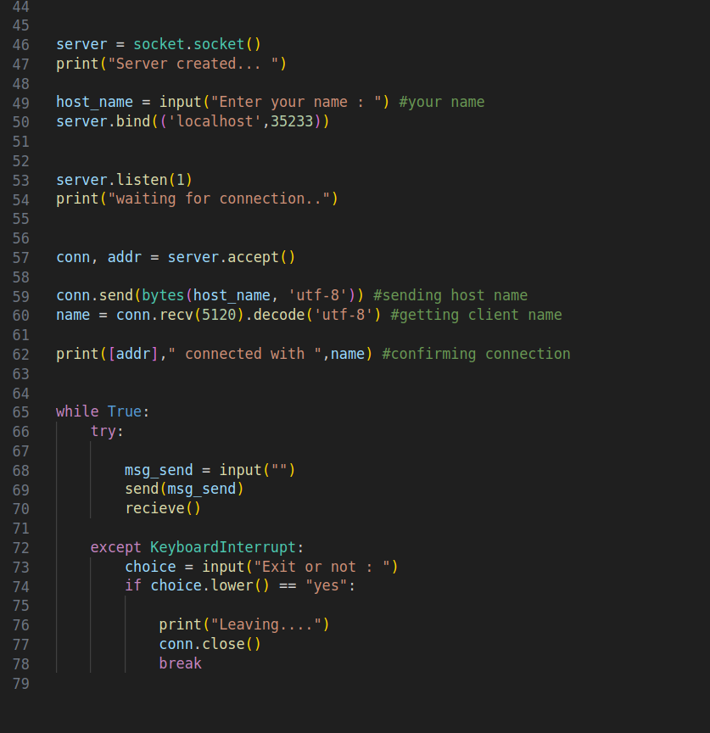
In the main code , it first creates a server and binds it to a port and to accepts connections from incoming clients. When the user wants to leave the chatapp the person running this program can just interrupt the code and it will check if you want to leave ot not.

Client side:

These are the main four modules in the client side which are similar to those in the server side.

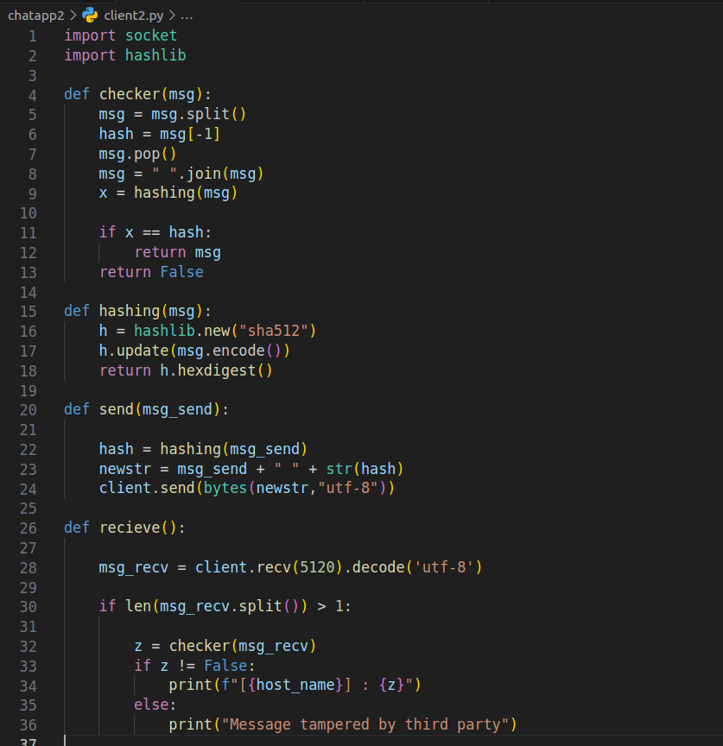

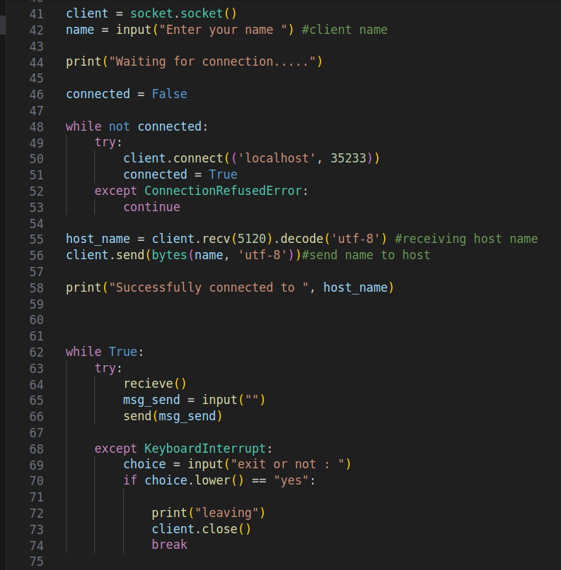

This is the main block of the program which is also similar to that of the server side. The client waits the server is active to connect to the server , so that the client and server can communicate.

Limitations of Flaws of this program:

1: the client and server cannot recieve and send messages simultaneously. This means that one party has to wait for the other party to send a message so that you can send a message. This program can only send one message at a time.

2: The message is not protected. The message is being sent alongside the hash value to conduct integrity checks on both sides. However one can access the message and easily read the messages.

