Adaptive Gated DenseNet121 for Paddy Disease Classification: Performance Gains and Limits of Sparsity-Based Pruning
Final research report based on saved Kaggle GPU simulations
Table 1. Report metadata
Item | Description
Base model | DenseNet121 with ImageNet transfer learning
Proposed model | Layer-gated Adaptive DenseNet121 with sigmoid gates
Dataset | Kaggle Paddy Disease Classification, 10 disease/condition classes
Framework | PyTorch / torchvision on Kaggle GPU
Report date | June 2026

Abstract
This study evaluates an Adaptive Gated DenseNet121 for paddy disease classification and compares it with a standard DenseNet121 transfer-learning baseline. The work is motivated by recent DenseNet121-based rice disease classification research and by the need for models that are accurate enough for field diagnosis while remaining suitable for future mobile deployment. The proposed method inserts learnable sigmoid gates into DenseNet121 dense-layer outputs and trains them jointly with the classifier using a sparsity-regularized objective. Experiments used the Kaggle Paddy Disease Classification dataset with an 80/20 stratified split over ten classes. The saved DenseNet121 baseline achieved 96.78% validation accuracy and 96.64% macro F1-score at epoch 16. The saved Adaptive model achieved 97.21% accuracy and 96.89% macro F1-score at epoch 16. Thus, adaptive gating produced a small performance gain in macro F1 and recall. Pruning became active at higher thresholds, but the useful compression region was narrow: threshold 0.825 reduced parameters modestly while retaining competitive F1, whereas stronger pruning caused severe accuracy collapse. The final conclusion is that adaptive gating improves feature modulation and classification performance, but the current sigmoid-gate sparsity formulation provides only limited reliable pruning for mobile compression.

1. Introduction
Rice diseases and pest-related symptoms can reduce yield and threaten food security, especially where diagnosis depends on manual expert inspection. Computer vision methods can support faster screening by learning visual symptoms directly from leaf images. DenseNet121 has become a strong architecture for such tasks because dense connectivity encourages feature reuse and stable gradient propagation.
The base paper by Ismail et al. reported strong DenseNet121 performance for rice disease classification and motivated the use of transfer learning for rice disease diagnosis. This project extends that direction by asking whether DenseNet121 can be made adaptive: instead of treating every dense-layer contribution as equally active, the model learns a scalar gate for each dense-layer output. The expected advantage is twofold: improve classification by weighting feature contributions and expose low-value gates that could be pruned after training.
The title of this paper deliberately reflects the experimental outcome. Adaptive gating produced a performance gain over the saved baseline, and pruning became active under the adaptive model, but the useful pruning region was narrow and unstable. The study therefore contributes both a positive classification result and an important negative pruning result.

2. Related Work
CNN-based plant disease recognition was popularized by studies showing that leaf images can be classified accurately using deep networks. DenseNet introduced dense connectivity, where layers receive previous feature maps through concatenation, improving feature reuse and reducing vanishing-gradient problems. The Paddy Doctor dataset and the Kaggle Paddy Disease Classification competition provide realistic paddy leaf images across multiple disease and condition classes, making them suitable for benchmarking transfer-learning models.
Pruning and sparsity research aims to reduce model size and inference cost by removing weak channels, layers, or connections. Network Slimming and related methods use sparsity pressure on scaling factors to identify removable structures. The adaptive method in this work follows a similar logic but applies gates to DenseNet dense-layer outputs. The saved results show that such gates can improve classification but require additional mechanisms to become genuinely prune-friendly.

3. Materials and Methods

3.1 Relation to Base Paper Dataset Scope
The base paper by Ismail et al. used a seven-class rice disease setup and reported 11,467 total images after augmentation, split into 8,026 training images and 3,441 test images. In contrast, this study used the Kaggle Paddy Disease Classification data with ten classes and 10,407 labeled images. The wider class set includes disease, pest-damage, and normal categories, making the classification task broader than the seven-disease setup in the base paper.
Table 2. Dataset scope compared with the DenseNet121 base paper
Study | Classes | Total labeled images | Evaluation split
Ismail et al. base paper | 7 rice disease classes | 11,467 augmented images | 8,026 train / 3,441 test
This study | 10 paddy disease/condition classes | 10,407 labeled images | 8,325 train / 2,082 validation

3.2 Dataset and Split
The experiments used the Kaggle Paddy Disease Classification dataset, consisting of ten classes: bacterial leaf blight, bacterial leaf streak, bacterial panicle blight, blast, brown spot, dead heart, downy mildew, hispa, normal, and tungro. The labeled data were split into 8,325 training images and 2,082 validation images using a stratified 80/20 split. The Kaggle test images were not used for reported validation metrics because their labels are hidden.
Table 3. Dataset and preprocessing summary
Property | Value
Training images | 8,325
Validation images | 2,082
Number of classes | 10
Input size | 224 x 224
Augmentation | Random horizontal flip and random rotation
Normalization | ImageNet mean and standard deviation

3.3 Baseline DenseNet121
The baseline model used torchvision DenseNet121 initialized with ImageNet weights. The final classifier was replaced with a ten-class linear layer. Training used AdamW optimization, cross-entropy loss, batch size 32, learning rate 1e-4, weight decay 1e-4, and early stopping based on validation macro F1-score.

3.4 Adaptive Gated DenseNet121
The adaptive model starts from the same DenseNet121 backbone but adds a learnable scalar gate to each DenseNet dense-layer output. For dense layer i, the feature output is transformed as y_i = sigmoid(g_i) x f_i(x), where g_i is a trainable gate logit. DenseNet121 contains 58 dense-layer outputs, so the adaptive model adds 58 gate parameters.
The saved Adaptive model experiment used sparsity_lambda = 0.0005 and gate_init = 2.0. The training objective combined cross-entropy with a sparsity penalty on the sigmoid gate values: L_total = L_CE + lambda * sum(|sigmoid(g_i)|).

3.5 Pruning Evaluation
After training, pruning was evaluated by loading the saved best adaptive checkpoint and testing multiple gate thresholds. Any dense layer with gate value below the threshold was eligible for replacement by a zero-output layer of matching shape. The method was evaluated by comparing parameter count, model size, accuracy, precision, recall, and macro F1-score after thresholding.

4. Results

4.1 Main Model Comparison
Table 4. Saved model and checkpoint summary
Model | Best epoch | Parameters
DenseNet121 baseline | 16 | 6,964,106
Adaptive gated DenseNet121 | 16 | 6,964,164
Table 5. Saved validation performance comparison
Model | Accuracy | Precision | Recall | F1 | Loss
DenseNet121 baseline | 96.78% | 97.35% | 96.03% | 96.64% | 0.1364
Adaptive gated DenseNet121 | 97.21% | 97.16% | 96.65% | 96.89% | 0.1441
The adaptive model slightly outperformed the saved DenseNet121 baseline, improving macro F1 by 0.002470 and validation accuracy by 0.004323. The gain is small but consistent with the hypothesis that learnable dense-layer gates can modulate feature reuse beneficially.
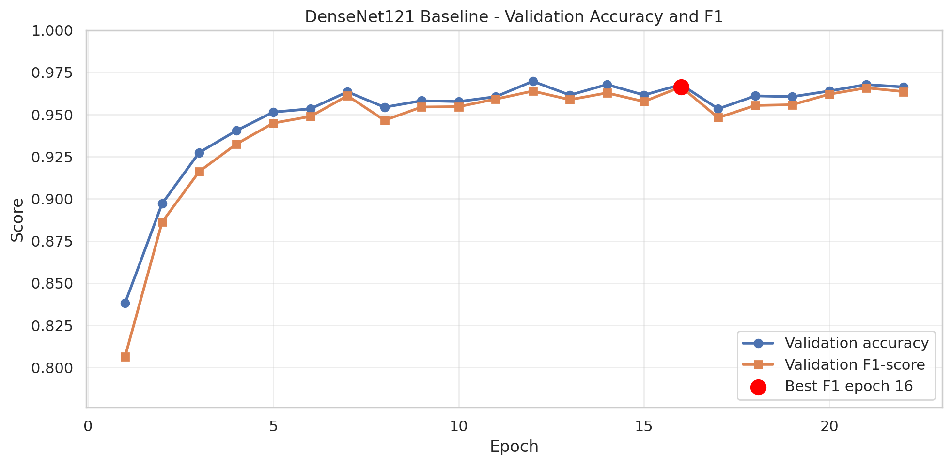
Figure 1. DenseNet121 baseline validation accuracy and macro F1-score over training.
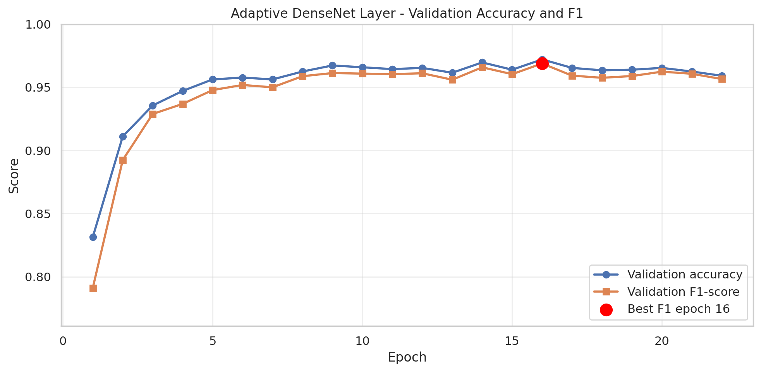
Figure 2. Adaptive gated DenseNet121 validation accuracy and macro F1-score over training.

4.2 Confusion Matrix Analysis
Both models produced strong diagonal confusion matrices, showing stable class separation across the ten paddy disease classes. The adaptive model improved some class-level decisions, including bacterial panicle blight and brown spot, but still showed confusion between visually similar disease or pest symptoms such as hispa versus normal and blast-related patterns.
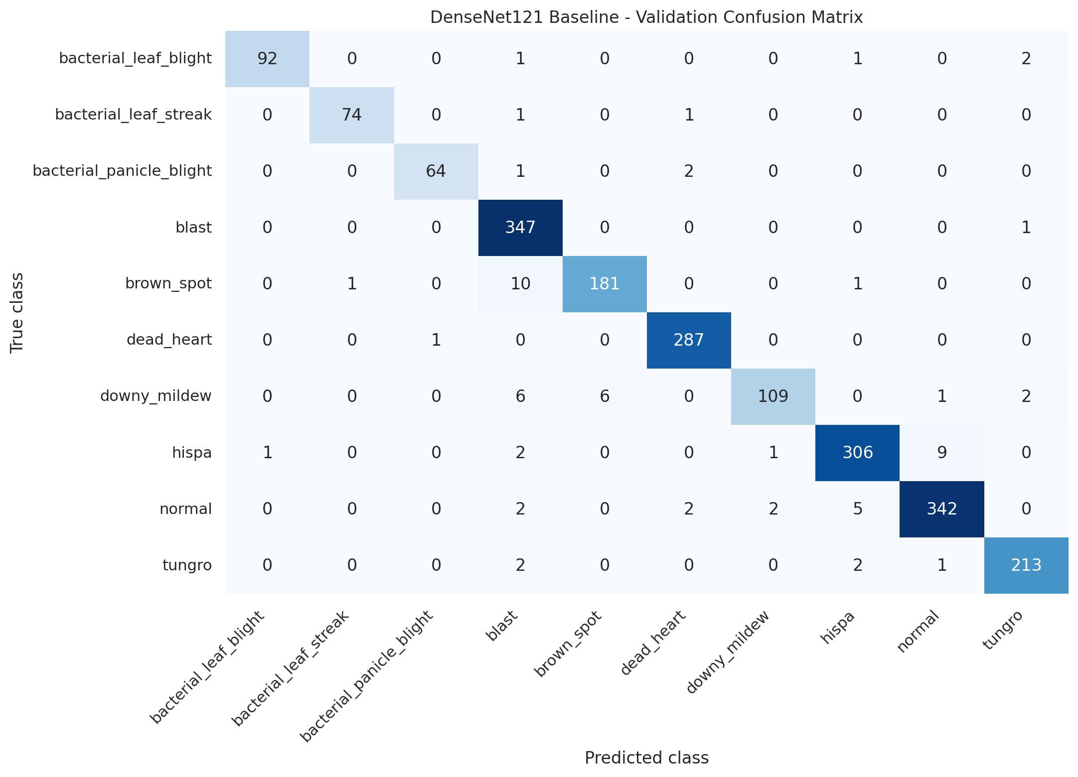
Figure 3. DenseNet121 baseline validation confusion matrix.
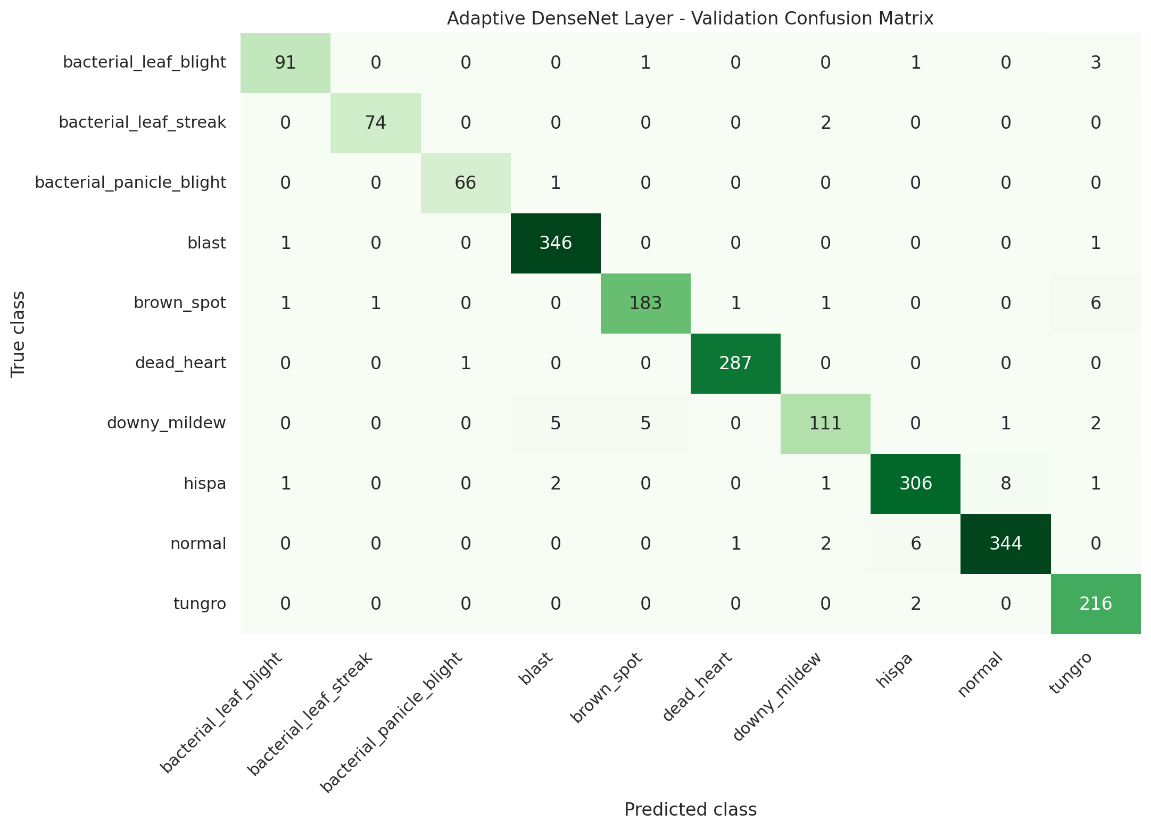
Figure 4. Adaptive gated DenseNet121 validation confusion matrix.

4.3 Gate Dynamics
The adaptive gate dynamics show that the mean gate value decreased gradually during training, confirming that the gate parameters were updated by the sparsity-regularized objective. However, the min-max range remained narrow. This means the gates did not separate into clearly important and clearly removable groups.
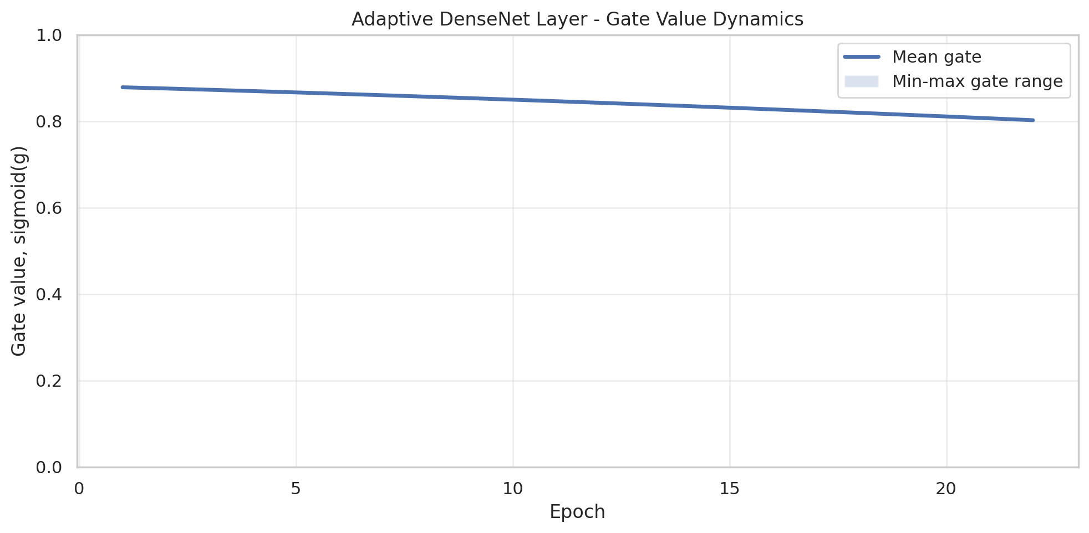
Figure 5. Adaptive DenseNet gate dynamics during training.

4.4 Pruning Outcomes
Table 6. Adaptive pruning evaluation results
Threshold | Params before | Params after | Size MB | Accuracy | F1
0.750 | 6,964,164 | 6,964,164 | 26.89 | 97.21% | 96.89%
0.800 | 6,964,164 | 6,964,164 | 26.89 | 97.21% | 96.89%
0.820 | 6,964,164 | 6,964,164 | 26.89 | 97.21% | 96.89%
0.823 | 6,964,164 | 6,964,164 | 26.89 | 97.21% | 96.89%
0.825 | 6,964,164 | 6,839,683 | 26.41 | 96.88% | 96.39%
0.827 | 6,964,164 | 5,111,024 | 19.73 | 17.20% | 5.05%
0.829 | 6,964,164 | 1,149,389 | 4.43 | 16.95% | 2.90%
0.831 | 6,964,164 | 858,827 | 3.31 | 16.95% | 2.90%
0.833 | 6,964,164 | 713,546 | 2.74 | 16.95% | 2.90%
The Adaptive pruning results show that pruning became active at threshold 0.825. At this point, parameters reduced from 6,964,164 to 6,839,683 and F1 decreased from 96.89% to 96.39%, which is a modest but usable compression result. However, raising the threshold to 0.827 reduced the model to 5,111,024 parameters but collapsed F1 to 5.05%. The method therefore shows only a narrow useful pruning window.

5. Discussion
The experiments support a nuanced conclusion. Adaptive gating slightly improved macro F1-score relative to the saved DenseNet121 baseline, suggesting that the DenseNet feature pathway can benefit from learnable modulation. The improvement is especially relevant because the adaptive model added only 58 scalar gate parameters, keeping the parameter count effectively equivalent to DenseNet121.
At the same time, the pruning objective was only partially achieved. The gate values moved enough to permit active pruning at threshold 0.825, but the transition from safe pruning to collapse was very sharp. This means the model learned soft reweighting with a fragile structural boundary rather than robust hard selection. For mobile deployment, soft gating should be combined with staged pruning and fine-tuning, hard-concrete gates, channel-level gates, or latency-aware optimization.
Compared with Ismail et al.'s DenseNet121-based rice disease classification work, this project keeps DenseNet121 as the core feature extractor but studies whether its dense connectivity can be made adaptive. The answer from the saved experiments is that adaptive gating improves classification marginally, but does not yet deliver compression. This makes the contribution useful as both an accuracy experiment and a cautionary pruning result.

6. Conclusion
This paper presented an Adaptive Gated DenseNet121 for paddy disease classification and compared it with a DenseNet121 baseline using saved Kaggle GPU simulations. The Adaptive model achieved 96.89% macro F1-score, exceeding the baseline F1-score of 96.64%. This demonstrates a small performance gain from learnable dense-layer gates. Pruning at threshold 0.825 reduced parameters modestly while retaining competitive F1, but stronger thresholds caused severe performance collapse. The final conclusion is therefore: Adaptive Gated DenseNet121 is promising for performance-aware feature modulation and can produce limited pruning, but the current sparsity-based pruning formulation does not yet provide robust mobile compression.

7. Future Work
- Repeat adaptive training with stronger sparsity coefficients, including lambda = 5e-4 and 1e-3, while preserving downloadable experiment archives.
- Use staged training: train for accuracy, increase sparsity pressure, prune, then fine-tune the pruned model.
- Test hard-concrete or L0 gates to encourage binary selection instead of soft gate clustering.
- Move from layer-output gates to channel-level gates, where pruning may produce smoother compression.
- Benchmark TorchScript latency on real mobile or edge hardware after pruning and quantization.
- Run repeated seeds and report mean and standard deviation to separate true gains from stochastic variation.

References
1. Ismail, A., Hamdy, W., Ibrahim, A. H., and Awad, W. A. (2026). Classification of rice plant diseases using efficient DenseNet121. Scientific Reports, 16, 7482. https://www.nature.com/articles/s41598-026-38078-6
2. Paddy Doctor: A Visual Image Dataset for Automated Paddy Disease Classification and Benchmarking. https://arxiv.org/abs/2205.11108
3. Kaggle Paddy Disease Classification competition dataset. https://www.kaggle.com/competitions/paddy-disease-classification/data
4. Huang, G., Liu, Z., van der Maaten, L., and Weinberger, K. Q. (2017). Densely Connected Convolutional Networks. CVPR. https://arxiv.org/abs/1608.06993
5. Mohanty, S. P., Hughes, D. P., and Salathe, M. (2016). Using Deep Learning for Image-Based Plant Disease Detection. Frontiers in Plant Science. https://doi.org/10.3389/fpls.2016.01419
6. Liu, Z., Li, J., Shen, Z., Huang, G., Yan, S., and Zhang, C. (2017). Learning Efficient Convolutional Networks through Network Slimming. https://arxiv.org/abs/1708.06519
7. Tan, M., and Le, Q. V. (2019). EfficientNet: Rethinking Model Scaling for Convolutional Neural Networks. https://arxiv.org/abs/1905.11946
8. Sandler, M., Howard, A., Zhu, M., Zhmoginov, A., and Chen, L.-C. (2018). MobileNetV2: Inverted Residuals and Linear Bottlenecks. https://arxiv.org/abs/1801.04381
9. Pacal, I. et al. (2024). A systematic review of deep learning techniques for plant diseases. Artificial Intelligence Review, 57, 304. https://doi.org/10.1007/s10462-024-10944-7

