Capstone Planning Document

Description:
For my Capstone Project, I will be building an interactive story invoking emotion about bullying using simple shapes.

To begin the with, users will see two spheres talking animatedly. They will be surrounded by buildings and trees.

A capsule will bully the two spheres. The user can choose to interact with the spheres, the capsule, or run away.

Features And Dependencies:

3D Models + Animations (Reference Images)
  - Sphere model and animation


  - Capsule


  - Buildings and trees
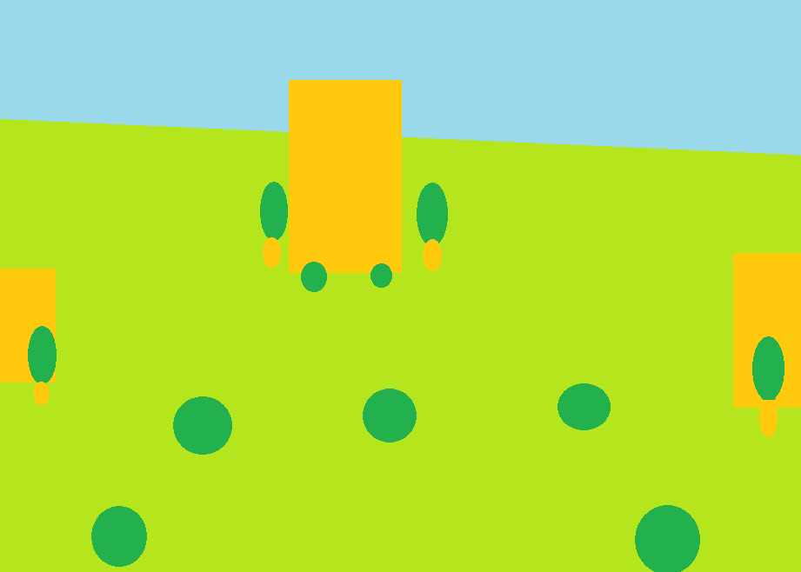
  - Run away


Game Loop
  - Bully walks up and scares children
  - Player makes decision
  - Animate decision
  - Present achievement
  - Restart

Other Effects
  - Lighting
  - Spatial Sound effects for children talking, being scary, running away
  - Animate spheres on y-axis to simulate talking
  - Sizing to make the capsule larger to scare children
  - Achievement window

