James' The Puzzler
This is a VR experience of a mystical puzzle in a medieval castle. It was built for Android with Google Cardboard using Unity and prefab models provided by Udacity.

Outcomes
https://youtu.be/IZE7w8ZwqSU
Users had fun playing the game. User feedback allowed me to make the experience better.

Process
Statement of Purpose
Puzzler is a new VR mobile application for new VR users which challenges them to solve a familiar type of puzzle in a new way.

Persona
This is a persona of a possible user of this game:

O
\|/
|
/ \

18
Student
Mackenzie
"Study hard, play hard."
He is a busy student who needs to take breaks from so much work. He likes to engage his reasoning skills. He's used VR before.
Design notes. Persona. Statement of purpose. Sketches of concept. User testing. UI sketches. User testing. Movement. User testing (VR sickness). Audio and visual feedback. User test.

Sketches
These are sketches for the design of the game:
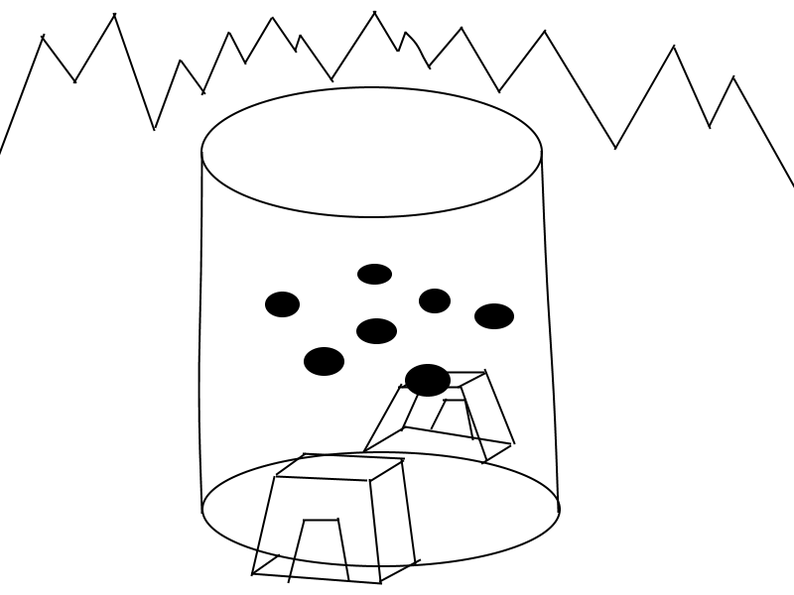
The original plan was a tower but was abandoned for a more simple castle.

User testing outcomes and iteration
I tested with two users who had no prior VR experience. They thought the scale of the castle was very appropriate, they enjoyed the medieval tower mood, and they could see everything well but the mountains, which I repositioned as a result. Some of the textures flashed where objects overlapped, so I rescaled and repositioned them to eliminate the flashing.

During the second user test, users tested the UI introduction and congratulation screens. The users had no complaints.

The third test was for simulator sickness, which the users did not experience. They thought the speed was just right.

The final test was for the completed project. The users really enjoyed the game, but could not complete it. Players should not be able to click on the orbs while the pattern is playing.

Breakdown of final piece
The player is presented with a UI screen welcoming them to the game and instructing them to press the start button to play.

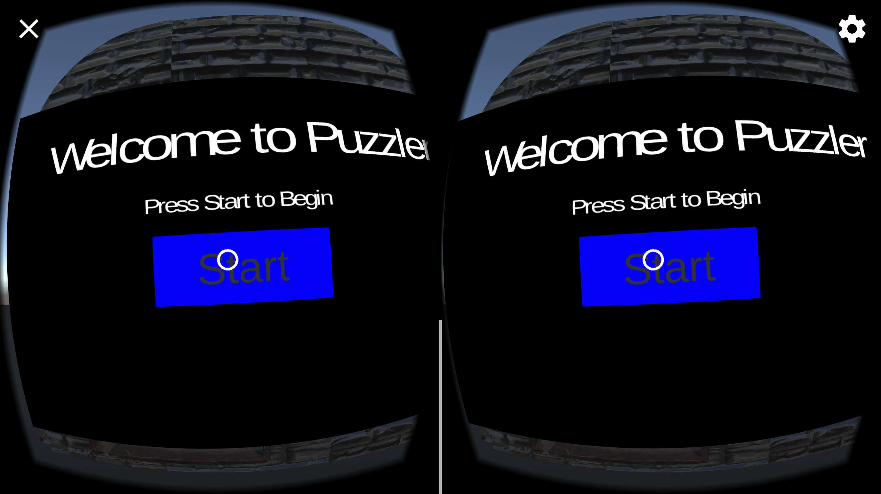
The player is then moved to into the castle next to the orb puzzle.
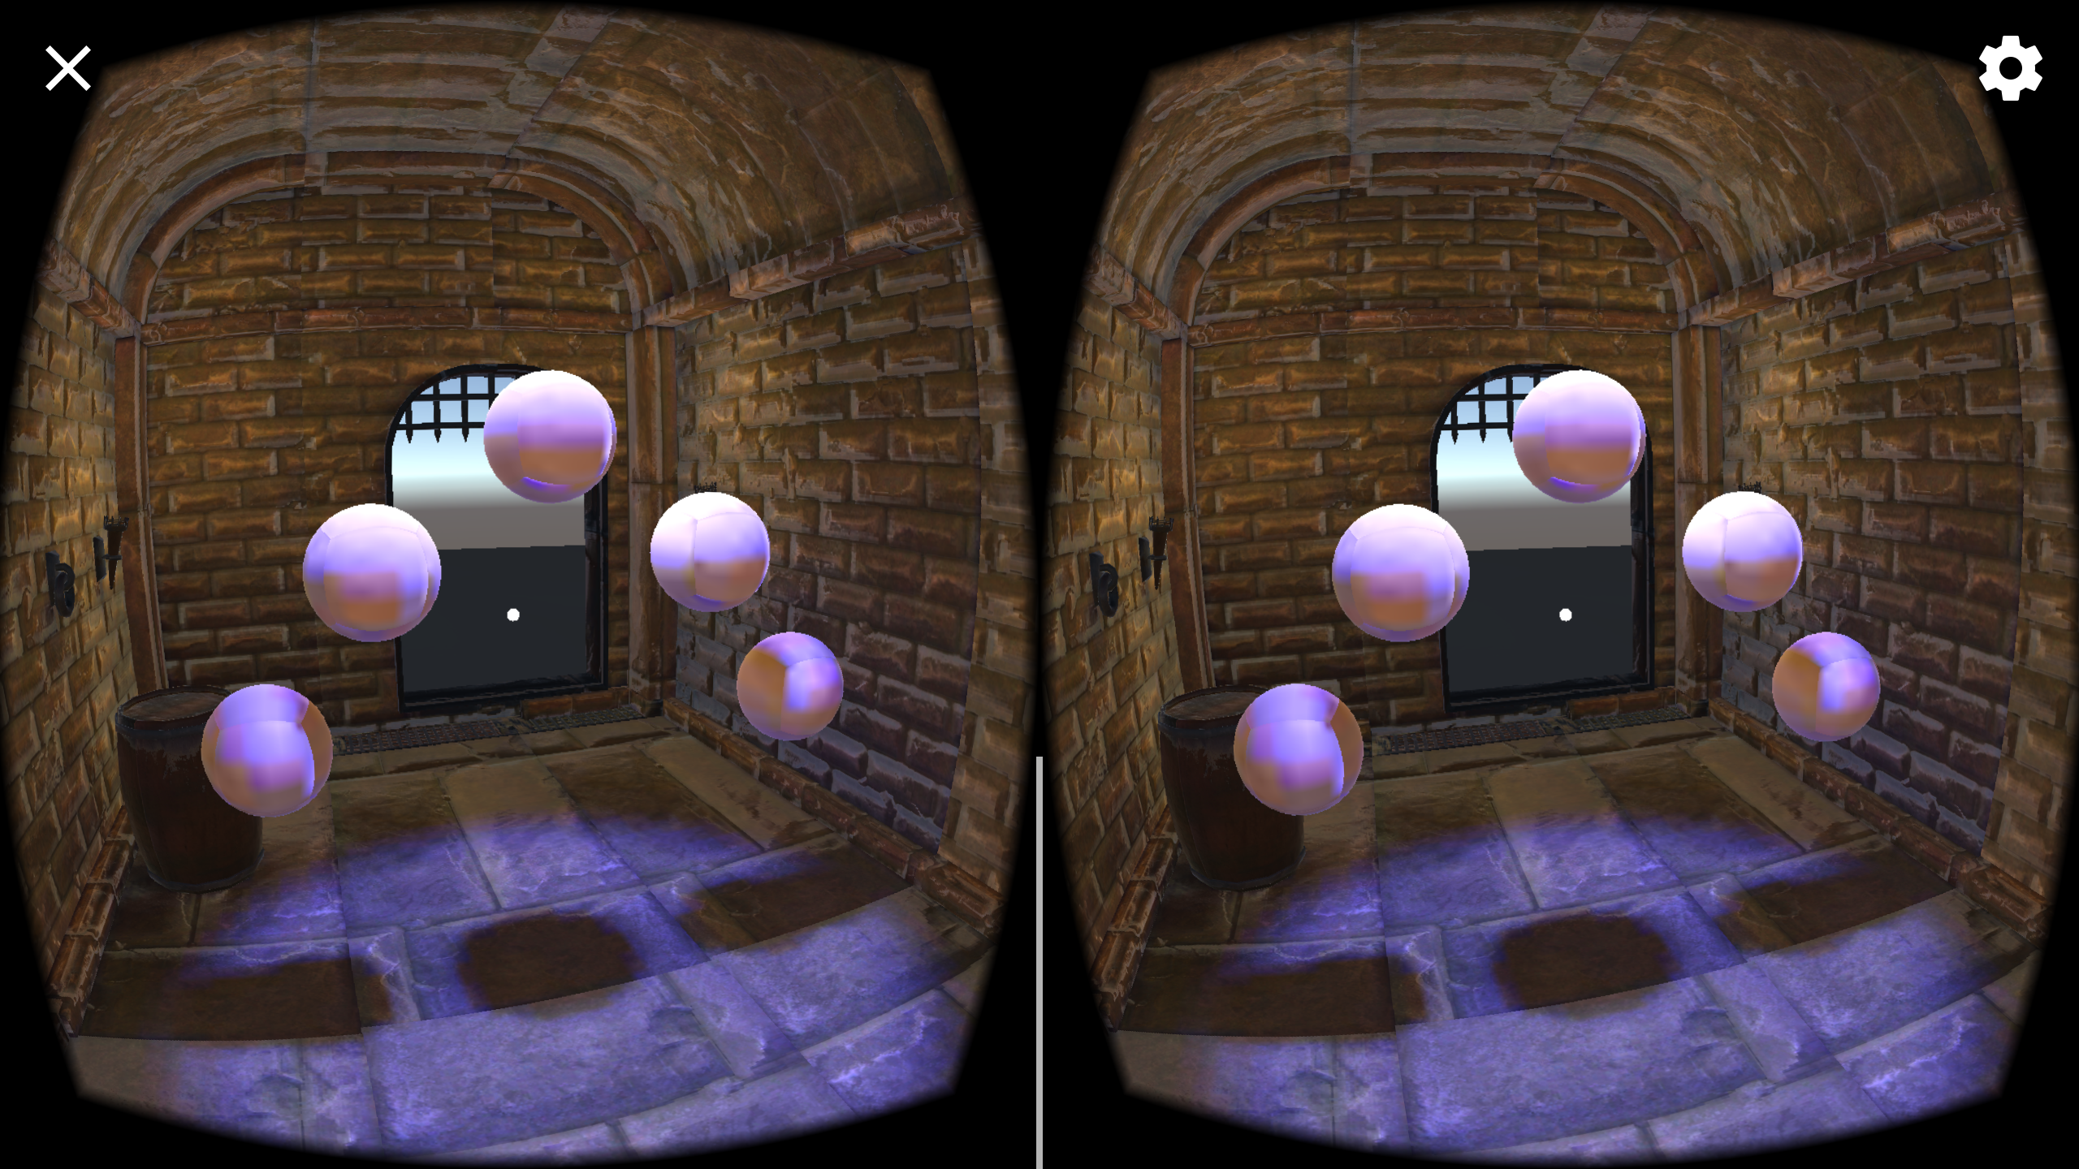
The orbs will play light up in a pattern for the player to repeat.
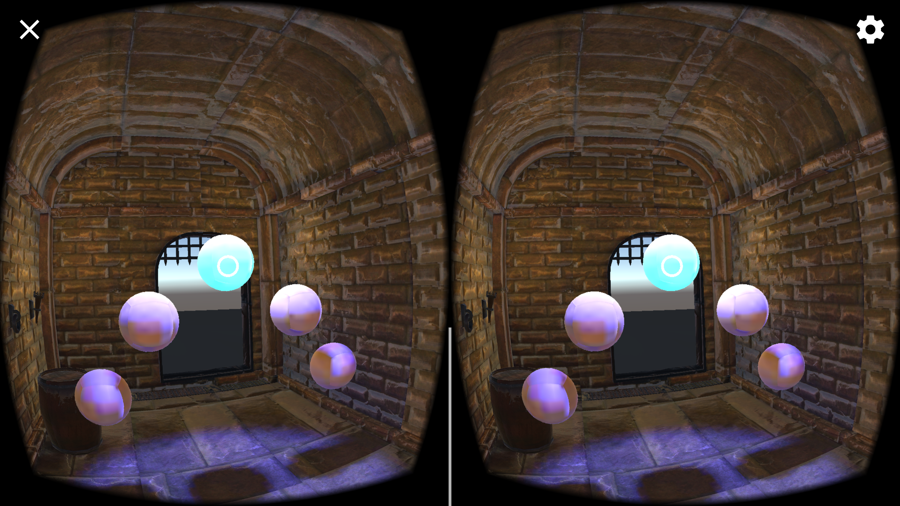
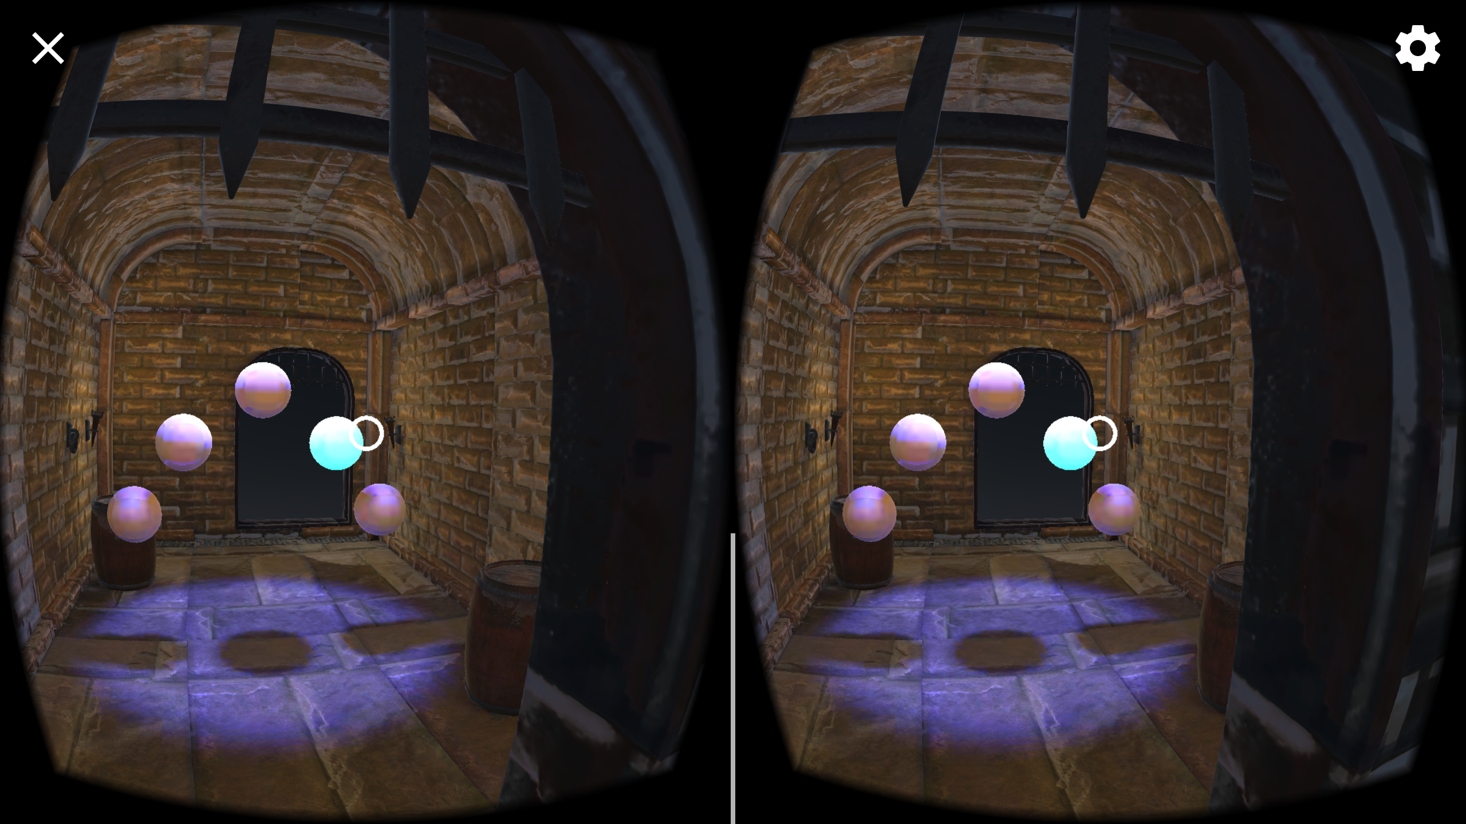
Players will then attempt to repeat the pattern.
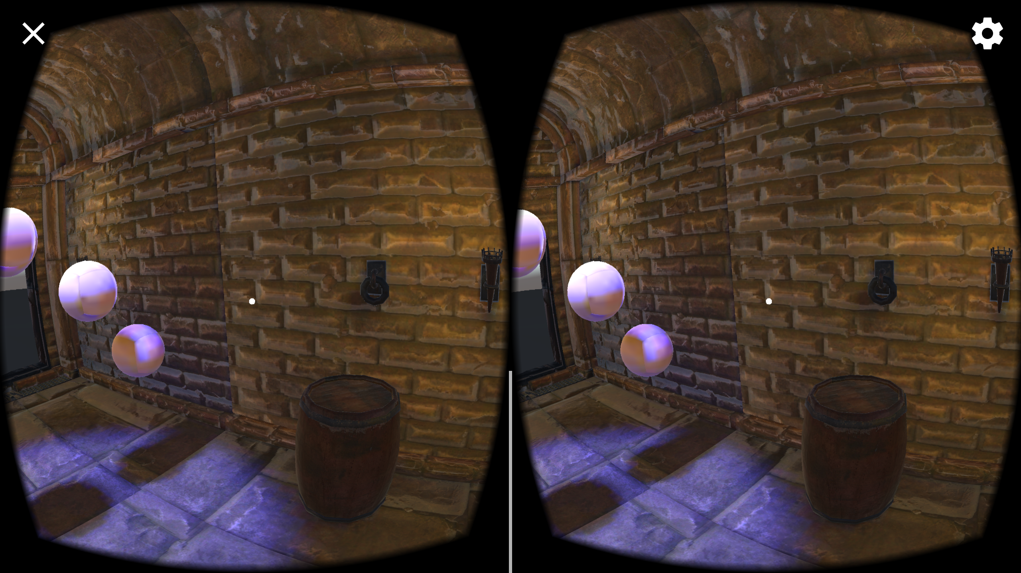
If the users fail, the pattern will repeat. If the users win, they will be taken outside to the congratulations screen.
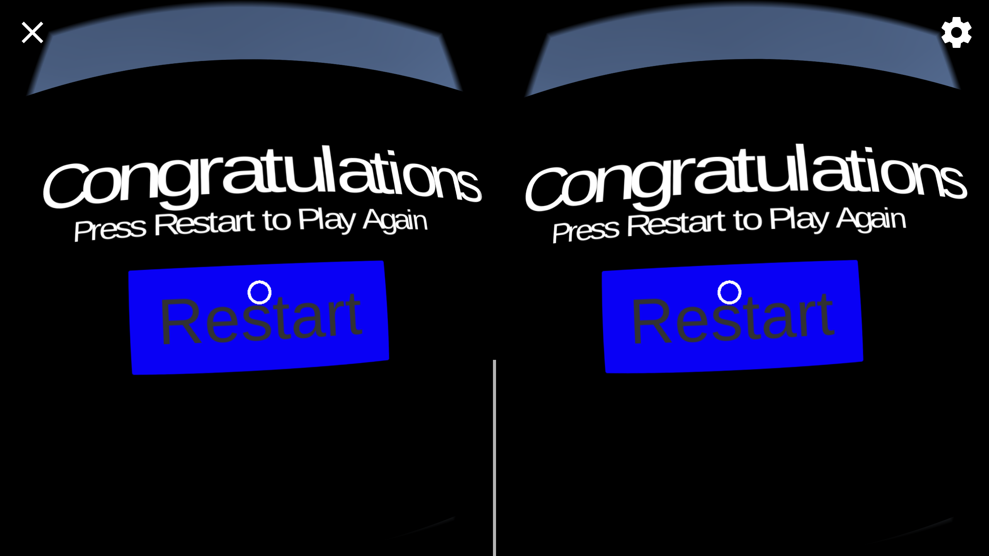
If they choose to play again, then can press the restart button, which will move them to the beginning of the game to play again.

Conclusion
The Puzzler gives players an introduction to a short VR game. It gives a broad example of what VR has to offer, from interaction with the virtual world to light and sound cues. The game gives users a short and simple challenge.

Next Steps
Prevent users from clicking on orbs while they're being shown the pattern.
Add a better sky box.
Add a win sound.
Add flames to the torches.
Add particles to orbs when clicked correctly.

