Shortest_paths

- Single source single destination:-
  - My Implementation:
    - (108 nodes , 290 edges)
      - 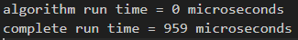
    - (136 nodes ,368 edges)
      - 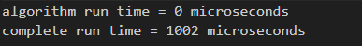
    - (171 nodes ,470 edges)
      - 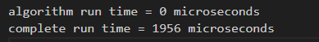
    - (214 nodes , 584 edges)
      - 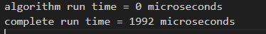
    - (268 nodes , 726 edges)
      - 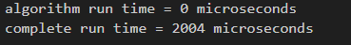
    - (335 nodes , 910 edges)
      - 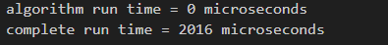
    - (419 nodes , 1140 edges)
      - 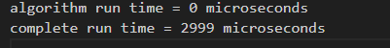
    - (524 nodes , 1406 edges)
      - 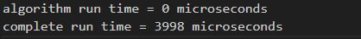
    - (655 nodes , 1758 edges)
      - 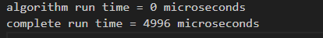
    - (819 nodes , 2226 edges)
      - 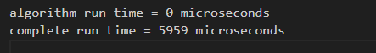
    - (1024 nodes , 2824 edges)
      - 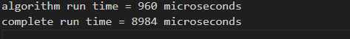
    - (1280 nodes , 3548 edges)
    - (1600 nodes , 4442 edges)
      - 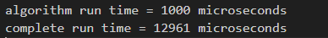
    - (2000 nodes , 5596 edges)
      - 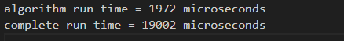
    - (2500 nodes , 6946 edges)
      - 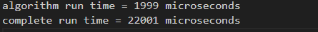
    - (3125 nodes , 8646 edges)
      - 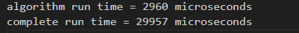
    - (3906 nodes , 10736 edges)
    - (4882 nodes , 14110 edges)
      - 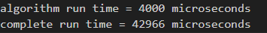
  - C++ boost graph library (BGL):
    - (108 nodes , 290 edges)
      - 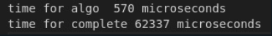
    - (136 nodes ,368 edges)
      - 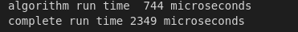
    - (171 nodes ,470 edges)
      - 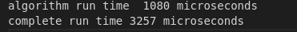
    - (214 nodes , 584 edges)
      - 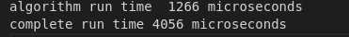
    - (268 nodes , 726 edges)
      - 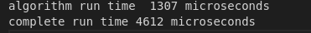
    - (335 nodes , 910 edges)
      - 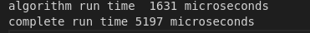
    - (419 nodes , 1140 edges)
      - 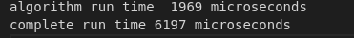
    - (524 nodes , 1406 edges)
      - 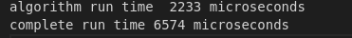
    - (655 nodes , 1758 edges)
      - 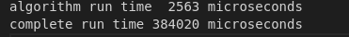
    - (819 nodes , 2226 edges)
      - 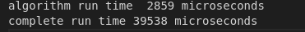
    - (1024 nodes , 2824 edges)
      - 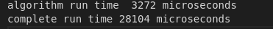
    - (1280 nodes , 3548 edges)
      - 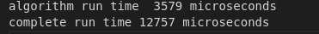
    - (1600 nodes , 4442 edges)
      - 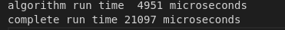
    - (2000 nodes , 5596 edges)
      - 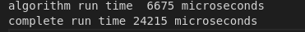
    - (2500 nodes , 6946 edges)
      - 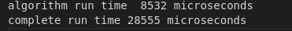
    - (3125 nodes , 8646 edges)
      - 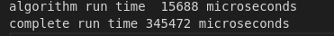
    - (3906 nodes , 10736 edges)
      - 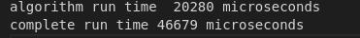
    - (4882 nodes , 14110 edges)
      - 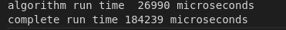
  - Python networkx library:
    - (108 nodes , 290 edges)
    - (136 nodes ,368 edges)
    - (171 nodes ,470 edges)
    - (214 nodes , 584 edges)
    - (268 nodes , 726 edges)
    - (335 nodes , 910 edges)
    - (419 nodes , 1140 edges)
    - (524 nodes , 1406 edges)
    - (655 nodes , 1758 edges)
    - (819 nodes , 2226 edges)
    - (1024 nodes , 2824 edges)
    - (1280 nodes , 3548 edges)
    - (1600 nodes , 4442 edges)
    - (2000 nodes , 5596 edges)
    - (2500 nodes , 6946 edges)
    - (3125 nodes , 8646 edges)
    - (3906 nodes , 10736 edges)
    - (4882 nodes , 14110 edges)
  - Python igraph library:
    - (108 nodes , 290 edges)
    - (136 nodes ,368 edges)
    - (171 nodes ,470 edges)
    - (214 nodes , 584 edges)
    - (268 nodes , 726 edges)
    - (335 nodes , 910 edges)
    - (419 nodes , 1140 edges)
    - (524 nodes , 1406 edges)
    - (655 nodes , 1758 edges)
    - (819 nodes , 2226 edges)
    - (1024 nodes , 2824 edges)
    - (1280 nodes , 3548 edges)
    - (1600 nodes , 4442 edges)
    - (2000 nodes , 5596 edges)
    - (2500 nodes , 6946 edges)
    - (3125 nodes , 8646 edges)
    - (3906 nodes , 10736 edges)
    - (4882 nodes , 14110 edges)
- Single source all destination:-
  - My Implementation:
    - (108 nodes , 290 edges)
      - 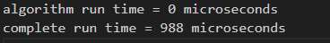
    - (136 nodes ,368 edges)
      - 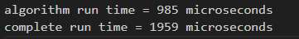
    - (171 nodes ,470 edges)
      - 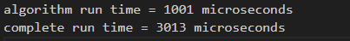
    - (214 nodes , 584 edges)
      - 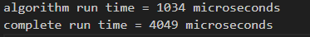
    - (268 nodes , 726 edges)
      - 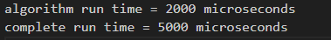
    - (335 nodes , 910 edges)
      - 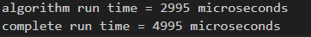
    - (419 nodes , 1140 edges)
      - 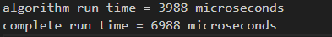
    - (524 nodes , 1406 edges)
      - 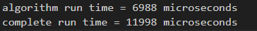
    - (655 nodes , 1758 edges)
      - 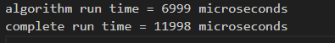
    - (819 nodes , 2226 edges)
      - 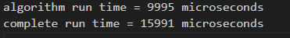
    - (1024 nodes , 2824 edges)
      - 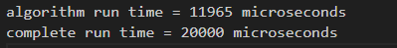
    - (1280 nodes , 3548 edges)
      - 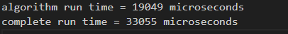
    - (1600 nodes , 4442 edges)
      - 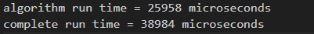
    - (2000 nodes , 5596 edges)
      - 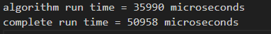
    - (2500 nodes , 6946 edges)
      - 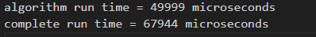
    - (3125 nodes , 8646 edges)
      - 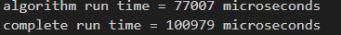
    - (3906 nodes , 10736 edges)
      - 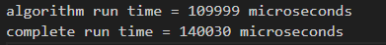
    - (4882 nodes , 14110 edges)
      - 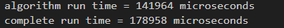
  - C++ boost graph library (BGL):
    - (108 nodes , 290 edges)
      - 
    - (136 nodes ,368 edges)
      - 
    - (171 nodes ,470 edges)
      - 
    - (214 nodes , 584 edges)
      - 
    - (268 nodes , 726 edges)
      - 
    - (335 nodes , 910 edges)
      - 
    - (419 nodes , 1140 edges)
      - 
    - (524 nodes , 1406 edges)
      - 
    - (655 nodes , 1758 edges)
      - 
    - (819 nodes , 2226 edges)
      - 
    - (1024 nodes , 2824 edges)
      - 
    - (1280 nodes , 3548 edges)
      - 
    - (1600 nodes , 4442 edges)
      - 
    - (2000 nodes , 5596 edges)
      - 
    - (2500 nodes , 6946 edges)
      - 
    - (3125 nodes , 8646 edges)
      - 
    - (3906 nodes , 10736 edges)
      - 
    - (4882 nodes , 14110 edges)
      - 
  - Python networkx library:
    - (108 nodes , 290 edges)
    - (136 nodes ,368 edges)
    - (171 nodes ,470 edges)
    - (214 nodes , 584 edges)
    - (268 nodes , 726 edges)
    - (335 nodes , 910 edges)
    - (419 nodes , 1140 edges)
    - (524 nodes , 1406 edges)
    - (655 nodes , 1758 edges)
    - (819 nodes , 2226 edges)
    - (1024 nodes , 2824 edges)
    - (1280 nodes , 3548 edges)
    - (1600 nodes , 4442 edges)
    - (2000 nodes , 5596 edges)
    - (2500 nodes , 6946 edges)
    - (3125 nodes , 8646 edges)
    - (3906 nodes , 10736 edges)
    - (4882 nodes , 14110 edges)
  - Python igraph library:
    - (108 nodes , 290 edges)
    - (136 nodes ,368 edges)
    - (171 nodes ,470 edges)
    - (214 nodes , 584 edges)
    - (268 nodes , 726 edges)
    - (335 nodes , 910 edges)
    - (419 nodes , 1140 edges)
    - (524 nodes , 1406 edges)
    - (655 nodes , 1758 edges)
    - (819 nodes , 2226 edges)
    - (1024 nodes , 2824 edges)
    - (1280 nodes , 3548 edges)
    - (1600 nodes , 4442 edges)
    - (2000 nodes , 5596 edges)
    - (2500 nodes , 6946 edges)
    - (3125 nodes , 8646 edges)
    - (3906 nodes , 10736 edges)
    - (4882 nodes , 14110 edges)
- All pairs Shortest paths:-
  - My Implementation:
    - (108 nodes , 290 edges)
      - 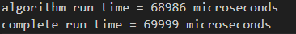
    - (136 nodes ,368 edges)
      - 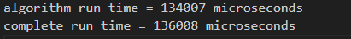
    - (171 nodes ,470 edges)
    - (214 nodes , 584 edges)
      - 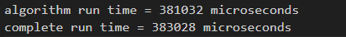
    - (268 nodes , 726 edges)
      - 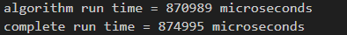
    - (335 nodes , 910 edges)
      - 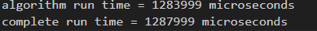
    - (419 nodes , 1140 edges)
    - (524 nodes , 1406 edges)
      - 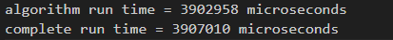
    - (655 nodes , 1758 edges)
      - 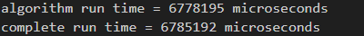
    - (819 nodes , 2226 edges)
    - (1024 nodes , 2824 edges)
      - 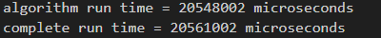
    - (1280 nodes , 3548 edges)
      - 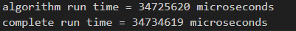
    - (1600 nodes , 4442 edges)
    - (2000 nodes , 5596 edges)
  - C++ boost graph library (BGL):
    - (108 nodes , 290 edges)
      - 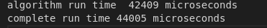
    - (136 nodes ,368 edges)
      - 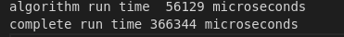
    - (171 nodes ,470 edges)
      - 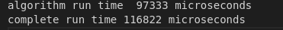
    - (214 nodes , 584 edges)
      - 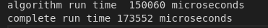
    - (268 nodes , 726 edges)
      - 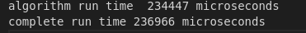
    - (335 nodes , 910 edges)
      - 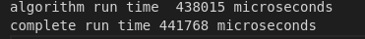
    - (419 nodes , 1140 edges)
      - 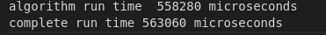
    - (524 nodes , 1406 edges)
      - 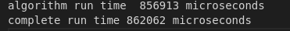
    - (655 nodes , 1758 edges)
      - 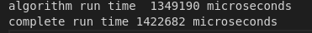
    - (819 nodes , 2226 edges)
      - 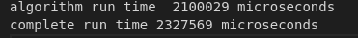
    - (1024 nodes , 2824 edges)
      - 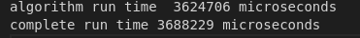
    - (1280 nodes , 3548 edges)
      - 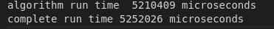
    - (1600 nodes , 4442 edges)
      - 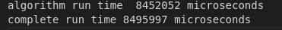
    - (2000 nodes , 5596 edges)
      - 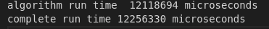
  - Python networkx library:
    - (108 nodes , 290 edges)
    - (136 nodes ,368 edges)
    - (171 nodes ,470 edges)
    - (214 nodes , 584 edges)
    - (268 nodes , 726 edges)
    - (335 nodes , 910 edges)
    - (419 nodes , 1140 edges)
    - (524 nodes , 1406 edges)
    - (655 nodes , 1758 edges)
    - (819 nodes , 2226 edges)
    - (1024 nodes , 2824 edges)
    - (1280 nodes , 3548 edges)
    - (1600 nodes , 4442 edges)
    - (2000 nodes , 5596 edges)
  - Python igraph library:
    - (108 nodes , 290 edges)
    - (136 nodes ,368 edges)
    - (171 nodes ,470 edges)
    - (214 nodes , 584 edges)
    - (268 nodes , 726 edges)
    - (335 nodes , 910 edges)
    - (419 nodes , 1140 edges)
    - (524 nodes , 1406 edges)
    - (655 nodes , 1758 edges)
    - (819 nodes , 2226 edges)
    - (1024 nodes , 2824 edges)
    - (1280 nodes , 3548 edges)
    - (1600 nodes , 4442 edges)
    - (2000 nodes , 5596 edges)

