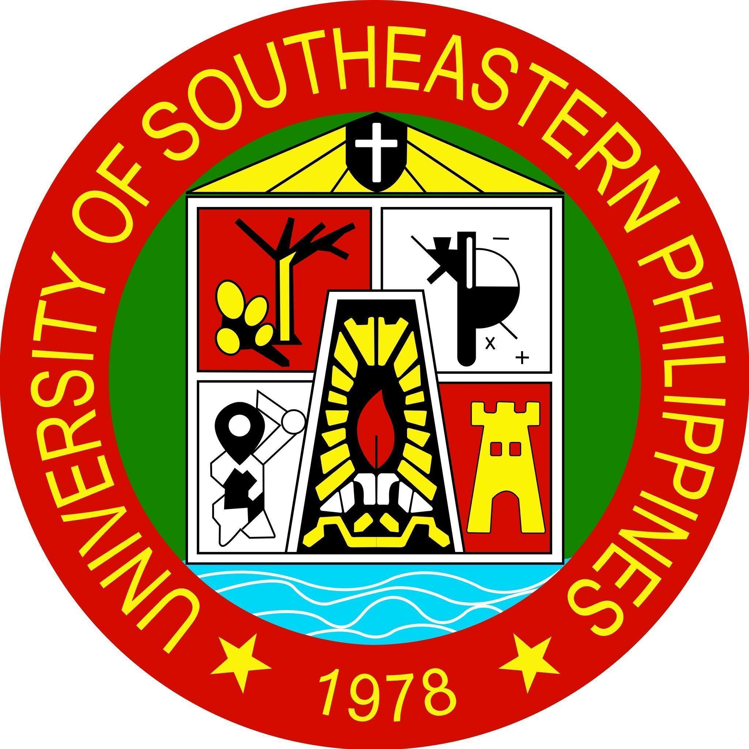
 | Republic of the Philippines  University of Southeastern Philippines  Iñigo St., Bo. Obrero, Davao City 8000  Telephone: (082) 227-8192  Website: www.usep.edu.ph  Email: president@usep.edu.ph | Form No. | FM-USeP-MID-02
 |  | Issue Status | 02
 |  | Revision No. | 01
 |  | Date Effective | 24 September 2026
 |  | Approved by | President
SYLLABUS EVALUATION FORM

Choose One: ☐ New ☐ Major Revision
Faculty Name
Program |  | Academic Unit
Course Title
Course Description
Semester |  | Academic Year

Instructions: Use this form to evaluate course syllabi. For each statement below, place a check (✓) under the appropriate column if the course FULLY meets the requirement, PARTIALLY complying with, or NOT FULFILLING the requirements. For indicators that are not fully met, write down the observed gap and recommended action.

EVALUATION STATEMENT | FULLY | PARTIALLY | NOT FULFILLING | OBSERVED GAP
The USeP Vision, Mission, and Goals are correctly stated in the syllabus.
The Institutional Graduate Attributes (IGAs) are fully listed and accurate.
The course code, title, units, and prerequisites match the approved curriculum.
The course description reflects the PSG or approved Program Structure.
The IGA-PGO-PI alignment table is present and correctly mapped.
The course outcomes (COs) are well-formulated (verb + content + standard).
The COs align with the mapped PGOs and PIs.
The SDG alignment section is present and clearly described.
The student workload is realistic and well-detailed.
Faculty information is complete with consultation hours.
Formative assessments are appropriate and aligned with COs.
Summative assessments are comprehensive and mapped to COs.
The measurement system (rubrics, assessment plan) is clearly stated and appropriate.
The learning plan includes clear ILOs written in the correct format.
The ILOs are aligned with the course outcomes (COs).
The TLAs reflect USeP’s educational philosophy:
- Student engagement is encouraged.
- Learners are given responsibility for their own learning.
- Critical and reflective thinking is promoted.
- Feedback and revision opportunities are provided.
References are updated, relevant, and in APA format.
Classroom policies reflect professionalism, inclusivity, and academic integrity.
Academic honesty and plagiarism policies are clearly stated.
Responsible use of AI tools is clearly addressed.
The syllabus contains the prescribed provision on inclusivity and reasonable accommodation.

Attached Checklist of Frameworks Integrated into Course Syllabus

INTEGRATION AREA | FULLY | PARTIALLY | NOT FULFILLING | OBSERVED GAP
The CDIO Framework (Conceive–Design–Implement–Operate) is embedded in COs, TLAs, or projects.
The Fourth Industrial Revolution (FIRe) skills are explicitly addressed in content or activities.
The course integrates relevant Sustainable Development Goals (SDGs) meaningfully.
The course applies Gender and Development (GAD) principles in language, examples, and policy.
Cultural sensitivity and conflict sensitivity are considered in content and classroom policies.

Recommendations for Course Syllabus Improvement

REVIEWED BY: | CONFORME:
___________________________________  ___________________________________  ___________________________________  (Course Committee)  Date: _____________ | ___________________________  Faculty  Date: _____________

– TO BE FILLED UP BY THE FACULTY SYLLABUS WRITER -
OBSERVED GAP | ACTION TAKEN

ENDORSED BY: | APPROVED BY:
___________________________________  Program Head  Date: _____________ | ___________________________  Dean  Date: _____________

Annex A

Checklist on Conceive, Design, Implement, Operate (Cdio) Framework, Fourth Industrial Revolution (Fire) Framework, Cultural And Conflict Sensitivity, Sustainable Development Goals (SDG)
and Gender and Development (GAD) Framework

Direction: Tick the appropriate box to indicate the presence or absence of the following indicators in the course syllabus reviewed.

COMPONENTS | YES | NO | REMARKS
Conceive, Design, Implement, Operate (CDIO) Framework Checklist
- The course objectives are clearly defined and encourage innovation and idea generation.
- The course provides opportunities for students to engage in iterative design and refinement.
- The course includes hands-on activities and practical implementation.
- The course includes real-world applications and user feedback.
Fourth Industrial Revolution (FIRe) Checklist
- The syllabus promotes critical thinking, creativity, communication, and collaboration through learning activities.
- The syllabus fosters character qualities such as curiosity, initiative, persistence, adaptability, leadership, and social and cultural awareness.
- The syllabus includes content on innovation and promotes inclusive practices in technology use and development.
- The syllabus incorporates discussions on the circular economy, sustainability, and green technologies.
Cultural Sensitivity and Conflict Sensitivity Checklist
- The syllabus content includes localized or culturally relevant examples, contexts, or activities.
- The instructional materials reflected in the syllabus are respectful of local, ethnic, or indigenous knowledge systems.
- Activities promote multicultural awareness, peace education, or community-based perspectives.
Sustainable Development Goals Framework Alignment
- Course topics explicitly or implicitly support one or more SDGs (e.g., Quality Education, Gender Equality, Climate Action)
- Teaching-learning activities encourage sustainability-oriented thinking and advocacy.
- Activities provide opportunities for students to reflect on or act on global/local development issues.
Gender and Development Framework Checklist
Note: At least one indicator must be marked yes to indicate minimum compliance with each domain.
Domain 1: Intended Learning Outcomes
The syllabus contains Intended Learning Outcome/s (ILO) that expect students to demonstrate understanding of one or more domains that can be applied within the context of the course.
1.1 Gender Equality: At least one or more ILOs embrace the principle of equal learning opportunities and expectations for all genders, ensuring fairness in student engagement and achievement.
1.2 Gender Equity: At least one or more ILOs aim to empower underrepresented or marginalized genders in the discipline.
1.3 Gender Sensitivity: At least one or more ILOs promote gender fair values and perspectives.
Domain 2: Teaching-Learning Activities (TLAs)
The Teaching-Learning Activities (TLAs) in the syllabus provide equal opportunities for participation among all learners regardless of their gender.
2.1 Gender Equality: At least one or more TLAs employ classroom activities that ensure equal engagement and participation for all learners.
2.2 Gender Equity: At least one or more TLAs employ classroom activities that support a learning environment that promotes respect and value for all genders.
2.3 Gender Sensitivity: At least one or more TLAs employ classroom activities encompassing various perspectives.
Domain 3: Learning Contents/Topics
The course syllabus’ learning contents integrate content knowledge on gender and women studies.
3.1 Gender Equality: At least one or more learning content/s provide a balanced representation of gender in texts, authors, and theories.
3.2 Gender Equity: At least one or more learning content/s includes discussion on gender issues relevant to different social, cultural, or economic groups.
3.3 Gender Sensitivity: At least one or more learning content/s explicitly include topics or discussions related to gender.
Domain 4: Assessment Tasks (ATs)
Assessment tasks (ATs), which include learning evidence/s (LEs) and assessment activities (AAs), are fair and responsive to gender, use inclusive language, unbiased performance criteria, and accessible formats.
4.1 Gender Equality: At least one or more ATs provide equal opportunities for students of all genders to demonstrate learning through varied assessment formats.
4.2 Gender Equity: At least one or more ATs include flexible assessment tasks provisions for students experiencing gender-related challenges or responsibilities.
4.3 Gender Sensitivity: At least one or more ATs and grading methods are free from gender biases or assumptions.
Curriculum Mapping Alignment
- Course Outcomes (COs) are clearly aligned with Program Goals/Objectives (PGOs) and Program Outcomes (PIs)
- Intended Learning Outcomes (ILOs), Content, TLAs, and Assessment Tasks are consistently aligned and clearly mapped based on the Assessment Plan.
- The Revised Bloom’s Taxonomy is applied across course learning outcomes and assessments, consistent with the appropriate PQF level.

Other Comments:
__________________________________________________________________________________________________________________________________________________________________________________________________________________________________________________________________________________________________________________________________________________________________________________________________________________________________________________________________

