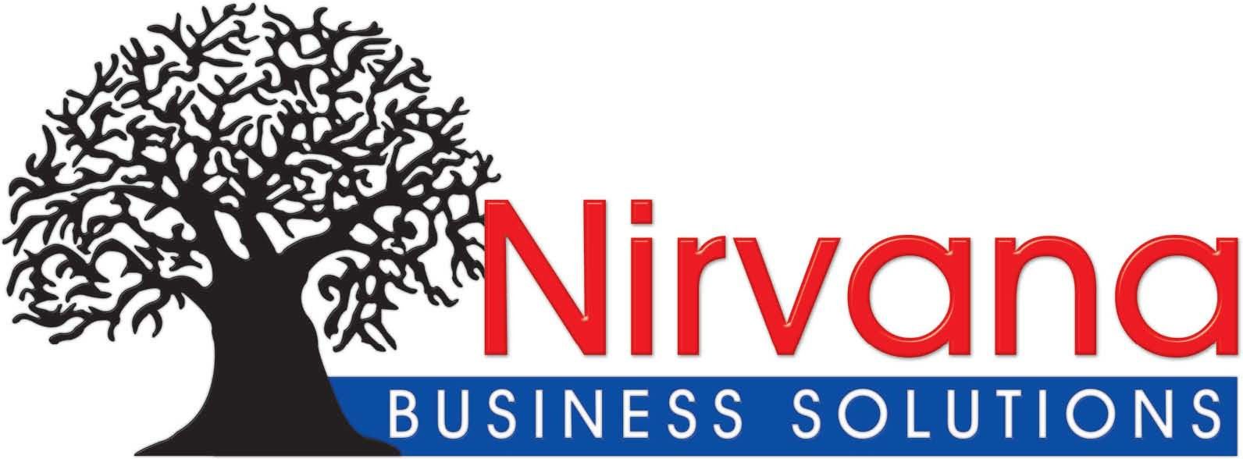

**BUSINESS PROFILE**

We would like to thank you for granting Nirvana Business Solution the opportunity to introduce the company to yourselves. Nirvana Business Solutions is a Zambian Company that started in 2013 in Mufulira as a Training Academy Specialized in Heavy Duty Machine Operations and Safety Trainings. Our Employees are well qualified with extensive experience in the following: Articulated Dump Truck, 360 Degree Excavator, Front End Loader, Tractor, Tractor Loader Backhoe, Motor Grader, Mobile Crane and Roller Compactor. Occupational Health and Safety, Safety Management, Risk Assessment, Safety Health and Environmental Representative, Mines Health and Safety, Construction Health and Safety, First Aid all Levels, Scaffolding Erectors and Heights training.

Our customers list under Constituency Development Fund – (CDF Skills) is as follows:

* Mwinilunga Town Council
* Mansa Municipal Council (Mansa Central Constituency & Bahati Constituency)
* Mwansabombwe Town Council
* Lawing Town Council
* Chipili Town Council
* Luangwa Town Council
* Lumezi Town Council
* Kapiri Town Council
* Mansa Municipal Council
* Kasama Municipal Council( Kasama Central Constituency & Lukasha Constituency)
* Senga Hill Town Council
* Mpulungu Town Council
* Zambezi Town Council
* Chavuma Town Council
* Lukulu Town Council
* Mitete Town Council
* Livingstone City Council
* Kazungula Town Council
* Pemba Town Council
* Sinazongwe Town Council
* Mkushi Town Council
* Chisamba Town Council
* Sesheke Town Council
* Chinsali Town Council
* Mufulira Central Constituency (Mufulira)
* Kankoyo Constituency (Mufulira)
* Kantanshi Constituency (Mufulira)
* Mwense Town Council
* Nkana Constituency (Kitwe City Council)
* Wusakile Constituency (Kitwe City Council )
* Ikelengi Town Council
* Shibuyunji Town Council
* Mumbwa Town Council
* Manyinga Town Council
* Kabompo Town Council
* Solwezi East Constituency (Mushindamo Town Council)
* Solwezi Central (Solwezi Municipal Council)
* Kalulushi Municipal Council
* Chingola Municipal Council)
* Chililabombwe Municipal Council
* Lufwanyama Town Council
* Chimwemwe Constituency (Kitwe City Council)
* Chitambo Town Council
* Mpika Town Council
* Lupososhi Town Council
* Kalomo Town Council
* Mpongwe Town Council
* Siavonga Town Council
* Mambwe Town Council
* Shiwan`gandu Town Council
* Kawambwa Town Council
* Chibombo Town Council
* Kanyama Constituency (Lusaka)

**Other Cooperate Clients are as follows:**

* Chambishi Copper Smelter
* African Wireless
* African Warehousing and Logistics
* Chikankata Town Council
* Likusasa Contractors (Zambia)
* Afro Egypt Engineering (Zambia Botswana and Malawi)
* MPI Zambia
* Venture Communication and construction
* China Communication Service (CCS)
* Vast Solutions Limited
* Frontier Bricks and Pavers
* Crossways Investment
* Huawei (Zambia)
* GNM Projects Zambia
* Avic Innovation International
* Julba Engineering Limited
* Murray and Roberts Mufulira
* China Henan Cooperation Zambia
* Nitrogen Chemicals Zambia
* HIS Towers (Zambia)
* Emerald Telecom Zambia
* Zambia Army Head Quarters

For More Information please don’t hesitate to contact: Mr Elias Mununga – Director Plot 0003 off Chilupulu Road –Suburbs Kamuchanga Next to Eagle Motel Mufulira Zambia Cell +260968463511 +260972602716 Email: eliasmununga@gmail.com