Software Requirements
Specification
for
< LK500 >
Version 1.8 approved
Prepared by < Zhengcao Liu>
<Thorlabs>
<September 2, 2025>
版权所有 不得复制
Copyright © Thorlabs, Inc. All rights reserved.

Contents
1. General Description 3
1.1 Operation system 3
1.2 Standards compliance 3
1.3 Software function 3
2. Specific Requirements 4
2.1 Performance Requirements 4
2.2 External Interface Requirements 4
3. Appendix 7
3.1 Command Response Format 7
3.2 Device Connection 7
3.3 Output mode selection 8
4. Revision History 9

General Description

Operation system
Windows XP, all service packs (32-bit)
Windows 7 (32-bit and 64-bit)
Windows 10(32-bit and 64-bit)
Windows 11(32-bit and 64-bit)

Standards compliance
USB2.0, USB3.0, LAN

Software function
Set and save control parameters
Set options
Show experiment data and curve
Save experiment data
Support SCPI
USB LAN communication

Specific Requirements

Performance Requirements

Support LK500

External Interface Requirements
User Interface
Resolution: 1024*768 default.
Resolution of preview window: 16:9.
Menu Bar:
This section describes the menu options required from the software menu bar.
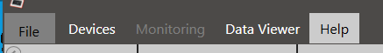
- Load File
Load File, Save, and Print Screen Shot and Exit the Software
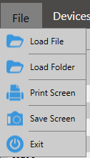
Detail information should be shown, such as record date, sample period, sample length.
Data format of record file shown as bellow.
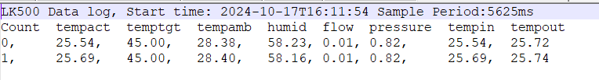
- Data Viewer
View and Analyze Loaded Files
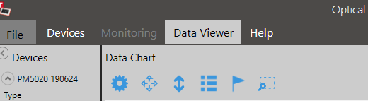
Data viewer window
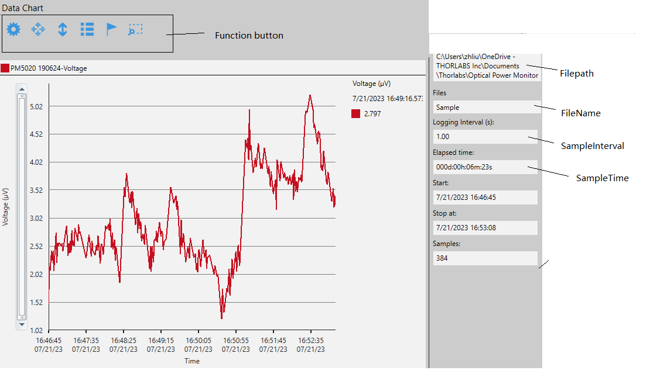
Function button.
Chart Setup button can be used to selected which parameter to be shown.
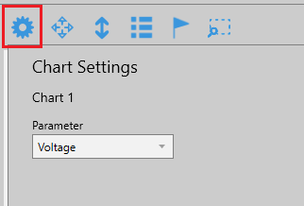
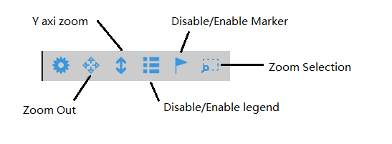
- Device
Connect the LK500 device /Disconnect to the LK500 device.
All the device connected to the PC should be shown in the list.
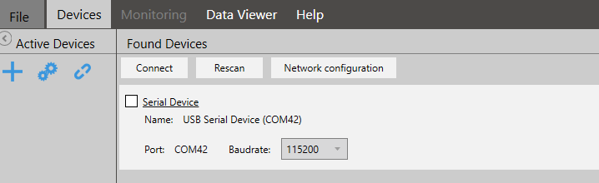
Network can be setup.
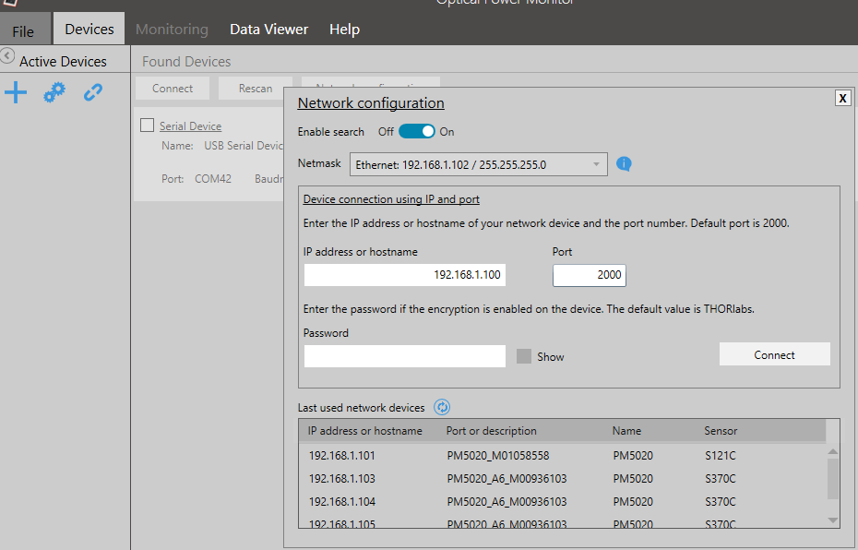
- Save
Save the current control parameter to a file.
- Load
Load the custom parameter form a saved file.
- Help
The 2 items provide there:
- Multilanguage operation: English, Chinese.
- About: the version information.
- Test mode: internal test patterns for troubleshooting.

Curve area:
Most useful information is shown in the Device window.
Include:
Auto Range: enabled to auto setup the range.
On/Off: Enable/Disable the temperature control.
Fan Speed: Setup fan work mode.
Pump: Setup pump speed.
Temperature Unit: Setup the temperature unit.
Kp/Ti/Td/Period: Setup PID for temperature control.
SensorSource: Select the sensor source.
Every time update the information, the Max and Min value should be calculated and updated.
About Auto Range:
It is used to control the range style, when it’s enabled, the shown range will changed according to the data got from the device, when it’s disabled, the shown range will not change. There is a picture explain the difference.
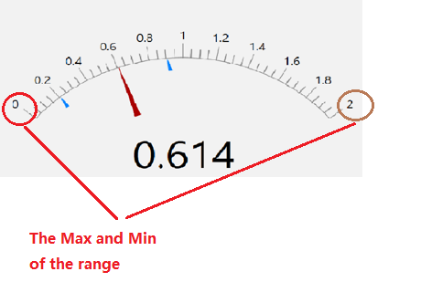
The autorange function is independent form the device, so the software should define two variables, MaxTemp and MinTemp, every time a new data got, a new MaxTemp and MaxTemp is updated, as the code shown below.
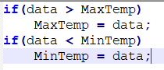
The block in the bottom show information important to use.
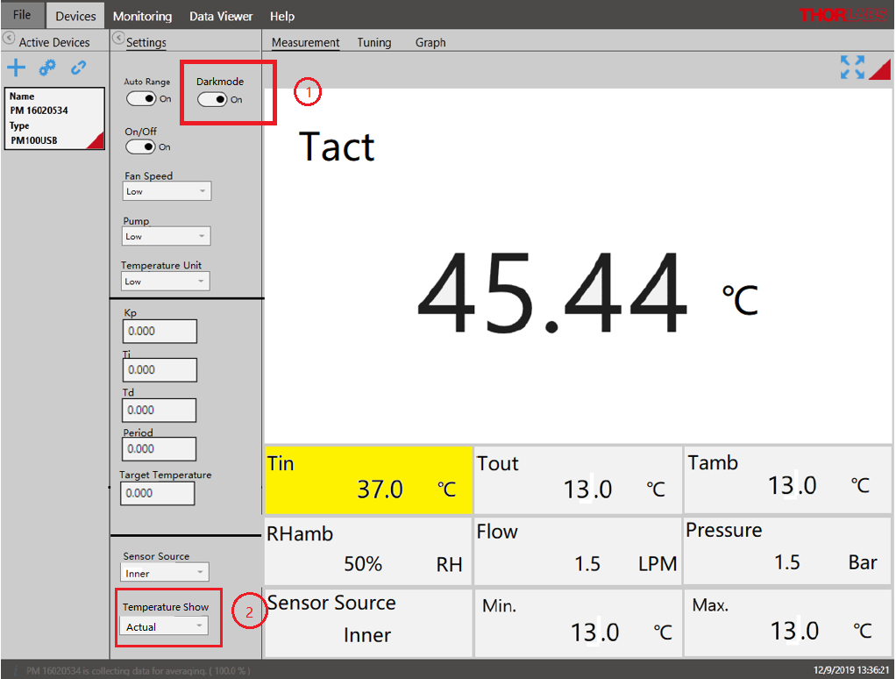
Darkmode is added to the UI, after enabled, the device will turn off all display light.
Temperature show is added, to switch the show between actual temperature and differ temperature.
After Tuning clicked.
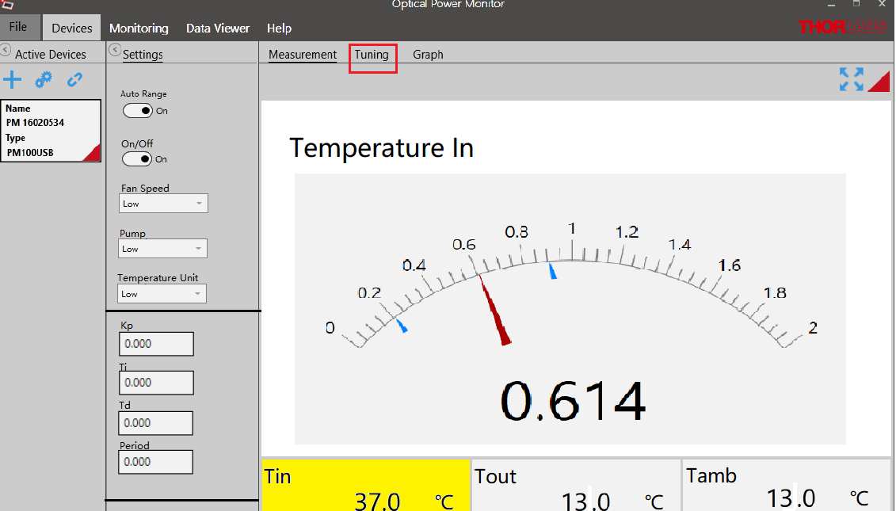

After Graph clicked.
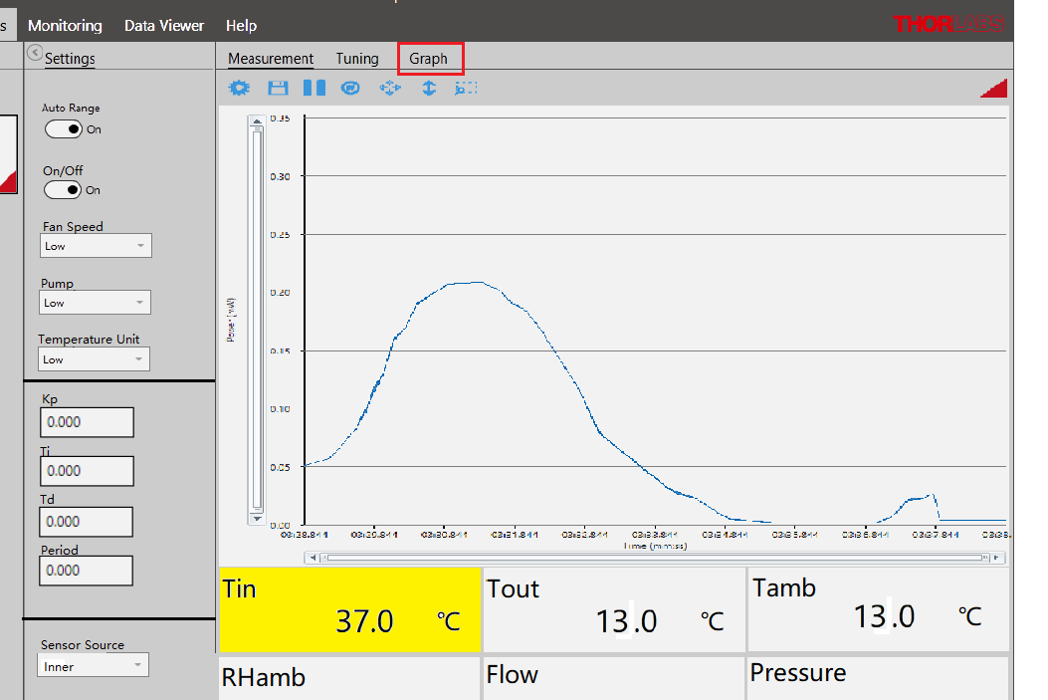
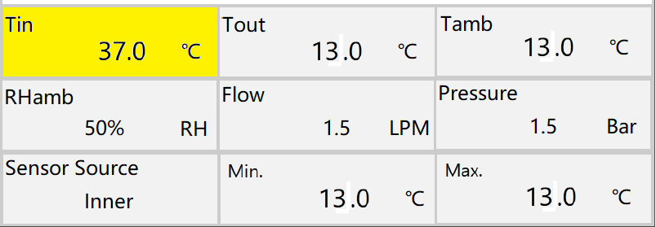

Temperature in(Tin)(℃): range as -10~60.0, floating coordinate value;
Temperature out(Tour)(℃): range as -10~60.0, floating coordinate value;
Actual Temperature (Tact)(℃): range as -10.00~60.00, fixed coordinate value;
Ambient temperature(Tamb) (℃): range as -10.0~60.0, fixed coordinate value;
Flow Sensor (Flow) (LPM): range as 0.0~3.0, fixed coordinate value;
Pressure Sensor (Flow) (Bar): range as 0.0~3.0, fixed coordinate value;
Status: heating, cooling, and normal;
Actual: unit as ℃, resolution as 0.01;
Target: unit as ℃, resolution as 0.1;
Inlet: unit as ℃, resolution as 0.01;
Outlet: unit as ℃, resolution as 0.01;
Ambient: unit as ℃, resolution as 0.01;
Pump: 0%, 10%, 20%......100%, Auto.
Fan: AUTO or MAX
Flow rate: unit as LPM, resolution as 0.1;
Control setting1:
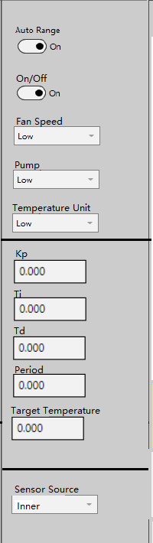
Target temperature (℃): range as -10~60, resolution as 0.1;
Temperature window (℃): range as 0~(+/-)10.0, resolution as 0.1;
Kp: range as 0.01~1000, resolution as 0.01;
Ti: range as 0.01~1000, resolution as 0.01;
Td: range as 0.01~1000, resolution as 0.01;
Period: range as 1.000 ~ 100.000, resolution as 0.001 ;
Control Sensor: Internal/External;
More option have been provided.
If use Inner sensor, no more other option provided.

If use external sensor, customer can select TSP-TH, product of Thorlabs, or use other sensor.
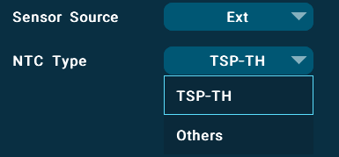
If Ext is selected, more option provided, Beta and Steinhart-Hart are different way to calculate the temperature.
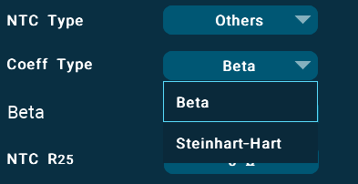
Pump Driver: range as 10~100, resolution as 10, or AUTO;
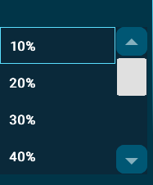
Fan Driver:AUTO or MAX;
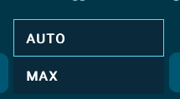
Reset factory default;
Status message: display status message, such as Normal, Warning and Error.

Control setting2:
Sequence
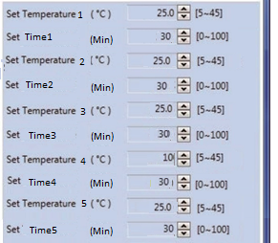
Set temperature 1(℃): range as -5~45, resolution as 0.1;
Set temperature 2(℃): range as -5~45, resolution as 0.1;
Set temperature 3(℃): range as -5~45, resolution as 0.1;
Set temperature 4(℃): range as -5~45, resolution as 0.1;
Set temperature 5(℃): range as -5~45, resolution as 0.1;
Set Time1(Min): range as 0~1000, resolution as 1;
Set Time2(Min): range as 0~1000, resolution as 1;
Set Time3(Min): range as 0~1000, resolution as 1;
Set Time4(Min): range as 0~1000, resolution as 1;
Set Time5(Min): range as 0~1000, resolution as 1;
Monitoring
Use the Monitoring panel to configure, execute, observe, and save long-term monitoring of
connected LK500. Long-term measurements can be recorded with a minimal interval of one PID period.
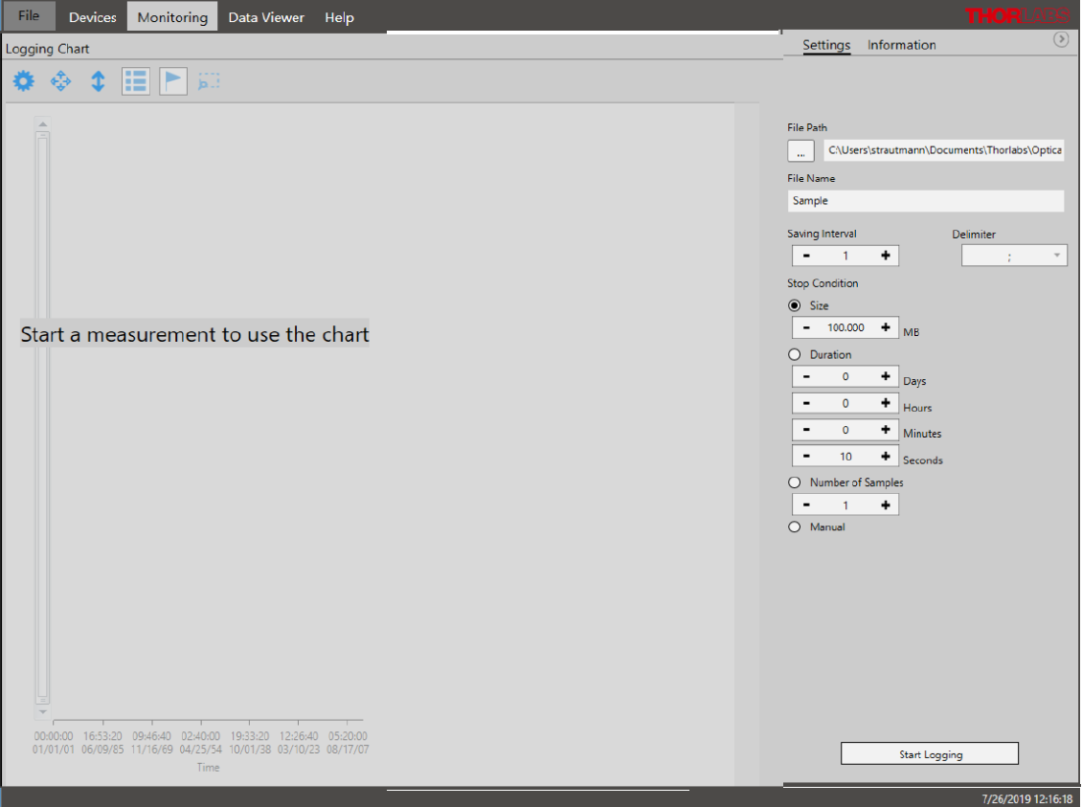
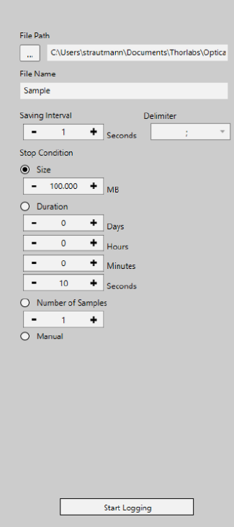
Different type of logging is provided, Size Duration, Number of Samples and manual.
Size Duration: Log the data with a setup file size.
Duration: Log the data with a setup duration time.
Number of Samples: Log the data with setup number of samples.
Manual: Log the data through manual.
Log interval can be setup only multiple of PID period.
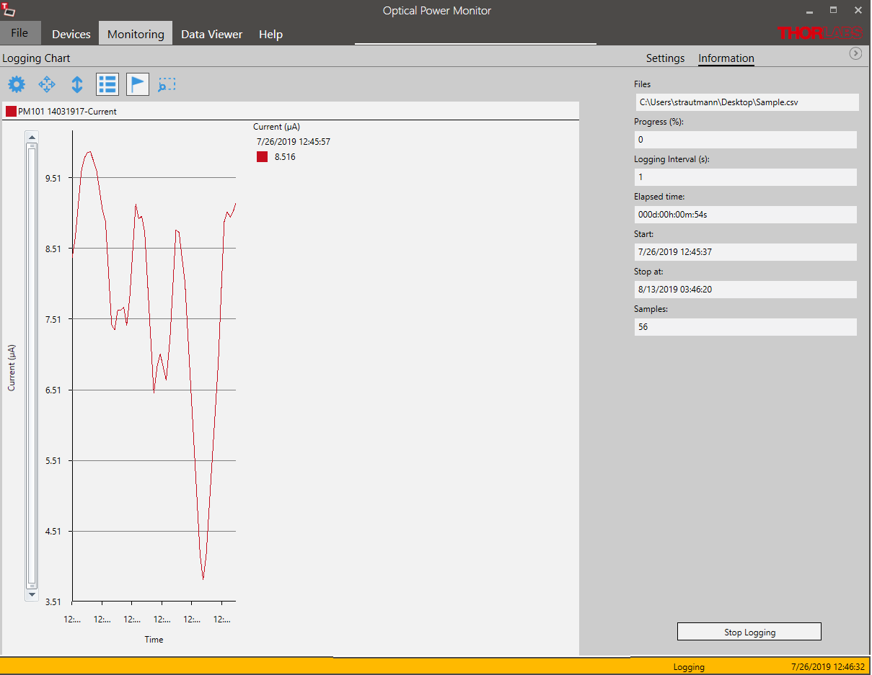
Help
In the HELP interface, choose the language, find the operating instructions, of files and software license under Information and change instrument drivers or update firmware of software.
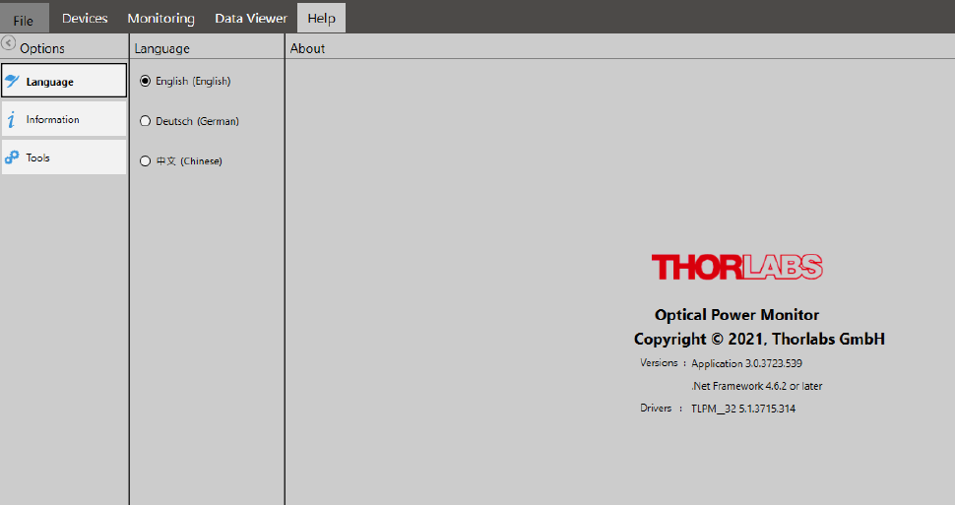

Information
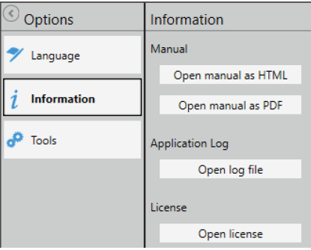
Please find the operating manual as online help (.chm file) or .pdf as well are the log file and the software license here. Please feel free to check for updates frequently.
Tools
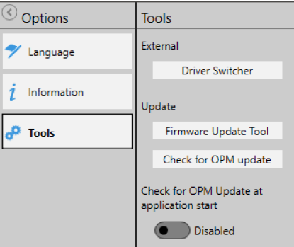
This interface leads you to the driver switcher to change the LK500 driver from the former LK500D.dll to the newer TL.dll. While the LK500D.dll supports older software, generated with the older driver, the TL.dll supports all functions of all Thorlabs power meters. Visit the section Instrument Driver for Thorlabs for more details.
The Firmware Update tool allows to search your PC for already downloaded firmware. In case you did not download a firmware and wish to search the web for the update, please go to the DEVICES menu and open the panel Information. Here, you will find a firmware update tool which searches the web for updates of the firmware for the connectedLK500. For questions, please contact Thorlabs .
Update 2024.12.19
The status of the UI is redefined, in the last version, the function of Status label is same as LK220, but LK500 is different from LK220. Redefine the function as below:
The Status label show the device work states, RUNNING and STOP:
RUNNING: When the device is working:
STOP: When the device is not working.
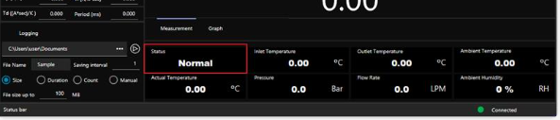
Update 2024.12.20
Heating Cooling selection:
A work mode selection function is added. It includes two options: Cooling, Heating. The style may same as the item shown in red box (this is only a suggestion; UI designer make the final decision). Next version may add AUTO option, but for now just Cooling& Heating.
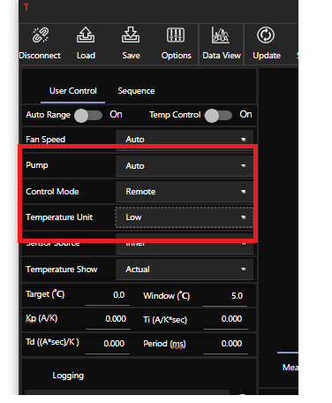
Update on Sequence:
Every step should add a Heating/Cooling selection.
When the Heating/Cooling selection is changed, the minimal value of period should longer than 5 minutes.
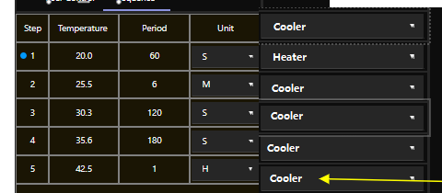
TRIGGERIN & ANALOGINPUT:
TRIGGERIN enable and ANALOGINPUT enable is added, On / Off states for these functions.
The item in the green box is a good choice for them.
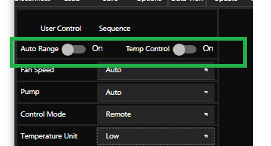
When TRIGGERIN enabled, the Temp Control item cannot be changed by click and its color also changed to indicated that it worked in a different state form the normal state, it should update its state according to the TRIGGERIN signal (read from SCPI command).
When ANALOGINPUT enabled, the Target function cannot be setup and its color also changed to indicated that it worked in a different state form the normal state, it should update the shown number according to the input analog signal (get from SCPI command).
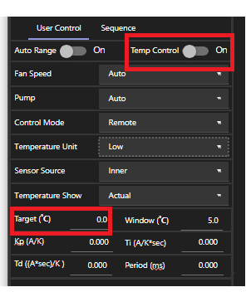
Update 2025.1.3
As we have two mode of temperature control, two set of PID is needed, so SCPI command is updated.
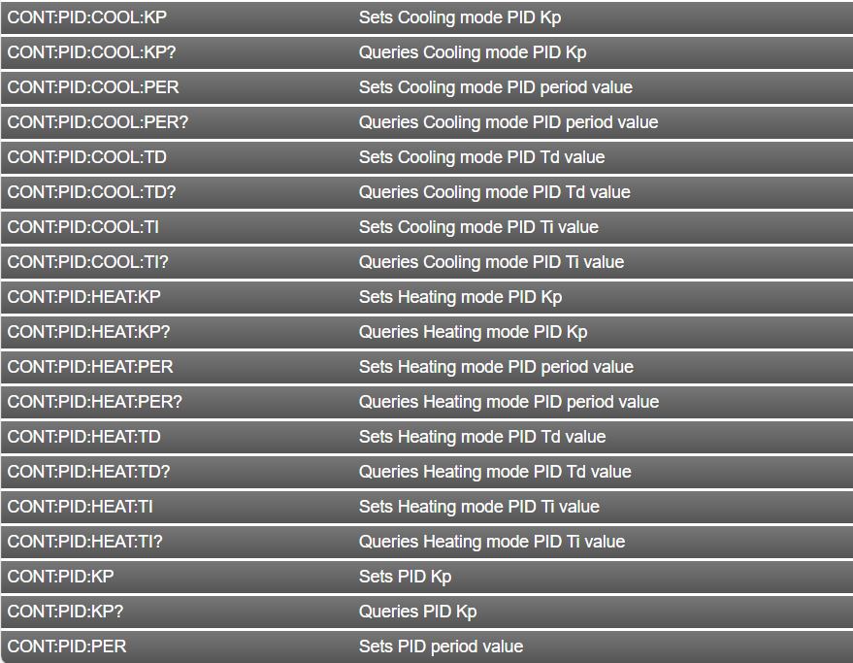
Status label show is updated, there are three show states, “Stop”, “Cooling”, “Heating”. When the device is not working, show “Stop”, after it start to control the temperature, it shows “Cooling” or “Heating”, according to the work mode.
Update 2025.3.14
Error and Warning is updated, please update the GUI when warnings and error occurs.
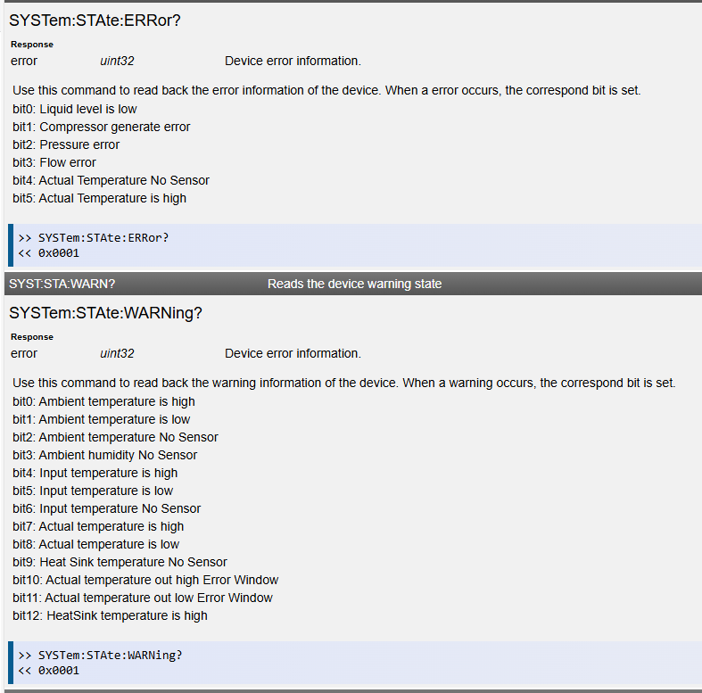
GUI should update according to the readded warning and error information.
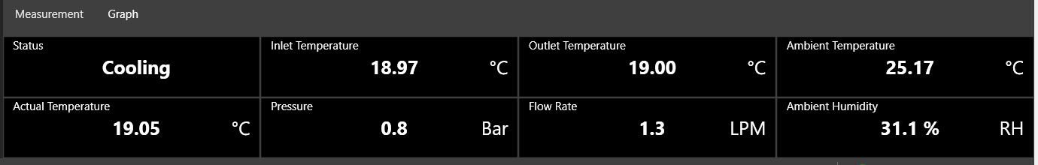

Update 2025.3.18
Some suggest about error warning show, just for reference.
Status bar show detail information, also the icon of connected will change according to error and warning message.
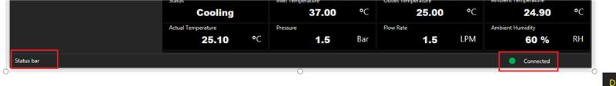
Error Show Req:
- Show a dialog with error information when a error occurred.
- For NoSensor error, show “NoNsensor” on the according number show item.
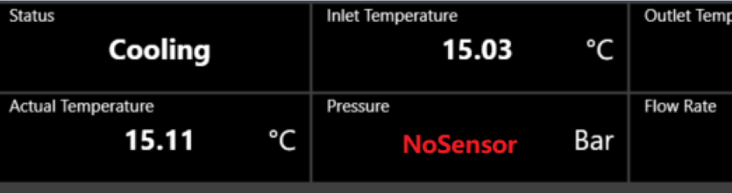
- When actual Temperature High error occurred, keep the temperature show and turn the background into red color, tell the customer which temperature is error also tell the customer how high the temperature is.
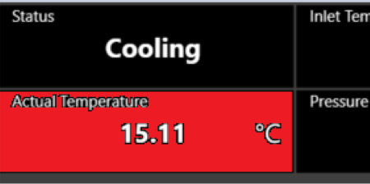
Warning Show Req:
- For temperature is high or temperature low warning(shown on the GUI), the temperature still keep show, just change the background color to yellow. HeatSink High not included, because its temperature not shown on the GUI.
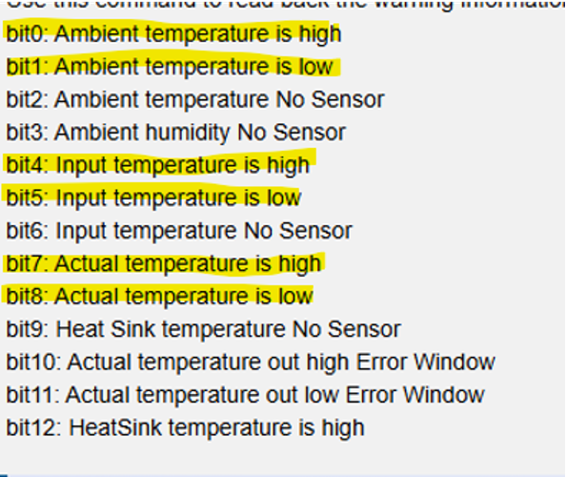
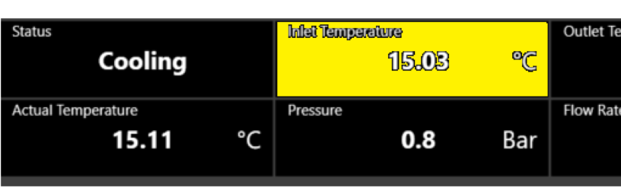
- For NoSensor warning, Show NoSensor with yellow color. HeatSink High not included, because its temperature not shown on the GUI.
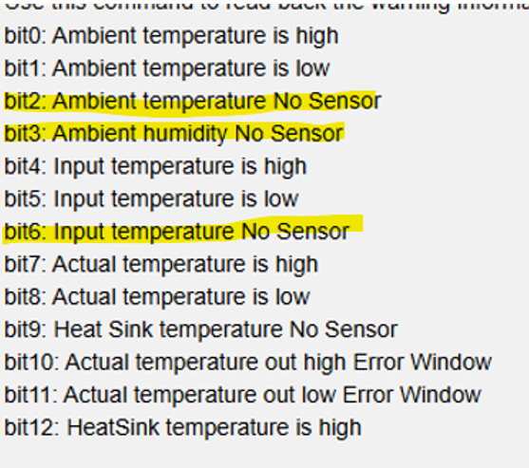
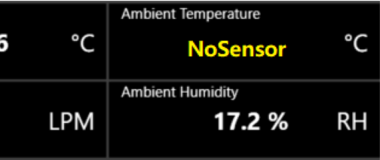
- For Error Window warning, change the Actual temperature background color into yellow
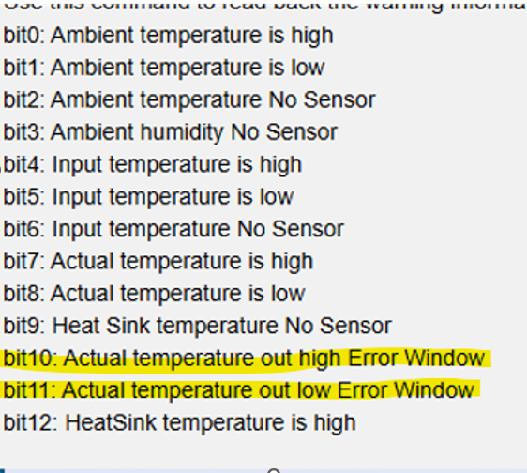
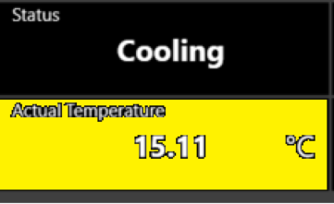

Update 2025.4.11
We have received the review feedback, some update is needed, as followed.
- The naming for controls between the device and the software should be the same. For example, make temp control run/stop.
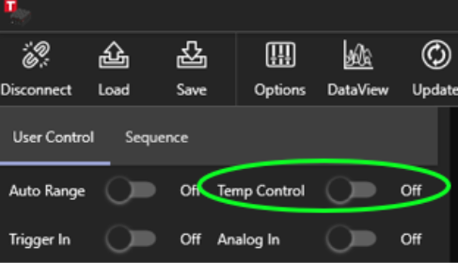
- Plot line in DataView and graph should keep same with Device, include Tact, Ttgt,Tin,Tout and Tamb.
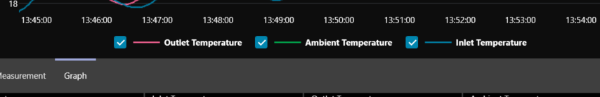
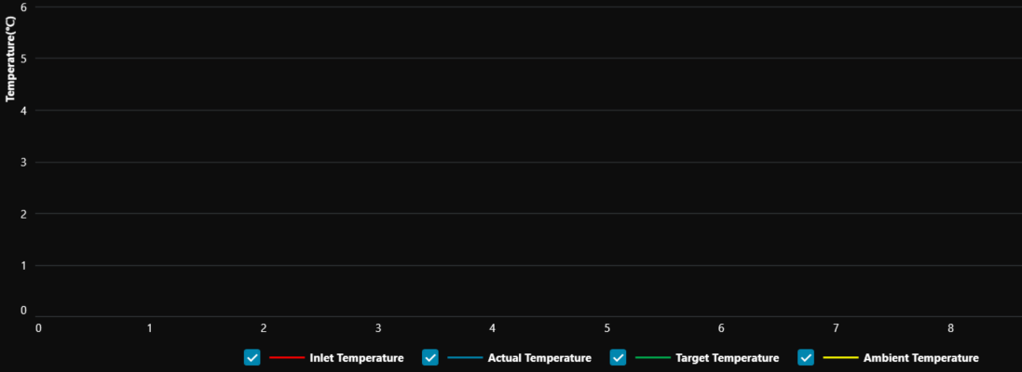
- Values should always display the same number of decimal points, see the dial display below.
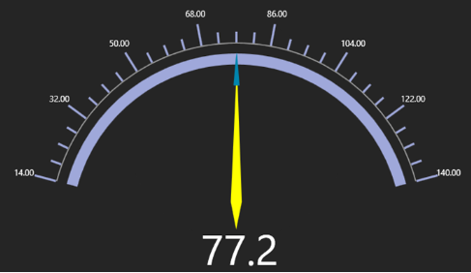
the dial display
- Include units wherever possible. For example:
- The sequence mode inputs.
- PID controls on the device.
- The digital above.
- The PID Unit should be removed.
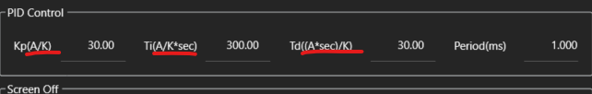
Update 2025.4.16
- Remove AutoReconnect function.
- Temp Control update to RUN/STOP.
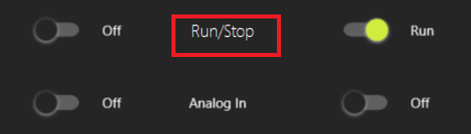
- The unit of DataView can be selected with a Combo Box.
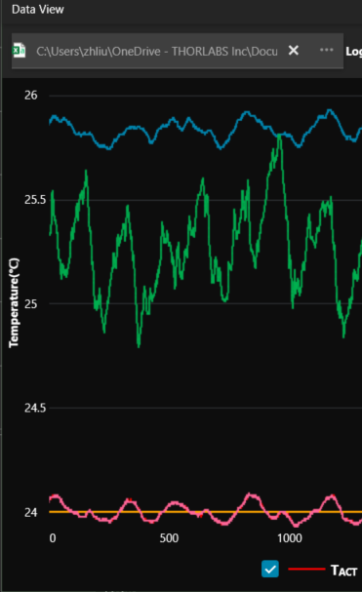
Update 2025.9.2
- Software logging time is not accurate, please add time record.
- Add cycle setup function as the firmware have added cycle function.
In CYCLE mode, the user can program 1 to 100 distinct temperature levels. A “ramp” time (in minutes) can be programmed for each step to determine how long it will take to get from the starting temperature to the stopping temperature. A “hold” time (also in 0.1minutes) can be programmed to determine how long the system will stay at the stopping temperature before moving on to the next step. During any step, CYCLE Mode can be paused, stopping the ramp or hold timers at their present count. Removing the paused function will resume the cycle at the same point at which it was paused.
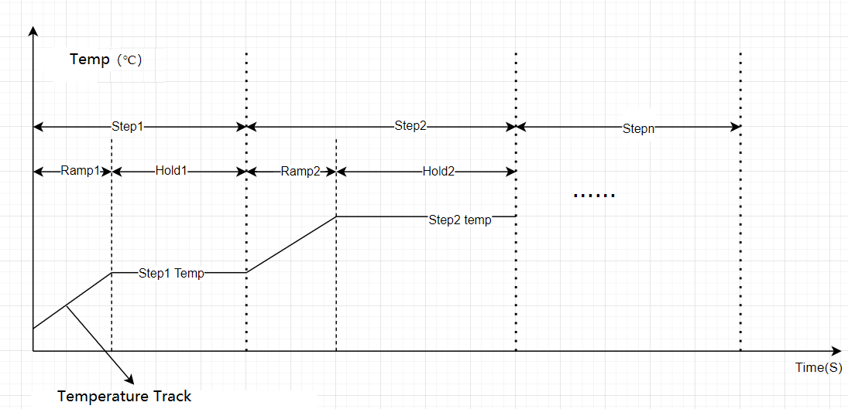
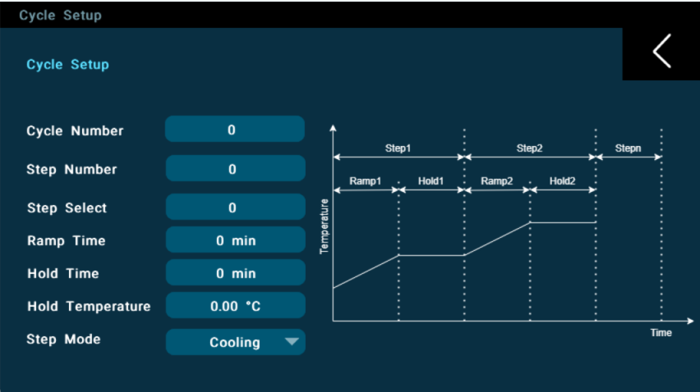
There are seven parameters that should be setup before the cycle work,
Cycle Number: cycle repeat number
Step Number: Step number in one cycle
Step Select: Which step is setup for now
Ramp Time: Ramp time for the selected step
Hold Time: Hold time for the selected step
Hold Temperature: hold temperature for the selected step
Step Mode: the work mode of the select step, Heating or cooling

Firmware will update information on the screen; software also should show the information.
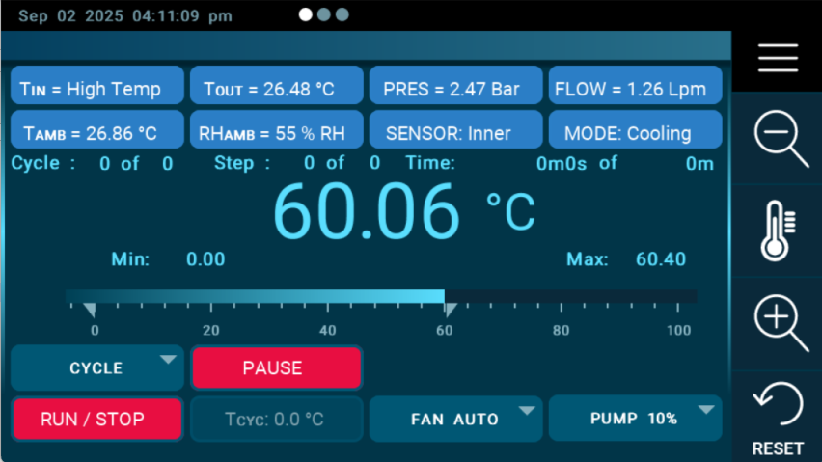
SCPI command for cycle
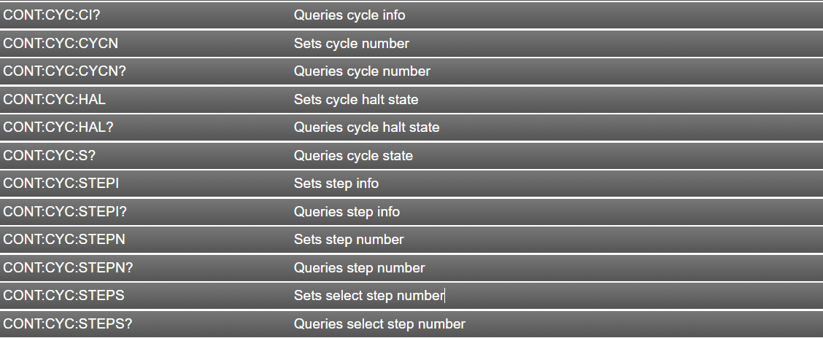
- Add compressor error show, more detail error information can be shown on software.
With the new command added, software can get error information with this command.
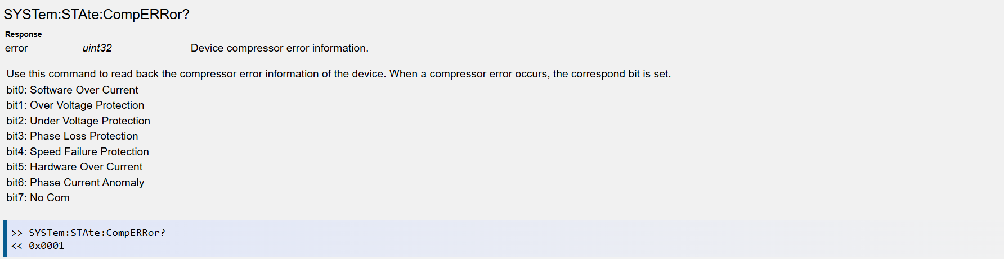
- Encryption is added; we have discussed that before, Jetty have designed the UI, I just copy it from the email.
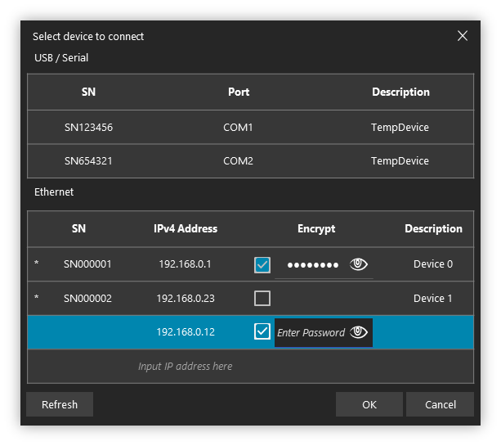
1. If manually entering an IP, the user can optionally check "encrypt." If checked, a password input field will be displayed. After entering the password, further relevant information will be obtained through background communication. The OK button will be unavailable at this time.
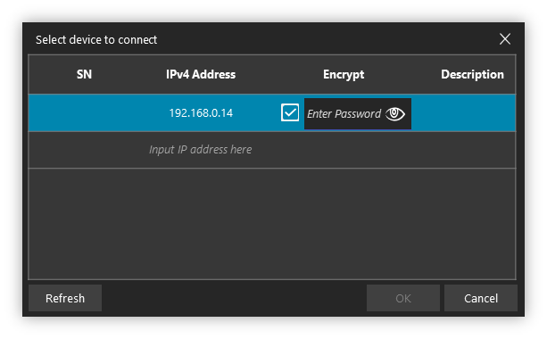
- After the initial communication is completed, the device's SN and model information will be displayed. Thereafter, the device can be used for further connections. The OK button will be available.
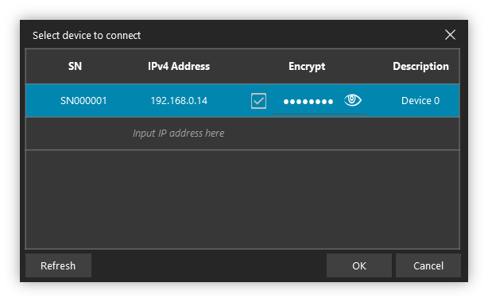
- If the upper computer actively initiates paging or the refresh button is pressed, the encryption status will be displayed based on the state returned by the device, and modifying the encryption status will not be supported.
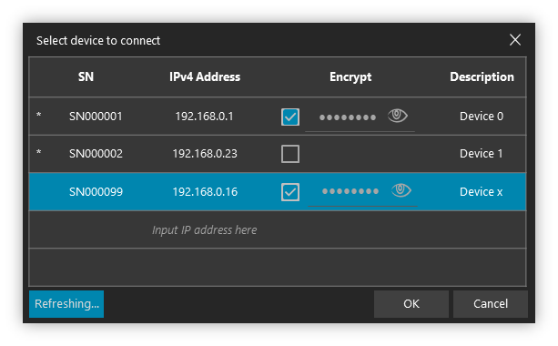

Appendix

Device Connection

Revision History

Revision | Effective Date | Description of Change | Revision Originator
V1.0 | 2024-10-21 | Initial Document created
V1.2 | 2024-12-18 | Add description of autorange
V1.2 | 2024-12-19 | Status label redefinition  Update parameter range
V1.3 | 2024-12-20 | TRIGGERIN ANALOGIN added  Cooler Heater added
V1.4 | 2025-3-16 | Error and warning added
V1.5 | 2025-3-18 | Error and Warning show added.
V1.6 | 2025-4-11 | Add feedback information from review.
V1.7 | 2025-4-16 | AutoReconnect remove && DataView unit select
V1.8 | 2025-9-2

List of reference：

