Software Requirements
Specification
for
< PDXC >
Version 2.19
Prepared by < Yuanlei >
<Thorlabs>
<OCT. 16th, 2025>
版权所有 不得复制
Copyright © Thorlabs, Inc. All rights reserved.

Contents
1. General Description 3
1.1 Operation system 3
1.2 Standards compliance 3
1.3 Software function 3
2. Specific Requirements 3
2.1 Performance Requirements 3
Support PDXC 3
2.2 Interface Requirements of PDX1 3
2.3 Interface Requirement of PDXR1(the whole part is new) 11
3. Appendix 13
3.1 Command list 13
3.2 Meeting notes (2019.09.04): 13
4. Revision History 14

General Description

Operation system
Windows 10(32-bit and 64-bit)
Windows 11

Standards compliance
USB2.0, RS-232

Software function
Easier way of setting and displaying parameters graphically
Set and save control parameters
Set options
Add an option for the stage init position after a power cycle(command: INITPOS?)
Show experiment data and curve
Save experiment data
Support Daisy-chain function, which can control at most 12 devices at a time.
Support SMC interface which added in new hardware.
Support Disable/Enable button for emergency.
Support D-Sub interface, closed-loop stages, including PDX1 and PD2, PDXR1.
Support Analog In mode in Open loop of D-Sub Stages(with or without encoder), Support Analog In mode in SMC output stages.

Specific Requirements

Performance Requirements

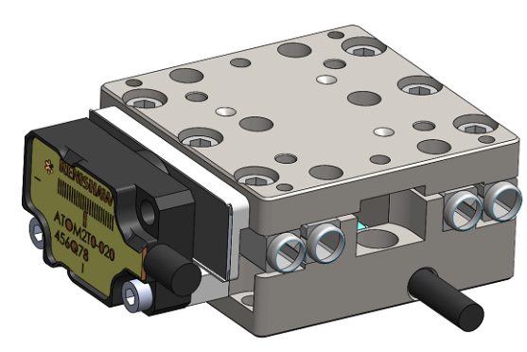
Support PDXC

Interface Requirements of PDX1
User Interface
Resolution: 1024*768 default.
Resolution of preview window: 16:9.

Menu Bar:
This section describes the menu options required from the software menu bar.


- Connect / Disconnect
Connect the device /Disconnect to the device.
- Store all Settings into device(s).
Store all necessary configurations for device, such as last position, velocity, step size etc. There are also parameters set in Trigger Mode.
- Home: Home the device(s) to find the 0 position of the stage.
- Options
The 3 items provide there:
- Settings: Set device parameters.
- Impulse Response (Not named Enquiries): Load and display data form device (now Hiding).
- Miscellaneous: Localization and theme setting.
- Update
Check for newer version of software.
- Support
Send email to techsupport@thorlabs.com
- Help
Device and software information.
Other Menus:
1. Restore
Used to restore all parameters to factory values.
- Disable
Used to Disable/Enable the device in emergency case.
When devices are disabled, the functions that moving the stage are forbidden, but the communication still keep going, and respond.

Controller SN display:
It can display SN of current controller, as illustrated in the plot bellow, where the SN is PDXC_V01, containing 8 letters.
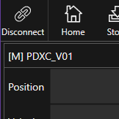

Status Bar:
The status indicator on the right side of status bar, usually has 4 kinds of state:
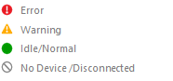
We can define these statuses by:
Error: The software has not received specific return-string in specific time. In detailed requirements, we want to have every error message a pop-up window to let user know and confirm, except that there only being a warning info (not pop-up, just displaying) in open loop when jogging out of scale range.
Warning: The software has received warning info from device.
Normal: The software has received all specific return-string in specific time, and no warning.
No device: The software cannot send command through interface, usually for USB port.
Besides, we need one more symbol to show current stage activated, D-sub or SMC, where it can pop-up message about the S/N and Item Number of stage by clicking or mouse on it for a short time. Or Just put this information into Options, got by command SN2? First time on power-up once.
Could it display all the information of the current stage instead of only show the SN of stage?

Value area (Main Interface):
The software can query the device’s mode upon power on, using command ‘SW?’ result of 0 means D-sub mode with encoder, of 1 means SMC mode, of 2 means D-sub mode without encoder (for future PD2).
D-sub output with encoder (SW=0):
For PDX1 stage:
Open Loop
Position: target and actual position, range -10.00000 to +10.00000 mm,
Velocity: 2 to 20 mm/s,
Jog Step: distance for each move action,
Trigger Mode: Such as the Closed Loop described below.
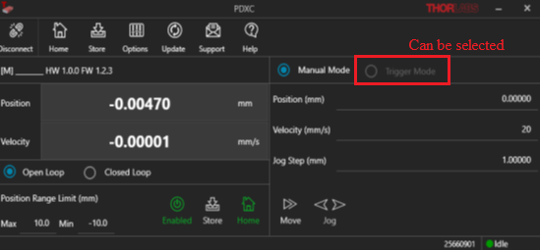

Closed Loop
Position: target and actual position, range -10.00000 to +10.00000 mm,
Velocity: 2 to 20 mm/s,
Jog Step: distance for each move action,
Trigger Mode
It can be enabled or disabled for external Trigger, by select the correspond mode. The user should make it work only in Closed Loop and Homed, before switching to this mode. This function is used to allow the device to operate under external control (I/O port in backend side of device). In default its input range of +10V to -10V stands for +10mm to -10mm position.
It is recommended that the GUI looks like this, where both Move and Jog buttons can be seen for either 1 in 3 sub modes in the Trigger mode, which make it flexible for user to manual move the stage while in Trigger mode.
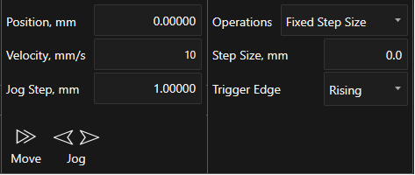
They are three operations inside Trigger Mode, Analog In, Fixed Step and Fixed Positions, here are the basic explanation.
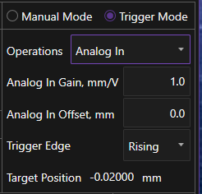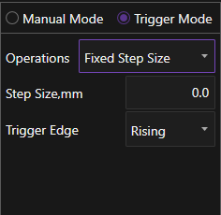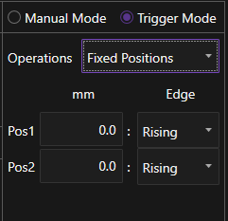
Analog In: User can set the gain and offset of analog in signal to represent the position of stage. By default, the input range of analog In signal is from -10V to 10V, representing positon of -10mm to 10mm with 1x for Gain and 0 for offset. User can set these two values accord to their applications. The mechanism of this operation works on the Trigger Edge selected to drive the stage to the Target Position displayed in bottom.
Fixed Step: In this operation the Trigger Edge will trigger to move the stage by a distance, specified by Step Size value each time.
Fixed Positions: In this operation, Pos1 will be executed on its Triger Edge selected while Pos2 will be executed on its Trigger Edge selected, too. This two steps will do in staggered way
Others:
Position Range Limit: Set the min and max value of position.
For PDX2 Stage:
Open Loop
Position: target and actual position, range -2.500000 to +2.50000 mm,
Velocity: 1 to 10 mm/s,
Jog Step: distance for each move action,0.0003 to 2.5mm

Closed Loop
Position: target and actual position, range -2.500000 to +2.50000 mm,
Velocity: 1 to 10 mm/s,
Jog Step: distance for each move action ,0.0003 to 2.5mm
Trigger Mode:
Analog In: User can set the gain and offset of analog in signal to represent the position of stage. The range of Gain was from 0.1 to 1, so the target position = Vin*Gain + offset. By default, the input range of analog In signal is from -10V to 10V, representing target positon of -2.5 to 2.5 mm with 0.4x for Gain and 0 for offset.
User can set these two values accord to their applications. The mechanism of this operation works on the Trigger Edge selected to drive the stage to the Target Position displayed in bottom.
Fixed Step: In this operation the Trigger Edge will trigger to move the stage by a distance, specified by Step Size value each time.
Fixed Positions: In this operation, Pos1 will be executed on its Triger Edge selected while Pos2 will be executed on its Trigger Edge selected, too. This two steps will do in staggered way.

For PDX3 Stage:
Open Loop
Position: target and actual position, range -25.00000 to +25.00000 mm,
Velocity: 1 to 10 mm/s,
Jog Step: distance for each move action,0.0003 to 25.00000mm

Closed Loop
Position: target and actual position, range -25.00000 to +25.00000 mm,
Velocity: 1 to 10 mm/s,
Jog Step: distance for each move action ,0.0003 to 25.00000mm
Trigger Mode:
Analog In: User can set the gain and offset of analog in signal to represent the position of stage. The range of Gain was from 0.1 to 1, so the target position = Vin*Gain + offset. By default, the input range of analog In signal is from -10V to 10V, representing target position of -25 to 25 mm with 2.5x for Gain and 0 for offset.
User can set these two values accord to their applications. The mechanism of this operation works on the Trigger Edge selected to drive the stage to the Target Position displayed in bottom.
Fixed Step: In this operation the Trigger Edge will trigger to move the stage by a distance, specified by Step Size value each time.
Fixed Positions: In this operation, Pos1 will be executed on its Triger Edge selected while Pos2 will be executed on its Trigger Edge selected, too. This two steps will do in staggered way.

For PDX4 Stage:
Open Loop
Position: target and actual position, range -6.00000 to +6.00000 mm,
Velocity: 1 to 15 mm/s,
Jog Step: distance for each move action,0.0003 to 6.00000mm

Closed Loop
Position: target and actual position, range -6.00000 to +6.00000 mm,
Velocity: 1 to 15 mm/s,
Jog Step: distance for each move action ,0.0003 to 6.00000mm
Trigger Mode:
Analog In: User can set the gain and offset of analog in signal to represent the position of stage. The range of Gain was from 0.1 to 1, so the target position = Vin*Gain + offset. By default, the input range of analog In signal is from -10V to 10V, representing target position of -6.0 to 6.0 mm with 0.6x for Gain and 0 for offset.
User can set these two values accord to their applications. The mechanism of this operation works on the Trigger Edge selected to drive the stage to the Target Position displayed in bottom.
Fixed Step: In this operation the Trigger Edge will trigger to move the stage by a distance, specified by Step Size value each time.
Fixed Positions: In this operation, Pos1 will be executed on its Triger Edge selected while Pos2 will be executed on its Trigger Edge selected, too. This two steps will do in staggered way.

For PDXZ1 Stage:
Open Loop
Position: target and actual position, range -2.2500000 to +2.250000 mm,
Velocity: 1 mm/s,
Jog Step: distance for each move action,0.0001 to 2.25mm

Closed Loop
Position: target and actual position, range -2.2500000 to +2.250000 mm,
Velocity: 1 mm/s,
Jog Step: distance for each move action ,0.0001 to 2.25mm
Trigger Mode:
Analog In: User can set the gain and offset of analog in signal to represent the position of stage. The range of Gain was from 0.1 to 1, so the target position = Vin*Gain + offset. By default, the input range of analog In signal is from -10V to 10V, representing target position of -2.25 to 2.25 mm with 0.4x for Gain and 0 for offset.
User can set these two values accord to their applications. The mechanism of this operation works on the Trigger Edge selected to drive the stage to the Target Position displayed in bottom.
Fixed Step: In this operation the Trigger Edge will trigger to move the stage by a distance, specified by Step Size value each time.
Fixed Positions: In this operation, Pos1 will be executed on its Triger Edge selected while Pos2 will be executed on its Trigger Edge selected, too. This two steps will do in staggered way.

For PDX1A/PDX1AV Stage:
Open Loop
Position: target and actual position, range -10.00000 to +10.00000 mm,
Velocity: 1 mm/s,
Jog Step: distance for each move action,0.0001 to 10.00000mm

Closed Loop
Position: target and actual position, range -10.00000 to +10.00000 mm,
Velocity: 1 mm/s,
Jog Step: distance for each move action, 0.0001 to 10.00000 mm
Trigger Mode:
Analog In: User can set the gain and offset of analog in signal to represent the position of stage. The range of Gain was from 0.1 to 1, so the target position = Vin*Gain + offset. By default, the input range of analog In signal is from -10V to 10V, representing target positon of -10.00 to 10.00 mm with 1.0x for Gain and 0 for offset.
User can set these two values accord to their applications. The mechanism of this operation works on the Trigger Edge selected to drive the stage to the Target Position displayed in bottom.
Fixed Step: In this operation the Trigger Edge will trigger to move the stage by a distance, specified by Step Size value each time.
Fixed Positions: In this operation, Pos1 will be executed on its Triger Edge selected while Pos2 will be executed on its Trigger Edge selected, too. This two steps will do in staggered way.

For PDX1D/PDX1DV Stage:
Open Loop
Position: target and actual position, range -10.00000 to +10.00000 mm,
Velocity: 1 ~10 mm/s,
Jog Step: distance for each move action,0.0001 to 10.00000mm

Closed Loop
Position: target and actual position, range -10.00000 to +10.00000 mm,
Velocity: 1~10 mm/s,
Jog Step: distance for each move action, 0.0001 to 10.00000 mm
Trigger Mode:
Analog In: User can set the gain and offset of analog in signal to represent the position of stage. The range of Gain was from 0.1 to 1, so the target position = Vin*Gain + offset. By default, the input range of analog In signal is from -10V to 10V, representing target position of -10.00 to 10.00 mm with 1.0x for Gain and 0 for offset.
User can set these two values accord to their applications. The mechanism of this operation works on the Trigger Edge selected to drive the stage to the Target Position displayed in bottom.
Fixed Step: In this operation the Trigger Edge will trigger the stage to move by a distance, specified by Step Size value each time.
Fixed Positions: In this operation, Pos1 will be executed on its Triger Edge selected while Pos2 will be executed on its Trigger Edge selected, too. These two steps will do in staggered way.

For PDXG1 Stage:
Open Loop
Position: target and actual position, range -8.00000 degrees to +8.00000 degrees
Velocity: 1~10 degree/s,
Jog Step: distance for each move action, 0.0004 to 8.000000 degrees

Closed Loop
Position: target and actual position, range -8.00000 degrees to +8.00000 degrees
Velocity: 1 mm/s,
Jog Step: distance for each move action, 0.0004 to 8.000000 degrees
Trigger Mode:
Analog In: User can set the gain and offset of analog in signal to represent the position of stage. The range of Gain was from 0.1 to 1, so the target position = Vin*Gain + offset. By default, the input range of analog In signal is from -10V to 10V, representing target position of -8.00 to 8.00 degrees with 1.25x for Gain and 0 for offset.
User can set these two values accord to their applications. The mechanism of this operation works on the Trigger Edge selected to drive the stage to the Target Position displayed in bottom.
Fixed Step: In this operation the Trigger Edge will trigger the stage to move by a distance, specified by Step Size value each time.
Fixed Positions: In this operation, Pos1 will be executed on its Triger Edge selected while Pos2 will be executed on its Trigger Edge selected, too. These two steps will do in staggered way.

Plot area (Impulse Response)(hided already):
A plot area required for the physical connected equipment, there should be able to display bellowing data:
The curve is Position (mm), input range from -1000000 to 1000000, which stands for -10mm to 10mm. We can replace Channel X/Y/Z by Position instead in the chart above.
It works only in D-sub mode, can support both open loop and closed loop. The firmware will make the commands compatible with each other so the software just send the same command.
It is better we can add FFT function in the GUI, which can reveal the resonance info hidden in the temporal response of the voltage/position.
It could be helpful if the GUI can calculate and plot speed/acceleration curves according to the position curves it gets from the controller.
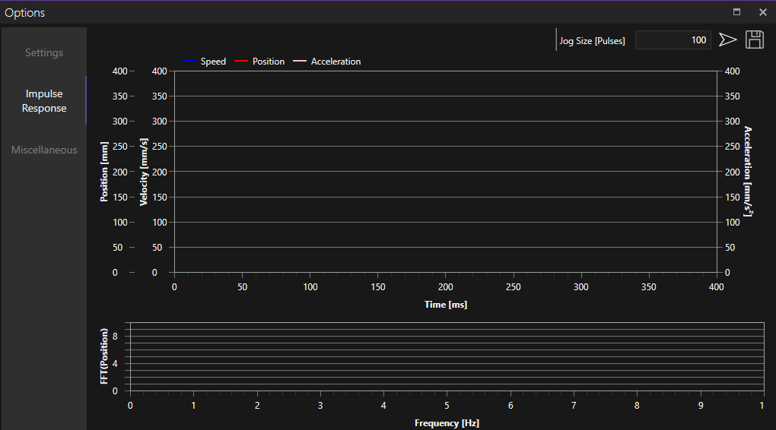
The GUI should support multi-device operations, the mode of which here is Daisy-chain operations.
Daisy-Chain Mode Support:
A special mode that several devices can work in chain, called daisy-chain mode, in this case several devices will response to single command, but at different format.
There is only one Main, others are Secondaries, and the software will only connect to Main only through USB port, place command or inquiry to all device, including Main and all Secondaries.
The user can set the devices into daisy-chain modes by selecting in drop-down menu, please be sure there is only one Main for chained devices.
When the joystick was connected to main mode PDXC, can select the wheels of the joystick binding to the slave mode of PDXC.
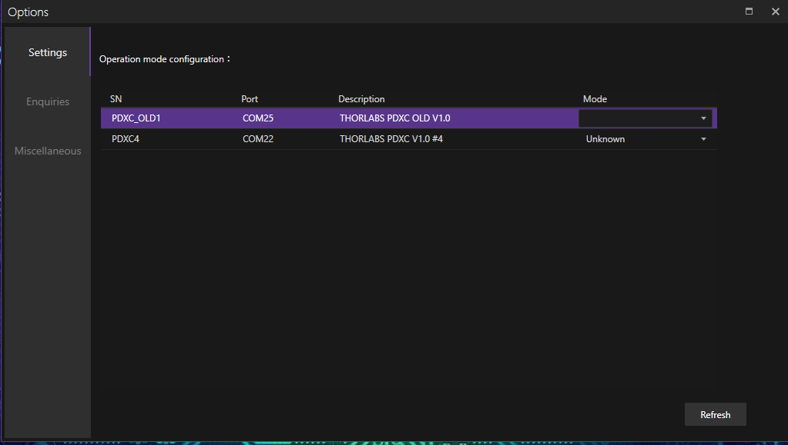
The GUI looked like the one in the following picture, where each device, whether in Main or Secondary, can be controlled respectively.
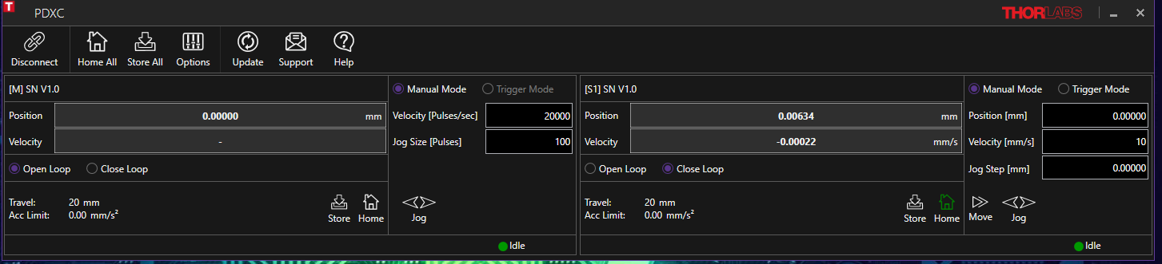
Control Simultaneously
It is preferred that the user can control all stages move at the same time, by adding a checkbox, named “Sync” in each place of GUI, to control whether the correspond devices will link with the Main in movement, before movement will be done simultaneously in Main menu.
The software can judge the selected devices are in the same mode with Main or not, then determine to activate or de-activate the check boxes.
The workflow is behaved like this, the user may want to revise destination position for all Secondary devices before finally revise for Main, then he can click the button “Move All” to move all stages in closed loop, or just jog left or right to control all Secondary devices and Main, to jog-move at the same time.
To simplify the procedures, we will delete the step of clicking Options menu the second time, instead we will add Daisy-chain button to display and let user set all parameters to configure all devices they want.

SMC Stage output (SW=1):
It is always open loop in this mode. Users can set Velocity (from 800 to 20000Hz), and their Step Size (from 1 to 65535) of each channel (two in all). The software here only can query the device’s mode upon power on, using command ‘SW?’ result of 0 means D-sub mode, of 1 means SMC mode. The single GUI looks like this, where menus are similar with D-sub, not containing Home, each channel can be switched on or off on the left of panel, Jog Left or Right on the bottom left, with their corresponding parameters settable on the right.
New demands: “Jog Step (Pulse)” modify to “Jog Step (Steps)”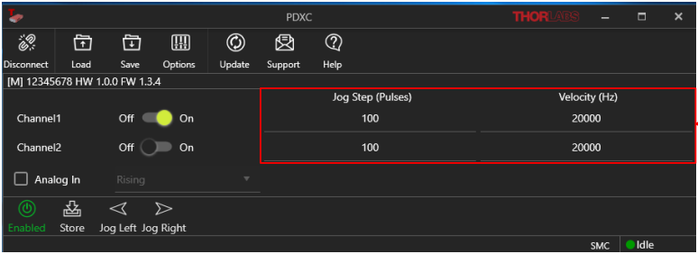
- Functions description:
There are two channels, each can control its own stage, both are open-loop stages, can only be driving by step size at particular velocity (steps/s). The former command is SS? Or SS=x for channel 1, or SS2? Or SS2=x for channel 2, and the latter one is frq? Or frq=x for channel 1, or frq2? Or frq2=x for channel 2.
- Save operation.
There is still a save-all-command used to save all the parameters into nonvolatile flash, as well as restore-command which is used to restore to factory state. It is the duty of firmware that implement it, but the software should have this command in GUI.
- Jog command used.
There are only two commands used to move the stage for SMC mode, MOVF=x or MOVB=x, with the former as forward direction while the latter one as backward.
- Support Daisy-Chain function.
- Analog In.
By default, when the input range of analog In signal is from 1V to 10V, representing with output forward amplitude 10% to 100% with 1x for Gain and 0 for offset, when the input range of analog In signal is from -1V to -10V, representing with output backward amplitude 10% to 100% with 1x for Gain and 0 for offset. A -1V~+1V input results in no movement. The type of trigger edge to start a movement can also be defined.
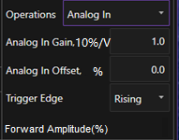

D-sub output without encoder (SW=2):
This mode was only for PD2 stage, only Open loop mode display, the GUI display would be more like the SMC mode.
New demands: “Jog Step (Pulse)” modify to “Jog Step (Steps)”
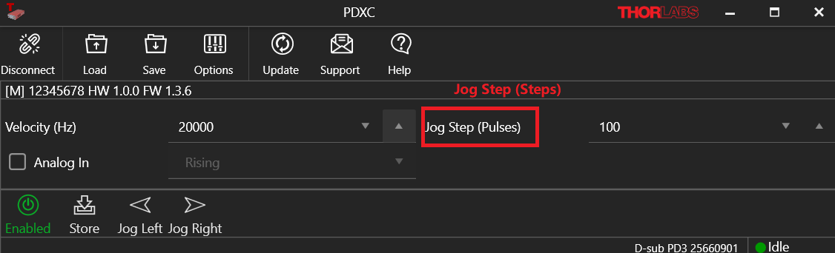
Parameters:
- Velocity (Hz):800~20000Hz
Command is FRQ3? Or FRQ3=x (x from 800 to 20000)
- Jog Step:1~65535
Command is SS3? Or SS3=x (x from 1 to 65535)
- *Forward Speed Level：10~100，step is 1
Command is SPD2F=x, (x from 10 to 100)
- *Backward Speed Level：10~100 is 1
Command is SPD2B=x，(x from 10 to 100)
*The number of range 10 to 100 need to confirm later, and these two parameters set was in the “options” menu, it was also effective for PD1 stage(SMC mode).
Jog command used.
Use MOVF=x.0 to forward direction , use MOVB=x.0 to backward direction (x from 1 to 65535)
- Analog In.
By default, when the input range of analog In signal is from 1V to 10V, representing with output forward amplitude 10% to 100% with 1x for Gain and 0 for offset, when the input range of analog In signal is from -1V to -10V, representing with output backward amplitude 10% to 100% with 1x for Gain and 0 for offset. A -1V~+1V input results in no movement. The type of trigger edge to start a movement can also be defined.

Interface Requirement of PDXR1(the whole part is new)
User Interface
Resolution: 1024*768 default.
Resolution of preview window: 16:9.

Menu Bar:
This section describes the menu options required from the software menu bar.

- Connect / Disconnect
Connect the device /Disconnect to the device.
- Store all Settings into device(s).
Store all necessary configurations for device, such as last position, velocity, step size etc. There are also parameters set in Trigger Mode.
- Home: Home the device(s) to find the 0 position of the stage.
- Options
The 3 items provide there:
- Settings: Set device parameters.
- Impulse Response (Not named Enquiries): Load and display data form device (now Hiding).
- Miscellaneous: Localization and theme setting.
- Update
Check for newer version of software.
- Support
Send email to techsupport@thorlabs.com
- Help
Device and software information.
Other Menus:
1. Restore
Used to restore all parameters to factory values.
- Disable
Used to Disable/Enable the device in emergency case.
When devices are disabled, the functions that moving the stage are forbidden, but the communication still keep going, and respond.

Controller SN display:
It can display SN of current controller, as illustrated in the plot bellow, where the SN is PDXC_V01, containing 8 letters.

Status Bar:
The status indicator on the right side of status bar, usually has 4 kinds of state:
We can define these statuses by:
Error: The software has not received specific return-string in specific time. In detailed requirements, we want to have every error message a pop-up window to let user know and confirm, except that there only being a warning info (not pop-up, just displaying) in open loop when jogging out of scale range.
Warning: The software has received warning info from device.
Normal: The software has received all specific return-string in specific time, and no warning.
No device: The software cannot send command through interface, usually for USB port.
Besides, we need one more symbol to show current stage activated, D-sub or SMC, where it can pop-up message about the S/N and Item Number of stage by clicking or mouse on it for a short time. Or Just put this information into Options, got by command SN2? First time on power-up once.

Value area (Main Interface):
D-sub output with encoder (SW=0):
Open Loop
Position: target and actual position, range from -180.0 degrees to +180.0 (GUI can set pos limit from -999.9 to 999.9)
Speed: 10 to 30 degrees/s.
Jog Step:0.00005 to 180 degrees (1 means 100 μdeg, min 0.5 means 50 μdeg)

Closed Loop
Position: target and actual position, range from -180.0 degrees to +180.0 (GUI can set pos limit from -999.9 to 999.9)
Speed: 10 to 30 degrees/s.
Jog Step:0.00005 to 180 degrees (min 0.5 means 50 μdeg)

Trigger mode:
They are three operations inside Trigger Mode, Analog In, Fixed Step and Fixed Positions, here are the basic explanation.
Analog In: User can set the gain and offset of analog in signal to represent the position of stage. The range of Gain was from 0.1 to 100, so the target position = Vin*Gain + offset. By default, the input range of analog In signal is from -10V to 10V, representing target position of -10 to 10 Deg with 1x for Gain and 0 for offset.
User can set these two values accord to their applications. The mechanism of this operation works on the Trigger Edge selected to drive the stage to the Target Position displayed in bottom.
Fixed Step: In this operation the Trigger Edge will trigger to move the stage by a distance, specified by Step Size value each time.
Fixed Positions: In this operation, Pos1 will be executed on its Triger Edge selected while Pos2 will be executed on its Trigger Edge selected, too. This two steps will do in staggered way.
Others:
Position Range Limit: Set the min and max value of position.

Appendix

Command list
See “Inertial Stage Command Protocol-not confirmed 1.xlxs”

Meeting notes (2019.09.04):
A. Each command will have return string which can tell format of command is correct or not, such like command not defined, data is out-of-range, etc. But this will not consistent with daisy-chain mode, where command set will not answer,
B. The software will use color for distinguishing emergency level, red for error, and yellow for warning, green for normal.
C. Also, the software will use option menu for functions that not use very frequently, such as PID parameters, Accelerator value changing, others still keep visible in main interface.
D. IO trigger command set is exclusive with other similar commands; it means that only one can be available on enabled.
E. Some command needs to store permanently, such as PID parameters, which will save automatically, others will clear after power-off. Is that right?
In Daisy-chain mode, the user need to set each device mode first (single or chained), then select the one that set as Main, and click daisy-chain mode in Option menu, the software will check if Main device is set correctly, if correct, it will enable drop-down (or other else?) to let user select how many device and set their salve number(8 in total?), after that all settings are done. The user can set/query each device by switching Taps (each tap corresponds to one device). To tell more, command set can be to all device one time, while query command only one device one time.

Known Bugs in V1.10 (2021.05.07):

Will display lost connection when the controller do “HOME” operation; (High Priority)

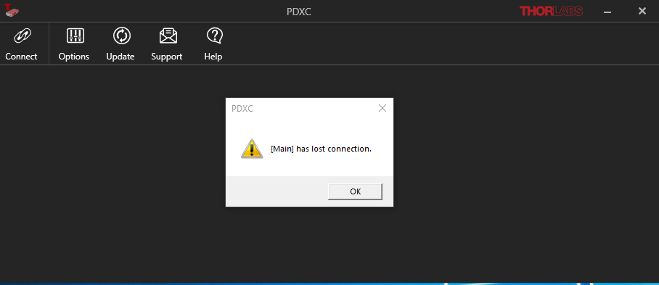

The channel select was not synchronized with the controller display; (Wishlist for future)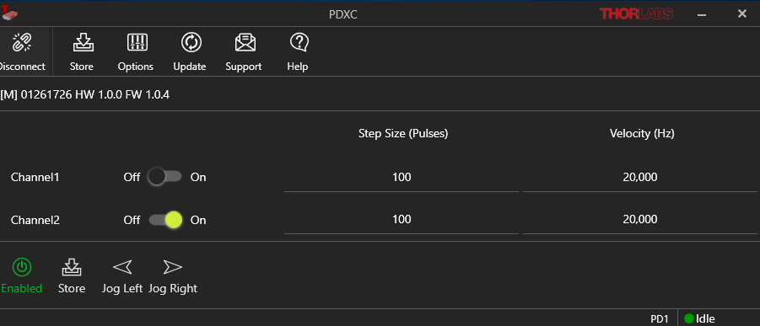

The PID parameters need to be locked, user need to unlock first before modify the P Share, I Share, D Share. (Wishlist for future) ;

Revision History
Revision | Effective Date | Description of Change | Revision Originator
V0.1 | 2019-08-14 | Initial Document created | J.Jiang
V0.2 | 2019-09-04 | Add command and function description according the meeting result. | J.Jiang
V0.3 | 2019-12-27 | Update GUI and features description | J.Gao/J.Jiang
V0.4 | 2020-01-03 | Add daisy-chain control part
V0.5 | 2020-02-17 | Add sync control of all devices | J Jiang
V0.64 | 2020-05-06 | Revise some places of display, simplify daisy-chain set. | J Jiang
V1.0 | 2020-07-21 | Sum-up all the requirement. | J Jiang
V1.31 | 2020-10-13 | New UI for SMC, and bug fixed for Trigger | J Jiang
V1.20 |  | Add PDXR support | J Jiang
V1.21 | 2021-05-08 | New UI for Open loop mode of D-Sub, and bug fixed for lost connection | Yuanlei
V1.22 | 2021-6-25 | New UI for D-Sub mode without encoder (PD2) | Yuanlei
V1.23 | 2021-11-10 | Add analog In mode in open loop in D-Sub mode and SMC mode, | Yuanlei
V1.24 | 2022-03-22 | Add joystick support in Daisy-Chan mode | Yuanlei
V1.34 | 2022-8-4 | Add D-Sub stage PDX2 | Yuanlei
V2.16 | 2023-11-28 | Add D-Sub stage PDXZ1,  Modify the name in the SMC and D-Sub no encoder stages  New option for the stage position behavior after a power cycle | Yuanlei
V2.17 | 2024-6-26 | Add D-Sub stage PDX1A/PDX1AV | Yuanlei
V2.18 | 2024-12-20 | Add D-Sub stage PDX3 and PDX4 | Yuanlei
V2.19 | 2025-10-16 | Add D-Sub stage PDX1D/PDX1DV and PDXG1 | Yuanlei

List of reference：

