

**THE IMAGINATION UNIVERSITY PROGRAMME**

**RVfpga Lab 3**

**Function Calls**

# INTRODUCTION

Function calls are a critical part of any program because they allow for modularity and reuse of code and, thus, make writing and debugging code easier. The C programming language also includes standard libraries, as well as processor/board specific libraries, of commonly used C functions, such as random number generators and common math functions. High-level functions are translated into assembly following a *Calling Convention*. This lab shows how to write and use functions in C programs – both functions written by the programmer as well as functions contained in C libraries. It also shows how functions are implemented in assembly language. At the end of the lab, we provide exercises on writing programs that use functions and library calls.

# Writing a C program that uses functions

A function – also called a subroutine or procedure – is code that is packaged into a block of code that has a defined operation and interface (inputs and outputs). This modularity increases efficiency by decreasing complexity and supporting reuse of code. A function can be called from any point in the program in such a way that, when the function finishes, program execution is resumed just after the function call. Functions may be called from another function (which are called *nested* functions), or even by the same function (named *recursive* calls).

To write a RISC-V program with functions, you follow the same general steps as described in Labs 1 and 2:

1. Create an RVfpga project
2. Write a C program
3. Download RVfpgaNexys onto Nexys A7 FPGA board (remember that you can also run these programs on simulation, using Verilator or Whisper)
4. Compile, download, and run/debug program

Refer to Lab 1 for detailed instructions for these steps. Below is a brief description of each step.

Step 1. Create an RVfpga project

Create your project named project1 in the following folder:

[RVfpgaPath]/RVfpga/Labs/Lab03

Step 2. Write a C program

Now you will add a C program to the project. Create a new file and type or copy/paste the following C program in the project. This program is also available in the following file:

[RVfpgaPath]/RVfpga/Labs/Lab03/LedsSwitches_functions.c

// memory-mapped I/O addresses

#define GPIO_SWs 0x80001400

#define GPIO_LEDs 0x80001404

#define GPIO_INOUT 0x80001408

#define READ_GPIO(dir) (*(volatile unsigned *)dir)

#define WRITE_GPIO(dir, value) { (*(volatile unsigned *)dir) = (value); }

void IOsetup();

unsigned int getSwitchVal();

void writeValtoLEDs(unsigned int val);

int main ( void )

{

unsigned int switches_val;

IOsetup();

while (1) {

switches_val = getSwitchVal();

writeValtoLEDs(switches_val);

}

return(0);

}

void IOsetup()

{

int En_Value=0xFFFF;

WRITE_GPIO(GPIO_INOUT, En_Value);

}

unsigned int getSwitchVal()

{

unsigned int val;

val = READ_GPIO(GPIO_SWs); // read value on switches

val = val >> 16; // shift into lower 16 bits

return val;

}

void writeValtoLEDs(unsigned int val)

{

WRITE_GPIO(GPIO_LEDs, val); // display val on LEDs

}

Save the file into the src directory of your project and name the file LedsSwitches_Functions.c.

Step 3. Download RVfpgaNexys onto Nexys A7 FPGA board

Download RVfpgaNexys onto the Nexys A7 board as you did in RVfpga Labs 1 and 2.

Step 4. Compile, download, and run program

Now you are ready to compile, download, and run/debug the program on RVfpgaNexys.

After pressing the Run  and Start Debugging  buttons, click on the Step Over button  (located in the top tool bar) or F10 twice until you get to line 19 that calls the getSwitchVal() function. Then press the Step Into button  (or F11). This will step into the getSwitchVal() function. If it is not already viewable, expand the VARIABLES → Local field on the left toolbar to view the val variable. The val variable may be listed as “optimized out” at this point in the program. Step (either Step Over or Step Into) once and view the val variable change to the value of the switches, as shown in Figure 1.

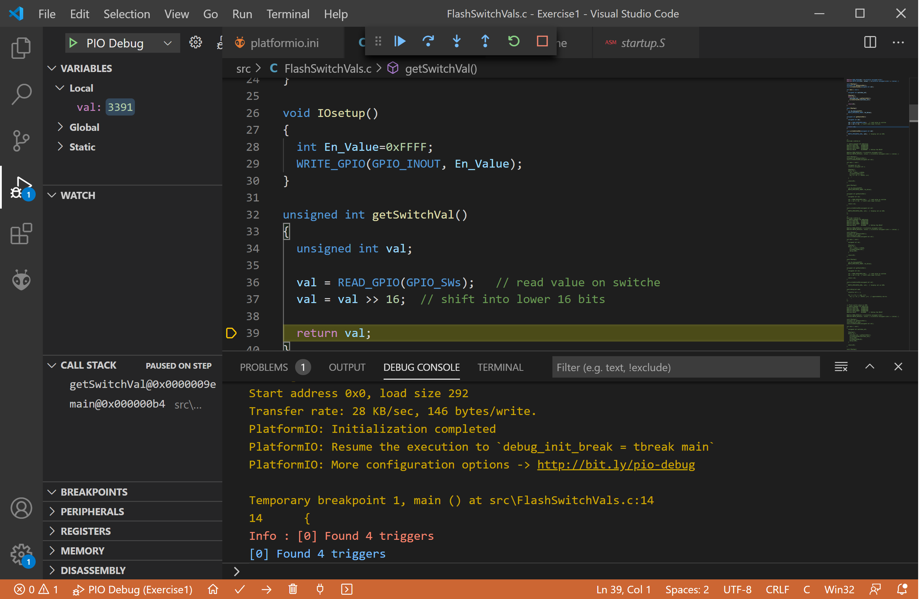

Figure 1. Stepping into the getSwitchVal() function

Now put a breakpoint at line 19 by clicking to the left of the line. You will see a red dot appear to the left indicating that it is now a breakpoint, as shown in Figure 2.

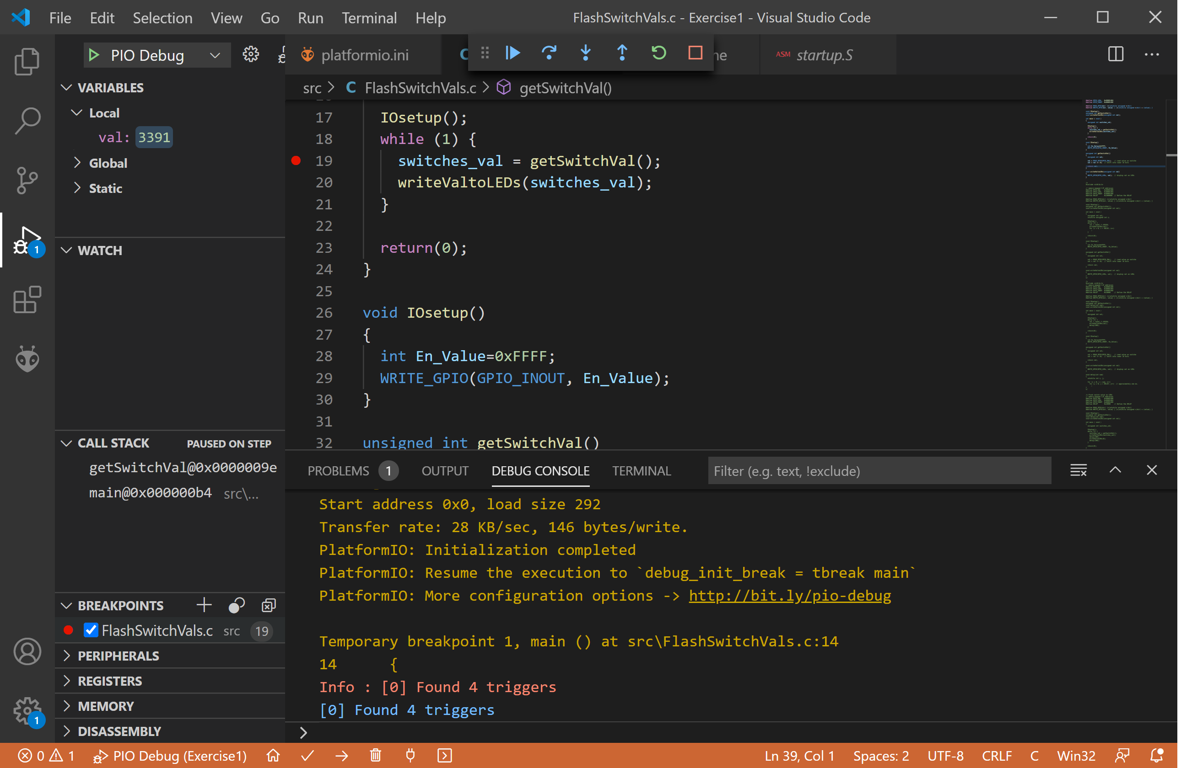

Figure 2. Setting a breakpoint

Press the Continue button  (or F5). The program will stop at line 19 once the breakpoint is reached. This time, press the Step Over button  (or F10). The function will execute, but the debugger will not enter the function. Only the effects of the function are shown. Particularly, the switches_val variable becomes the value of the switches, as shown in Figure 3.

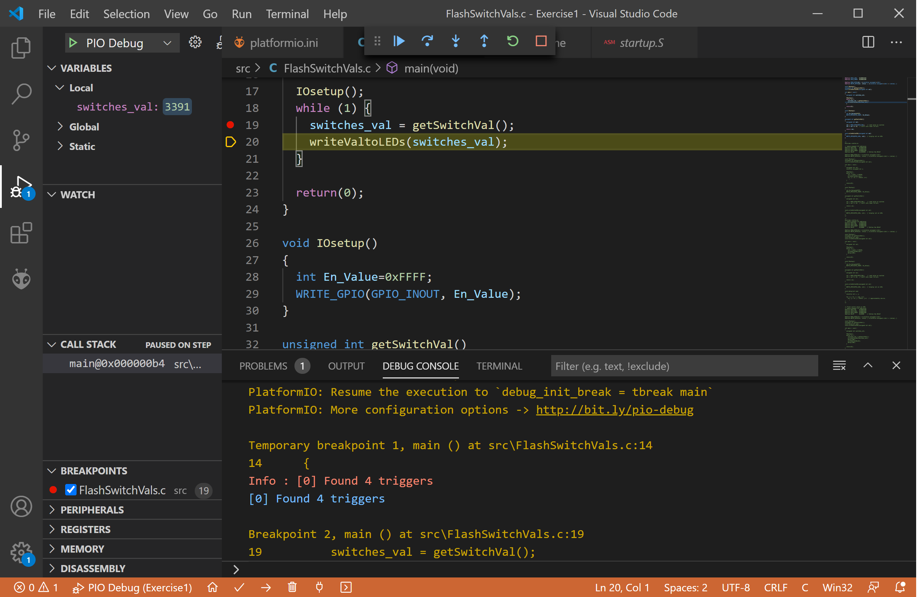

Figure 3. Stepping over a function

# Writing a C program with calls to library functions

High-level programming languages such as C include libraries of functions that are commonly used by programmers. You can google “C standard libraries” to find a list of commonly used C libraries. These libraries of functions can be used by including the header file that gives the declaration of the included functions. This is done by adding the following line to the top of the C program file:

#include <libraryname>

“libraryname” is replaced by the name of the library. For example, the math library (math.h) provides common functions such as fabs(), which computes the absolute value of a floating-point number, fmax(), which returns the largest of two floating point numbers, etc.

Another common library is the C standard library (stdlib.h). Some of the functions included in this library generate random numbers. For example, the program below displays a random number on the LEDs by including the stdlib.h header file (#include <stdlib.h>) and calling the rand() function that returns a random number. Copy and paste the program below into a PlatformIO RVfpga project and run it on RVfpgaNexys on the Nexys A7 FPGA board.

#include <stdlib.h>

// memory-mapped I/O addresses

#define GPIO_SWs 0x80001400

#define GPIO_LEDs 0x80001404

#define GPIO_INOUT 0x80001408

#define DELAY 0x1000000 // Define the DELAY

#define READ_GPIO(dir) (*(volatile unsigned *)dir)

#define WRITE_GPIO(dir, value) { (*(volatile unsigned *)dir) = (value); }

void IOsetup();

unsigned int getSwitchVal();

void writeValtoLEDs(unsigned int val);

int main(void)

{

unsigned int val;

volatile unsigned int i;

IOsetup();

while (1) {

val = rand() % 65536;

writeValtoLEDs(val);

for (i = 0; i < DELAY; i++)

;

}

return(0);

}

void IOsetup() {

int En_Value=0xFFFF;

WRITE_GPIO(GPIO_INOUT, En_Value);

}

unsigned int getSwitchVal() {

unsigned int val;

val = READ_GPIO(GPIO_SWs); // read value on switches

val = val >> 16; // shift into lower 16 bits

return val;

}

void writeValtoLEDs(unsigned int val) {

WRITE_GPIO(GPIO_LEDs, val); // display val on LEDs

}

This program is also available in the following file:

[RVfpgaPath]/RVfpga/Labs/Lab03/RandomNumberLEDs.c

In addition to these C standard libraries, Western Digital (WD) provides, within its Firmware Package (<https://github.com/westerndigitalcorporation/riscv-fw-infrastructure>), specific libraries for the SweRV EH1 processor (PSP, which you can find in your system at ~/.platformio/packages/framework-wd-riscv-sdk/psp/) and for the Nexys A7 board (BSP, which you can find in your system at ~/.platformio/packages/framework-wd-riscv-sdk/board/nexys_a7_eh1/bsp/). As we explained in the Getting Started Guide (Section 6.F – *HelloWorld_C-Lang* program), these libraries are included in the project by adding the proper line in platformio.ini and by including the proper files at the beginning of the C program.

These libraries provide functions and macros that allow programmers to use interrupts, print a string, read/write individual registers, among other things. In the RVfpga Getting Started Guide and in these labs, you will use many of these functions in the examples and exercises.

# RISC-V Calling Convention

This section describes the RISC-V Calling Convention, which defines how high-level functions are translated into RISC-V assembly language. This calling convention is a part of the Application Binary Interface (ABI). By defining a convention, functions written by different programmers or contained in libraries can be used across programs. In RISC-V, the jump and link instruction (jal) invokes a call to a function. For example, the following code calls the function func1:

jal func1

This instruction both jumps to the label func1 *and* saves the address of the instruction after jal into the return address register (ra = x1). The function then returns by using the return (ret) pseudo-instruction (or jump register instruction: jr ra), which jumps to the address stored in ra.

Functions may be called with input arguments and may also return a value to the calling function. By RISC-V convention, input arguments are passed to the function in registers *a0*–*a7*. If additional arguments are needed, they are placed on the stack. Again by convention, return values are placed in registers *a0* and *a1*. The agreement on which registers are used to pass arguments and return values is defined by the RISC-V Calling Convention.

In order to safely invoke a function from any location in the program, it is essential that the function preserves the architectural state of the machine (i.e. the contents of those registers than can be seen by the programmer). Suppose that we have a program with a main function that has a loop that uses register t0 for storing the index of the loop. In the body of the loop, a function called SortVector is invoked, and this function SortVector uses register t0 for storing the address of vector A (see Figure 4). Thus, register t0 is overwritten in function SortVector, which has the undesirable side effect of modifying the index of the loop and causing its execution to be incorrect.

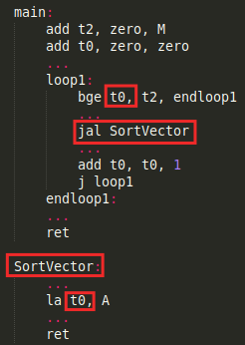

Figure 4. Example of the conflict in the use of a register among the main program and a function

Obviously, this wouldn’t have happened if the programmer of the main program had selected another register to implement the loop index (for example, t1). However, it is not reasonable (and in some cases, not even possible) to force the programmer to know every internal detail of the implementation of a function before calling it.

A more practical solution is for every function to create a temporary copy in memory of all those registers that will be modified, and to restore their original values before returning to the *caller* program. This solution is implemented by means of the Call Stack, which is a memory region that is accessed using a LIFO (Last-In-First-Out) policy. This region is used to store all the information related to the live functions of the program (i.e. those functions that have started, but not finished their execution), and which begins at the end of the available memory (i.e. in the higher addresses), and grows towards lower addresses.

A function is normally structured into three parts:

* Entry code (Prologue)
* Function Body
* Exit code (Epilogue)

The *Prologue* must create the function’s stack frame and store registers on the stack, if needed. The *stack frame* is the memory region used by a function during its execution. The *Epilogue* restores the architectural state of the *caller* program and releases the memory space occupied by the *stack frame*, thus leaving the stack exactly as it was before executing the *Prologue*.

Accesses to the stack are managed by means of a pointer, called the *stack pointer* (sp *=* x2), which stores the address of the last occupied location of the stack. Before a program begins, sp must be initialized with the address of the base of the stack (i.e. the highest address of the stack region). In the RVfpga System, the sp register is initialized by the _start function, which is implemented in file *~/.platformio/packages/framework-wd-riscv-sdk/board/nexys_a7_eh1/startup.S*. At initialization, the stack is empty. A second pointer, the *frame pointer* (fp = x8) points to the base address (i.e. the highest address) of the active function’s *stack frame*.

Functions use the *stack frame* as a private memory region, which can only be accessed from the function itself. A part of the *stack frame* is devoted to save a copy of the architectural registers that are to be modified by the function and, in some cases, it can also be used as a way of passing parameters to the function through memory locations.

Table 1 describes the intended role that the RISC-V convention assigns to each integer register. As also illustrated in Table 1, some registers must be preserved by a called function whereas some others may be overwritten by the function (i.e., they are not preserved).

* If the function needs to overwrite any preserved registers, it must first make a copy of such register in its *stack frame* and restore the value before returning to the *caller* (i.e., the function that called it). In addition to the stack pointer (sp) and return address register (ra), twelve integer registers s0–s11 are preserved across calls and must be saved by the *callee* if used by it.
* On the other hand, the *caller* must be aware that some registers need not be preserved by the *callee* and, thus, could be lost after the call. Note that, in addition to the argument and return value registers (a0–*a7*), seven integer registers t0–t6 are temporary registers that are volatile across calls and must be saved by the *caller* if used again after the function invocation.

**Table 1. RISC-V integer registers**

|  |  |  |  |
| --- | --- | --- | --- |
| **Name** | **Register Number** | **Use** | **Preserved** |
| **zero** | **x0** | Constant value 0 | - |
| **ra** | **x1** | Return address | Yes |
| **sp** | **x2** | Stack pointer | Yes |
| **gp** | **x3** | Global pointer | - |
| **tp** | **x4** | Thread pointer | - |
| **t0-2** | **x5-7** | Temporary variables | No |
| **s0/fp** | **x8** | Saved register / Frame pointer | Yes |
| **s1** | **x9** | Saved register | Yes |
| **a0-1** | **x10-11** | Function arguments / Return values | No |
| **a2-7** | **x12-17** | Function arguments | No |
| **s2-11** | **x18-27** | Saved registers | Yes |
| **t3-6** | **x28-31** | Temporary variables | No |

In the example from Figure 4, there would be two solutions according to this convention:

* The main program could use a register for the loop index that is guaranteed to be preserved by the SortVector function (such as s0) instead of t0.
* The main function could keep using t0, but then it has to preserve its contents in the stack before calling SortVector and restore it after returning from SortVector.

The stack expands as more memory is needed by functions’ stack frames and contracts as those functions complete. The stack grows downwards (towards lower addresses) and the stack pointer shall be aligned to a 16-byte boundary upon procedure entry. In the standard ABI, the stack pointer must remain aligned throughout procedure execution.

**Example**

The following example implements a sorting algorithm, first in C (Figure 5) and then in RISC-V assembly language (Figure 6). The input is an array A of N elements, each being an integer greater than 0. The output is another array, B, that stores the elements of A in decreasing order.

In C, the main function calls function SortVector, which receives the addresses of arrays A and B, and their size (N), and stores the elements of A into B element-by-element, in decreasing order. This SortVector function calls another function, MaxVector, which receives the address of array A and its size, and returns the maximum value of array A and resets that value, so that it is no longer considered in the following iterations.

|  |
| --- |
| #define N 8  int MaxVector(int A[], int size)  {  int max=0, ind=0, j;  for(j=0; j<size; j++){  if(A[j]>max){  max=A[j];  ind=j;  }  }  A[ind]=0;  return(max);  }  int SortVector(int A[], int B[], int size)  {  int max, j;  for(j=0; j<size; j++){  max=MaxVector(A, size);  B[j]=max;  }  return(0);  }  int main ( void )  {  int A[N]={7,3,25,4,75,2,1,1}, B[N];  SortVector(A, B, N);  return(0);  } |

Figure 5. Sorting algorithm in C language

Figure 6 illustrates the same algorithm written in assembly. We analyse the program taking into account the concepts explained in the previous sections.

* **main function**
  + Prologue
    - First, space is reserved in the stack for storing the preserved registers that are used in the function: add sp, sp, -16. Note that, according to the convention, the sp register must always be kept 16-byte aligned to maintain compatibility with the 128-bit version of RISC-V, RV128I.
    - Given that no saved register is used by this function, s0-s11 registers need not be stored in the stack. However, register ra must be saved, given that main calls function SortVector, which updates the value stored in ra.
  + Function Body
    - The SortVector function is invoked using instruction jal SortVector. Before calling the function, according to the Calling Convention, the 3 input parameters are placed in registers a0 (address of A), a1 (address of B), and a2 (size of A and B arrays).
  + Epilogue
    - The register that was saved in the stack at the prologue (ra) is now restored.
    - The stack pointer (sp) is also restored to its initial position: add sp, sp, 16.
* **SortVector function**
  + Prologue
    - First, space is reserved in the stack for storing the preserved registers that are used in the function: add sp, sp, -32.
    - Then, the saved registers used by the function (s1-s3) are stored in the stack, one by one.
    - Register ra must also be saved, because SortVector calls the MaxVector function, which overwrites the value stored in ra.
  + Function Body
    - First, the input parameters (a0, a1 and a2) are moved into preserved registers (s1, s2 and s3), so that they can be used after the execution of function MaxVector.
    - For computing vector B, a loop is implemented that, in each iteration, computes the maximum value of A and stores it into B. For computing the maximum value of A, the MaxVector function is invoked in each iteration of the loop: jal MaxVector. Before calling the function, according to the Calling Convention, the input parameters to this function are moved into registers a0 and a1. When the function finishes execution, it returns the maximum value of A in register a0.
    - Note that the loop mostly uses the saved registers to store variables. These registers are guaranteed by the RISC-V Calling Convention to preserve their value after the execution of the MaxVector (i.e. the function must preserve their values).
    - Registers a0 and a1 can be modified by the function. Thus, they must be prepared before every invocation.
    - Register t1 needs to be reused after MaxVector returns. Thus, it must be preserved in SortVector’s stack before calling the function (sw t1, 16(sp)) and restored after executing it (lw t1, 16(sp)).
  + Epilogue
    - The registers that were saved in the stack during the prologue, are now restored.
    - The stack pointer (sp) is also restored to its initial position: add sp, sp, 32.
* **MaxVector function**
  + Prologue
    - First, space is made on the stack for storing the preserved registers that are used in the function: add sp, sp, -16.
    - Then, the saved register used by the function (i.e., register s1) is stored in the stack: sw s1, 0(sp). Note that, if this register were not saved by this function, the execution of the *caller* function (SortVector) would fail, as it is also using this register for storing the address of vector A.
    - Because this function does not invoke another one (it is a *leaf* function), ra needs not be saved in this case.
  + Function Body
    - The function uses s1 and some temporary registers to calculate the maximum value of array A.
  + Epilogue
    - The function must prepare the return value before returning to the *caller*: mv a0, t2.
    - The register that was saved on the stack during the prologue (s1), is now restored.
    - The stack pointer (sp) is also restored to its initial position: add sp, sp, 16.

|  |
| --- |
| .globl main  .equ N, 8  .data  A: .word 7,3,25,4,75,2,1,1  .bss  B: .space 4*N  .text  MaxVector:  add sp, sp, -16  sw s1, 0(sp)  mv s1, zero  mv t2, zero  loop2:  beq s1, a1, endloop2  lw t1, (a0)  ble t1, t2, else2  mv t2, t1  mv t3, a0  else2:  add a0, a0, 4  add s1, s1, 1  j loop2  endloop2:  sw zero, (t3)  mv a0, t2  lw s1, 0(sp)  add sp, sp, 16  ret  SortVector:  add sp, sp, -32  sw s1, 0(sp)  sw s2, 4(sp)  sw s3, 8(sp)  sw ra, 12(sp)  mv s1, a0 # Address of vector A  mv s2, a1 # Address of vector B  mv s3, a2 # Size of vectors A and B  mv t1, zero  loop1:  beq t1, s3, endloop1  mv a0, s1  mv a1, s3  sw t1, 16(sp)  jal MaxVector  lw t1, 16(sp)  sw a0, (s2)  add s2, s2, 4  add t1, t1, 1  j loop1  endloop1:  lw s1, 0(sp)  lw s2, 4(sp)  lw s3, 8(sp)  lw ra, 12(sp)  add sp, sp, 32  ret  main:  add sp, sp, -16  sw ra, 0(sp)  la a0, A  la a1, B  add a2, zero, N  jal SortVector  lw ra, 0(sp)  add sp, sp, 16  ret  .end |

Figure 6. Sorting algorithm in assembly language

Figure 7illustrates the state of the stack at the point of executing the body of the MaxVector function.

* The *stack frame* of the main function is shown in blue, and it includes the returning address (ra) for that function.
* The *stack frame* of the SortVector function is shown in green, and it includes the saved registers used by this function (s1-s3), register t1, and *ra*.
* Finally, the *stack frame* of the MaxVector function, which is the *active stack frame* (the *stack frame* of the function that is executing), is shown in yellow, and it includes the saved register used by this function (s1).



Figure 7. Stack state at the body of function MaxVector for the assembly program from Figure 6.

**TASK:** The assembly program from Figure 6 is provided in a Platformio project available at: *[RVfpgaPath]/RVfpga/Labs/Lab03/SortingAlgorithm_Functions*. Execute this program on the board (or on the ISS simulator) using the step-by-step debugger option for analysing the value stored in the various registers (s, ra, a, etc.) as well as the values stored in the stack, according to the RISC-V Calling Convention.

- File *.pio/build/swervolf_nexys/firmware.dis*, generated by PlatformIO after compilation of your program, can be useful in order to know the addresses of each instruction in your program.

- You can use the Memory Console for analysing the evolution of the stack as well as the contents of arrays A and B.

- In this project we use a tuned *link.lds* script in which the *sp* register is forced to be 16-byte aligned. You can find the script at *[RVfpgaPath]/RVfpga/Labs/Lab03/SortingAlgorithm_Functions/ld/link.lds*. Alignment of the sp register is forced using the ALIGN() command:

.stack :

{

_heap_end = .;

. = . + __stack_size;

/* Force 16-B alignment of SP register */

**. = ALIGN(16);**

_sp = .;

} > ram : ram_load

# Exercises

Now create your own C/Assembly programs that include function calls by completing the following exercises.

Remember that if you leave the Nexys A7 board connected to your computer and powered on, you do not need to reload RVfpgaNexys onto the board between different programs. However, if you turn off the Nexys A7 board, you will need to reload RVfpgaNexys onto the board using PlatformIO.

Remember as well that you can run these programs on simulation, using Verilator or Whisper.

Exercise 1. Write a C program that displays the inverse of the switches on the LEDs. Name the program DisplayInverse_Functions.c.

For example, if the switches are (in binary): 0101010101010101, then the LEDs should display: 1010101010101010; if the switches are: 1111000011110000, then the LEDs should display: 0000111100001111; and so on. Include a getSwitchesInvert() function that returns the inverted value of the switches. The function declaration is:

unsigned int getSwitchesInvert();

Exercise 2. Write a C program that flashes the value of the LEDs onto the switches. Name the program FlashSwitchesToLEDs_Functions.c

The value should pulse on and off about every two seconds. Include a function called delay() that causes a delay of num milliseconds. This can be done empirically and does not need to be exact. The function declaration looks like this:

void delay(int num);

Exercise 3. Write a C program that measures reaction time. Your program should time how long it takes for a person to switch on the right-most switch (SW[0]) after all of the LEDs light up. You will use the rand() function from the stdlib.h library to generate a random amount of time to delay between each time the user attempts to test their reaction time. Name the program ReactionTime.c.

The program should work as follows.

1. The user toggles the right-most switch off (down) to indicate they’d like to begin.
2. The program turns off all of the LEDs, then waits for a random amount of time (but no longer than about 3 seconds). You will want to use the delay() function from Exercise 2.
3. Then all the LEDs turn on and the program begins counting the number of milliseconds until a user switches the right-most switch on.
4. When the user toggles the right-most switch (SW[0]) on, the number of milliseconds it took to toggle the switch up (on) is displayed in binary on the LEDs and in decimal on the serial console.
5. The game then repeats by the user toggling the right-most switch down (off).

Exercise 4. One issue with the rand() function is that it uses a predictably random sequence of numbers. That is, each time you run the program it will start with the same random number and follow the same sequence of random numbers. Run your program from Exercise 3 several times to see that it starts with the same random number and follows the same random sequence.

However, if you use the srand() function first, it will seed the rand() function with a random starting point. The only issue is that srand() must be given an input argument, an unsigned integer, that itself is random. Give srand() a random number, for example, the number of milliseconds until the user toggles the switch off to begin the game.

Rewrite Exercise 3 to produce a truly random sequence of times before the LEDs turn on. Use functions when possible. Name the program ReactionTimeTrulyRandom.c.

Exercise 5. Rewrite Exercise 4 so that the LEDs display a growing bar of LEDs, proportional to reaction time. This way, the person viewing their reaction time can more easily tell if they are getting faster – without having to interpret the binary representation of the number of milliseconds. You may choose the range of reaction times corresponding to each range of lit LEDs. For example, for quick reaction times, only a few LEDs on the right should light up. An increasing number of LEDs to the left should light up as reaction times increase. A very slow reaction time would light up all of the LEDs. Name the program ReactionTimeBar.c.

Exercise 6. Write a C program that implements a “Simon says” game. The following should happen:

1. The program blinks a pattern on the three right-most LEDs and waits for the user to press the corresponding sequence of switches using the three right-most switches. Switches[2:0] correspond to LED[2:0], with LED[0] being the right-most LED and Switches[0] being the right-most switch.
2. The random patterns should start by lighting 1 LED, then 2 LEDs, then 3, etc.
3. The user then tries to repeat the sequence using the three right-most switches. The corresponding LED should light up as the user toggles the switches up (and turn off when the user toggles the switch back down).
4. If the user enters the correct sequence, after a pause, the next pattern should display, with one more LED in the sequence.
5. If the user enters the wrong sequence, the LEDs stay lit and no new sequence is played.
6. The game is reset by pushing the left-most switch (Switches[15]) up (on) and then down (off).

Use functions of your choice to modularize the program and make it easier to write, debug, and understand. Remember to use standard C libraries as desired to write your program. Name the program SimonSays.c.

Exercise 7. Given a vector, A, of 3*N elements, we want to obtain a new vector, B, of N elements, so that each element of B is the absolute value of the sum a triplet of consecutive elements of A. For example:

B[0] = |A[0]+A[1]+A[2]|, B[1] = |A[3]+A[4]+A[5]|, ...

Write a RISC-V assembly program called Triplets.S (the program must conform to the RISC-V calling convention):

* The main program implements the computation of B, according to the following high-level pseudo-code:

#define N 4

int A[3*N] = {a list of 3*N values};

int B[N];

int i, j=0;

void main (void)

{

for (i=0; i<N; i++){

B[i] = res_triplet(A,j);

j=j+3;

}

}

* Function res_triplet returns the absolute value of the sum of 3 consecutive elements of the vector V, starting at position p. It is implemented according to the specification given by the following high-level pseudo-code:

int res_triplet(int V[ ], int pos)

{

int i, sum=0;

for (i=0; i<3; i++)

sum = sum + V[pos+i];

sum=abs(sum);

return sum;

}

* Function abs(int x) returns the absolute value of its input argument.

Exercise 8. Write a RISC-V assembly program called Filter.S (the program must be compliant with the standard for function management studied before). You can use the following pseudo-code:

#define N 6

int i, j=0, A[N]={48,64,56,80,96,48}, B[N];

for (i=0; i<(N-1); i++){

if( (myFilter(A[i],A[i+1])) == 1){

B[j]=A[i]+ A[i+1] + 2;

j++;

}

}

* Write the equivalent RISC-V assembly code, including any directives required to reserve memory space, and declaring the corresponding sections (.data, .bss and .text). Function myFilter returns the value 1 if the first argument is a multiple of 16 and the second is greater than the first; otherwise, it returns a 0.
* Write the assembly code of the function myFilter.

Exercise 9. We want to build a RISC-V assembly program called Coprimes.S (the program must be compliant with the standard for function management studied before), such that given a list of pairs of integers (>0) finds which pairs are composed of coprime (or mutually prime) numbers. It is understood that two numbers are coprime if the only common divisor they have is 1.

We assume that the input data are contained in an array, D, of the form:

D=(x0, y0, c0, x1, y1, c1, ... , xN-1, yN-1, cN-1)

Each triplet (xi, yi, ci) is interpreted as follows: xi and yi represent a pair of numbers, and ci is initially 0. After running the program, the value of each ci must have been modified in such a way that ci = 2, if xi and yi are coprime; and ci = 1, otherwise.

For example:

For the following input vector: D = (3,5,0, 6,18,0, 15,45,0, 13,10,0, 24,3,0, 24,35,0)

The final result should be: D = (3,5,2, 6,18,1, 15,45,1, 13,10,2, 24,3,1, 24,35,2)

* Write a RISC-V assembly program that traverses the array D and generates the result according to the specification given in the left box below. The program calls the function check_coprime (int D [], int i), whose input arguments are the starting address of D and the number of the pair that we want to check (from 0 to M-1). The function checks if the numbers of the i-th pair of array D are coprime and stores the result in the corresponding memory location.
* Write the code for the functions check_coprime, according to the specification given in the right box below. Remember that function gcd(int a, int b) was implemented in Lab 2 according to the Euclidean algorithm, and it returns the greatest common divisor (gcd) of the two input arguments. If the gcd is 1, then the numbers are coprime.

|  |  |
| --- | --- |
| #define M 6  int D[]= {a list de M*3 int values}  void main ( ) {  int i;  for (i=0; i<M; i++)  check_coprime(D,i);  } | void check_coprime (int A[ ], int pos) {  int res;  res= gcd( A[3*pos], A[(3*pos)+1] );  if (res == 1)  A[(3*pos)+2]=2;  else  A[(3*pos)+2]=1;  } |