**RVfpga System Modifications**

In this document we summarize the changes that you must make to the RVfpga System to complete the exercises in RVfpga Labs 6-10. This RVfpga System extended version, available at *[RVfpgaPath]/RVfpga/Labs/RVfpgaLabsSolutions/RVfpga_Solutions/src*, includes all of the changes together. We describe the specific changes necessary for completing each of the lab exercises here.

Exercises that require changes to the RVfpga System are:

* Lab 6 – Exercise 3
* Lab 6 – Exercise 4
* Lab 7 – Exercise 3
* Lab 8 – Exercise 2
* Lab 9 – Exercise 2

**Lab 6 – Exercise 3.** Extend RVfpgaNexys to access the five on-board pushbuttons.

* rvpfganexys.xdc

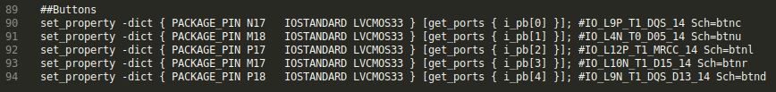

* rvpfganexys.sv





* swervolf_core.v



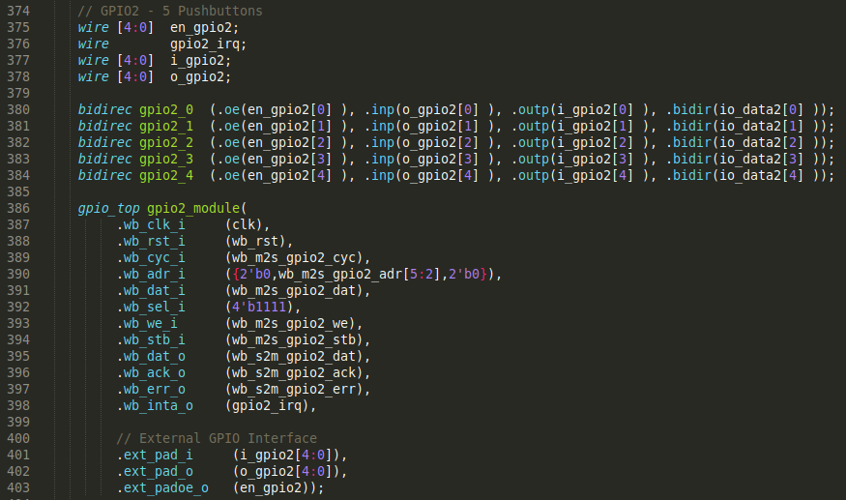

* wb_intercon.vh

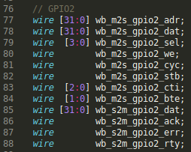

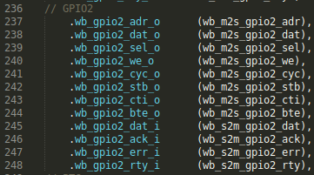

* wb_intercon.v

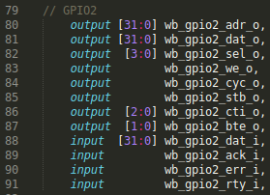

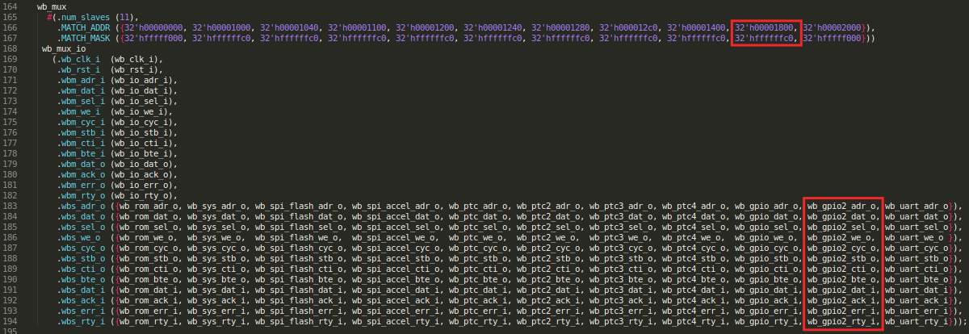

**Lab 6 – Exercise 4.** Design another controller for the five on-board pushbuttons. In contrast to the previous exercise, in this case you must implement your own GPIO controller in Verilog/SystemVerilog.

* rvpfganexys.xdc



* rvpfganexys.sv





* swervolf_core.v





* swervolf_syscon.v



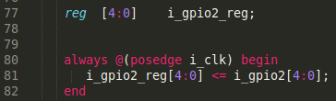



**Lab 7 – Exercise 3.** Modify the controller described in this lab so that the 8-digit 7-segment displays can show any combination of ON/OFF LEDs.

* swervolf_syscon.v

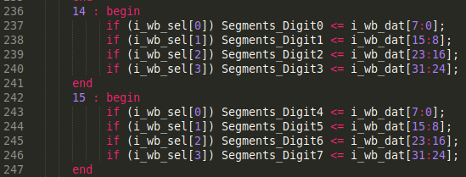

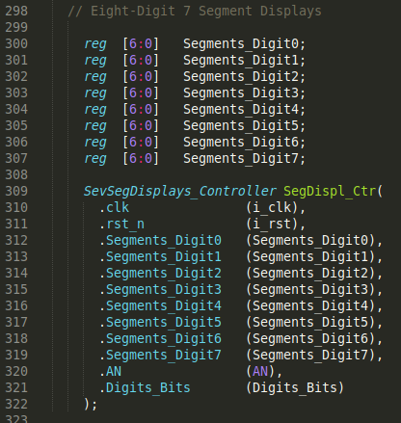

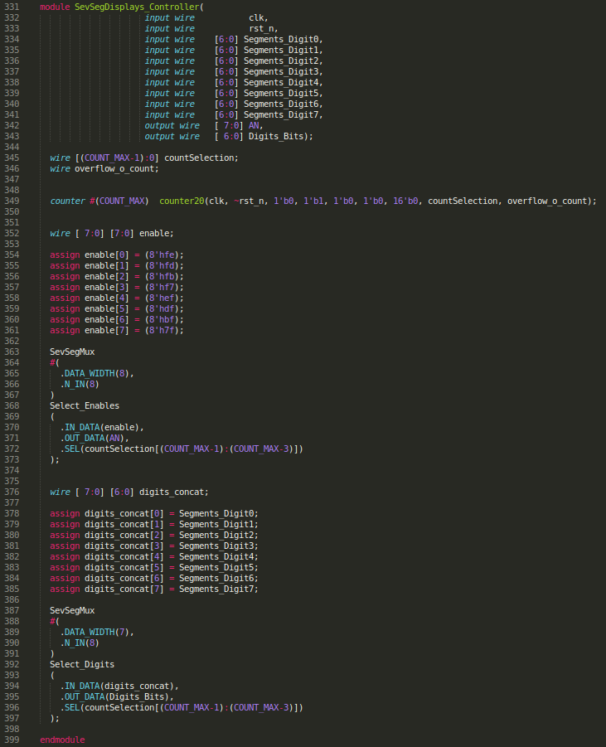

**Lab 8 – Exercise 2.** Modify RVfpgaNexys so that it connects the PWM output signal of the timer to one of the two tri-color LEDs available on the Nexys A7 board.

* rvpfganexys.xdc



* rvpfganexys.sv

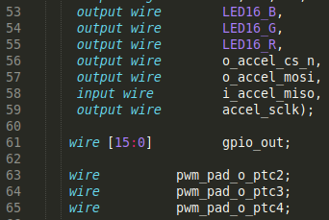





* swervolf_core.v



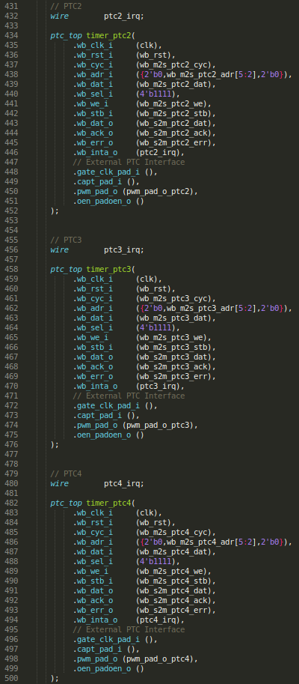

* wb_intercon.vh

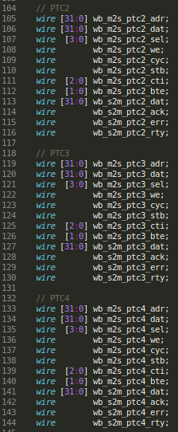

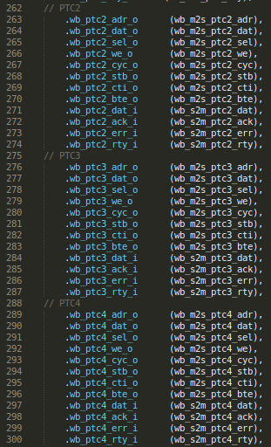

* wb_intercon.v

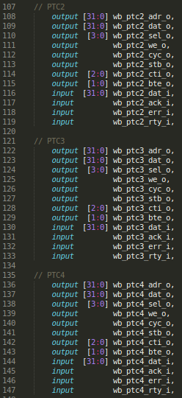

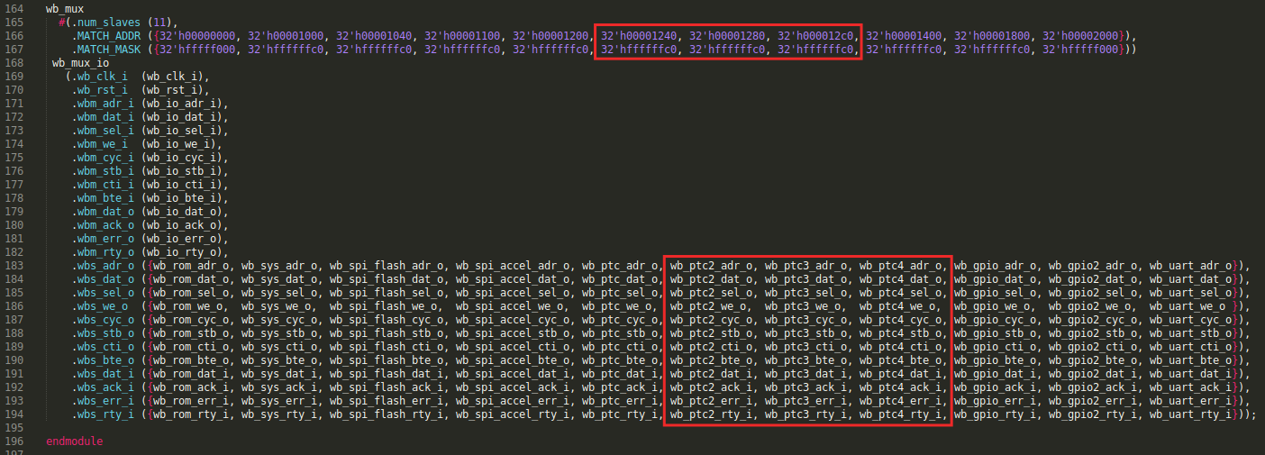

**Lab 9 – Exercise 2.** Expand RVfpgaNexys so that it includes a second interrupt source through IRQ4 that comes from the second GPIO that you included in Lab 6 for controlling the on-board pushbuttons.

* swervolf_core.v



* swervolf_syscon.v



