We have reduced the value stored in register LRC for the simulation.

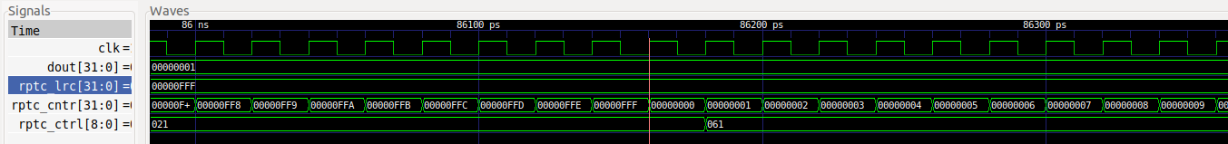

* When register CNTR reaches the value stored in register LRC, bit INT of CRTL goes to 1 and the CNTR resets and continues counting up.

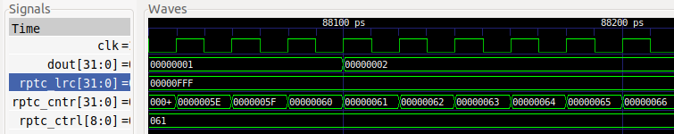

* Some cycles later, the x28 register is incremented in our program, which makes the value shown in the 8-digit 7 Segment Displays increment by 1.