# EXERCISES

**Exercise 1**

Complete solutions for this exercise are provided in folder:

*[RVfpgaPath]/RVfpga/Labs/RVfpgaLabsSolutions/Programs_Solutions/Lab18/Minu*

**Exercise 2**

Complete solutions for this exercise are provided in folder:

*[RVfpgaPath]/RVfpga/Labs/RVfpgaLabsSolutions/Programs_Solutions/Lab18/MinMaxMinuMaxu*

**Exercises 3 and 4**

Complete solutions for these two exercises are provided in folder:

*[RVfpgaPath]/RVfpga/Labs/RVfpgaLabsSolutions/Programs_Solutions/Lab18/FloatingPoint*

**Exercises 5 and 6**

Solutions not provided.

**Exercise 7**

Complete solutions for this exercise are provided in folder:

*[RVfpgaPath]/RVfpga/Labs/RVfpgaLabsSolutions/Programs_Solutions/Lab18/NewHwCounter*

* 1. **Changes in the Verilog Code**:
     1. File **swerv_types.sv**:

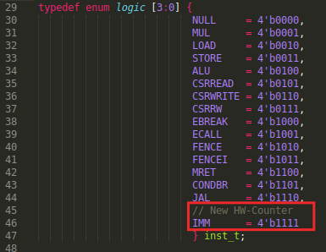

* + 1. File **dec_tlu.ctl.sv**:

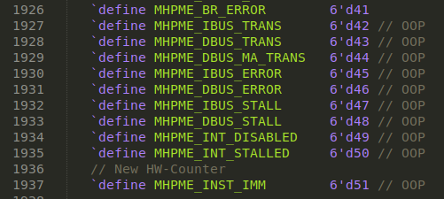

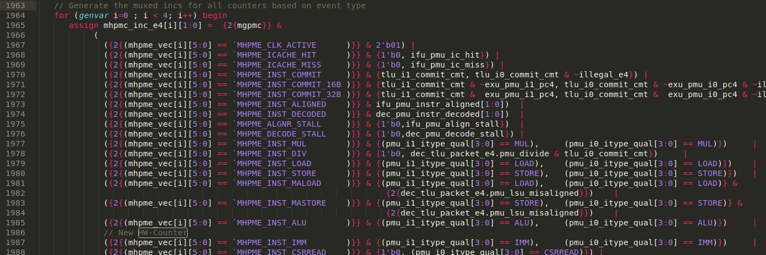

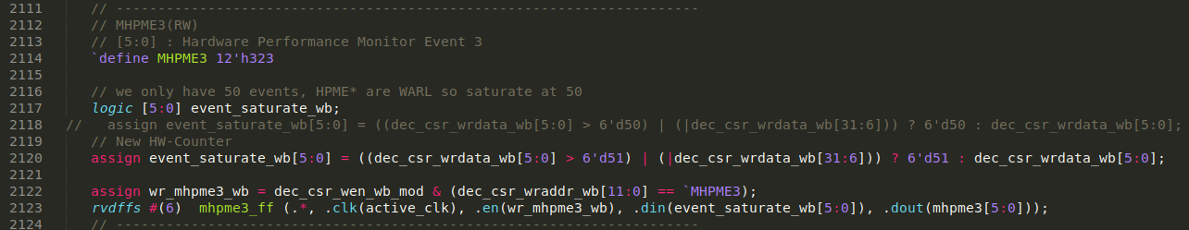

* + 1. File **dec_decode_ctl.sv**:

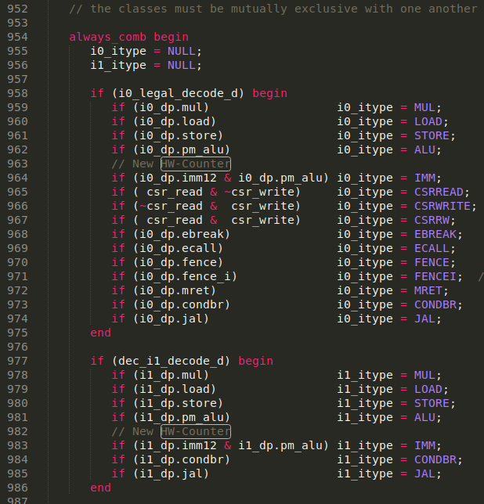

* 1. **Verilator Simulation**:

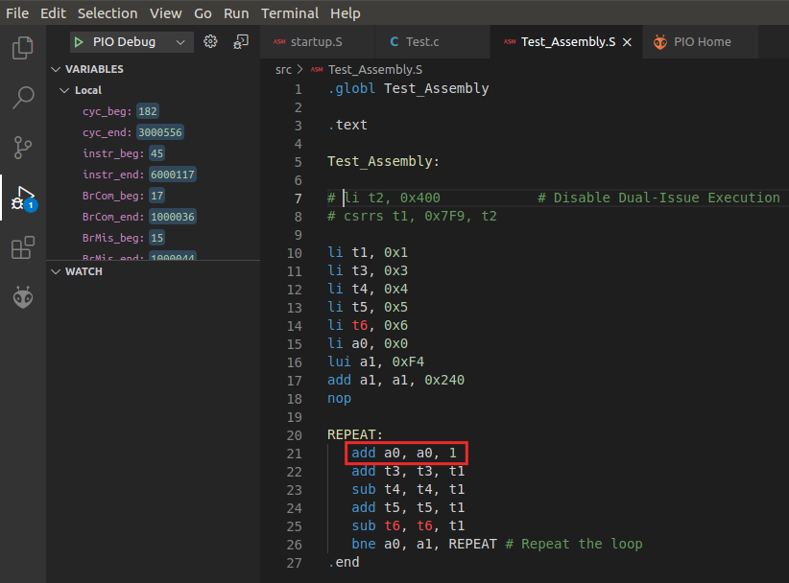

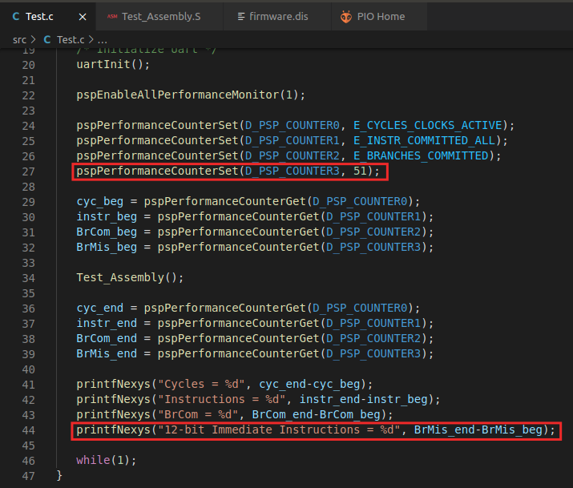

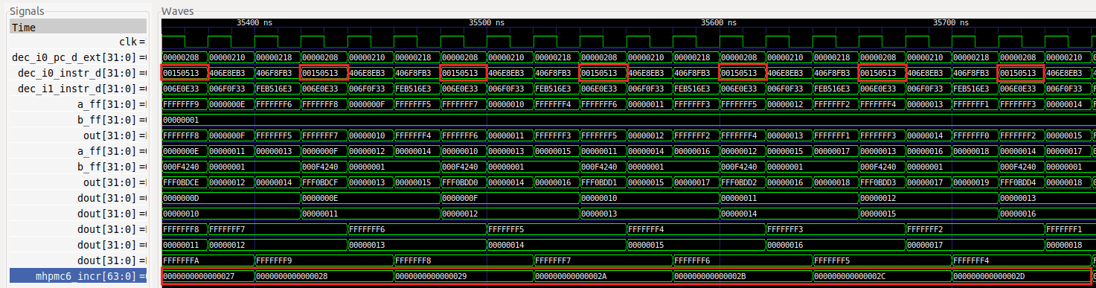

* 1. **On-board execution**:

