# TASKS

**TASK:** Using theinstructions provided in Lab 1, implement a new RVfpga System that includes a 64 KiB ICCM.

Remember that the ICCM is disabled in our default system. Thus, as explained in Section 2.A of the SweRVref document, in order to enable the ICCM you must include the following line in file *[RVfpgaPath]/RVfpga/src/SweRVolfSoC/SweRVEh1CoreComplex/include/common_defines.vh*:

`define RV_ICCM_ENABLE 1

In addition, the parameters provided in the default RVfpga System are for a 512 KiB ICCM. Thus, in order to implement a 64 KiB ICCM, you must modify the following lines of the same file (file common_defines.vh):

* RV_ICCM_DATA_CELL ram_16384x39 🡪 RV_ICCM_DATA_CELL ram_2048x39
* RV_ICCM_BITS 19 🡪 RV_ICCM_BITS 16
* RV_ICCM_ROWS 16384 🡪 RV_ICCM_ROWS 2048
* RV_ICCM_INDEX_BITS 14 🡪 RV_ICCM_INDEX_BITS 11
* RV_ICCM_SIZE_512 🡪 RV_ICCM_SIZE_64
* RV_ICCM_SIZE 512 🡪 RV_ICCM_SIZE 64
* RV_ICCM_EADR 32'hee07ffff 🡪 RV_ICCM_EADR 32'hee00ffff

As explained in Section 2.A of the SweRVref document, instead of manually modifying file *common_defines.vh*, you can also modify the configuration of the SweRV EH1 processor using the *swerv.config* script.

Solution not provided.

**TASK:** Draw a figure similar to Figure 2 for the ICCM implemented in the previous task.

Solution not provided.

**TASK:** Replicate the simulation from Figure 4 on your own computer. To do so, follow the next steps (as described in detail in Section 7 of the GSG):

* If necessary, generate the simulation binary (*Vrvfpgasim*).
* In PlatformIO, open the project provided at: *[RVfpgaPath]/RVfpga/Labs/Lab20/LW-SW_Instruction_DCCM*.
* Establish the correct path to the RVfpga simulation binary (*Vrvfpgasim*) in file *platformio.ini*.
* Generate the simulation trace using Verilator (Generate Trace).
* Open the trace on GTKWave.
* Use file *scriptLoadStore.tcl* (provided at *[RVfpgaPath]/RVfpga/Labs/Lab20/LW-SW_Instruction_DCCM*) for opening the same signals as the ones shown in Figure 4. For that purpose, in GTKWave, click on *File → Read Tcl Script File* and select the *scriptLoadStore.tcl* file.
* Click on *Zoom In* () several times and analyse the region starting at 43,900 ps.

Solution provided in the main document of Lab 20.

**TASK:** Explain how signals rden_bank, wren_bank, and addr_bank are obtained in lines 103, 104, and 105 of module **lsu_dccm_mem**.



Signal wren_bank

* Signal wren_bank[7:0] contains 8 bits, one per bank. Writing bank *i* is enabled when wren_bank[i]==1.
* If the LSU sets signal dccm_wren (we analysed this signal in Lab 13), one bank is written, as determined by field Bank of the address provided in: dccm_wr_addr.

Signal rden_bank

* Signal rden_bank[7:0] contains 8 bits, one per bank. Reading of bank *i* is enabled when rden_bank[i]==1.
* If the LSU sets signal dccm_rden (we analysed this signal in Lab 13), one or two banks are read (depending on the access being aligned or unaligned), as determined by field Bank of the addresses provided in: dccm_rd_addr_lo and dccm_rd_addr_hi.

Signal addr_bank

* Signal wren_bank[7:0][11] contains 8 11-bit addresses, one per bank.
  + In case of a write, the address is obtained from signal dccm_wr_addr.
  + In case of a read, the address is either in signal dccm_rd_addr_lo (upon an aligned read), or signals dccm_rd_addr_lo and dccm_rd_addr_hi (upon an unaligned read).

**TASK:** Simulatean unaligned read to the DCCM and analyse how it is handled inside the DCCM. You can use the program above (*[RVfpgaPath]/RVfpga/Labs/Lab20/LW-SW_Instruction_DCCM/*) and simply substitute the load instruction as follows:

lw t3, (t4) → lw t3, **1**(t4)

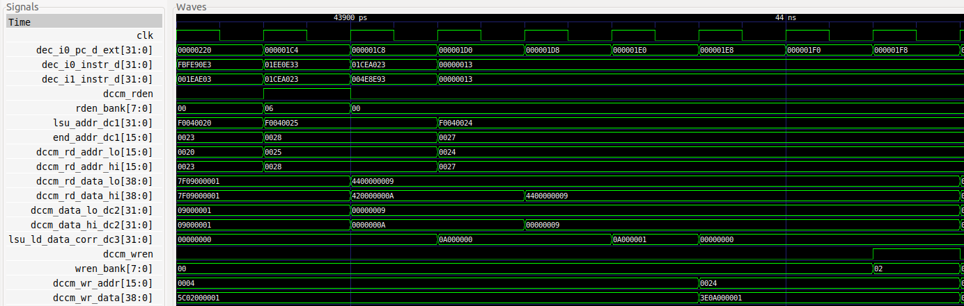

* Signal dccm_rden = 0x06, thus two banks are enabled for reading.
* Two values are provided to the core:
  + dccm_data_lo_dc2 = 0x9
  + dccm_data_hi_dc2 = 0xA
* The core aligns the value as explained in Lab 13: lsu_ld_data_corr_dc3 = 0x0A000000
* 5 cycles later the value, plus one, is written in the DCCM: dccm_wr_data = 0x3E**0A000001**

**TASK:** Simulatea DCCM bank conflict by modifying the program from Figure 4 (*[RVfpgaPath]/RVfpga/Labs/Lab20/LW-SW_Instruction_DCCM/*).

**1st modification:** Remove the 20 nop instructions, regenerate the simulation, and analyse the lw and sw in a random iteration of

the loop.

**2nd modification:** Modify the immediate of the sw instruction to make the lw and sw try to access the same bank in the same cycle:

sw t3, (t4) 🡪 sw t3, **8**(t4)

1st modification:

// Access arrayla t4, Dli t5, 50li t0, 1000la t6, Dadd t6, t6, t0li t5, 1REPEAT_Access: lw t3, (t4) add t3, t3, t5 sw t3, (t4) add t4, t4, 4 bne t4, t6, REPEAT_Access # Repeat the loop

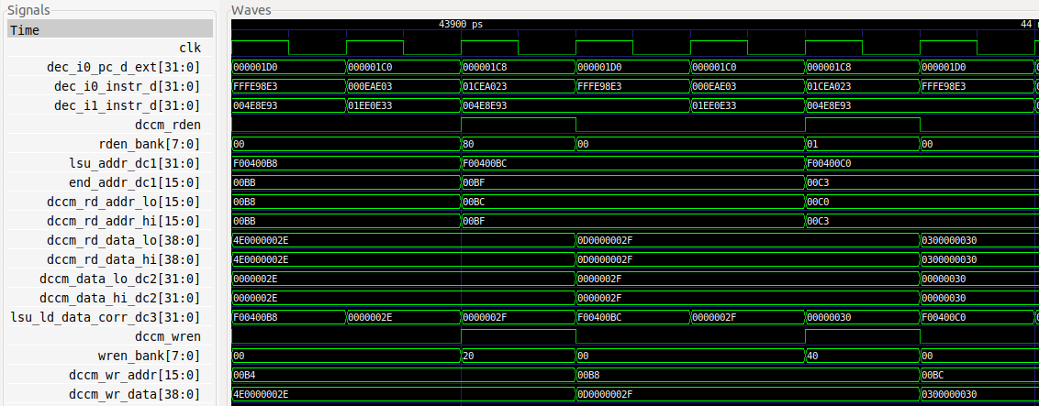

In this case, the DCCM read and DCCM write occur in the same cycle. However, because they are to different banks, they can be performed in the same cycle.

2nd modification:

// Access arrayla t4, Dli t5, 50li t0, 1000la t6, Dadd t6, t6, t0li t5, 1REPEAT_Access: lw t3, (t4) add t3, t3, t5 sw t3, 8(t4) add t4, t4, 4 bne t4, t6, REPEAT_Access # Repeat the loop

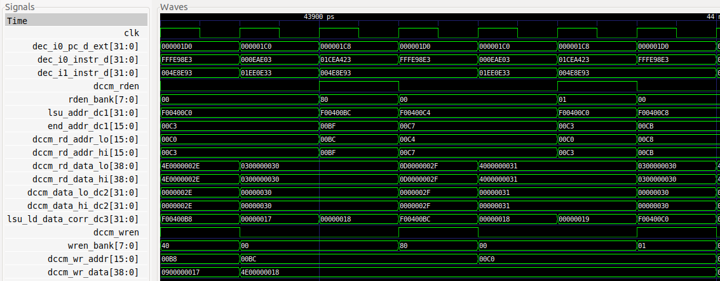

Again, the DCCM read and DCCM write occur in the same cycle. However, in contrast to the last example, the read and write are to the same bank, so the write is delayed one cycle.

**TASK:** In file *platformio.ini* (see Figure 10), comment out line 18 and uncomment line 19 so that the program uses the linker script provided at: *[RVfpgaPath]/RVfpga/Labs/Lab20/RealBenchmarks/CoreMark_HwCounters/ld/link_DCCM-ICCM.ld*. Analyse this new linker script, which uses both the DCCM for storing most data and the ICCM for storing the instructions. Execute the CoreMark benchmark and compare the results with the ones obtained in this section. In this case, given that our default RVfpga System does not include an ICCM, use either the bitstream that you created in the first task of this lab or the bitstream we provide at: *[RVfpgaPath]/RVfpga/Labs/Lab20/RealBenchmarks/rvfpganexys_DCCM-ICCM.bit*.

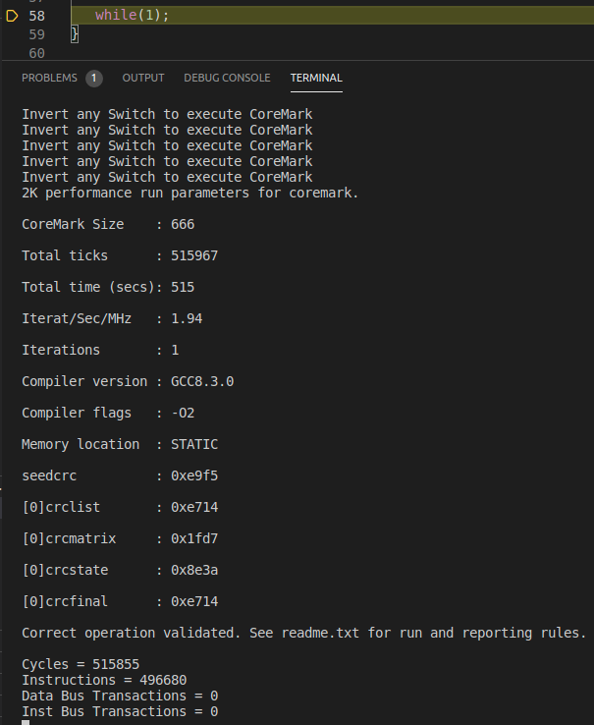

In this case, the CM/MHz (i.e., the value of Iterat/Sec/MHz) is 1.94. When using the DCCM only, the CM/MHz is 1.88. This slight increase in performance is due to a small decrease in the number of cycles, when compared to using only the DCCM. The improvement is small because the SweRV EH1 processor has an I$ and thus, using the ICCM makes only a small difference. Finally, you can observe that now both the data and instruction bus transactions are 0, given that both data and instructions are accessed from the DCCM and ICCM respectively.

**TASK:** Modify the compilation optimization to -O3 and explain the results.

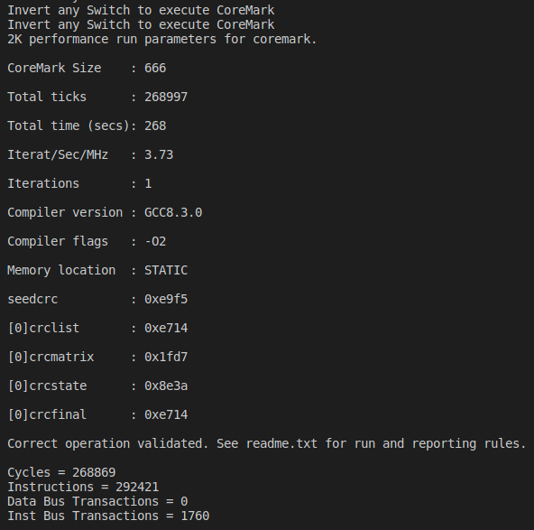

In this case, the CM/MHz (i.e., value of Iterat/Sec/MHz) is 3.73. The number of instructions, and thus number of cycles, has decreased somewhat with respect to the execution where the DCCM and -O2 are used.

# EXERCISES

1. Do the same analysis as was done for CoreMark but this time using the Dhrystone benchmark. A PlatformIO project that contains the Dhrystone benchmark is in: *[RVfpgaPath]/RVfpga/Labs/Lab20/RealBenchmarks/Dhrystone_HwCounters*. As required by all benchmarks, this Dhrystone benchmark has been adapted to the specific system, in this case the RVfpga System, using the sources provided at <https://github.com/chipsalliance/Cores-SweRV>. File *Test.c* is similar to the one from CoreMark (Figure 6) but it invokes function main_dhry(), which includes the Dhrystone benchmark itself.

* No compiler optimizations, no DCCM, no ICCM

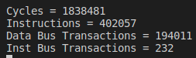

* DCCM

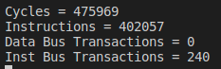

* DCCM and ICCM

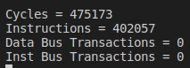

* Compiler optimizations (-O2) and DCCM

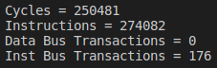

* Compiler optimizations (-O3) and DCCM

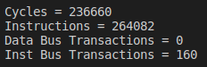

1. Do the same analysis as was done for CoreMark but this time for the ImageProcessing application. A PlatformIO project that contains the ImageProcessing application is in: *[RVfpgaPath]/RVfpga/Labs/Lab20/RealBenchmarks/ImageProcessing_HwCounters.* These are the applications we used in Lab 5 for transforming an RGB image into grayscale. File *Test.c* is similar to the one from CoreMark (Figure 6) but it invokes function ImageTransformation(), which includes the Image Transformation benchmark that we analysed in Lab 5. The DCCM of the default RVfpga System is not big enough to store the image, so instead use the RVfpga System (bitstream) that has a 128 KiB DCCM, which is at: *[RVfpgaPath]/RVfpga/Labs/Lab20/RealBenchmarks/Bitstreams/rvfpganexys_DCCM-128.bit*.

* No compiler optimizations, no DCCM, no ICCM

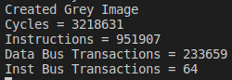

* DCCM

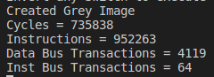

* Compiler optimizations (-O2) and DCCM

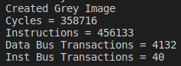

* Compiler optimizations (-O3) and DCCM

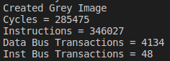

1. Enable/disable various core features as described in Section 2.C of this lab. Compare the performance results – that is, values of the HW Counters when executing the programs on these modified cores. Run all three programs (CoreMark, Dhrystone, and ImageProcessing) on these modified RVfpga Systems on the Nexys A7 board. Variations include:

- Using different Branch Predictor configurations and implementations (such as

always not-taken, Gshare, and the bimodal predictor implemented in Exercise 1 of

Lab 16).

- Enabling/disabling the dual-issue feature.

- Using various I$/DCCM/ICCM configurations (such as different sizes or different I$

Replacement Policies).

Solution not provided.