**CODES:**

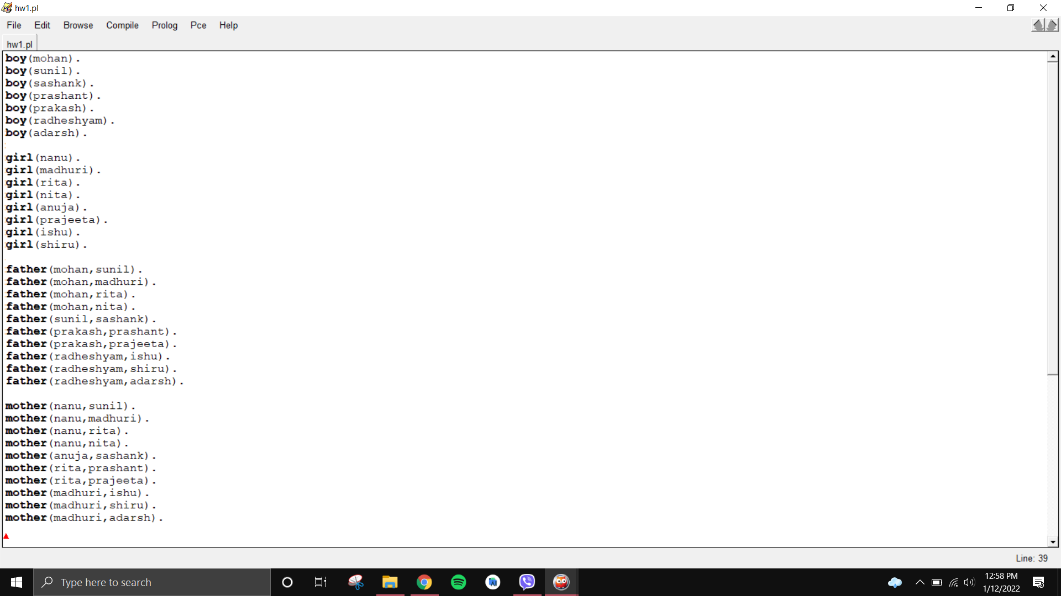

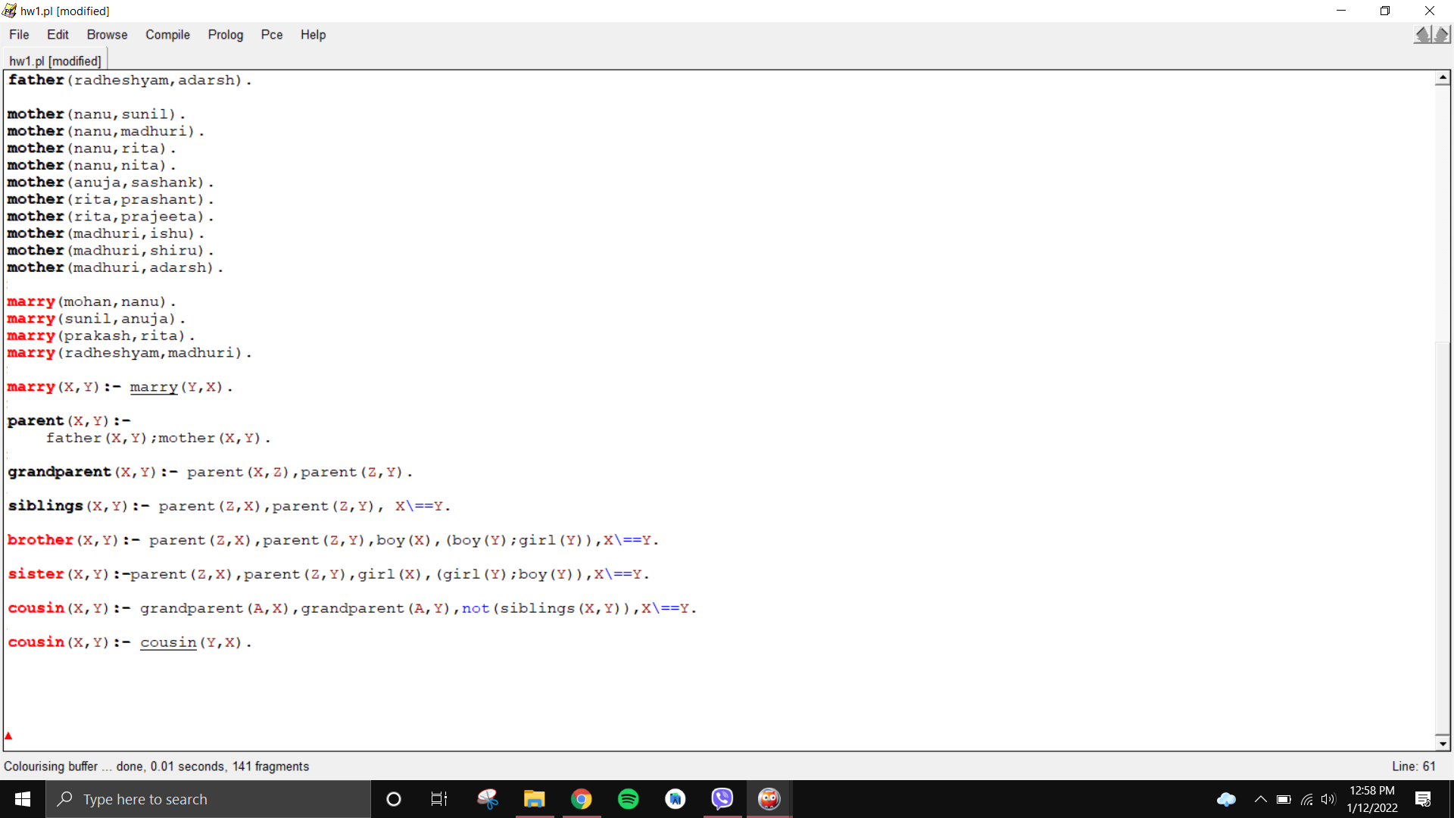

**OUTPUTS:**

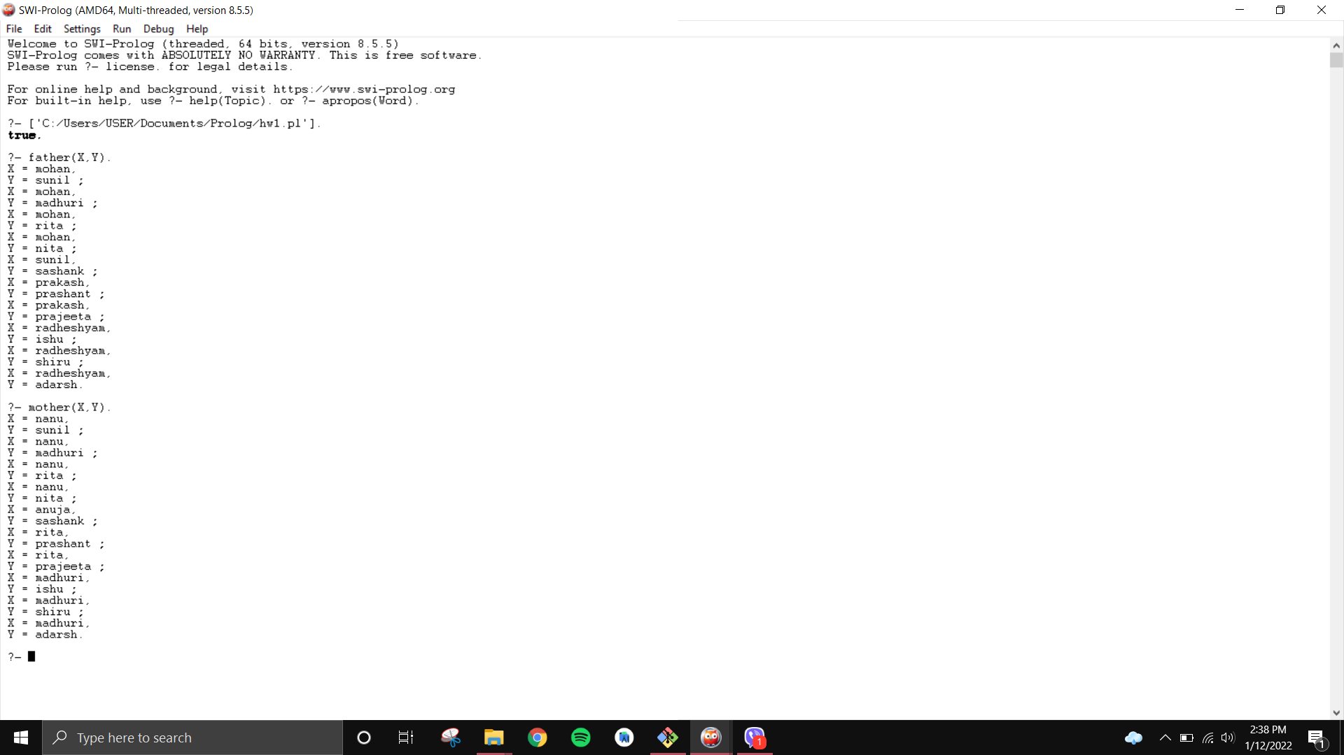

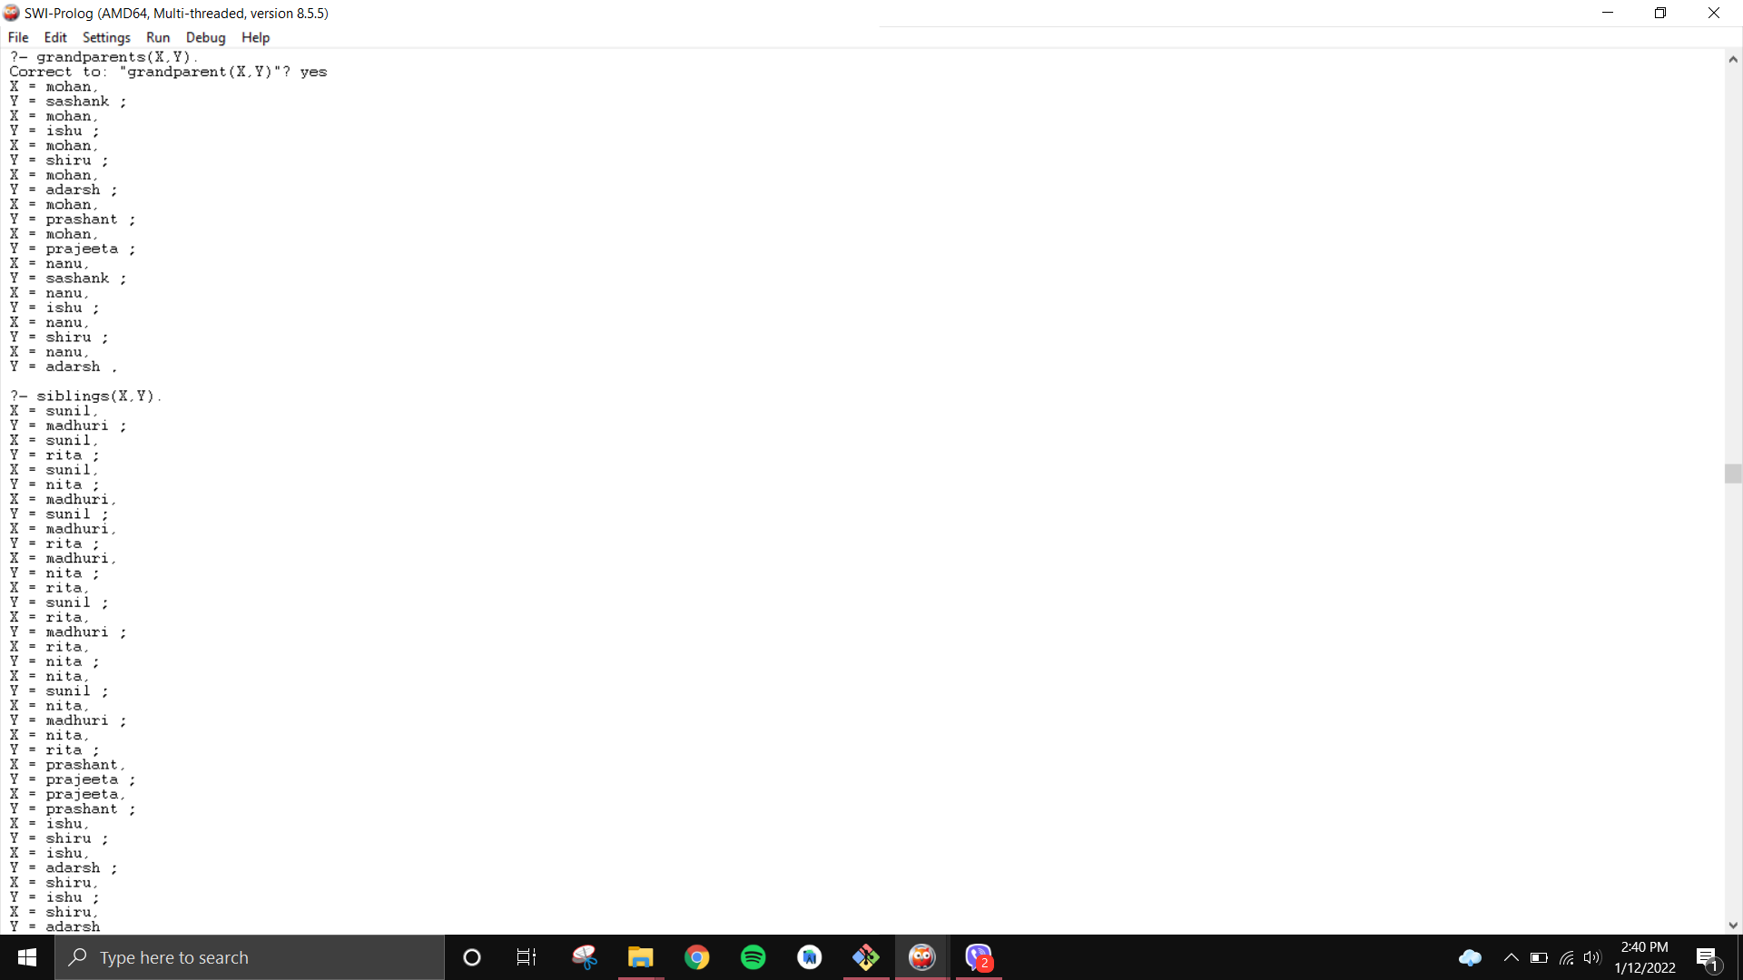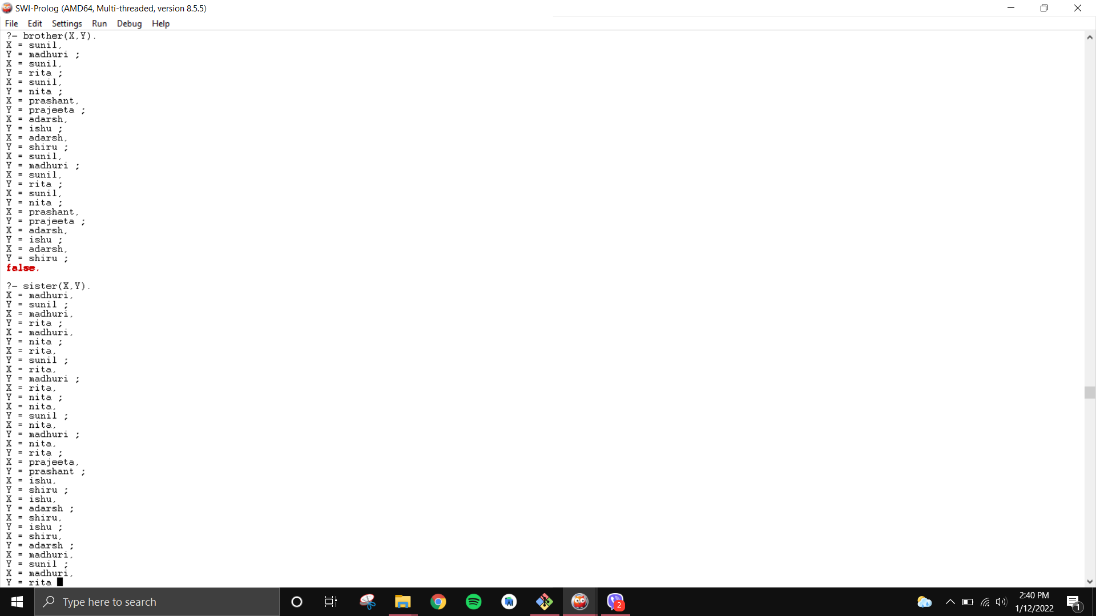

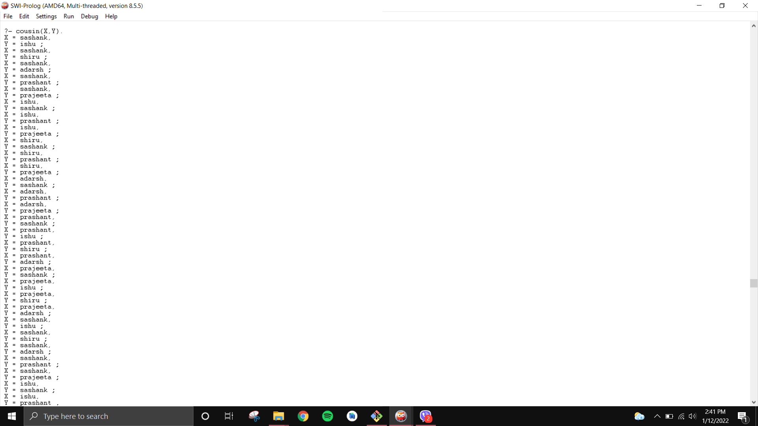

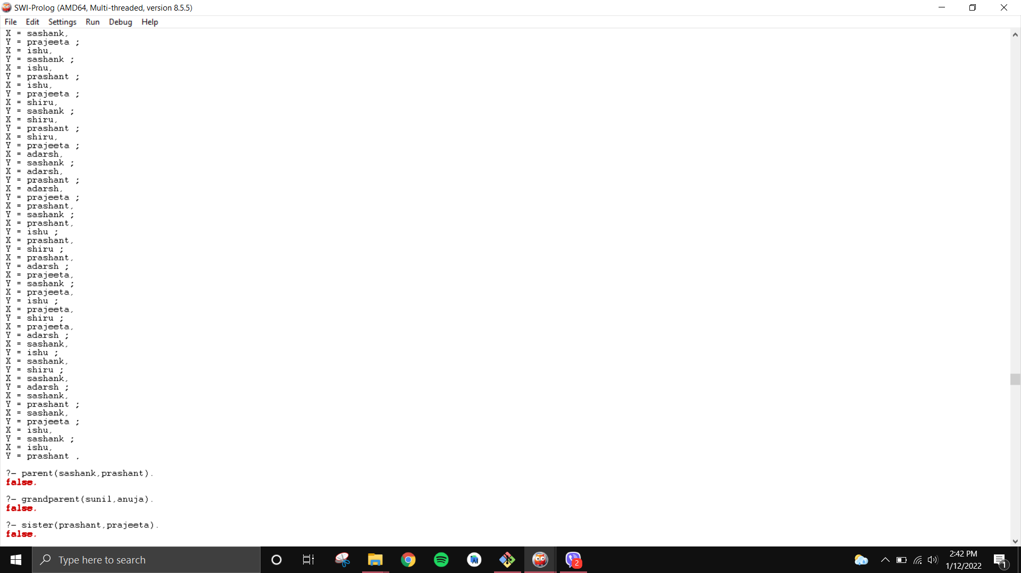

**DISCUSSION**:

In this lab, we learned how to use PROLOG and how to create predicates using PROLOG, and compile the written program. We also checked the truth value for various relations.

**CONCLUSION**:

Hence, in this lab, we learned about creating propositional logic in PROLOG.