

Creative Division System

# User Manual

Version 1.0

25/02/2021

Table of Contents

1. Introduction 1

2. Setup 2

2.1 Set-up Considerations 2

3. Getting Started (Client-side) 3

3.1 Login & Logout 3

3.2 Account & Profile 6

3.3 Job Request 7

3.4 Meeting Request 12

4. Getting Started (Printer-side) 17

4.1 Login & Logout 17

4.2 Account & Profile 20

4.3 Managing Printing Job 22

4.4 Accessing Webmail 23

## Introduction

This User Manual (UM) provides the information necessary for client-side & printer-side to effectively use the Creative Division System.

For more information you can directly contact Creative Division:

1. Arif (ext. 9414)
2. Ajwad (ext. 9415)
3. Amirun (ext. 9416)
4. Qistina (ext. 9417)

## Setup

### Set-up Considerations

Creative Division System screens are designed to be viewed at a minimum screen resolution of 800 x 600. To optimize your access to the system:

1. Please disable pop-up blockers prior to attempting access to the Creative Division System.
2. We recommend to use Google Chrome browser version 5.0 or higher.
3. Please make sure you have a connection to internet.
4. The link to access Creative Division System “[https://www.e-crea7ive.com](https://www.e-crea7ive.com/)”.

## Getting Started (Client-side)

The following sections provide detailed, step-by-step instructions on how to use the various functions or features of the Creative Division System.

***Note:*** *For client-side, you will be provided only one account for each department.*

### Login & Logout

**3.1.1 How to login?**

**Step 1**

To login, open this link on your browser, [https://e-crea7ive.com](https://e-crea7ive.com/), once you have opened the link, you will see the front page. Next, click on “Go to System” to open the login page.

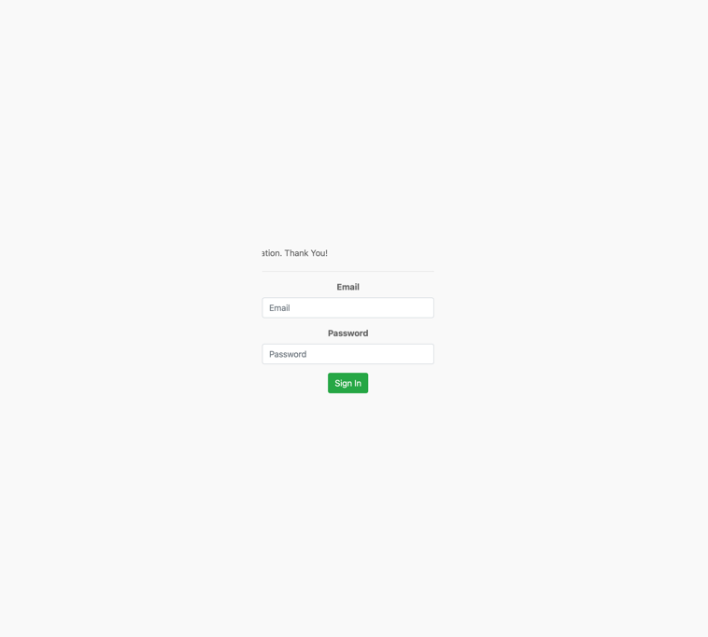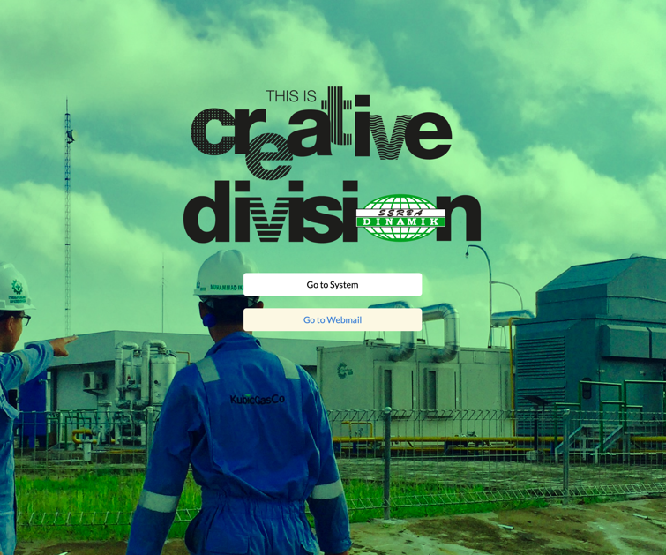

**Step 2**

Next, enter your Email (that have been provided for each department), in the “Email” field. Then, you can proceed to enter your password in the “Password” field.

***Note:*** *If you forgot your Email and Password, please contact Administrator for assistance.*

**Step 3**

When you are ready, click on the Login button to access your Creative System account. Now, you are already logged in to the system as a user & you will see dashboard of the Creative System on the screen.

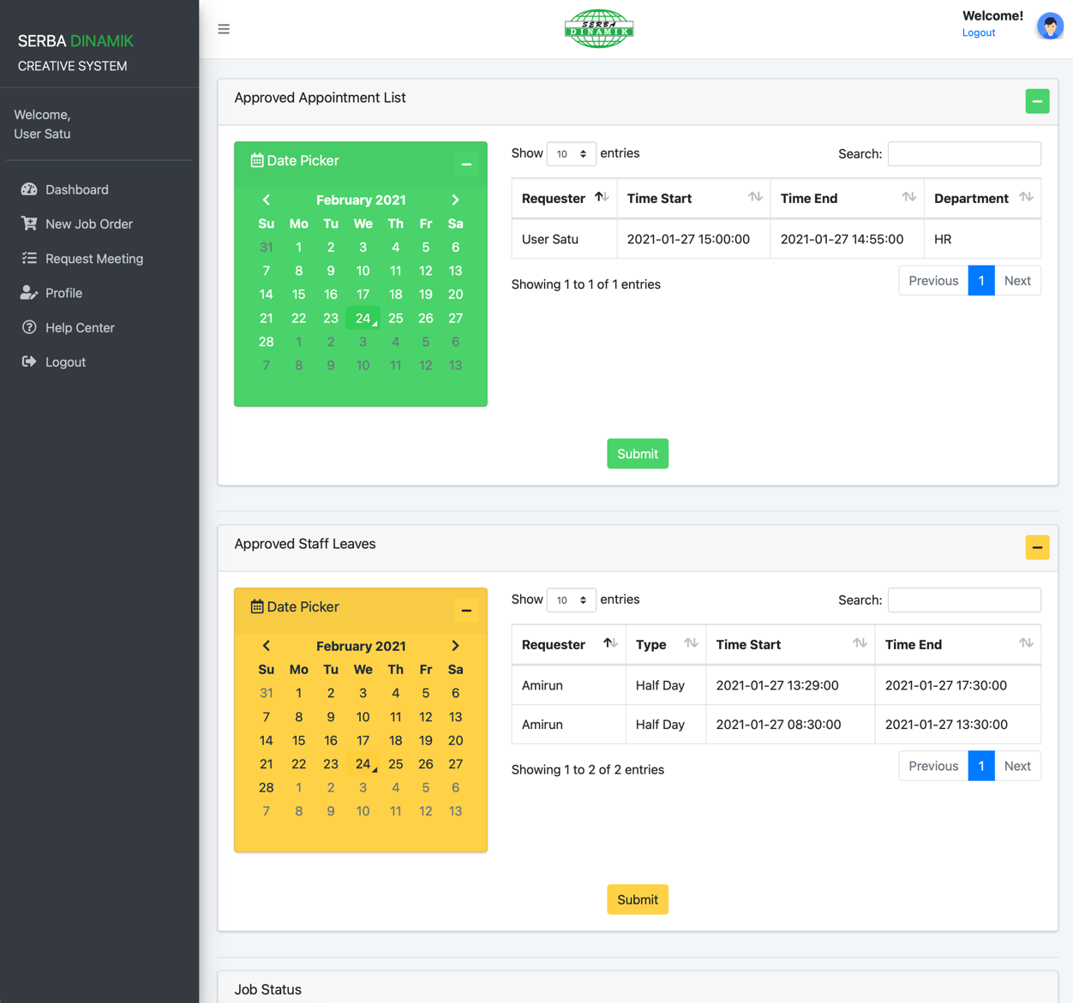

**3.1.2 How to logout?**

**Step 1**

Once you log in to Creative System you will see the dashboard as the front page. To logout, you can either click the button at the top right corner of your screen or the last button on the menu navigation tab located on the left of your screen.

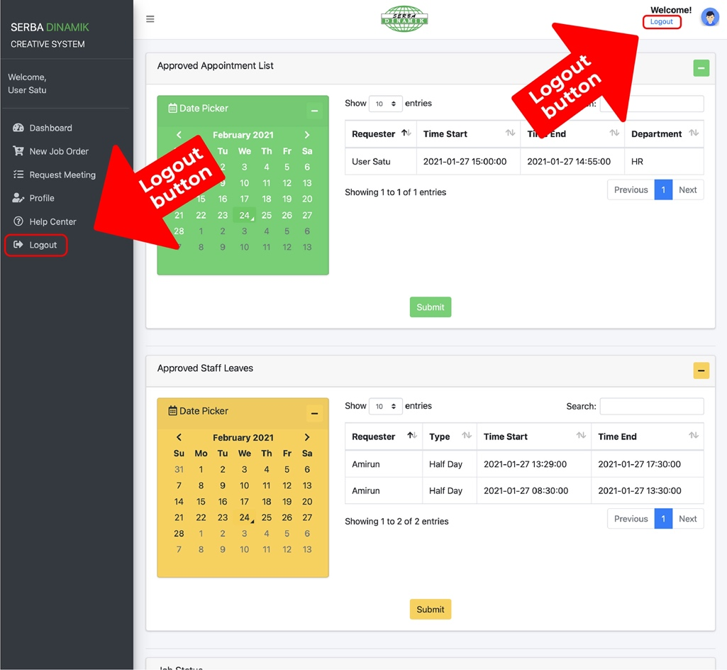

### Account & Profile

**3.2.1 How do I change my password or update my profile?**

**Step 1**

On your dashboard, navigate to the menu navigation tab on the left of your screen, click on “Profile”.

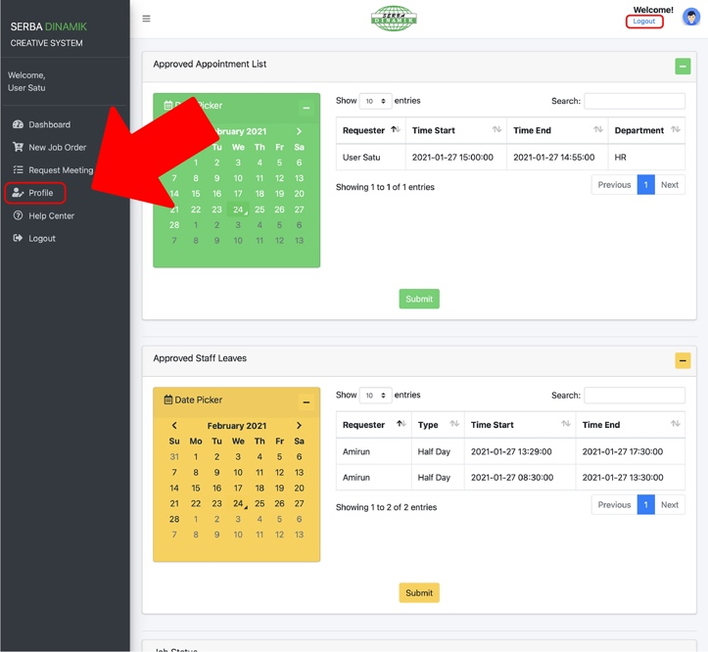

**Step 2**

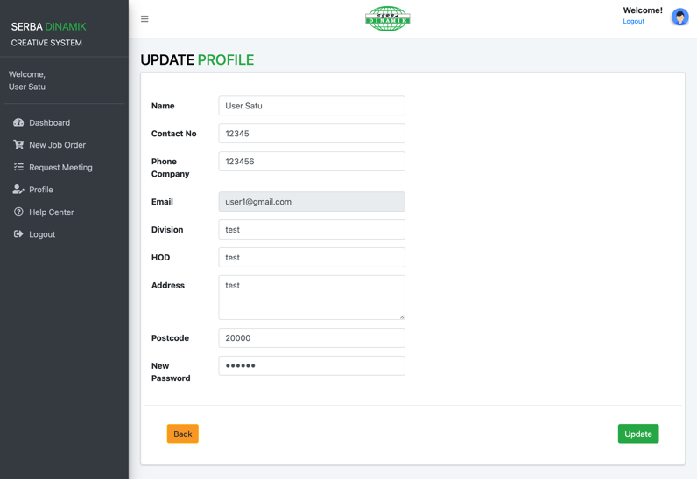Now, you will be in Update Profile page and you can proceed to update your profile or password.

***Note:*** *You are allowed to change or update all of your information except your email.*

### Job Request

**3.3.1 How do I request a job?**

**Step 1**

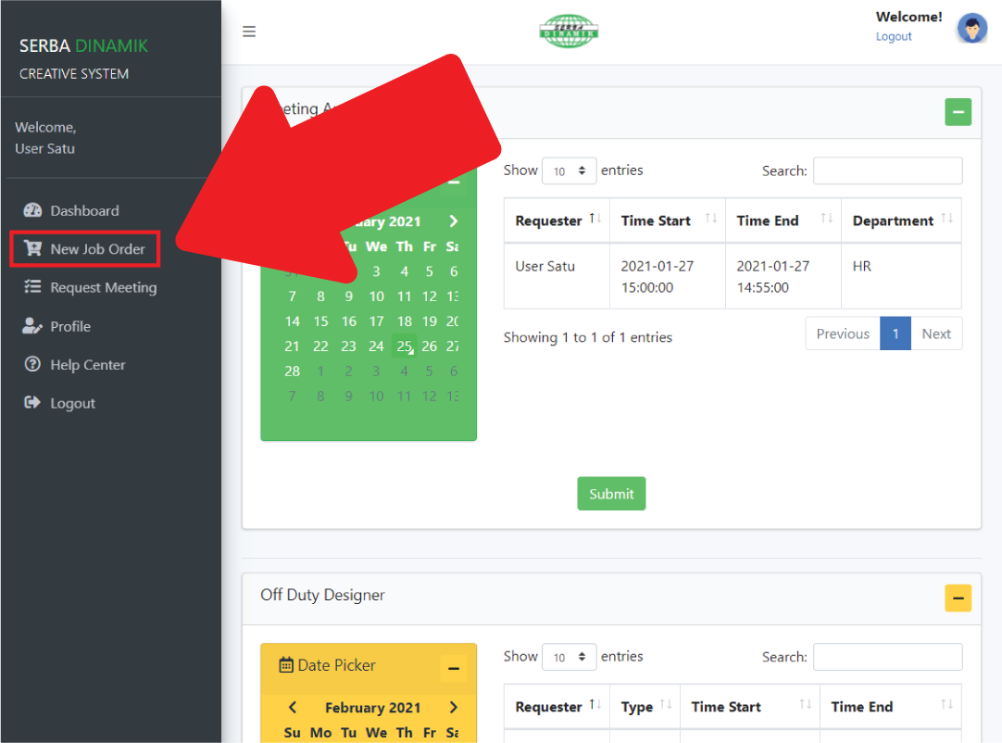On your dashboard, navigate to the menu navigation tab on the left of your screen, click on “New Job Order”.

**Step 2**

You will see on your screen “New Order” form. Please fill in all the information according to your job request.

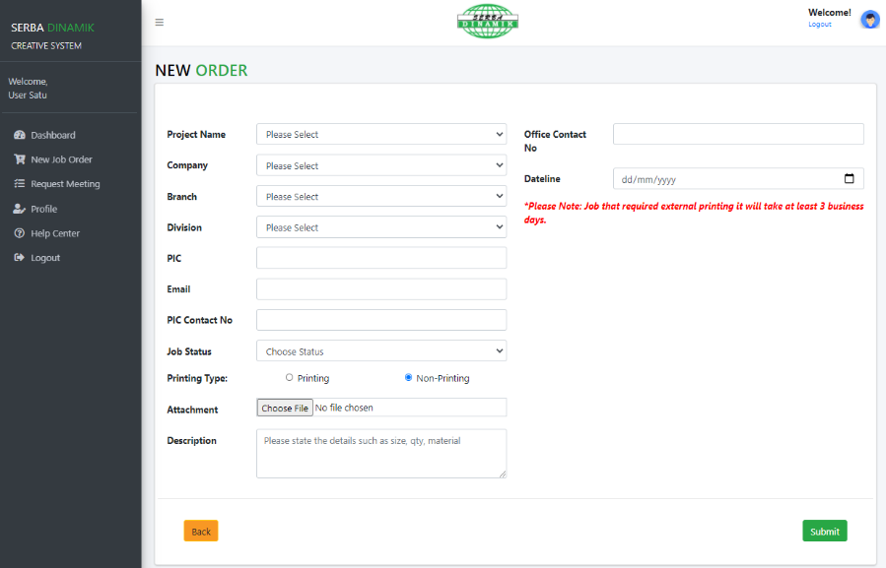

**Step 3**

Next, please check thoroughly all the information you already filled in. Once you satisfied with all the information, click the green “Submit” button on the bottom right of your screen.

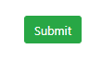

***Important:*** *Please make sure all the information you filled in is the correct information to avoid false information.*

***Note:*** *If you are not certain about the information, feel free to contact Creative Division.*

**Step 4**

After you clicked the “Submit” button the please wait for a while for the system to process & save your information.

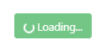

***Note:*** *Loading time vary depending on your internet connection. Make sure you have a stable internet connection.*

**Step 5**

You will be notified once your job request successfully submitted.

**

***Note:*** *If you want to cancel your job request, please contact Creative Division.*

*After your job request successfully submitted, you can check your requested job status on your dashboard.*

**3.3.1 How do I track my job request status?**

**Step 1**

On your dashboard, scroll to bottom of your page and you will see four tables named “  
Job Status”, “Job List”, “Printing” and also “Delivery”.

**Job Status Table:**

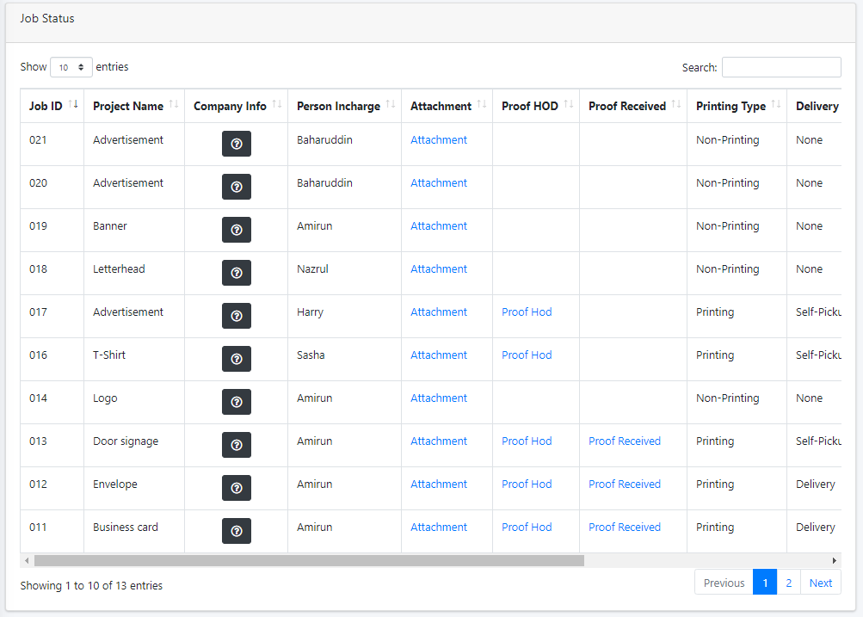

**Job List Table:**

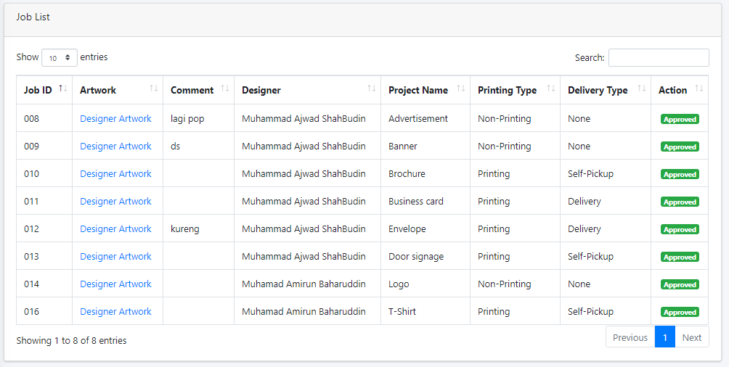

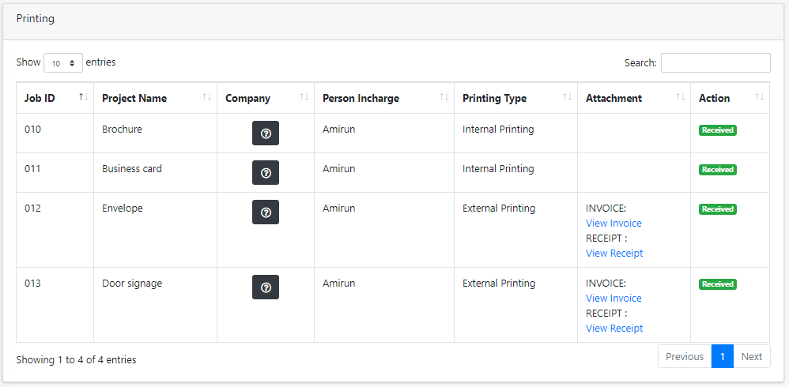**Printing Table:**

**Delivery Table:**

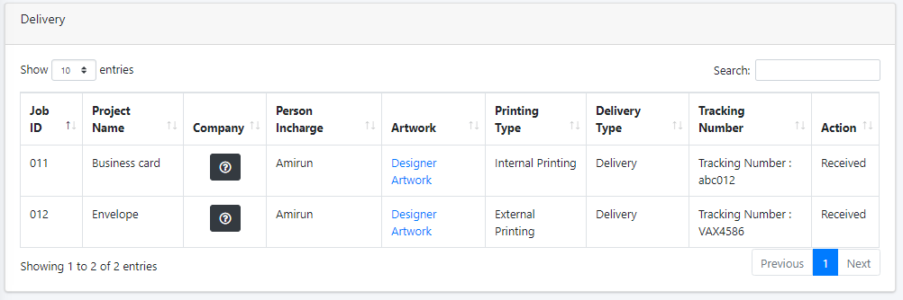

***Note:*** *You can sort according to row of the table using “up arrow” and “down arrow” or search using search field on the top right of each table using “keyword” of your requested job information.*

### Meeting Request

**3.4.1 How do I request for a meeting?**

**Step 1**

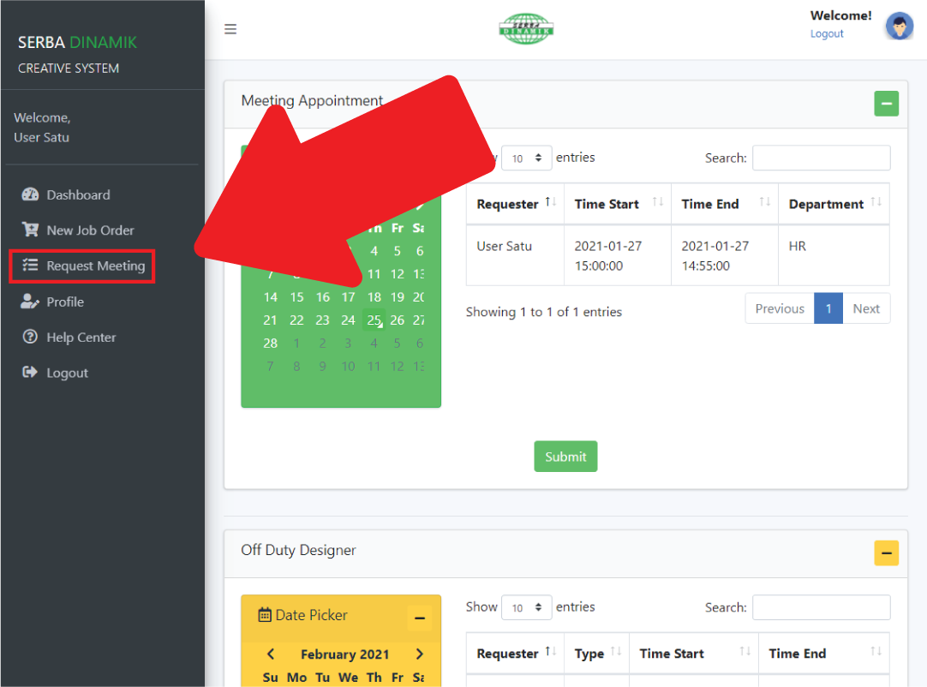On your dashboard, navigate to the menu navigation tab on the left of your screen, click on “Request Meeting”.

**Step 2**

You will see on your screen “Request Meeting” form. Please fill in all the information according to your meeting request.

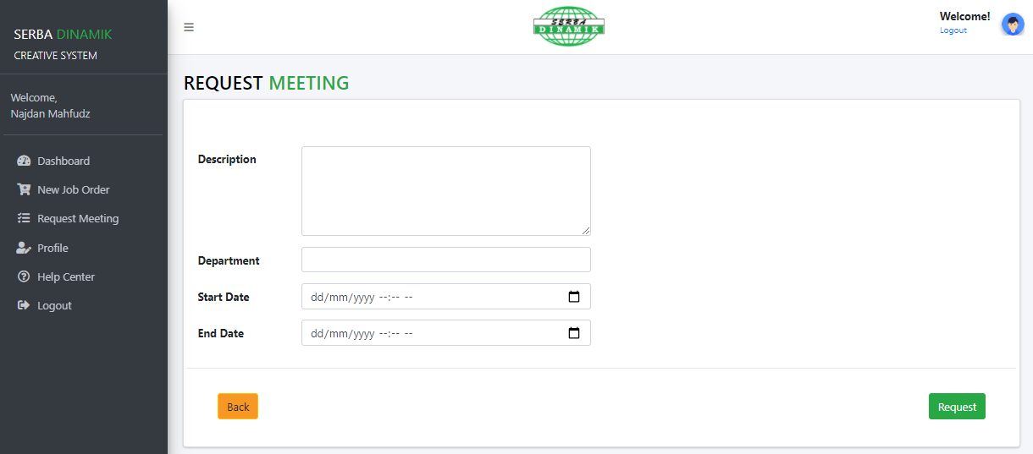

**Step 3**

Next, please check thoroughly all the information you already filled in. Once you satisfied with all the information, click the green “Request” button on the bottom right of your screen.



***Important:*** *Please make sure all the information you filled in is the correct information to avoid false information.*

***Note:*** *If you are not certain about the information, feel free to contact Creative Division.*

**Step 4**

After you clicked the “Request” button the please wait for a while for the system to process & save your meeting request.



***Note:*** *Loading time may vary depending on your internet connection. Make sure you have a stable internet connection.*

**Step 5**

Your meeting request have been successfully submitted. Please wait for the administrator to check and approve your meeting request.



***Note:*** *If you want to cancel your meeting request, please contact Creative Division.*

*After your meeting request have been approved by the administrator, you can check your requested meeting status on your dashboard.*

**3.4.2 How do I track my meeting request status?**

**Step 1**

On your dashboard, navigate to the menu navigation tab on the left of your screen, click on “Request Meeting”.

**Step 2**

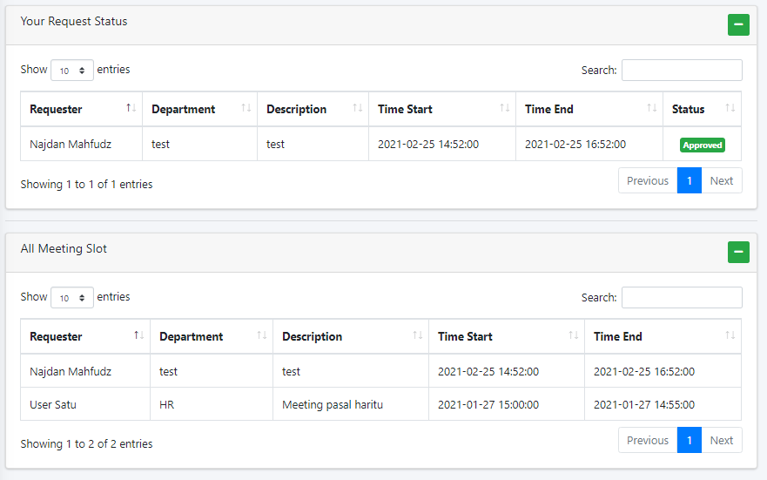Next, scroll to the bottom of the page and you will see two table named “Your Request Status” and “All Meeting Slot”. You can check all your meeting request information on that table.

***Note:*** *The table only shows your meeting request once the administrator have already approved it.*

## Getting Started (Printer-side)

The following sections provide detailed, step-by-step instructions on how to use the various functions or features of the Creative Division System.

***Note:*** *For printer-side, you will be provided only one in the system.*

### Login & Logout

**4.1.1 How to login?**

**Step 1**

To login, open this link on your browser, [https://e-crea7ive.com](https://e-crea7ive.com/), once you have opened the link, you will see the front page. Next, click on “Go to System” to open the login page.



**Step 2**

Next, enter your Email, in the “Email” field. Then, you can proceed to enter your password in the “Password” field.

***Note:*** *If you forgot your Email and Password, please contact Administrator for assistance.*

**Step 3**

When you are ready, click on the Login button to access your Creative System account. Now, you are already logged in to the system as a user & you will see dashboard of the Creative System on the screen.

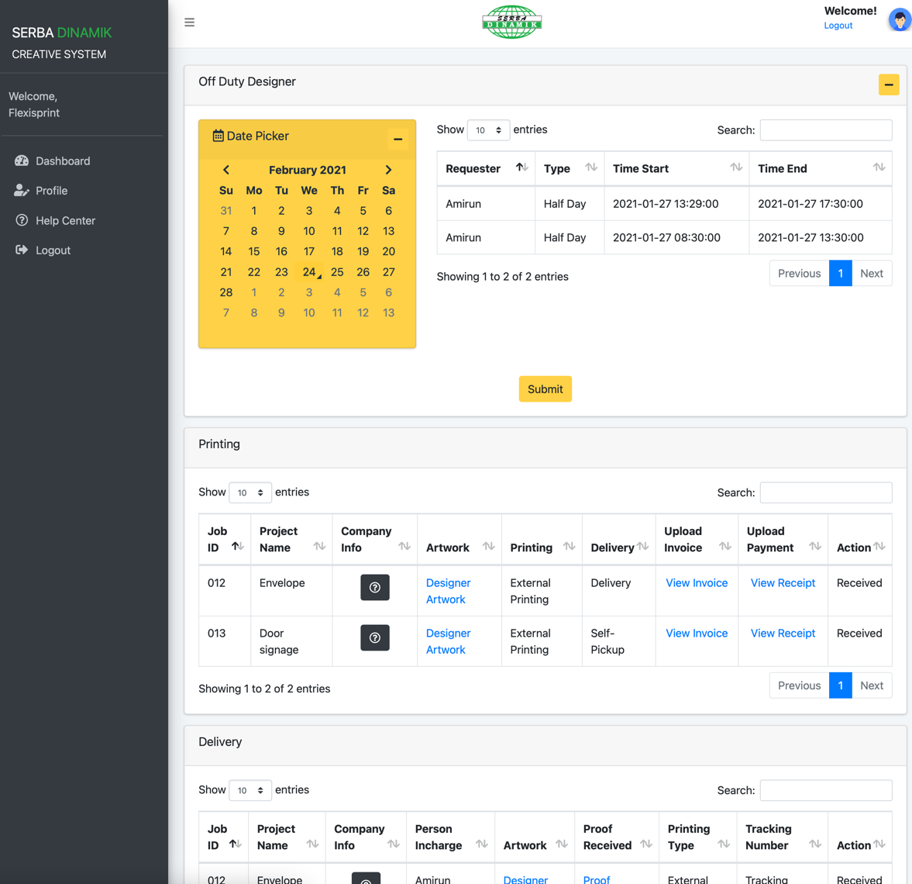

**3.1.2 How to logout?**

**Step 1**

Once you log in to Creative System you will see the dashboard as the front page. To logout, you can either click the button at the top right corner of your screen or the last button on the menu navigation tab located on the left of your screen.



### Account & Profile

**3.2.1 How do I change my password or update my profile?**

**Step 1**

On your dashboard, navigate to the menu navigation tab on the left of your screen, click on 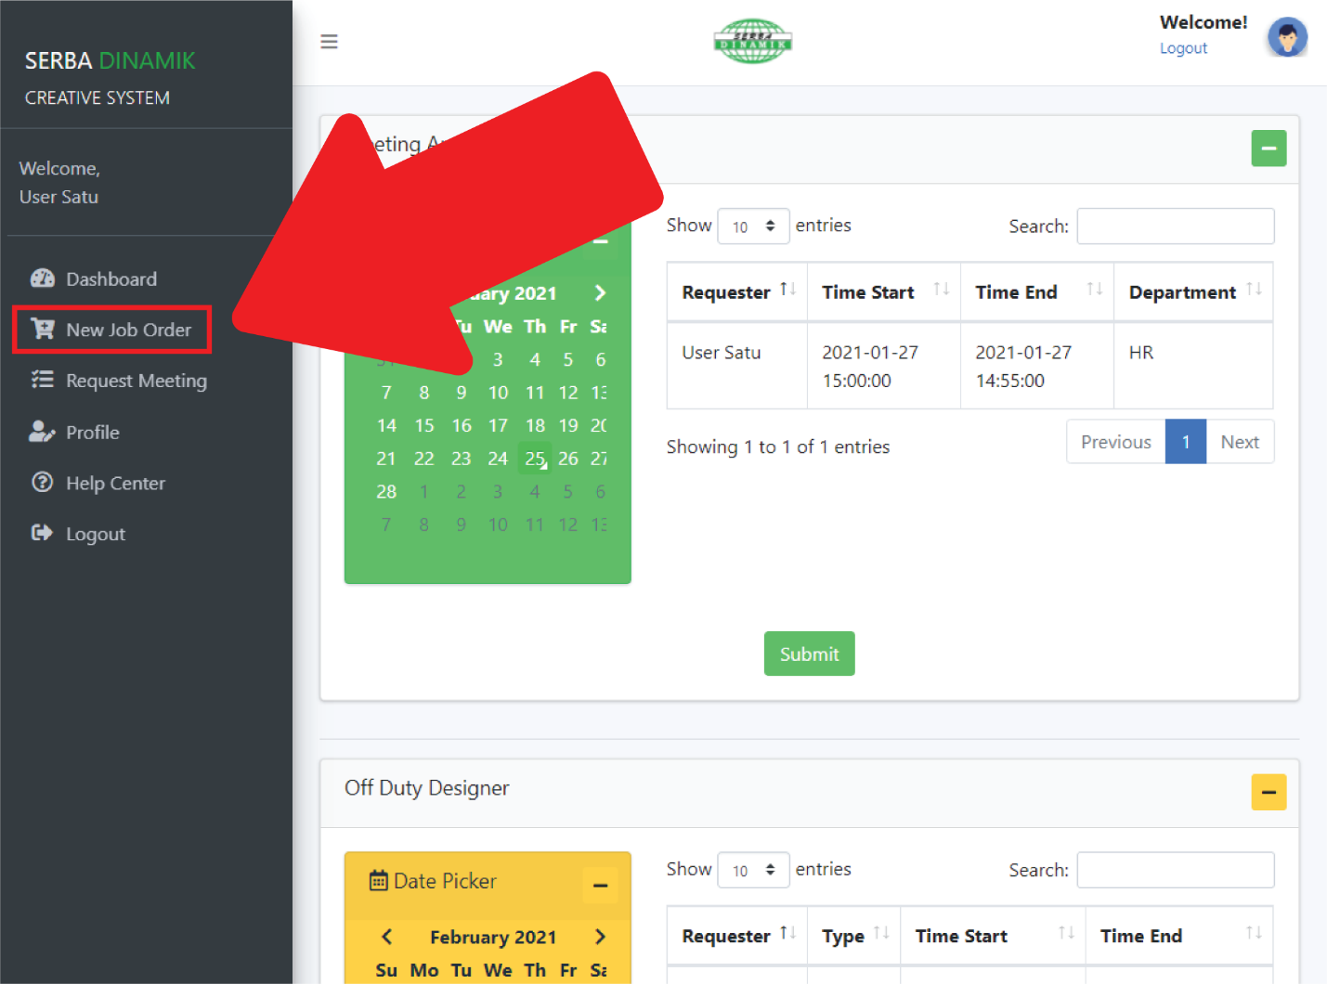.



**Step 2**

Now, you will be in Update Profile page and you can proceed to update your profile or password.

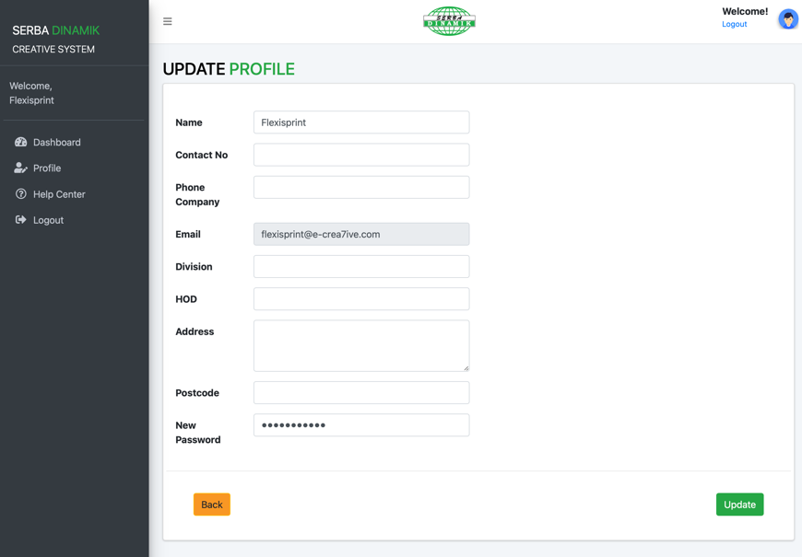

***Note:*** *You are allowed to change or update all of your information except your email.*

### Managing Printing Job

**4.3.1 How do I track my job request status?**

**Step 1**

On your dashboard, scroll to bottom of your page and you will see two tables named “  
Printing” and also “Delivery”.

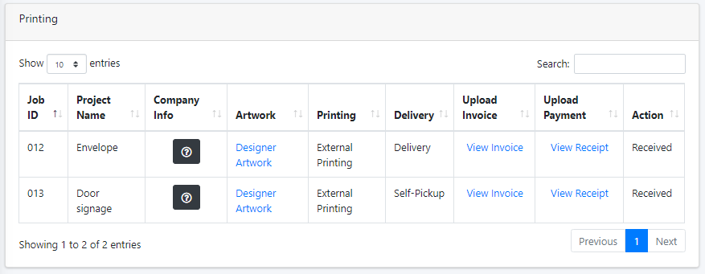

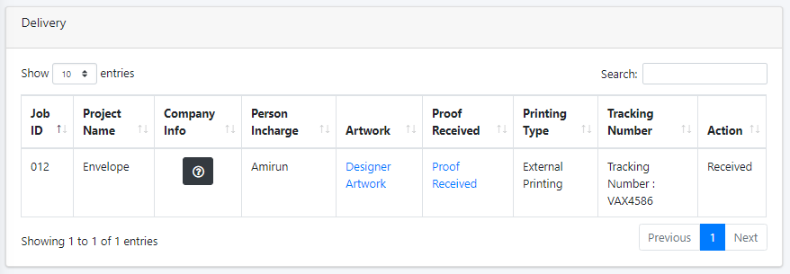

***Note:*** *You can sort according to row of the table using “up arrow” and “down arrow” or search using search field on the top right of each table using “keyword” of your printing job information.*

### Accessing Webmail

**4.4.1 How to login and check email?**

**Step 1**

To login, open this link on your browser, [https://e-crea7ive.com](https://e-crea7ive.com/), once you have opened the link, you will see the front page. Next, click on “Go to Webmail” to open the login page.



**Step 2**

Next, enter your “Email Address” and “Password”, then click login.

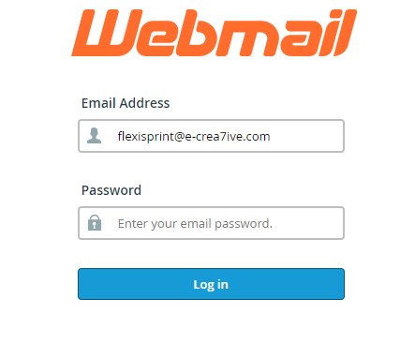

**4.3.1 How to change my webmail password?**

**Step 1**

Navigate to the navigation tab on the left-side of your screen. Click on “Webmail Home” button.

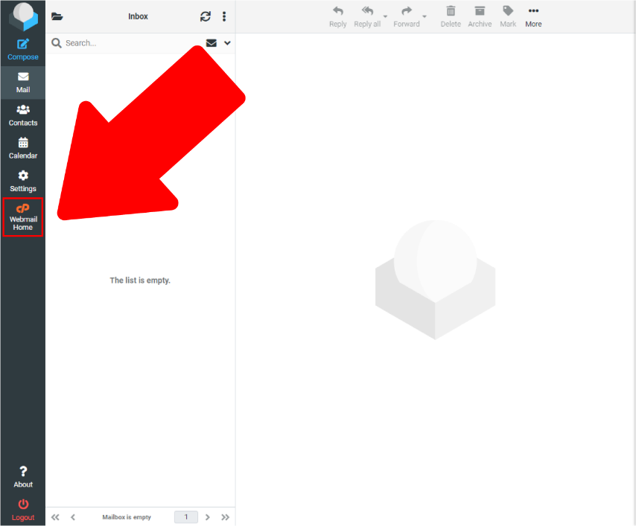

**Step 2**

Scroll bottom and navigate to “Edit Your Settings” section and click on “Password & Security”.

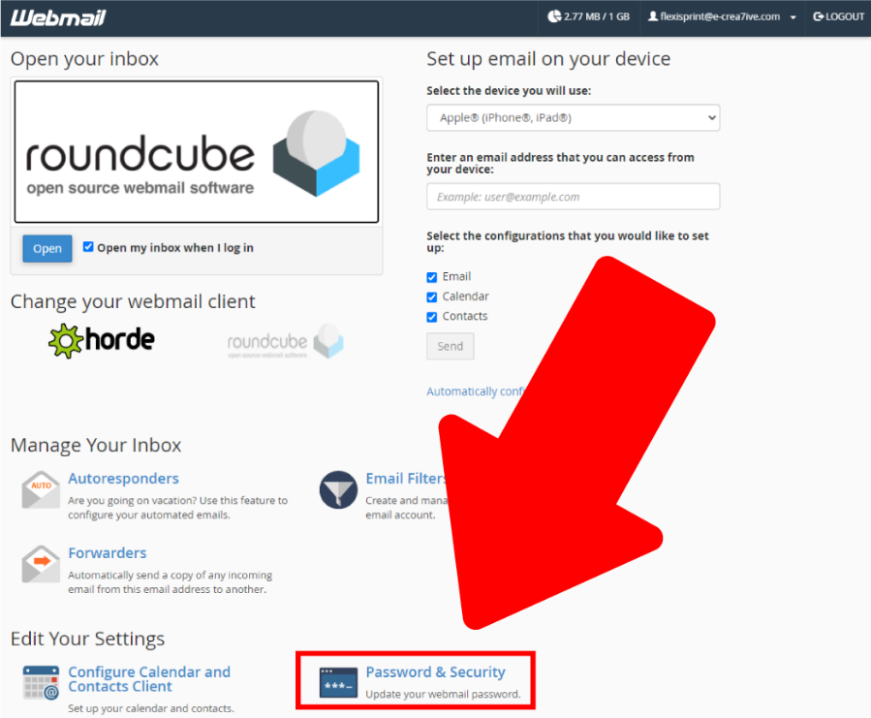

**Step 3**

Now you can insert your new password and confirm new password, then click “Save”.

