There are many PC-based oscilloscopes, multimeters, and logic analyzers, but few instruments with all of these capabilities. It is our belief that we can design and build a low-cost instrument.
The multimeter is, in general, a well-understood device with respect to its functionality. According to Tedd and Kennedy in their patent, the device generally consists of an ammeter, voltmeter and ohmmeter with user-controlled switches to multiplex a small set of probes and display over the three sensors [1]. As technology improved, the sensor hardware was moved to a set of analog-digital converters, such as in the NI PCMCIA-4050 Portable 5½ digit Multimeter [2]. This device combines a signal conditioner which controls the switching mechanism referenced in [1] before feeding the signal to an analog-digital converter and then allowing that signal to be processed by a computer system (see Figure 1). LabVIEW, a general measurement software suite, is run on the host system to interpret the ADC output. The NI PCMCIA-4050, when combined with a PCMCIA-equipped PDA that has the portable version of LabVIEW installed, can form an impromptu multimeter from consumer-level hardware and a simply-purchased (if expensive) add-on [3].
The signal conditioner is a lead-in component of the multimeter that ensures that incoming analog signal is an equivalent voltage before being converted to a digital waveform by the analog-digital converter.
Low-performance digital oscilloscopes are in the reach of the hobbyist; a straightforward design includes an analog-digital converter (ADC), an amplification circuit to give better conversion accuracy, and a microcontroller to take the output and pass it to a processing device (in this case, a PC) [4]. A flow diagram for this basic architecture is shown in Figure 2.
Similarly, low-performance logic analyzers are also easy to construct by the hobbyist—usually by directly sampling the signal through a parallel port interface or a similar direct-access computer I/O port [5]. This approach is limited by the maximum sampling rate of the supporting interface. A trigger condition can be added to the design for more sophistication. Standalone units are effectively small computer systems that store the signals in memory (see Figure 3).
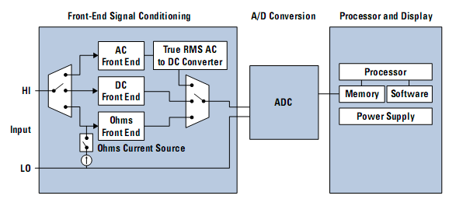Figure 1: A general digital multimeter architecture [6]
Creators of the Handyscope HS3 claim to be the first to combine the oscilloscope and multimeter and make it PC-based [7]. Such a system has a hardware component that serves to acquire data and is transfered to a PC to process the data. The Handyscope HS3 does just this and information about its capabilities, characteristics, and limitations shall be analyzed.
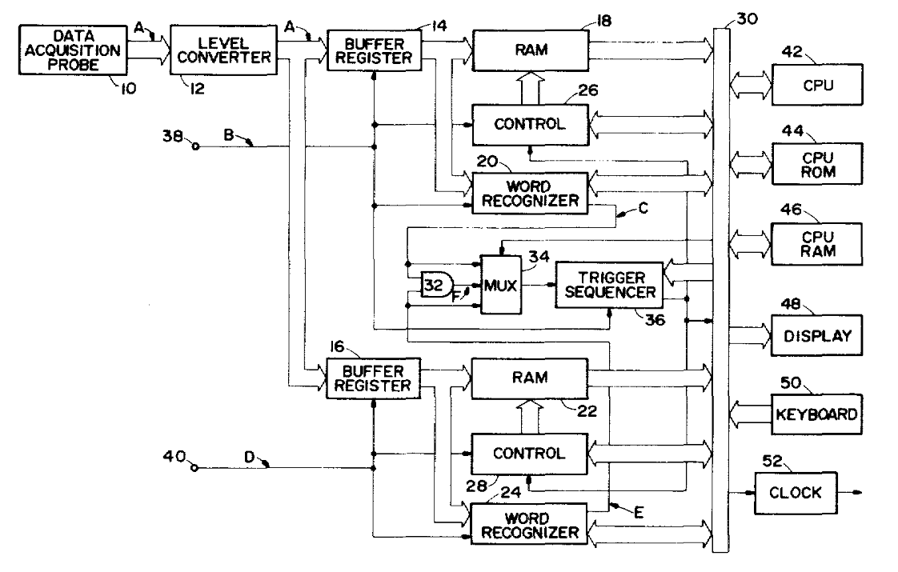Figure 3: Standalone Logic Analyzer Block Diagram [8]
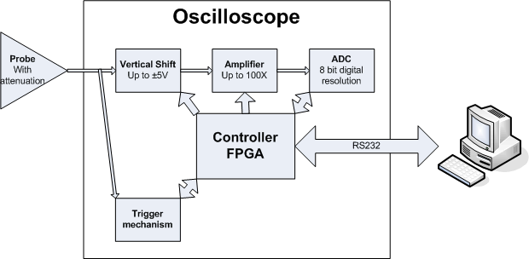Figure 2: Digital Oscilloscope Diagram [4]
The Handyscope HS3 has 2 channels for inputs and 1 output to the PC [7]. It has a 100 Megahertz sampling speed and can record up to 128,000 samples [7]. Its input voltage can range from .2 to 80 volts [7]. The hardware is connected to the PC with a USB 2.0 or 1.1 [7]. Therefore it is capable of being used with older computers as well. It comes with two oscilloscope probes that were designed specifically to be used with the Handyscope HS3 [7].
The software provided with the Handyscope HS3 effectively turns the PC into a oscilloscope, spectrum analyzer, voltmeter, and transient recorder [9]. It can be used with both Windows and Linux. The dynamic link library of the Handyscope HS3 comes with an example program so the user can easily write their own measuring program [7]. The source code is in Delphi [7]. The DLL's can be downloaded from the company's website. Hardware and software updates can also be downloaded free of charge from the company's website. The Handyscope HS3 allows the user to save their settings to a disk so it can be used each time they use the software [7]. An inexperienced user can use an automatic setup routine, which allows for instant measurements [7]. Another capability of this instrument is that it has an arbitrary waveform generator that operates independent of the measuring system[9]. This allows the user to generate test signals in any shape desired. It is also possible to regenerate previously measured signals [9].
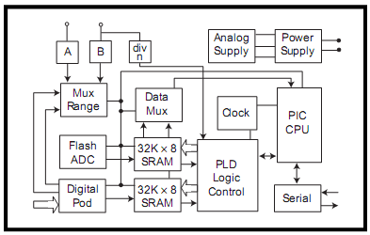Figure 4: Block diagram of mixed-signal capture engine [11]
Device | Handyscope HS3 | BS100U Bitscope
Digital Interface |  | USB
Oscilloscope |  | X
Voltmeter
Supported Host Systems | Windows, Linux | Windows, Linux
Size | 25mm * 170mm * 140mm
Table 1: Comparison of Handyscope HS3 and BS100U [7], [10]

There are 5 main tools used to evaluate the data. It has an arbitrary waveform generator, digital storage oscilloscope, spectrum analyzer, voltmeter, and transient recorder. They appear to be very user friendly and settings can be easily controlled. The BS100U Bitscope is a PC-based, mixed signal oscilloscope that is similar to the Handyscope HS3 except it does not include as many capabilities [10]. Some important features it has that makes it competitive with the current project:
- Users can control sweep rate
- Users can control vertical deflection
- Storage of waveforms
- Display several waveforms at the same time
- Spectral analysis
- Battery power options
- Usability with all popular platforms
- Zooming features
- Multi-colored displays [10]
The size of the Handyscope HS3 is rather small. It measure 25 x 170 x 140 millimeters and weighs 17 ounces [7]. This size is comparable to the size of a person's hand. It is very important to keep the size small because one of the attractive reasons people will want to pursue this device is because it eliminates the big, bulky machines.
[1] United States Patent: 4604569. http://patft.uspto.gov/netacgi/nph-Parser?Sect2=PTO1&Sect2=HITOFF&p=1&u=%2Fnetahtml%2FPTO%2Fsearch-bool.html&r=1&f=G&l=50&d=PALL&RefSrch=yes&Query=PN%2F4604569. Accessed Oct. 29, 2008.
[2] NI PCMCIA-4050 – Products and Services – National Instruments. http://sine.ni.com/nips/cds/view/p/lang/en/nid/12912. Accessed Oct. 22, 2008.
[6] NI PCMCIA-4050 and 4060 Data Sheet. http://www.ni.com/pdf/products/us/3mi463-466.pdf Accessed Oct. 22, 2008.
[3] Build a Bluetooth Enabled PDA Digital Multimeter with LabVIEW PDA. http://zone.ni.com/devzone/cda/tut/p/id/3052. Accessed Oct. 12, 2008.

[4] Digital Oscilloscope. http://glory.honour.ca/projects/Oscilloscope/Oscilloscope.html. Accessed Oct. 12, 2008
[5] Simple logic Analyser. http://uvasux.googlepages.com/simplelogicanalyser Accessed Oct 12, 2008

[8] Logic Analyzer for a multiplexed digital bus. http://www.google.com/patents/pdf/Logic_analyzer_for_a_multiplexed_digital.pdf?id=gKsyAAAAEBAJ&output=pdf&sig=ACfU3U3CQnk57TMwh6AYDXSjBfEQAoR78g. Accessed Nov 6, 2008.

[7] Handyscope Instrument Description, http://74.125.113.104/search?q=cache:jU-oY3le0wUJ:www.egmont.com.pl/tiepie/katalog/HS3_spec.pdf+handyscope+HS3&hl=en&ct=clnk&cd=7&gl=us Accessed Oct 12, 2008

[10] Brilldea BS100U. http://www.brilldea.com/product_BS100U.html Accessed Oct 12, 2008

[11] “Bitscope: A Mixed-Single Capture Engine”. http://i.cmpnet.com/edtn/ccellar/e043pdf1.pdf. Accessed Oct. 12, 2008.

[9] USB Oscilliscope - Handyscope HS3, http://www.tiepie.com/uk/products/External_Instruments/USB_Oscilloscope/Handyscope_HS3.html Accessed Oct 12, 2008

