The Digital Oscilloscope
The oscilloscope is one of the most used electronic testing tools. It is a tool that displays voltage signals over a period of time. It presents this as a graph. The vertical axis of the graph is for the voltage of the system and the horizontal axis is for the time. Uses of an oscilloscope would be:
- finding the time and voltage values of the signal
- finding the frequency of a signal
- debugging a circuit
- finding out what part of a signal is due a direct current (DC) and what part of the signal is due to alternating current (AC).
- and what part of the signal is noise[1].

The digital oscilloscope works by taking voltage signals from the probes and then the oscilloscope then displays it.(See Figure 1.) When following Figure 1 the oscilloscope will work by:
- retrieving the voltage signal with the probes
- taking that signal to the attenuator and vertical amplifier will adjust the amplitude of the signal
- the Analog to Digital Converter then takes samples of the analog signal.(The number of samples is determined by the Sample Clock.)
- the samples are then saved in memory to create the waveform
- this data is then sent to the computer where it will be processed by the software we will make and be displayed by the monitor.

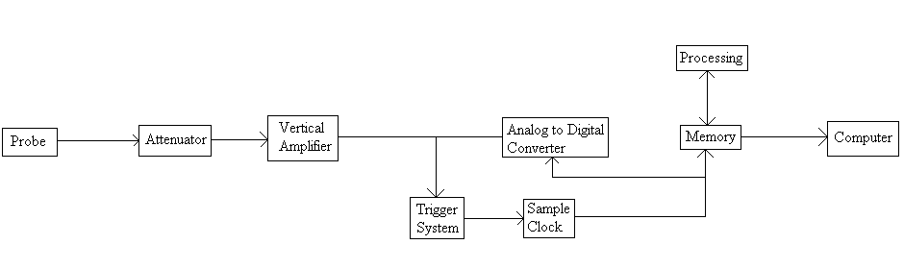
Figure 1 [1]

The analog to digital converter that would preferably be used would be AD7822.
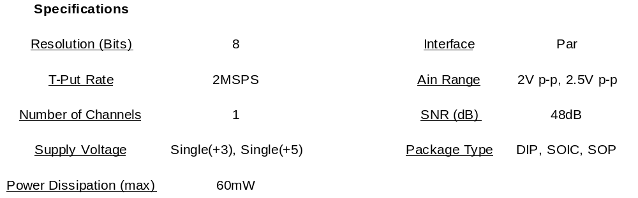Table 1 [2]
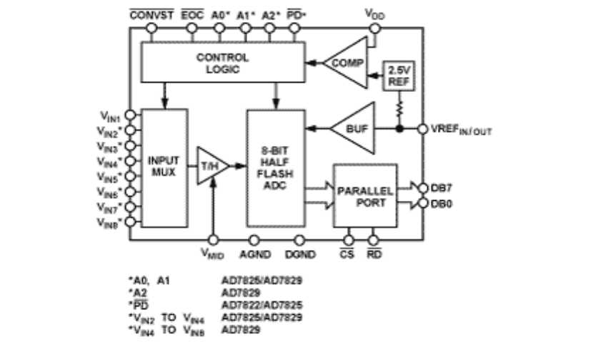 [2]
Figure 2: A diagram of AD7822 [2]
This converter will give a more preferable sampling rate and since the package comes in both SOP and DIP it can be used for the prototype and the final product.

Logic Analyzer
A logic analyzer is a tool that helps debug digital circuits. Now, an oscilloscope can be used for this to but an oscilloscope cannot view multiple lines at once. A logic analyzer on the other hand can look at multiple lines at once. It also allows the user to view the circuit the same way that the hardware views it and one can also control the trigger of events with it.
The logic analyzer works like in Figure 3. By following Figure 3 the logic analyzer will work as follows:
- the input probes acquire a sample
- the input is then buffer until the clock allows it to go on to the acquisition memory
- the acquisition memory is then controlled by the memory control which is determined by the trigger logic
- and finally the data is sent to the computer where the software that we will make will analyze and display it.
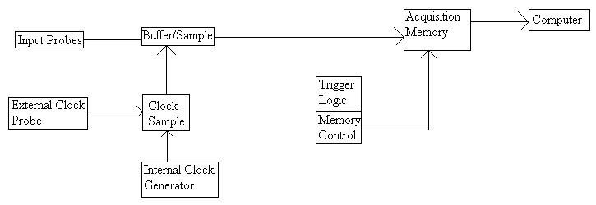
Figure 3 [3]

[1] “The Oscilloscope,” https://www.cs.tcd.ie/courses/baict/bac/jf/labs/scope/oscilloscope.html Accessed Oct. 28, 2008
[2] “AD7822: 3 V/5 V, 2 MSPS, 8-Bit, 1-/4-/8-Channel Sampling ADCs,” http://www.analog.com/en/analog-to-digital-converters/ad-converters/AD7822/products/product.html Accessed Nov. 5, 2008
[3] “The XYZs of Logic Analyzers,” http://web.mit.edu/6.111/www/s2007/handouts/LA.pdf Accessed Nov. 7, 2008

