Signal conditioning subsystem:

The purpose of this subsystem is to scale the analogue input to an appropriate level so that it can be read by the analogue to digital converter. The goal is to scale the output voltage to be between 0 and 5 volts and allow proper shifting and amplification via user interaction with the software. Circle 1 indicates where the input voltage is applied. The diode and resistor configuration allows the input range to be from -12.7 to +12.7. A reference voltage of + and -12 volts is used here and also supplies all the operation amplifiers. Circle 2 shows another voltage going into the inverting position of an op amp. This voltage is delivered through a digital to analogue converter. This allows the user to shift the voltage up or down. This voltage should range from 0 to +5 volts. Unable to test it with the micro controller, I directly used a voltage supply to simulate the voltage the digital to analogue converter would supply. The op amps by circles 1 and 2 are voltage followers and act as buffers with the output equaling the input. The op amp by circle 5 acts as an inverting summer. Essentially the sum of the input voltage and voltage produced by the digital to analogue converter are summed together and inverted. It will also be amplified through the use of a multiplexer. Like the digital to analogue converter, the multiplexer gets information from the microcontroller and activates the desired output to use a resistor. These resistors, shown by circle 4, vary to allow for different levels of amplifications. For example, for 2x amplification, the 20k resistor is used (20k/10k = 2x amplification) and this is multiplied by the sum of the earlier voltages. The last op amp shown by figure 6 scales the signal to between 0 and 5 volts.
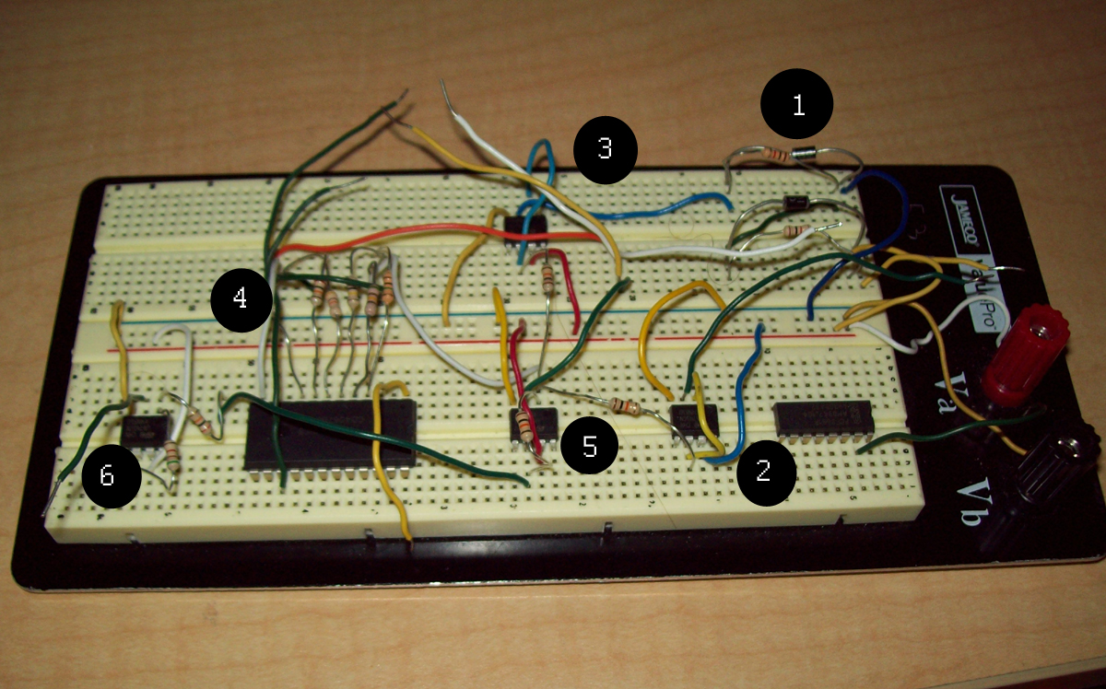

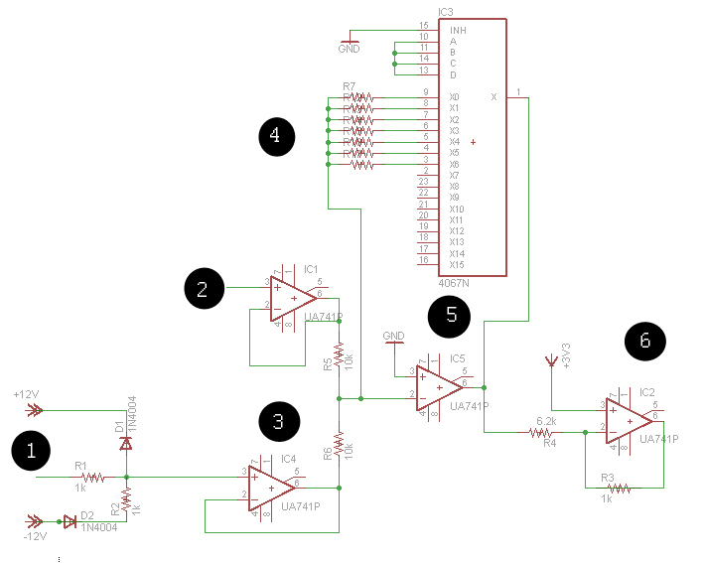

Equipment list:

12 resistors
3 1k resistors
2 used to clamp voltage level by circle 1
1 used for inverting amplifier by circle 6
1 6.2k resistor used for the inverting amplifier by circle 6
3 10k resistors
2 following the outputs of the op amps by circle 2 and 3
1 for the variable resistance used by the multiplexer by circle 4
1 20k resistor for the variable resistance used by the multiplexer by circle 4
1 50k resistor for the variable resistance used by the multiplexer by circle 4
1 100k resistor for the variable resistance used by the multiplexer by circle 4
1 500k resistor for the variable resistance used by the multiplexer by circle 4
1 1M resistor for the variable resistance used by the multiplexer by circle 4

2 IN4001 diodes used to clamp the input voltage shown by circle 1
4 741 op amps
1 4067 analogue multiplexer for variable feedback shown by circle 4
1 PCF8591 digital to analogue converter shown by circle 2

Component | Basic Specs | Number of Units | Cost per unit | Total Cost
Resistors | Carbon film | 12 | $0.10 | $1.20
Multiplexer | Single ended, 16 inputs | 1 | $1.09 | $1.09
Op Amps | Max +/-22 volt supply | 4 | $0.25 | $1.00
DAC | I2C interface | 1 | $3.49 | $3.49
Diodes | Forward voltage 1V@1A | 2 | $0.30 | $0.60
Total cost = $7.38

Schedule for components:
It took us a week at the most for our parts to arrive after ordering them from various companies. Building this circuit is straight forward and simple. It can easily be done within a day. The troubleshooting is where most of the time will take. It took me about 3 months of troubleshooting to get values that I was content with. Also, it could take longer depending if you test it with the micro controller or not. I would anticipate this would take a month to complete at the most to get it to perform ideally. The next paragraph describes my suggested technique to test the circuit after it is put together.

Testing the circuit:
Setting up the source voltages can be a little tricky. Since the 741 op amps are not rail to rail, the +12 and -12 reference voltages must be supplied using 2 different voltage sources. If the circuit is going to be implemented separately from the microcontroller, another voltage source should be used as the voltage to the op amp by circle 2. Another voltage source of 3 volts should be applied to the noninverting input of the op amp by circle 6. Finally the input voltage should be applied to circle 1. I had trouble testing it initially with so many voltage sources, but I was able to find 2 triple power supply units to test it with. The feedback resistor of the op amp by circle 5 can be manually placed there instead of through the multiplexer if being tested without the micro controller. To test the circuit, I would first test to see if the voltage clamper works correctly by circle 1. Use a multimeter to test the voltage before op amp 3 and adjust the input to points outside the + and -12,7 volts. The output should not be bellow -12.7 nor above +12.7 volts. Next, I would test the op amps by circles 2 and 3 and make sure the output voltage is equal to the input. Then record the voltage coming out of the op amp by circle 5 with 10k feedback. This should be approximately equal to the inversion of the sum of the input and digital to analogue voltages.
V = - [V(DAC) + V(IN)]
If this is correct, I would finally test the output voltage coming out of the op amp by circle 6. Put the input voltage to the max of 12.7 and the DAC voltage to its max of 5. This should yield an output of 0. Then set the input voltage to -12.7 and the DAC voltage to 0. The output voltage should be around 5 volts. Any other input voltage levels should show an output voltage between 0 and 5 and be approximately:
V(OUT) = 3 - .16447[V(dac) + V(in)]

Fault analysis:
There are several obvious but overlooked reasons as to why this circuit would not operate properly. When I started off, I could not get any voltage out of an op amp I was using. I kept testing and asking for help and could not figure out what was wrong. Finally I moved the op amp to another part of the breadboard and it operated correctly right away. The breadboard was not working properly where I first placed the op amp. A faulty breadboard can be tested with a multimeter to make sure the connections are properly working.
It is possible to ruin your diodes or op amps if excess voltage is give to them. If the diodes are facing the wrong direction they will also not operate properly. If there as any doubt of the components not working correctly, get new parts to replace them. The diodes and op amps are cheap so it won't cost very much to use another one.
If you are getting voltage values that are different than what the equation resulted in, it could be because of variances in each device. Make sure to use resistors with gold (5%) tolerances. Also, you should measure the exact values before plugging them into the equations I used, not the theoretical values.

Appendix:
Data sources and websites:
The information for the preceeding components were all found on the internet which was accessed on April 12, 2009.

The digital to analogue converter can be purchased from Mouser Electronics. PCF8591 is the part number that can be obtained from www.mouser.com. The resistors can also be ordered here.

The 2 diodes can be purchased from www.digi-key.com with part number 1N4001DICT-ND.

The multiplexer can be purchased from www.jameco.com with part number 13215. The op amps can also be purchased here with part number 24539.

The equations derived earlier were all from basic op amp equations. However the final output equation was derived by setting the max output from the op amp by circle 5 to 5 and the minimum output to 0 for a negative feedback op amp:
0 = V – 17.7k
5 = V +12.7k
where k = R2/R1
With 2 equations and 2 unknowns, I solved for 1 and plugged that into the other equation to obtain the final output equation of V = 3-.16447[V(dac) + V(in)]

Final simulation results (with 1x amplification):
Input Voltage | DAC Voltage | Output Voltage
12.7 | 5 | 1.4
10 | 3 | 1.9
2 | 4 | 3.2
-12.7 | 0 | 5.1

Although these results were not precisely how I planned, they are still within the range of the analogue to digital converter to read.

