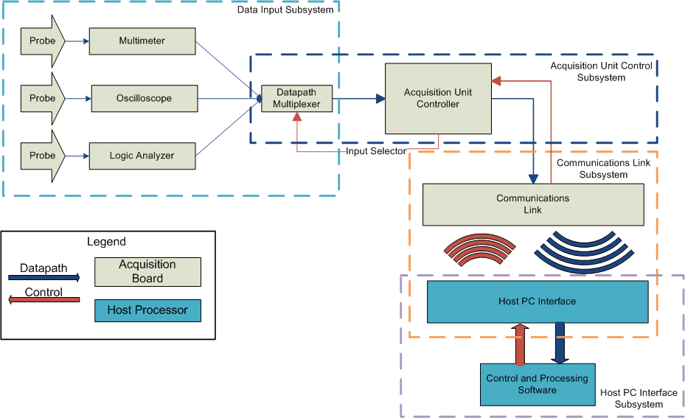Figure 1: Overall Subsystem Block Diagram

Overview

The device will be divided into several subsystems for convenience of design and testing. These general subsystems are shown above in Figure 1. From a datapath perspective, signals are picked up in the input subsystem and converted into digital signals, which are then passed to the acquisition control sub-processor. The sub-processor relays the signal to the communication link subsystem via a common interface such as RS232, which then transmits that same data to the host processor. The host processor performs the necessary transformations and renders it to the user. A reverse procession is seen with the control signaling – control requests start from the user and are passed along to the acquisition unit control subsystem.

Multimeter

The multimeter subsystem of the project will measure the voltage, current, and resistance. It will only serve to acquire data. A digital type of multimeter will be implemented because the value of the readings must be displayed displayed after the data is relayed to the computer. There will be 2 probe inputs where the multimeter will get data on the voltage, current and resistance. The figures below shows a block diagram of the multimeter that will be implemented in the design. The display section will be implemented on the software of the computer.

As depicted in Figure 2, the signal would first be sent through an amplifier to scale it to the appropriate values. These would be +25 and -25 volts. A signal conditioner would then scale this voltage to an appropriate range for the analogue to digital converter. An integrated controller would then convert the analogue signal to a digital one. Control logic would be used to synchronize operation of the ADC to the computer display.
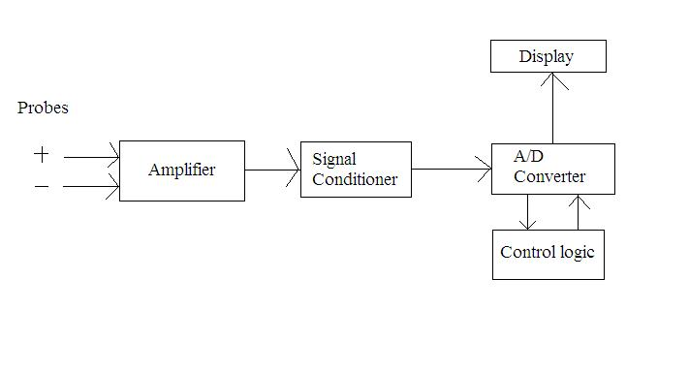Figure 2: Block Diagram of probe to converter

The multimeter will able to record currents up to 1 amp, voltages up to 25 volts, and 3 different resistances. These resistances will be 100k, 10k, and 100 ohms. Since we are using a digital multimeter, we must have an input impedance. This input impedance should be high enough so that it does not affect the performance of the circuit being tested. The sensitivity of the system will be within .1 volts. This will corresponds to .1 mA to 10 mA.
Basic data acquisition features that can be performed include being able to display the maximum and minimum readings. Furthermore, the user should be able to select the number of samples taken up to the maximum possible sample rate of the system.

We will use a 5 ½ digit resolution for the multimeter. This will allow the display of values ranging from -99,999 to +99,999. This should be sufficient for displaying virtually all values being measured.
Parts required would be an amplifier, signal conditioner, ADC integrated controller, and parts for the control logic. The schematic of the multimeter needs to be designed and collaborated with the other subsystems to determine the parts necessary.

The analogue to digital converter used for the multimeter portion of the project will be the National Semiconductor ADC10040CIMT (see Figure 3 for block diagram). This part will cost approximately $5. Our target bandwidth for the system will be dependent on the resolution of the ADC and the mode of connection. The ADC10040CIMT will allow us to have 10 bit samples at 40M S/s.
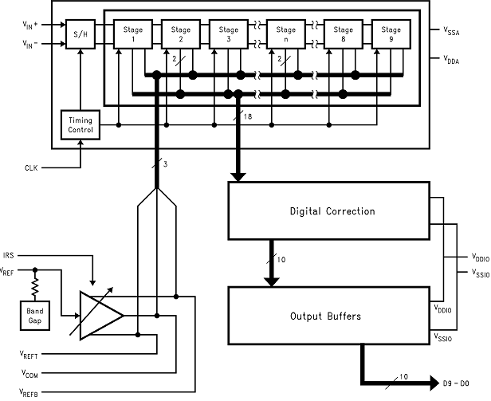Figure 3: ADC10040CIMT Block Diagram [1]
In relation to the other subsystems, the multimeter will be connected in parallel with a logic analyzer and oscilloscope. This information will then be sent via wireless connection Software will be designed to display the voltage, current, and resistance measured by the multimeter with 5 ½ digits. Figure 4 shows this portion of the subsystem in relation to the rest of the system.
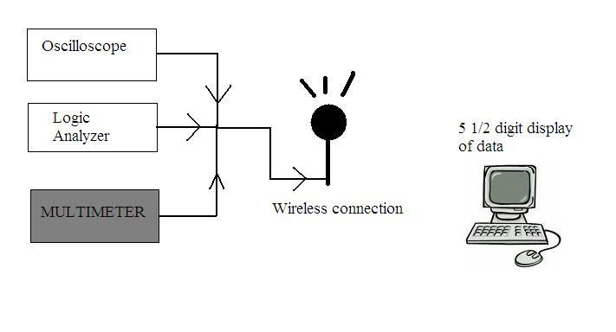Figure 4: Multimeter's Position in Logical Block Diagram

Digital Oscilloscope
The oscilloscope is one of the most used electronic testing tools. It is a tool that displays voltage signals over a period of time. It presents this as a graph. The vertical axis of the graph is for the voltage of the system and the horizontal axis is for the time. Uses of an oscilloscope would be:
- finding the time and voltage values of the signal
- finding the frequency of a signal
- debugging a circuit
- finding out what part of a signal is due a direct current (DC) and what part of the signal is due to alternating current (AC).
- and what part of the signal is noise[2].
The digital oscilloscope works by taking voltage signals from the probes and then the oscilloscope then displays it (See Figure 5). When following Figure 1 the oscilloscope will work by:
- retrieving the voltage signal with the probes
- taking that signal to the attenuator and vertical amplifier will adjust the amplitude of the signal
- the Analog to Digital Converter then takes samples of the analog signal.(The number of samples is determined by the Sample Clock.)
- the samples are then saved in memory to create the waveform
- this data is then sent to the computer where it will be processed by the software we will make and be displayed by the monitor.
The analog to digital converter that would preferably be used would be AD7822.
This converter will give a more preferable sampling rate and since the package comes in both SOP and DIP it can be used for the prototype and the final product.
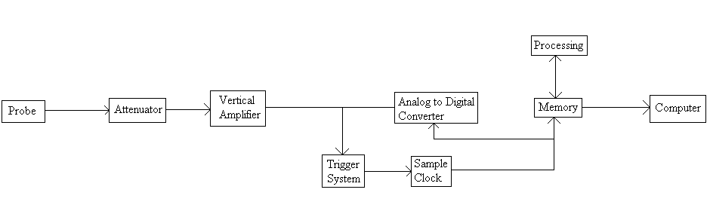Figure 5: Digital Oscilloscope Block Diagram [2]
Figure 6: AD78222 Functional Diagram [3]

Logic Analyzer
Table 1: AD7822 Specifications [3]
A logic analyzer is a tool that helps debug digital circuits. Now, an oscilloscope can be used for this to but an oscilloscope cannot view multiple lines at once. A logic analyzer on the other hand can look at multiple lines at once. It also allows the user to view the circuit the same way that the hardware views it and one can also control the trigger of events with it.
The logic analyzer works like in Figure 7. By following Figure 7 the logic analyzer will work as follows:
- the input probes acquire a sample
- the input is then buffer until the clock allows it to go on to the acquisition memory
- the acquisition memory is then controlled by the memory control which is determined by the trigger logic
- and finally the data is sent to the computer where the software that we will make will analyze and display it.
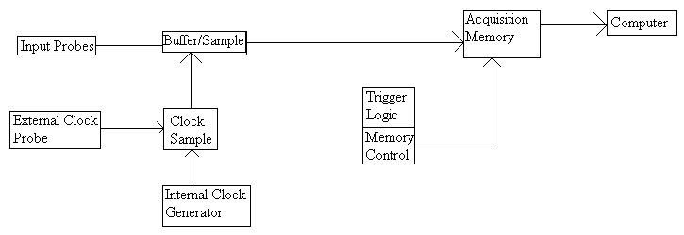Figure 7: Logic Analyzer Block Diagram [4]

Communications Subsystem

Connectivity refers to the connection between a PC or stand alone device to another PC or stand alone device. The connection allows communication and the transfer of data between the two devices. There are a great many ways to connect two or more devices using either a wired or wireless connection. Wired connections run a wire between the two devices to transfer data. The most popular wired connection by far is the USB port. It runs a wire between the two devices, or a point to point connection, and transfers data through the wire. Wireless connectivity has a couple more options. The more popular ones are Bluetooth, ZigBee technology, and Wi-Fi. Bluetooth technology is geared toward voice and data applications and operates on an unlicensed 2.4GHz bandwidth. It can operate fine, depending on the quality of the hardware, at a distance up to 100m. The technology is able to penetrate solid objects, like walls, and is omni-directional, meaning it does not need to be in line of sight with the device to which it is transferring data. Best of all, Bluetooth technology is low cost, with most Bluetooth chips costing just under $3. ZigBee technology is a relatively new wireless connection formally adopted at the end of 2004. It's specifications are very similar to Bluetooth, but is geared more for the industrial field. ZigBee does not have very high data transfer rates, but it makes up for that with low power consumption, low cost, and ease of use. Wi-Fi is a wireless connection used to test and certify 802.11 based wireless equipment. Although relatively popular, Bluetooth costs a third of the price to implement and uses a fifth of the power Wi-Fi consumes.

In order to make the project work, some sort of connection is needed in order to transmit data from the black box monitoring device to the PC to be monitored. The client has specified that wireless Bluetooth technology be implemented into the device. Bluetooth is a wireless communication link, operating in the unlicensed ISM band at 2.4 GHz using a frequency hopping transceiver [5]. It allows real-time AV and data communications between Bluetooth Hosts. The link protocol is based on time slots.

The most basic core of a Bluetooth device consists of a RF transceiver, baseband controller and protocol stack. All other components are optional, giving manufacturers variety when building Bluetooth devices. Almost all Bluetooth wireless connections use low power consumption, are low cost, and have relatively high security. There are several different ways to implement Bluetooth hardware into the diagnostics tool. One way is through modules. Bluetooth modules are completely self contained systems, with an interface that connects with other components of the circuit. Most hardware modules can be dropped in the circuit and loaded into the system, making them easy to use. Another way is with an Integrated Circuit (IC) chip. Integrated circuits are normally just referred to as chips and are circuits that have been etched onto tiny chips of silicon, or semiconductors. They can perfom very basic input and output functions and work best with the connectivity system as a whole. Integrated Circuits can be used in a variety of devices, including computer hardware like the microprocessor and in audio and video equipment. A more advanced type of IC chip is the Multi-chip Module. According to wikipedia, a Multi-Chip Module (MCM) is a specialized electronic package where multiple integrated circuits or other modules are packaged in such a way as to facilitate their use as a single IC. The MCM itself will often be referred to as a "chip" in designs, thus illustrating its integrated nature. This sort of “chip” would allow for more complex functions than just a regular IC chip. Finally, most Manufacturers of IC chips and modules, and even manufacturers of Connectivity technologies offer a Development Kit, which is essentially a complete kit, with circuit board, antenna, and all necessary hardware and software needed to piece together a legitimate connectivity solution. However, most development kits can run between $200 and $400 U.S., which is too far out of range for the budget of this project. The optimal choice for the project would be to use a module to connect the device to the monitored PC.
Figure 8: Bluetooth Device Architecture
The following examples are possible Bluetooth devices that could be implemented into the project. Entire Development kits are available for Bluetooth, including hardware and the software needed to program the device. Modules and Integrated Circuit, or IC, chips are also being considered, which include all the necessary hardware, just not the software.

Cambridge Silicon Radio offers a Casira Bluetooth Development kit. It's a single IC chip solution for Bluetooth implementation, integrating a 2.4GHz radio, baseband controller, and microcontroller all on one board. The chip uses bluecore7 technology (see Table 2 for a overview of specifications), which is the most advanced chip for Bluetooth, and meets low energy consumption standards. No price is listed, but the company can be contacted for sample chips and any additional information [6].

National Semiconductors sells connectivity processors, or modules, with Bluetooth baseband integrated circuits. Two modules that the company sells are of interest to this project. The LMX5453 is a micro module with integrated Bluetooth 2.0 baseband controller and a 2.4GHz radio. The LMX9838 is a serial port module with Bluetooth 2.0 baseband controller and a 2.4GHz radio. The full serial port Bluetooth node also includes an antenna. The LMX9838 qualifies as a Bluetooth endproduct, meaning it is ready to be used as an application without additional testing. The LMX5453 supports communication with a USB interface and features point to point management, transferring data at a rate of 723Kbps. Although samples are offered with a request to the company, a complete evaluation kit can be purchased for just under $200 [7].

Bluetooth version | 2.1
Bluetooth Tx output power | +10dBm*
Bluetooth Rx sensitivity | -93dBm*
Process geometry 90nm Chip area | 11.7mm2
External component count (eBOM) | 10 or fewer
Low ‘page scan’ power | 0.45 milliwatts
AuriStream® power (EV3)1 | 11 milliwatts
CVSD power (EV3)1 | 19 milliwatts
HV3 operating power | 18 milliwatts*
Standby power | 40 microwatts*
* Simulated typical values
Table 2: Bluecore 7 Specifications

The Bluegiga company (http://www.bluegiga.com) also offers modules with Bluetooth capabilities. Two similar module models that were of interest to the current project were the WT11 and the WT12. The WT11 boasts a radio, antenna, and fully implemented protocol stack. The module is USB 2.0 compliant and is pin to pin compatible with the WT12 [8]. The WT12 class 2 Bluetooth 2.0 EDR module has an Integrated chip antenna, comes with complete development, testing, and verification services, and contains everything from the radio to the antenna . Both modules are based on the CSR BC04 chipset (see Figure 8) [8][9]. The IC Bluecore chip, manufactured by LM technologies, runs at between a 3V to 3.6V power operation and is fully compliant with the Bluetooth 2.0+ EDR specifications [9].
Figure 9: CSR BC04 IC Chipset Functional Block Diagram
SparkFun Electronics offers their own module based on Bluetooth technology [10]. The Bluetooth DIP module is a serial port module that is based off of the bgb203 IC chip, made by NXP semiconductors, which provides complete plug and play operation and is sized below 50nm². The chip has also been packaged in such a way that it requires no RF layouts or external components. The module, with the IC chip, can transfer data at rates up to 1Mbps, has a low power sleep mode, and is compatible with Bluetooth products that support SPP, or serial port profile.
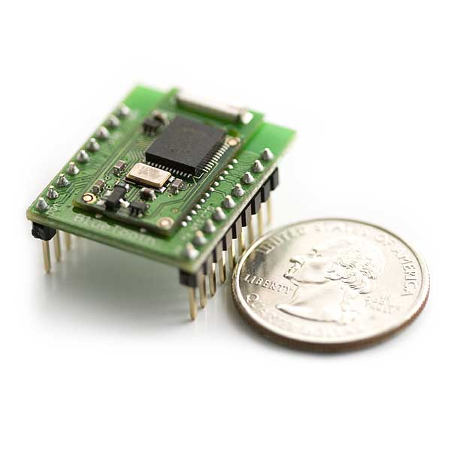Illustration 1: WRL-08461 Bluetooth DIP Module [10]

Host PC Interface Subsystem
The software-based Host PC interface subsystem has one basic goal: to expose the functionality of the data acquisition hardware to the end-user. This can be obtained via a few methods: buy or build. Each has its own advantages and disadvantages. The two options do overlap in certain areas as well. This current subsystem relies on a common interface from the communications subsystem.

The strengths of the build approach become apparent most notably in their startup costs. While engineer time is not fungible, there is a danger in spending much for little immediate return. This approach also affords somewhat more flexibility when considering deployment to multiple platforms. In a built approach, the Host interface would be encapsulated in an object that would contain methods to access the (buffered) datastream within. Depending on the platform support desired, this programmer's interface or API could be done in any number of languages. Figure 10 depicts a simple definition of such an interface. Using programs would first call start() to gather data from the unit, then stop() to halt gathering. Read() would extract that data from the interface for the using program. Write() would allow the user to send commands to the acquisition unit. A user-side interface would then have to be written to allow for logging of measurements, etc. A bought approach would wrap the functionality in Figure 10 within an already-existing framework such as LabVIEW. However, this can quickly become more expensive for the end-user even as it simplifies the work of the developer.
Figure 10: A sample UML diagram for a host interface.

Acquisition Unit Control Subsystem
The control logic on the data acquisition unit is seen as a slave to the host PC, and such can be kept relatively simple. A standard microcontroller will be used for this section of the project, such as a PIC microcontroller that is compatible with the bit-width of the analog-digital converters used. It will also interface with the on-unit communications subsystem (as seen in Figure 1 and again in Figure 11).
Figure 11: Acquisition Unit Control Subsystem Overview

[1] ADC10040 - 10-Bit, 40 MSPS, 3V, 55.5 mW A/D Converter. http://www.national.com/pf/DC/ADC10040.html. Accessed Nov. 5, 2008

[2] “The Oscilloscope,” https://www.cs.tcd.ie/courses/baict/bac/jf/labs/scope/oscilloscope.html. Accessed Oct. 28, 2008

[3] “AD7822: 3 V/5 V, 2 MSPS, 8-Bit, 1-/4-/8-Channel Sampling ADCs,” http://www.analog.com/en/analog-to-digital-converters/ad-converters/AD7822/products/product.html. Accessed Nov. 5, 2008

[4] “The XYZs of Logic Analyzers,” http://web.mit.edu/6.111/www/s2007/handouts/LA.pdf. Accessed Nov. 7, 2008
[5] Bluetooth. Http://www.bluetooth.com. Accessed Nov. 5, 2008.
[6] CSR – Better Connected. http://www.csr.com/. Accessed Nov. 5, 2008.
[7] National Semiconductor Home. Http://www.national.com/. Accessed Nov. 5, 2008.
[8] Bluegiga – WT11 Class 1 Bluetooth Module http://www.bluegiga.com/WT11_Class_1_Bluetooth_Module. Accessed Nov. 5, 2008.
[9] Bluegiga – WT12 Class 2 Bluetooth Module http://www.bluegiga.com/WT11_Class_2_Bluetooth_Module. Accessed Nov. 5, 2008.
[10] SparkFun Electronics – Bluetooth DIP Module. http://www.sparkfun.com/commerce/product_info.php?products_id=8461. Accessed Nov. 5, 2008.

