The purpose of the signal conditioning subsystem is to scale the analogue input to an appropriate level so that it can be read by the analogue to digital converter. The goal is to scale the output voltage to be between 0 and 5 volts and allow proper shifting and amplification via user interaction with the software.
As drawing 201 shows, this was implemented using 4 operational amplifiers, a digital to analogue converter, a multiplexer, resistors, and diodes.
741 operational amplifiers were chosen for this circuit because they are the most inexpensive op amps to purchase and their specs allow for them to be used in this circuit. A reference voltage of +/- 12 volts was used to supply these op amps, which allow for a maximum of +/- 22 volts[3].
The input voltage is allowed to range from -12.7 volts to +12.7 volts. The diode and resistor configuration shown in drawing 201 assures the input voltage cannot vary outside of this range. These standard diodes and resistors were chosen because only basic diodes and resistors were needed and these components were very inexpensive. This input voltage is applied to the non-inverting input of an operational amplifier. The output of this op amp goes back to the inverting op amp, so it acts as a voltage follower[5].
Another voltage is produced from a digital to analogue converter. This voltage ranges from 0 to 5 volts. The purpose of the digital to analogue converter is to shift the signal up and down. The user controls this shift using the software on the computer. Because this requires communication with the micro controller, a digital to analogue converter was chosen with an I2C interface. Consequently the PCF8591 was selected to produce a voltage ranging from 0 to 5 that goes into the non-inverting input of an op amp. This op amp also acts as a voltage follower.
These 2 voltages were each placed in series with a 10k resistor and both connected to the inverting input of another op amp. This op amp serves to amplify the voltage signal. Essentially the output from this op amp is the sum of the input and DAC voltages multiplied by the amplification[5]. The 4067 analogue multiplexer is used to select the appropriate resistance. Like the digital to analogue converter, the multiplexer gets information from the micro controller and activates the desired output to use a resistor. These resistors vary from 10k ohms to 1M ohms to allow for different levels of amplifications. For example, for 2x amplification, the 20k resistor is used (20k/10k = 2x amplification) and this is multiplied by the sum of the earlier voltages[5].
The final op amp is used to scale the signal down to between 0 and 5 volts for the analogue to digital controller to read. An inverting op amp configuration is used with 3 volts going into the non-inverting input.
The output of this op amp is then sent to the analogue to digital converter.
Figure 201 and table 201 summarize the different parts of the circuit.
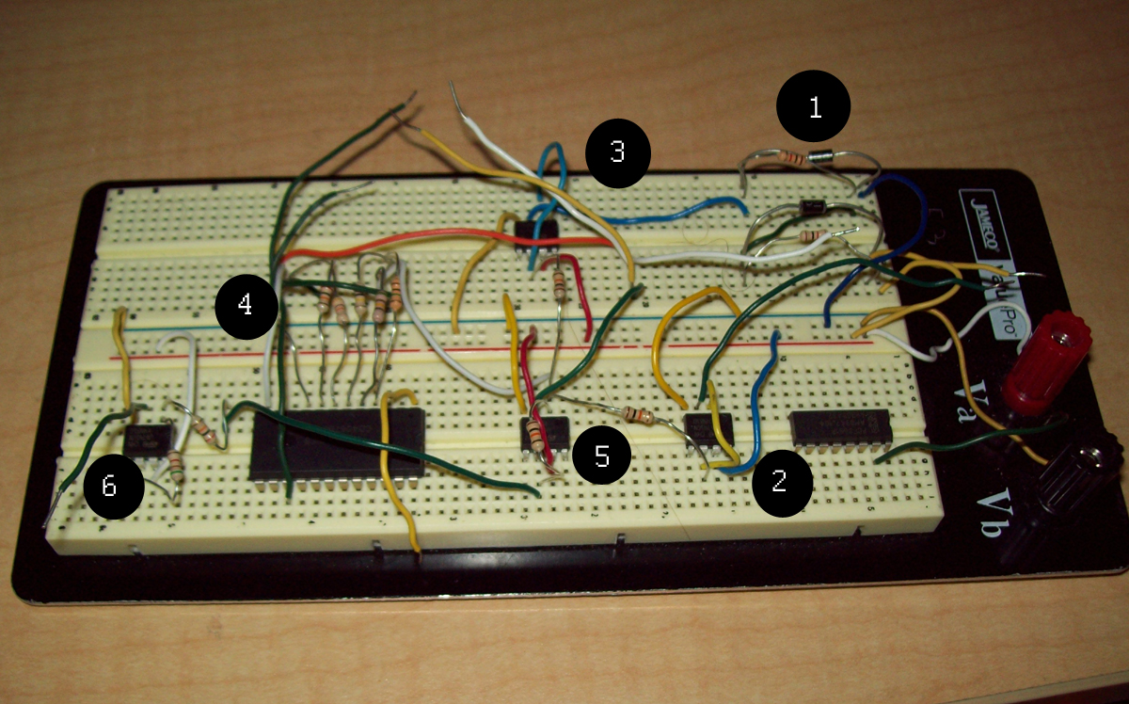
Figure 201 – Signal Conditioning Photograph

Table 201 – Component functions
Circle | Function
1 | Resistors and diodes used to clamp voltage between -12.7 and +12.7
2 | DAC voltage fed into op amp
3 | Input voltage fed into op amp
4 | Multiplexer used to select resistance value
5 | Inverting op amp that has variable negative feedback
6 | Scaling op amp

Constructing the circuit is straight-forward and the connections can be seen from drawing 201. Setting up the circuit to be tested requires multiple voltage sources.
Setting up the source voltages can be a little tricky. Since the 741 op amps are not rail to rail, the +12 and -12 reference voltages must be supplied using 2 different voltage sources[1].
If the circuit is going to be implemented separately from the micro controller, another voltage source should be used as the voltage to the op amp by circle 2 in figure 201. Another voltage source of 3 volts should be applied to the non-inverting input of the op amp by circle 6 in figure 201. Finally the input voltage should be applied to circle 1 in figure 201. Finding multiple power supplies is necessary before testing the unit as a whole.
The feedback resistor of the op amp by circle 5 in figure 201 can be manually placed there instead of through the multiplexer if being tested without the micro controller.
To start off, the voltage clamp of the diodes and resistors by circle 1 in figure 201 is tested. Use a multimeter to test the voltage before it reaches the first op amp. Adjust the input to points outside the + and -12.7 volts. The output should not be bellow -12.7 nor above +12.7 volts[1].
Next, test the op amps by circles 2 and 3 in figure 201 and make sure the output voltage is equal to the input. Then record the voltage coming out of the op amp by circle 5 in figure 201 with 10k feedback. This should be approximately equal to the inversion of the sum of the input and digital to analogue voltages[5].

V = - [V(DAC) + V(IN)]

If this is correct, finally test the output voltage coming out of the op amp by circle 6 in figure 201. Put the input voltage to the max of 12.7 and the DAC voltage to its max of 5. This should yield an output of 0. Then set the input voltage to -12.7 and the DAC voltage to 0. The output voltage should be around 5 volts. Any other input voltage levels should show an output voltage between 0 and 5 and be approximately:

V(OUT) = 3 - .16447[V(dac) + V(in)]

When testing the circuit, the actual output voltage did not match up with the theoretical output described by the equation V(OUT) = 3 - .16447[V(dac) + V(in)]. Table 202 shows the different input voltages and the resulting outputs of the theoretical and actual voltages.

Table 202 – Expected and Actual Results
Input Voltage | DAC Voltage | Theoretical Voltage | Actual Voltage
12.7 | 5 | 0.09 | 1.4
10 | 3 | 0.86 | 1.9
2 | 4 | 2.01 | 3.2
-12.7 | 0 | 5.08 | 5.1

Although these results did not match up precisely with what was expected, they are still within the range of the analogue to digital converter to read. They were just scaled to different values.
There are several obvious but overlooked reasons as to why this circuit would not operate properly. Understanding the op amp is key to knowing what is wrong. During preliminary testing, the op amp was not showing any output voltage when constructed as a voltage follower. After many attempts, no output voltage could be obtained. Finally the op amp was moved to another part of the breadboard and it operated correctly right away. A part of the breadboard used was not operating correctly. A faulty breadboard can be tested with a multimeter to make sure the connections are properly working.
It is possible to ruin the diodes or op amps if excess voltage is give to them. If the diodes are facing the wrong direction they will also not operate properly. If there as any doubt of the components not working correctly, get new parts to replace them. The diodes and op amps are cheap so it won't cost very much to use another one.
If the actual voltages and theoretical voltages are varying, it could be because of variances in each device. Make sure to use resistors with gold (5%) tolerances. Also, the exact measurements should be obtained before plugging them into the equations used, not the theoretical values.
It is recommended to change the parameters surrounding the final op amp to alter the output. Changing the resistances of the negative feedback and the voltage level of the non-inverting output should be done to alter the output.

20 components must be obtained to build this circuit. Each part is shown in drawing 201 and table 203. 12 resistors are used. 3 1k resistors are used, with 2 for the voltage clamp and 1 for the final op amp. 1 6.2k resistor is used for the final op amp. 3 10k resistors are used with 2 being placed after each voltage follower and the other in the variable resistance feedback. The remaining 5 are used in the variable resistance feedback with values of 20k, 50k, 100k, 500k, and 1M ohms.
2 1N4001 diodes, 4 741 op amps, 1 4067 multiplexer, and 1 digital to analogue converter are also used.
Table 203 – Circuit components
Part | Part Number | Specifications
Resistor | - | Metal Film
Diode | 1N4001 | Standard rectifier, reverse voltage = 50V
Operational Amplifier | 741 | +/- 22 max supply voltage
Multiplexer | 4067 | 16 channel analogue mux
Digital to analogue converter | PCF8591 | 8 bit, I2C interface
[2] [3] [8] [7]
The cost to create the first model is shown in table 204. The resistors, diodes, and op amps were all on hand so no money was spent obtaining them. A total of $4.58 was spent building the first model.

Table 204 – Cost data to create prototype
Component | Number of Units | Cost per unit | Total Cost
Resistors | 12 | 0 – on hand | $0.00
Multiplexer | 1 | $1.09 | $1.09
Op Amps | 4 | 0 – on hand | $0.00
DAC | 1 | $3.49 | $3.49
Diodes | 2 | 0 – on hand | $0.00
Total cost = $4.58
[2] [8]

To create this create with no parts on hand, the total cost comes to $7.38 as broken down in table 205.

Table 205 – Cost data to implement circuit
Component | Number of Units | Cost per unit | Total Cost
Resistors | 12 | $0.10 | $1.20
Multiplexer | 1 | $1.09 | $1.09
Op Amps | 4 | $0.25 | $1.00
DAC | 1 | $3.49 | $3.49
Diodes | 2 | $0.30 | $0.60
Total cost = $7.38
[2][8][3][7]

It took approximately 1 week to ship when parts for the prototype were ordered. Building this circuit is straight forward and simple. It can easily be done within a day. The troubleshooting is where most of the time will take. It took me about 3 months of troubleshooting to get values that I was content with. Also, it could take longer depending if you test it with the micro controller or not. I would anticipate this would take a month to complete at the most to get it to perform ideally. 1 week to obtain the parts and 3 weeks to build and troubleshoot.
The circuit described here can function even with variances in the expected values. In addition, it is better to test this circuit out when it is actually connected to the micro controller to ensure it works with the system as expected.
Only 6 variable resistances were used for the prototype and a multiplexer could have been used with less channels. The size of the multiplexer depends on how many different amplification levels are wanted. With 6 resistance values, an 8 channel multiplexer could be used to save some money.
Another concern realized late into the process was how the analogue to digital converter would fit in with the rest of the data path. No time was spent looking and understanding this process during the building of this circuit. The only concern was making sure the final output was between 0 and 5 volts. To implement the entire system, the data sheet of the analogue to digital converter must be evaluated and a solution created to fit in the analogue to digital converter with the data path.
This circuit alone is functional but was never tested with the rest of the system.

The following is a list of vendors recommended to construct this subsystem.

The resistors can be purchased from Jameco Electronics, Digikey Electronics, and Newark for $0.10, $0.08, and $0.10, respectively [3][7][6].

The digital to analogue converter can be purchased from Mouser Electronics, Newark, and Futurelec for $3.49 $3.44, and $3.50, respectively [8][6][4].

The diodes can be purchased from DigiKey Electronics, Newark, and Futurelec for $.30, $.33, and $30, respectively[7][6][4].

The multiplexer can be purchased from Jameco Electronics, Digikey Electronics, and Newark all for $1.09, $1.58 and $1.58, respectively [3][7][6].

The op amps can be purchased from Jameco Electronics, West Florida Components, and Newark for $0.25, $.20, and $0.29, respectively[3][9][6].

The equations derived earlier were all from basic op amp equations. However the final output equation was derived by setting the max output from the op amp by circle 5 to 5 and the minimum output to 0 for a negative feedback op amp:
0 = V – 17.7k
5 = V +12.7k
where k = R2/R1
With 2 equations and 2 unknowns, one unknown was solved and plugged that into the other equation to obtain the final output equation of V = 3-.16447[V(dac) + V(in)]

References

[1] Haibo Wang (private communication), 2009

[2] HCT4067 DataSheet, http://web.mit.edu/6.115/www/datasheets/74hc4067.pdf, 2009

[3] Jameco.com, Accessed April 12th 2009

[4] Futurelec, Electronic Components SuperStore, www.futurelec.com, 2009

[5] Olia, Masoud. How to Prepare for the Fundamentals of Engineering FE/EIT Exam, Barron's Education Series, 2000. pp 125-127

[6] Newark Electronics Distributor, www.newark.com, 2009

[7] Digi-Key Corporation, www.digi-key.com, 2009

[8] Mouser Electronics, www.mouser.com, 2009

[9] West Florida Components, www.westfloridacomponents.com, 2009

