Literature review for multimeter:

A typical multimeter is able to read voltage, current and resistance. They are able to perform these measurements in both DC and AC. Many have further capabilities that can measure other quantities such as capacitance or conductance. For this project our multimeter will only acquire data for the voltage, current, and resistance.

There are analogue and digital multimeters. A digital can display the readings numerically. For this project it will be necessary to use a digital format because the reading must be displayed digitally on the computer.

The resolution of a digital multimeter is usually expressed in the number of digits displayed. The last digit is usually a half digit that can display either a 1 or 0. For example, a 3 ½ digit multimeter can display 3 digits from 0 to 9 plus the half digit that can be 0 or 1. However, with increased levels, the time between readings increases.

There are some important capabilities that most multimeters have. Auto-polarity shows whether the reading is positive or negative. Sample and hold is a phrase used to describe a device that is capable of displaying the information after it is removed from the circuit. In relation to our project, this means the computer should be able to display the results even after the circuit is removed. Many multimeters are also capable of auto-ranging. This means they automatically select an appropriate range to be displayed. For example, a reading of 2.345 won't be displayed as .0002.

An example of a typical, economical multimeter is the Mastech MAS830L. The DC voltage ranges from .2 to 600 volts. The DC current ranges from .0002 to .2 amps. The resistance ranges from 200 to 2M ohms. These ranges are in steps in multiples of 10. These are good numbers to compare our multimeter measurements ranges for our project. It costs $30.

Digital multimeters are usually about the size of a brick. The multimeter within this project should be smaller than that because it will not need a display and only serves to acquire data.

Multimeters can vary greatly in price. Cheap ones of around 20 dollars can be purchased that perform the basic multimeter functions. On the other hand, higher end multimeters can cost as much as $500. For our project we only want to perform measurements on voltage, current, and resistance. Therefore the cost of the multimeter portion of the project should be low.

Multimeter subsystem:
The multimeter subsystem of the project will measure the voltage, current, and resistance. It will only serve to acquire data. A digital type of multimeter will be implemented because the value of the readings must be displayed displayed after the data is relayed to the computer. There will be 2 probe inputs where the multimeter will get data on the voltage, current and resistance. The figures below shows a block diagram of the multimeter that will be implemented in the design. The display section will be implemented on the software of the computer.

The signal would first be sent through an amplifier to scale it to the appropriate values. These would be +25 and -25 volts. A signal conditioner would then scale this voltage to an appropriate range for the analogue to digital converter. An integrated controller would then convert the analogue signal to a digital one. Control logic would be used to synchronize operation of the ADC to the computer display. A block diagram of this process is shown below.

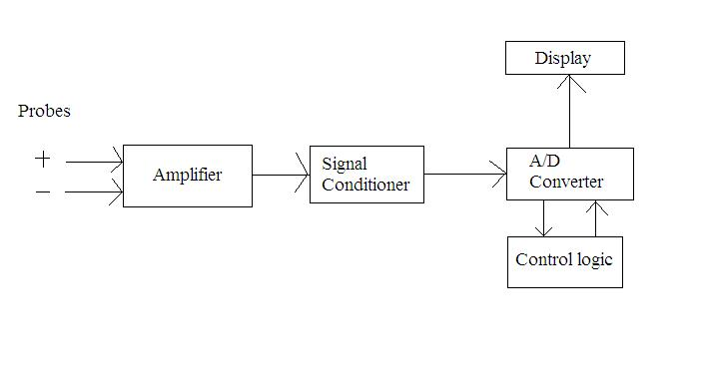

The multimeter will able to record currents up to 1 amp, voltages up to 25 volts, and 3 different resistances. These resistances will be 100k, 10k, and 100 ohms. Since we are using a digital multimeter, we must have an input impedance. This input impedance should be high enough so that it does not affect the performance of the circuit being tested. The sensitivity of the system will be within .1 volts. This will corresponds to .1 mA to 10 mA.

Basic data acquisition features that can be performed include being able to display the maximum and minimum readings. Furthermore, the user should be able to select the number of samples taken up to the maximum possible sample rate of the system.

We will use a 5 ½ digit resolution for the multimeter. This will allow the display of values ranging from -99,999 to +99,999. This should be sufficient for displaying virtually all values being measured.

Parts required would be an amplifier, signal conditioner, ADC integrated controller, and parts for the control logic. The schematic of the multimeter needs to be designed and collaborated with the other subsystems to determine the parts necessary.

The analogue to digital converter used for the multimeter portion of the project will be the National Semiconductor ADC10040CIMT. This part will cost approximately $5. Our target bandwidth for the system will be dependent on the resolution of the ADC and the mode of connection. The ADC10040CIMT will allow us to have 10 bit samples at 40M S/s.

In relation to the other subsystems, the multimeter will be connected in parallel with a logic analyzer and oscilloscope. This information will then be sent wirelessly to a computer where the information will be displayed. Software will be designed to display the voltage, current, and resistance measured by the multimeter with 5 ½ digits. A very general diagram shows the multimeter in relation to the other subsystems.

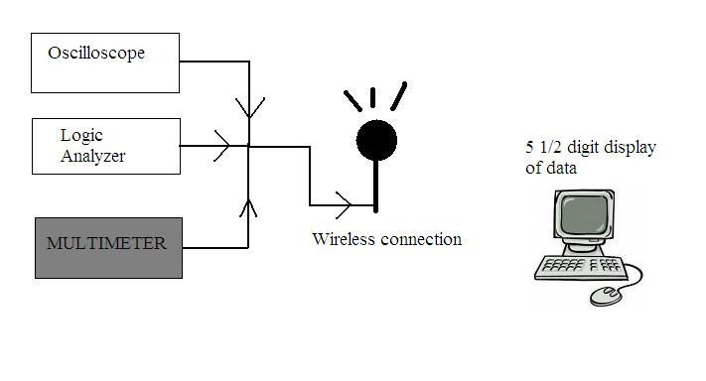

References
http://www.tpub.com/content/neets/14188/css/14188_123.htm
http://www.national.com/pf/DC/ADC10040.html
http://books.google.com/books?id=7JctZRlQujoC&pg=PA439&lpg=PA439&dq=multimeter+functional+diagram&source=web&ots=PB7aHQdOEn&sig=XLcKJ12A2d4RYwQy8U2XoXrbqkA&hl=en&sa=X&oi=book_result&resnum=6&ct=result#PPA439,M1
http://www.radio-electronics.com/info/t_and_m/digital-multimeter/dmm-specs-specifications.php
http://www.airborn.com.au/circuits/meter.html

