<DRAFT>
Proposal for a Wireless Electronic Diagnostic Tool

Saluki Engineering Company
P74-DIAGTOOL
November 12, 2008

November 12, 2008

Saluki Engineering Co.
Southern Illinois University
College of Engineering
Carbondale IL, 62901

Attention: Dr. F. Harackiewicz

Subject: Project #74
We are pleased to submit “A proposal for the PC Diagnostics Tool Project” in response to your request.

The Device used to monitor the state of a PC uses the most advances technologies and materials allowed on a minimal budget. Of particular note is the implementation of Bluetooth technology in the project. This technology consumes low power, is easy to use, and best of all, is low cost.

If you have any questions or concerns, please do not hesitate to contact us.

Sincerely,

Joe Lenox
Project Manager
Executive Summary

This report contains in its major parts a Review of relevant literature, followed by a Description of the Project, then an overview of the Project's major subsystems. The problem addressed by this Proposal is the lack of low-cost multipurpose electronic diagnostic equipment suitable for field or hobbyist use. It is believed that utilizing general-use consumer technologies and offloading the major processing to standard devices such as PCs will provide acceptable performance at low cost. The team expects to spend four months doing the design work and expects the cost to not exceed $<COST>.
RESTRICTION ON DISCLOSURE OF INFORMATION

The information provided in or for this proposal is the confidential, proprietary property of the Saluki Engineering Company of Carbondale, Illinois, USA. Such information may be used solely by the party to whom this proposal has been submitted by Saluki Engineering Company and solely for the purpose of evaluating this proposal. The submittal of this proposal confers no right in, or license to use, or right to disclose to others for any purpose, the subject matter, or such information and data, nor confers the right to reproduce, or offer such information for sale. All drawings, specifications, and other writings supplied with this proposal are to be returned to Saluki Engineering Company promptly upon request. The use of this information, other than for the purpose of evaluating this proposal, is subject to the terms of an agreement under which services are to be performed pursuant to this proposal.
Table of Contents
Letter to the Client | ii
Executive Summary | iii
Introduction | 1
Literature Review | 2
Basis of Design | 5
Project Definition | 5
Engineer's Scope of Work | 6
Subsystem Technical Discussion | 6
Pricing | 17
Organization Chart | 17
RASI Chart | 18
Projected timeline for work schedule | 19
Action Item List | 19
References | 20
Appendix: Personnel Resumes | 22

Introduction

Literature Review
There are many PC-based oscilloscopes, multimeters, and logic analyzers, but few instruments with all of these capabilities. It is our belief that we can design and build a low-cost instrument.
The multimeter is, in general, a well-understood device with respect to its functionality. According to Tedd and Kennedy in their patent, the device generally consists of an ammeter, voltmeter and ohmmeter with user-controlled switches to multiplex a small set of probes and display over the three sensors [1]. As technology improved, the sensor hardware was moved to a set of analog-digital converters, such as in the NI PCMCIA-4050 Portable 5½ digit Multimeter [2]. This device combines a signal conditioner which controls the switching mechanism referenced in [1] before feeding the signal to an analog-digital converter and then allowing that signal to be processed by a computer system (see Figure 1). LabVIEW, a general measurement software suite, is run on the host system to interpret the ADC output. The NI PCMCIA-4050, when combined with a PCMCIA-equipped PDA that has the portable version of LabVIEW installed, can form an impromptu multimeter from consumer-level hardware and a simply-purchased (if expensive) add-on [3].
The signal conditioner is a lead-in component of the multimeter that ensures that incoming analog signal is an equivalent voltage before being converted to a digital waveform by the analog-digital converter.
Low-performance digital oscilloscopes are in the reach of the hobbyist; a straightforward design includes an analog-digital converter (ADC), an amplification circuit to give better conversion accuracy, and a microcontroller to take the output and pass it to a processing device (in this case, a PC) [4]. A flow diagram for this basic architecture is shown in Figure 2.
Similarly, low-performance logic analyzers are also easy to construct by the hobbyist—usually by directly sampling the signal through a parallel port interface or a similar direct-access computer I/O port [5]. This approach is limited by the maximum sampling rate of the supporting interface. A trigger condition can be added to the design for more sophistication. Standalone units are effectively small computer systems that store the signals in memory (see Figure 3).
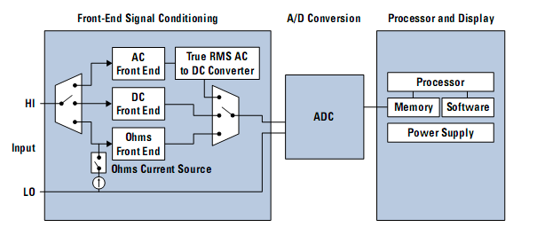Figure 1: A general digital multimeter architecture [6]
Creators of the Handyscope HS3 claim to be the first to combine the oscilloscope and multimeter and make it PC-based [7]. Such a system has a hardware component that serves to acquire data and is transfered to a PC to process the data. The Handyscope HS3 does just this and information about its capabilities, characteristics, and limitations shall be analyzed.
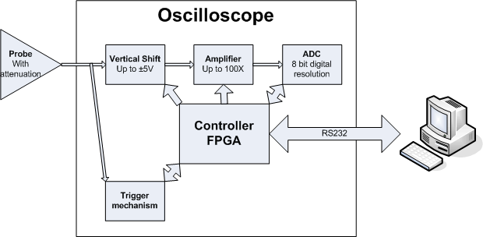Figure 2: Digital Oscilloscope Diagram [4]
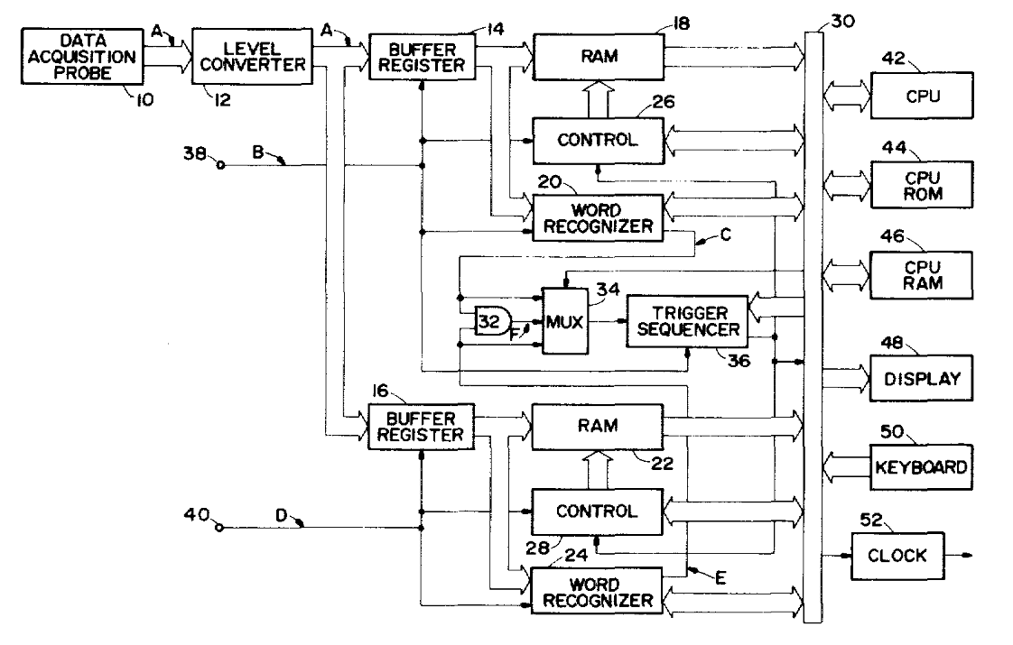Figure 3: Standalone Logic Analyzer Block Diagram [8]
The Handyscope HS3 has 2 channels for inputs and 1 output to the PC [7]. It has a 100 Megahertz sampling speed and can record up to 128,000 samples [7]. Its input voltage can range from .2 to 80 volts [7]. The hardware is connected to the PC with a USB 2.0 or 1.1 [7]. Therefore it is capable of being used with older computers as well. It comes with two oscilloscope probes that were designed specifically to be used with the Handyscope HS3 [7].
The software provided with the Handyscope HS3 effectively turns the PC into a oscilloscope, spectrum analyzer, voltmeter, and transient recorder [9]. It can be used with both Windows and Linux. The dynamic link library of the Handyscope HS3 comes with an example program so the user can easily write their own measuring program [7]. The source code is in Delphi [7]. The DLL's can be downloaded from the company's website. Hardware and software updates can also be downloaded free of charge from the company's website. The Handyscope HS3 allows the user to save their settings to a disk so it can be used each time they use the software [7]. An inexperienced user can use an automatic setup routine, which allows for instant measurements [7]. Another capability of this instrument is that it has an arbitrary waveform generator that operates independent of the measuring system[9]. This allows the user to generate test signals in any shape desired. It is also possible to regenerate previously measured signals [9].
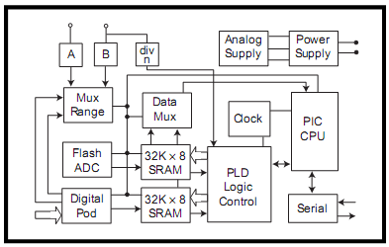Figure 4: Block diagram of mixed-signal capture engine [11]
Device | Handyscope HS3 | BS100U Bitscope
Digital Interface |  | USB
Oscilloscope |  | X
Voltmeter
Supported Host Systems | Windows, Linux | Windows, Linux
Size | 25mm * 170mm * 140mm
Table 1: Comparison of Handyscope HS3 and BS100U [7], [10]

There are 5 main tools used to evaluate the data. It has an arbitrary waveform generator, digital storage oscilloscope, spectrum analyzer, voltmeter, and transient recorder. They appear to be very user friendly and settings can be easily controlled. The BS100U Bitscope is a PC-based, mixed signal oscilloscope that is similar to the Handyscope HS3 except it does not include as many capabilities [10]. Some important features it has that makes it competitive with the current project:
- Users can control sweep rate
- Users can control vertical deflection
- Storage of waveforms
- Display several waveforms at the same time
- Spectral analysis
- Battery power options
- Usability with all popular platforms
- Zooming features
- Multi-colored displays [10]
The size of the Handyscope HS3 is rather small. It measure 25 x 170 x 140 millimeters and weighs 17 ounces [7]. This size is comparable to the size of a person's hand. It is very important to keep the size small because one of the attractive reasons people will want to pursue this device is because it eliminates the big, bulky machines.
Basis of Design
The documents to be used as basis of design for the project are as follows:
Proposal Request document.
This proposal document.
Should a conflict occur between these two documents, the proposal itself control.

Project is to study the feasibility of constructing a multipurpose device at low cost to perform data acquisition and design software which, when combined, would effectively allow the Device and its host processor to perform the functions of a multimeter, logic analyzer and oscilloscope.

Project Description

This Project is to study the feasibility and, if deemed possible, construct a Device to perform the duties of a multimeter, logic state analyzer, and oscilloscope at a relatively low cost.

Engineer's Scope of Work

The engineering team will do the following:
Design sensor and probe parts for the acquisition unit.
Design control logic for the acquisition unit.
Develop a wireless communication system to interface the unit with a standard PC-compatible.
Develop software to interpret signals from the unit for a user sufficiently skilled in the art of electronics.

The engineering team will produce the following deliverables:
Data acquisition unit
Hardware connection driver source code and associated Microsoft Windows-compatible compiled binaries.
Data processing software source code and associated Microsoft Windows-compatible compiled binaries.
Schematics and PCB layout for data acquisition unit control hardware.
Schematics and PCB layout for unit-processor connection hardware.
Schematics and PCB layout for analog-digital conversion hardware.
Assembly instructions for data acquisition unit prototype.
A list of maximum capabilities for the data acquisition unit with regards to the individual modes.

Subsystem Descriptions
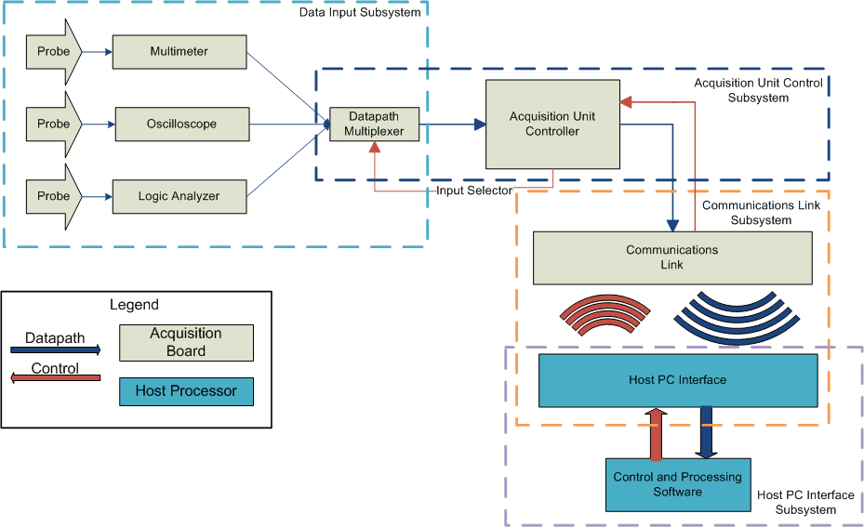Figure 5: Overall Subsystem Block Diagram

Overview

The device will be divided into several subsystems for convenience of design and testing. These general subsystems are shown above in Figure 1. From a datapath perspective, signals are picked up in the input subsystem and converted into digital signals, which are then passed to the acquisition control sub-processor. The sub-processor relays the signal to the communication link subsystem via a common interface such as RS232, which then transmits that same data to the host processor. The host processor performs the necessary transformations and renders it to the user. A reverse procession is seen with the control signaling – control requests start from the user and are passed along to the acquisition unit control subsystem.

Multimeter

The multimeter subsystem of the project will measure the voltage, current, and resistance. It will only serve to acquire data. A digital type of multimeter will be implemented because the value of the readings must be displayed displayed after the data is relayed to the computer. There will be 2 probe inputs where the multimeter will get data on the voltage, current and resistance. The figures below shows a block diagram of the multimeter that will be implemented in the design. The display section will be implemented on the software of the computer.

As depicted in Figure 2, the signal would first be sent through an amplifier to scale it to the appropriate values. These would be +25 and -25 volts. A signal conditioner would then scale this voltage to an appropriate range for the analogue to digital converter. An integrated controller would then convert the analogue signal to a digital one. Control logic would be used to synchronize operation of the ADC to the computer display.
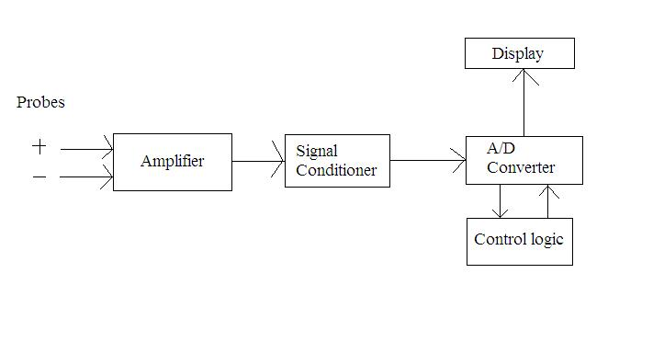Figure 6: Block Diagram of probe to converter

The multimeter will able to record currents up to 1 amp, voltages up to 25 volts, and 3 different resistances. These resistances will be 100k, 10k, and 100 ohms. Since we are using a digital multimeter, we must have an input impedance. This input impedance should be high enough so that it does not affect the performance of the circuit being tested. The sensitivity of the system will be within .1 volts. This will corresponds to .1 mA to 10 mA.
Basic data acquisition features that can be performed include being able to display the maximum and minimum readings. Furthermore, the user should be able to select the number of samples taken up to the maximum possible sample rate of the system.

We will use a 5 ½ digit resolution for the multimeter. This will allow the display of values ranging from -99,999 to +99,999. This should be sufficient for displaying virtually all values being measured.
Parts required would be an amplifier, signal conditioner, ADC integrated controller, and parts for the control logic. The schematic of the multimeter needs to be designed and collaborated with the other subsystems to determine the parts necessary.
The analogue to digital converter used for the multimeter portion of the project will be the National Semiconductor ADC10040CIMT (see Figure 3 for block diagram). This part will cost approximately $5. Our target bandwidth for the system will be dependent on the resolution of the ADC and the mode of connection. The ADC10040CIMT will allow us to have 10 bit samples at 40M S/s.
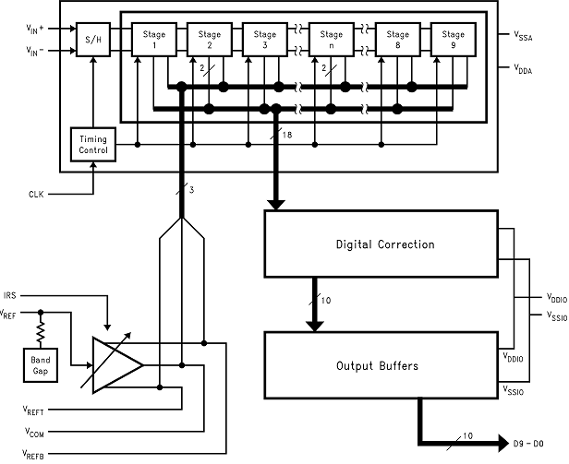Figure 7: ADC10040CIMT Block Diagram [12]

In relation to the other subsystems, the multimeter will be connected in parallel with a logic analyzer and oscilloscope. This information will then be sent via wireless connection Software will be designed to display the voltage, current, and resistance measured by the multimeter with 5 ½ digits. Figure 4 shows this portion of the subsystem in relation to the rest of the system.
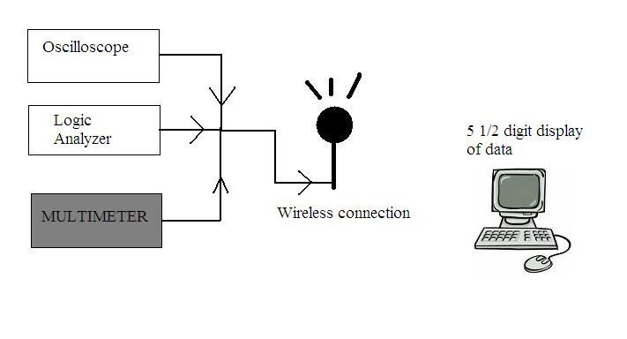Figure 8: Multimeter's Position in Logical Block Diagram

Digital Oscilloscope
The oscilloscope is one of the most used electronic testing tools. It is a tool that displays voltage signals over a period of time. It presents this as a graph. The vertical axis of the graph is for the voltage of the system and the horizontal axis is for the time. Uses of an oscilloscope would be:
- finding the time and voltage values of the signal
- finding the frequency of a signal
- debugging a circuit
- finding out what part of a signal is due a direct current (DC) and what part of the signal is due to alternating current (AC).
- and what part of the signal is noise[13].
The digital oscilloscope works by taking voltage signals from the probes and then the oscilloscope then displays it (See Figure 5). When following Figure 1 the oscilloscope will work by:
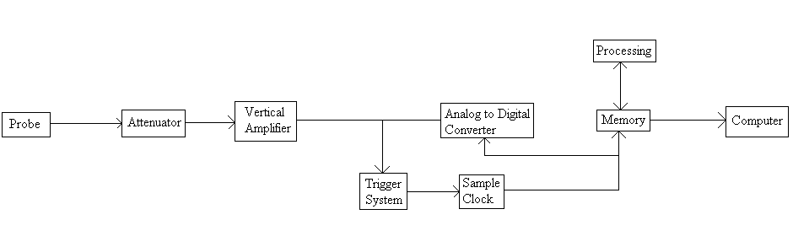Figure 9: Digital Oscilloscope Block Diagram [13]
- retrieving the voltage signal with the probes
- taking that signal to the attenuator and vertical amplifier will adjust the amplitude of the signal
- the Analog to Digital Converter then takes samples of the analog signal.(The number of samples is determined by the Sample Clock.)
- the samples are then saved in memory to create the waveform
- this data is then sent to the computer where it will be processed by the software we will make and be displayed by the monitor.
The analog to digital converter that would preferably be used would be AD7822.
This converter will give a more preferable sampling rate and since the package comes in both SOP and DIP it can be used for the prototype and the final product.
Figure 10: AD78222 Functional Diagram [14]

Logic Analyzer
Table 2: AD7822 Specifications [14]
A logic analyzer is a tool that helps debug digital circuits. Now, an oscilloscope can be used for this to but an oscilloscope cannot view multiple lines at once. A logic analyzer on the other hand can look at multiple lines at once. It also allows the user to view the circuit the same way that the hardware views it and one can also control the trigger of events with it.
The logic analyzer works like in Figure 7. By following Figure 7 the logic analyzer will work as follows:
- the input probes acquire a sample
- the input is then buffer until the clock allows it to go on to the acquisition memory
- the acquisition memory is then controlled by the memory control which is determined by the trigger logic
- and finally the data is sent to the computer where the software that we will make will analyze and display it.
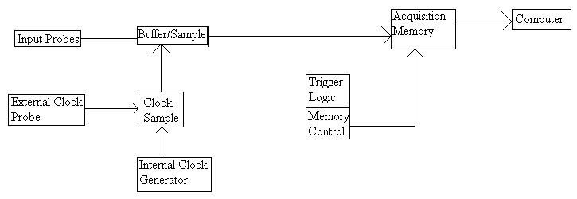Figure 11: Logic Analyzer Block Diagram [15]

Communications Subsystem

Connectivity refers to the connection between a PC or stand alone device to another PC or stand alone device. The connection allows communication and the transfer of data between the two devices. There are a great many ways to connect two or more devices using either a wired or wireless connection. Wired connections run a wire between the two devices to transfer data. The most popular wired connection by far is the USB port. It runs a wire between the two devices, or a point to point connection, and transfers data through the wire. Wireless connectivity has a couple more options. The more popular ones are Bluetooth, ZigBee technology, and Wi-Fi. Bluetooth technology is geared toward voice and data applications and operates on an unlicensed 2.4GHz bandwidth. It can operate fine, depending on the quality of the hardware, at a distance up to 100m. The technology is able to penetrate solid objects, like walls, and is omni-directional, meaning it does not need to be in line of sight with the device to which it is transferring data. Best of all, Bluetooth technology is low cost, with most Bluetooth chips costing just under $3. ZigBee technology is a relatively new wireless connection formally adopted at the end of 2004. It's specifications are very similar to Bluetooth, but is geared more for the industrial field. ZigBee does not have very high data transfer rates, but it makes up for that with low power consumption, low cost, and ease of use. Wi-Fi is a wireless connection used to test and certify 802.11 based wireless equipment. Although relatively popular, Bluetooth costs a third of the price to implement and uses a fifth of the power Wi-Fi consumes.

In order to make the project work, some sort of connection is needed in order to transmit data from the black box monitoring device to the PC to be monitored. The client has specified that wireless Bluetooth technology be implemented into the device. Bluetooth is a wireless communication link, operating in the unlicensed ISM band at 2.4 GHz using a frequency hopping transceiver [16]. It allows real-time AV and data communications between Bluetooth Hosts. The link protocol is based on time slots.

The most basic core of a Bluetooth device consists of a RF transceiver, baseband controller and protocol stack. All other components are optional, giving manufacturers variety when building Bluetooth devices. Almost all Bluetooth wireless connections use low power consumption, are low cost, and have relatively high security. There are several different ways to implement Bluetooth hardware into the diagnostics tool. One way is through modules. Bluetooth modules are completely self contained systems, with an interface that connects with other components of the circuit. Most hardware modules can be dropped in the circuit and loaded into the system, making them easy to use. Another way is with an Integrated Circuit (IC) chip. Integrated circuits are normally just referred to as chips and are circuits that have been etched onto tiny chips of silicon, or semiconductors. They can perfom very basic input and output functions and work best with the connectivity system as a whole. Integrated Circuits can be used in a variety of devices, including computer hardware like the microprocessor and in audio and video equipment. A more advanced type of IC chip is the Multi-chip Module. According to wikipedia, a Multi-Chip Module (MCM) is a specialized electronic package where multiple integrated circuits or other modules are packaged in such a way as to facilitate their use as a single IC. The MCM itself will often be referred to as a "chip" in designs, thus illustrating its integrated nature. This sort of “chip” would allow for more complex functions than just a regular IC chip. Finally, most Manufacturers of IC chips and modules, and even manufacturers of Connectivity technologies offer a Development Kit, which is essentially a complete kit, with circuit board, antenna, and all necessary hardware and software needed to piece together a legitimate connectivity solution. However, most development kits can run between $200 and $400 U.S., which is too far out of range for the budget of this project. The optimal choice for the project would be to use a module to connect the device to the monitored PC.
Figure 12: Bluetooth Device Architecture
The following examples are possible Bluetooth devices that could be implemented into the project. Entire Development kits are available for Bluetooth, including hardware and the software needed to program the device. Modules and Integrated Circuit, or IC, chips are also being considered, which include all the necessary hardware, just not the software.

Cambridge Silicon Radio offers a Casira Bluetooth Development kit. It's a single IC chip solution for Bluetooth implementation, integrating a 2.4GHz radio, baseband controller, and microcontroller all on one board. The chip uses bluecore7 technology (see Table 2 for a overview of specifications), which is the most advanced chip for Bluetooth, and meets low energy consumption standards. No price is listed, but the company can be contacted for sample chips and any additional information [17].
National Semiconductors sells connectivity processors, or modules, with Bluetooth baseband integrated circuits. Two modules that the company sells are of interest to this project. The LMX5453 is a micro module with integrated Bluetooth 2.0 baseband controller and a 2.4GHz radio. The LMX9838 is a serial port module with Bluetooth 2.0 baseband controller and a 2.4GHz radio. The full serial port Bluetooth node also includes an antenna. The LMX9838 qualifies as a Bluetooth endproduct, meaning it is ready to be used as an application without additional testing. The LMX5453 supports communication with a USB interface and features point to point management, transferring data at a rate of 723Kbps. Although samples are offered with a request to the company, a complete evaluation kit can be purchased for just under $200 [18].

Bluetooth version | 2.1
Bluetooth Tx output power | +10dBm*
Bluetooth Rx sensitivity | -93dBm*
Process geometry 90nm Chip area | 11.7mm2
External component count (eBOM) | 10 or fewer
Low ‘page scan’ power | 0.45 milliwatts
AuriStream® power (EV3)1 | 11 milliwatts
CVSD power (EV3)1 | 19 milliwatts
HV3 operating power | 18 milliwatts*
Standby power | 40 microwatts*
* Simulated typical values
Table 3: Bluecore 7 Specifications

The Bluegiga company (http://www.bluegiga.com) also offers modules with Bluetooth capabilities. Two similar module models that were of interest to the current project were the WT11 and the WT12. The WT11 boasts a radio, antenna, and fully implemented protocol stack. The module is USB 2.0 compliant and is pin to pin compatible with the WT12 [19]. The WT12 class 2 Bluetooth 2.0 EDR module has an Integrated chip antenna, comes with complete development, testing, and verification services, and contains everything from the radio to the antenna . Both modules are based on the CSR BC04 chipset (see Figure 8) [19][20]. The IC Bluecore chip, manufactured by LM technologies, runs at between a 3V to 3.6V power operation and is fully compliant with the Bluetooth 2.0+ EDR specifications [20].
Figure 13: CSR BC04 IC Chipset Functional Block Diagram
SparkFun Electronics offers their own module based on Bluetooth technology [21]. The Bluetooth DIP module is a serial port module that is based off of the bgb203 IC chip, made by NXP semiconductors, which provides complete plug and play operation and is sized below 50nm². The chip has also been packaged in such a way that it requires no RF layouts or external components. The module, with the IC chip, can transfer data at rates up to 1Mbps, has a low power sleep mode, and is compatible with Bluetooth products that support SPP, or serial port profile.
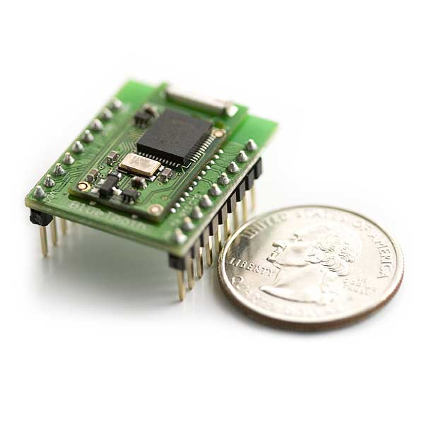Illustration 1: WRL-08461 Bluetooth DIP Module [21]

Host PC Interface Subsystem
The software-based Host PC interface subsystem has one basic goal: to expose the functionality of the data acquisition hardware to the end-user. This can be obtained via a few methods: buy or build. Each has its own advantages and disadvantages. The two options do overlap in certain areas as well. This current subsystem relies on a common interface from the communications subsystem.

The strengths of the build approach become apparent most notably in their startup costs. While engineer time is not fungible, there is a danger in spending much for little immediate return. This approach also affords somewhat more flexibility when considering deployment to multiple platforms. In a built approach, the Host interface would be encapsulated in an object that would contain methods to access the (buffered) datastream within. Depending on the platform support desired, this programmer's interface or API could be done in any number of languages. Figure 10 depicts a simple definition of such an interface. Using programs would first call start() to gather data from the unit, then stop() to halt gathering. Read() would extract that data from the interface for the using program. Write() would allow the user to send commands to the acquisition unit. A user-side interface would then have to be written to allow for logging of measurements, etc. A bought approach would wrap the functionality in Figure 10 within an already-existing framework such as LabVIEW. However, this can quickly become more expensive for the end-user even as it simplifies the work of the developer.
Figure 14: A sample UML diagram for a host interface.

Acquisition Unit Control Subsystem
The control logic on the data acquisition unit is seen as a slave to the host PC, and such can be kept relatively simple. A standard microcontroller will be used for this section of the project, such as a PIC microcontroller that is compatible with the bit-width of the analog-digital converters used. It will also interface with the on-unit communications subsystem (as seen in Figure 1 and again in Figure 11).
Figure 15: Acquisition Unit Control Subsystem Overview

Price

<For this draft, the manager was not appraised of the cost of the chosen units. This will be rectified post-haste.>.

Organization Chart

RASI

Timeline

Preliminary Action Item List

Conclusion

In summary, this is a Proposal for the design of a Wireless Electronic Design Tool. SEC is pleased to have been included in the bidders for this particular work.
References
[1] United States Patent: 4604569. http://patft.uspto.gov/netacgi/nph-Parser?Sect2=PTO1&Sect2=HITOFF&p=1&u=%2Fnetahtml%2FPTO%2Fsearch-bool.html&r=1&f=G&l=50&d=PALL&RefSrch=yes&Query=PN%2F4604569. Accessed Oct. 29, 2008.
[2] NI PCMCIA-4050 – Products and Services – National Instruments. http://sine.ni.com/nips/cds/view/p/lang/en/nid/12912. Accessed Oct. 22, 2008.

[3] Build a Bluetooth Enabled PDA Digital Multimeter with LabVIEW PDA. http://zone.ni.com/devzone/cda/tut/p/id/3052. Accessed Oct. 12, 2008.

[4] Digital Oscilloscope. http://glory.honour.ca/projects/Oscilloscope/Oscilloscope.html. Accessed Oct. 12, 2008
[5] Simple logic Analyser. http://uvasux.googlepages.com/simplelogicanalyser Accessed Oct 12, 2008

[6] NI PCMCIA-4050 and 4060 Data Sheet. http://www.ni.com/pdf/products/us/3mi463-466.pdf Accessed Oct. 22, 2008.

[7] Handyscope Instrument Description, http://74.125.113.104/search?q=cache:jU-oY3le0wUJ:www.egmont.com.pl/tiepie/katalog/HS3_spec.pdf+handyscope+HS3&hl=en&ct=clnk&cd=7&gl=us Accessed Oct 12, 2008

[8] Logic Analyzer for a multiplexed digital bus. http://www.google.com/patents/pdf/Logic_analyzer_for_a_multiplexed_digital.pdf?id=gKsyAAAAEBAJ&output=pdf&sig=ACfU3U3CQnk57TMwh6AYDXSjBfEQAoR78g. Accessed Nov 6, 2008.

[9] USB Oscilliscope - Handyscope HS3, http://www.tiepie.com/uk/products/External_Instruments/USB_Oscilloscope/Handyscope_HS3.html Accessed Oct 12, 2008

[10] Brilldea BS100U. http://www.brilldea.com/product_BS100U.html Accessed Oct 12, 2008

[11] “Bitscope: A Mixed-Single Capture Engine”. http://i.cmpnet.com/edtn/ccellar/e043pdf1.pdf. Accessed Oct. 12, 2008.

[12] ADC10040 - 10-Bit, 40 MSPS, 3V, 55.5 mW A/D Converter. http://www.national.com/pf/DC/ADC10040.html. Accessed Nov. 5, 2008

[13] “The Oscilloscope,” https://www.cs.tcd.ie/courses/baict/bac/jf/labs/scope/oscilloscope.html. Accessed Oct. 28, 2008

[14] “AD7822: 3 V/5 V, 2 MSPS, 8-Bit, 1-/4-/8-Channel Sampling ADCs,” http://www.analog.com/en/analog-to-digital-converters/ad-converters/AD7822/products/product.html. Accessed Nov. 5, 2008

[15] “The XYZs of Logic Analyzers,” http://web.mit.edu/6.111/www/s2007/handouts/LA.pdf. Accessed Nov. 7, 2008
[16] Bluetooth. Http://www.bluetooth.com. Accessed Nov. 5, 2008.
[17] CSR – Better Connected. http://www.csr.com/. Accessed Nov. 5, 2008.
[18] National Semiconductor Home. Http://www.national.com/. Accessed Nov. 5, 2008.
[19] Bluegiga – WT11 Class 1 Bluetooth Module http://www.bluegiga.com/WT11_Class_1_Bluetooth_Module. Accessed Nov. 5, 2008.
[20] Bluegiga – WT12 Class 2 Bluetooth Module http://www.bluegiga.com/WT11_Class_2_Bluetooth_Module. Accessed Nov. 5, 2008.
[21] SparkFun Electronics – Bluetooth DIP Module. http://www.sparkfun.com/commerce/product_info.php?products_id=8461. Accessed Nov. 5, 2008.

Wesley Tredinnick
wes86@siu.edu
630-202-1097
Permanent Address:  1493 W Galena Blvd  Aurora, IL 60506 | College Address:  275 Neely Drive Room 1628  Carbondale, IL 62901
OBJECTIVE

Seeking an Electrical Engineering internship beginning Summer 2009

EDUCATION

Bachelor of Science in Electrical Engineering, December 2009
Southern Illinois University, Carbondale, IL 62901

EXPERIENCE

Customer Service, Target – Marion, IL | May 2008 - Present
- Assist customers in finding products
- Unload trailer, stock floor, and backstock products
- Work in team to efficiently stock the floor

Cashier, Culver's Restaurant – Aurora, IL | May 2007 – August 2007
Addison, IL | December 2004 – August 2005
- Ran the cash register by taking orders and handling transactions
- Operated the shake and custard machine
- Maintained a clean dining room while making sure the guests were satisfied

Assistant, Stanley Consultants – Chicago, IL | May 2003 – August 2003
- Copied, filed, and organized documents
- Drove construction plans to IDOT
- Assisted engineers with tasks such as creating spreadsheets for items, copying backup files for lawyers, and retrieving information on past projects

HONORS/AWARDS

- Dean's List – Fall 2005, Spring 2006, Spring 2007
- University Honors Program
- Culver's Employee of the Month – May 2005
Tiffany Gallops

Mailing:
P.O.Box 864
Carbondale, IL 62903
618-521-8116
Permanent:
813 S. Skyline Dr.
Carbondale, IL 62901
heshin.a.gogo@gmail.com

OBJECTIVE: Computer engineering position in the SEC.

SUMMARY: • Graduating in May 2010 with a BS in Computer Engineering.
• Minor in Mathematics and Computer Science.
• Experience with wireless and broadband networks.

EDUCATION: Bachelor of Science in Computer Engineering, May 2010
Southern Illinois University, Carbondale, Illinois

Courses taken included:
Digital Integrated Circuits Java Programming
VSLI Design C++ Programming
Digital Signal Processing Web Design
Computer Architecture

EXPERIENCE: Retail Sales, November 2003 to January 2004, November 2004 to Present
Macy’s, University Mall, Carbondale Illinois
• Consistently excellent customer service given over the course of four years.
• Consistently met goals and exceeded expectations.
• member of the diamond club, a club honoring the most outstanding individuals.

Independent Contractor, September 1995 to Present

Southern Illinoisan, Carbondale Illinois
• Daily Delivery of Product to over 120 customers, regardless of weather.
• Independent work without supervision.
• Outstanding Customer Service given for over 13 years.

ACTIVITIES:
• Member, IEEE Student Chapter, 2008

Douglas Palmer
dpalmer1986@gmail.com
Permanent Address: College Address:
1335 Nolan Court 1225 Point Drive, Room 104
Mount Zion, IL 62549 Carbondale, IL 62901
Tel: (217) 864-1078 Tel: (217) 714-7258

Objective:
To secure an entry level electrical engineering position that will utilize my experience, education and proven abilities as well as allow for upward mobility commensurate with achievement.

Education:
- Bachelor of Science in Electrical Engineering at Southern Illinois University at Carbondale, IL in August of 2009. GPA: 3.2/4.0
- Eastern Illinois University, August 2005 – May 2007.

Relevant Coursework
- Signals and Systems
- Digital Circuit Design
- Citcuit Analysis
- Verilog and VHDL

Experience:
Sales Associate August 2002- August 2007
Polo Ralph Lauren Factory Outlet Tuscola, IL
- Provide excellent service & support to customers
- Worked on customer service & checkout, facility maintenance

Technical Skills:
- Windows system use.
- Microsoft Office
- PSpice
- CAD
- MATLAB.
- Experience with circuit design
- Experience in computer programming in C++

Honors/Awards
- Deans List, Summer 2008
Activities:
- President, Southern Illinois University Kendo Club, September 2008

Joseph D. Lenox
Permanent:  1202 Camp Ave  Rockford, IL 61103  815-566-9086  lordofhyphens@gmail.com | Campus:  800 E. Grand Ave Apt 41B  Carbondale, IL 62901  815-566-9086  lordofhyphens@gmail.com
OBJECTIVE: Obtaining experience in the field of Electrical Engineering/Computer Engineering during Summer 2009.

SUMMARY: • Adaptable, versed in Computer Engineering, Electrical Engineering, and Computer Science domains.
• Experience in data mining and software design.
• Trained in Agile software development methods.
• Enjoys problem-solving and meeting design challenges.
• Self-driving and works well within a team.

EDUCATION: Senior in Computer Engineering and Electrical Engineering
Southern Illinois University - Carbondale
Courses taken include:
JAVA Programming Software Engineering with Agile Methods
Operating System Design Linux/UNIX Systems Programming
Discrete Logic/Digital Systems VLSI Test and Automation
VLSI Test and Automation Computer Organization Design
Digital Control Systems
Manager for Senior Design Project – PC-Based Modular Wireless Diagnostic Tools

EXPERIENCE: Undergraduate Researcher – Southern Illinois University College of Engineering
• Studied the effects of data prefetching on VLIW processors architectures.
• Worked with the Trimaran Compiler Collection and Simu simulator.

Intern - Hamilton Sundstrand Aerospace
• Designed/Developed examination generator for internal use.
• Adapted existing mainframe database into accessible SQL Server database and built search tooling for it.
• Using internal tooling, developed company-wide system to track, process and aggregate site audit reports.
• Performed data mining, analysis, and reporting.
• Streamlined working group's scheduling process.

Research Assistant - Southern Illinois University Department of Curriculum
• Developed models for research project.
• Implemented new designs utilizing PHP, C, and NWScript (an internal C-like scripting tool).

20th and 21st Egyptian Campaign Committee Chairman
• Developed automation of attendee registration.
• Oversaw events and handled on-site issues.
• Streamlined paperwork loads.
• Worked with vendors for convention support.

SKILLS: • Fluent in PHP, C/C++, Java.
• Familiar with ModelSim, Cadence Design Tools, and Xilinx CAD.
• Familiar with EAGLE PCB layout editor.

ACTIVITIES: • Vice President and President, SIUC-Strategic Games Society, 2006-2008
• Chairman of 20th and 21st Egyptian Campaign Gaming Convention Committee

AWARDS: • Illinois State Scholar
• Hamilton Sundstrand Achievement Award
• Hamilton Sundstrand Level 2 Award

