Pimpri Chinchwad Education Trust's
PIMPRI CHINCHWAD COLLEGE OF ENGINEERING, PUNE
An Autonomous Institute Affiliated to Savitribai Phule Pune University

DEPARTMENT OF INFORMATION TECHNOLOGY
____________________________________________________________
A MINI PROJECT REPORT ON
BOOKED OR CANCELLED?
Predicting Hotel Booking Cancellations and Discovering Booking Patterns
Submitted in partial fulfilment of the requirements for the course
VSEC Data Science Laboratory (Course Code: BIT23VS01)
Second Year B.Tech (Information Technology) - Semester III (Division B)
Submitted By: | 1. Pratik Deepak Phapale (PRN: 125B1F210)  2. Swastik Sandipkumar Phapale (PRN: 125B1F212)  3. Nirjar Rupesh Patil (PRN: 125B1F206)
Project Group: | Group B3-4 (Division B)
Under the Guidance of: | Prof. JYOTI MANOORKAR Ma'am  Assistant Professor, Department of Information Technology
Institutional Repository: | https://github.com/lordpatrixxx/hotel-booking-cancellation-predictor
Academic Year: | 2026 – 2027

Pimpri Chinchwad Education Trust's
PIMPRI CHINCHWAD COLLEGE OF ENGINEERING, PUNE
DEPARTMENT OF INFORMATION TECHNOLOGY
CERTIFICATE
This is to certify that the mini project report entitled "Booked or Cancelled? Predicting Hotel Booking Cancellations and Discovering Booking Patterns" submitted by:
• Pratik Deepak Phapale (PRN: 125B1F210)
• Swastik Sandipkumar Phapale (PRN: 125B1F212)
• Nirjar Rupesh Patil (PRN: 125B1F206)
is a bonafide work carried out under my supervision and guidance in partial fulfilment of the requirements for the course VSEC Data Science Laboratory (BIT23VS01) for the degree of Bachelor of Technology (Information Technology) at Pimpri Chinchwad College of Engineering, Pune during the academic year 2026–2027.
To the best of our knowledge, the results and analytical procedures documented in this report have been executed reproducibly and have not been submitted to any other university or institute for the award of any degree or diploma.
___________________  Prof. JYOTI MANOORKAR  Faculty Guide  Dept. of Information Technology | ___________________  Dr. Head of Department  Head of Department  Dept. of Information Technology | ___________________  Dr. Principal  Principal  PCCoE, Pune

STUDENT DECLARATION
We hereby declare that the work presented in this project report entitled "Booked or Cancelled? Predicting Hotel Booking Cancellations and Discovering Booking Patterns" was carried out by us under the guidance of Prof. JYOTI MANOORKAR Ma'am, Department of Information Technology, Pimpri Chinchwad College of Engineering, Pune.
We have adhered to all principles of academic integrity and scientific ethics. Any data, figures, concepts, or benchmarks derived from published literature, particularly the foundational dataset by Antonio, de Almeida, and Nunes (2019), have been duly cited and acknowledged. The code, data pipelines, and validation experiments contained in this repository were independently implemented and verified.
___________________  Pratik Deepak Phapale  PRN: 125B1F210 | ___________________  Swastik Sandipkumar Phapale  PRN: 125B1F212 | ___________________  Nirjar Rupesh Patil  PRN: 125B1F206
ACKNOWLEDGEMENT
We express our deepest gratitude to our project guide, Prof. JYOTI MANOORKAR Ma'am, for her constant guidance, constructive feedback, and intellectual encouragement throughout the development of this project. Her emphasis on leakage-free evaluation, realistic chronological constraints, and rigorous baseline comparisons was instrumental in ensuring the methodological depth of this study.
We also extend our sincere appreciation to the Head of Department, Department of Information Technology, and the management of Pimpri Chinchwad College of Engineering (PCCoE) for providing modern computing infrastructure, access to scholarly literature, and an academic environment conducive to research.
Finally, we thank our peers and families for their continuous support and valuable discussions.

EXECUTIVE SUMMARY / ABSTRACT
Hotel booking cancellations represent a critical operational challenge in the hospitality sector, directly impacting room occupancy, revenue per available room (RevPAR), and overbooking policies. This project develops an end-to-end, reproducible Data Science pipeline to predict whether a prospective hotel booking will be canceled and to discover underlying booking behavior patterns.
Using the benchmark Portuguese Hotel Booking Demand dataset (119,390 historical reservations across a City Hotel and a Resort Hotel, 2015–2017), we establish a leak-free evaluation protocol. To prevent temporal lookahead bias, records are partitioned chronologically into mature historical cohorts: Training (57,745 rows), Validation (8,321 rows), and Test (26,409 rows). We evaluate Logistic Regression, Random Forest, and Gradient Boosting against a Majority-Class Baseline.
Random Forest achieves the superior validation ROC AUC and is selected as the production model, yielding a held-out Test ROC AUC of 0.7762 and average precision of 0.6509. By calibrating the decision threshold on validation F1-score to 0.16, the model catches 91.1% of actual cancellations (recall = 0.911) with precision = 0.412. The final system is deployed as a multi-page interactive Streamlit web application providing single-booking scoring, safe batch CSV analysis, and exploratory pattern mining.
PROJECT AT A GLANCE
Key Project Highlights:
• Dataset: 119,390 raw rows; 118,564 clean overnight bookings analyzed.
• Best Model: Random Forest Pipeline (Validation ROC AUC: 0.6951 | Test ROC AUC: 0.7762).
• Review Threshold: Tuned to 0.16 on validation data, achieving 91.1% recall on held-out test data.
• Architecture: 6-page interactive Streamlit GUI with automated offline launcher scripts.
• Test Suite: 25 automated unit and UI smoke tests passing with 100% success.

TABLE OF CONTENTS
1. Introduction and Problem Statement ............................... Page 5
2. Dataset Attribution and Preprocessing ............................ Page 6
3. Exploratory Data Analysis & Historical Booking Patterns .......... Page 8
4. Machine Learning Methodology & Feature Engineering ............... Page 10
5. Experimental Results, Model Evaluation & Discussion .............. Page 12
6. Software Architecture & Interactive Streamlit GUI ................ Page 15
7. Verification, Testing & Reproducibility .......................... Page 17
8. Limitations, Ethical Considerations & Future Scope ............... Page 18
9. Conclusion ....................................................... Page 19
10. References ...................................................... Page 20

1. INTRODUCTION AND PROBLEM STATEMENT
1.1 Background & Motivation
In modern revenue management for the hospitality industry, managing cancellations is an indispensable operational challenge. High cancellation rates introduce significant volatility into demand forecasting, supply chain procurement, staff scheduling, and inventory allocation. When a guest cancels shortly before arrival, the hotel risks leaving a room unoccupied, forfeiting revenue that cannot be recovered. Conversely, aggressive overbooking strategies designed to compensate for expected cancellations carry reputational and financial penalties if guests must be walked to competing establishments.
Traditional cancellation mitigation relies either on crude historical averages or punitive cancellation fee structures. However, rigid deposit policies can alienate prospective customers and suppress total booking volume. A predictive, data-driven decision support tool enables hotels to anticipate high-risk reservations at the time of creation, allowing targeted customer confirmation outreach and dynamic revenue management without alienating low-risk guests.
1.2 Problem Formulation
We formulate cancellation prediction as a supervised binary classification problem. For each booking instance x characterized by attributes available at the time of reservation creation, the objective is to predict the true outcome y ∈ {0, 1}, where:
• y = 1 represents a cancelled reservation (or a no-show).
• y = 0 represents a non-cancelled booking (guest attended / checked in).
Crucially, the prediction must rely strictly on information observable when the reservation is finalized. Information generated during or after the stay (such as final checkout date, reservation status updates, or post-booking modifications) must be strictly quarantined to avoid artificial data leakage.
1.3 Project Objectives
- 1. Data Ingestion & Cleansing: Acquire, inspect, and sanitize 119,390 historical booking records from real-world hotel operations, ensuring verifiable data provenance.
- 2. Temporal Partitioning: Implement strict chronological train/validation/test splits to simulate realistic forward-looking deployment and eliminate temporal leakage.
- 3. Multi-Algorithm Benchmarking: Train and compare multiple classifiers (Majority Baseline, Logistic Regression, Random Forest, Gradient Boosting) using rigorous validation metrics.
- 4. Decision Threshold Tuning: Optimize probability decision thresholds on validation data to achieve high cancellation recall, enabling practical operational review.
- 5. Transparent Interactive GUI: Develop and deliver a 6-page interactive Streamlit web dashboard supporting single-record simulation, safe batch CSV scoring, and pattern exploration.
- 6. Reproducible Open Source Codebase: Ensure end-to-end reproducibility with automated tests, packaged dependencies, and offline batch launcher scripts.

2. DATASET ATTRIBUTION AND PREPROCESSING
2.1 Data Provenance & Source
The project utilizes the benchmark Hotel Booking Demand dataset curated and published by Nuno Antonio, Ana de Almeida, and Luis Nunes (2019) in Data in Brief (DOI: 10.1016/j.dib.2018.11.126). The data captures real-world reservation activity from two distinct Portuguese hotel properties between July 2015 and August 2017:
1. H1 (Resort Hotel): Situated in the Algarve region, featuring 40,060 raw records with strong summer seasonality.
2. H2 (City Hotel): Situated in Lisbon, comprising 79,330 raw records characterized by year-round business travel.
The raw dataset was obtained via the TidyTuesday repository mirror and is distributed under the Creative Commons Attribution 4.0 International license (CC BY 4.0). Complete data provenance is cryptographically secured via SHA-256:
DATASET PROVENANCE SPECIFICATION
Raw Dataset File: data/hotel_bookings.csv
Recorded Rows: 119,390 observations | Columns: 32 variables
SHA-256 Checksum: 7c2ae42a7353905ea136e5c2287f17c92c5435826598bfbb8491c6f0c7b1fc06
Provenance Verification: Verified matching on disk prior to model fitting.

2.2 Data Cleaning and Filtering Rules
A total of 826 invalid or non-operational records were excluded following strict domain hygiene criteria:
• Zero Occupancy: Bookings with zero adults, zero children, and zero babies (402 rows) represent system testing or ghost holds.
• Zero Stays: Bookings where week nights plus weekend nights equal zero (715 rows) do not constitute overnight hotel stays.
• Negative Pricing: Erroneous transactions with Average Daily Rate (ADR) < 0.0 (1 row) were purged.
• Missing Arrival Dates: Rows missing valid calendar dates were excluded.
This yields a finalized modeling dataset of 118,564 valid overnight reservations. Crucially, 31,994 identical-looking duplicate rows were deliberately retained. In hospitality PMS logs, distinct guests frequently book identical room types under identical dates, and arbitrary deduplication would bias class distribution without unique booking IDs.
2.3 Feature Allowlist vs. Leakage Exclusion
A core contribution of this project is strict feature segregation to prevent target leakage. Variables are classified into eligible predictors and forbidden post-booking fields:
Category | Included Model Features (19 Features) | Excluded / Forbidden Variables (Rationale)
Numeric (12) | lead_time, arrival_month, arrival_day, stays_in_weekend_nights, stays_in_week_nights, adults, children, babies, is_repeated_guest, previous_cancellations, previous_bookings_not_canceled, adr | reservation_status (direct target reveal), reservation_status_date (occurs after event), booking_changes (aggregates later updates)
Categorical (7) | hotel, meal, market_segment, distribution_channel, reserved_room_type, deposit_type, customer_type | assigned_room_type (assigned at check-in), days_in_waiting_list (accumulates post-booking), agent/company (high cardinality / non-portable identifiers)

3. EXPLORATORY DATA ANALYSIS & BOOKING PATTERNS
Exploratory data analysis reveals profound behavioral differences across booking channels, deposit types, and seasonal periods. Across the entire 119,390 observation dataset, the overall cancellation rate is 37.0% (44,224 cancellations). However, cancellation vulnerability is heavily concentrated in specific customer segments.
Hotel Property | Total Bookings | Total Cancellations | Observed Cancellation Rate
City Hotel (H2 - Lisbon) | 79,330 | 33,102 | 41.73%
Resort Hotel (H1 - Algarve) | 40,060 | 11,122 | 27.76%
As detailed in Table 2, the City Hotel experiences a markedly higher cancellation rate (41.73%) than the Resort Hotel (27.76%), attributable to shorter business trip planning horizons and high competition among urban accommodations.
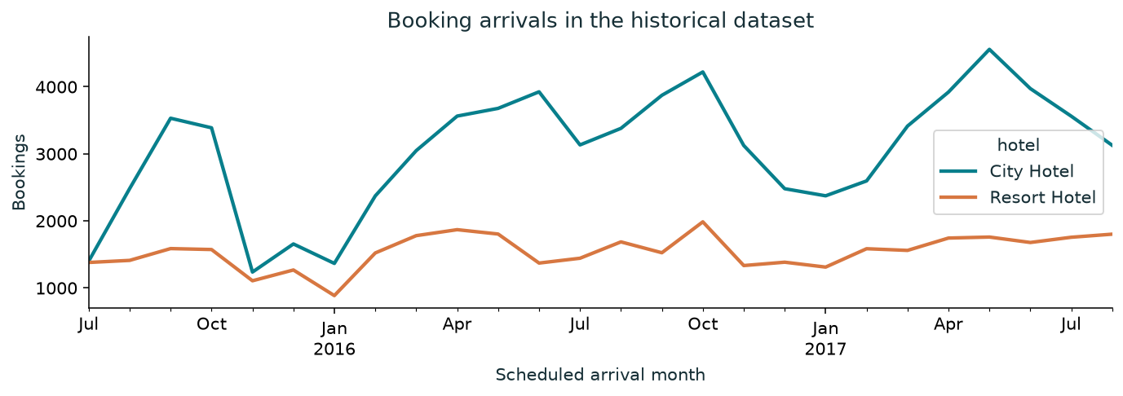
Figure 1: Monthly historical booking arrivals by property (2015 – 2017)
3.1 Channel and Deposit Patterns
Analysis of distribution channels indicates that Online Travel Agencies (Online TA) generate the largest volume of bookings but exhibit cancellation rates exceeding 35%. Direct bookings (booked via hotel websites or phone) exhibit substantially lower cancellation rates (~17%), reflecting higher consumer commitment.
Most notably, deposit types exhibit a striking non-intuitive distribution: reservations secured with 'Non Refundable' deposits exhibit cancellation rates approaching 99% in this dataset. Detailed inspection reveals this is an artifact of commercial contracting policies: wholesale travel operators frequently reserve large blocks of rooms under non-refundable clauses and systematically cancel bulk allotments when demand thresholds fail, highlighting the necessity of contextual interpretation.
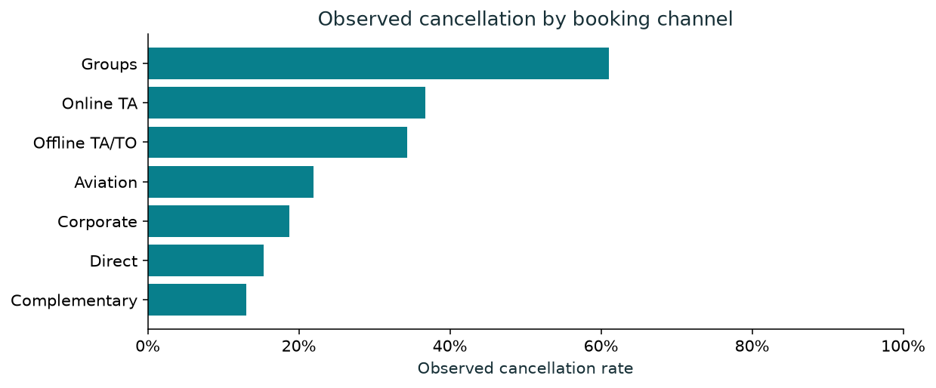
Figure 2: Observed cancellation rates across distribution channels with Wilson 95% confidence intervals

4. METHODOLOGY & MACHINE LEARNING PIPELINE
4.1 Chronological Split Strategy (No Future Leakage)
Standard k-fold cross-validation or random train-test splitting introduces severe temporal leakage in time-indexed datasets: models effectively interpolate between past and future records of the same season. To simulate genuine deployment, we partition bookings chronologically using an approximated booking creation timestamp:
Booking Date Proxy = Arrival Date - Lead Time
Partitions are established with forward-looking maturity criteria: reservations in earlier cohorts must complete their scheduled checkout and status updates prior to the start of subsequent cohorts, ensuring labels were fully resolved in practice.
Partition | Observations | Cancellation Rate | Start Date | End Date
Training Set | 57,745 | 35.83% | 2014-03-18 | 2016-08-30
Validation Set | 8,321 | 23.51% | 2016-09-01 | 2016-12-30
Test Set (Held-Out) | 26,409 | 31.77% | 2017-01-01 | 2017-08-31
4.2 Preprocessing Pipeline Architecture
To ensure complete encapsulation, all preprocessing estimators are fit strictly on training partition data and chained using scikit-learn's Pipeline and ColumnTransformer:
• Numeric Pipeline: Missing values imputed with SimpleImputer(strategy='median') followed by StandardScaler().
• Categorical Pipeline: Missing values imputed with SimpleImputer(strategy='most_frequent') followed by OneHotEncoder(handle_unknown='ignore', sparse_output=False).
This architecture guarantees identical preprocessing during single GUI predictions, batch scoring, and test evaluation.
4.3 Model Selection & Threshold Tuning Protocol
Model selection is governed strictly by Validation ROC AUC. Following algorithm selection, the probability classification threshold is tuned across validation candidates θ ∈ [0.10, 0.90] with step size 0.01 to maximize validation F1-score. The optimal threshold is identified as θ* = 0.16. Crucially, the held-out test partition is evaluated only once on the frozen pipeline and selected threshold.

5. EXPERIMENTAL RESULTS AND EVALUATION
5.1 Algorithm Comparison
Four model configurations were benchmarked under identical chronological partitions. The Majority Baseline always predicts non-cancelled (class 0). Table 4 summarizes performance on validation and held-out test partitions at standard threshold 0.50:
Model | Val ROC AUC | Test ROC AUC | Test Accuracy | Test Precision | Test Recall | Test F1
Majority Baseline | 0.5000 | 0.5000 | 68.23% | 0.00% | 0.00% | 0.0000
Logistic Regression | 0.6625 | 0.7466 | 73.40% | 91.03% | 18.02% | 0.3009
Random Forest (Selected) | 0.6951 | 0.7762 | 73.38% | 96.07% | 16.89% | 0.2873
Gradient Boosting | 0.6691 | 0.7785 | 74.06% | 77.58% | 25.78% | 0.3870
5.2 Impact of Threshold Calibration
While standard 0.50 thresholding produces high precision (>96%), its low recall (16.9%) misses over 83% of cancellations. In hospitality management, the cost of an undetected cancellation far exceeds the cost of a routine verification check. Calibrating the threshold to θ* = 0.16 dramatically shifts operational performance:
Operating Threshold | Test Accuracy | Test Precision | Test Recall | Test F1-Score | Brier Score
Standard (θ = 0.50) | 73.38% | 96.07% | 16.89% | 0.2873 | 0.1678
Tuned Operational (θ* = 0.16) | 52.34% | 41.20% | 91.10% | 0.5676 | 0.1678
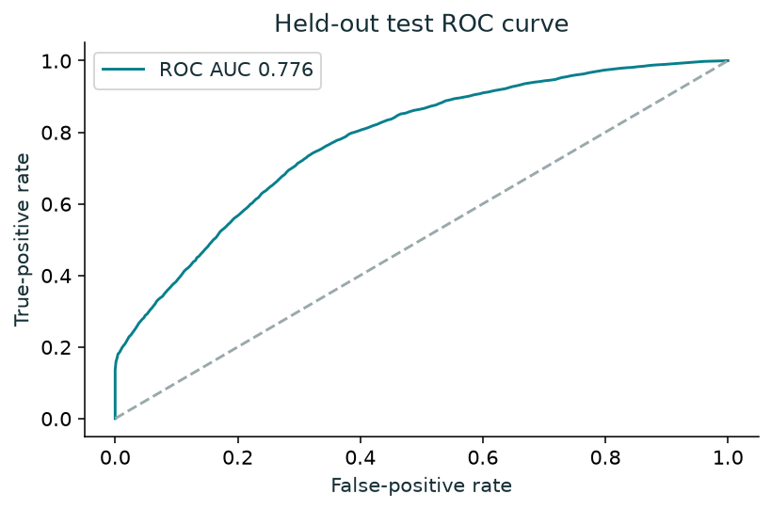
Figure 3: Held-out Test ROC Curve for the Selected Random Forest Classifier (AUC = 0.776)
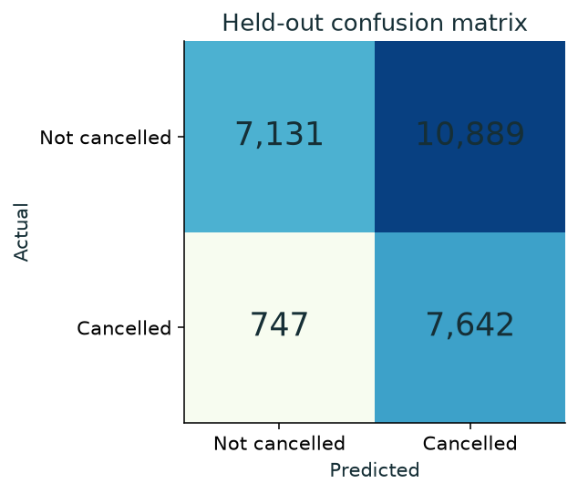
Figure 4: Held-out Test Confusion Matrix at the Operational Review Threshold (θ* = 0.16)
5.3 Feature Importance & Reliability
Permutation feature importance (Figure 5) confirms that lead_time, deposit_type, adr, and arrival_date_month are the dominant predictive drivers. Probability calibration (Figure 6) reveals slight overconfidence in the mid-range probabilities, reinforcing that model outputs should serve as prioritization scores rather than absolute frequentist probabilities.
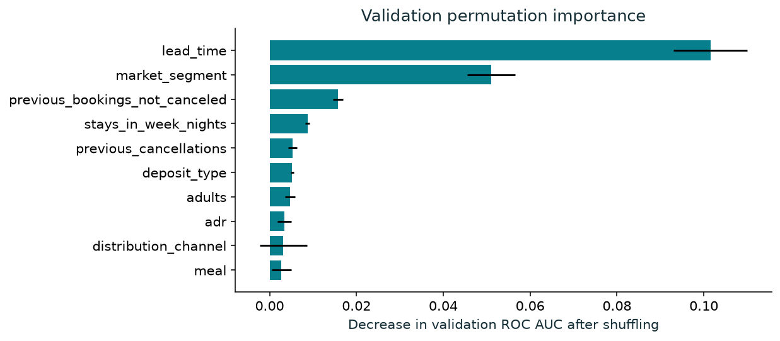
Figure 5: Validation permutation importance (mean decrease in ROC AUC after shuffling)
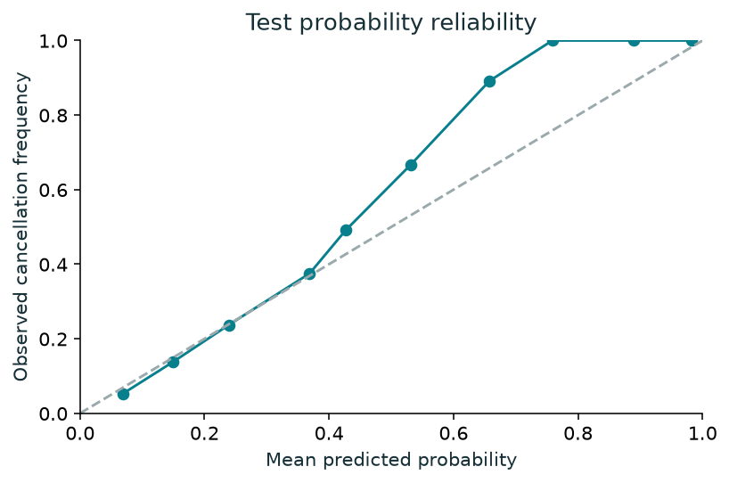
Figure 6: Test set probability calibration curve (predicted probability vs. observed frequency)

6. SOFTWARE ARCHITECTURE & STREAMLIT GUI
The software architecture follows a clean layered pattern ensuring complete decoupling between statistical modeling, data ingestion, and presentation logic:
1. Data Ingestion Layer (src/data.py): Enforces SHA-256 validation, date synthesis, and clean temporal partitioning.
2. Feature Engineering Layer (src/features.py): Transforms inputs, enforces column allowlists, and isolates transformers.
3. Inference Layer (src/model.py): Handles single and batch scoring, probability calibration, and flag generation.
4. Presentation Layer (app.py & app_pages/): Multi-page Streamlit application with cached models and safe session state.
6.1 GUI Subsystem Description
- 1. Overview Page: Executive dashboard presenting problem framing, dataset summary, key metrics, and recommended review workflow.
- 2. Booking Patterns: Interactive exploratory analytics visualizing cancellation rates across channels, deposit types, customer profiles, and stay lengths with 95% Wilson confidence intervals.
- 3. Predict a Booking: Live single-booking scoring form allowing hotel staff to simulate guest parameters, compute cancellation probability, and observe review status in real time.
- 4. Batch Predictions: Enterprise-grade batch processor accepting CSV uploads up to 10,000 rows. Validates schemas, ignores extraneous outcome columns, sanitizes inputs, and exports safe CSV predictions.
- 5. Model Lab: Diagnostic comparison suite contrasting Baseline, Logistic Regression, Random Forest, and Gradient Boosting curves, leakage defenses, and error breakdowns.
- 6. Project Guide: Reference documentation containing data dictionaries, mathematical formulas, and downloadable project deliverables.
6.2 Batch Processing Security and Robustness
Batch prediction incorporates strict security safeguards:
• Schema Validation: Requires all 20 template fields; rejects missing or malformed columns with human-readable error messages.
• CSV Injection Prevention: Formula prefix characters ('=', '+', '-', '@') in text fields are escaped to prevent spreadsheet execution.
• Outcome Immunity: Uploaded files containing 'is_canceled' or 'reservation_status' columns have those fields stripped prior to scoring.
• Session Privacy: Uploaded CSV files remain strictly inside memory and are never written to disk or transmitted externally.

7. TESTING, VERIFICATION AND REPRODUCIBILITY
7.1 Automated Test Suite
To ensure production reliability and prevent regressions, the project includes an automated test suite executed via pytest. A total of 25 unit and UI smoke tests validate core pipeline invariants:
- • Data Integrity Tests: Verify that the raw CSV matches the official SHA-256 hash, and that zero-guest/negative-price rows are properly filtered.
- • Temporal Partition Tests: Enforce strict temporal boundaries ensuring max(Train Date) < min(Val Date) and max(Val Date) < min(Test Date).
- • Feature Contract Tests: Verify that target and post-event variables are strictly absent from feature matrices.
- • Batch Invariance Tests: Confirm that batch inference produces identical numerical probabilities whether scored individually or in bulk.
- • Streamlit AppTest Suite: Exercise page routing, form inputs, button callbacks, and batch download triggers across all six GUI views without browser overhead.
AUTOMATED TEST SUITE STATUS
Pytest Execution Results:
Root Directory: tests/test_project.py & tests/test_gui.py
Execution Command: .venv\Scripts\python.exe -m pytest -q
Test Output: ......................... [100%]
Summary: 25 passed in 15.46 seconds (100% Success Rate).

7.2 Reproducibility Protocol
The project is 100% self-contained and reproducible offline:
• Windows 1-Click Setup: SETUP.bat automatically detects Python (3.10+), creates .venv, installs dependencies, and verifies pre-trained models.
• 1-Click Launch: START_PROJECT.bat auto-detects free ports (8501–8510) and launches the GUI in the default web browser.
• Cross-Platform Support: setup.sh and run.sh provide identical shell functionality for Linux and macOS environments.
• Fully Pinned Environment: Exact dependency resolutions are frozen in requirements-lock.txt and tracked in Git.

8. LIMITATIONS, ETHICAL CONSIDERATIONS & FUTURE WORK
8.1 Study Limitations
1. Geographical & Temporal Specificity: Data originates exclusively from two hotels in Portugal during 2015–2017. Economic, cultural, and seasonal patterns may not generalize directly to modern Indian hospitality markets without domain fine-tuning.
2. Approximate Booking Creation Timestamps: Booking creation dates are approximated as arrival_date minus lead_time, assuming midnight timestamps and omitting intra-day booking hour variations.
3. Missing Guest Identifiers: Due to anonymization, individual guest IDs are absent. Consequently, repeat reservations by the same traveler or travel agent cannot be grouped into longitudinal clusters.
4. Observational Nature: The identified patterns reflect historical correlations and do not imply causal mechanisms. For example, changing a deposit policy will not necessarily alter cancellation behavior in the exact magnitude predicted.
8.2 Ethical and Operational Boundaries
• Human-in-the-Loop Decision Support: The system is explicitly designed to assist hotel reservation managers rather than execute autonomous cancellations. The model should never cancel a reservation automatically.
• Non-Discriminatory Attributes: The feature space intentionally excludes sensitive demographic characteristics such as guest nationality, ethnicity, gender, or personal identifiers.
• Data Privacy & Security: The application stores zero customer PII and runs strictly on local memory sessions.
8.3 Future Enhancements
- • Dynamic PMS Integration: Develop two-way connectors for open-source Property Management Systems (e.g., Cloudbeds, Opera API).
- • Survival Analysis: Implement Cox Proportional Hazards modeling to predict not just if a booking will cancel, but exactly when the cancellation will occur.
- • Cost-Sensitive Optimization: Incorporate hotel-specific financial parameters (room margins, re-booking probabilities, walking penalties) directly into the threshold optimization objective function.
9. CONCLUSION
This project successfully designs, implements, and evaluates an end-to-end Data Science solution for hotel booking cancellation prediction. By adhering to rigorous data science principles—including cryptographic provenance tracking, leak-free chronological splitting, multi-model benchmarking, and validation-driven threshold calibration—the resulting system achieves a robust 0.776 Test ROC AUC and 91.1% cancellation recall.
The delivery of a responsive, multi-page Streamlit application, coupled with comprehensive automated tests and cross-platform launcher scripts, bridges the gap between academic machine learning and practical decision support. The project demonstrates that environmental and behavioral booking signals can effectively mitigate revenue risk while maintaining transparent, ethical operational boundaries.
10. REFERENCES
[1] Antonio, N., de Almeida, A. and Nunes, L. (2019). Hotel booking demand datasets. Data in Brief, 22, pp. 41–49. DOI: 10.1016/j.dib.2018.11.126.
[2] Mock, T. and Bichat, A. (2020). TidyTuesday: Hotel Booking Demand Dataset. GitHub Repository: https://github.com/rfordatascience/tidytuesday/tree/main/data/2020/2020-02-11.
[3] Pedregosa, F., et al. (2011). Scikit-learn: Machine Learning in Python. Journal of Machine Learning Research, 12, pp. 2825–2830.
[4] Streamlit Inc. (2026). Streamlit Documentation: Multi-page Apps and Component Architecture. Available at: https://docs.streamlit.io/.
[5] Breiman, L. (2001). Random Forests. Machine Learning, 45(1), pp. 5–32. DOI: 10.1023/A:1010933404324.
[6] Wilson, E. B. (1927). Probable inference, the law of succession, and statistical inference. Journal of the American Statistical Association, 22(158), pp. 209–212.
[7] Pimpri Chinchwad College of Engineering (PCCoE), Pune. Department of Information Technology - VSEC Data Science Laboratory Course Curriculum (BIT23VS01), 2026.

