FFM: Flood Forecasting Model Using Federated Learning
Now after all possible enhancements machine and deep learning algorithms are heading towards Federated learning as this federated learning provide data security, scalability and on time response availability. As we know machine or deep learning algorithms are dependent on dataset for training a model and this dataset has to upload to centralized server from local machines through internet and this data uploading may take huge network delay or latency for upload and this data will get exposed to centralized server and data security will be breached and due to network latency we may see delay in response also.
In some natural disaster scenarios like earthquake, floods, storm we need to have quick predicted response so government or peoples can take necessary action on time. So in propose work author applying Federated Learning for flood forecasting which allow local machines to train a model on local data and then upload only trained model to centralized server for global training and this technique avoid dataset upload which remove all existing barriers such as Latency, data breached and security. Local machine or centralized servers just have to take test data for prediction so network response and prediction will be quick.
In propose work author using FFNN (feed forward neural network) algorithm to predict flood and this algorithm will trained dataset and then update weights based on learning rate and training epochs. Epoch with less loss and high accuracy will have high weight and can predict label with high accuracy.
Propose work consists of following modules
- The first step is onsite training and transmission of local data models using regional datasets towards central server for model aggregation.
- The next step, global model is trained based on local modes that calculates multiple parameters and predicts the client station where flood is about to happen with 5 days lead time.
- n the last step, local feed forward neural network (FFNN) model is trained on that specific client station to calculate expected water level and inform authorities for taking necessary actions regarding flood preparedness, mitigation and recovery.
In propose work author using 18 stations or rivers dataset to train FFNN algorithm locally and then report trained model to centralized server for global updates. Author has not published dataset on internet so we are using KERALA flood dataset from KAGGLE website. In below screen we are showing dataset details
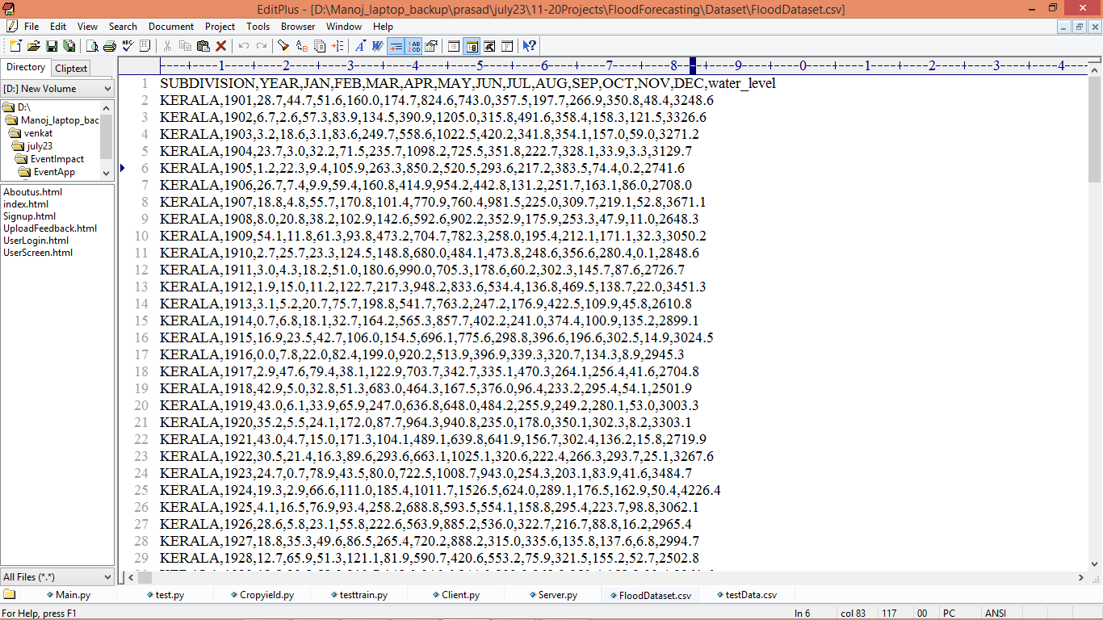
In above dataset screen first row represents dataset column names and remaining rows represents dataset values where dataset has recordings of monthly rainfall and last column contains Water Level and based on predicted water level authorities will inform citizens about flood.
Extension Concept
In propose work author has used traditional Feed Forward neural network algorithms and did not used any advanced algorithms like Convolution2D Neural Network which gain popularity in all domains for its accurate and successful prediction accuracy of more than 90%. So to enhance accuracy we have used CNN2D as extension for flood forecasting.
Each algorithm performance is measure in terms of accuracy, MSE (mean square error) and RMSE (root mean square error) where MSE and RMSE refers to difference between True dataset value and predicted value, so the lower the difference the better is the algorithm.
We have designed this application as Window based project as this project has to upload trained model to centralized and JUPYTER will not give flexibility of model upload to server so we designed as window based application.
To implement this project we have designed following modules
- Upload Flood Dataset: using this module we will upload, read and display dataset to application
- Pre-process Dataset: using this module we will remove missing values, normalized and shuffle the dataset values
- Train & Test Split: used to split dataset into train and test where application using 80% dataset for training and 20% for testing
- Run Feed Forward Neural Network: this module used to trained FFNN algorithm by using train data as input and this trained model can be applied on test data to calculate prediction accuracy.
- Run Extension CNN2D Algorithm: this module used to trained CNN2D algorithm by using train data as input and this trained model can be applied on test data to calculate prediction accuracy.
- Upload Federated Model to Server: using this module locally trained models can be upload to centralized servers for global updates
- Accuracy Comparison Graph: can be used to plot comparison graph between propose FFNN and extension CNN2D
- Flood Forecasting using Test Data: can be used to upload test data and then extension model will predict water level which help in knowing flood conditions.
SCREEN SHOTS
First double click on ‘runServer.bat’ file to start centralized server and get below output
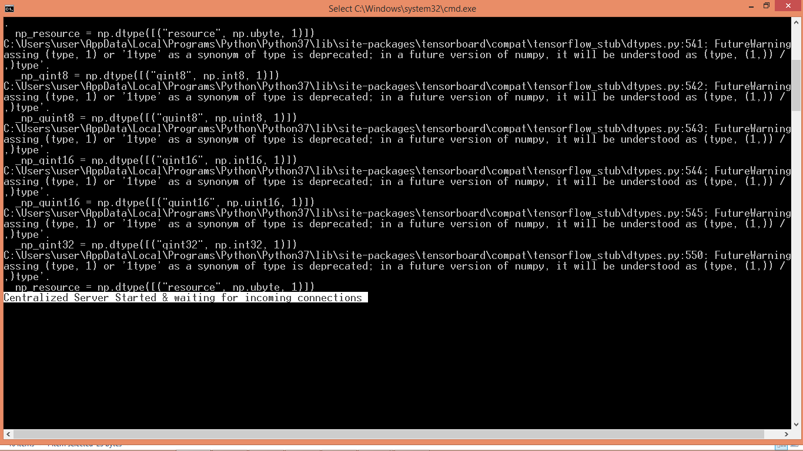
In above screen Centralized server started and now let it run and then double click on ‘run.bat’ file to start client which will train model locally by uploading local dataset and get below output
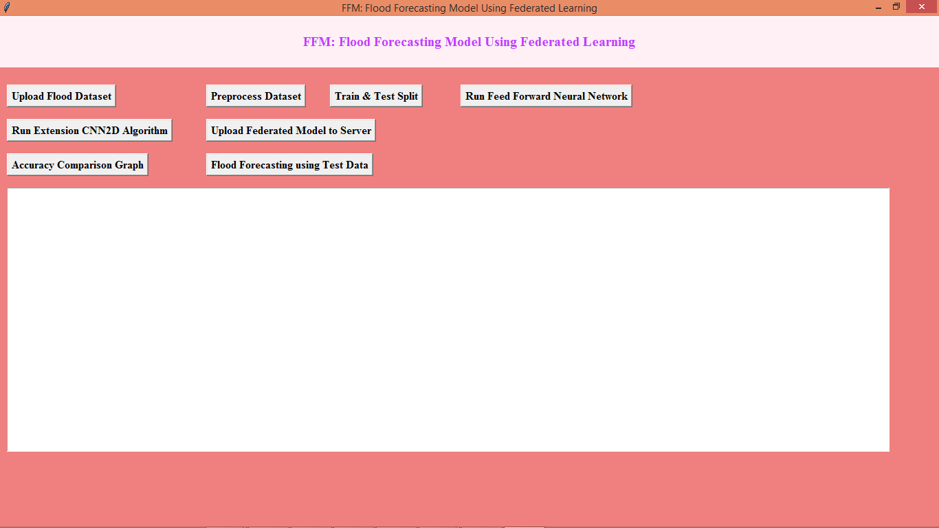
In above screen click on ‘Upload Flood Dataset’ button to load dataset and get below screen
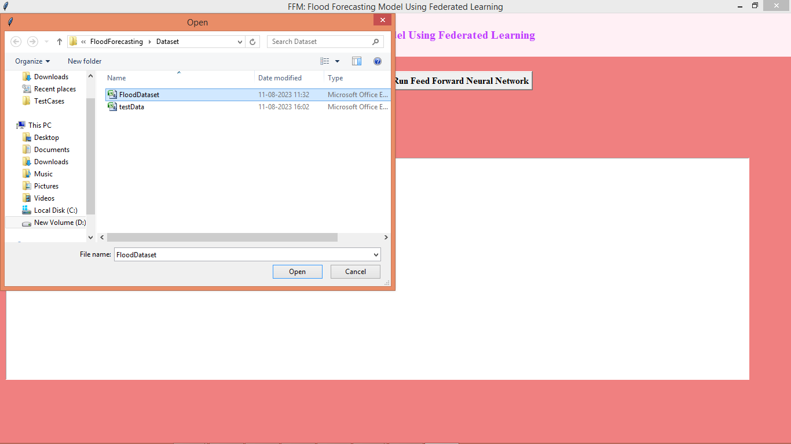
In above screen selecting and uploading ‘Flood Dataset’ and then click on ‘Open’ button to load dataset
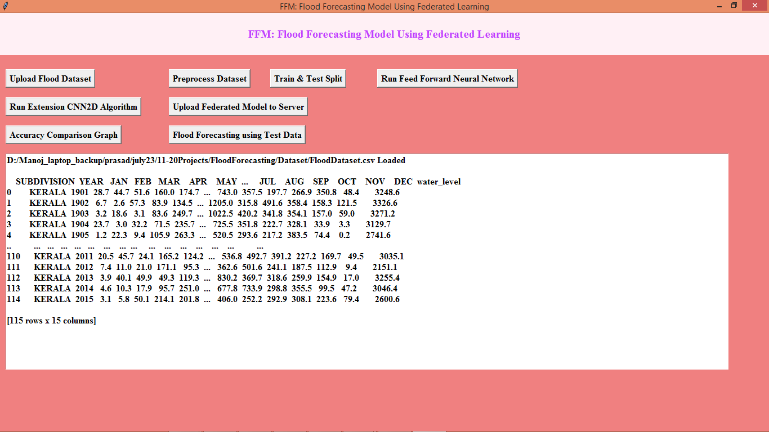
In above screen dataset loaded and now click on ‘Pre-process Dataset’ button to process dataset and get below output
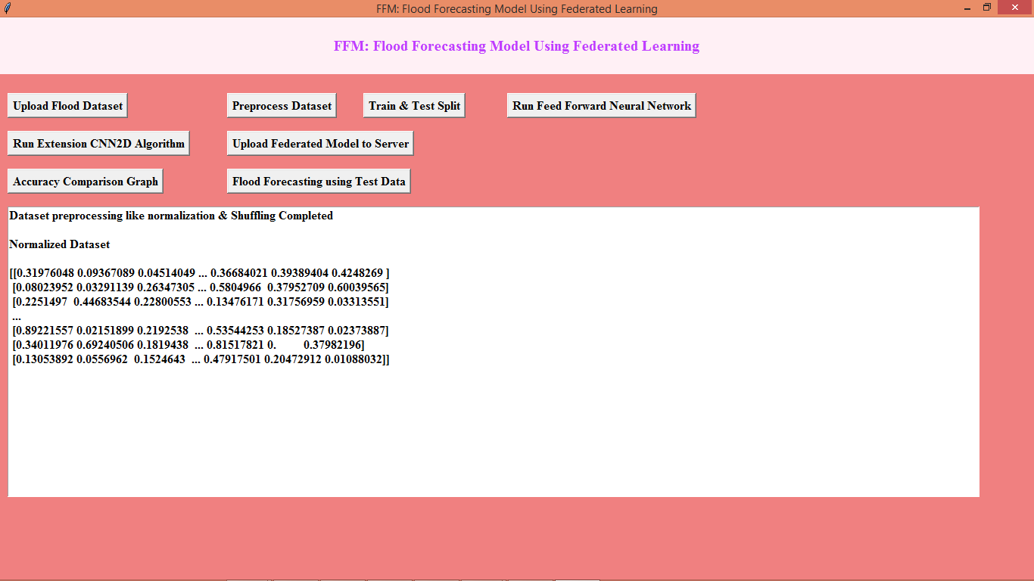
In above screen dataset pre-processing such as normalization and shuffling completed and now click on ‘Train & Test Split’ button to split dataset and get below output
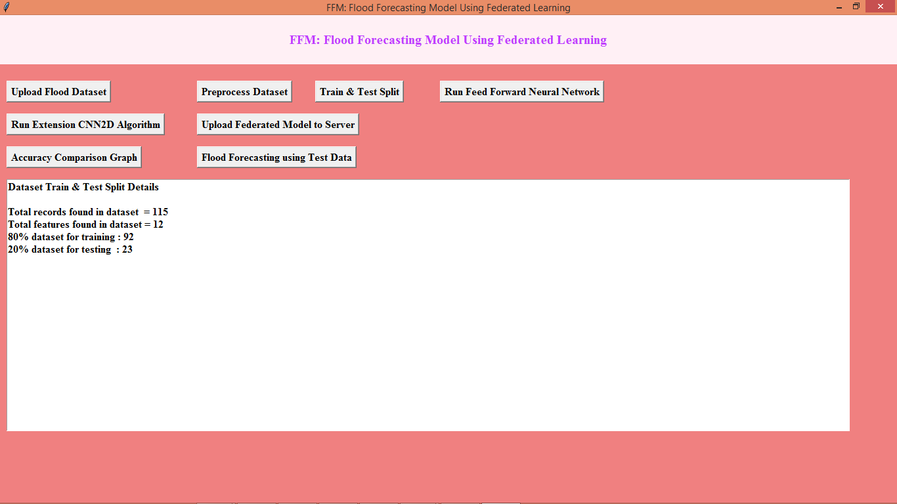
In above screen displaying dataset size and then displaying train and test size and now click on ‘Run Feed Forward Neural Network’ button to train propose FFNN algorithm and get below output
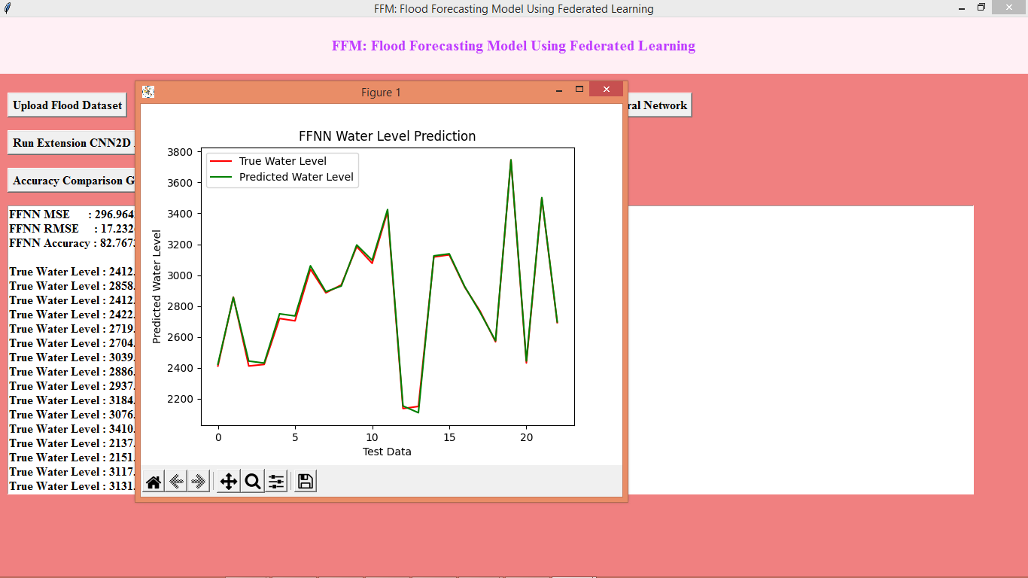
In above screen FFNN training completed and in above graph x-axis represents Number of Days and y-axis represents Water level where red line represents True water level and green line represents Predicted water level and we can see both lines are fully overlapping with little gap so we can say predicted and true values are very close and FFNN giving best prediction and now close above graph to get below output
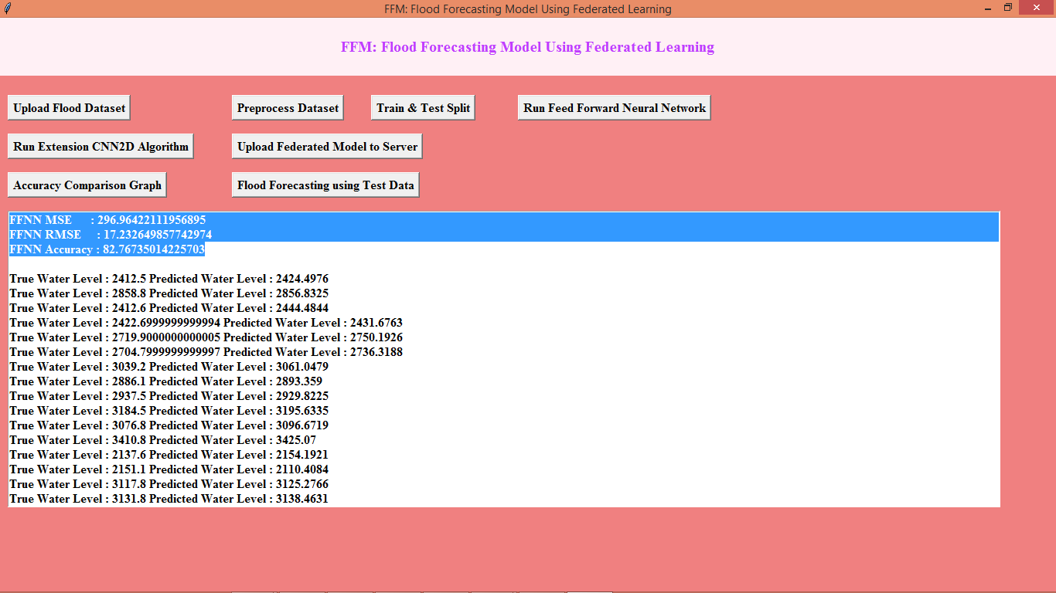
In above screen in first 3 lines we can see FFNN algorithm MSE, RMSE and accuracy values and then we can see true and predicted water levels for future days and now click on ‘Run Extension CNN2D Algorithm’ button to train extension algorithm
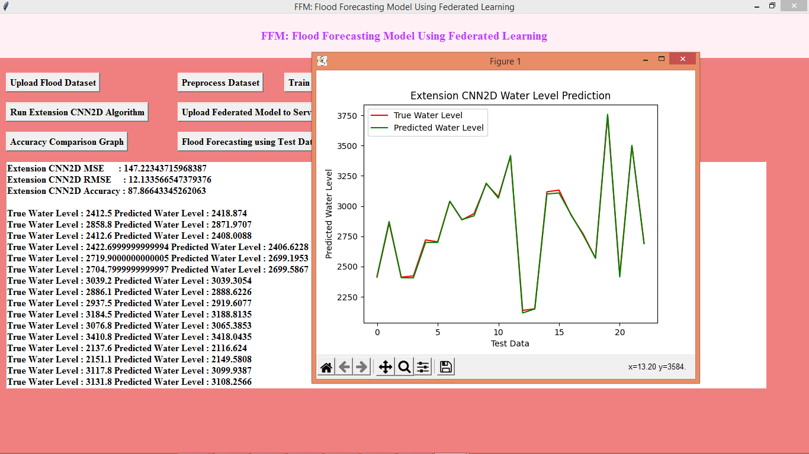
In above screen with extension we can see both predicted and true which means reads and green lines are fully overlapping so we can say extension model is better than propose and we can see MSE and RMSE also lower compare to propose and accuracy is high for extension algorithm and now close above graph and then click on ‘Upload Federated Model to Server’ button to upload trained model to server and get below output
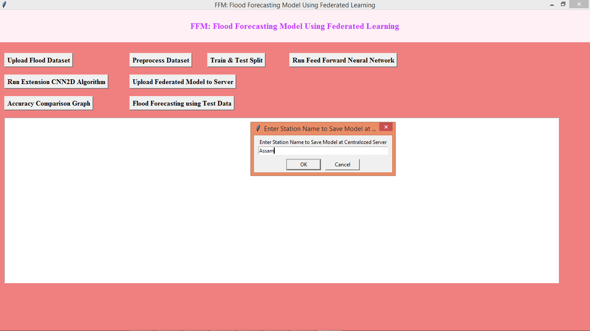
In above screen just enter some station name and then click OK button to upload model to server and get below output
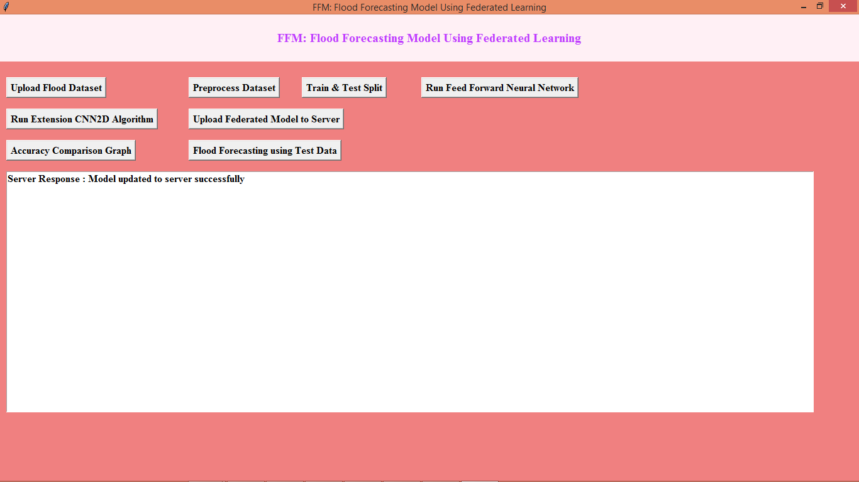
In above screen we got response from server as ‘model uploaded’ and in below server screen we can see received model details
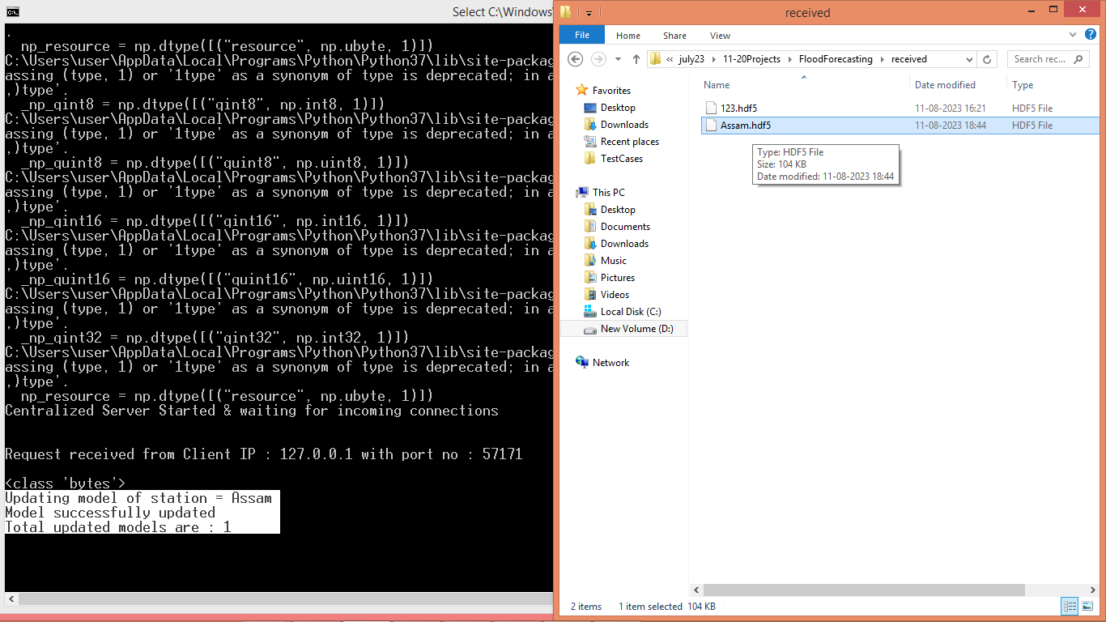
In above screen in white colour text we can see server output about model saving and in server ‘received’ folder we can see ‘Assam’ model is saved and similarly for all given station server will saved model.
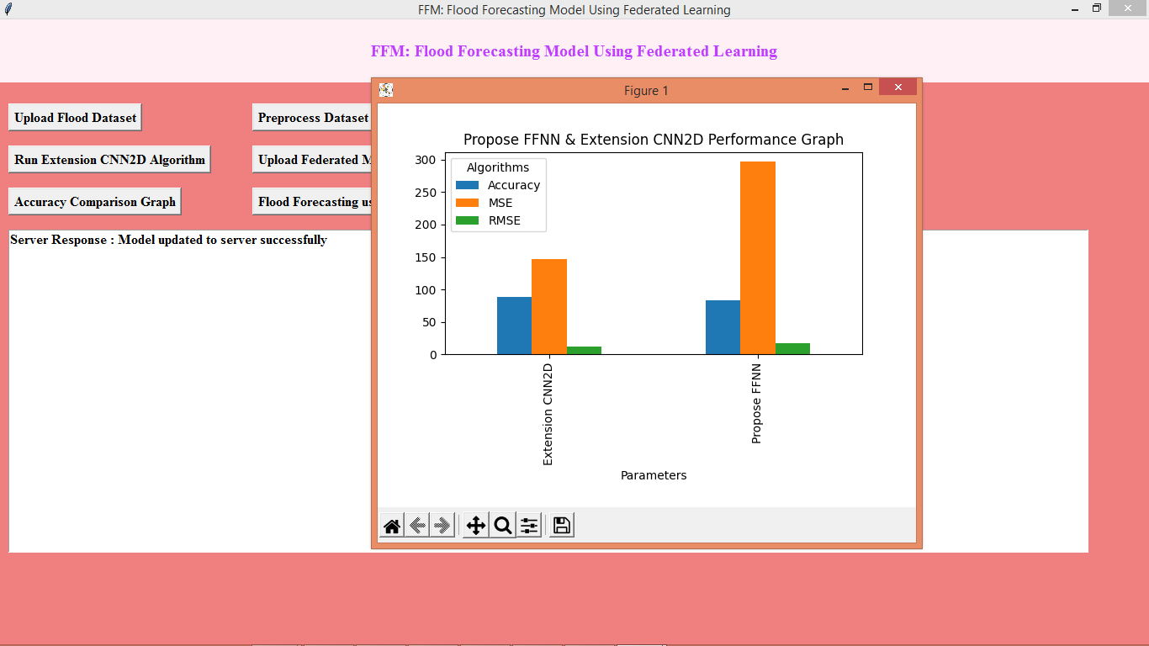
In above comparison graph x-axis represents algorithm names and y-axis represents accuracy and MSE values and we can see for extension algorithm accuracy is high and MSE, RMSE error is lower compare to propose FFNN algorithm and now close above graph and then click on ‘Flood Forecasting using Test Data’ button to upload test and then predict water level
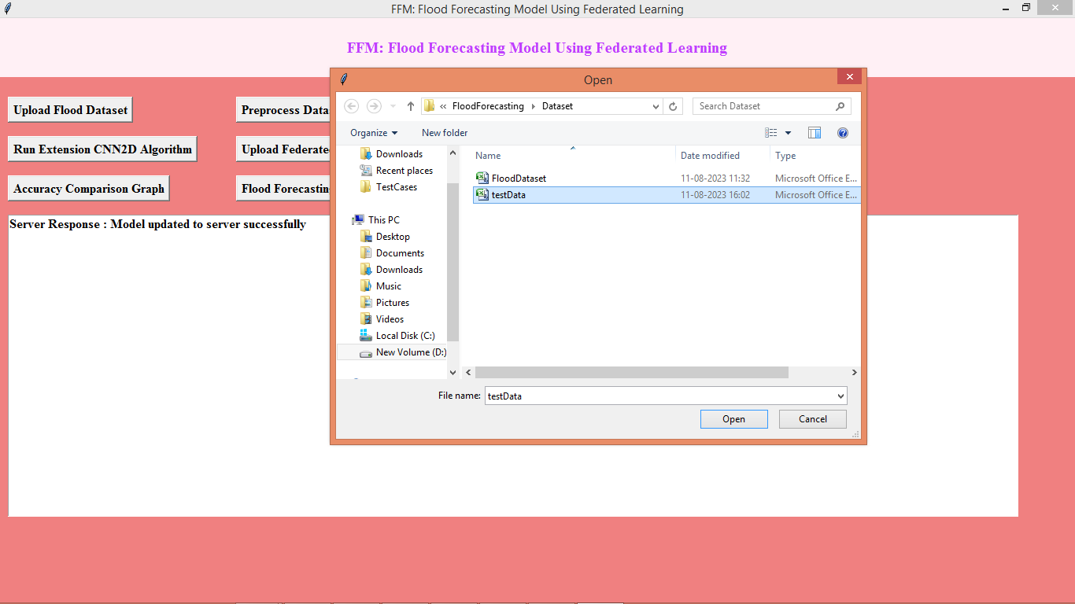
In above screen uploading test data and then click on ‘Open’ button to get below output
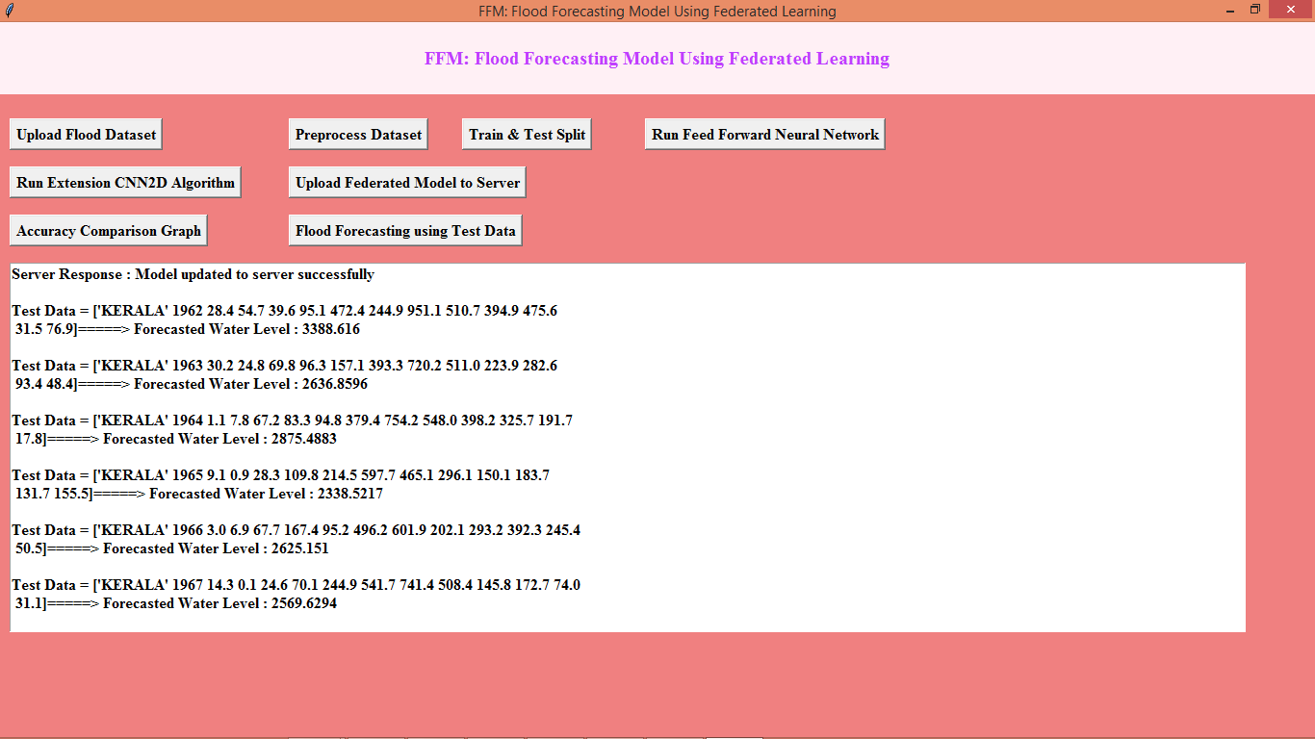
In above screen before arrow symbol we can see test data and after arrow symbol = we can see predicted water level

