Machine Learning-Based Graduate Admission Prediction Framework

In this project as per your instruction we have added extensive analysis and visualization on given dataset. This dataset contains more than 8000 records and this dataset was trained on various algorithms as CNN2D, Decision Tree, SVM, Random Forest, KNN and Linear Regression. Each algorithm performance is evaluated in terms of R2Score and MSE. R2Score refers to correct prediction percentage and MSE (mean square error) refers to difference between predicted and original test values.
We have coded this project using JUPYTER notebook and below are the code and output screens with blue color comments
As you want complex model so we have implemented multi-layer CNN2D (convolution neural network 2D) instead of plain ANN algorithm.
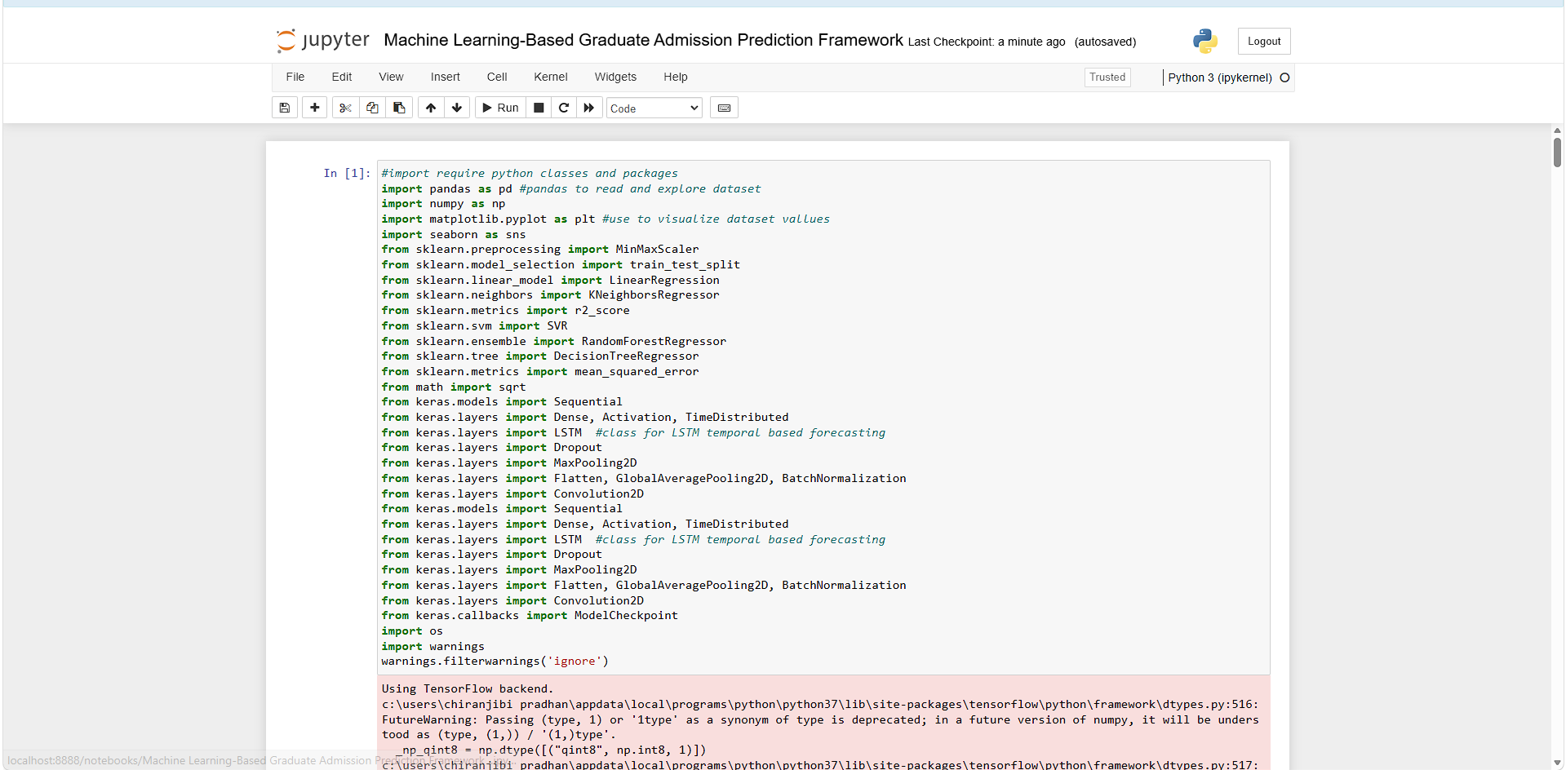
In above screen importing required packages and classes
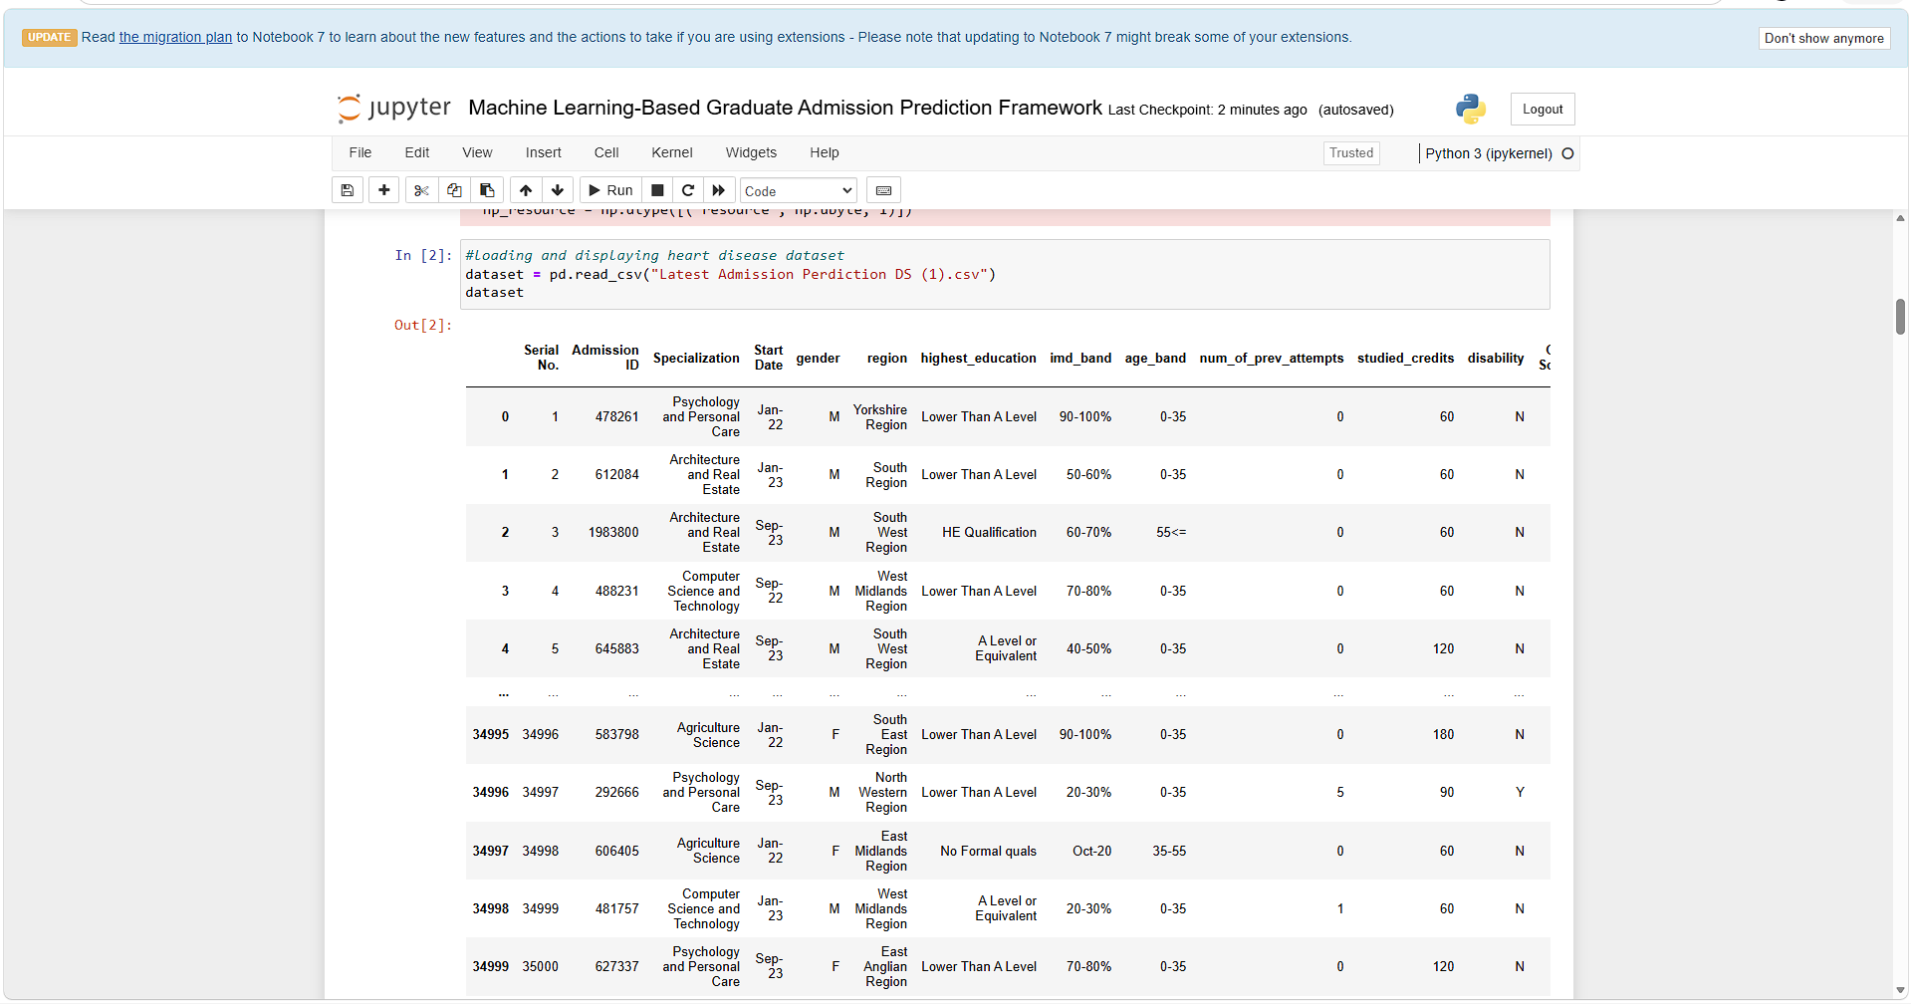
In above screen loading and displaying dataset values
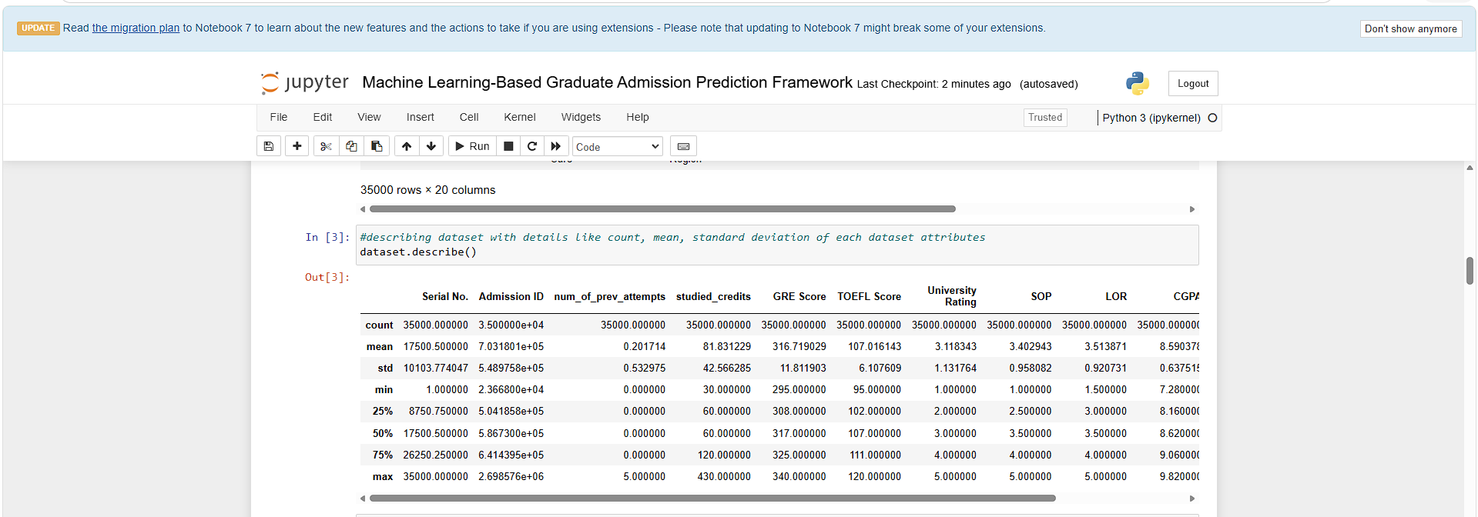
In above screen describing dataset with mean, count, standard deviation of each column.
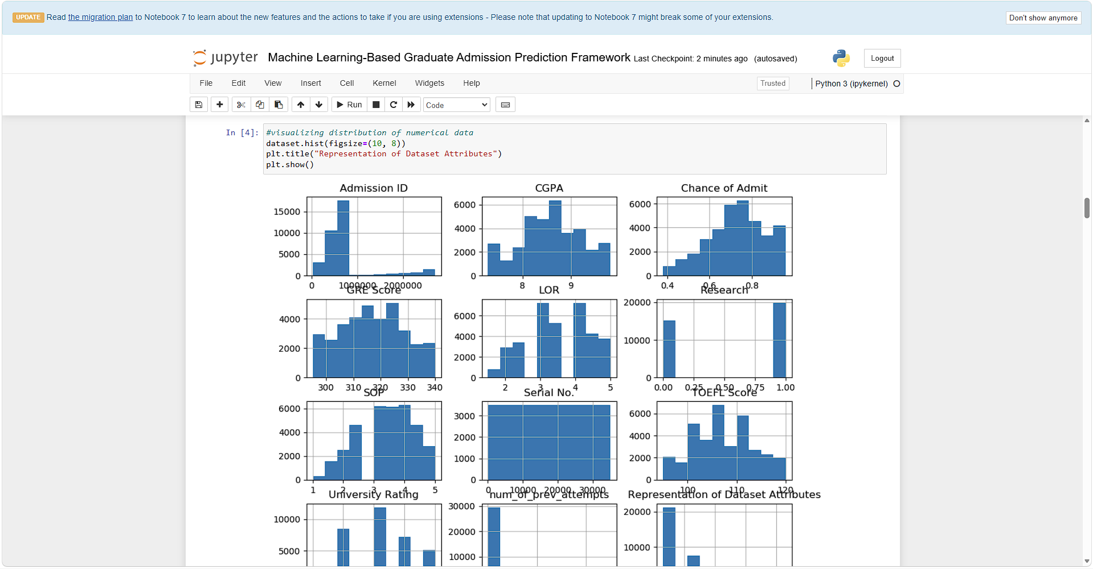
In above screen visualizing values of all columns based on their high and low values
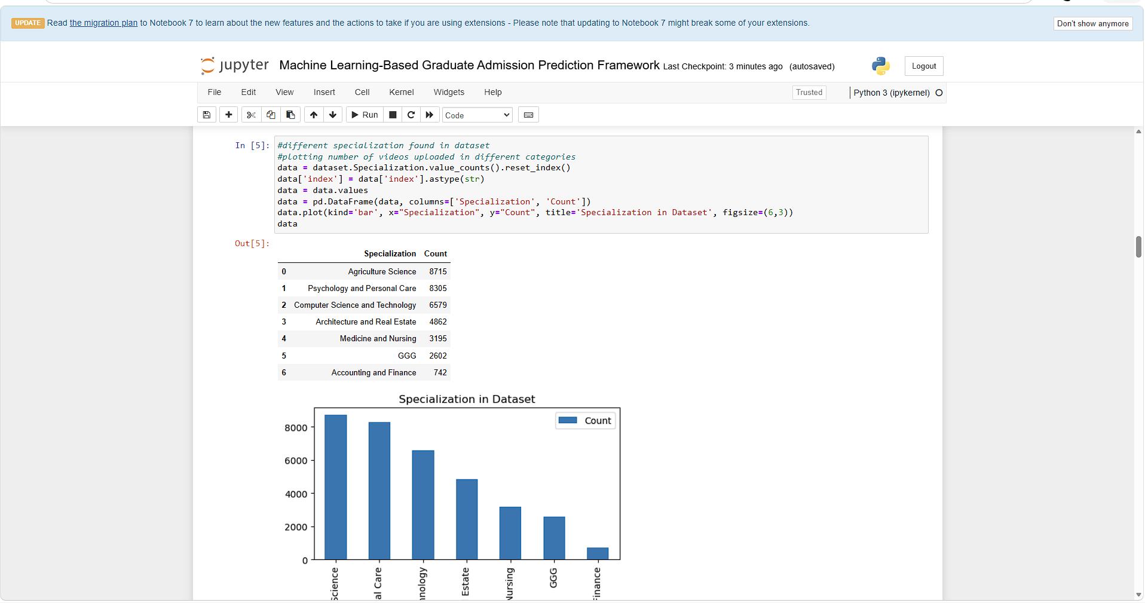
In above 2 screens displaying graph of different number of admissions done in different specialization where x-axis represents Specialization name and y-axis represents count
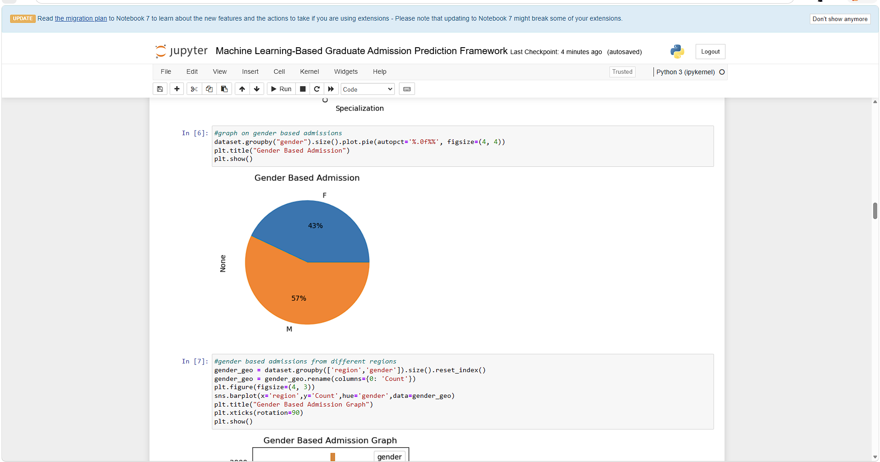
In above screen visualizing graph of number of admission taken by male and female gender
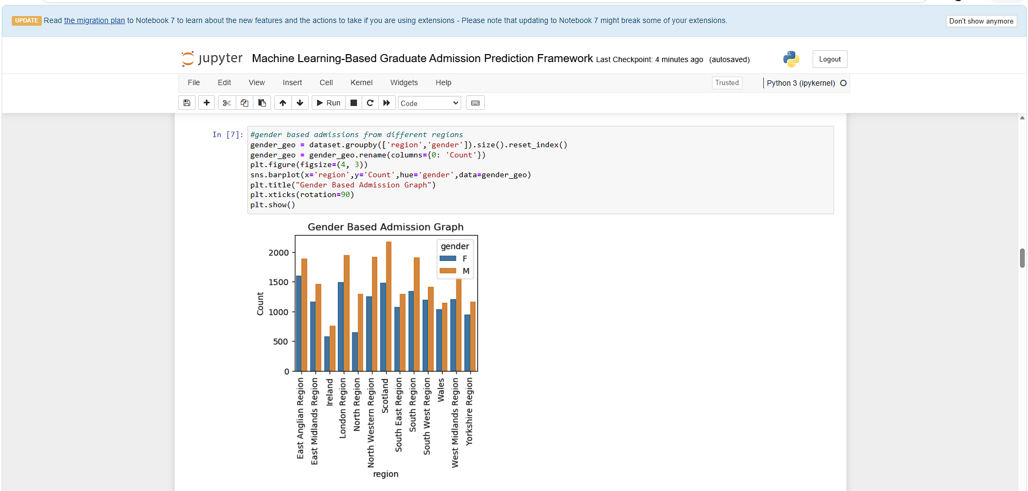
In above screen visualizing number of admission taken by gender from different regions where x-axis represents ‘Region Name’ and y-axis represents gender count
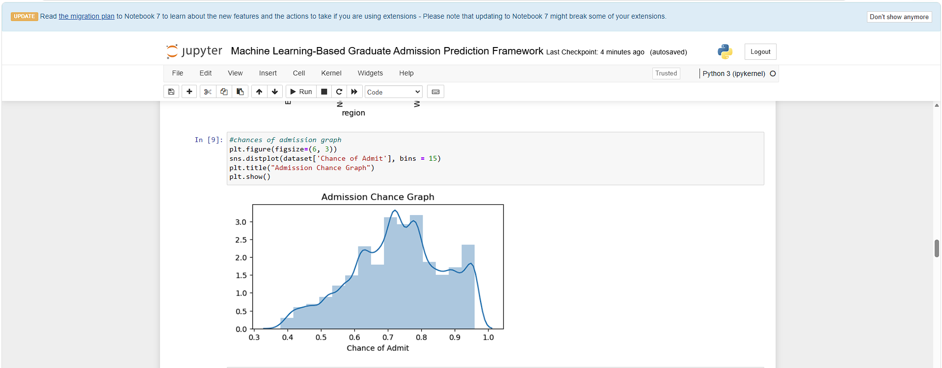
In above screen displaying graph of admission chances on different percentage
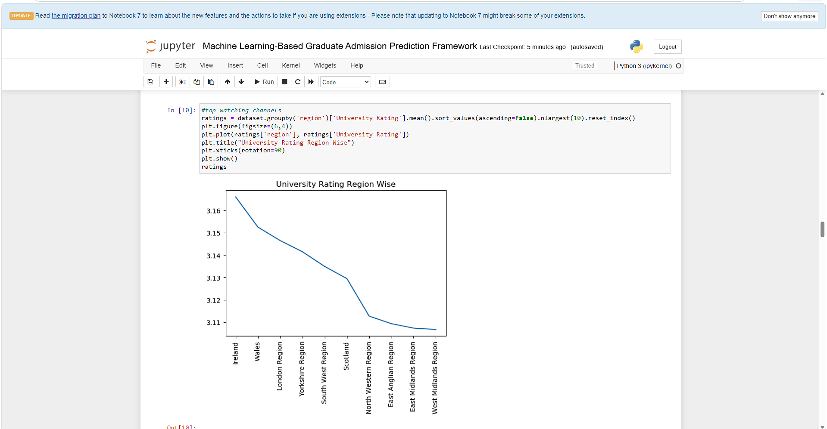
In above screen displaying graph of ratings of different regions universities where x-axis represents Region Name and y-axis represents ratings

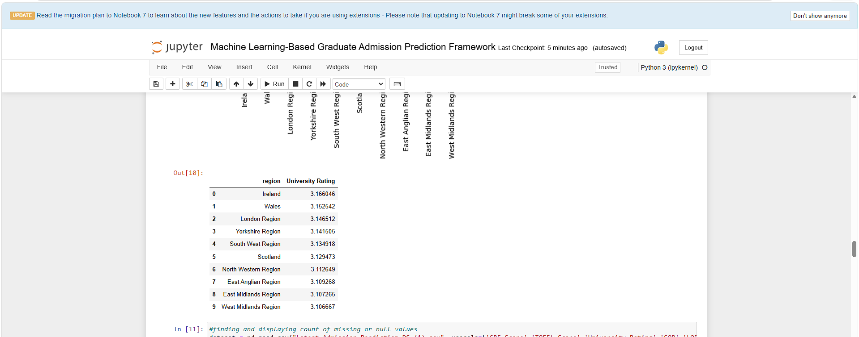
In above screen can see ratings of different regions university
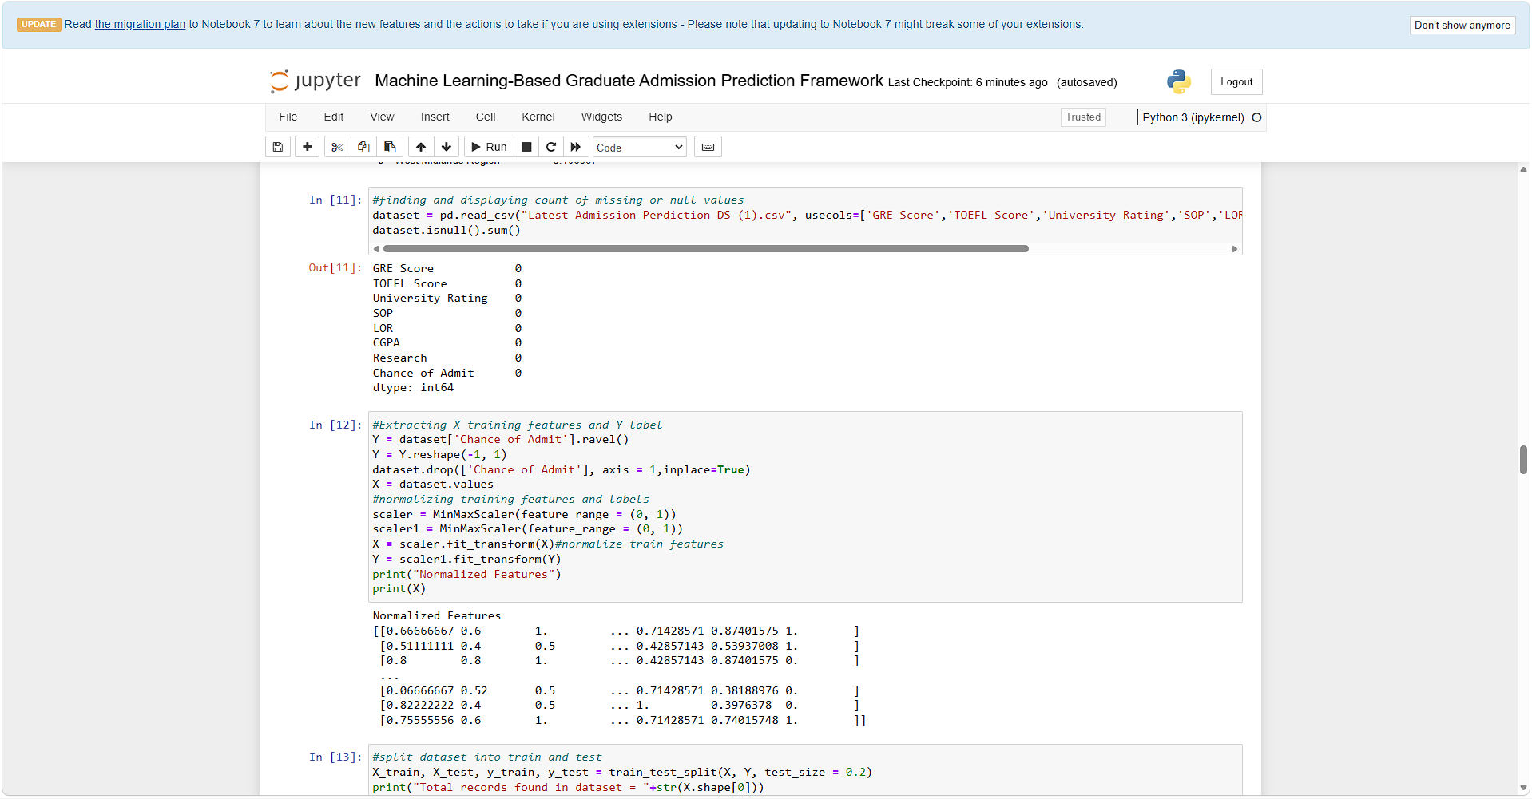
In above screen finding missing values from dataset but it contains 0 missing values and applying data processing and normalization
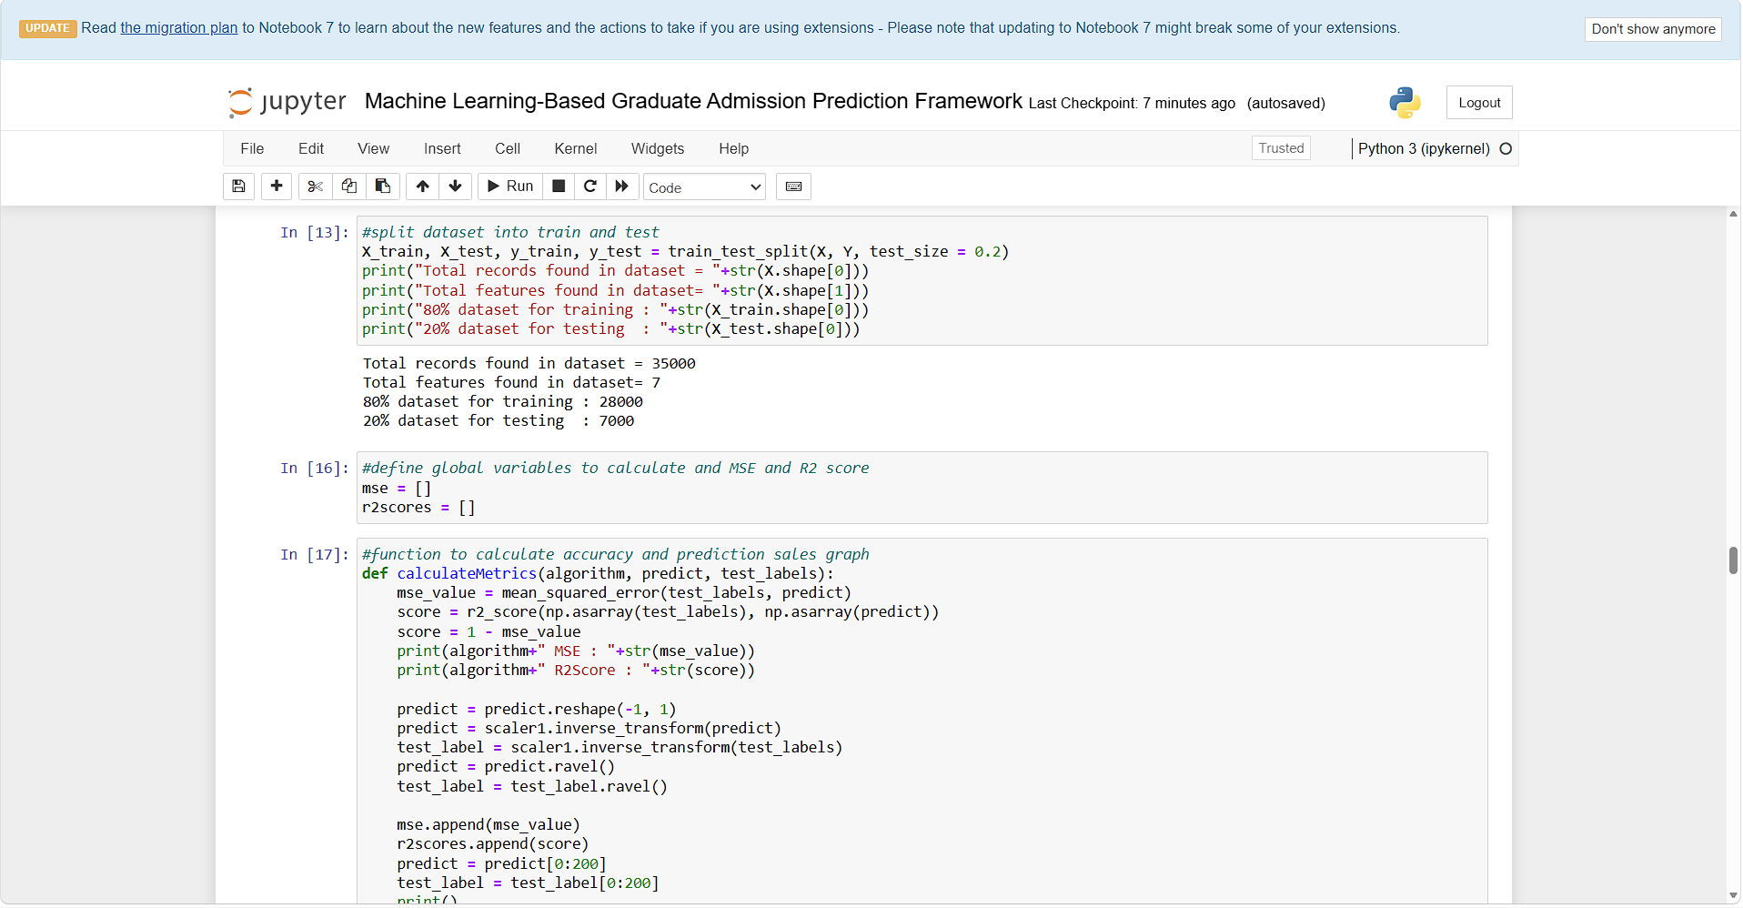
In above screen splitting processed dataset into train and test where application using 80% dataset for training and 20% for testing
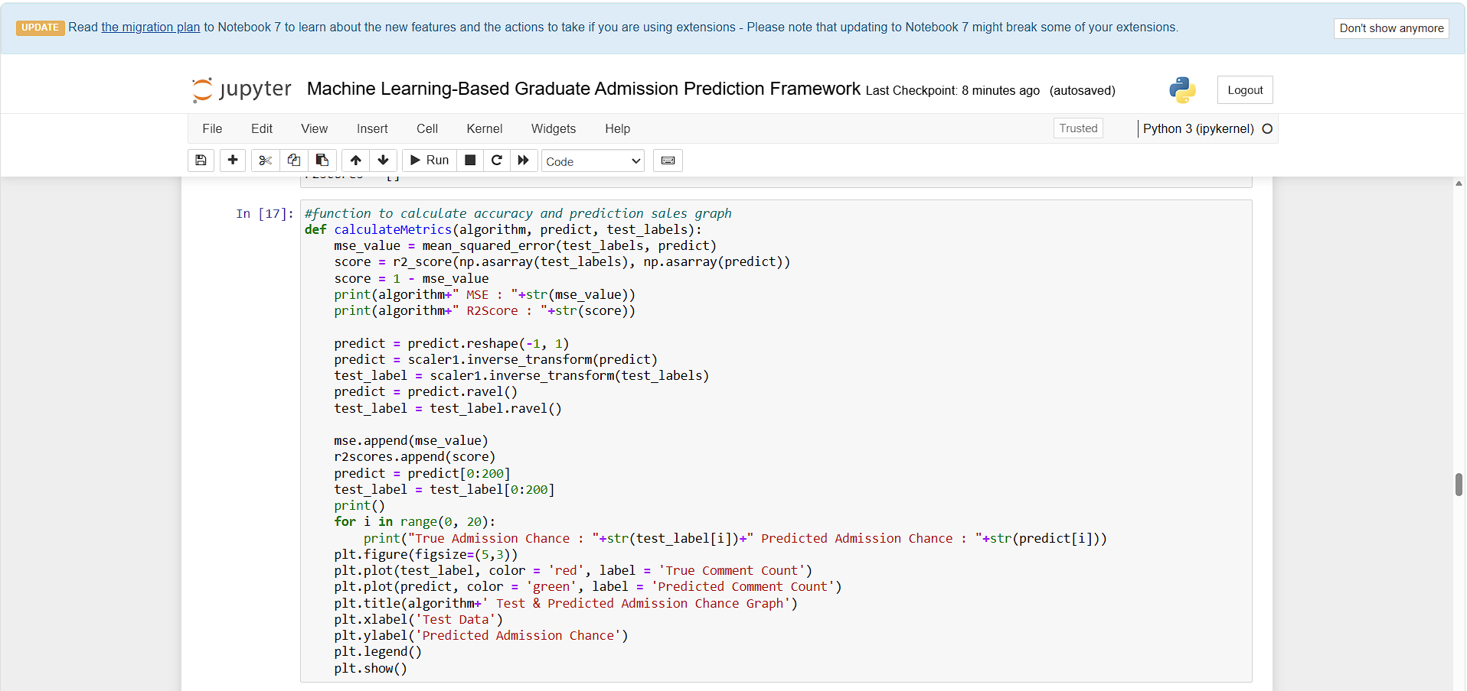
In above screen defining function to calculate MSE and R2SCORE from predicted and test labels
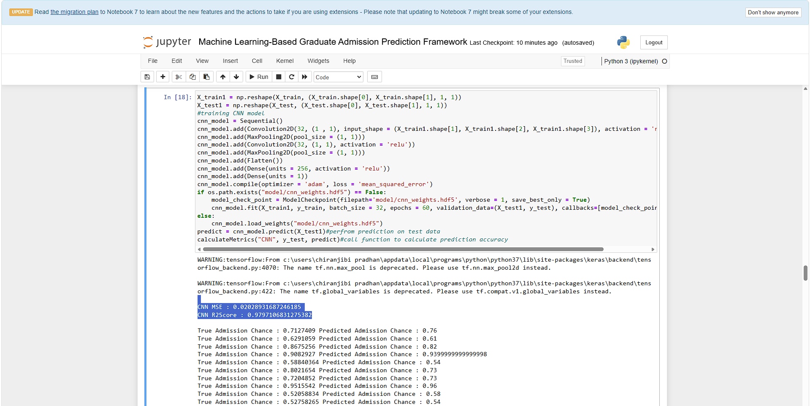
In above screen training CNN algorithm and after executing above block will get output and CNN got 0.018 as the MSE and 98.11 as the R2 score and then can see test data admission percentage and predicted admission percentage which is very close
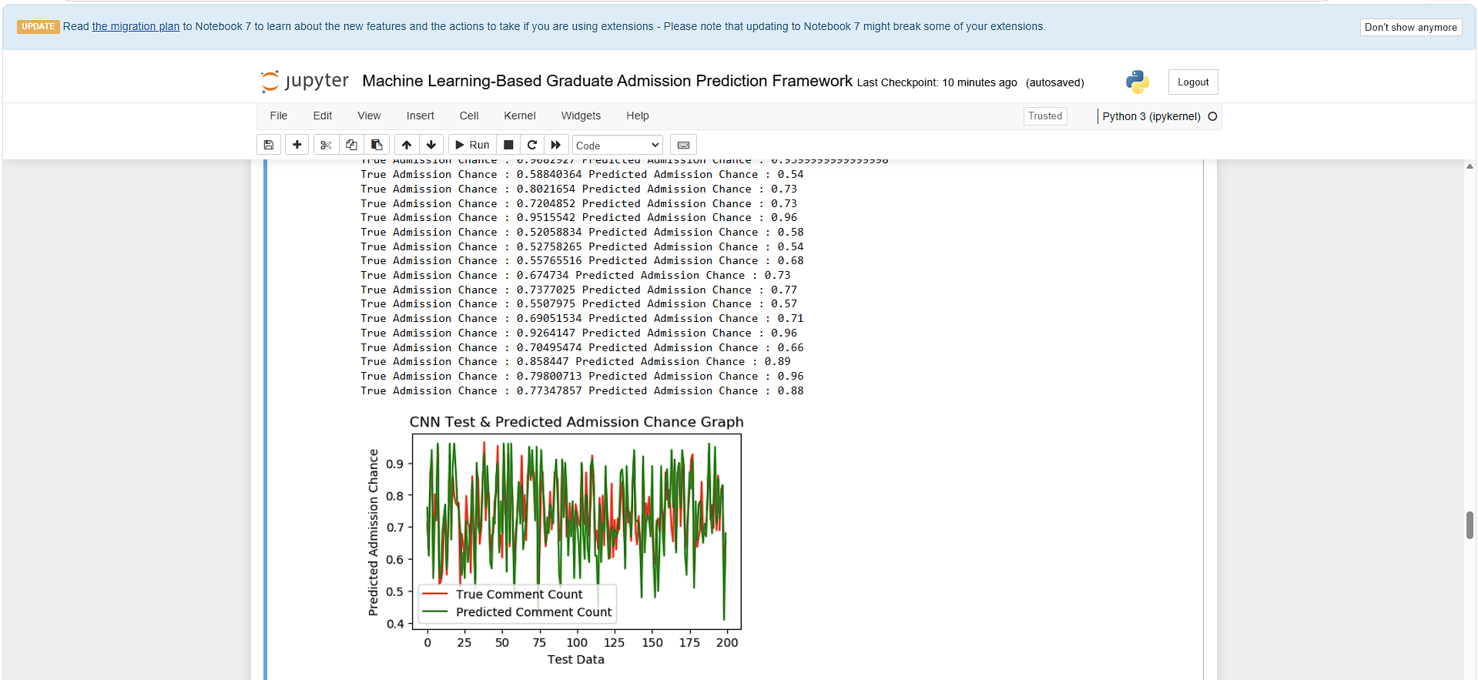
In above CNN prediction graph where x-axis represents Test Data count and y-axis represents admission percentage. Red line represents Test data admission percentage and green line represents predicted admission percentage and can see both lines are fully overlapping with tiny gap so we can say CNN is more accurate in admission percentage prediction
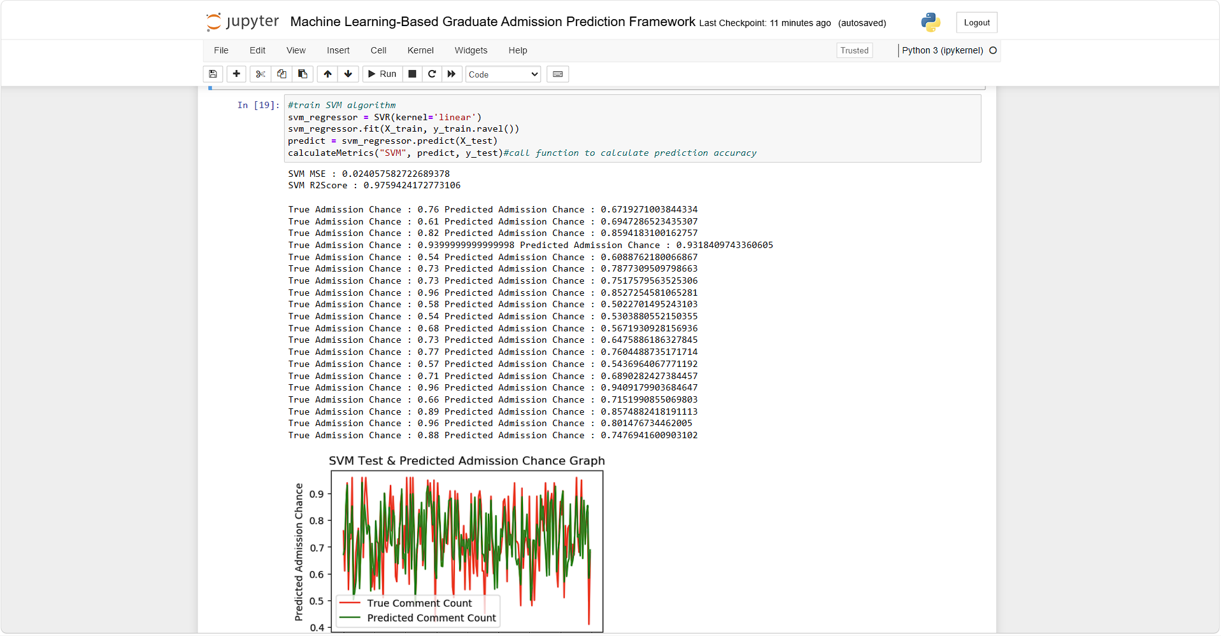
In above screen SVM got 0.97% as the R2SCORE and can see predicted and true percentage and below is the graph and SVM prediction is little un-accurate as both lines has major gap
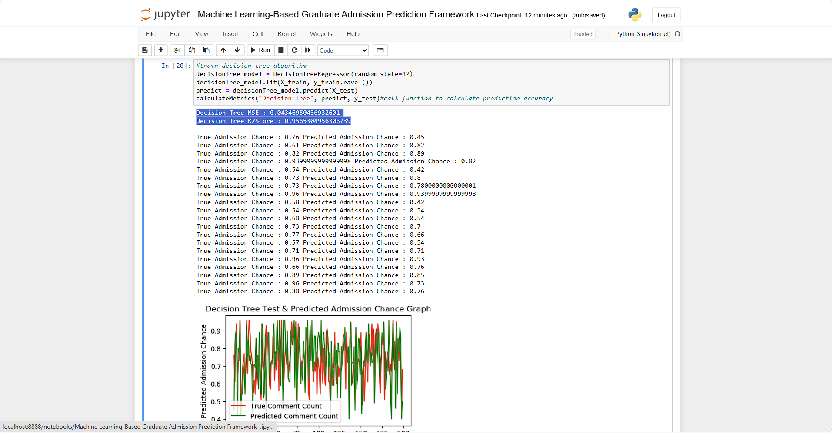
In above screen training decision tree and it got 95% R2SCORE
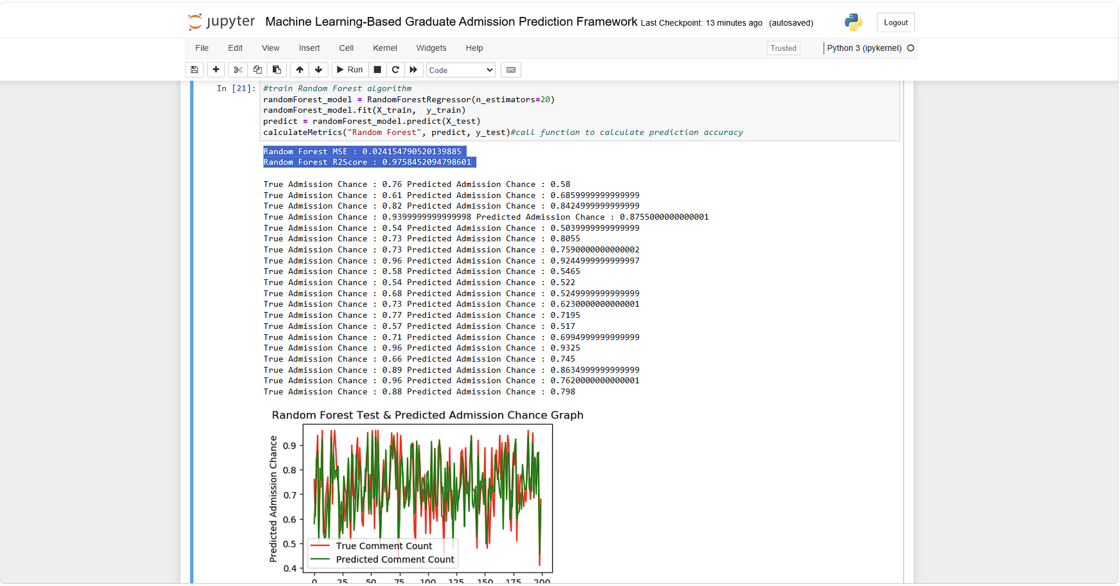
In above screen Random Forest got 97% R2Score
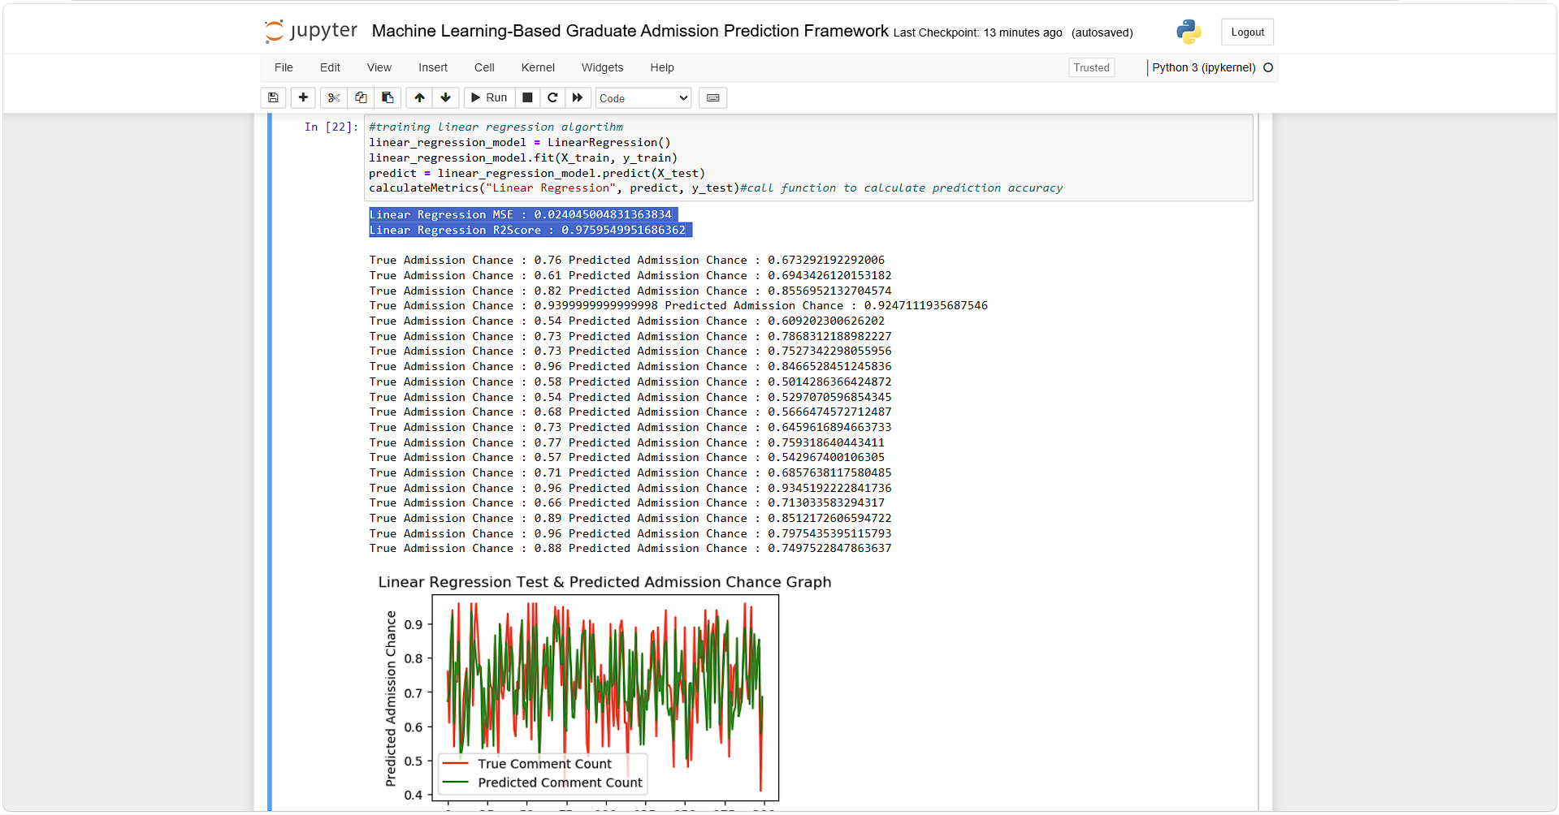
In above screen Linear Regression got 0.97% R2Score
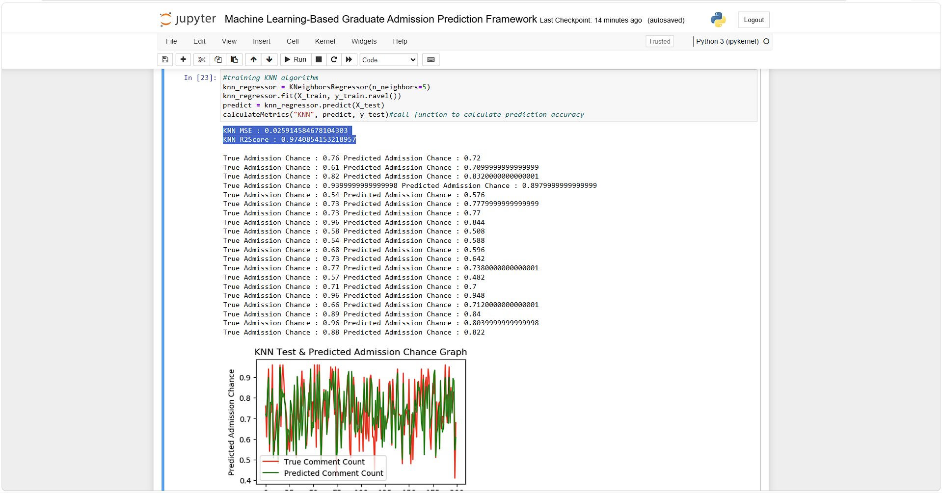
In above screen KNN got 97% R2Score
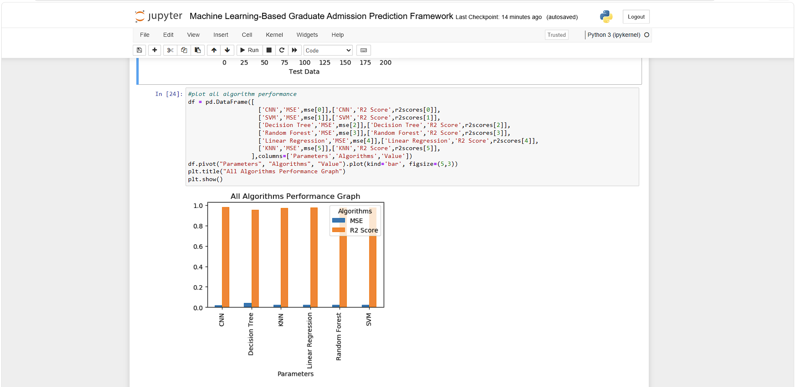
In above screen displaying all algorithm performance graph where x-axis represents algorithm names and y-axis represents MSE and R2score in different color bars and in all algorithm CNN got high R2 score and less MSE score
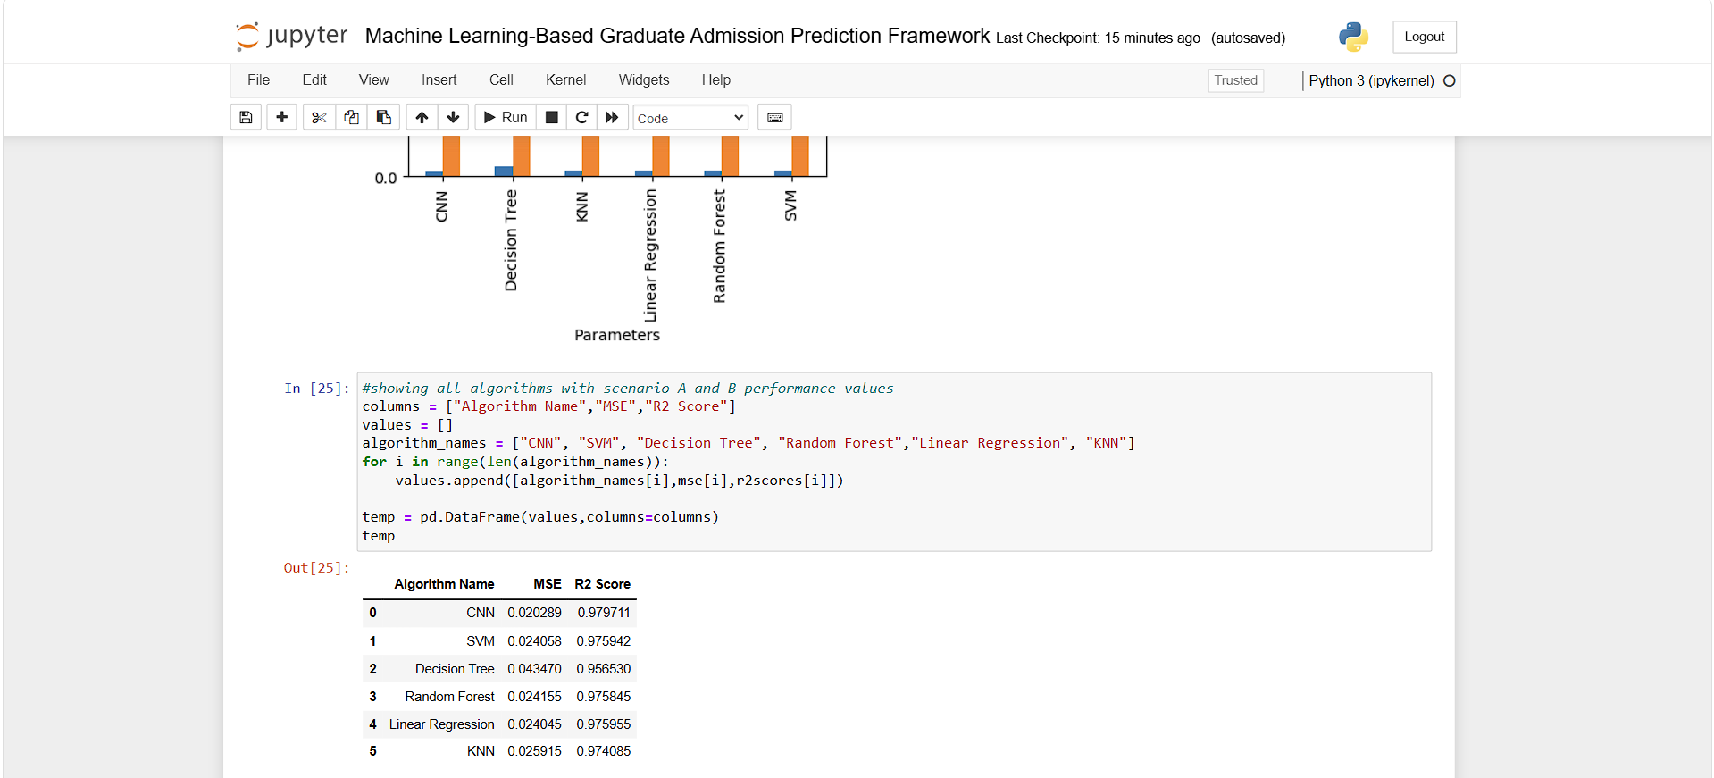
In above screen can see all algorithm performance in tabular format
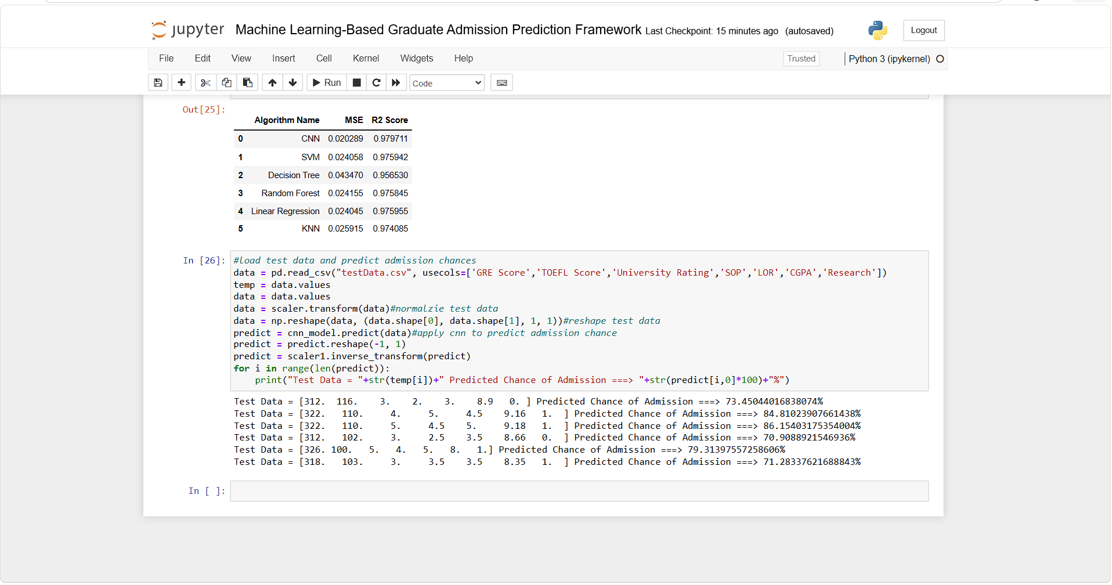
In above screen uploading test data file and then CNN predicting admission percentage and in above output square bracket contains test data and after = symbol can see predicted admission percentage.

