

**SHIPPING INSTRUCTIONS**

**Book the courier collection before providing the sample.**

[**www.tolmar.com.au/Cxbladder/**](http://www.tolmar.com.au/CxBladder/) **or 02 9333-0445 between 9:00am – 5:00pm Mon– Fri**

**Option 1: You received the kit from your doctor or you work for one.**

Once the urine sample has been collected, the kit needs to be activated and time is of the essence. Please go to [www.tolmar.com.au/cxbladder](http://www.tolmar.com.au/cxbladder)/ and process a payment as outlined below. When your payment is completed, DB Schenker will organize the priority collection of your test by courier.

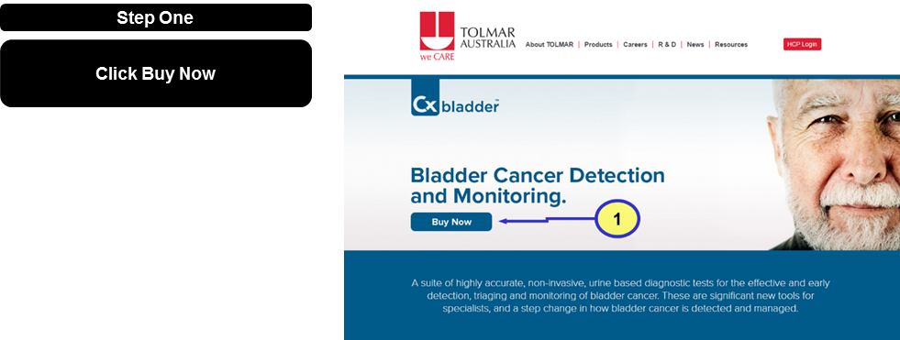

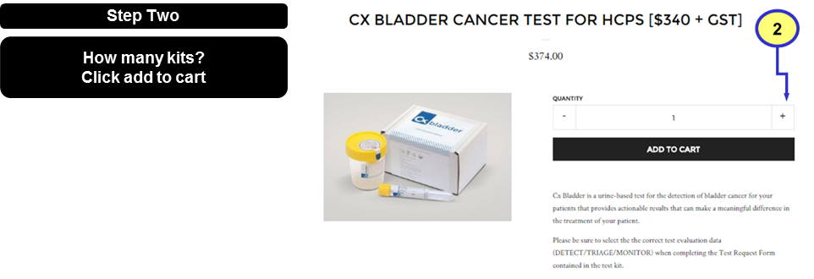

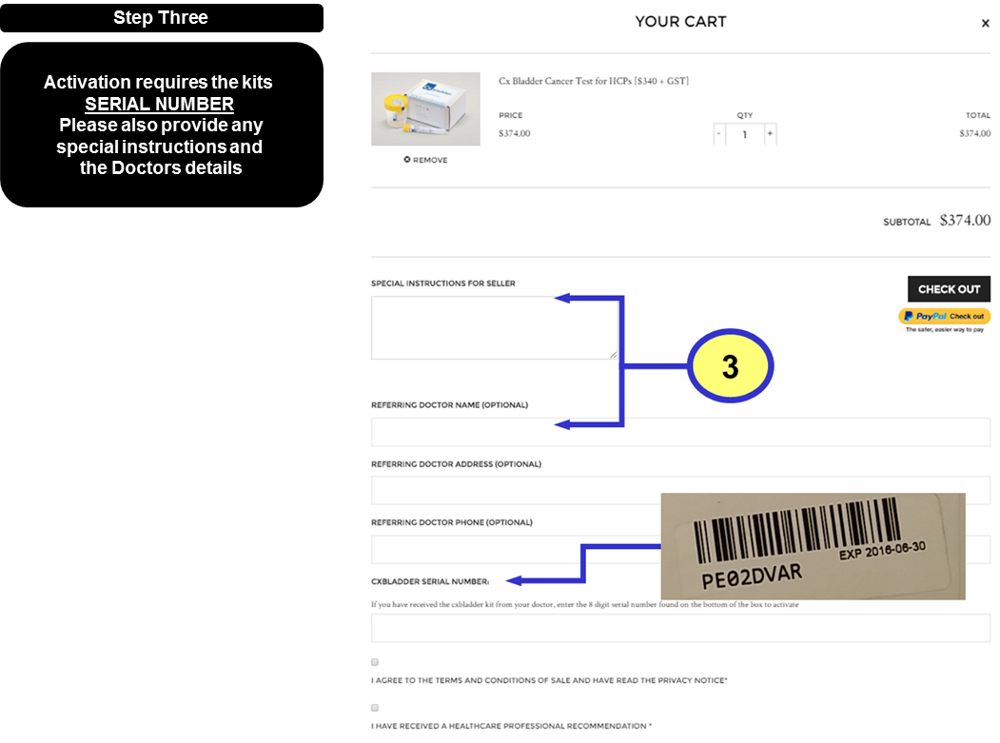

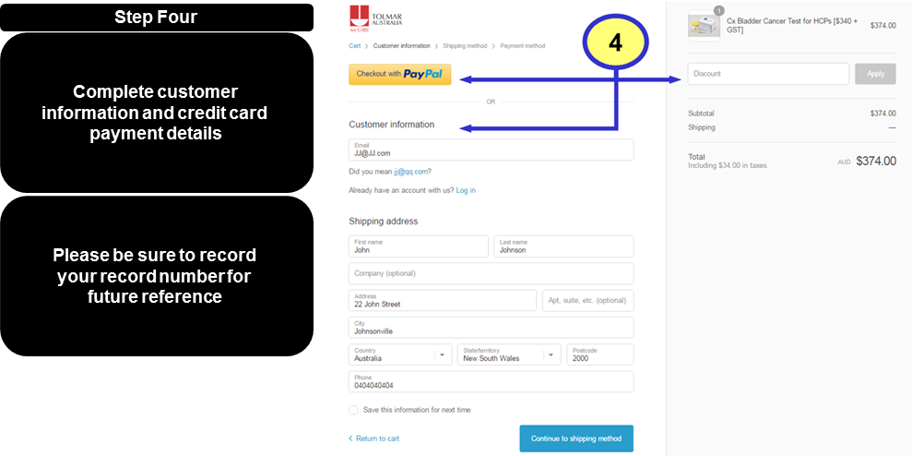

**Replacement test kits will be automatically couriered to you by DB Schenker**

**Option 2: If you purchased the kit online or from our call centre, our logistics partner DB Schenker will have been in contact with you. If you have any questions please contact them on 02 9333 0445.**

**For any medical enquiries please call 1800 TOLMAR (1800 865627)**

**For general product enquiries please call 1300 CXBLADDER (1300 292523)**