8.10.2014
Wallner.: Upload von dem Pflichtenheft auf Github, mittels des Git Bash Programms.
Danner, Heiss:Recherche zur Raspberryprogrammierung

Guide zum Upload von Dateien mittels Git Bash auf Github
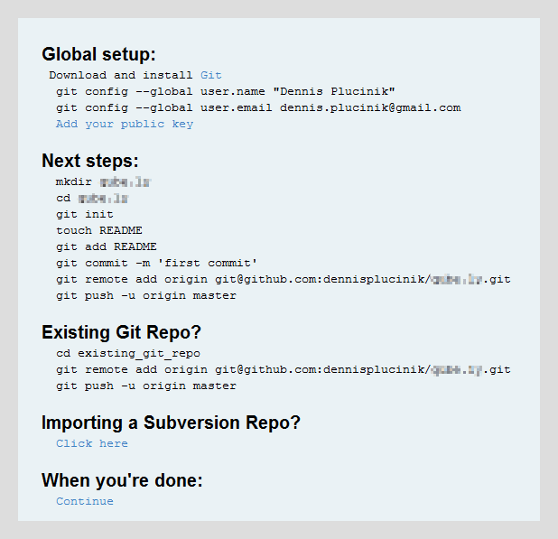
http://www.srf.ch/wissen/digital/billig-pc-raspberry-pi-die-anleitung-fuer-einsteiger

Set up your public key (http://help.github.com/win-set-up-git/#_set_up_ssh_keys)
You will not be able to connect without doing this first.
- set up some kind of config
git config --global user.name "Dennis Plucinik"
git config --global user.email dennis.plucinik@gmail.com
- Create a folder where you want your repository to live
For me (on Windows 7), GitBash opened up on c:\Users\Dennis so I had to navigate a bit to get to the right folder...
cd Dropbox/Clients/Current
Then we follow GitHub's lead
mkdir {projectName}
cd {projectName}
- Initialize repo
git init
If successful, you should see a comment "Initialized empty Git repository in c:/{wherever}/.git/
- Type in a bunch of other stuff
Apparently we are touching, adding, committing, remote adding, and pushing...
touch README
git add README
git commit -m 'first commit'
git remote add origin git@github.com:dennisplucinik/{projectName}.git
git push -u origin master
Hopefully I figure out what all this is for.
At this point I actually couldn't continue because the last command (git push -u ...) gave me an error about my account billing :\ I'll pick up on this when that gets cleared up later.
...the evening passes...
Ok, I checked this morning and my account is authenticated just fine. So after getting README to send up properly, open Explorer and copy your project files from wherever they were previously into the new folder containing your local .git repo. Now try this:
git add .
git commit -m 'adding entire project'
git push -u origin master
You should see your files going up along with a success message. Truthfully by this time I started monkeying around with setting up the EGit plugin in Eclipse. I had some issues with setting ssh paths correctly but I think I'll be writing another post to cover that soon.
UPDATE: Configuring the EGit Plugin for Eclipse.

Pinbelegung:
http://raspberrypiguide.de/

#make persistant
#Ls (zeigt die befehle die wir brauchen)

15.10.2014
Heiss, Wallner: Programmieranfänge mit raspberry (lampe über GPIO Ausgänge ansteuern)
Mit der Sprachsteuerungssoftware Jasper befasst.
Danner: Pflichtenheft Verbesserung und Bericht Erstellung

