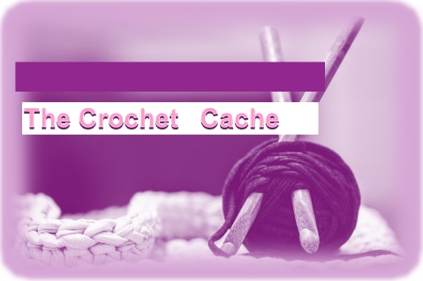**Tipsy Shells Scarf**

**Skill Level:** Easy

**Abbreviations:**

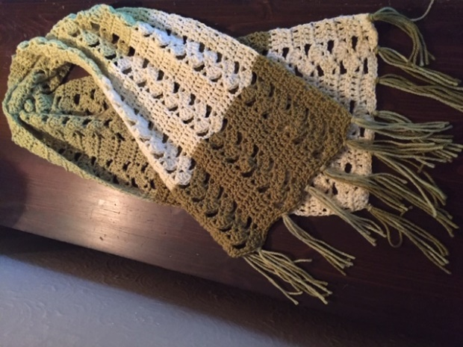Ch – Chain

Sc – Single Crochet

Dc – Double Crochet

St – Stitch

Rep – repeat/repetition

**Materials:**

US H/8 5.0 mm Crochet Hook (or appropriate hook for chosen yarn)

1 ball Caron Cakes – Colorway: Pistachio

**Measurements:** 59” (150 cm) x 12” (31.5 cm) without fringe.

**Instructions:**

Ch 40. (Or a multiple of 12 plus 4, for desired width.)

**Foundation Row:** 1 Sc in 2nd ch from hook and in every ch across row, turn.

**Row 1:** Ch 3 (counts as first dc here and throughout), skip first Sc, 1 dc in each of the next 3 sts, *skip next 2 sts, 5 dc in next st, ch 2, skip next 4 sts, 1 dc in each of next 5 sts, repeat from * across ending last rep with 1 dc in each of last 4 sts, turn.

**Row 2:** Ch 3, skip first dc, 1 dc in each of the next 3 dc, *skip next ch-2 space, 5 dc in first dc of next shell, ch 2, skip next 4 dc of shell, 1 dc in each of the next 5 dc, repeat from * across, ending last rep with 1 dc in each of the next 3 dc, 1 dc in top of turning ch, turn.

Rep row 2 for pattern until desired length is achieved (appx. 59’’/ 150cm). Fasten off. Weave in ends

**Finishing:** Cut 3 pieces of yarn for fringe 12” in length, fold in half and loop through the end of the scarf, starting in a corner. Repeat across the ends of the scarf six more times or until fringe is as thick as desired.