Mandy Powell

Project Description

The purpose for this site is to provide a blog based around a weekly crochet project. I will choose the project, make it myself, and tell the story of my feelings towards the project. The blog will include pictures of the Work In Progress as well as a downloadable PDF of the pattern itself. All patterns will either be of my own creation or free patterns that I have obtained from other crochet sources.

The “home” page will be the blog for the project of the week and the link to the PDF pattern for it. At the bottom of the blog there will be a comment box for users to input their own questions, comments, etc. (see screenshots at the end)

The page titled “cache” will be a database of previous PotWs with pictures of the project and links to the corresponding PDFs. At the top of this page, I want a photo carousel that displays random images of the databased projects.

The page titled “Resources” will be a page of links to my favorite crochet sites, many of which I chose the patterns for the PotWs from.

Navigation buttons for the site are across the top, as well as a search button which can pull key words from the databased PDFs (hopefully, not 100% sure how to do that).

Along the right side of site there is a field to submit the user’s email address and receive a notification via e-mail when a new PotW has been posted.

**Suggested Milestones for the project:**

**Checkpoint 1 –** Basic site layout and navigation functionally working.

**Checkpoint 2 –** Database of PDFs for patterns created and e-mail submission functioning.

**Checkpoint 3 –** Photo carousel, search, and comment box features working.

**Final Submission –** All specified functionality working.

**Screen shots of Mock Up:**

Home Page Cache Page

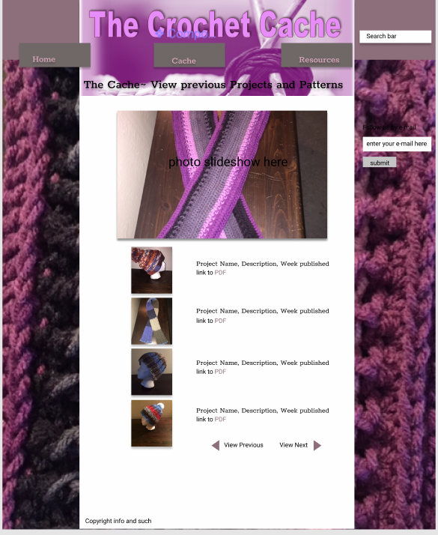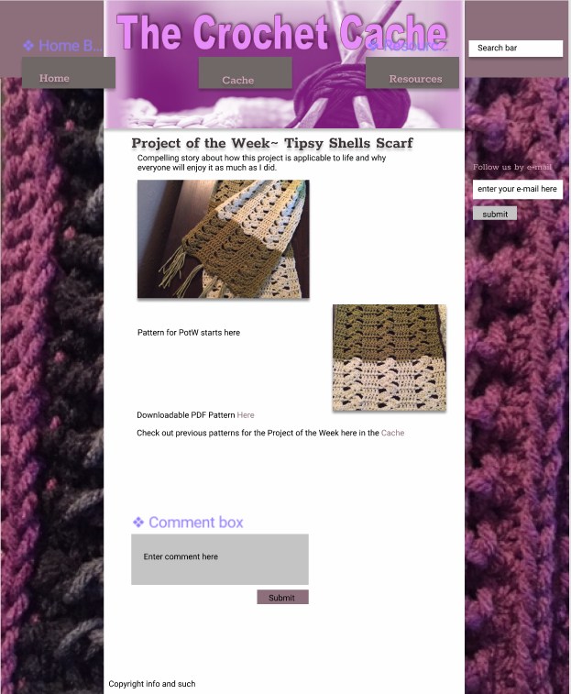

Resource Page

