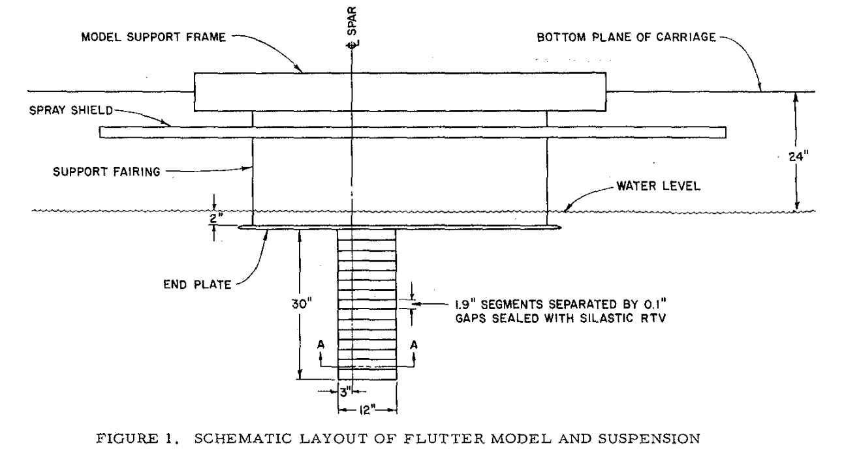
ABRAMSON paper

1. the layout
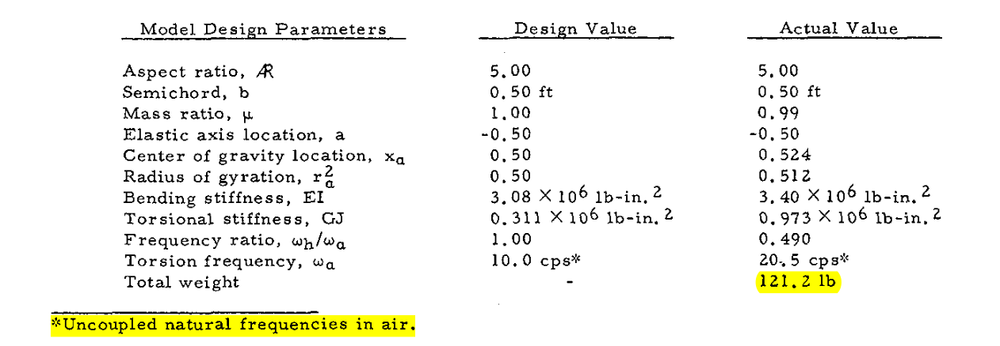
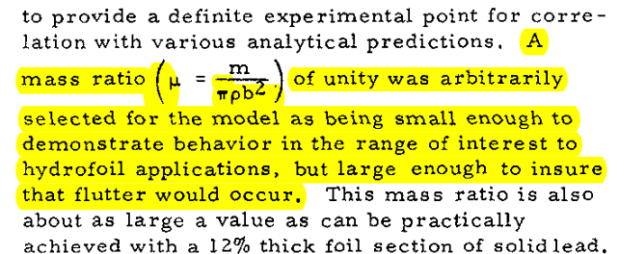

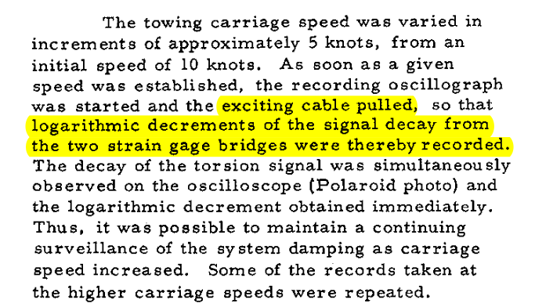
2. the test

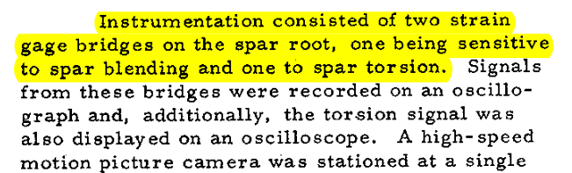

3. the results

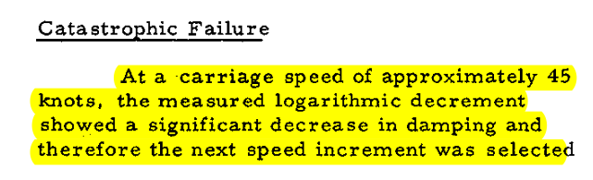
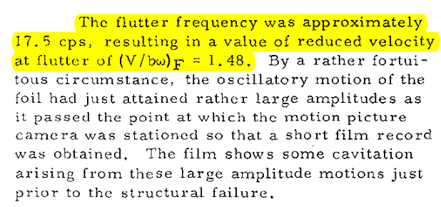

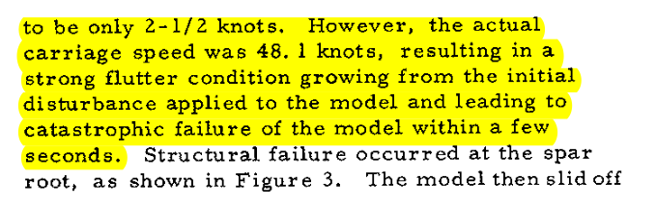

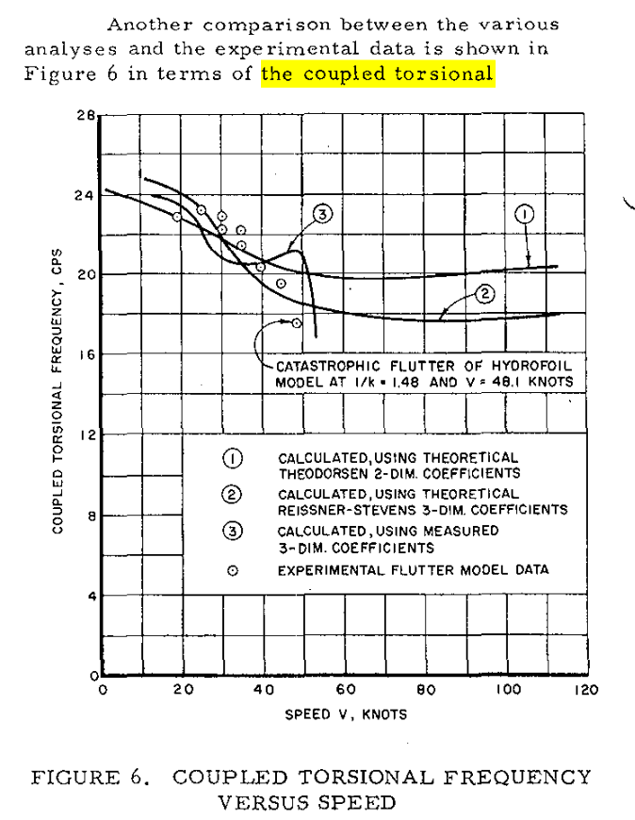

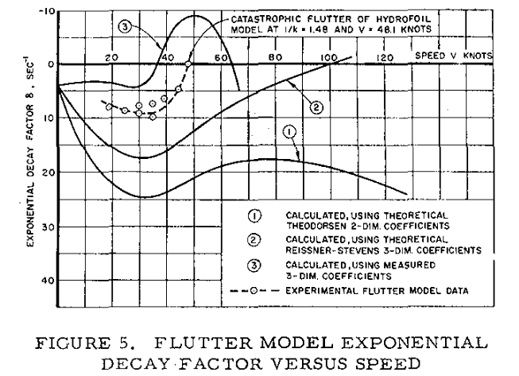

3. my the results

Frequencies comparison (notebook)

Reduced flutter speed comparison (notebook)

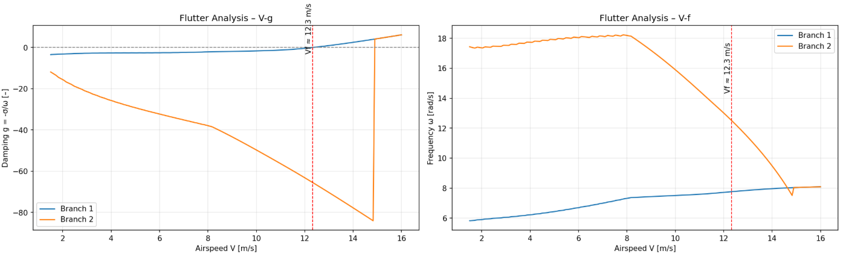

======================================================
VELOCITY STEP 154: V = 14.83 m/s
======================================================

✓ CONVERGED at iteration 3
wet_eigenvalues: [-72.68284972+28.33650534j; 84.0195905 +47.21050132j; -3.96162494+50.47939474j]... (first 5)
k = 3.18745, ω = 47.2105 rad/s, γ = 1.779680, p = 84.019591+47.210501j

======================================================
VELOCITY STEP 155: V = 14.90 m/s
======================================================

✓ CONVERGED at iteration 3
wet_eigenvalues: [-72.75307805+28.10118599j; 84.54555271+46.01480592j; -4.08686022+50.50800585j]... (first 5)
k = 3.38763, ω = 50.5080 rad/s, γ = -0.080915, p = -4.086860+50.508006j

3. increasing lag states

