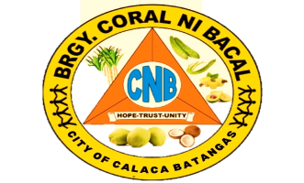 **Republic of the Philippines**

**Province of Batangas**

**City of Calaca**

**BARANGAY CORAL NI BACAL**

**OFFICE OF THE PUNONG BARANGAY**

barangay business permit

Control No.:42120052

OR No.:

**Date Issue:**

**TO WHOM IT MAY CONCERN;**

This is to certify that represent by

resident of and with postal address at Barangay Coral ni Bacal,

Calaca City, Batangas has applied for a business permit in this barangay.

This certifies further that he/she completed all the necessary requirement assigned by this barangay and therefore deserves this **BARANGAY BUSINESS PERMIT**.

Issued upon the request of Mr./ Mrs./ Ms. for whatever legal purposes it may serve, with CTC No. issued on at City of Calaca Batangas.

**IN WITNESS WHEREOF**, I have hereunto set may hand this day of

, 2024 at Barangay Coral ni Bacal, City of Calaca, Batangas .

**HON. JOHN RYAN M. CABAÑEROS**

*Punong Barangay*

*Note: Not Valid without official Seal*