AI Boost, AI Drag
A colleague described how his firm used to get an urgent message to Iran before email existed. A project director wrote it by hand, someone typed it, it flew for three days, reached the firm's Iran office, went by boat to the shore, and came back as a spoken answer someone wrote down on the other end.
[YOUR DETAIL HERE: confirm the decade and whether this was your colleague's own project, so the anecdote is exact]
The typing, the flight, the boat, all of it was also, without anyone planning it that way, how a junior person in that office learned the job: doing the routine part of the work under someone more senior, over and over, until judgment formed. AI is now absorbing that same routine layer inside engineering and consulting firms, and the training courses firms are buying to close the resulting skills gap are not doing what firms think they are doing.
A 2026 survey of enterprise leaders by DataCamp, run with YouGov, found 23 percent of respondents say video based courses make it hard to apply what was taught to real work, and 24 percent point to a lack of hands on practice as the reason training does not stick (DataCamp, 2026 State of Data and AI Literacy Report). A field study inside one large firm found the same pattern from the other direction: 713,564 prompts from nearly 4,000 employees across 15 functional areas over eight months in 2025 showed that sophisticated AI use tracked closely with seniority, and formal training produced no lasting gain for anyone who went through it (arXiv, Sophistication in GenAI Use: Field Evidence from a Large Firm).
Both results point to the same explanation. Cognitive apprenticeship research has argued for decades that expert judgment, the kind that lets someone recognize which detail in a report actually matters, forms through observation, guided practice, and increasing responsibility on real problems, not through explicit instruction on its own (EduTech Wiki, University of Geneva, on cognitive apprenticeship theory). A course can hand someone the vocabulary. It cannot hand someone the thousand small corrections that used to happen automatically, because those corrections were built into doing the routine work under a senior person's eye.
Two Microsoft engineering leaders, Mark Russinovich and Scott Hanselman, gave this effect a name worth borrowing: an AI boost for senior engineers, whose output multiplies because they can steer and verify what the model produces, and an AI drag on junior engineers, who cannot yet do either (IBTimes UK, on Russinovich and Hanselman). Bryan Hancock and Charlotte Seiler put a sharper point on why that gap exists: automating research, documentation, and preliminary analysis "strips away the very activities through which young employees built instincts" (same source).
That effect now shows up in real hiring data, not just in survey answers. Stanford's Digital Economy Lab, tracking real time payroll data through its Canaries Dashboard, found that employment for workers 22 to 25 in the most AI exposed occupations sat 19 percent below where it would be if it had kept pace with less exposed peers of the same age, as of June 2026, up from a 15 percent gap a year earlier. Employment in that group fell about 11 percent between November 2022 and June 2026 in the most exposed roles, while it grew about 10 percent in the least exposed ones over the same period (Stanford Digital Economy Lab, Canaries Dashboard, August 2026). The adjustment is happening mostly through firms hiring fewer young people, not through letting go of the ones already in the door.
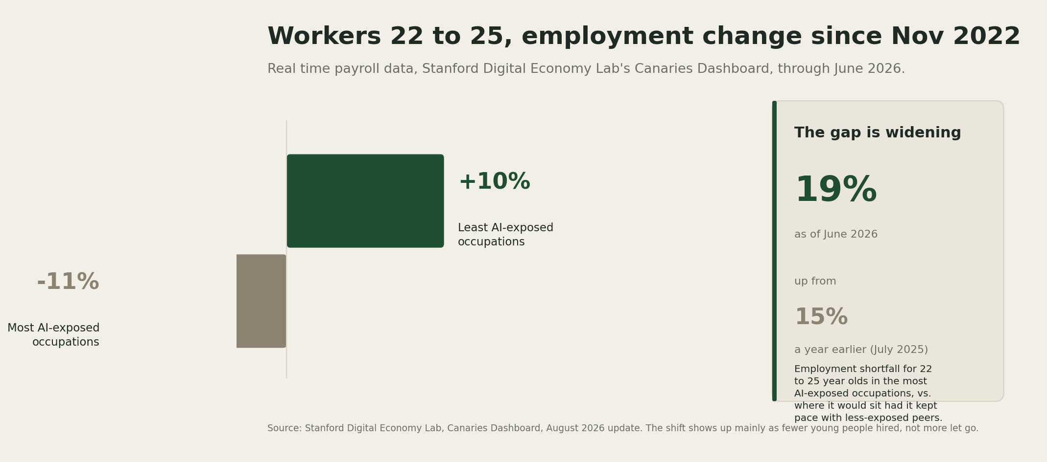
Workers 22 to 25 in AI-exposed occupations are falling behind their peers. Employment in the most AI-exposed roles fell 11 percent since November 2022, while it grew 10 percent in the least-exposed roles. The overall gap widened from 15 percent to 19 percent in the year to June 2026.
The fix does not look like more training content. UC Santa Barbara professor Matt Kinder frames the actual stakes plainly: firms that let AI erase what he calls the bottom rung of the career ladder, without replacing what that rung taught, will run out of people able to do the judgment work the rung used to produce, likely within three to five years (same source). What is already being tested looks structural rather than educational: redesign entry level roles around interrogating and verifying AI output instead of producing first drafts, reinvest the time AI frees up into scheduled coaching rather than banking it as margin, and treat a junior's early mistakes on real, supervised work as the training itself, not as a cost to eliminate (Senior Executive, on rebuilding the leadership pipeline under AI).
Judgment gets built through supervised practice on real stakes. Most AI training budgets right now are pointed at a course instead.
I will put a date on this. Stanford's Canaries Dashboard updates on real payroll data, so this is checkable: by its next major update after June 2027, the 19 percent employment gap for 22 to 25 year olds in AI exposed occupations will not have narrowed, because the fix that would narrow it, redesigning junior roles around supervised verification rather than training completion, is not yet visible at any real scale. Confidence: medium, since the gap has widened at each check so far and nothing points to a reversal yet.
What I am watching next is whether any large engineering or consulting firm publishes something more specific than a training completion number: a description of what its junior staff are actually held responsible for now, and whether that description has shifted toward judgment and verification, or still reads like a shorter version of the same task list AI already does faster.

