AI Adoption, Two Years In
Two years ago, 32 people at the law firm Ropes & Gray sent a few hundred AI prompts a month. Today, close to 2,200 people at that same firm send more than 282,000 prompts a month, each user roughly three times as active as a year earlier (Breitbart, citing Wall Street Journal reporting). Across the street from law, Citigroup has crossed 80 percent employee AI tool adoption, logged 42 million AI interactions since its platform launched, and now has more than 10,000 engineers using AI tools daily (Marketscale, citing the same reporting).
Neither number came from a mandate arriving on a Monday. Both came from two years of people convincing other people, one workflow at a time. That timeline is worth sitting with, because it answers a question this newsletter gets asked often: is a firm behind if its own AI seats still look quiet two years in? The honest answer, based on the two clearest growth curves published so far, is that two years may be closer to the middle of the curve than the end of it.

The claim
David Maister spent thirty years telling professional service firms the same thing, laid out in his profitability formula: margin, multiplied by rate, multiplied by utilization, multiplied by leverage. Utilization sits inside that formula, and Maister's point was never that more of it is automatically good. Once utilization already covers a person's cost to the firm, more hours logged stop adding profit on their own. The only lever left is the value each hour produces, the rate the firm can charge and the leverage of who is doing the work.
Firms buying AI seats are running the identical trade without having named it yet. A seat that gets opened every day is a fact about activity. A deliverable that got faster, cleaner, or cheaper to produce is a fact about value. They are not the same fact, and the growth curves at Ropes & Gray and Citigroup, real as they are, only tell us about the first one.

What the data actually shows
Start with what is genuinely strong here. The Ropes & Gray and Citigroup numbers are primary, company reported figures, not survey estimates, and they describe the same shape: adoption climbing for two years through internal champions and daily habit rather than a single rollout event. Ropes & Gray runs a network of more than 60 champions inside the firm. Citigroup's number, more than 10,000 engineers using AI tools daily, did not happen the week the platform launched. It happened after 42 million logged interactions accumulated the habit.
Microsoft's 2026 Work Trend Index puts a structure around why that takes so long. It splits AI users into three groups rather than a single adoption percentage: about 19 percent are what the report calls "Frontier" users, with both strong personal skill and real organizational support behind them. Another 31 percent are held back by what the report calls unclaimed capacity or organizational blockers, meaning the will is often there and the support is not. The remaining half sit in an "emergent zone," still finding their footing (Microsoft WorkLab). The same report finds that organizational factors, culture, manager support, and how work gets structured, account for more than twice the measured impact of individual effort alone.
Put the three findings side by side and a picture forms. Two firms with genuinely strong adoption took two years to get there. Microsoft's own research says half of all AI users, across every firm, are still in the middle of that same climb. And the thing that predicts whether someone reaches the frontier group is mostly organizational, not personal effort. None of that describes a technology that firms are behind on. It describes a technology that takes about two years to become a habit, when the habit is actively cultivated.

The other half of the question
Everything above is a usage story. None of it yet answers whether the extra usage produced better work, and that gap is where this piece actually starts.
IntuitionLabs documented one detailed account of a developer, Harika Yenuga, who burned through 200,000 tokens in twenty minutes on a single session (IntuitionLabs). The interesting part of her story is not the size of that number. It is what she did next: she looked closely at what the task actually needed, rebuilt her workflow around it, and cut her own consumption by 70 percent while, by her own account, getting the same or better result. That is a single case, not a statistic, but it is a useful illustration of the distinction this piece keeps drawing. Two people can generate an identical token count in a week. One of them has checked whether that volume bought anything. The other has not, and from outside, a login dashboard cannot tell them apart.
Cross how often a seat gets used against whether anyone has checked its output against an outcome, and four situations fall out, none of them inherently a mistake.
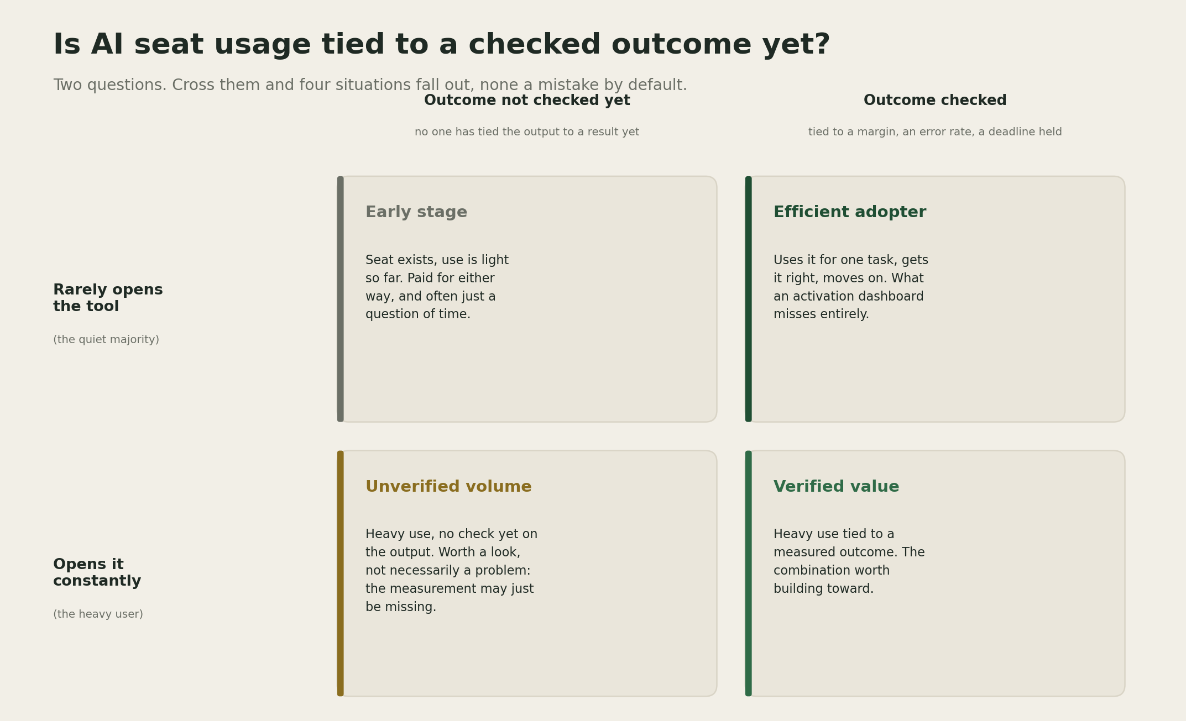
Is AI seat usage tied to a checked outcome yet? A 2x2 matrix crossing how often a seat gets opened against whether its output has been checked against an outcome: early stage, efficient adopter, unverified volume, and verified value.
Economist Charles Goodhart made the underlying point in 1975, writing about monetary policy: a statistical regularity tends to collapse once it becomes a target of control (Goodhart's law). The line most people actually quote, "when a measure becomes a target, it ceases to be a good measure," was coined later, by the anthropologist Marilyn Strathern in 1997, not by Goodhart himself, but the mechanism is his. A firm that adopts login count or token volume as its success metric will, with very little effort, get more logins and more tokens. Nothing about that guarantees it also gets a lower error rate, a faster deliverable, or a healthier margin. That is not a criticism of the firms currently measuring only activity. Most firms, two years into a technology this new, are exactly where you would expect them to be: watching the number the billing system already hands them, because the number that would actually answer the question does not yet exist in their systems.

The benefit case
A firm sitting on a growth curve like Ropes & Gray's or Citigroup's has something most competitors do not: a real, internal record of which tasks its heaviest users gravitated toward, and what its champions were actually telling people in those 60-plus conversations. That is close to free research into what the tool is good for inside that specific firm's own work, well ahead of any generic vendor case study. The Yenuga example points at the same opportunity at individual scale. A firm that asks its own heaviest users what they changed about their workflow, rather than only asking how much they used, gets a shortcut to the efficient adopter quadrant instead of waiting to discover it by accident.

The risk case
I hold the following loosely, because the right amount of measurement depends on how mature a firm's own rollout already is. Building a system that ties a specific AI assisted task to a specific deliverable's error rate or margin takes real infrastructure, and most firms have not built it yet, which is a reasonable place to be this early. Build that infrastructure too heavily or too soon, ahead of a rollout that is still finding its habits, and a firm can slow down adoption that would have found its own value faster left alone. There is also a subtler risk in the other direction. A firm that reads Goodhart's law as a reason to distrust usage data entirely will throw away a genuinely useful leading signal, the Ropes & Gray and Citigroup numbers included, while it waits for a perfect outcome metric that may take years to build. What I trust without much reservation is the underlying shape of Maister's argument, tested across decades of professional service firms: a metric that stops at activity, whether that activity is billable hours or token counts, keeps getting more activity, and that fact alone does not tell a partner anything about whether the work improved.

The throughline
A rising number of logins or tokens is a fact about activity, and a firm still has to check separately whether it is also a fact about better work.

A prediction
Prediction (2026-08-01): By the end of 2027, at least one major professional services or AEC firm will publicly report an AI usage metric tied to project margin or error rate, alongside its login or token numbers rather than instead of them. Confidence: medium.

What I am watching next
Whether more firms publish a growth curve like Ropes & Gray's or Citigroup's, since two data points is a pattern worth watching, not yet a rule. I am also watching whether any firm publishes what happened to a margin or error rate number over the same two year window, which would be the first real evidence connecting the usage curve to the value curve rather than assuming the two move together. Right now the usage story is easy to find because the billing system produces it automatically. The value story almost never gets published alongside it, which likely says more about how early this measurement discipline still is than about how much any single firm has accomplished.

