AI Seats and the Utilization Problem
Half the staff at a typical AEC or consulting firm never open the AI tool they were given. A smaller group treats the monthly token quota like a scoreboard. Neither number tells a partner whether the work got better.

The claim
David Maister spent thirty years telling professional service firms the same thing: once utilization covers its cost, more hours logged stop making a firm more profitable, and the only lever left is the value each hour produces. Firms buying AI seats are running the identical trade without knowing it. A seat that gets opened every day is not the same fact as a deliverable that got better, and most firms are only tracking the one that is easy to count.

What happened
Microsoft and LinkedIn's 2024 Work Trend Index found that 78 percent of AI users bring their own AI tools to work rather than wait for an employer rollout, rising to 85 percent among Gen Z employees (Microsoft WorkLab). The tool shows up in a person's workflow long before it shows up on a firm's licensing spreadsheet. By the time the firm buys an official seat, adoption already looks uneven: some people have been running the tool for a year, others are opening it for the first time because IT sent a reminder email.
The opposite pattern shows up further along the same curve. IntuitionLabs tracked a developer named Harika Yenuga who burned through 200,000 tokens in twenty minutes on a single session, then rebuilt her workflow and cut that consumption by 70 percent once she looked at what the task actually needed (IntuitionLabs). One group has not started. The other started, found the tool genuinely useful, and kept scaling the same habit past the point where more tokens bought more value.

Why it matters to a firm like yours
Treat the firm as a machine: inputs, people, a feedback loop, outputs. The input is a seat, priced the same whether it gets opened once a quarter or runs all day. Maister's own formula for a professional firm's profit runs on margin, rate, utilization, and leverage, and his argument was never that more utilization is automatically good. Past a certain point, activation just tells a partner that people are busy. It does not tell them the firm earns more per hour of that busyness. An AI seat inherits the same ceiling. A high activation number says the tool got opened. Nothing in that number says whether the output needed less editing before a partner could send it, or whether the project shipped with fewer errors. [YOUR DETAIL HERE]
Economist Charles Goodhart made the underlying point in 1975, writing about monetary policy: a statistical regularity tends to collapse once it becomes a target of control (Goodhart's law). The line everyone actually quotes, "when a measure becomes a target, it ceases to be a good measure," was coined later by the anthropologist Marilyn Strathern, not by Goodhart himself, but the mechanism is his. Track seat logins as the success metric, and a firm will get more seat logins. It has no built in reason to also get better work.
Cross how often a seat gets opened against whether anyone has checked its output against an outcome, and four situations fall out.
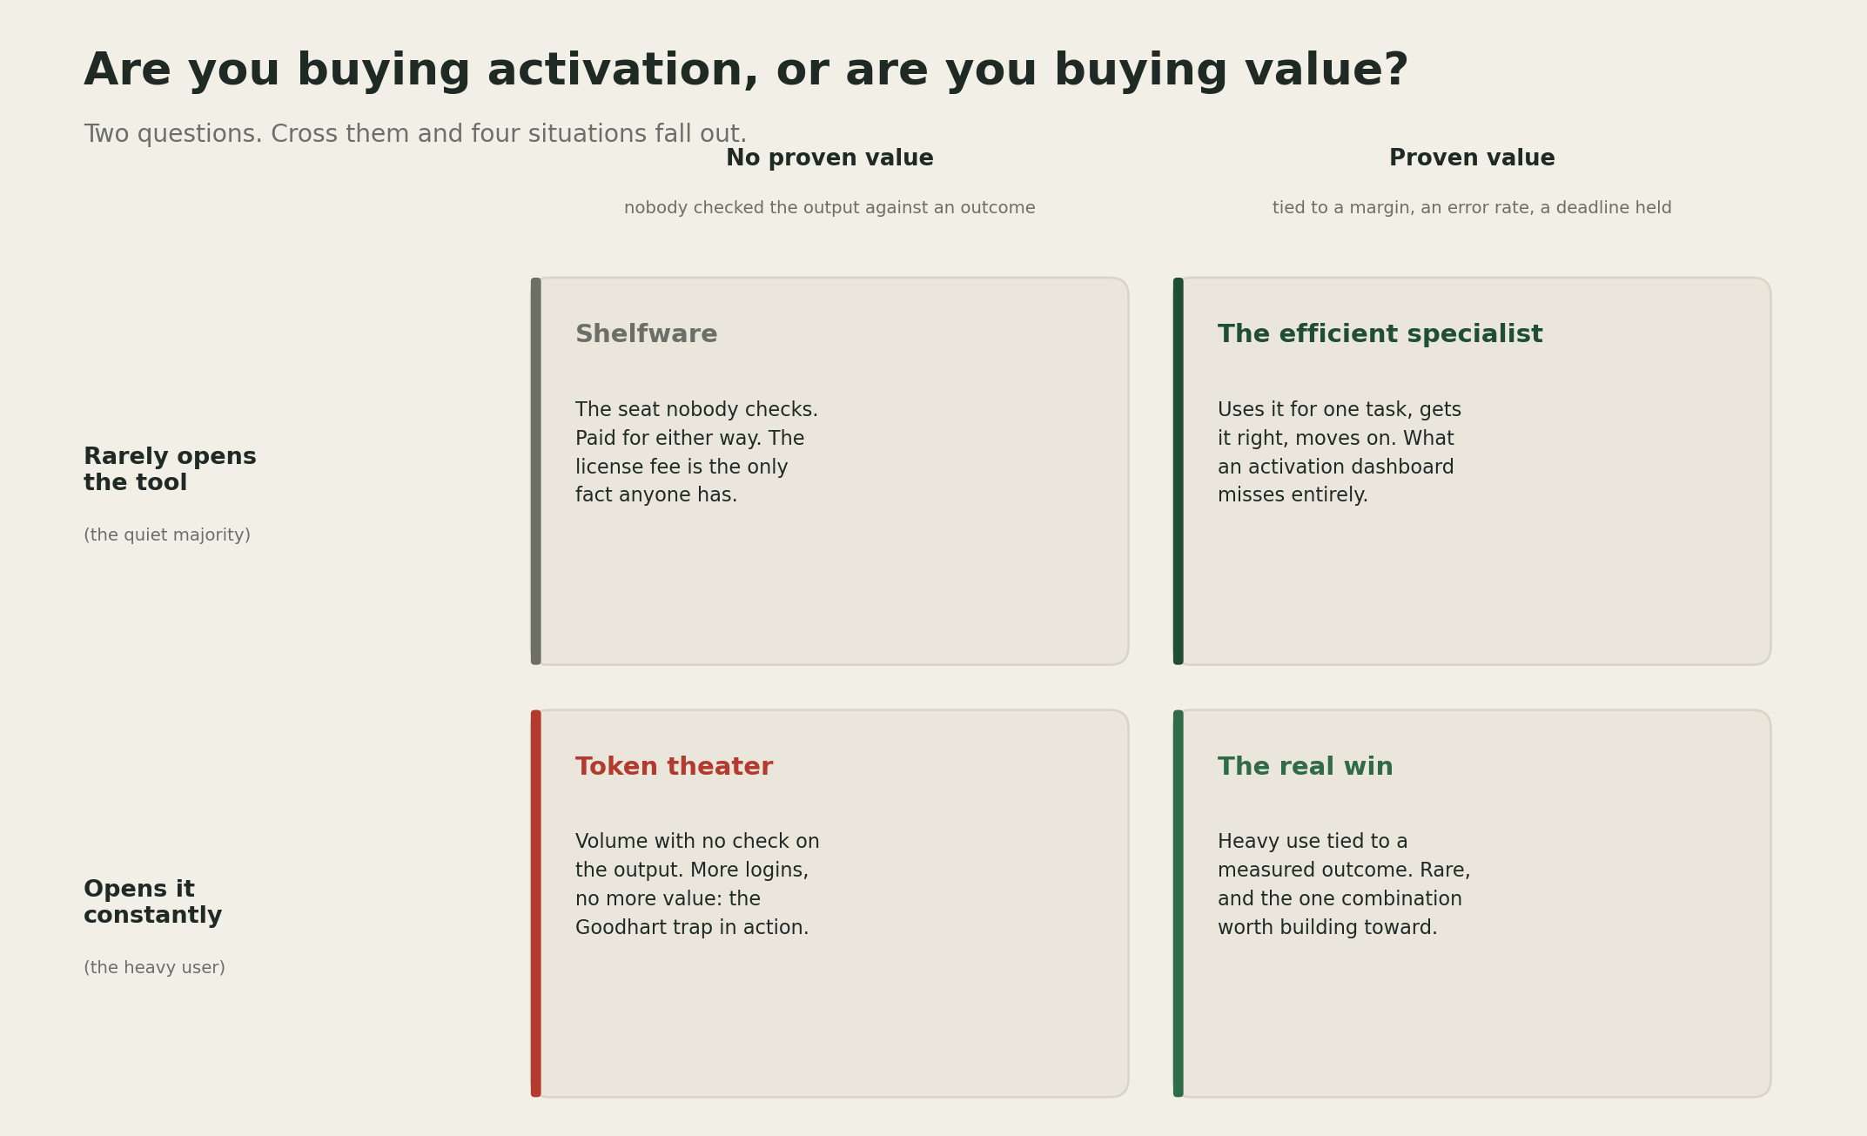
Are you buying activation, or are you buying value? A 2x2 matrix crossing how often a seat gets opened against whether its output has been checked against an outcome: shelfware, the efficient specialist, token theater, and the real win.
The two boxes that get discussed are the two boxes that create no confusion: shelfware is a budget conversation, and the real win is the case everyone is chasing. The two that actually decide how a firm spends its year are the quiet ones either side, the specialist whose light touch already works and never shows up as a success story, and the token theater box, which looks identical to the real win on every dashboard that only counts logins.

The benefit case
A firm that measures the outcome instead of the login gets two different populations to learn from. The quiet majority who never opened the tool can be shown, concretely, what a Yenuga level user found worth the effort, rather than told in the abstract that AI helps. The heavy users stop being a cost line to manage down. They become a source of technique instead, since someone who ran a workflow enough times to cut their own token spend by 70 percent has already done the optimization work a firm would otherwise pay a consultant to redo.

The risk case
I hold this loosely, because the right amount of measurement depends on how mature the rollout already is. Watching outcomes instead of logins takes real infrastructure: a way to tie a specific AI assisted task to a specific deliverable's error rate or margin, and most firms have not built that yet. Build it too early or too heavily, and a firm can slow down a rollout that would have found its own value faster left alone. What I trust without much reservation is Maister's underlying claim, tested across decades of professional service firms: a metric that stops at activity, whether that activity is billable hours or token counts, keeps getting more activity and nothing else.

The throughline
An opened seat and a better deliverable are two separate facts, and a firm that only tracks the first one is pricing AI the same way it priced the billable hour.

A prediction
Prediction (2026-08-01): By the end of 2027, at least one major AEC or consulting firm will publicly report an AI adoption metric tied to project margin or rework rate, rather than seat activation or token volume alone. Confidence: medium.

What I am watching next
Whether any vendor sells a report built around hours saved or errors avoided instead of logins and tokens. That is currently the easiest number for Microsoft, Anthropic, and OpenAI to produce from their own billing systems, not necessarily the most useful one for a buyer. I am also watching whether firms start treating their heaviest AI users the way good firms already treat their most efficient timekeepers, as a source of technique to copy, rather than a number to explain in a budget meeting.

