The Speed Premium
A shorter schedule is now worth real money. Right now, the client keeps almost all of it.
AI is cutting how long engineering delivery takes. That is good for the client, who gets the finished project sooner. It is not automatically good for the consulting company. Most companies bill by the hour, so going faster means billing fewer hours for the same job. Companies that reprice around the days they save, instead of the hours they worked, can keep a share of that value instead. Recent case studies put that value at tens of millions of pounds per project.

The problem, before any vendor's pitch
Bent Flyvbjerg is an Oxford professor who has studied large projects for three decades. His numbers are stark. Nine out of ten megaprojects run over budget. By his own math, only about one project in a thousand hits its cost, schedule, and benefit targets all three at once (Flyvbjerg, "The Iron Law of Megaproject Management," Oxford Handbook of Megaproject Management, 2017). London's Jubilee Line extension overran by 80 percent. Boston's Big Dig overran by 220 percent. This problem is old. It has nothing to do with any company's AI plans. It is simply how big the prize is.

The capability, not the vendor
AI models trained on historical schedule data are now measurably better at forecasting project durations than the traditional method engineers have used for decades. A 2024 technical paper published with AACE International found these models at least twice as accurate, checked against real project outcomes (nPlan, AACE International Technical Paper RISK 4435, 2024). The test was not a demo: on a UK rail program, eighteen project control staff ran the AI alongside their existing process for a year before adopting it fully. That paper happens to come from one vendor, nPlan, but the capability itself is not proprietary to any single company. It is the kind of tool an engineering consultancy can build, buy, or partner for directly, the same way firms already buy structural analysis or BIM software.

What that is worth in cash terms
The same shift shows up in a widely publicized case: McKinsey's Capital Excellence Practice and a scheduling software company called ALICE Technologies. Their tool tests thousands of possible sequences through a project instead of relying on one baseline plan. In July, they published case studies from real clients (ALICE Technologies). Worth flagging: McKinsey runs its own engineering and digital advisory practice, so publicizing a result like this also serves its own business.
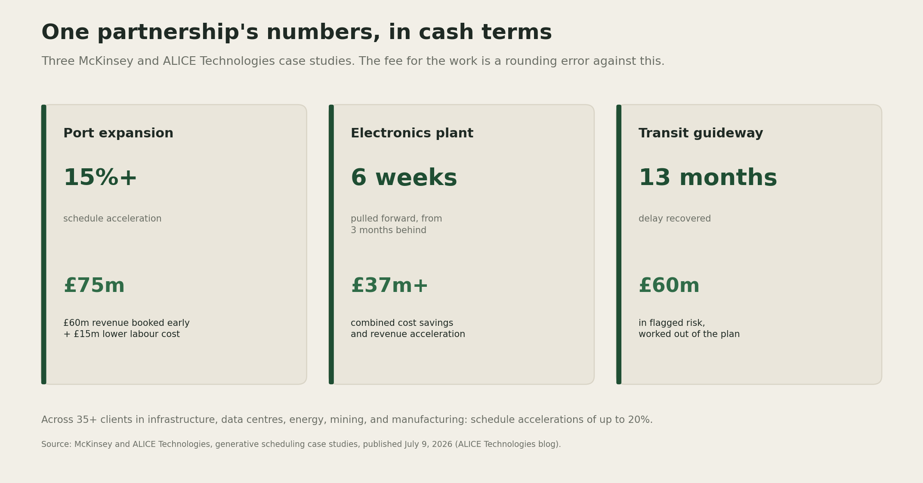
Three capital projects using generative scheduling: a port expansion, an electronics plant, and a transit guideway, each showing the schedule move and the pounds of client value it produced.
A port expansion project finished more than 15 percent ahead of schedule. That was worth £75 million: £60 million in revenue booked early, plus £15 million saved on labor. An electronics manufacturer was three months behind schedule on a facility with over 1,000 pieces of equipment to install. The AI pulled the schedule back by six weeks and captured more than £37 million in savings and earlier revenue. A transit guideway project was more than a year behind. It recovered thirteen months of delay and worked out £60 million of risk that had already been flagged. Across more than 35 clients, the partnership reports schedule gains of up to 20 percent.
All of that money sits with the client, not the consulting company, unless the company charges for it. The old pricing model works against speed. A company that bills by the hour bills fewer hours when it goes faster. It gets paid less for doing the one thing the client values most.
McKinsey made this same point in a separate report on July 15, 2026: companies that control their own project data, and that can "charge for outcomes rather than work processes," will benefit most (Construction Dive). Read that as market intelligence rather than instruction, given who is saying it. The report's warning is worth noting either way: today's productivity gains will "likely soon be table stakes." This pricing window will not stay open long.

The two tests
A company that wants a share of that value cannot just claim it. It has to answer two questions honestly first.
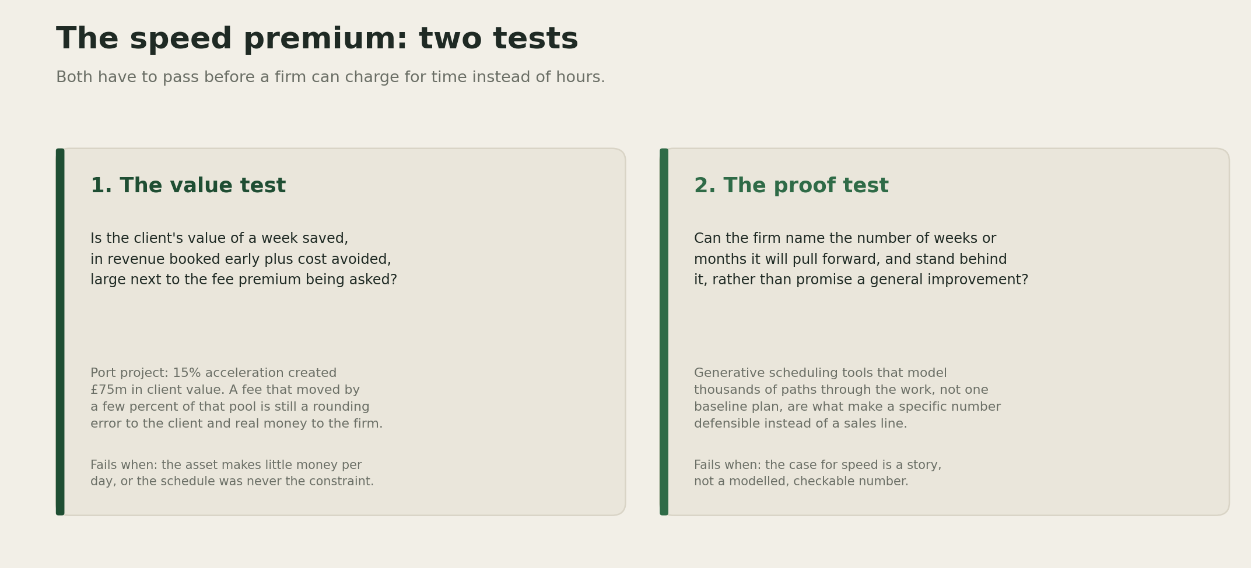
The speed premium: the value test asks whether the client's gain from a week saved is large next to the fee premium being asked, and the proof test asks whether the consulting company can name and stand behind the specific number of weeks it will pull forward.
The value test asks a simple question: is the client's gain from one saved week big enough to justify a higher fee? Add up the early revenue and the cost avoided. On the port project, that gain was £75 million. A fee that moved by just two or three percent of that pool would be a rounding error to the client. To the company, it would be real money. Most engineering fee schedules were never built with a number like that in mind.
The proof test asks a harder question: can the company name the exact number of weeks it will save, and stand behind that number? A vague promise to be faster is not enough. This is exactly what generative scheduling tools are built to do. They model thousands of paths through a project and compare each one to the baseline plan. That turns a vague promise into a specific number the client can hold the consulting company to.
I am fairly confident the value test passes on most large capital projects. Flyvbjerg's research and the numbers above both point the same way. I am less confident about how fast clients will accept the proof test's other half: a fee tied to a schedule number. Many AEC clients are public agencies or regulated utilities. Their procurement rules change slowly. The technology is moving faster than their contracts can keep up.

Where it fails
Both tests can fail on their own. Take a school or a community center. These assets earn little money per day, so there is little value to share, no matter how fast the design comes together. The value test fails. Or take a company with no scheduling analytics of its own. If it asks for a higher fee based on general confidence, not a real number, it is really asking the client to pay for a story. Any competitor could tell the same story. The proof test fails. A fee that fails these tests reads as opportunistic, not earned. Sophisticated clients notice the difference.
[YOUR DETAIL HERE]

The throughline
A schedule a consulting company can measure and defend is worth pricing on its own terms. A schedule a consulting company can only promise to improve stays billed by the hour, and every hour AI removes from that bill is revenue the consulting company just handed back to the client for nothing.

A prediction
Prediction (2026-07-26): Within two years, at least one top ten global engineering or construction consultancy will sell a schedule acceleration bonus as a named, standard product, with a modeled baseline behind it. Right now this only shows up in case studies. Confidence: medium.

What I'm watching
Two things. First, whether an established engineering consultancy, not a software vendor, is the one to publish its own schedule linked fee structure first. That would be the clearest sign the value test works for firms that already hold the client relationship and the delivery risk, which is most of this newsletter's readers. Second, whether vendors like nPlan and ALICE start pricing a share of the value they create, instead of just selling seats and licenses.

