Potato

Corn | 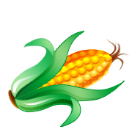
Green
Beans
Candy  Corn | 
Cupcake | 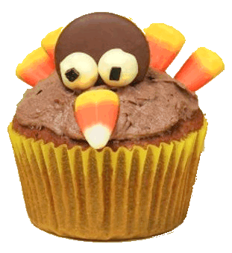
Pumpkin | 
Turkey
Pumpkin
Pie
Thanksgiving Copy and Paste
Name: Loreley

