**ESN 117 - NUMERICAL SOLUTIONS TO CE PROBLEMS**

**COMPLETE MODELING ACTIVITY**

LOREMIA, MAE ANN A. AUGUST 20, 2025

BSCE III

1. **PROBLEM STATEMENT**

*Deflection of a simply supported beam under a central point load*

A simply supported beam of length 2m is subjected to a point load of 1000N at its center. The beam is made of steel with Young’s modulus of 2.1 x ${10}^{11}$ Pa, and its moment of inertia is $8.5 x {10}^{−6}m^{4}$. Calculate the maximum deflection at the center of the beam and plot the deflection shape along its length.

1. **COMPLETE SOLUTION**

**Given Values:**

P = 1000N, where P is the point load at its center

L = 2m, where L is the length of the supported beam

E = 2.1 x ${10}^{11}$ Pa, where E is the beam’s Young’s modulus

I = $8.5 x {10}^{−6}m^{4}$, where I is its momemnt of inertia

**Formula:**

$δmax =\frac{P L^{3}}{48 x E x I}$**Deflection at any point (x):**

For $0≤ x ≤ \frac{L}{2}$:

$δ(x)=\frac{Px}{48 x E x I} (3L^{2 }−4x^{2})$

For $\frac{L}{2}< x ≤ L$:

$δ(x)=\frac{P(L−x)}{48 x E x I} (3L^{2 }−4{(L−x)}^{2})$

**Calculate Maximum Deflection:**

$δmax =\frac{1000 (2^{3})}{(48)(2.1 x {10}^{11})(8.5 x {10}^{−6})}$

$δmax =\frac{1000 (8)}{(48)(2.1 x {10}^{11})(8.5 x {10}^{−6})}$

$δmax =\frac{8000}{8.568 x {10}^{7}}$

$δmax ≈{9.34 x 10}^{−5}m$

$δmax ≈0.0934 mm$

1. **SCILAB CODE**

**// Given values**

**P = 1000; // Load at center (N)**

**L = 2; // Length of beam (m)**

**E = 2.1e11; // Young’s modulus (Pa)**

**I = 8.5e-6; // Moment of inertia (m^4)**

**// Maximum deflection at center**

**delta_max = (P * L^3) / (48 * E * I);**

**disp("Maximum deflection at center (m): " + string(delta_max));**

**// Deflection along the beam**

**x = 0:0.01:L;**

**delta = zeros(x);**

**for i = 1:length(x)**

**if x(i) <= L/2 then**

**delta(i) = (P * x(i) / (48 * E * I)) * (3*L^2 - 4*x(i)^2);**

**else**

**delta(i) = (P * (L-x(i)) / (48 * E * I)) * (3*L^2 - 4*(L-x(i))^2);**

**end**

**end**

**// Plot deflection shape**

**plot(x, delta*1000); // Convert to mm for readability**

**xlabel("Position along beam (m)");**

**ylabel("Deflection (mm)");**

**title("Deflection of Simply Supported Beam under Central Load");**

1. 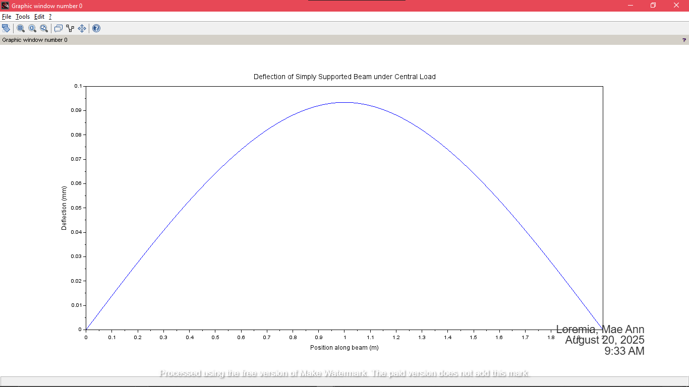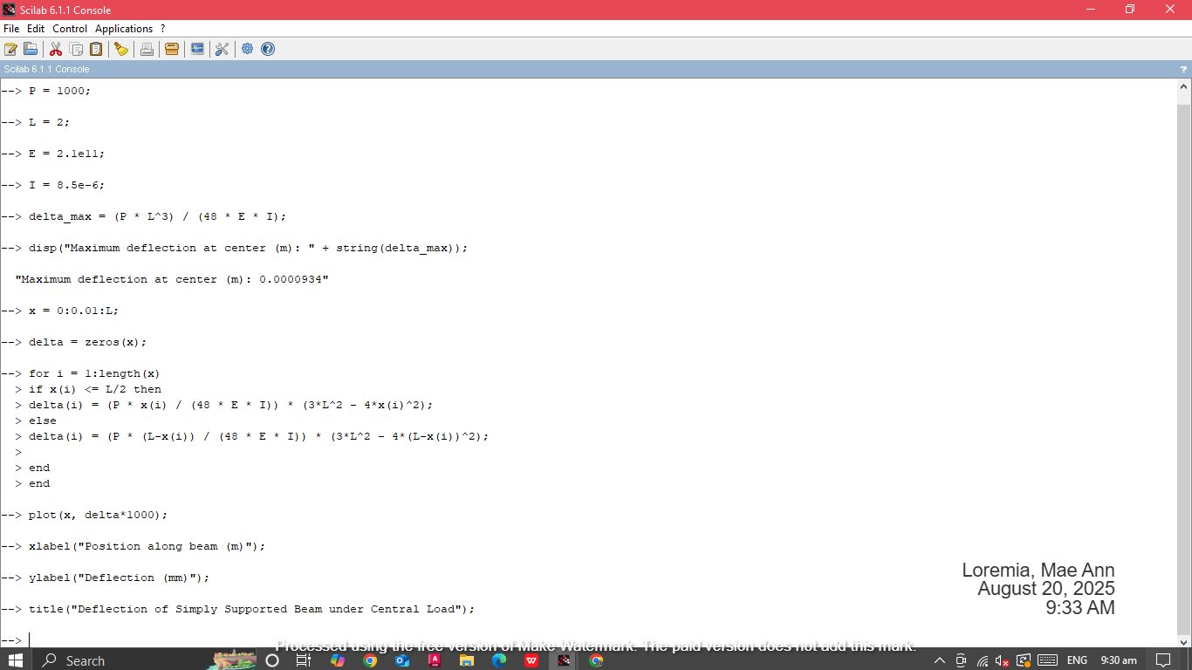**SCREENSHOT OF THE OUTPUT**