**VETERINARY MANAGEMENT SYSTEM - PROJECT PURPOSE**

*Lorena Gamarra and Nedis Barreto*

Our project is based on the creation of a program for management of a veterinary clinic.  
Providing the following basic options: animals, owners and employees registration also management of the consults.

In the registration of the animal we will insert the relevant information of the animal, including photo. As well as owner data (offering the option of one additional owner). When creating a new consult, it will be possible to search by animal's name, owner’s name or by phone number (1st or 2nd owner). Only after locating the animal will it be possible to start a new consult, in this moment will be allowed to update cadastral data. Otherwise the suggestion of creating a new register will be offered.

At the time of the consultation the veterinarian will have access to all information about the animal. During the consult, the employee will can include all description of the procedure (performed procedures, vaccines, medications, used materials and others), also will be possible to schedule the next consul date. Another option is to register prescription medications and exams, with an option to print or send a PDF file via email to the client.

At the end of the consultation, the doctor can generate a payment order, which consists of a list of available services and values, with the option of using a check box to select the service that was provided, besides having the possibility of Manually add some other service that was not previously registered, and their respective value. At the bottom of this screen, the total value will appear, and a discount field will appear with a radio button to select the discount type ($ or%).

**Technologies and Features**

* Ribbon – Quick access menu
* LINQ – Search for the animal or owner by name or phone
* StackPanel – Possible to be used in dialogue windows for confirmations
* TabControl – Better distribute content to facilitate usability
* Camera access – Capture animals photo for registration
* PDF-generation – To send the Clinical history of the animal to other clinics and send by email to the owners the requests for exams and medicines
* Printing - Exam requirements and medicines / payment voucher
* Installer - Creation of an executable file to facilitate installation by the end user
* Localization - Translation on multiple languages by position of the device
* Storing binary data (pictures, etc.) in a BLOB – Storage of images in the AZURE cloud database

**Challenging items**

* Implementation of the use of the camera
* Location system for language change
* Creation of an executable for the project.

**Screenshots** *(Preliminary version)*

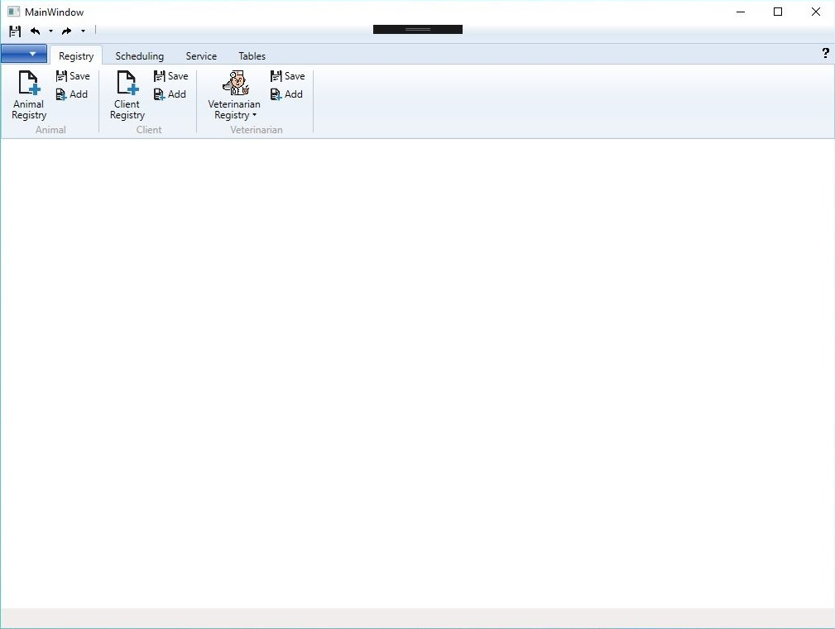

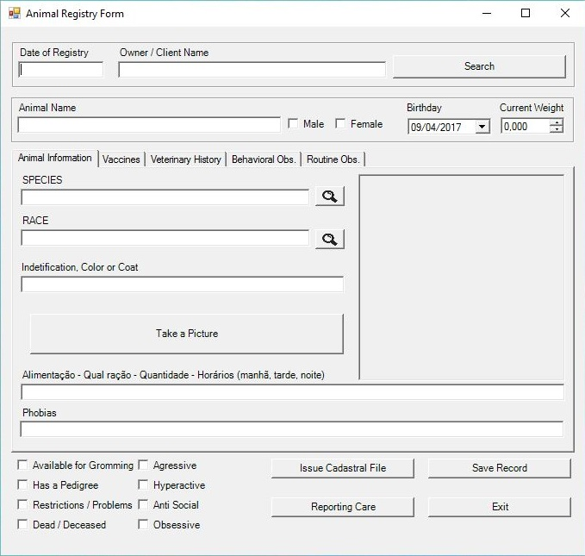

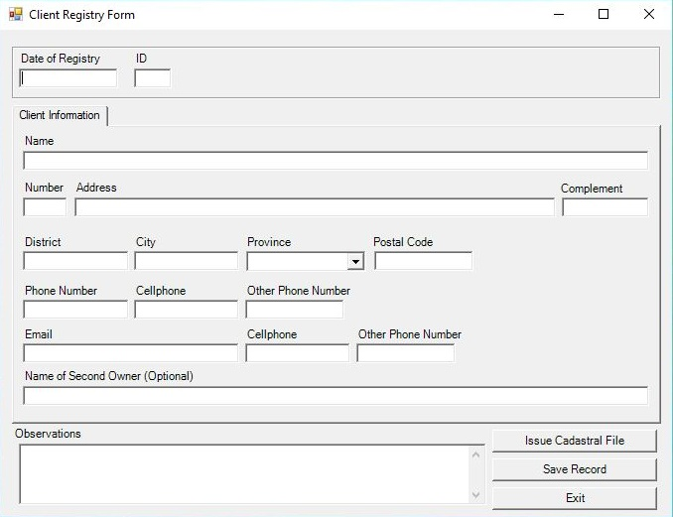

**Design of the database** *(Preliminary version)*

