**The high costs of diabetes medication in the U.S.**

**By Lorena Sandoval**

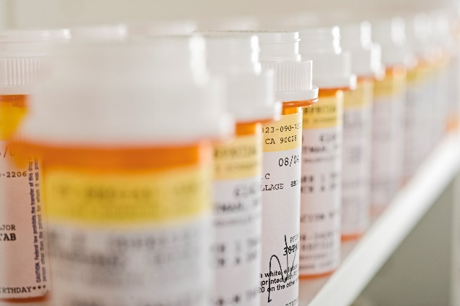

Diabetes is a disease that arises from the body’s inability to process sugar, caused by the lack of insulin. It has become a global epidemic, with the total number of people with diabetes projected to rise from [171 million in 2000 to 366 million in 2030](https://diabetesjournals.org/care/article/27/5/1047/27412/Global-Prevalence-of-DiabetesEstimates-for-the). Insulin was first discovered in the early 1920s and extracted from the pancreas of cattle and pigs to treat diabetes. A synthetic “human” version was created in the late 1970’s, circumventing allergic reactions caused by animal insulin. Although the discovery, isolation and production of insulin has saved the lives of millions of people, increasing incidence rates along with astronomical costs have negative health implications for Americans.

In 2000, first generation, [long-acting basal insulin analogs](https://www.ncbi.nlm.nih.gov/pmc/articles/PMC6824364/) were developed using recombinant deoxyribonucleic acid technology to alter the amino acid sequence of human insulin. In 2015, [second-generation insulin](https://www.ncbi.nlm.nih.gov/pmc/articles/PMC6824364/) was introduced with a flatter pharmacokinetic (PK) profile, one-third the volume, fewer injections, and a decreased risk of hypoglycemia. These newer medications provide additional clinical benefits but [similar efficacy in lowering HbA1c](https://pubmed.ncbi.nlm.nih.gov/30034546/), average blood sugar (glucose) levels. Isolation and production of insulin have saved the lives of millions of people, but increasing incidence rates along with astronomical costs have negative health implications for Americans.

Although patients and providers now have more options, out-of-pocket costs for both uninsured and insured patients have increased dramatically in the U.S. over the past 10 years. From 2014 to 2019, the [annual average out of pocket cost](https://www.ncbi.nlm.nih.gov/pmc/articles/PMC7646207/) for Medicare patients rose from $3,819 to $5,917. In 2022, the average [annual supply for uninsured patients](https://www.nbcwashington.com/news/health/nearly-1-in-5-us-adults-with-diabetes-ration-insulin-to-save-money-study-finds/3184715/) with type 1 diabetes was $12,000. Some Americans have resorted to [traveling to Mexico](https://www.statnews.com/2018/12/07/patent-abuse-rising-drug-prices-lantus/#:~:text=Just%20look%20at%20Lantus,-By%20Tahir%20Amin&text=A%20rare%20point%20of%20consensus,to%20make%20medicines%20more%20affordable) to purchase a five-pen carton of Lantus for approximately $50, compared to $280 in the U.S. . High out-of-pocket costs force approximately one out of four patients to take smaller doses or skip doses altogether to [ration their supply](https://www.ajmc.com/view/gathering-evidence-on-insulin-rationing-answers-and-future-questions). Although Medicare has capped the out-of-pocket costs for most diabetic drugs, it has grown exponentially over the years. As a result, both insured and uninsured patients are at risk for insulin rationing.

Lantus, a second-generation, long-acting form of insulin filed its patent in 1994 and became one of the ”world’s bestselling drugs”. Although it was set to expire in 2015, additional patents filed after its approval [extended the patent](https://www.biopharmadive.com/news/insulin-drugmakers-under-scrutiny-for-pricing-patent-practices/541275/) to 2031, with the most patents filed in the U.S. compared to other developed nations. As a result, [the U.S. represents only 15% of the global insulin market](https://www.forbes.com/sites/joshuacohen/2021/01/05/insulins-out-of-pocket-cost-burden-to-diabetic-patients-continues-to-rise-despite-reduced-net-costs-to-pbms/?sh=5ebbed8340b2) but generates close to 50% of the industry’s insulin revenue. This process of slightly altering medication over time, regardless of significant differences in outcomes, is known as “[evergreening](https://www.statnews.com/2018/12/07/patent-abuse-rising-drug-prices-lantus/#:~:text=Just%20look%20at%20Lantus,-By%20Tahir%20Amin&text=A%20rare%20point%20of%20consensus,to%20make%20medicines%20more%20affordable.)”. Since 2012, costs for newer versions of insulin have risen over [15% annually](https://www.statnews.com/2018/12/07/patent-abuse-rising-drug-prices-lantus/#:~:text=Just%20look%20at%20Lantus,-By%20Tahir%20Amin&text=A%20rare%20point%20of%20consensus,to%20make%20medicines%20more%20affordable.). Even with the [2010 FDA approval of Semglee](https://www.fda.gov/news-events/press-announcements/fda-approves-first-interchangeable-biosimilar-insulin-product-treatment-diabetes), a biosimilar to Lantus, prices are still out of reach. As of 2022, The [average wholesale price for a 5-pack of insulin pens](https://www.fda.gov/news-events/press-announcements/fda-approves-first-interchangeable-biosimilar-insulin-product-treatment-diabetes#:~:text=Semglee%20(insulin%20glargine%2Dyfgn)%20is%20the%20first%20interchangeable%20biosimilar,effective%20options%20for%20treating%20diabetes.) is $177.58 for Semglee compared to $510.31 for Lantus.

Furthermore, [patent expirations](https://www.cambridge.org/core/journals/journal-of-law-medicine-and-ethics/article/abs/approximating-future-generic-entry-for-new-drugs/56765AF1008397172510060B253281D9) providing the possibility of generic drugs are often obscure and complex. As a result, many physicians and patients do not know when generic versions are available. [Generic manufacturers file lawsuits](https://www.cambridge.org/core/journals/journal-of-law-medicine-and-ethics/article/abs/approximating-future-generic-entry-for-new-drugs/56765AF1008397172510060B253281D9) to prevent additional patents or settle with brand-name manufacturers to prevent further delays. A comprehensive open access application could serve to provide the public with patent expiration dates to allow them to request generic prescription as soon as they are available.

The initial discovery of insulin in the 1920s resulted in the successful treatment of diabetes. Previously, patients had no recourse, and often opted for minimal calorie intake to extend their lives by a few years. Although there was some progress with the [Inflation Reduction Act](https://www.nbcwashington.com/news/health/nearly-1-in-5-us-adults-with-diabetes-ration-insulin-to-save-money-study-finds/3184715/), signed into law by President Joe Biden in August 2022 capping out-of-pocket monthly costs for seniors at $35, the disproportionate out of pocket costs for the rest of Americans is cause for concern. Lawmakers must prevent the delay of generic insulin products to address insulin rationing and out-of-control prices.