Simple v5 ancestry pipeline steps 1 to 7
  - One model and one workflow folder
2,003 training people and 501 test people
Plan for a later rerun
Keep the original seven-step order and use one ancestry model. Steps 1 through 6 prepare the reference data, train the classifier, and test it. Step 7 applies the same saved model to compatible personal v5 files. All workflow-specific code, inputs, and results would be organized under one cloud folder.
Companion Observable ancestry inference notebook
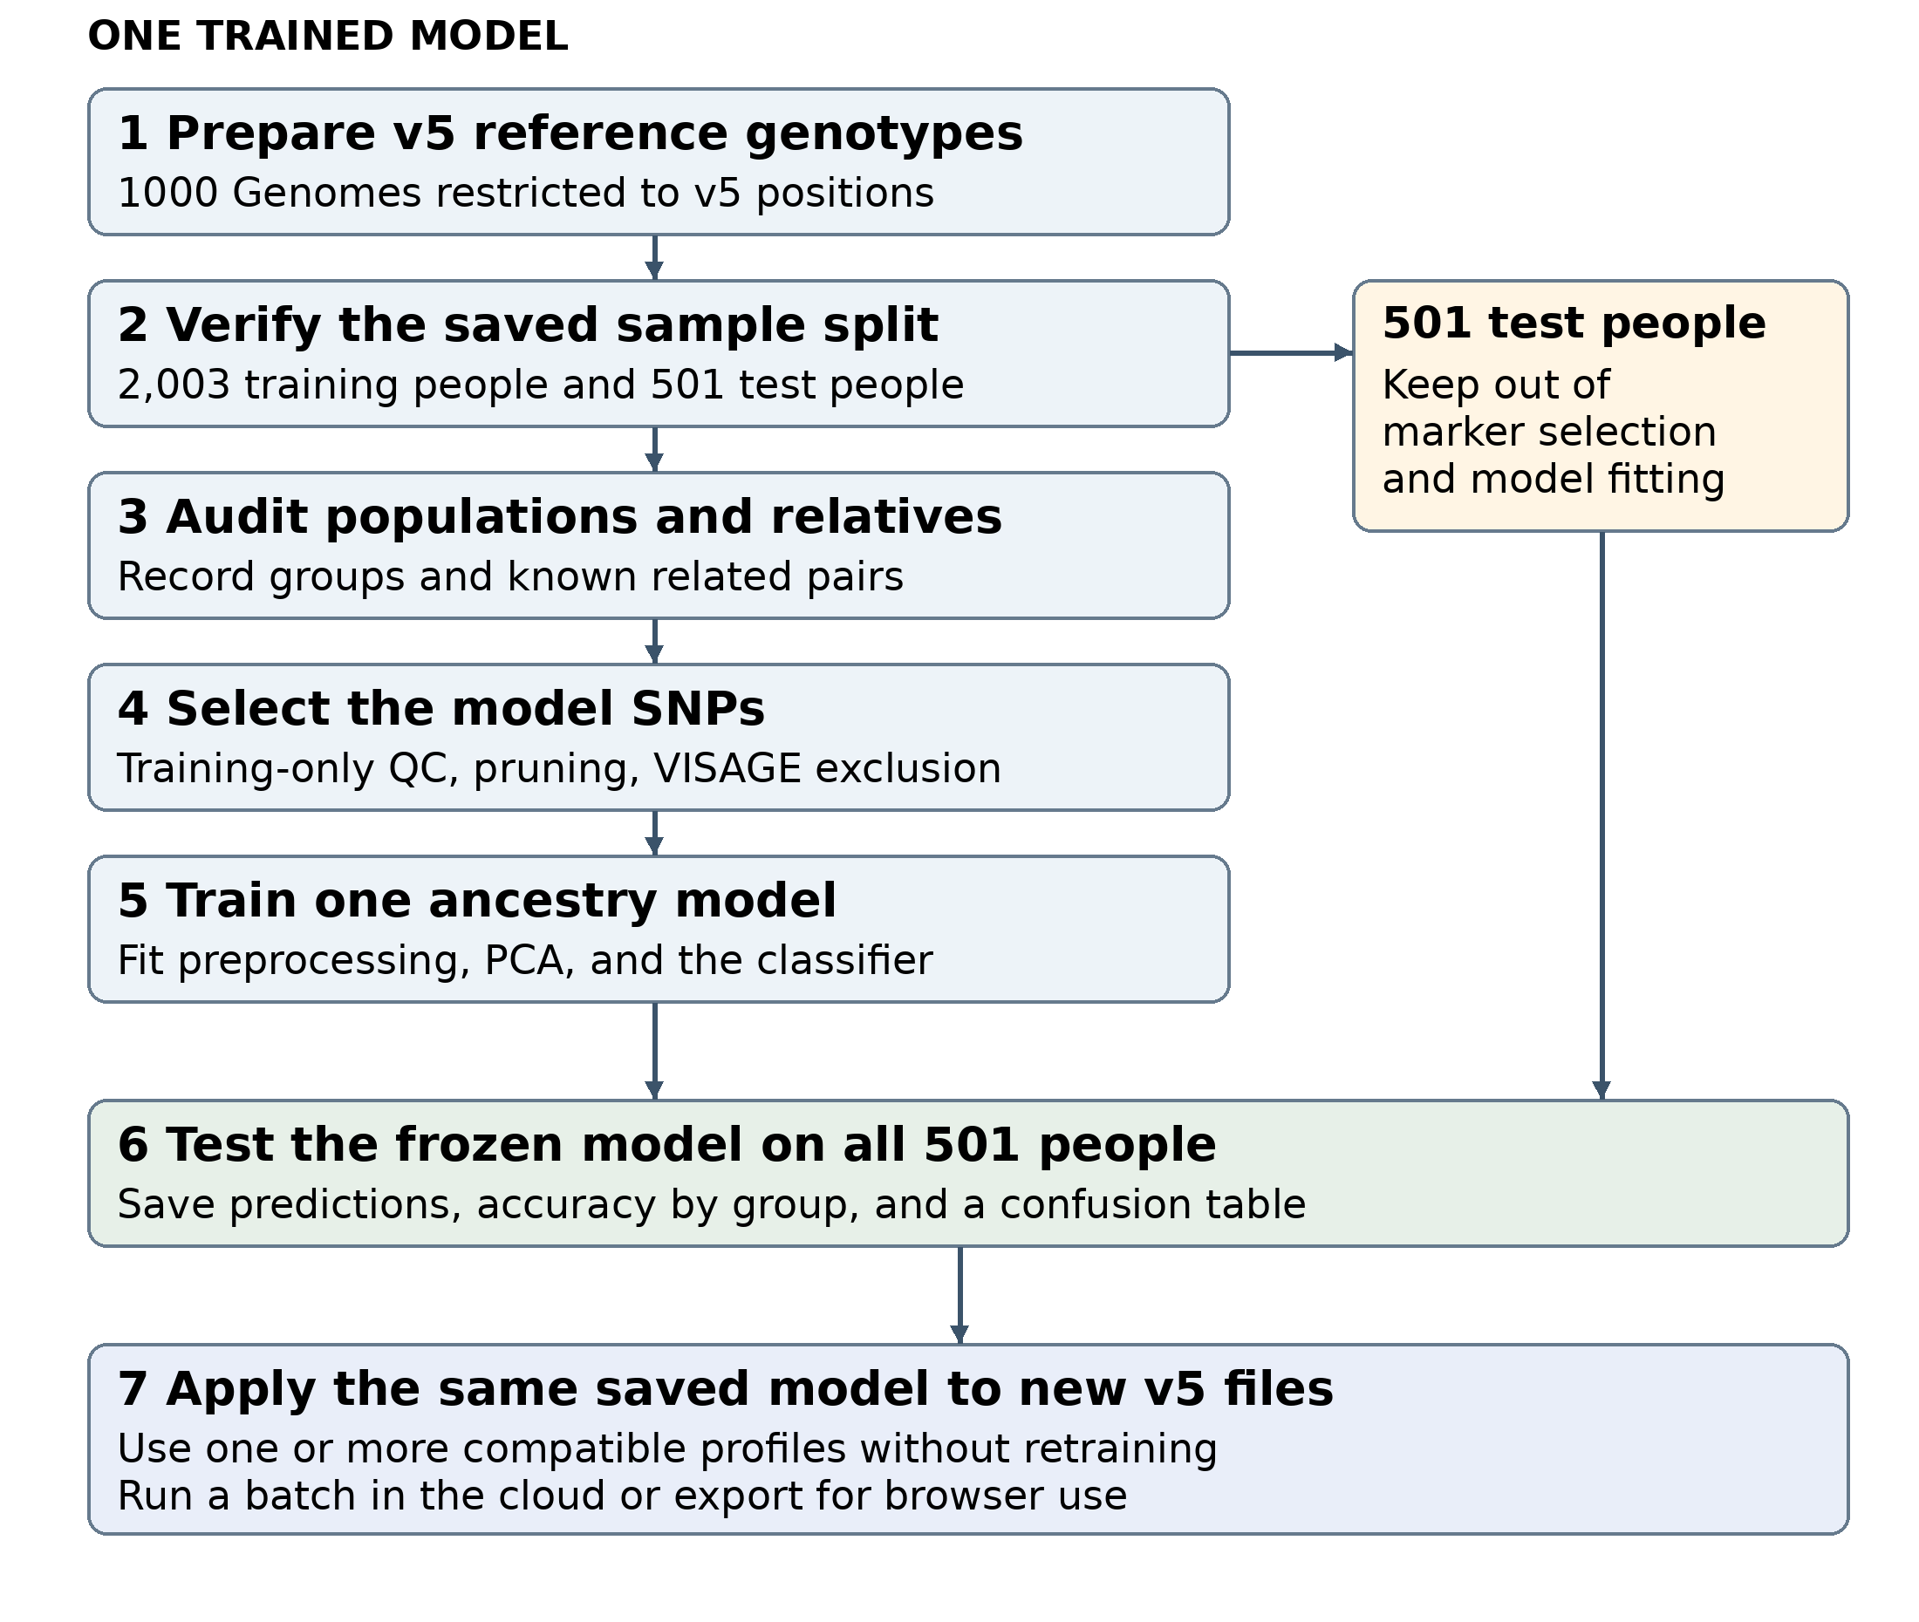
Step 6 evaluates the 501 reference test people. Step 7 uses personal v5 profiles and loads the saved model without repeating training.
Marker policy: retain the chosen without-VISAGE-34 setting. Exclude the same 34 verified marker IDs from the final panel and train one classifier. This is a future workflow design, not a newly completed rerun.

Steps 1 to 4 prepare the reference data

1 Prepare the v5 reference genotypes
Read the Phase 3 reference files already stored in gs://ref1000g/phase3/. Match the verified 23andMe v5 positions on chromosomes 1 through 22, check genome build and alleles, and save one prepared PLINK genotype set per chromosome. The training examples come from 1000 Genomes restricted to v5 marker locations.
Keep all 2,504 reference people in the prepared data. Use the saved ID lists to select training or test people when required. Record the manifest version, source files, and usable-marker counts. This keeps one common prepared genotype set instead of making multiple complete copies.

2 Verify and preserve the sample split
Keep train2003.txt and test501.txt exactly as supplied. Confirm that there are 2,003 unique training IDs and 501 unique test IDs, that nobody appears in both lists, and that every ID belongs to the reference dataset. Save normalized lists and checksums for reproducibility.

3 Audit populations and relatives
Match the IDs to the population panel and report training and test counts by population and broad reference group. Check the published related-pair report against the split. Keep the full 2,003-person training group and all 501 test people, as chosen for this plan.
The existing audit identified five known close pairs crossing training and test. Record them in the new report so the test results can be interpreted in that context. Related training people should stay in the same group if cross-validation is used.

4 Run training SNP quality checks and LD pruning
Use only the 2,003 training people to select markers. Apply the established missingness, allele-frequency, and LD-pruning rules. In simple terms, remove markers with too many missing calls or very rare variants, and reduce repeated information from correlated markers.
Apply the documented VISAGE exclusion policy and save one final ordered panel with the counted allele for each marker. Use that same panel in training and testing. Record all settings and exclusions in the marker audit. The final marker count is a result of this run and should not be assumed in advance.

Steps 5 to 7 fit test and apply one model

5 Train one PCA and reference-group classifier
Start with the chosen settings of 10 principal components and logistic C of 1.0. Fit missing-value filling, scaling, PCA, and the classifier using the training people. PCA compresses the DNA measurements into a smaller set of patterns; the classifier uses those patterns to predict AFR, AMR, EAS, EUR, or SAS reference-group labels.
If settings are retuned, use training-only cross-validation with related training people kept together. Save the complete fitted pipeline, the exact marker order and counted alleles, and the training report. Fitting these components is done once for the chosen model.

6 Test the frozen model on all 501 people
Load the test people and apply the saved marker definitions and fitted transformations. Compare predicted groups with the known 1000 Genomes labels. Save predictions, overall and per-group accuracy, a confusion table, and coverage checks. The test people do not select SNPs, fit PCA, or tune the classifier.
The earlier chosen model used 335,632 markers and correctly assigned 500 of 501 test labels. These are historical results for comparison. Report the actual count and performance of the rerun. Since these test results are already known and five test people have known training relatives, describe this as a repeated benchmark with that relatedness context.

7 Apply the saved model to one or more v5 files
Select compatible personal genotype files identified as v5 on genome build 37. Match their positions and alleles to the saved marker list, check usable-marker coverage, and apply the same fitted pipeline. A profile with insufficient usable data should receive a clear reason rather than an unreliable assignment.
Save one report per file and a combined predictions table. Retain the predicted group, quality checks, source-file identity, and model version. The same model can process the previously classified 74 files or a later batch without repeating steps 1 through 6.
For browser use in Diseasome, export this single pipeline to a browser-compatible representation, verify agreement with Python, and connect it to new uploads. Conversion must retain preprocessing, marker order, allele coding, PCA, and classifier parameters. A new upload runs inference rather than retraining. [3]
The result describes broad reference-group similarity. Classifier scores are not ancestry mixture percentages or substitutes for self-reported race and ethnicity.

One cloud folder for all seven steps
Proposed workflow folder:
gs://ref1000g/ancestry/v5_2003_pipeline/
Use one RUN_ID for the reference model build, such as a date and time. Give each later application batch its own APPLY_ID inside that model run. Paths below are relative to the prefix above.
Folder or file | What it would contain
input/ | The original ID lists, v5 manifest or verified derivative, population panel, related-pair report, and the 34 verified VISAGE IDs
source/RUN_ID/ | Exact code, configuration, Dockerfile, dependency versions, deployment script, and README
results/RUN_ID/01_prepared/ | One prepared genotype set per chromosome and variant maps
results/RUN_ID/02_sample_split/ | Validated 2,003-person and 501-person ID lists
results/RUN_ID/03_pop_relatives/ | Population counts and documented relative-pair audit
results/RUN_ID/04_marker_qc/ | SNP QC and pruning reports, final marker list, and VISAGE exclusion audit
results/RUN_ID/05_model/ | Fitted pipeline, ordered markers, counted alleles, and training summary
results/RUN_ID/06_test/ | Predictions for all 501 test people and evaluation reports
results/RUN_ID/07_apply/APPLY_ID/ | Per-file personal predictions, quality checks, and combined predictions table
results/RUN_ID/run_manifest.json | Input checksums, settings, source snapshot, software versions, and image reference
results/RUN_ID/model_ready.json | Completion record after steps 1 through 6 validate

Each application batch would write its own success record inside 07_apply/APPLY_ID/. New personal files can therefore be classified later without repeating the reference model build or changing earlier results.
The full reference chromosome files remain in gs://ref1000g/phase3/. Personal source files can remain in their existing private storage. The workflow records their locations and versions, rather than copying all raw data into the new folder.

Run once for training and reuse for prediction

One source package with two uses
The proposed package would contain run_pipeline.py, config.json, requirements.txt, Dockerfile, deploy.sh, and README.md. It could provide a build mode for steps 1 through 6 and an apply mode for step 7. Both modes would use the same model definitions and workflow folder.
Cloud Shell would hold this small source package and launch the computation. Cloud Run would read the bucket inputs and perform the work. The bucket stores the workflow files, Artifact Registry stores the image, and the run manifest records which code and image produced the outputs. [1]

Training and testing
One Cloud Run Job with one task could execute steps 1 through 6 sequentially. Each completed step would save a checkpoint. A restart should reuse that step only when the required outputs, input checksums, and settings still match; otherwise start a new RUN_ID.
Size the job for the most demanding stage. The previous training configuration of 8 vCPU and 32 GiB is a starting point to evaluate. Temporary files consume ordinary Cloud Run memory too, so process chromosomes sequentially and clear temporary data when no longer needed. [2]

Application after training
A later batch execution can load the saved model and process specified v5 profiles in apply mode. Browser use requires the additional export and verification described in step 7. The batch job is not itself a continuously running web API. [1, 3]
Saved artifact | What it is used for
model.joblib | The fitted Python pipeline for this single model
selected_markers.tsv | The required marker order and counted alleles
training_summary.json | Cohort, marker count, settings, and provenance
Test reports | Reference predictions and performance from step 6
Application reports | Personal-file predictions and quality checks from step 7

This document is a plan for a later implementation and rerun. The combined executable package and browser export still need to be assembled and checked. All seven steps use one chosen 2,003-person ancestry model.
Observable ancestry inference notebook
1 Cloud Run Jobs | 2 Job memory guidance
3 Model persistence and browser export options

