Understanding genotype embeddings and population analysis
  - Classification and clustering for your 2003 training people and 501 test people
28 October 2026
An embedding is a numerical summary of a person's SNP genotypes. Once those summaries exist, you can use them to predict known reference groups or to explore genetic similarities. The distinction depends on where population labels enter the learning process.
For your proposed experiment, learn the genetic representation from the training people without population labels, freeze it, and compare two downstream analyses using exactly the same embeddings. For a fair comparison with PCA, fit both representations on the same chromosome-22 v5 SNP panel. Keep the 501 test people separate throughout fitting.

The terms in plain language
Term | Meaning
Genotype | The two allele copies a person carries at one SNP, represented consistently as a count such as 0, 1, or 2.
Encoder | The learned calculation that turns a long SNP profile into a numerical representation.
Embedding | The resulting vector of numbers for a person. Its coordinates are learned features rather than ancestry percentages.
Population label | A known reference category attached to a sample, such as EUR or a more specific population code.
Frozen model | A model whose learned weights stay fixed while it processes new people.

The two population analyses
Classification asks which predefined label fits a person. Clustering asks which people have similar representations. Both can be useful, but they answer different research questions. A classifier can learn a useful boundary even when the embeddings do not form sharply separated clusters. [3, 4]
Scope: this is a proposed embedding experiment. Your completed PCA plus logistic regression classifier is a separate, existing analysis; it was not SNPBag.

How an encoder can learn without population labels
Self-supervised learning creates a training task from the genetic data themselves. A model hides observed genotype values, predicts the hidden values, and compares its predictions with the original observations. No population label is needed to create that feedback.

A small example of reconstruction
SNP | Original value | Shown to the model | Learning target
A | 0 | 0 | No hidden target here
B | 1 | Hidden | Recover 1
C | 2 | 2 | No hidden target here
D | 0 | Hidden | Recover 0

These values are an invented illustration. The model also needs SNP identities so that it knows which location each value describes. It cannot treat every genotype count of 1 as the same biological measurement.
The encoder learns patterns that help reconstruction. For example, nearby SNPs can be correlated because they are often inherited together. Differences in allele frequencies across reference populations can also become part of the representation, even though the model never receives those population names.

Where SNPBag fits
The SNPBag methods describe masked genotype learning and a reconstruction objective for producing embeddings, followed by a separate population classifier trained with labels. They do not establish end-to-end population-label training of the original encoder in that classification stage. [1]

Why this is called self supervised
The original genotype supplies the target. A reconstruction decoder is the part that tries to recover the input from the representation. The encoder and decoder improve through training feedback, much as a masked-word model learns from text with words hidden. The analogy concerns the training task; SNP inputs require their own representation. [2]
Accurate reconstruction is useful evidence that the representation preserves some genetic information. It does not guarantee that the resulting embeddings will classify populations, reconstruct rare alleles accurately, or improve a polygenic score. Each intended use needs its own evaluation.

Classification learns a named answer
For supervised population classification, every training embedding is paired with its known label. The classifier learns a rule connecting numerical features to those labels. During prediction it returns one of the categories used in training, often with a probability for each category. [3]

What changes during training
With a frozen encoder, only the classifier's weights change. If a training person labeled EUR is predicted as SAS, the classifier receives an error signal and adjusts its decision rule. The person's embedding remains the same.
If you instead allow that error signal to update the encoder, its embeddings also change to make the population task easier. That is supervised representation learning. It can be a valid model design, but a later cluster plot would then use features already shaped by population labels.

Clustering discovers groups of similar vectors
Clustering receives embeddings without training labels. In K-means, you choose a number of clusters, K; the algorithm learns centers and assigns people to the closest center. A new person can be assigned using those saved centers. The numerical cluster IDs have no built-in population meaning. [4, 5]
Question | Classifier | K means clustering
Uses labels to fit the final method | Yes | No
Output for one person | A named category such as EUR | An arbitrary cluster such as 2
What determines the grouping | Learned decision boundaries | Distance from learned cluster centers
How known labels are used | To fit and evaluate predictions | To interpret and evaluate assignments afterward

A cluster could include several neighboring reference populations, or one labeled population could spread across clusters. Population histories and admixture can create continuous variation. Choosing K = 5 does not guarantee recovery of the five broad reference groups.
The 19-population confusion matrix you shared is a classification result. A two-dimensional embedding plot is a visualization; it does not by itself prove that a clustering algorithm recovered those populations. [1]

Where labels may enter the workflow
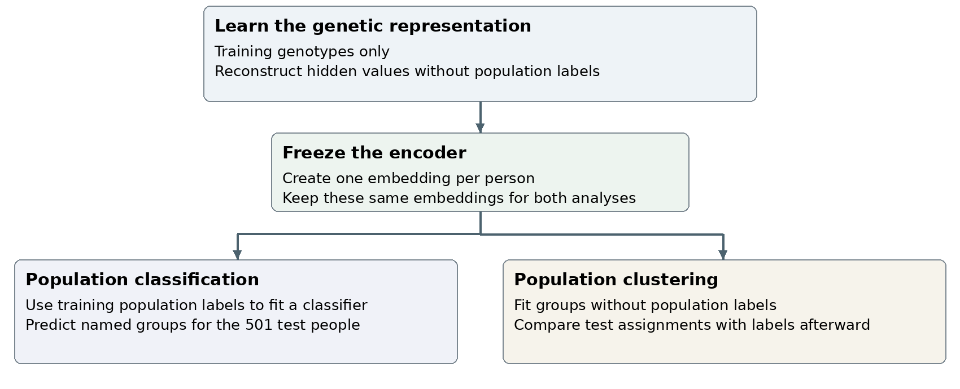
Proposed comparison using a shared representation and two downstream methods

Freezing protects the meaning of the comparison
Freezing means no further weight updates. It does not erase information already learned. If the encoder previously learned from population labels, freezing preserves that label-directed learning too.
For an analysis intended to explore structure without label guidance, keep population labels out of encoder fitting, reconstruction-model selection, clustering choices, and embedding selection. Use reconstruction validation to choose encoder settings. Population labels can then be used to measure and describe the resulting groups.

Label information and test leakage are different issues
Using training labels for a supervised classifier is expected. Test leakage occurs when information from the held-out people affects choices that are supposed to be learned using training data. Even label-free fitting on the 501 test genotypes changes the experiment: it becomes an analysis that has used the test inputs.
A published pretrained model needs a provenance check. If the test people, or synthetic genomes derived from them, contributed to pretraining, describe the result as using a representation with prior reference-cohort exposure. You should not claim those people were completely unseen throughout model development.
For your own model trained from scratch, prevent that issue by using only training people as reconstruction inputs or synthetic-data founders. This condition is part of the proposed experimental design, not a claim about a completed SNPBag run.

A practical experiment with your saved split

Fit using the 2003 training people
- Start with shared v5-overlap SNPs on chromosome 22. Apply SNP quality checks using training people only; use the panel before LD pruning for this matched experiment. Keep locations, counted alleles, and genotype coding consistent.
- Reserve validation people within the 2,003 to choose reconstruction settings. Keep known relatives together when assigning validation groups. [7]
- Learn the encoder without population labels. Choose reconstruction settings without examining test performance.
- Freeze the selected encoder and generate embeddings. Fit logistic regression on training embeddings and population labels. Separately fit K-means on training embeddings without labels.
- Fit PCA on exactly the same QC-passed SNPs. Use logistic regression for the matched classification comparison and K-means for the matched clustering comparison. Use comparable training-only tuning procedures. [9, 10]

Evaluate using all 501 test people
Transform the test people with the frozen preprocessing and encoder. Apply the saved classifier or cluster centers. Report both analyses separately; the shared test set makes comparisons paired rather than statistically independent.
Analysis | Useful evaluation | Meaning
Classification | Accuracy and balanced accuracy | Correct named labels overall and averaged across reference groups.
Classification | Confusion table | Which expected categories were predicted as other categories.
Clustering | Adjusted Rand index or ARI | Agreement between two partitions, allowing arbitrary cluster numbering.
Clustering | Cluster by population counts | Which labeled populations appear together or split across clusters.

ARI = 1 means the partitions agree perfectly up to cluster numbering. Values near 0 indicate chance-level agreement; negative values are possible. ARI is not a percentage of people classified correctly. [6]
Interpret the clusters alongside missing calls, technical differences, and known relatives. These can affect genetic similarity. Calculate PRS313 separately with its published variants and weights, then overlay it for exploration; an embedding coordinate or cluster label is not a PRS.

A fair comparison with your PCA model
Your existing PCA classifier uses SNPs across chromosomes 1 through 22 after quality filtering and LD pruning. A chromosome-22 transformer would use less genetic information. Their accuracy can be compared as complete workflows, but any difference would reflect both the SNP panel and the representation method.

Fit a new PCA baseline on the same SNPs
Keep the same | PCA approach | Transformer approach
Training people | 2,003 | Same 2,003
Test people | 501 | Same 501
Input SNPs | Same QC-passed chromosome-22 v5 panel before LD pruning | Same SNPs and allele coding
Representation | PCA coordinates | Learned embeddings
Population prediction | Logistic regression | Same classifier type
Clustering | K-means on PCA coordinates | K-means on embeddings
Model choices | Choose settings using training people only | Use a comparable validation procedure

The earlier prepared chromosome-22 report contained 8,450 SNP records before later QC. Treat that as a starting count from the previous preparation, not a guaranteed count for this run. Recount after training-only QC and record the exact shared marker list.

Why use the panel before LD pruning
This experiment retains SNP correlations that may help hidden-genotype reconstruction. Give PCA the same unpruned panel so that a marker-selection difference does not explain the result. This is a comparison design choice; it does not guarantee that either representation will perform better.

What each comparison can tell you
The matched chromosome-22 comparison asks whether the transformer representation helps relative to PCA when the people and SNP inputs agree. Keep the existing genome-wide, LD-pruned PCA model as a separate practical benchmark. A smaller v5-specific model is compatible with your intended uploads, but is not automatically more accurate.
Fit preprocessing and model settings using training people, then transform the test people with the saved pipeline. Report accuracy and confusion tables for classification, and ARI and population composition for clustering. These use the same 501 people, so their results are paired. [10]

Sources and a concise decision guide
Choose supervised classification when the goal is to predict existing reference labels for new people. Choose clustering when the goal is to explore how profiles group by similarity. For the proposed comparison, use one frozen reconstruction encoder and the same train and test people for both.
The proposed experiment is inspired by genotype representation learning. Reproducing the published SNPBag model also requires verified model weights, its SNP dictionary, allele conventions, preprocessing, and compatible inference code.
[1] Xu and colleagues 2025 SNPBag preprint version 2. Open source
Sections Genome embedding and Population classification distinguish representation learning from the downstream population classifier.
[2] Devlin and colleagues 2019 BERT. Open source
Background on learning representations through masked inputs and adapting a pretrained encoder.
[3] Scikit learn logistic regression. Open source
Supervised classification and categorical prediction.
[4] Scikit learn clustering guide. Open source
Clustering objectives, assumptions, and the distinction between discovering groups and predicting labels.
[5] Scikit learn KMeans. Open source
Fit cluster centers and predict assignments for new observations.
[6] Scikit learn adjusted Rand score. Open source
Chance-adjusted agreement between partitions and interpretation of the score.
[7] Scikit learn StratifiedGroupKFold. Open source
Validation groups that preserve group membership while attempting class balance.
[8] Your Observable ancestry notebook. Open source
Companion context for the existing reference-data pipeline. The embedding experiment described here is proposed work.
[9] Scikit learn PCA. Open source
Fit a principal-component representation and transform new observations using the learned directions.
[10] Scikit learn data leakage guidance. Open source
Fit preprocessing and choose model settings without using the held-out test people.

