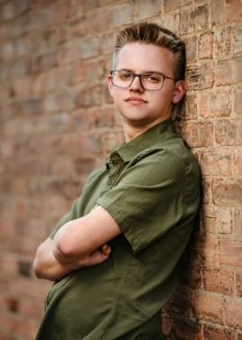
TIMOTHY CHRISTENSEN.
Stillwater, Oklahoma · 918-928-9202 · timothy@jl2t.com · timothy-christensen.com

SUMMARY

Sports Media major and student journalist with 45+ published bylines covering Oklahoma State athletics — football, basketball, baseball, golf and more. Experienced in game recaps, feature writing and on-deadline reporting, with credentialed coverage of Big 12 Football Media Days.

EDUCATION

Oklahoma State University — Stillwater, OK Expected May 2028
B.A. in Sports Media · GPA: 3.908

EXPERIENCE

Staff Writer — The O'Colly Sept 2024 – Present
Oklahoma State University's independent student newspaper · Stillwater, OK
- Published 45+ bylined stories across six sports, including football, men’s and women’s basketball, baseball, golf and equestrian.
- Wrote recurring analysis columns — “Headset Check” (2024 season) and “Report Card” (2025 season) — breaking down Cowboy football game decisions week over week.
- Covered Big 12 Football Media Days in Frisco, Texas as credentialed media, interviewing coaches and players on the floor and on camera.
- Filed game recaps and postgame stories on tight deadlines from live events, following AP Style.
- Reported enterprise features on topics including the NCAA revenue-sharing settlement and conference sponsorships.

SKILLS

Reporting · Feature writing · AP Style · Interviewing · Game recaps · Deadline writing · Video editing · Social & short-form content

PORTFOLIO
timothy-christensen.com — personal portfolio site with all published clips, video appearances and contact information.

